
Derek A. Hamilton, Ph.D
Department of Psychology
Logan Hall
MSC03 2220
1 University of New Mexico Albuquerque, NM 87131
Allison Diamond Oct 3, 2014
Journal of Visualized Experiments
To the Editor:

This letter accompanies a revised manuscript 52407 entitled “Moderate prenatal alcohol exposure and quantification of social behavior in adult rats” submitted for your consideration as an original protocol article and video in JoVE. The changes to the manuscript were tracked (in MS Word) with the filename 52407_R1_082514_R2.docx.
We thank the reviewers and veterinarian for the comments and suggestion on improving the manuscript and video. Rebuttal comments are contained in a separate document as requested.

Thank you for considering our manuscript for publication in JoVE.

Sincerely,
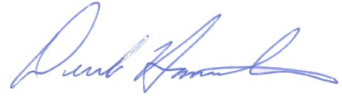
Derek Hamilton, Ph.D.
Associate Professor of Psychology and Neurosciences
Chair : Cognition, Brain and Behavior Area

