Submission ID #: 52332

Editor Name: Melissa Ceo

Videographer name:

Film Date:

Authors and Affiliations:
Hari Sreedhar¹*, Vishal K. Varma¹*, Peter L. Nguyen², Bennett Davidson³, Sanjeev Akkina⁴, Grace Guzman², Suman Setty², Andre Kajdacsy-Balla², Michael J. Walsh²

*Equal contribution

¹Department of Bioengineering
²Department of Pathology
³Department of Biological Sciences and Department of Chemistry
⁴Department of Nephrology
University of Illinois at Chicago
Chicago, USA

Title: High-Definition Fourier Transform Infrared (FT-IR) Spectroscopic Imaging of Human Tissue Sections Towards Improving Pathology

Corresponding Author:

Michael J. Walsh: walshm@uic.edu

Co-authors:

Hari Sreedhar: hsreed2@uic.edu

Vishal K. Varma: vvarma4@uic.edu

Peter L. Nguyen: pnguye8@uic.edu

Bennett Davidson: bdavid5@uic.edu

Sanjeev Akkina: sakkina@uic.edu

Grace Guzman: graceguz@uic.edu

Suman Setty: ssetty@uic.edu

Andre Kajdacsy-Balla: aballa@uic.edu

A. Will you require JoVE to record video microscopy, such as filming a complex dissection or microinjection technique? (Y/N) N (If you can record images/videos using your own camera/software, then mark No) If yes, please list make and model of your microscope: _____________________________________________
B. Does your protocol include detailed, step-by-step, descriptions of software usage? (Y/N) Y If yes, we will need you to record using screen recording software to capture the steps. If you use a Mac, QuickTime X also has the ability to record the steps.
C. Which steps of your protocol will viewers benefit most from having filmed? Please list 4-6 steps using the step numbers listed in this document. 2.18 (Change Objective), 2.7 (Focus Condenser), 2.2 (Purge and Liquid Nitrogen), 2.1 (Sectioning)
D. What is the single most difficult aspect of this procedure and what do you do to ensure success? Please list the steps using the step numbers listed in this document. Changing the objectives is the most difficult. One should ensure that the proper threads are used and that the objectives have been aligned.
E. Will the filming need to take place in multiple locations? (Y/N) Y If yes, how far apart are the locations? On the same floor of the same building.

1. Introduction (Schematic Overview and Interview)

A. Schematic Overview (read by voice talent at JoVE):

Procedural Narrative:
The overall goal of this procedure is to obtain high-definition infrared images of tissue samples. (Intro)

This is accomplished by first sectioning tissue samples onto infrared-compatible slides. (P1, show second image of P1 – the gray rectangle and brown circle. Lower brown circle onto rectangle to look like third P1 image. Make a section of the top part of the image move away from the rectangle to look like fourth P1 image. Once this section has moved away from the rectangle rotate it so that it looks like the fifth P1 image and make the blue rectangle appear behind it.)

The second step is to set up a high-definition imaging apparatus by installing the appropriate objectives. (P2, rotate the fifth P1 image so it appears like it does in the P2 image. Then make the top and bottom black Imaging Objective and Condenser cylinders appear above and below the blue rectangle.)

Next, the background of the substrate is collected and the tissue sample is scanned. (P3, show P2 and make the two black cylinders move to the left. Then make the red arrow appear from the top Imaging Objective cylinder to the blue rectangle as shown in the left P3 image. Then make the red Background Spectrum appear. After making the red arrow and Background Spectrum disappear, make the black cylinders move to the right. Then make the red arrow appear from the top Imaging Objective cylinder to the brown part of the blue rectangle and make the red Sample Spectrum appear.)

The final step is to use appropriate software for data processing and visualization. (P4, show the Sample Spectrum from P4. Make the red Process arrow appear followed by the right spectrum when data processing is mentioned. Make the red arrow from the spectrum to the left square image appear when visualization is mentioned.)

Ultimately, high-definition infrared imaging is used to visualize and obtain biochemical information from biological tissues in a non-perturbing fashion. (P5, show Figures 5A and 5C.)

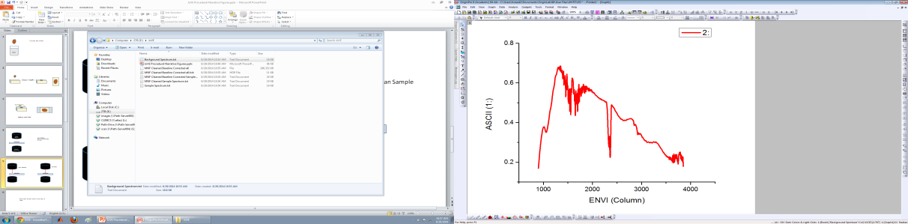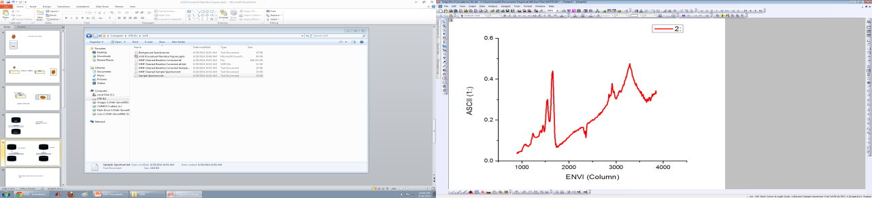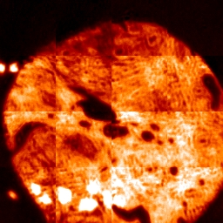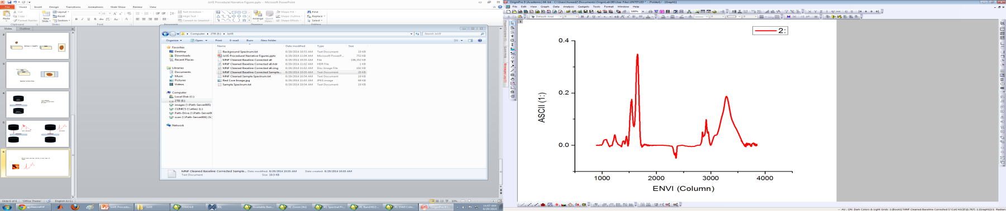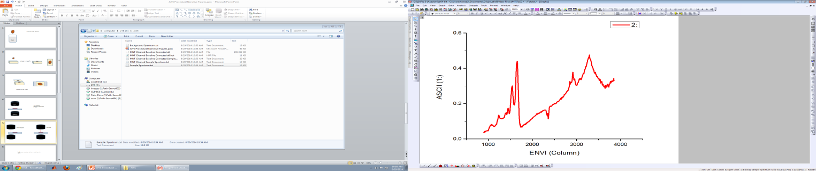

Formalin

Imaging Objective
Condenser
(Transmission)

Process

(P1)

(P1)

(P2)

(P3)

(P4/5)
Background Spectrum
Sample Spectrum

Video Editor: Use 52332_JoVE Procedural Narrative Storyboard.pptx

B. Interview: (Said by you on camera. Don’t forget to smile!)
  - Vishal Varma: The main advantage of this technique over existing methods, like light microscopy, is that the inherent biochemistry of the tissue can be studied without the use of dyes or probes.
  - Peter Nguyen: This method can help answer key questions in the field of pathology, such as predicting recurrence of diabetic nephropathy and classifying the progression of liver disease through hepatocarcinogenesis.
  - Hari Sreedhar: The implications of this technique extend toward disease diagnosis and prognosis, given that it provides vast amounts of biochemical information that is not available from traditional histopathology.
  - Bennett Davidson: Though this method can be used for diagnosis, it can also be used to track tissue changes in the process of wound healing and identify key tissue features such as stem cells in the GI tract and brain.
  - Michael Walsh: Demonstrating the procedure will be Andy Hall, a technician from the Research Resources Center at UIC.
    - Interview style: Author saying the above
    - The named technician, post doc, student looks up from workbench or desk or microscope and acknowledges the camera.

Protocol (read by voice talent at JoVE):
- FT-IR Microscope Set-up and Preparation for High-definition Capabilities
  - First, section a formalin-fixed paraffin-embedded tissue block at 4-micrometer thickness onto an IR compatible slide using a microtome.
    - MED: Talent places tissue block in microtome, sets the appropriate thickness and begins to section the tissue.
    - CU: Piece of sectioned tissue as talent affixes it to IR compatible slide.
  - Following this, purge the FT-IR microscope and spectrometer using dry air to remove atmospheric water from the system. Then, cool both the focal plane array detector and the internal mercury cadmium telluride detector in the microscope using liquid nitrogen.
    - MED: Talent purges the microscope and spectrometer with dry air.
    - MED-over the shoulder: Talent pours liquid nitrogen into tanks in system.
  - Mount the sample slide on the microscope stage for FT-IR imaging. After ensuring that the visible light is “ON”, focus on the sample using the sample capture program.
    - MED: Talent mounts sample slide on the microscope stage.
    - MED-over the shoulder: Talent turns the knobs on the system while looking at the sample capture program on the computer.
    - SCREEN: Image of sample on the computer after focusing.
  - Next, open the bundle software package and click ‘Collect’. Click ‘Diagnostics’ and select ‘Align Spectrometer’. Then, click on ‘Imaging Setup’.
    - MED-over the shoulder: Talent at computer opens bundle software package and clicks ‘Collect’.
    - SCREEN: Computer screen as talent clicks ‘Diagnostics’ and ‘Align Spectrometer’.
    - MED-over the shoulder: Talent at computer clicks on ‘Imaging Setup’ in the software.
  - To calibrate the system, in the ‘Optics’ tab select ‘Detector’ as ‘Ground’, ‘Microscope Detector’ as ‘Left’, and then select ‘Transmittance’ under ‘Optics mode’ (TEXT: Choice of optics mode depends on type of slide used).
    - SCREEN: Computer screen as talent selects the appropriate parameters in the software.
  - Click ‘Setup’, which will open up the ‘Lancer Control’ window. For transmission mode, in ‘Lancer Control’ click on ‘Raw’. Using the stage control joystick and watching the live view of the FT-IR interferogram image, move to a clean area of the slide.
    - SCREEN: Computer screen as talent clicks ‘Setup’ in the software.
    - SCREEN: Computer screen as talent clicks on ‘Raw’ in the ‘Lancer Control’ screen.
    - MED-over the shoulder: Talent moves the stage control joystick to move to a clean area of the slide while watching the live view of the FT-IR interferogram image on the computer.
  - At this point, adjust the integration time to approximately 8,000 counts and the bottom condenser objective to increase the number of counts to its maximum. Watch the shape of the bottom right image in Lancer Control to ensure that it is Gaussian in appearance and relatively uniform.
    - MED-over the shoulder: Talent at computer adjusts integration time and
    - [split shot] bottom condenser objective.
    - SCREEN: Computer screen showing Gaussian shape and uniform appearance of bottom right image.
  - After adjusting the integration time again, move the stage to find a piece of tissue with structure, preferably the edge of a tissue. Then, perfect the focus of the image.
    - MED-over the shoulder: Talent uses the joystick to move the stage while looking at the tissue image on the computer.
    - SCREEN: Computer screen as talent focuses the image.
  - Using the stage control joystick, move to a clean area of the slide. Press the ‘Calibrate’ button.
    - MED-over the shoulder: Talent uses the joystick to move the stage while looking at the tissue image on the computer.
    - SCREEN: Computer screen as talent presses ‘Calibrate’ button in the software.
  - After selecting ‘Okay’ twice, in the ‘Optics’ tabs select ‘Detector’ equals ‘MCT’ and ‘Microscope Detector’ equals ‘Right’. Then, click ‘Setup’. Once the FT-IR interferogram is visualized on the screen, click on ‘Find Centerburst’ and ‘Okay’.
    - SCREEN: Computer screen as talent selects appropriate parameters in the ‘Optics’ tab.
    - MED-over the shoulder: Talent at computer clicks ‘Setup’ in the software.
    - SCREEN: Computer screen as talent clicks ‘Find Centerburst’ and ‘Okay’.
  - In the ‘Optics’ tab reselect ‘Detector’ equals ‘Ground’, ‘Microscope Detector’ equals ‘Left’. Then, select ‘Setup’.
    - SCREEN: Computer screen as talent reselects the appropriate parameters in the ‘Optics’ tab.
  - After ensuring the image is still on a clean area in Lancer Control, click ‘Calibrate’ again and ‘Okay’.
    - SCREEN: Computer screen showing image as talent clicks on ‘Calibrate’ and ‘Okay.’
  - To collect a background FT-IR image, go to the ‘Electronics’ tab and select an appropriate spectral resolution, which is typically of 4 or 8 inverse centimeters for tissue.
    - SCREEN: Computer screen as talent selects appropriate spectral resolution in ‘Electronics’ tab.
  - Go to the ‘Background’ tab and type 128 in ‘Scans to co-add’. Select the ‘New File’ button and place the background file in the appropriate folder.
    - SCREEN: Computer screen as talent types number of scans in ‘Background’ tab.
    - SCREEN: Computer screen as talent selects ‘New File’ button and places background file in appropriate folder.
  - After clicking ‘Background’ and waiting for the scan to finish, confirm where to save the file. Click a region on the background FT-IR image and check the spectrum.
    - SCREEN: Computer screen as talent presses ‘OK’ in dialogue box to confirm where file should be saved.
    - MED-over the shoulder: Talent at computer clicks on a region of the background FT-IR image and looks at it.
  - At this point, click ‘Setup’ and in Lancer Control use the live IR view to find the area of interest.
    - SCREEN: Computer screen as talent clicks ‘Setup’ and looks at live IR view to choose area.
  - Go to the ‘Electronics’ tab and type the number of scans to co-add. Then, click ‘Scan’.
    - SCREEN: Computer screen as talent types number of scans in ‘Electronics tab’.
    - SCREEN: Computer screen as talent clicks ‘Scan’ in the software.
  - To prepare the FT-IR microscope for high-definition analysis, screw in the 36X objective in place of the 15X objective (TEXT: Align objective prior to use).
    - MED: Talent removes 15X objective from microscope and screws in 36X objective.
    - MED-over the shoulder: Talent screws in the lens extension tubes into microscope.
- Visualizing and Classifying IR Spectral Datasets
  - At this point, open image processing and analyzing software and load the IR data file.
    - MED-over the shoulder: Talent sits down at computer, opens software and loads IR data file.
  - Apply a baseline correction algorithm to the IR data by selecting ‘Spectral tools’ and scroll down and click ‘Absorbance spectra’. When the pop-up menu appears, select ‘Baseline correction’.
    - SCREEN: Computer screen as talent selects ‘Spectral tools’ and clicks on ‘Absorbance spectra’.
    - SCREEN: Computer screen as talent selects ‘Baseline correction’.
  - Perform Spectral normalization by selecting ‘Normalize spectra’ under the ‘Absorbance Spectra’ menu options.
    - SCREEN: Computer screen as talent selects ‘Normalize spectra’ in the ‘Absorbance Spectra’ menu options.
  - Following this, observe a list of all the IR frequencies collected within the image. Click on the frequencies that correspond to specific biomolecules to observe an image of the tissue at the selected frequency (TEXT: See text protocol for more details).
    - MED-over the shoulder: Talent at computer looks at the list of IR frequencies on the screen.
    - SCREEN: Computer screen as talent clicks on appropriate frequencies and visualizes image of tissue at selected frequency.
  - To create images that will allow visualization of different biomolecular components, click on ‘Spectral Tools’ and then select ‘Peak Height Ratios’.
    - SCREEN: Computer screen as talent clicks on ‘Spectral Tools’ and selects ‘Peak Height Ratios’.
  - Scan the corresponding adjacent stained tissue section using a separate whole slide imager system that captures brightfield images. Alongside the IR image, bring up the digital image of the stained tissue with a visible image program.
    - MED-over the shoulder: Talent uses whole slide imager system to scan the stained tissue section.
    - SCREEN: Computer screen as talent brings up digital image of stained tissue next to IR image using visible image.
  - Next, right click on the image at a region of interest and select ‘Z profile’ to give the spectral information at the selected pixel.
    - SCREEN: Computer screen as talent clicks on region of interest and selects ‘Z profile’.
  - To mark specific pixels on the image, right click on the image and select ‘ROI tool’. Create the classes that are to be labeled, for example normal, dysplasia, and cancer classes. Then select ‘ROI type’ ‘Point’.
    - SCREEN: Computer screen as talent clicks on image and selects ‘ROI tool.’
    - SCREEN: Computer screen as talent creates appropriate classes.
    - SCREEN: Computer screen as selects ‘ROI type’ ‘Point’.
  - Following this, select the class to select pixels for and draw on the appropriate pixels on the IR image. Derive the average spectra for each of the classes using the ‘Average ROI’ tool.
    - SCREEN: Computer screen as talent selects appropriate class and draws pixels on IR image.
    - SCREEN: Computer screen as talent uses ‘Average ROI’ tool to derive average spectra for each of the classes.
  - Finally, compare derived spectra by plotting in graphing software.
    - SCREEN: Computer screen as talent plots data in graphing software.
- Results: High-definition FT-IR imaging of Tissue for Disease Diagnosis
  - FT-IR imaging allows for the derivation of IR images of tissue that can give different contrasts depending on IR frequency. Every pixel is composed of the entire spectrum, with different peaks corresponding to different biomolecules that can give information about the biochemical properties of cell types or disease states.
    - LAB MEDIA: Figure 1 (Slide1.JPG, 52332fig1highres.jpg) (Video Editor: Show images A-C for first sentence. Show image D for second sentence. Make numbers and black arrows as well as list appear when “with different peaks corresponding to different molecules” is mentioned in the voiceover.)
  - FT-IR instrumentation has evolved from measuring in a single point mapping mode using opaque apertures to imaging mode using cassegrain objectives, using either an illuminating objective coupled with a collecting objective in transmission-mode or a single objective that both illuminates and collects in reflection-mode.
    - LAB MEDIA: Figure 2 (Slide2.JPG, 52332fig2highres.jpg) (Video Editor: Highlight right Transmission-mode image when “an illuminating objective coupled with a collecting objective in transmission mode” is mentioned in second sentence. Highlight left Reflection-mode image when “a single objective that both illuminates and collects in reflection-mode” is mentioned in second sentence.)
  - The advances in spatial resolution for tissue imaging have been of critical importance as cell types and tissue structures can now be identified. In this case, the kidney glomeruli functional units were observed.
    - LAB MEDIA: Figure 3 (Slide3.JPG, 52332fig3highres.jpg) (Video Editor: Zoom into each image for first sentence, from A to C. Leave image C on the screen for second sentence.)
  - In a liver tissue core, it is possible to visualize hepatocytes and regions of infiltrating fibrosis that divides two distinct areas of dysplasia and non-dysplastic cirrhosis.
    - LAB MEDIA: Figure 4 (Slide4.JPG, 52332fig4highres.jpg) (Video Editor: Show images A and B and make Hepatocytes and Fibrosis labels with corresponding arrows appear. Then show image C.)
  - Increased spatial resolution allows isolation of specific structural features that may be chemically modified by disease before histological changes are apparent. Biochemical changes in kidney glomerular structures such as the Bowman’s capsule, mesangium, glomerular basement membrane and tubular basement membrane can be identified through FT-IR imaging.
    - LAB MEDIA: Figure 5 (Slide5.JPG, 52332fig5highres.jpg) (Video Editor: Show images A (without labels and arrows) and B for first sentence. Zoom into image A for first part of second sentence and show labels with arrows. Show image C for last part of second sentence.)

- Conclusion (said by authors on camera)
  - Hari Sreedhar: While attempting this procedure, it’s important to remember to fully deparaffinize slides before scanning.
  - Vishal Varma: Following this procedure, other methods like traditional immunohistochemical analysis can be performed on the same tissue section in order to correlate biochemical signatures with tissue morphology.
  - Michael Walsh: After its development, this technique paved the way for researchers in the field of tissue imaging to explore the biomolecular status of small cell types and structures within tissues.
  - Peter Nguyen: After watching this video, you should have a good understanding of how to obtain high-definition FT-IR analysis of tissue samples and perform basic spectral analysis.
  - Bennett Davidson: Don't forget that working with liquid nitrogen can be extremely hazardous and precautions such as cryo-safe gloves and safety goggles should always be taken while performing this procedure.

Provided Media

Authors, Please list all images, movie files, or 3-D rendered animations that can be included in the video per editor’s request. The step in the script/video where these images will be inserted should be specified. For example:

6.2 – 0123_PIname_Figure1.tif - dual color imaging of tumor angiogenesis at 40X
6.2 – 0123_PIname_Figure2.tif - dual color imaging of tumor angiogenesis at 100X

Formats: For static images we prefer .tiff, .eps, Illustrator, Powerpoint or Photoshop files at dimensions of at least 720X480 pixels and 300 dpi. The higher resolution, the better. Likewise any exported movie files should have at minimum these dimensions and be rendered to .mov, .mp4, or .avi files.

All the numbering for each step in the images correspond to the steps listed. Some steps have more than one image because we are showing the steps of the process, they have been labeled as 2.3.2 if the step was 2.3 and so on.

2.3 - Sample Capture Find and Focus Tissue.jpg

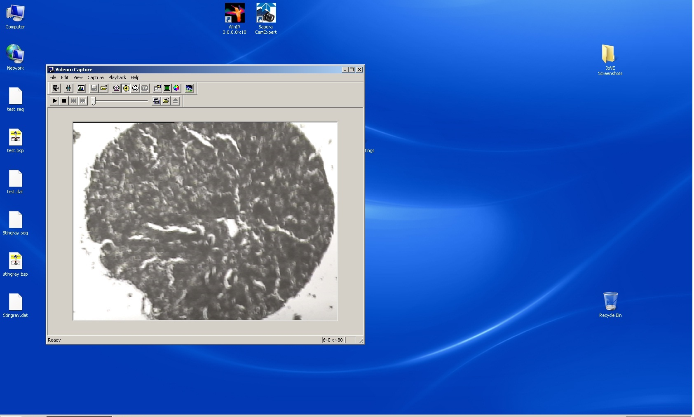

2.4 - How to align spectrometer.jpg

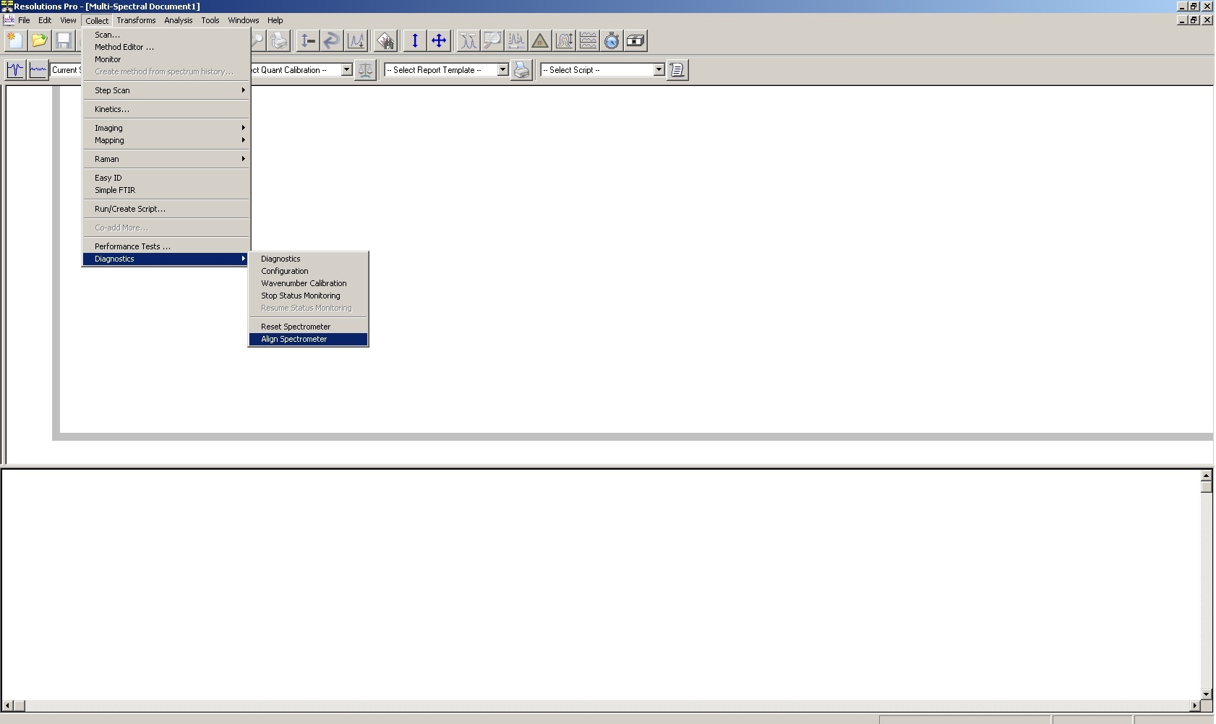

2.4.2 - Spectrometer Alignment Progess Screen.jpg
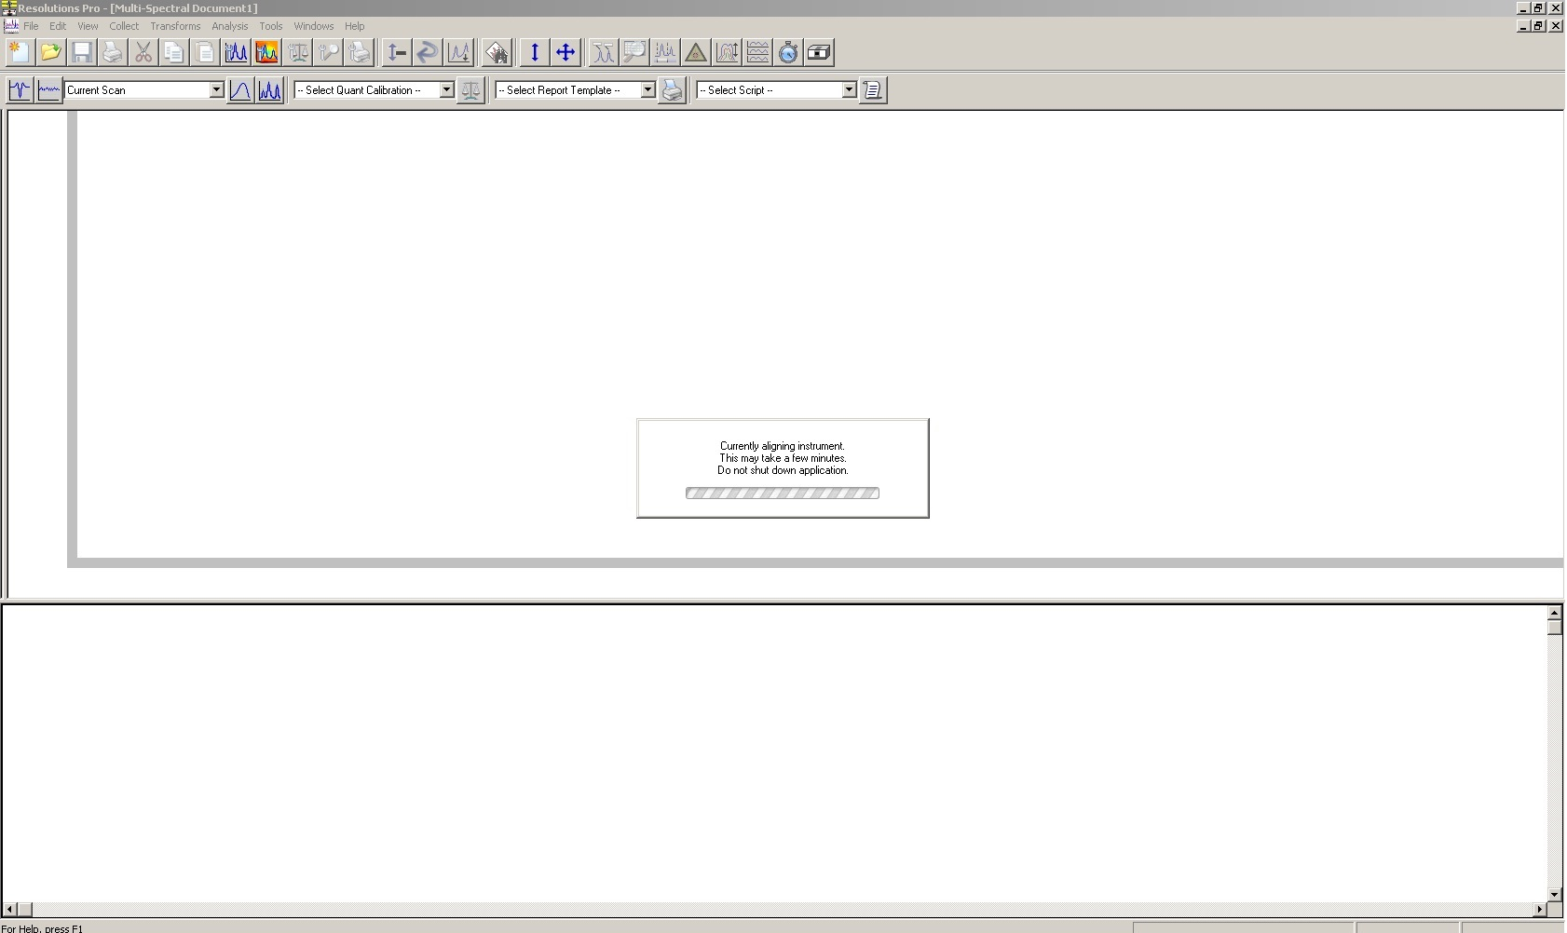

2.5 - Optics Tab.jpg
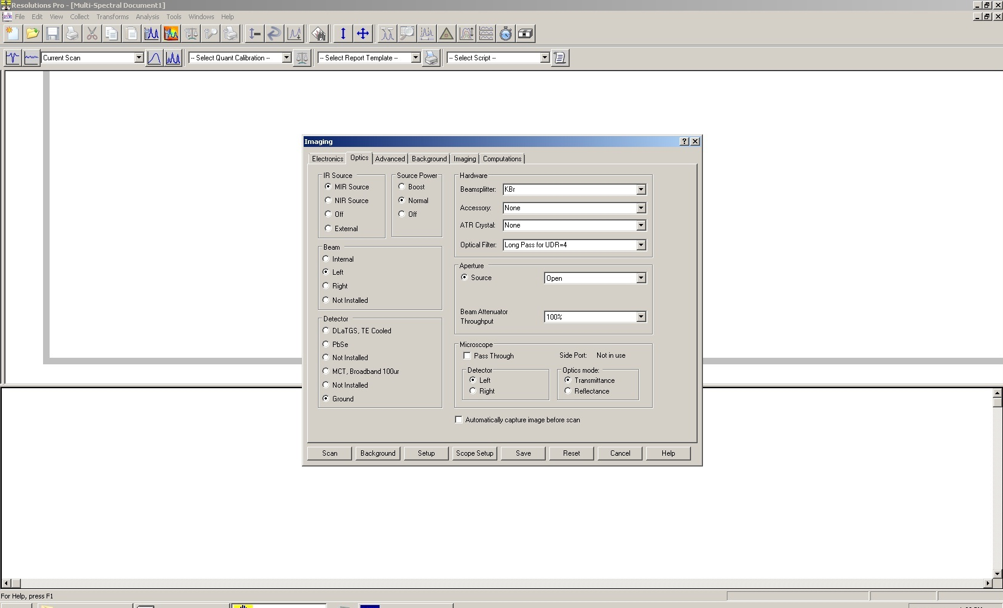
2.6 - Lancer Control Raw View.jpg

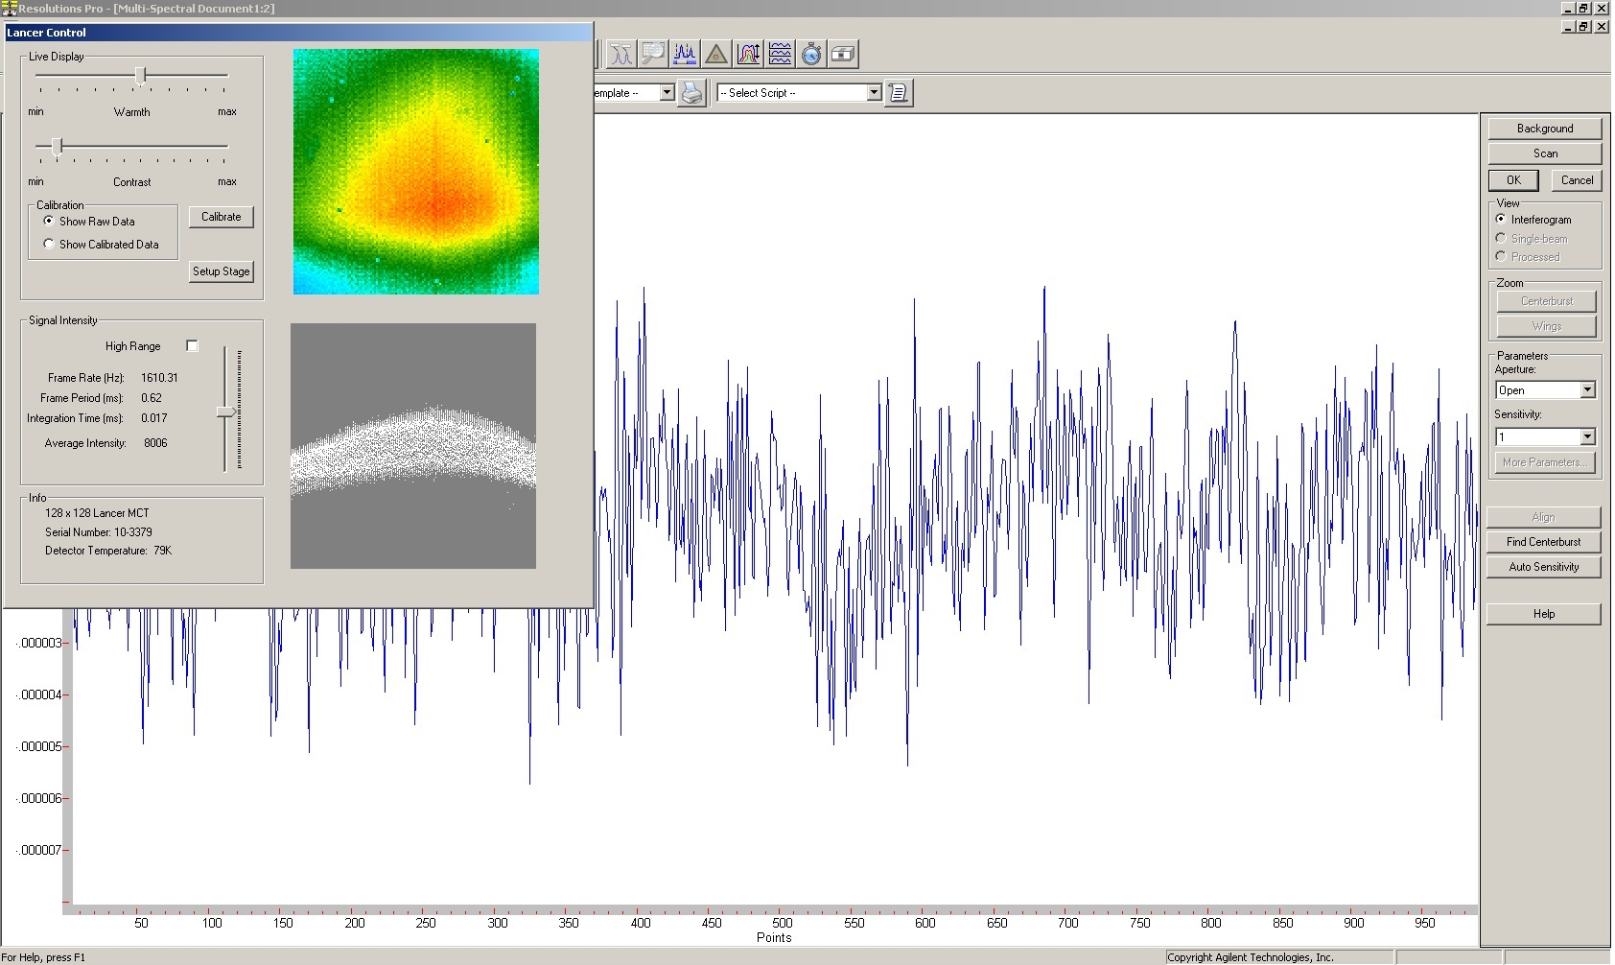

2.8 - Adjust Focus on Edge of Tissue.jpg
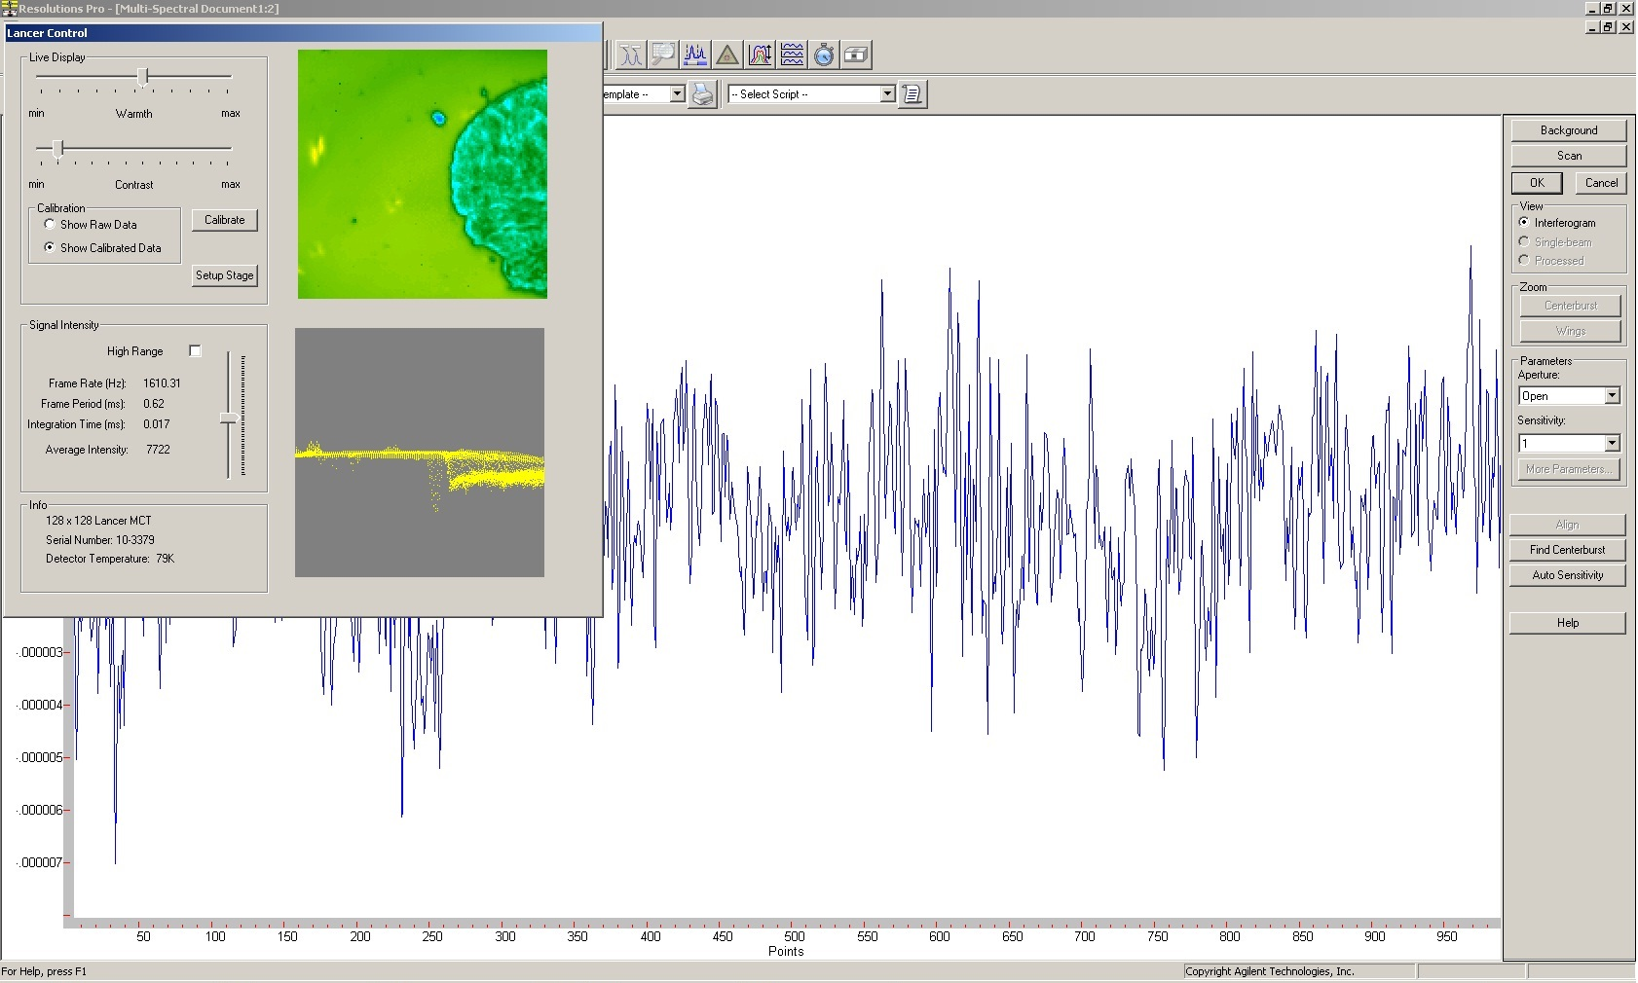

2.9 - Calibration.jpg
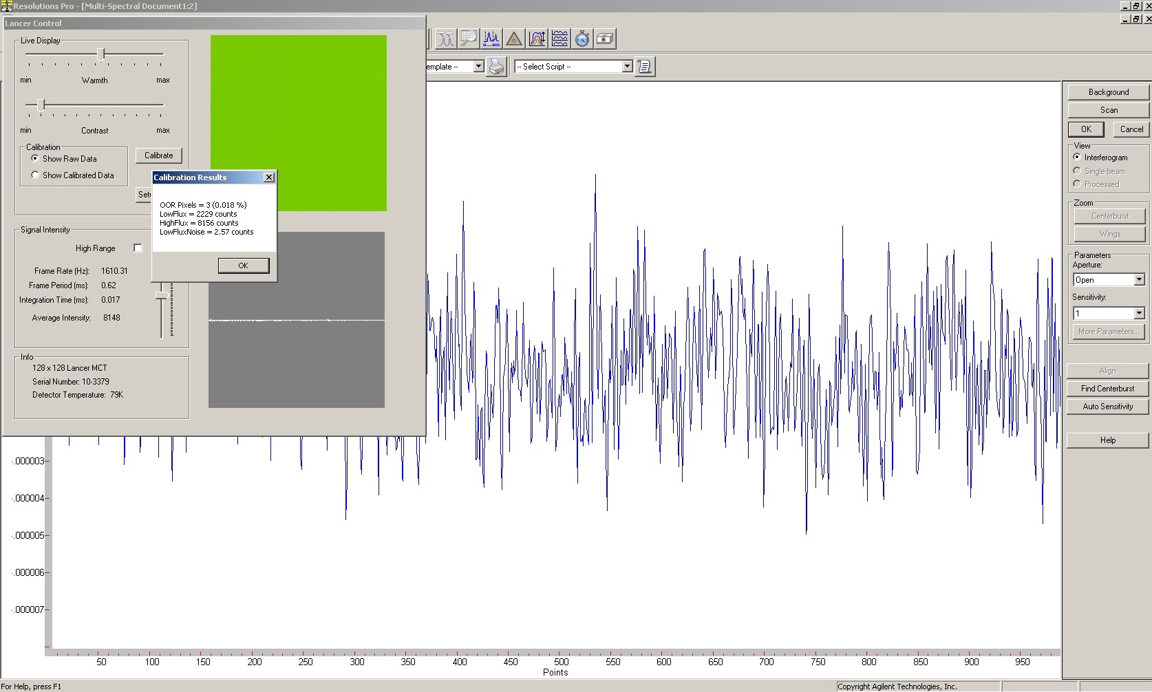

2.10 - Optics Setup to find Centerburst.jpg

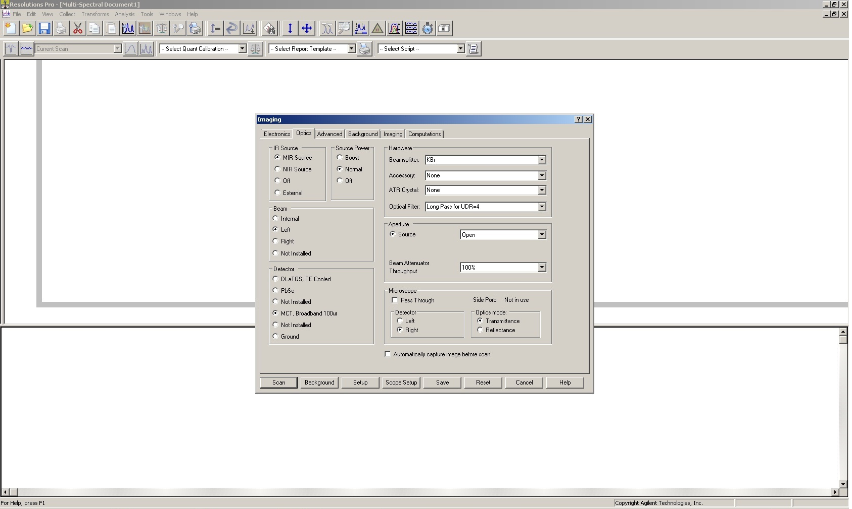

2.10.2 - Before Finding Centerburst.jpg
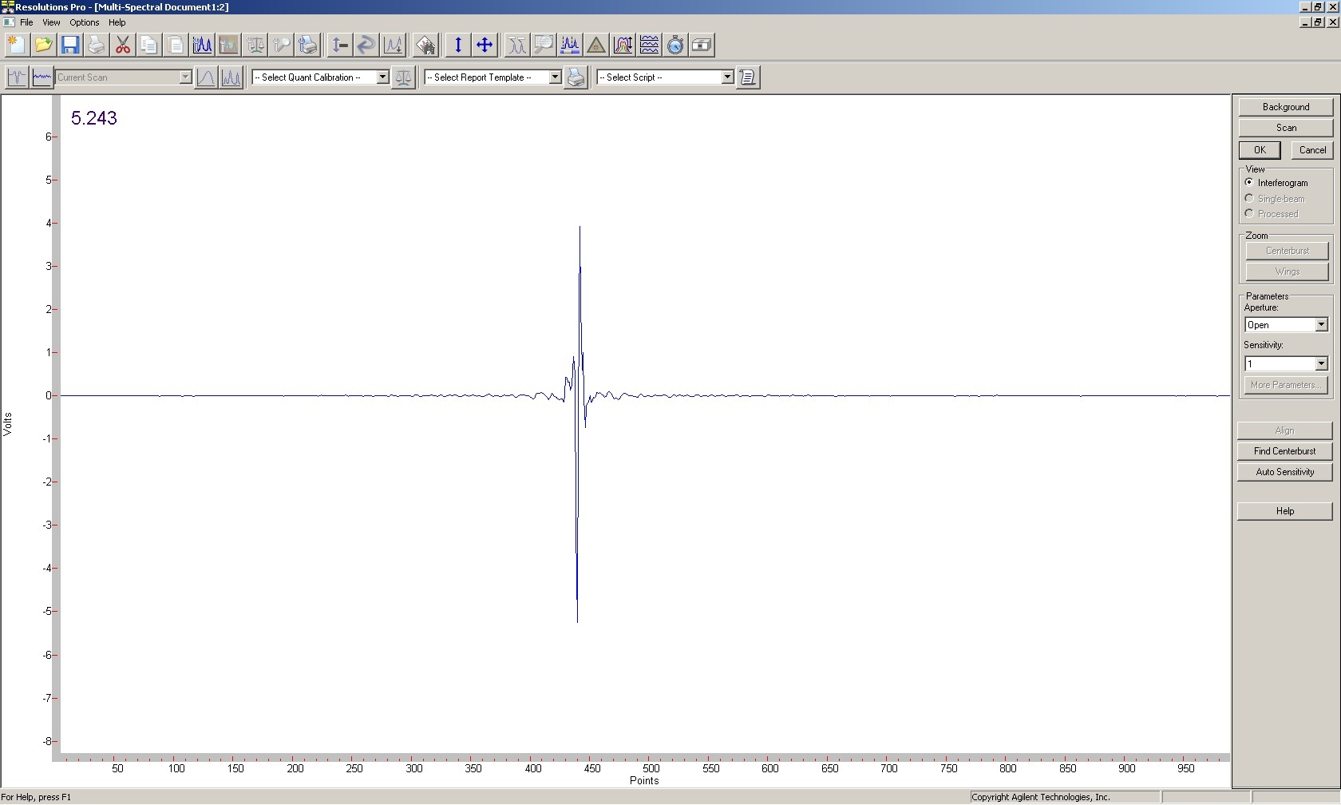

2.10.3 - After Finding Centerburst.jpg

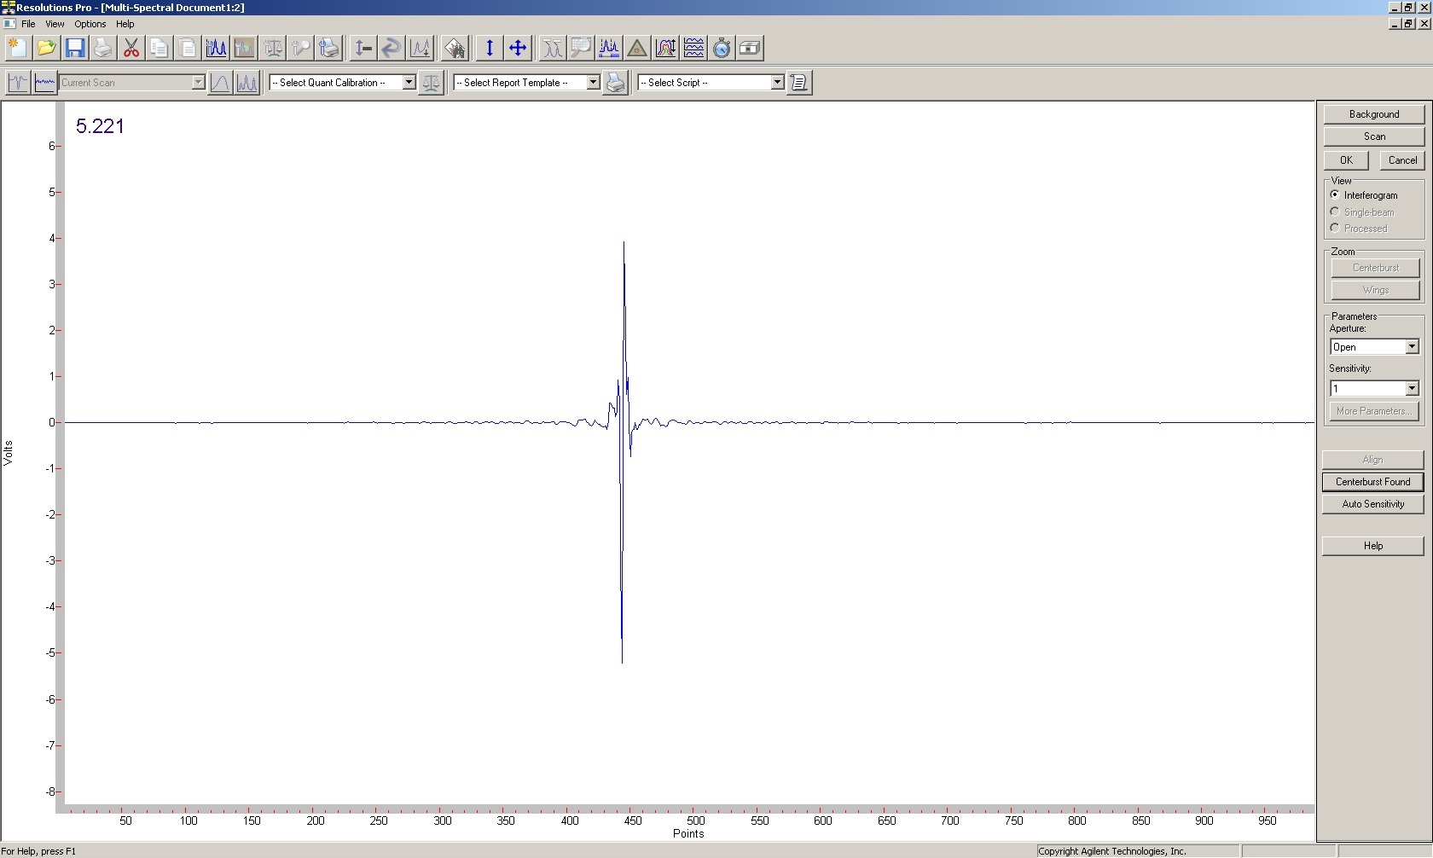

2.11 - Optics Setup for Recalibration.jpg
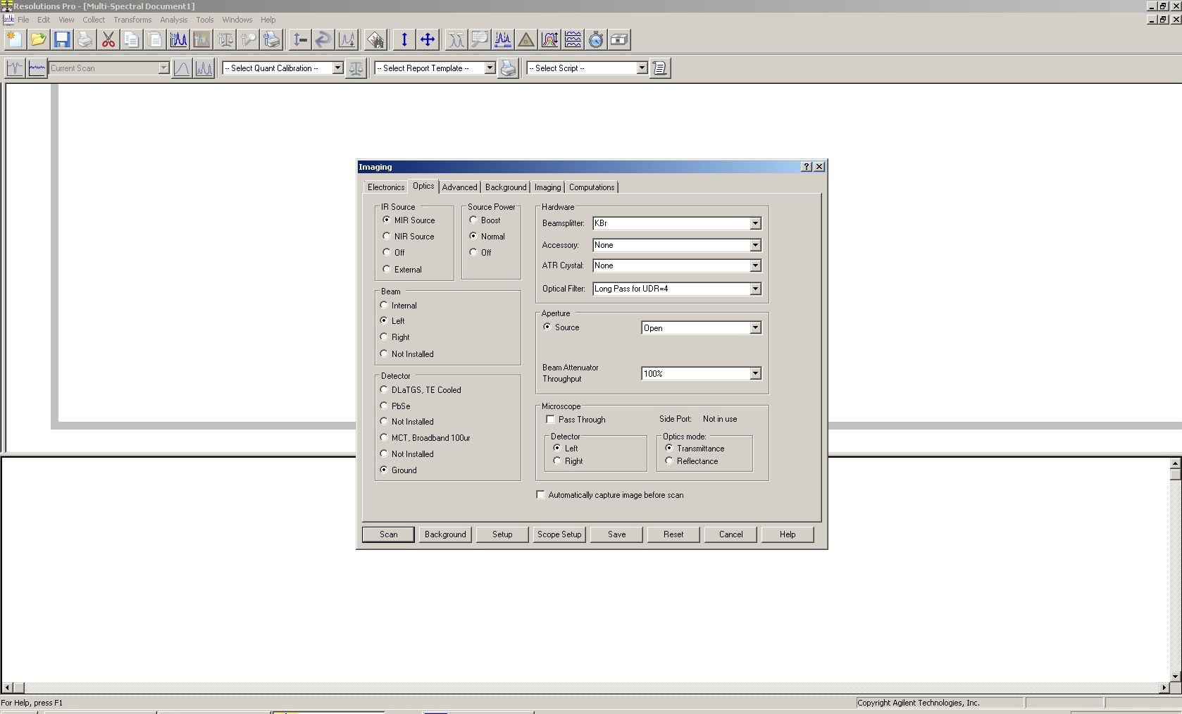

2.12 - Recalibration.jpg

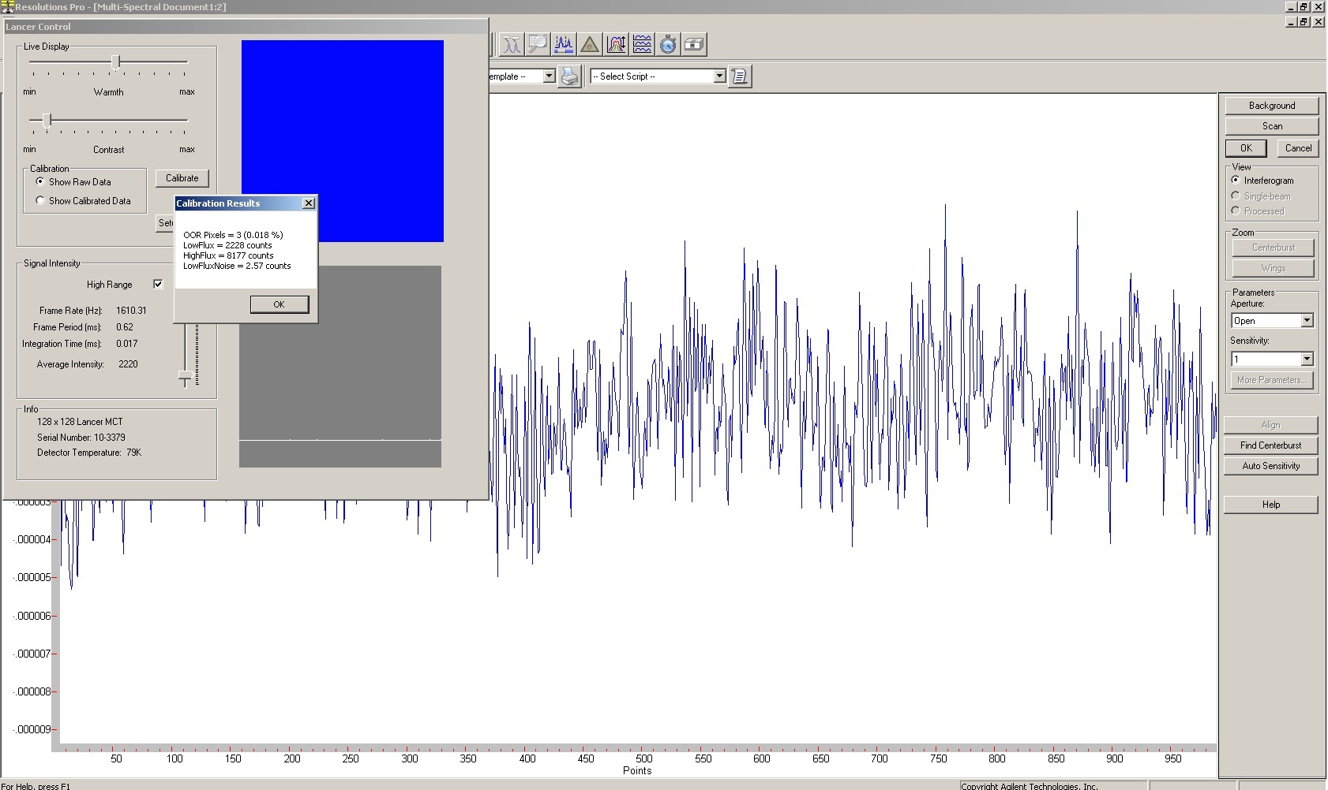

2.13 - Electronics Setup for Background.jpg
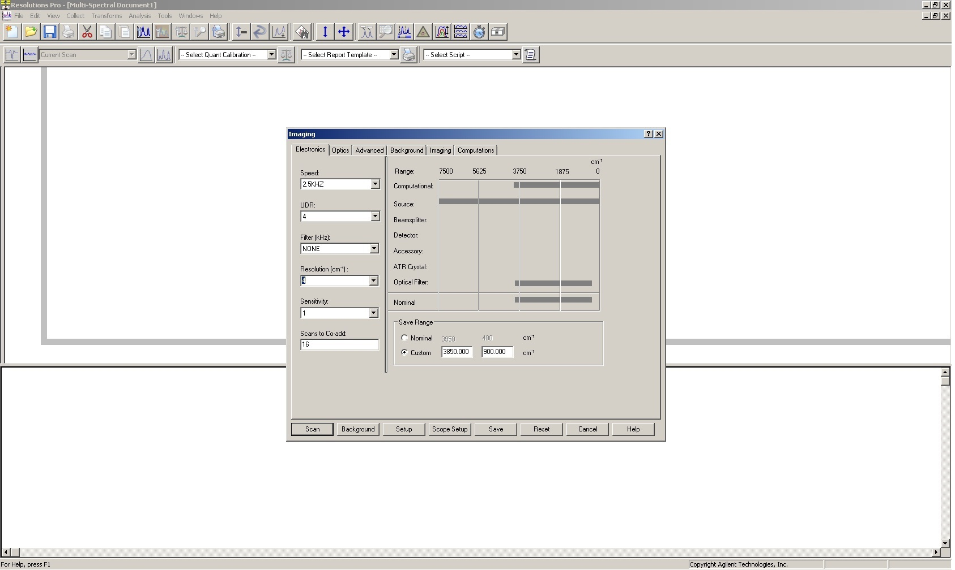

2.14 - Background Tab Settings.jpg

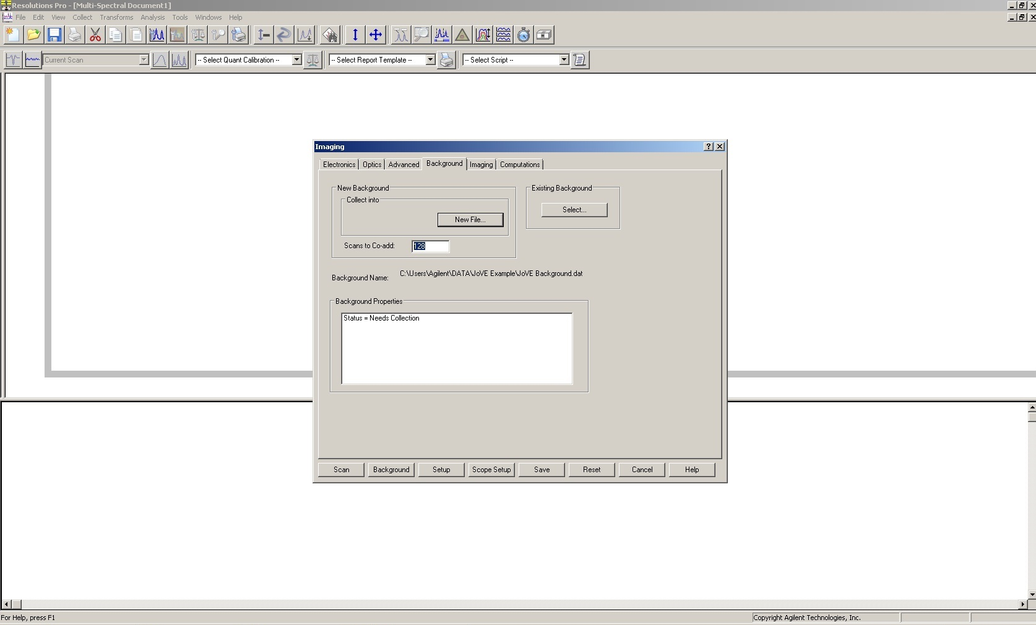

2.15 - Background Tab Select Save Location.jpg

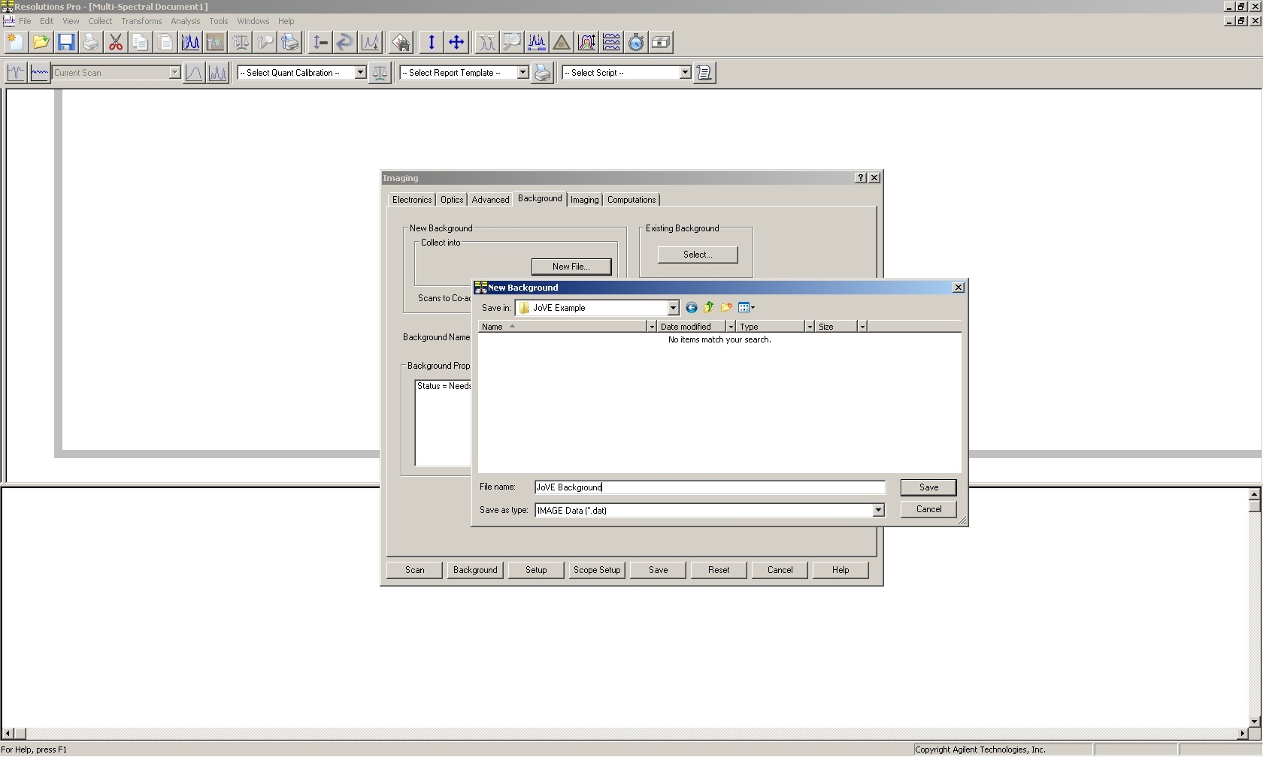

2.16 - Tissue of Interest and Check Focus.jpg
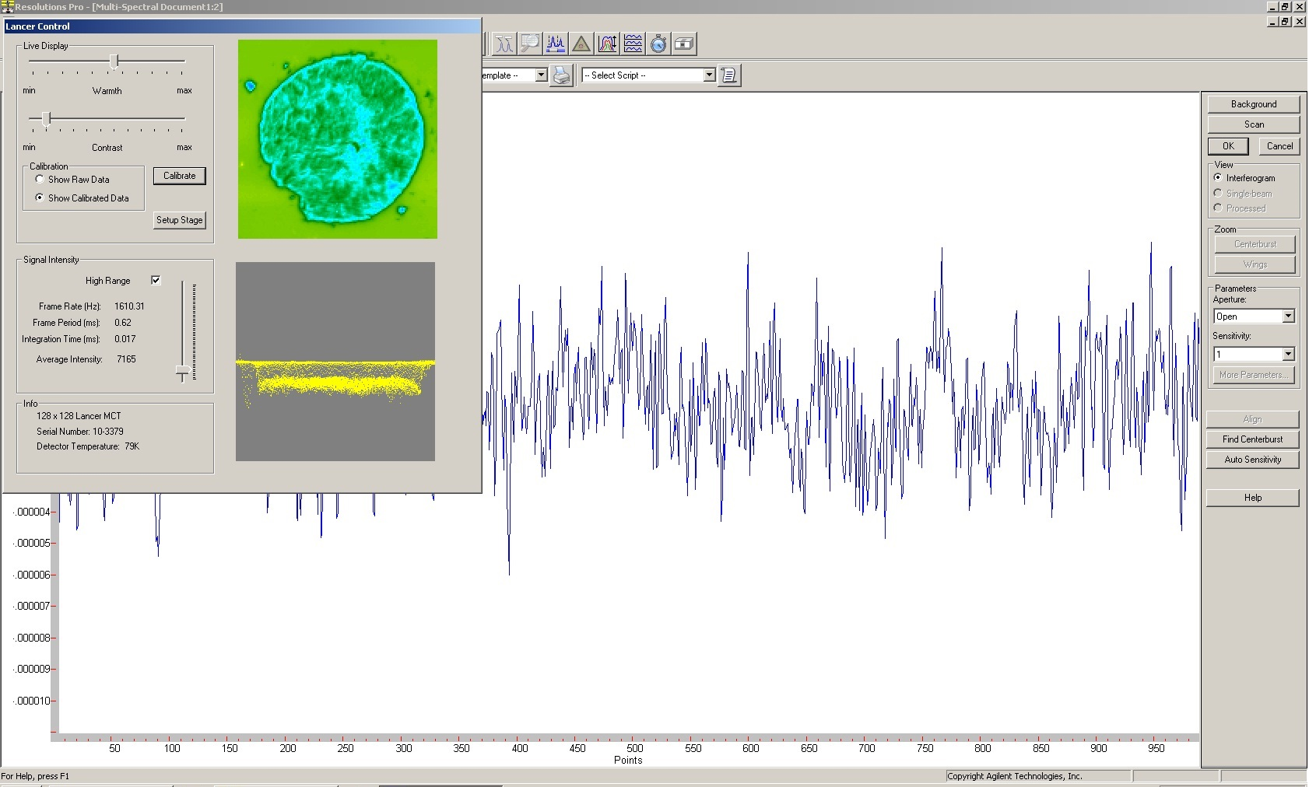

2.17 - Electronics Tab for Scan Setup.jpg
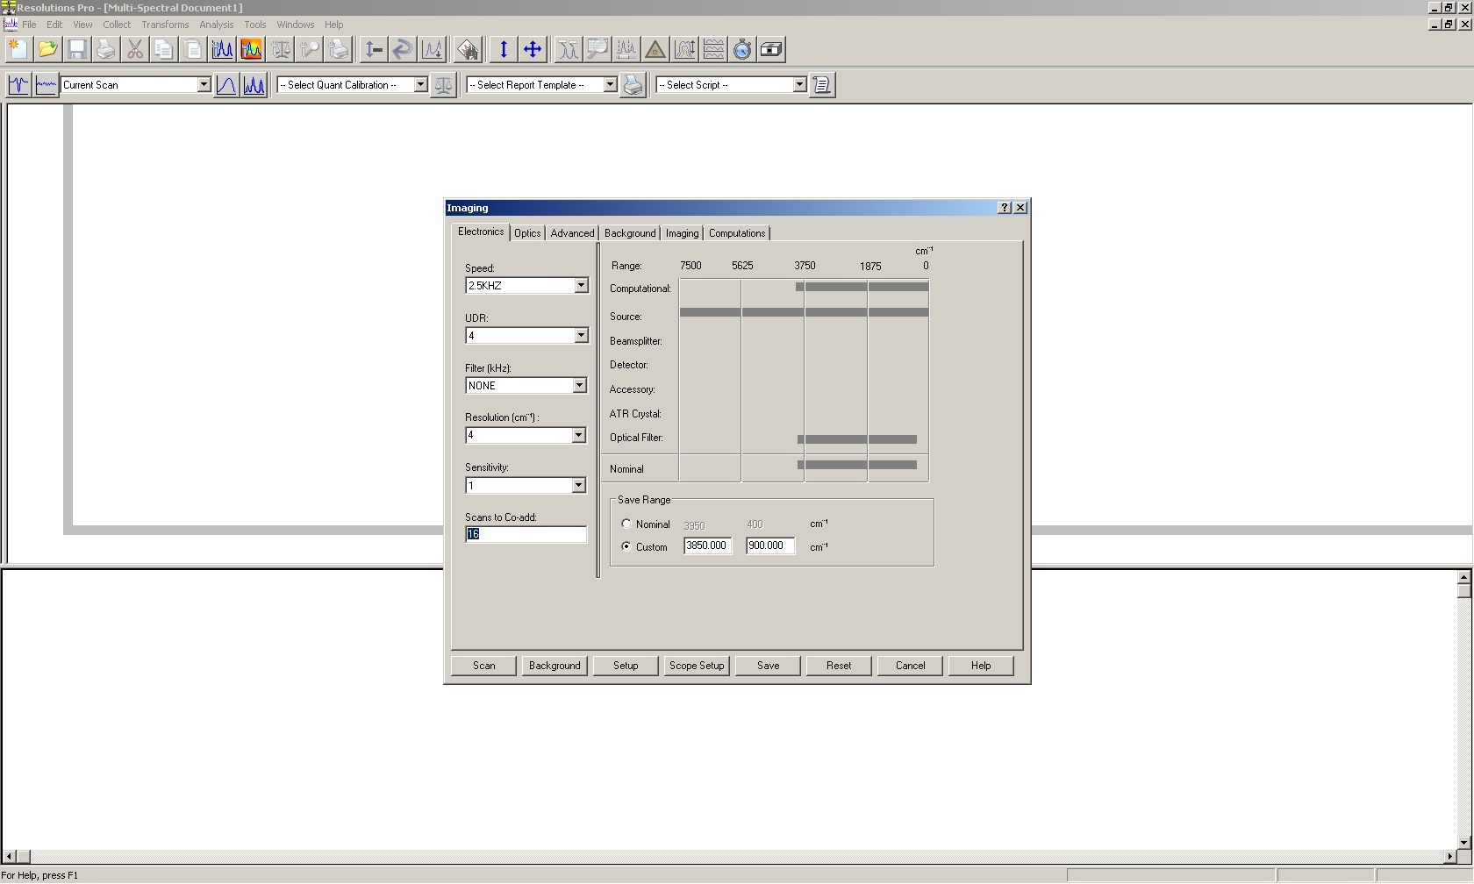

3.2 - Baselining data.png

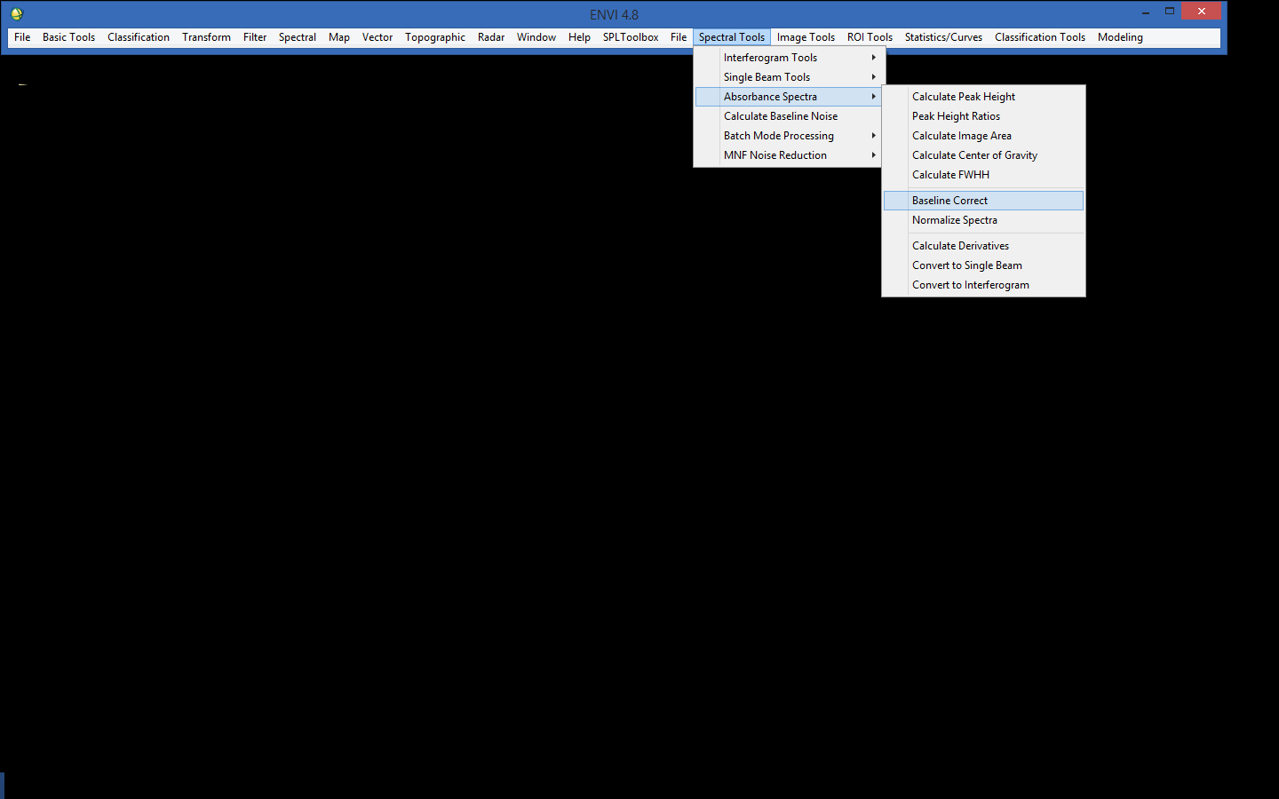
3.3 - Normalize Spectra.png

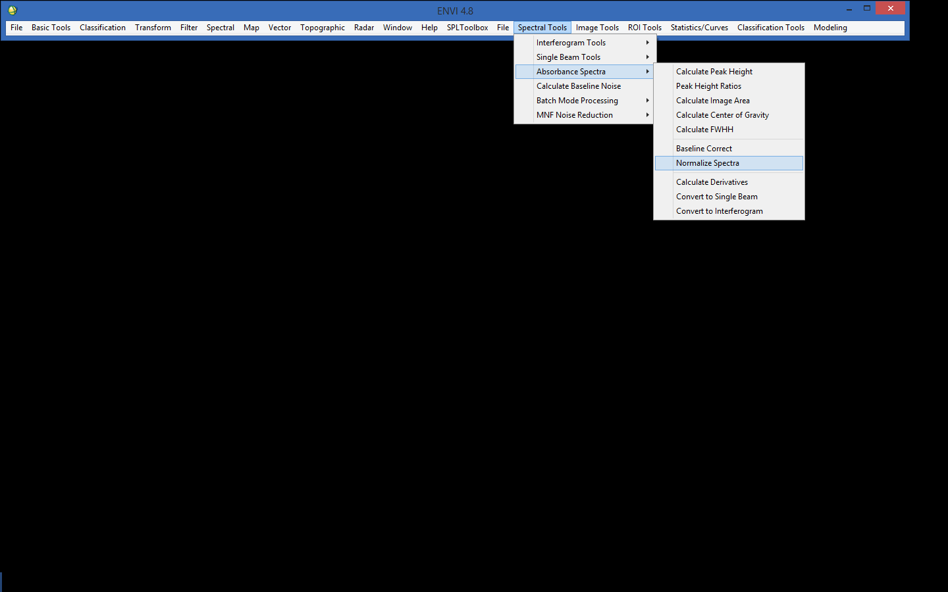

3.4 - Visualizing IR frequencies.png

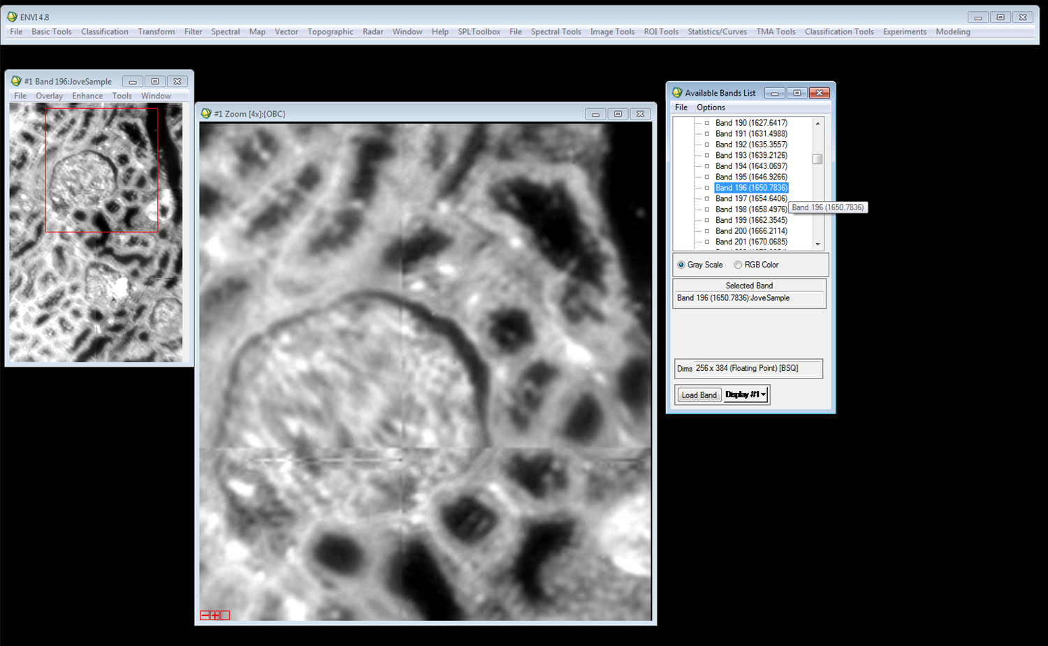

3.6 - Using digitally scanned slide alongside FT-IR image.png
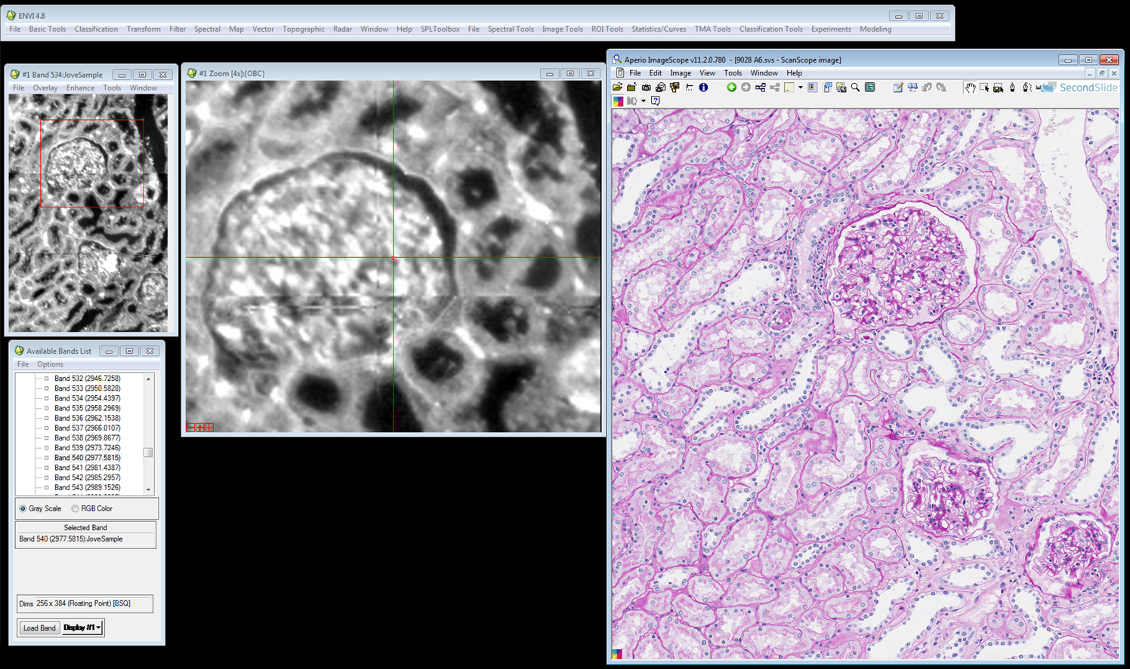

3.7 - Obtaining chemical signature from a single pixel.png

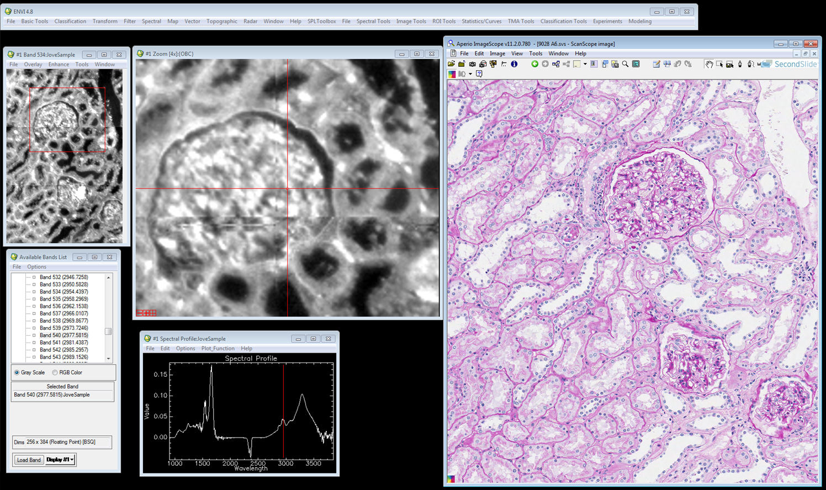

3.8 - Drawing ROI from an image.png

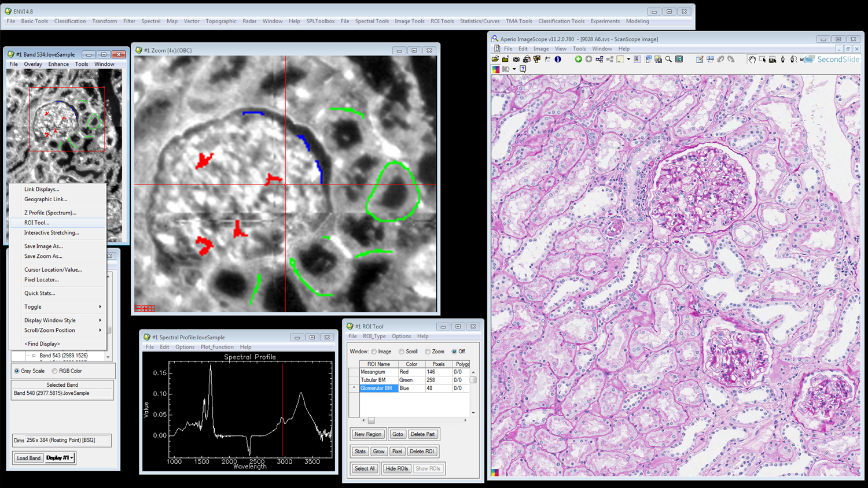

General Preparation

It’s critical for a smooth and organized shoot that all reagents are accounted for, in advance.

Any overnight or long incubation steps should be recognized and specimens/samples be prepared in advance so that prior steps can be recorded and shooting can continue with pre-prepared specimens/samples.

All tubes/flasks should be pre-labeled neatly before we arrive.

Ex. Luciferase assay done in 96 well plates should be labeled with negative/positive control wells and experimental samples are labeled accordingly.

You will receive more detailed preparation instructions, as well as an introduction to your videographer, closer to your filming date.

