Submission ID #: 52325

Editor Name: Renee Choi

Videographer Name: Paul Donahue

Film Date: 11/21/14

Authors and Affiliations:
Diana Kuehn, Shoaib Majeed, Emmanuel Guedj, Remi Dulize, Karine Baumer, Anita Iskandar, Stephanie Boue, Florian Martin, Radina Kostadinova, Carole Mathis, Nikolai V. Ivanov, Stefan Frentzel, Julia Hoeng, Manuel C. Peitsch

Biological Systems Research, Philip Morris International R & D, Philip Morris Products S. A., Neuchatel, Switzerland

Title: Impact Assessment of Repeated Exposure of Organotypic 3D Bronchial and Nasal Tissue Culture Models to Whole Cigarette Smoke

Corresponding Author:

Stephanie Boue

Biological Systems Research

Philip Morris International R & D

Philip Morris Products S.A.

Neuchatel, Switzerland

Stephanie.boue@pmi.com

Fax: 41 58 242 2811

Tel: 41 58 242 2243

Co-authors: Diana Kuehn: Diana.kuehn.@pmi.com; Shoaib Majeed: shoaib.majeed@pmi.com; Emmanuel Guedj: Emmanuel.guedj@pmi.com; Remi Dulize: remi.dulize@pmi.com; Karine Baumer: karine.baumer@pmi.com; Anita Iskandar: anita.iskandar@pmi.com; Florian Martin: florian.martin@pmi.com; Radina Kostadinova: radian.kostadinova@pmi.com; Carole Mathis: carole.mathis@pmi.com; Nikolai V. Ivanov: nikolai.ivanov@pmi.com; Stefan Frentzel: Stefan.frentzel@pmi.com; Julia Hoeng: Julia.hoeng@pmi.com; Manuel C. Peitsch: manuel.peitsch@pmi.com

A. Will you require JoVE to record video microscopy, such as filming a complex dissection or microinjection technique? (Y/N)____N_____ (If you can record images/videos using your own camera/software, then mark No) If yes, please list make and model of your microscope: _____________________________________________
B. Does your protocol include detailed, step-by-step, descriptions of software usage? (Y/N)__N______ If yes, we will need you to record using screen recording software to capture the steps. If you use a Mac, QuickTime X also has the ability to record the steps.
C. Which steps of your protocol will viewers benefit most from having filmed? Please list 4-6 steps by their protocol number. 2.4, 2.5, 2.7, 3.1.3, 7.2.2, 7.2.4_______________
D. What is the single most difficult aspect of this procedure and what do you do to ensure success? Please list the step by its protocol number.
2.7 (smoke generation and tissue exposure) -> necessitates conditioning and setup of machines for best reproducibility
E. Will the filming need to take place in multiple locations? (Y/N) __N_____ If yes, how far apart are the locations? __All steps happen on the same floor of the same building, but in different labs._________________________________________________

1. Introduction (Schematic Overview and Interview)

A. Schematic Overview (read by voice talent at JoVE):

Procedural Narrative:
The overall goal of this procedure is to assess the impact of repeated exposure of organotypic 3D bronchial and nasal tissue culture models to whole cigarette smoke. (Intro)

This is accomplished by first culturing organotypic bronchial and nasal tissue culture models at the air-liquid interface. (P1: As soon as the voice over begins reveal the images provided for P1 with all text (Do not display the text given by the authors on the very top in large font, the title). Label above the figure on the left “Bronchial” and the figure on the right labeled “Nasal.” Immediately highlight with a yellow box the area between the labels “Test atmosphere (air)” and “Culture medium (liquid)” on both images.)

The second step is to generate aerosol with a smoking machine and expose the tissue cultures according to the experimental design in an exposure system. (P2: Do not show the title text provided by the authors in large font on top. Show the figure on the left with the carousel of cigarettes (box with circle on top) first, then immediately reveal the figure on the right. If possible, add animation of the smoke going from the smoke carousel (circle with cigarettes and a dark gray oval in the middle) into the tube.)

Next, the exposure impact is assessed by measuring the ciliary beating frequency and tissue integrity of the culture. (P3: Show the image provided by the authors for P3, if possible, add movement to the cilia (the small hairs on top of the cells so they are pulsing from left to right.)

The final step is to measure transcriptomics changes induced by the aerosol using microarray technology. (P4: As soon as the voice over begins, show all of the figures labeled “Exposure, and RNA extraction (both rows), with all text provided by the authors (do not display the title text in large font on top). Reveal the text “Microarray Processing, then the figures one by one underneath, then the two arrows on the right, and finally the two plates and remaining figures on the right.)

Ultimately, a network-based systems biology approach is used to show the impact of whole cigarette smoke on the tissue culture. (P5: In a split screen, show the figure provided by the authors on the left and Figure 3 and 5B on the right)

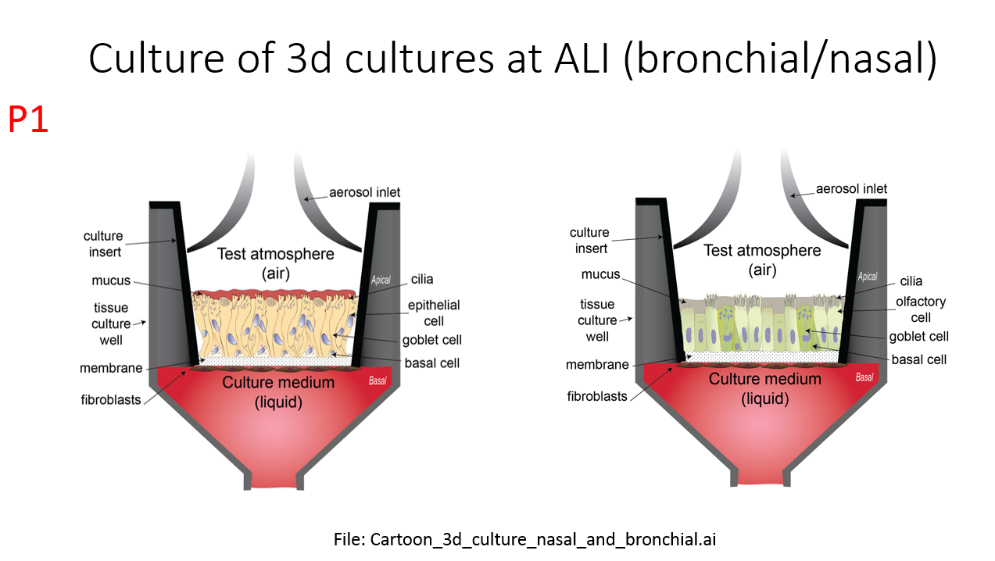
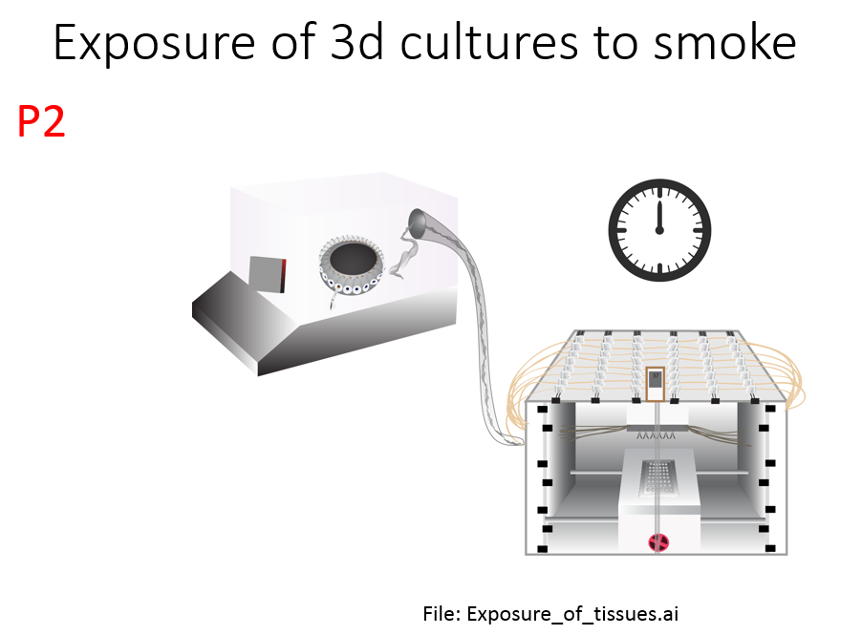
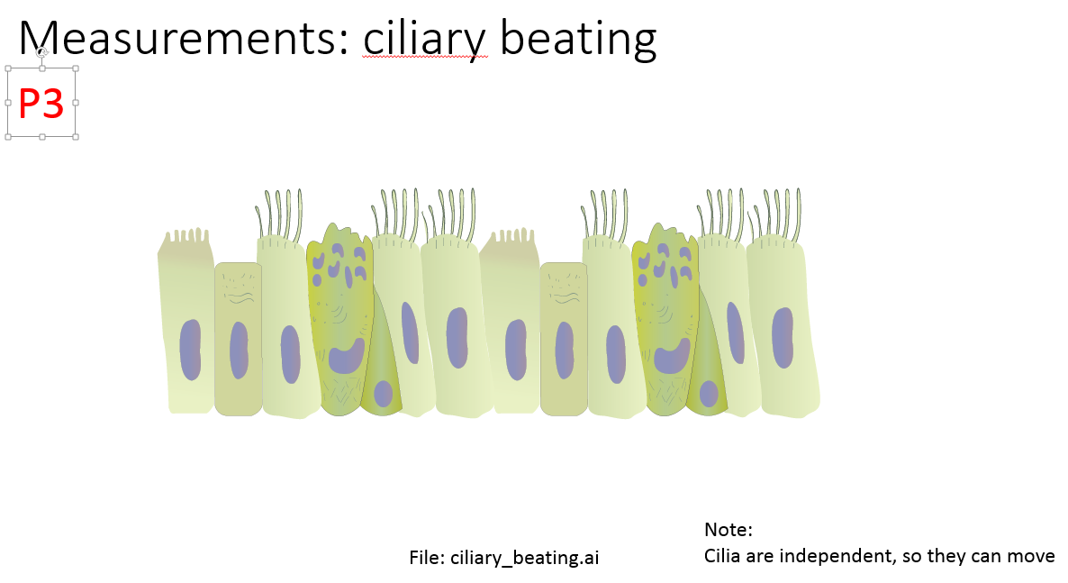
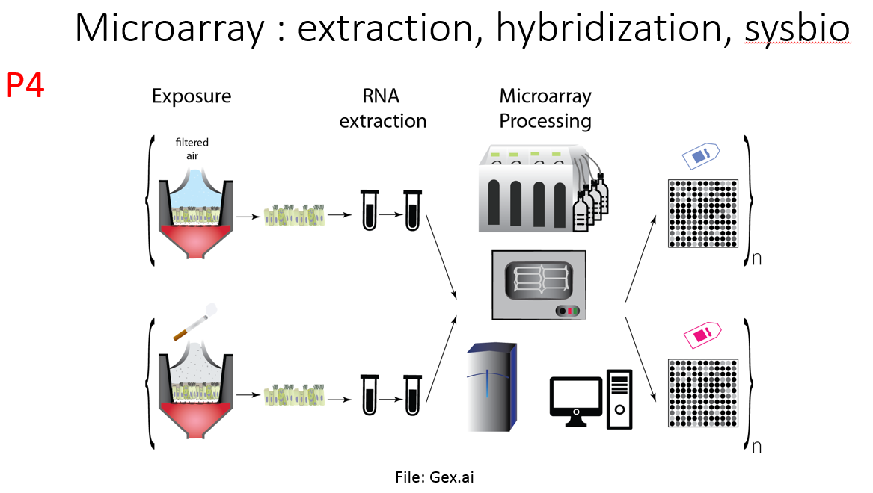
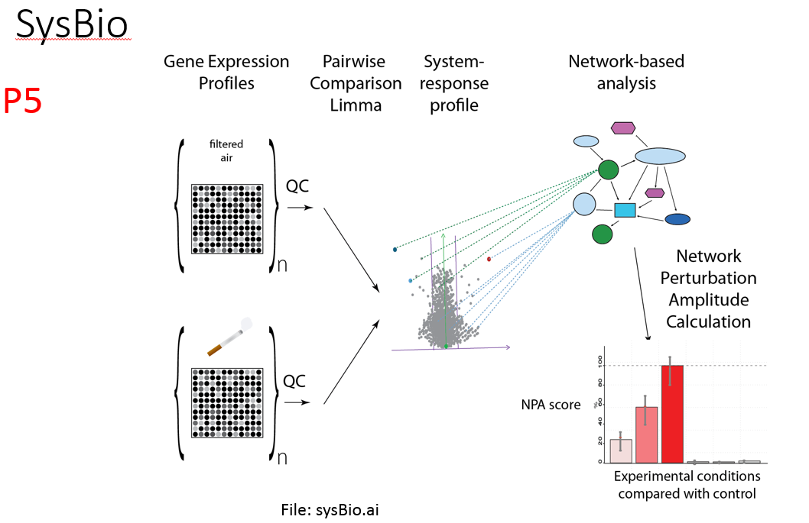

B. Interview: (Said by you on camera. Don’t forget to smile!)

Note - As discussed, the senior author Julia Hoeng will be the only one speaking.
  - [mis-slated 8.1] Julia Hoeng: The main advantage of this technique over existing methods in respiratory toxicology is that the approaches are aligned with regulatory agency requirements to find alternatives to animal testing.
It enables the assessment of the effects of short term cigarette smoke exposure on cells grown at the air–liquid interface, mimicking the conditions occurring in the human respiratory tract.
  - Demonstrating the procedure will be discipline experts from my laboratory.
    - Interview style: Author saying the above
    - The named technician, post doc, student looks up from workbench or desk or microscope and acknowledges the camera.

Protocol (read by voice talent at JoVE):
- Culture of Organotypic Bronchial Tissue
  - To begin the experiment, add 0.7 mL of pre-warmed culture media to each well of a sterile 24-well plate.
    - MED/WIDE: Talent approaches hood.
    - MED: Talent prepares the 24-well plate under the hood and places it within reach.
  - Next, remove the tissue packaging, and transfer the tissue culture inserts to the freshly prepared 24-well plate. Maintain the tissue culture in an incubator and replace the media every 2 days.
    - MED – Over the Shoulder: Talent picks up tissue culture insert plate, removes packaging, discards packaging, and transfers the inserts to the plate.
    - MED: Talent finishes loading the plate with tissue culture inserts and places the plate in an incubator, if possible capture the settings on the incubator. (TEXT: 37 ˚C, 5 % CO₂, 90 % humidity)
  - During the media change, examine the tissues under a light microscope to ensure they are contamination-free and that there is no leakage of media.
    - MED – Over the Shoulder: Under the hood, talent replaces new media into the last wells on the plate,
    - [added, in fact, separate shot, used to be with 2.3.1] then takes the plate to the light microscope.
    - SCOPE: If possible, capture a microscope image of the healthy tissue. [This could be taken from the cilia beating movie]
- In vitro Cigarette Smoke (CS) Exposure
  - Three days before exposure experiments, wash the apical side of the tissue culture with 200 µL of culture media.
    - MED/WIDE: Talent takes tissue culture to bench.
    - MED – Over the Shoulder: Talent adds tissue culture media to the plate and disposes it,then refills the plate with tissue culture media.
  - Next, pre-warm the climatic chamber of the in vitro system and the cultivation base module to 37 ˚C. After it has warmed, fill the cultivation base module with 17.5 mL of media per row.
    - MED: Talent places climatic chamber in incubator. If possible, capture the temperature setting on the thermometer after the door is closed. fills a plate with medium
    - MED – Over the Shoulder: Talent carries climatic chamber to bench then sets it down and fills two rows with media. Puts inserts in cultivation base module
    - [added] - Talent brings module to climatic chamber
    - [added] Shot showing the temperature in the climatic chamber
  - Remove the tissues from the incubator and transfer the tissue culture inserts from the culture plate to the cultivation base module of the in vitro exposure system. Then cover the cultivation base module with a glass lid.
    - MED: Talent removes culture plates from the incubator and moves them to the hood.
    - CU: Talent sits at the bench or other workstation, removes inserts, and begins transferring the inserts into the in vitro exposure system cultivation base module.
    - MED: Talent covers the cultivation base module with lid.
  - Transfer the tissues into the climatic chamber for exposure to mainstream cigarette smoke, or CS. Generate cigarette smoke using a calibrated 30-port carousel smoking machine
    - MED: Talent removes climatic chamber cultivation base modules with inserts from heating plate and places on bench.
    - CU: Talent transfers tissues into climatic chamber (TEXT: See Health Canada Intense regime for parameters).
    - MED: Side view, talent turns on the carousel smoking machine. Capture the smoke generated in the shot.
  - Smoke the cigarettes to a standard butt length, approximately 35 mm at 55 mL puff over two seconds, twice a minute, and eight second-pump exhaust time. Mainstream cigarette smoke generated is accumulated and released to the in vitro exposure system. Expose the tissues for 6-7 minutes. After transferring the tissues back to a culture plate, place them back in the incubator for one hour.
    - [added] Cigarette is loaded and lit
    - [added] Smoke is accumulated and released to the in vitro system

You can use the video done by Vitrocell, which shows the smoke going through the exposure system to contact the tissue. This is not something that could be filmed, but it may be added if needed (The company Vitrocell agreed to it)
    - Deleted shot MED – Over the Shoulder: Talent is adjusting parameters to meet the specified criteria, if possible, capture the settings used in the shot.
    - MED – Over the Shoulder: Talent removes the tissues from the smoking machine climatic chamber
    - Inserts are transferred back into a culture plate
    - The culture plate is then put into and places them in the incubator. (TEXT: 37 ˚C, 5 % CO₂, 90 % humidity)
- Measurement of Ciliary Beating & Transepithelial Electrical Resistance (TEER)
  - Remove the tissue culture plates from the incubator and leave them under the hood at room temperature for 30 minutes to stabilize the cilia beating. After stabilization, observe the tissues under a light microscope connected to the CiliaMetric Software.
    - MED/WIDE: Talent removes tissue culture plates from the incubator, walks them over to the hood and sets them down, then sets a timer and walks away.
    - MED: The timer goes off and the talent obtains tissue cultures plates from the incubator and walks them to the microscope, then sits down and opens the software.
  - Next, record the frequency of the ciliary beating, measuring the frequency every three seconds for one minute.
    - SCREEN: Talent navigates screen and begins recording a movie the frequency of the ciliary beating. Talent measures the frequency.
  - 48h after exposure, add 200 µL of culture media to the apical surface of the human bronchial epithelial tissues and measure the tissue resistance by inserting a chopstick electrode into the basal media and into the newly added media on the apical side of the tissue culture without touching the tissue.
    - MED – Over the Shoulder: Talent obtains tissues, sets them down and adds culture media to the surface of the tissues.
    - CU/ECU: Talent inserts electrode into media and into basal media, be sure to capture the orientation of the probe, and that it is not touching the tissue. (TEXT: Repeat 5 times)
  - After the measurements, gently remove the media from the apical side of the tissue cultures using a Pasteur pipette connected to a vacuum pump…and return the tissues to the incubator
    - CU: Media is vacuumed with a Pasteur pipette be sure to capture how much of the media remains after the vacuuming.
    - CU/MED: Try to keep the shot as continuous as possible. Zoom out from CU as talent immediately places the tissue to the incubator (TEXT: 37 ˚C, 5 % CO₂, 90 % humidity)
- Cytochrome P450 (CYP) 1A1/1B1 Activity
  - To measure cytochrome P450 enzymatic activity, prepare a new plate with previously-prepared luciferin-CEE substrate and transfer the inserts into that plate, cover and incubate the tissue inserts overnight.
    - MED: Side view. Talent is at bench beside labeled media, (capture the label in the shot if possible) and adds the media
    - [Added] Transfer tissues onto newly prepared plate
  - After the incubation, transfer 50 µL of culture media from each tissue insert into a 96-well opaque white luminometer plate at room temperature…then add 50 µL of luciferin detection reagent to each well…and incubate the plate at room temperature for 20 minutes.
    - MED – Over the Shoulder: Talent removes the tissue from the incubator and
    - [split shot] Talent transfers culture media from the tissue insert into a new 96-well plate.
    - MED – Over the Shoulder: Talent moves luciferin detection reagent bottle into frame and begins to add small aliquots to each well of the new plate.
    - MED: Talent covers the plate and sets a timer for 20 minutes.
  - Once incubation is finished, measure the luminescence with a luminometer.
    - MED: Talent sets plate into luminometer and takes measurement.
- RNA Extraction
  - Collect the plate of 3D organotypic tissue inserts from the incubator and wash each insert on the plate three times with cold PBS and aspirate the PBS with a Pasteur pipette between washes.
    - MED/WIDE: Talent removes plate from incubator, takes them to the bench, aspirates the liquid on the plates, and adds cold PBS to the plates, then aspirates the PBS and put back again PBS. If possible, keep the reagents used in the shot.
  - After the last wash, aspirate the PBS and cover the plate to prevent the insert from drying.
    - MED – Over the Shoulder: Talent aspirates the remaining PBS and covers the plate.
  - Next, cut out the insert membrane for each insert from the plate until the membrane lies down flat on the blade. Transfer the tissue from the blade to the homogenizing tube and screw the lid on the tube, then shake it, vortex it, and place on dry ice.
    - CU: Talent cuts the insert membrane and lays it down so it is flat on the blade, then shows blade and tissue to camera.
    - CU: Talent transfers the tissue to the homogenizing tube, screws the lid on the tube
    - [split shot] Talent shakes the tube, and vortexes it, and puts on dry ice
  - Defrost and grind samples with the homogenizing instrument at 6000 rpm for 45 seconds. Leave for 5 min at room temperature and then add 140 µL of chloroform to the sample and vortex again for 15 seconds.
    - MED: Side view, talent uses homogenizing instrument to grind samples, if possible, capture the settings entered on the instrument in the shot.
    - MED: Side view, talent adds chloroform to the sample, closes the lid, then vortexes the sample.
  - Transfer the whole sample from the homogenizing tube to a phase lock tube, place it on a thermoshaker, and shake it for two minutes at 1400 rpm at room temperature. Then, leave for 2 minutes at room temperature.
    - MED: Talent transfers sample to a phase lock tube, then places the phase lock tube on the thermoshaker (capture the rpm of the thermoshaker)
    - [split shot] and sets a timer for two minutes.
  - Once shaking is complete, spin the tube for 15 min at 4ºC at 12,000 G. Transfer the supernatant to a new 2 mL tube. Follow with RNA precipitation, wash, suspension, and purification.
    - MED – Over the Shoulder: talent removes the tube from the shaker
    - [split shot] Leave for 2min and then places it into a centrifuge, and enters the settings. Capture the settings if possible.
    - CU: Talent removes the tube from the centrifuge and shows the tube to the camera to show the separate phases of the sample,
    - [split shot] and moves the supernatant (top layer) to a new tube.
    - MED: Talent sets bench for RNA precipitation, wash, suspension, purification. (TEXT: See accompanying text protocol for complete RNA instructions)
- Microarray Workflow & Washing and Staining
  - Prepare the liquid handling system and target synthesis. Place the extracted RNA, the plates and all necessary reagents and labwares in the robot. First, RNA concentrations will be normalized. Then, the deck will be changed for the next steps from amplification to labeling, purification and fragmentation.
    - MED/CU: Talent performs the necessary adjustments on the liquid handling system. Inserts reagents in the system
    - MED – Over the Shoulder: The technician inserts the reagents in the system. robot pipetting (recommend fast forward)
    - [added] Change deck (the shoot shows also the computer with the setup)
  - Next, the hybridization mix is added to 33 µL of the fragmented and labeled aRNA.
    - MED – Over the Shoulder: Reagents are lined up on the bench, talent adds small volumes to PCR tube. (TEXT: 4.2 µL control oligonucleotide B2 (3nM), 12.5 µL 20x eukaryotic hybridization controls, 25 µL 100 % DMSO, 125 µL 2x hybridization buffer, 50 µL H₂O: Final Volume 216.7 µL) reagent bought ready to use
  - Denature the samples and pre-wet the array with 200 µL of pre-hybridization mix from the hybridization wash and stain kit, then place the chip in the hybridization oven set at 45 ˚C and 60 rpm for 10 minutes. Remove the pre-hybridization buffer and load 200 µl of the sample.
    - [added] Denature samples (covering plate, and putting in the machine)
    - \MED – Over the Shoulder/CU: Talent wets the array, and pan to reveal the hybridization wash and stain kit.
    - MED – Over the Shoulder: Follow the talent as he/she plates the chip in the hybridization oven and enters the parameters. Capture the settings on the digital or analog display.
    - [added] Talent removes rack from the oven and the denatured samples to put them all on the bench,
    - MED: Talent removes the buffer and
    - [split shot] adds sample to the array.
  - Incubate the array for 16 h at 45 ºC and 60 rpm in the oven. Aspirate the cocktail from the chip and fill the microarray with 250 µL of wash buffer A.
    - MED: Talent walks array to oven and ensures the correct temperature and rpm are set.
    - MED: Side view. Talent aspirates the liquid from the chip, then fills it with buffer. If the label of the buffer was not already in the shot, pan or zoom out to reveal wash buffer A.
    - [added] Close-up on the chip being filled to show the liquid (optional)
  - Open the software and run fluidics from the software menu bar. Select the module of interest, and the Prime_450 program for each module. Assign the right chip to each module by scanning the barcode of the chip and place the chips in the fluidics system.
    - MED – Over the Shoulder: Talent sits at the computer beside microarray and opens the software, then selects fluidics and scans a few chips
    - SCREEN: A module is selected, then Prime_450 is selected to all modules.Talent puts chips in fluidics
    - SCREEN: Talent assigns chips to modules, then selects the FS450-001 protocol, instructions appear on the screen. Talent puts stickers on the chip so it doesn’t leak.
  - Finally, ensure the scanner is warm, then load the chip into the autoloader of the scanner, and scan the microarray.
    - CU: Talent checks that the scanner has been warmed up, then loads the chip into the scanner, and scans the microarray.
- Results: Applicability of Human Organotypic Tissue Models
  - The cilia beating frequency, or CBF, of nasal tissue was measured before and after exposure to air or cigarette smoke, or CS. The CBF in nasal tissue was slower after exposure to CS. A lower beating frequency of the cilia reduces the efficiency to remove mucous and infectious agents.
    - LAB MEDIA: Figure 3 (Video Editor: Display the graph on the bottom, Human Organotypic Nasal Tissue Model. When “CBF” is said, box or highlight in color the text on the y-axis “CBF (Hz)” then immediately remove the highlighting. When “cigarette smoke” is said, highlight in color or box the text “CS” on the x-axis of the graph and remove it immediately. When “eliminated” is said, place a small box or circle in the empty space on the right of the graph (to the right of the two red bars).
  - Microarray analyses were conducted to study the impacts of CS exposure in organotypic bronchial and nasal tissue models 48 hours after exposure. This CS impact in vitro was compared to the impact of smoking on human bronchial epithelial tissue collected by bronchoscopy and nasal epithelial brushing, respectively. The network-based, systems biology approach shows a positive correlation between the backbone nodes of in vivo and in vitro datasets.
    - LAB MEDIA: Figure 5B (Video Editor: Show Figure 5B without the text at the top (“Activation of Each Node in the Xenobiotic…”) and remove the text on the right of each graph (“Backbone Correlation” and “Gene-expression correlation”). When “organotypic bronchial tissues” is said, highlight the y-axis (left line on the square) on both the bronchial and nasal graphs by shading in yellow, then immediately remove the highlighting. When “human bronchial” is said, highlight the x-axis in the same way, but in green. When “The network-based…” is said, add the text seen in the figure, “Backbone Correlation: Pearson: 0.77 Spearman: 0.80…”)

- Conclusion (said by authors on camera):
  - Julia Hoeng: While attempting this procedure, it is important to remember that this is a newly developing research area.
There are two key components: on the one side a well characterized whole aerosol exposure platform and the other side a relevant experimental system which may consist of a three-dimensional tissue culture model to best mimic the specific architecture, the biochemical and mechanical cues, as well as the cell-cell interactions of the microenvironment relevant to the tissue or target organ under investigation.

Provided Media

Insert your media filenames here.

P1 - Cartoon_3d_culture_nasal_and_bronchial.ai

P2 - Exposure_of_tissues.ai

P3 - ciliary_beating.ai

P4 - Gex.ai

P5 - sysBio.ai

8.1.1. - Figure 3.ai

8.2.1 - Figure5B.ai

General Preparation

It’s critical for a smooth and organized shoot that all reagents are accounted for, in advance.

Any overnight or long incubation steps should be recognized and specimens/samples be prepared in advance so that prior steps can be recorded and shooting can continue with pre-prepared specimens/samples.

All tubes/flasks should be pre-labeled neatly before we arrive.

Ex. Luciferase assay done in 96 well plates should be labeled with negative/positive control wells and experimental samples are labeled accordingly.

You will receive more detailed preparation instructions, as well as an introduction to your videographer, closer to your filming date.

