Samir N. Ghadiali, Ph.D.

Associate Professor, Director of Graduate Studies

Department of Biomedical Engineering

Bevis Hall, Room 270

1080 Carmack Road

The Ohio State University

Columbus, OH 43210

ghadiali.1@osu.edu

614-292-7742

May 9, 2014

Dear Editor:

On behalf of our co-authors, please find our electronic manuscript submission entitled “Method of isolated ex-vivo lung perfusion in a Rat Model: Lessons Learned from Developing a Rat EVLP Program” for consideration in the Journal of Visualized Experiments. In this manuscript we describe our development of a rat ex-vivo lung perfusion (EVLP) model and our refinements that allow for a reproducible model for future expansion. We believe this work is ideally suited for your journal since many of the surgical and monitoring techniques needed during to successfully implement this system can be best conveyed in a visualized format. We have provided a detailed text of the methods as well as several figures of key points in this procedure but feel that the unique multimedia format provided by your journal would greatly increase the impact of this publication.

Below we describe the author contributions as requested.
Kevin Nelson: 1st author, responsible for conducting experiments, writing the manuscript and conducting data analysis.
Emre Eren: responsible for conducting experiments
Dr. Tyler Spata: responsible for conducting experiments and writing the manuscript
Dr. Malak Tadres: responsible for conducting experiments
Chris Bobba: responsible for conducting experiments
Dr. Sylvester Black: responsible for conducting surgical procedures related to the EVLP, writing the manuscript and conducting data analysis, manuscript review
Dr. Samir Ghadiali: co-corresponding author, responsible for overall program development, writing the manuscript and conducting data analysis
Dr. Bryan Whitson: co-corresponding author, responsible for overall program development, conducting surgical procedures related to the EVLP, writing the manuscript and conducting data analysis.

Below we list six suggested peer-reviewers:
1. Dr. Daniel Weiss, University of Vermont, Daniel.weiss@med.uvm.edu
2. Dr. Donald Gaver, Tulane University, dpg@tulane.edu
3. Dr. Naomi Chesler, University of Wisconsin, Chesler@engr.wisc.edu
4. Dr. Pablo Sanchez, University of Maryland, psanchez@smail.umaryland.edu
5. Dr. Edward Cantu, III, University of Pennsylvania, edward.cantu@uphs.upenn.edu
6. Dr. Peter Bitterman, University of Minnesota, bitte001@umn.edu

This manuscript provides the granular detail needed to successfully utilize this small animal model and would be of considerable interest to your readership. This manuscript is not under consideration elsewhere. None of the contents of the manuscript have been previously published. All of the authors have reviewed the manuscript and there are no conflicts of interest.

Please do not hesitate to contact me with any questions or concerns that may arise. Thank you for your consideration.

Sincerely,
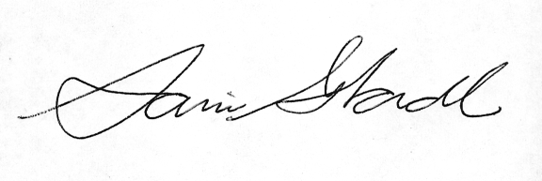
Dr. Samir N. Ghadiali, PhD Associate Professor (Joint Appointment)
Associate Professor, Director of Graduate Studies Department of Internal Medicine
Department of Biomedical Engineering Dorothy M. Davis Heart & Lung Research Institute
The Ohio State University Ohio State University Medical Center

