

Molecular Medicine
and Genetics
April 16, 2014

Dear Editor-In-Chief,

On behalf of my co-authors, I submit for consideration of publication in your journal, JoVE, our manuscript entitled, Rapid fractionation and isolation of whole blood components in samples obtained from a community-based setting, as an invited submission. The manuscript and its components are an original compilation and are not under consideration by any other journal. All participants in the described study were consenting adults. Publication permissions have been obtained from all manufacturers of the products mentioned herein. We would like to request expedited processing of our manuscript due to a pending move of the laboratory around July 1, 2014.

We outline an optimized, streamlined protocol that enables rapid, high-throughput processing of whole blood samples in a non-clinical setting. Included are methods for simultaneous peripheral blood mononuclear cell (PBMC), DNA, RNA and serum isolation from a single blood draw performed in the homes of consenting participants across a metropolitan area, with processing initiated within two hours of collection. We have used these techniques to process over 1600 blood specimens yielding consistent, high quality material which has subsequently been used in successful DNA methylation, genotyping, gene expression and flow cytometry analyses.

Thank you for your consideration.

Best Wishes,

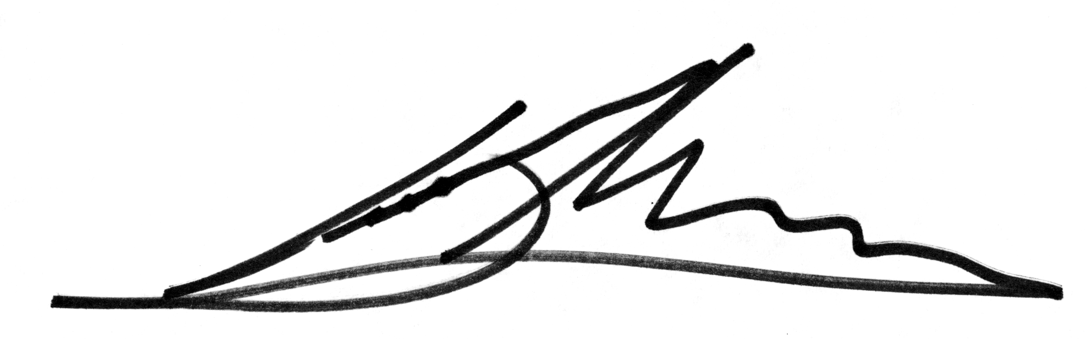
Derek Wildman
Associate Professor
Center for Molecular Medicine and Genetics
Wayne State University
Detroit, Michigan
dwildman@wayne.edu

