Submission ID #: 52227

Editor Name: Renee Choi

Videographer Name:

Film Date:

Authors and Affiliations: Amy Weckle¹, Allison E. Aiello², Monica Uddin³, Sandro Galea⁴, Rebecca M. Couborn⁵, Richelo Soliven⁶, Helen Meier⁵, Derek E. Wildman¹

¹ Department of Molecular and Integrative Physiology, University of Illinois at Urbana-Champaign, Urbana, Illinois, USA;

²Department of Epidemiology, Gillings School of Global Public Health, University of North Carolina , Chapel Hill, North Carolina, USA;

³Department of Psychology, University of Illinois at Urbana-Champaign, Urbana, Illinois, USA;

⁴Department of Epidemiology, Mailman School of Public Health, Columbia University, New York, New York, USA;

⁵Department of Epidemiology, University of Michigan School of Public Health, Ann Arbor, Michigan, USA;

⁶Center for Molecular Medicine and Genetics, Wayne State University School of Medicine, Detroit, Michigan, USA;

Title: Rapid Fractionation and Isolation of Whole Blood Components in Samples Obtained from a Community-based Setting

Corresponding Author:

Derek E. Wildman

Department of Molecular and Integrative Physiology

University of Illinois at Urbana-Champaign

Urbana, Illinois, USA

wildmand@illinois.edu

ph. 217-300-0939

fax 217-244-0877

Co-authors:
Amy Weckle: aweckle@illinois.edu; Allison E. Aiello: aaiello@unc.edu; Monica Uddin: muddin@illinois.edu; Sandro Galea: sgalea@bu.edu; Rebecca M. Coulborn: rebecca.coulborn@gmail.com; Richelo Soliven: rsoliven04@gmail.com; Helen Meier: hspink@med.umich.edu

Authors, please fill out the brief questionnaire below.

A. Will you require JoVE to record video microscopy, such as filming a complex dissection or microinjection technique? (Y/N)____N_____ (If you can record images/videos using your own camera/software, then mark No) If yes, please list make and model of your microscope: _____________________________________________
B. Does your protocol include detailed, step-by-step, descriptions of software usage? (Y/N)__N_____ If yes, we will need you to record using screen recording software to capture the steps. If you use a Mac, QuickTime X also has the ability to record the steps.
C. Which steps of your protocol will viewers benefit most from having filmed? Please list 4-6 steps using the step numbers listed in this document. 2.2; 2.3; 3.1; 4.1; 5.1; 5.3
D. What is the single most difficult aspect of this procedure and what do you do to ensure success? Please list the steps using the step numbers listed in this document._ step 4.2 involves a risk of exposure to bloodborne pathogens. We have reduced this risk by using a metal spatula to unsheathe the needle.__________________________
E. Will the filming need to take place in multiple locations? (Y/N) ____N___ If yes, how far apart are the locations? ___________________________________________________

1. Introduction (Schematic Overview and Interview)

A. Schematic Overview (read by voice talent at JoVE):

Procedural Narrative:
The overall goal of this procedure is to provide a streamlined protocol that enables rapid, high-throughput, simultaneous processing of whole blood samples in a non-clinical setting. (Intro)

Vacutainer processing is performed in an overlapping manner to enable efficient isolation of high-quality fractions of DNA, RNA, peripheral blood mononuclear cells, or PBMCs, serum, and residual fractions of plasma and red blood cells. (P1: Reveal each row of tubes as each item is mentioned. Reveal the row of tubes labeled DNA when said, then RNA on the bottom, if possible, leave enough space to show the row for PBMCs below DNA when said. Maintain the order of the arrows as shown in the graphic provided by the authors.)

Processing begins with centrifugation of the serum vacutainer, removal of an aliquot from one Ficoll containing vacutainer for DNA isolation, centrifugation of the Ficoll tubes, then completion of DNA isolation. (P2: Shots 2.2.2 & 2.3.2)

After DNA isolation, leukocyte-derived RNA isolation from the K2 EDTA vacutainers can occur. The blood from each vacutainer is passed through a respective filter and washed with PBS, then treated with an RNA stabilization agent. (P3: Show the complete graphic provided by the authors with all “x2” text when “leukocyte” is said. When the second sentence begins, darken each image one by one from left to right until the image on the far right is darkened. Shots 4.2.1 & 4.3.1)

Returning to the Ficoll containing vacutainers, the residual plasma is drawn off, and the mononuclear layer is washed with PBS. While the tubes are spinning, the residual red blood cells are collected and the separated serum is aliquotted. Finally, PBMCs are preserved in cell freezing medium. (P4: Show the two tubes with blue tops and swirls in the top middle of the PPT slide, add an arrow to the right and show the tube the arrow is pointing to (labeled “x2”), and display the tube with the text “x2.” When “residual plasma” is said, add two arrows and the upper two tubes with the provided text, but not the “residual” tube on the bottom. Add graphics to the tube with the blue cap to indicate that the tube is spinning when the second sentence begins. Add an arrow to the right and add the “residual” tube when “residual red blood cells…” is said. When the third sentence is said leave only the blue capped tube on the screen and remove the other tubes, then add the arrow and show the tubes labeled PBMCs with the text below. Shots 6.2.2 & 6.6.1)

Ultimately, high-quality fractions of fresh blood can be produced within two hours of collection and all assay-ready specimens can be available within two days. (P5 Slide 4)

Paste a copy of your graphic overview here. The original file should be Adobe Illustrator (preferred) or PowerPoint (see instructions) and should be uploaded through your online submission on the JoVE website. Please keep all layers in the file (i.e., do not flatten the file).

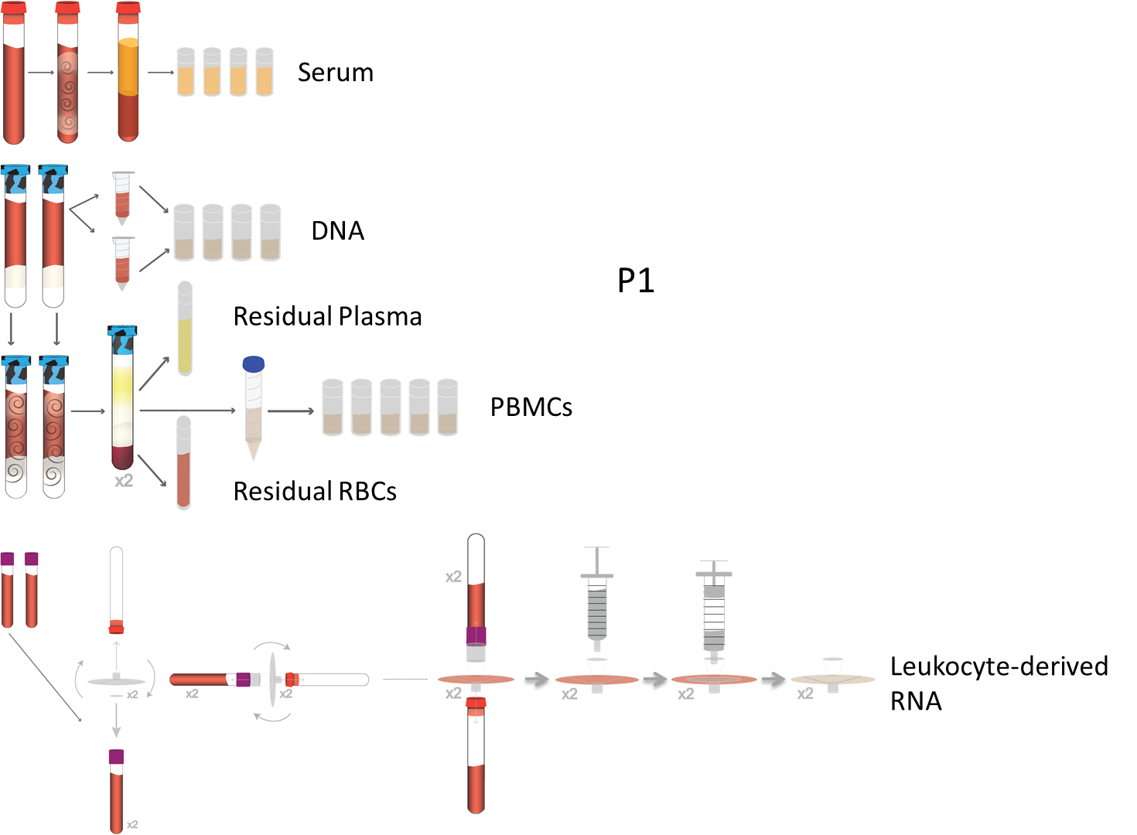

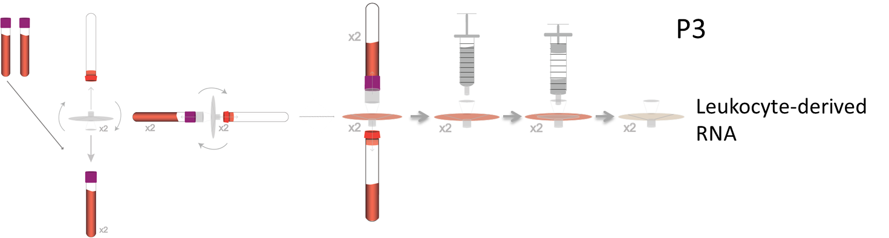
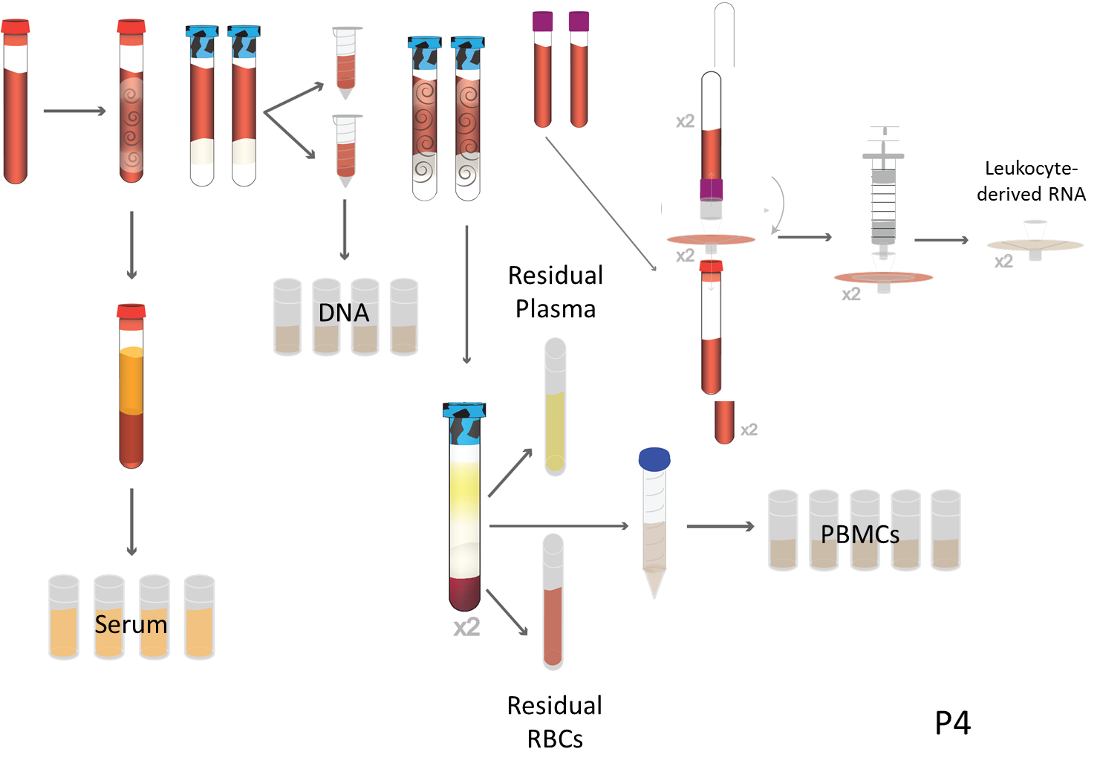

B. Interview: (Said by you on camera. Don’t forget to smile!)
  - Derek Wildman: The main advantage of this technique over existing methods is that the procedures can be performed simultaneously in a non-clinical setting, thus producing starting material within two days for a multitude of downstream applications including microarray, epigenetic, real-time RT-PCR, and flow cytometry analyses.
  - **Derek Wildman: Demonstrating the procedure will be Amy Weckle, my laboratory manager.
    - Interview style: Author saying the above
    - The named technician, post doc, student looks up from workbench or desk or microscope and acknowledges the camera.

Protocol (read by voice talent at JoVE):
- Serum, DNA, and PBMC Isolation Stage 1
  - To begin whole blood sample processing, ensure the buffers, centrifuge, and heat block have all been prepared [2.1.1 – WIDE/MED]. Document the time of the vacutainer delivery on the sample tracking sheet [2.1.2 - MED]
    - Talent arrives in the lab with vacutainers in hand, sets them down and checks that the buffers, centrifuge, and heat block have been prepared and set respectively.
    - Table S1. Highlight cells C3-C7 and display in a split screen with the footage.
  - After receipt of the samples, document the serum isolation start time on the specimen log [2.2.1-MED]. Immediately start processing by centrifuging the 7.0 mL serum vacutainer with the brake and acceleration off using a swinging bucket rotor with aerosol caps for 20 min at 1300 x g, 4 ˚C (Read as, “thirteen hundred g’s, 4 degrees Celsius.”) [2.2.2-MED].
    - *Over the shoulder, Film as written, Table S1. Highlight 2 cells EFG 36-38, or display only the two cells. Display the footage in a split screen with the table.
    - *Film as written. Capture the parameters of the centrifuge if possible. Take 2 best, use the end of the clip
  - While the serum vacutainer is being centrifuged, document the DNA isolation start time [2.3.1-MED-TXT]. In a BSL2 cell culture hood, invert the vacutainers containing the Ficoll gel five times and add 200 µL of whole blood from the top of one of the vacutainers into each of the two 20 μL aliquots of protease [2.3.2-MED]. Leave the protease and blood microcentrifuge tubes in the hood, and continue to the centrifugation of the Ficoll containing vacutainers [2.3.3-MED].
    - *Film as written, TEXT: The level of blood remaining in the vacutainer should be no less than 2.5 inches above the ficoll layer.
    - *Side view, Film as written Take 2 best
    - *Film as written

Mix-up on labeling shots so 2.3.3 is for 2.4.2 … and 2.4.2 is for 2.3.3
  - Before centrifugation, document the PBMC isolation start time, which must be within two hours of blood draw [2.4.1-MED-Over the Shoulder]. Invert the Ficoll containing vacutainers, already in the aerosol tight containers, 8-10 times…then centrifuge the vacutainers with the brake and acceleration off for 30 minutes at 1600 x g, 22 °C (Read as “sixteen hundred g’s, 22 degrees Celsius.”) [2.4.2-MED].
    - *Over the shoulder, Film as written, Table S1. Highlight cells EFG 44-47, or display only cells EFG 44-47 and show in a split screen with the footage.
    - *Film as written, capture the settings of the centrifuge in the shot, if possible.
- DNA Isolation Stage 2
  - Return to the DNA isolation samples in the hood and add 200 µL of Buffer AL to each of the protease and blood microcentrifuge tubes [3.1.1-MED]. Cap the tubes and remove them from the hood, then vortex them for 15 seconds [3.1.2-MED]. After vortexing, immediately flash spin the samples [3.1.3-MED].
    - *Side view, Film as written
    - *Over the Shoulder, Film as written
    - *Film as written
  - Proceed with DNA isolation as described in the accompanying text protocol until the DNA is eluted from the column [3.2.1-MED].
    - Talent proceeds with experiment, performing miscellaneous tasks. Take 2 alternative shot
  - Upon elution, pool the DNA from the 2 columns per participant for a total yield of 800 µL per participant [3.3.1-MED-Over the Shoulder].
    - *Over the shoulder, Film as written
- Leukocyte RNA Isolation Stage 1
  - Document the start time of leukocyte RNA isolation [4.1.1-MED-LM] Pierce the rubber septum of the K2 EDTA vacutainer with a transfer spike [4.1.2-CU-TXT]. Retain the sheath and screw cap for later use [4.1.3-MED].
    - *Film as written (LAB MEDIA: Table SI 2 cells EF 54-59)
    - *Film as written, TEXT: Following BSL2 standard practices, care should be taken to avoid exposure to bloodborne pathogens Take 2 best
    - *Film as written
  - Following assembly of the K2 EDTA tube system, use the end of a metal spatula to safely unsheathe the needle, and insert the needle into an empty 10 mL evacuated blood collection tube [4.2.1-CU/ECU]. Invert the K2 EDTA vacutainer-filter-receiver tube assembly to complete the setup [4.2.2-CU].
    - *Film as written
    - *Film as written
  - After filtration and a PBS wash, withdraw 3 mL of the RNA stabilization agent using a new 5 mL syringe [4.3.1-MED]. Flush the filter ensuring that the RNA stabilization agent remains attached [4.3.2-MED]. Then detach the syringe from the filter without retracting the plunger [4.3.3-MED].
    - *Film as written. Get a side view of this footage, if possible.
    - *Film as written
    - *Film as written
  - Seal the filter inlet and outlet with the sheath and screw cap retained from the transfer spike and leave the filter saturated with the RNA stabilization agent [4.4.1-CU/ECU]. Store the filter at -80 ˚C for at least 2 hours until time permits for completion of RNA isolation [4.4.2-MED-TXT].
    - *Capture the degree of filter saturation, if possible. Take 2 best
    - *Film as written, TEXT: RNA captured on the filters samples can be stored for up to one year without loss of RNA integrity upon compete isolation.
- PBMC Isolation Stage 2
  - Once the vacutainer is returned to the BSL2 hood [5.1.1-MED], remove the stopper and use a serological pipette to withdraw 1.5 mL of the top plasma layer without getting close to the mononuclear layer [5.1.2-CU/ECU-LM]. Transfer the plasma from the two vacutainers to a 5 mL cryovial then log the volume collected [5.1.3-MED-TXT].
    - *Film as written
    - *Film as written, Lab Media: Figure 2, display this image in a split screen with the shot.
    - *Over the shoulder, Film as written, TEXT: See accompanying text protocol for storage instructions
  - Transfer the remaining plasma and the mononuclear layer [5.2.1-MED] using a serological pipette to a 15 mL conical tube then add enough previously prepared 1X PBS to bring the total volume in the conical tube to 15 mL [5.2.2-MED]. Cap the tube and invert it 5 times, then centrifuge the tube with the brake and acceleration off for 15 minutes at 300 x g, 22 °C (Read as, “300 g’s, 22 degrees Celsius.”) [5.2.3-MED].
    - *Film as written, Over the Shoulder, LAB MEDIA, Figure 2, display this image in a split screen with the footage
    - *Film as written, Over the Shoulder
    - *Film as written
  - Return to the Ficoll containing vacutainers in the hood and collect the red blood cells, or RBCs [5.3.1-MED]. Use a 5 ¾ inch Pasteur pipet to swirl around and loosen the outside of the Ficoll gel layer and remove it [5.3.2-CU]. Use a serological pipet to collect and transfer the RBCs to a 5 mL cryovial then log the volume [5.3.3-CU].
    - *Film as written, Over the Shoulder
    - *Film as written
    - *Film as written
  - Next, transfer the plasma and RBC cryovials to a controlled rate freezing container and store them at -80 ˚C for at least 24 hours [5.4.1-MED]. After 24 hours transfer the samples to a cryobox and return them to -80 ˚C for long term storage [5.4.2-MED].
    - *Film as written
    - *Film as written Take 2 Has additional B-Roll shots with Freezer and storing boxes in the Freezer
  - When the centrifugation is complete, return the conical tube to the hood [5.5.1-MED], and aspirate the liquid, leaving 500 μL of PBS without disturbing the pellet [5.5.2-CU/ECU-TXT].
    - *Film as written
    - *Film as written, TEXT: Leave 200 µl of PBS above the pellet
  - Add 1X PBS to bring the volume to 10 mL and resuspend the pellet gently [5.6.1-CU]. Cap the tube and invert it 5 times, then centrifuge the sample with the brake and acceleration off for 10 minutes at 300 x g, 22 °C (Read as, “300 g’s, 22 degrees Celsius.”) [5.6.2-MED].
    - *Film as written
    - *Film as written, Over the Shoulder
- Serum Isolation Stage 2 and PBMC Isolation Stage 3
  - After centrifugation, aliquot the top serum layer from the vacutainer, into 2 mL cryovials and document the volume [6.1.1-MED-TXT]. Use 4 cryovials and aliquot 200 µl into cryovial 1, 1000 µl into cryovial 2, then divide the remaining volume into cryovials 3 and 4 [6.1.2-MED]. Transfer the cryovials to a cryobox and keep them at -80 ˚C for long-term storage [6.1.3-MED] and document the freezer start time.
    - *Film as written, TEXT: See Table S1 in the accompanying text protocol throughout this section
    - *Film as written, Over the Shoulder
    - *Film as written
  - Continue with PBMC isolation, returning the samples to the hood after centrifugation. [6.2.1-MED] Aspirate as much supernatant as possible without disturbing the pellet [6.2.2-CU/ECU]. Resuspend the pellet in 2.5 mL of PBMC Freezing Medium 1 [6.2.3-MED].
    - *Film as written Use take 2
    - *Film as written
    - *Film as written
  - Add 2.5 mL of PBMC Freezing Medium 2 containing DMSO and RPMI medium to the previously prepared cell solution and gently vortex the sample [6.3.1-MED]. Then aliquot 10 µl of the cell solution into a microcentrifuge tube [6.3.2MED-TXT]. Add 10 µL of 0.4% trypan blue stain into the microcentrifuge tube and mix the solution by pipetting several times [6.3.3-MED].
    - *Film as written
    - *Film as written, TEXT: Further dilution may be necessary
    - *Film as written
  - Next, pipet 10 µL of the mixture into a cell counting chamber slide [6.4.1-MED] and place the slide into the cell counter within 3 minutes of mixing [6.4.2-MED]. Zoom in and focus on the cells then select Count Cells to obtain a PBMC count [6.4.3-CU/ECU].
    - *Film as written
    - *Film as written
    - *Film as written
  - If the viable PBMC number is above 3 million cells per milliliter, aliquot the sample into a maximum of 5 cryovials at a concentration of at least 3 million cells per milliliter each [6.5.1-MED]. Document the cell count per cryovial on the specimen log [6.5.2-MED]. See the accompanying text protocol for how to proceed if the viable PBMC number is below 3 million cells per milliliter.
    - *Film as written
    - *Film as written
  - Finally, transfer the cryovials to a controlled rate freezing container and place them at -80 ˚C for at least 24 hours [6.6.1-MED/WIDE]. After 24 hours transfer the cryovials to a cryobox and place the box in the vapor phase of a liquid nitrogen tank for long term storage [6.6.2-MED/WIDE]. Document the freezer start time on the specimen log [6.6.3-MED].
    - *Film as written
    - *Film as written
    - *Film as written
- Results: Ideal Leukocyte RNA Processing Yields
  - The leukocyte RNA isolation and filter processing methods yielded this gel image resulting from capillary electrophoresis. Two distinct bands were produced with minimal degradation, representing 18S and 28S [place a red box around each row of bands] ribosomal RNA.
    - LAB MEDIA: Figure 3 Gel in upper left corner.

- Conclusion (said by authors on camera)
  - Derek Wildman: While attempting this procedure, it’s important to remember that maintaining accurate records is critical. We recommend developing a database to store all of the cryovial information including the volume, concentration, quality, barcode, and storage location at the outset. Further recommendations on sample organization can be found in the text protocol. 5th take best

Provided Media

Insert your media filenames here.

General Preparation

It’s critical for a smooth and organized shoot that all reagents are accounted for, in advance.

Any overnight or long incubation steps should be recognized and specimens/samples be prepared in advance so that prior steps can be recorded and shooting can continue with pre-prepared specimens/samples.

All tubes/flasks should be pre-labeled neatly before we arrive.

Ex. Luciferase assay done in 96 well plates should be labeled with negative/positive control wells and experimental samples are labeled accordingly.

You will receive more detailed preparation instructions, as well as an introduction to your videographer, closer to your filming date.

