Submission ID #: 52203

Editor Name: Melissa Ceo

Videographer name:

Film Date:

Authors and Affiliations:
Srikanth Kudithipudi, Denis Kusevic, Sara Weirich, Albert Jeltsch

Institute of Biochemistry
Stuttgart University
Stuttgart, Germany

Title: Specificity Analysis of Protein Lysine Methyltransferases Using SPOT Peptide Arrays

Corresponding Author:

Albert Jeltsch: albert.jeltsch@ibc.uni-stuttgart.de

Co-authors:

Srikanth Kudithipudi: srikanth.kudithipudi@ibc.uni-stuttgart.de

Denis Kusevic: denis.kusevic@ibc.uni-stuttgart.de

Sara Weirich: sara.weirich@ibc.uni-stuttgart.de

A. Will you require JoVE to record video microscopy, such as filming a complex dissection or microinjection technique? (Y/N) N (If you can record images/videos using your own camera/software, then mark No) If yes, please list make and model of your microscope: _____________________________________________
B. Does your protocol include detailed, step-by-step, descriptions of software usage? (Y/N) N If yes, we will need you to record using screen recording software to capture the steps. If you use a Mac, QuickTime X also has the ability to record the steps.
C. Which steps of your protocol will viewers benefit most from having filmed? Please list 4-6 steps using the step numbers listed in this document. 2.2, 2.9, 2.10, 3.2, 3.3, 3.5
D. What is the single most difficult aspect of this procedure and what do you do to ensure success? Please list the steps using the step numbers listed in this document. Question not applicable.
E. Will the filming need to take place in multiple locations? (Y/N) N If yes, how far apart are the locations? ___________________________________________________

1. Introduction (Schematic Overview and Interview)

A. Schematic Overview (read by voice talent at JoVE):

Conceptual Narrative:
The overall goal of the following experiment is to investigate the substrate specificity of Protein lysine methyltransferases, or PKMTs. (Intro)

This is achieved by identification of an initial substrate and preparation of peptide arrays with several variants of this substrate containing single amino acid exchanges at different positions. (P1, show Peptide array synthesis slide. Show top left rectangle and make green dots appear on it (or just have green dots already on rectangle). Then make gray cylinder attached to the blue drop with red dots appear above rectangle. If possible, show the gray cylinder first and make the blue drop appear from the gray cylinder. Then lower one of the red dots onto the left green dot to look like third rectangle image. Then make red dots in the blue drop turn green. Repeat the same animation for lowering one of the green dots onto the central green dot of rectangle. After making the gray cylinder disappear, make multiple colored dots appear above the three dots to look like the bottom rectangle.)

As a second step, the peptide array is incubated with the PKMT in the presence of a radioactive methyl group donor, which allows detection of peptide methylation by transfer of radioactivity to the corresponding peptide spot. (P2, show Peptide array methylation slide. If possible, use the last rectangle image from P1 and show this first. For the first part of the sentence, make the gray rectangle disappear to just show the colored dots. Then make the blue PKMT image appear to the right of the colored dots. Following this, make the 80-well plate appear below both the dots and PKMT. Lower the dots and PKMT onto the plate and make them fade into the plate. For the second part of the sentence, make the clear wells turn red and pink to look like the right plate. Finally make the activity triangle appear above the plate.)

Next, the array is exposed to an x-ray film and quantitatively analyzed in order to determine the methylation activity at each of the peptides and to define the specificity profile of the PKMT. (P3, show Data analysis slide. Make right plate with red and pink colored wells split into three to look like left image in slide. Then make the central multicolored image appear from these plates when “exposed to an x-ray film” is mentioned. When “quantitatively analyzed” is mentioned, make the blue arrow to the right of the multicolored image appear followed by the left graph.)

The results show which amino acids in the substrate peptide are critical for its methylation by the PKMT. (P4, show Figure 5C.)

Video Editor: Use 52203_Schematic Overview Graphic.pptx
Peptide array synthesis

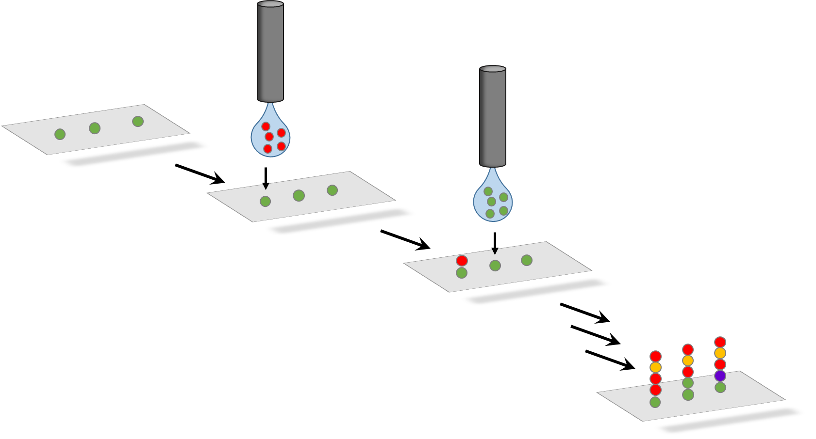

Peptide array methylation

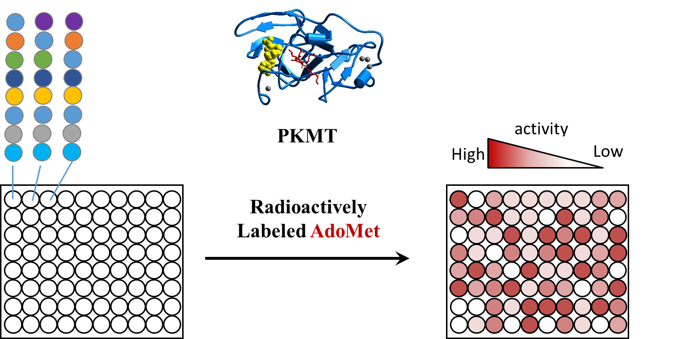

Data analysis

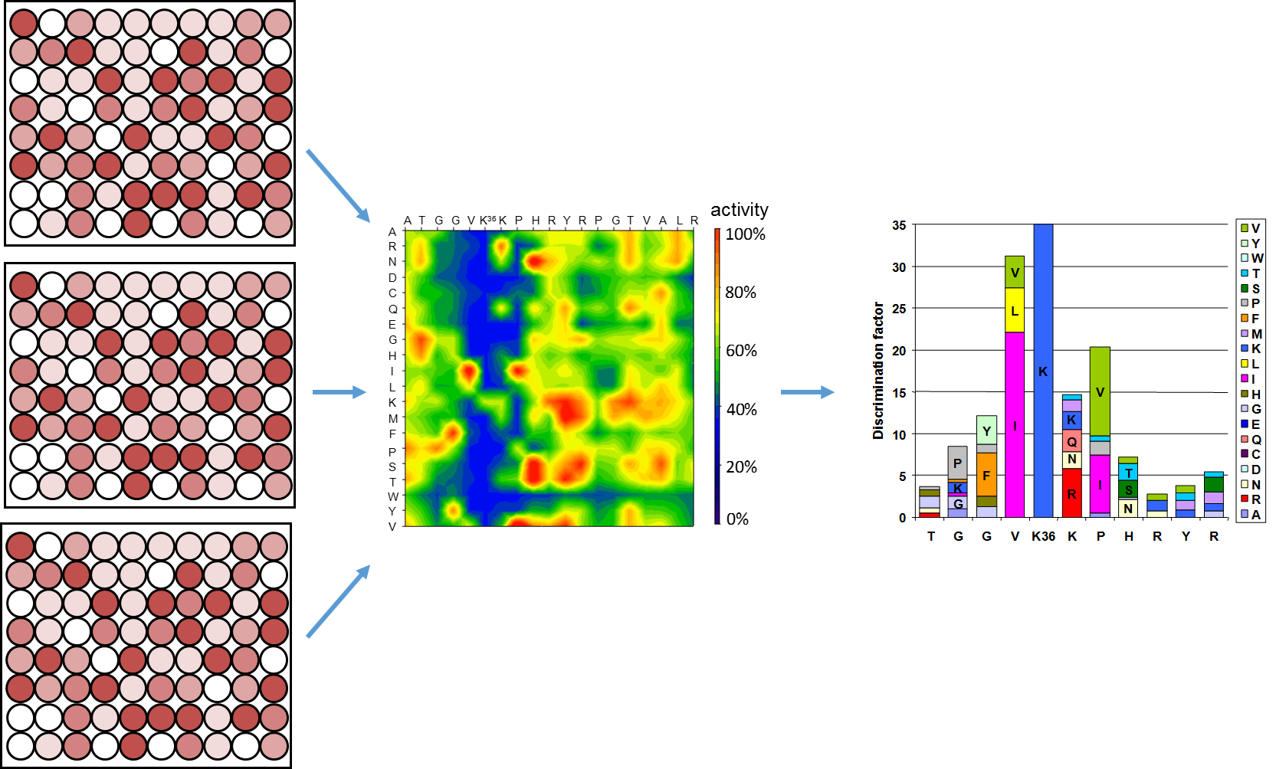

B. Interview: (Said by you on camera. Don’t forget to smile!)
  - Srikanth Kudithipudi: The main advantage of this technique over existing methods, like methylation of individual peptides, is that a number of different peptides can be tested in one experiment in a cost efficient manner.
  - Denis Kusevic: This method can help answer key questions in the Protein lysine methylation field, such as the identification of previously unknown novel substrates of PKMTs.
  - Sara Weirich: Though this method can provide insight into the specificity of PKMTs, it can also be applied to other systems, such as Protein Kinases, other Protein Methyltransferases or Acetyltransferases.
  - Albert Jeltsch: I first had the idea for this method, when I became familiar with the possibility of preparing large custom peptide arrays at reasonable costs using peptide SPOT synthesis.

Protocol (read by voice talent at JoVE):
- Preparation of Peptide Arrays
  - To begin this procedure, design peptide sequences for the synthesis using the MultiPep Spotter software. Enter the peptide sequences as a single letter code with each letter defining the specific amino acid.
    - WID/MED: Talent walks up to computer connected to peptide synthesizer and opens the computer software.
    - MED-over the shoulder: Talent enters the appropriate peptide sequence in the computer software.
  - Following this, pre-swell the Amino-PEG functionalized SPOT membrane in N,N-Dimethylformamide, or DMF, for 10 minutes. When finished, place the wet membrane on the SPOT synthesizer frame without any air bubbles or wrinkles.
    - MED: Talent adds DMF to membrane.
    - CU: Wet SPOT membrane as talent places it in synthesizer frame.
  - Dry the membrane completely for at least 10 minutes before starting the synthesis program. Wash the membrane three times with 100% ethanol.
    - MED-over the shoulder: Talent adds ethanol to membrane. Switch on the vacuum manually, to remove the DMF and also ethanol that would be added to the membrane for washing in the next step.
    - MED: Talent uses vacuum manifold of synthesizer to remove the ethanol from membrane. MED-over the shoulder: Talent adds ethanol to membrane
  - To generate the amide bond with the free amino group on the membrane, activate the carboxy group of the incoming amino acid by adding DIC (TEXT: DIC: N, N’-Diisopropylcarbodiimide) and Ethyl hydroxyimino cyanoacetate to the amino acid derivative.
    - MED-over the shoulder: Talent programs the synthesizer to add the appropriate reagents to the amino acid derivative. CU: Vial containing the amino acid derivatives and other reagents are added to it.
    - CU: Vial containing the amino acid derivative as reagents are added to it. Amino acids and reagents are placed in the designated manifolds of the machine.
    - MED-over the shoulder: Talent programs the synthesizer to add the appropriate reagents to the amino acid derivative.
  - Following activation, spot the desired volumes of activated amino acids on the Amino-PEG functionalized membrane using the programmable robot.
    - MED: Talent programs the robot to spot the activated amino acids onto membrane.
  - Repeat the previous step three times to ensure better coupling of the first activated amino acid. After incubating the membrane for 20 minutes, wash it with DMF to remove uncoupled amino acids.
    - CU: Membrane as robot spots activated amino acids onto it.
    - MED: Talent programs synthesizer to add DMF to membrane for washing.
  - After drying and blocking the free amino groups, wash the membrane with DMF four times and then incubate with 20% piperidine in DMF for 20 minutes to remove the Fmoc protecting group.
    - CU: Membrane as DMF is added to it for washing.
    - Reuse shot 2.3.2.
    - MED-over the shoulder: Talent programs synthesizer to add piperidine solution to membrane.
  - After washing and drying the membrane, repeat the spotting and Fmoc removal steps until the desired peptide length is achieved.
    - Reuse shot 2.5.1.
    - CU: Membrane as piperidine solution is added to it for Fmoc removal.
  - Following the last Fmoc group deprotection, wash the membrane with DMF and 100% ethanol. Then, treat the membrane with 0.02% bromophenol blue in DMF for a minimum of 5 minutes until it completely turns blue.
    - MED-over the shoulder: Talent programs synthesizer to add appropriate solvent to membrane for washing. Talent manually adds bromophenol blue staining solution to the membrane until it covers the membrane completely.
    - CU: Membrane as robot adds bromophenol blue solution to it to show color change. Apply vacuum manually to remove the bromophenol blue solution from the membrane.
    - Wash the membrane with ethanol to destain the bromophenol blue from the membrane
  - After washing and drying the membrane, remove it from the synthesizer (TEXT: If needed, photograph membrane to document peptide synthesis) and place it in a chemical resistant box.
    - MED: Talent removes membrane from synthesizer and put it in the chemical resistant box.
    - Talent place the box containing membranes on the shaker
  - Treat it with 20 to 25 milliliters of a side chain deprotection mixture consisting of 95% trifluoroacetic acid to cleave the side chain protecting groups and scavenger reagents (TEXT: Scavenger reagents: 2.5% water, 2.5% triisopropylsilane) to protect the amino acid side chains from modification. After ensuring that the deprotection mixture covers the membrane completely, close the box and incubate for 1 to 2 hours while shaking gently.
    - MED-over the shoulder: Talent places membrane in chemical resistant box. {Comment: Included with the 2.10.1}
    - CU: Membrane in box as talent adds side chain deprotection mixture and scavenger reagents to it and closed the box.
    - MED: Talent closes box, places it on rocking shaker, and turns shaker on.
    - Talent discards the side chain deprotection mixture into the halogen waste container
  - Following incubation, wash the membrane six times with 20 to 25 milliliters of dichloromethane for 2 minutes each. After washing twice with 100% ethanol, dry the membrane in a desiccator overnight.
    - MED-over the shoulder: Talent adds dichloromethane to membrane.
    - CU: Membrane as talent removes dichloromethane from it with a pipette.
    - MED: Talent places membrane in desiccator to dry overnight.
- Peptide Array Methylation
  - Next, pre-incubate the peptide array membrane in a sealed plastic bag containing the respective methylation buffer without enzyme and labeled [methyl-3H]-AdoMet (pronounced Ado-Met with radioactively labeled methyl group) for 10 minutes (TEXT: Buffer volume depends on array size).
    - MED-over the shoulder: Talent places peptide array membrane in labeled plastic bag containing appropriate reagents and seals it.
  - Discard the pre-incubation buffer and incubate the membrane in 8 milliliters of methylation buffer containing the respective PKMT for 1 to 2 hours (TEXT: Required enzyme amount depends on PKMT activity).
    - MED: Talent cuts the seal of the bag and removes pre-incubation buffer.
    - CU: Membrane in the bag as talent adds methylation buffer to it.
  - Following this, discard the methylation buffer in a radioactive waste container and wash the peptide arrays five times with 20 milliliters of buffer containing 100 millimolar ammonium bicarbonate and 1% SDS for 5 minutes to remove the bound protein.
    - MED-over the shoulder: Talent discards methylation buffer in radioactive waste container.
    - CU: Peptide arrays as talent adds buffer to them.
    - MED: Talent removes buffer from peptide arrays with a pipette. Talent places the bag containing membrane and buffer on the shaker.
    - MED: Talent removes buffer from peptide arrays with a pipette
  - After discarding the last washing buffer in the radioactive waste container, incubate the membrane for 5 minutes in 10 milliliters of amplify solution. Then, discard the amplify solution in the radioactive waste container for organic solvents. Seal the peptide array in a plastic bag and put it in an autoradiography cassette.
    - MED-over the shoulder: Talent adds amplify solution to membrane.
    - MED: Talent discards amplify solution in appropriate waste container. Talent places the box containing membrane and amplify on the shaker.
    - MED-over the shoulder: Talent seals peptide array in plastic bag and places it in autoradiography cassette. MED: Talent discards amplify solution in appropriate waste container.
    - MED-over the shoulder: Talent seals peptide array in plastic bag and places it in autoradiography cassette.
    - Talent sticks the membrane in the autoradigraphy cassette using radio labelled stickers {Comment: To caution others from touching it}.
  - Place the autoradiography film on the peptide array in a dark room (TEXT: Procedure is being done in light for videography purposes only). Then, close the cassette carefully. After exposing the film at -80 degrees Celsius, develop it to analyze the results.
    - CU: Peptide array as talent places autoradiography film onto it and closes the cassette.
    - MED-over the shoulder: Talent closes the cassette.
    - MED: Talent removes film from cassette and places it in the film developing machine.
    - Talent places the film in developing machine.
  - Finally, capture the image a couple of times with different exposition times to avoid saturation of strongly methylated peptide substrates.
    - MED-over the shoulder: Talent compares the different images captured using film developing machine.
- Results: Characterization of Methylated Peptide Arrays
  - An example of a methylation reaction of a peptide array with NSD1 (pronounced N-S-D-1) is shown here. The horizontal axis represents the sequence of the peptide, and in the vertical direction the altered amino acid is indicated. Methylation with NSD1 show that it specifically acts on H3K36 (pronounced H-3-K-3-6) and recognizes 3 to 4 amino acid residues on either side of the target lysine.
    - LAB MEDIA: Figure 4A (Slide4.jpg, 52203fig4highres.jpg, 52203fig4large.jpg) (Video Editor: For third sentence, make “ATTGVKKPHRYRPGTVALRE” appear. Then make red arrow appear from this line to peptide array.)
  - Consolidation of the three peptide array experiments of NSD1 is shown here. Around 85% of the peptides show standard deviations smaller than plus or minus 20% and more than 97% of the peptides demonstrate standard deviations smaller than plus or minus 30%.
    - LAB MEDIA: Figures 4B and 4C (Slide4.jpg, 52203fig4highres.jpg, 52203fig4large.jpg) (Video Editor: Zoom into Figure B for first sentence. Zoom into Figure C for second sentence.)
  - The calculated discrimination factor data shows that NSD1 prefers aromatic residues at the minus 2 position. At the minus 1 and plus 2 sites it prefers hydrophobic aliphatic residues and at the plus 1 site there is a preference for arginine, lysine, glutamine or asparagine.
    - LAB MEDIA: Figure 5A (Slide5.jpg, 52203fig5highres.jpg, 52203fig5large.jpg) (Video Editor: Highlight the third bar (G) from the left when “aromatic residues at the minus 2 position” is mentioned in first sentence. For second sentence, highlight fourth bar (V) and seventh bar (P) from the left for “minus 1 and plus 2 sites”. Highlight sixth bar (K) from the left when “plus 1 site” is mentioned in second sentence.)
  - Potential novel peptide substrates can be found by database searches of the human proteome. Strong methylation of some of these peptides with AdoMet confirm their identity as novel NSD1 peptide substrates.
    - LAB MEDIA: Figures 5B and 5C (Slide5.jpg, 52203fig5highres.jpg, 52203fig5large.jpg) (Video Editor: Show Figure B for first sentence. Show Figure C for second sentence. Highlight ATRX, U3, H4K44, H1.5K168 for second sentence.)

- Conclusion (said by authors on camera)
  - Denis Kusevic: While attempting this procedure, it’s important to remember to use the most appropriate initial substrate.
  - Srikanth Kudithipudi: Following this procedure, other methods like methylation of the corresponding proteins in vitro and in cells can be performed in order to find out if proteins are accepted as substrates as well.
  - Albert Jeltsch: After its development, this technique paved the way for researchers in the field of Protein lysine methylation to define the substrate specificity of many PKMTs and identify several novel substrates which helps to understand the important biological function of PKMTs.
  - Sara Weirich: Don't forget that working with radioactivity and organic solvents in peptide synthesis can be hazardous and appropriate precautions should always be taken while performing this procedure.

Provided Media

Authors, Please list all images, movie files, or 3-D rendered animations that can be included in the video per editor’s request. The step in the script/video where these images will be inserted should be specified. For example:

6.2 – 0123_PIname_Figure1.tif - dual color imaging of tumor angiogenesis at 40X
6.2 – 0123_PIname_Figure2.tif - dual color imaging of tumor angiogenesis at 100X

Formats: For static images we prefer .tiff, .eps, Illustrator, Powerpoint or Photoshop files at dimensions of at least 720X480 pixels and 300 dpi. The higher resolution, the better. Likewise any exported movie files should have at minimum these dimensions and be rendered to .mov, .mp4, or .avi files.

Insert your media filenames here.

General Preparation

It’s critical for a smooth and organized shoot that all reagents are accounted for, in advance.

Any overnight or long incubation steps should be recognized and specimens/samples be prepared in advance so that prior steps can be recorded and shooting can continue with pre-prepared specimens/samples.

All tubes/flasks should be pre-labeled neatly before we arrive.

Ex. Luciferase assay done in 96 well plates should be labeled with negative/positive control wells and experimental samples are labeled accordingly.

You will receive more detailed preparation instructions, as well as an introduction to your videographer, closer to your filming date.

