Dear Editor and Reviewers:
Many thanks for your detailed feedback on our paper. We believe that we have addressed 100% of your reservations and questions. For clarity, our responses are in blue text, and all changes made in the paper are also highlighted in blue.
Once again, many thanks for your service to the community.

Editorial comments:
A) The Protocol requires additional detail in several areas:
1)The system set up in step 2.1 should be described in more detail. A table of equipment used could be referenced, but the components should be briefly described in general terms.
2)Please describe how the photoarray is arranged in step 2.1.2, rough dimensions of setup, spacing of lasers, ect.
3)4.1.1.1. How is the DFT used? Is this in a program? What steps are taken to accomplish this?
4)In step 4.1.3.3. How is the posterior probability calculated?
5)How is step 4.2.2.1.1. completed? Is there an equation used?
6)Please verify that matlab code required to run the circadian.wbf file is available in the Chen 2013 reference or included in the supplementary files.
7)Please define the "Bayesian classifier" in step 4.1.3
B)Grammar: "Classify an unknown insect sounds"...
C)The length is at 2.75 pages, but asks in step 4.2.2.1.2 to follow the steps in a section that is not highlighted. This will exceed the length limit unless something else is removed.
D)Visualization issue: In step 4.3.1 "Learn the geographic distribution of insects" doesn't really have a visual. Could the authors suggest something for this?
E)Please take this opportunity to thoroughly proofread your manuscript to ensure that there are no spelling or grammar issues. Your JoVE editor will not copy-edit your manuscript and any errors in your submitted revision may be present in the published version.
F)Please disregard the comment below if all of your figures are original. If you are re-using figures from a previous publication, you must obtain explicit permission to re-use the figure from the previous publisher (this can be in the form of a letter from an editor or a link to the editorial policies that allows you to re-publish the figure). Please upload the text of the re-print permission (may be copied and pasted from an email/website) as a Word document to the Editorial Manager site in the "Supplemental files (as requested by JoVE)" section. Please also cite the figure appropriately in the figure legend, i.e. "This figure has been modified from [citation]."

The Editor’s comments have already been addressed previously. The only change we made is the adding of a note paragraph explaining what a “Bayesian Classifier” is. Many thanks.
Reviewers' comments:
Reviewer #1:
Manuscript Summary:
The goal of this study is to introduce an inexpensive, non-invasive recording system that could accurately classify flying insects with respect to species and sex, even in a mixed population. Although the authors tested this system in laboratory setting, they propose that the system will be valuable if deployed in the field for entomological research and medical entomology, e.g. to count and classify insect vectors and assess sex ratios when insect sterile technique is used for population control. The device that the authors have developed show good performance in laboratory setting and is quite effective in classifying many different species of insects, including Drosophila simulans, Musca domestica, as well as multiple Culex and Aedes species. The topic of investigation fits of the scope of this journal and this method will be of interest to scientists in other institutions.
Many thanks for your kind words!

However, the reviewer feels that the authors need to address some important issues elaborated below, before this manuscript can be accepted.
The reviewer therefore recommends major revision before this study can be considered for publication. Specific comments that needs to be addressed are detailed below:
Major Concerns:
(1) It was mentioned that these optical sensors can be used to record the "sound" of insect flight from meters away (line 86) with complete invariance to wind noise and ambient sounds - which is great. However, it was also mentioned in lines 411-413 that flashing lights, camera flashes and vibrations near the cages will introduce noise to the data, making it necessary to perform these experiments in the dark room and in places where there is no vibration. I see a big problem with this especially if the goal is to deploy these sensors in the field. I am sure there will be lots of lights and vibrations in the field - does that mean it is not realistic to use this system in the field? I think the authors need to address this. Have they tried this system outdoors (or in a caged outdoor setting) and monitor the quality of the data (i.e. noise level) and accuracy y as compared to lab setting?

We report only on the lab setting of our work for brevity and clarity. However we have already considered and addressed all these issues you mention.
First, “flashing lights, camera flashes and vibrations near the cages will introduce noise to the data,”. We have design our sensor to be “Lego-like”, so that it can quickly be adapted to fit into existing insect traps (of which there are dozens of designs). In the figure to the right we show one such example of our sensor placed in a popular commercial trap called the Zumba Trap. Note that here the sensor is inside a darkened ABS pipe, so it is completely “blind” to any external light.
Note also that this trap is designed to be suspended, isolating it from vibration. Our sensor can sense low frequency movement from wind, or a mouse climbing on the trap, but our software simply filters this information away.
In general, the reviewer is correct in thinking that there are some issues with field deployment. However co-author, Dr. Agenor Mafra-Neto has decades of experience in field deployment of insect traps on six continents, and has been awarded multiple patents for insect traps/counting devices. He has done preliminary field tests with the sensor, it works beautifully in the field.
Our paper simply reflects our understating of the spirit of “journal of visualized experiments”, not “journal of visualized deployments”.
(2) If these systems cannot be deployed into the field, then the authors need to address the value of using them in laboratory setting. It will not likely be used for species identification in lab setting as researchers generally work with known species. What experiments can these sensors be potentially used for? I think the authors have presented really great data, e.g. Figure 5, and illustrated the accuracy that can be attained using their system, but they have to address whether their device can really be used in the field (which is not a darkroom), and if not, then what can researchers use these recording devices in the lab. Maybe they can elaborate?

Please see the answer above, but we will briefly elaborate.  Even without using a physical trap apparatus to isolate our device from vibration and light “pollution”, our device still works in the field. The figure to the right shows how we are using the device to study mosquito breeding grounds.  Of course the tree “vibrates” in the wind, but simple signal processing lets use ignore this.  Also, the shadow of leaves blowing in the wind would produce a signal if the shadow crosses the photodiodes, but that signal would be 3 to 20Hz. Even the slowest butterflies will flap their wings at 50Hz or greater.  In general, outdoor deployment is easier than indoor deployment. Indoors (especially if not on the ground floor), the floor can vibrate if a large person walks past the device. More importantly, indoors certain kinds of cheap fluorescent lights or old style computer/TV screens (CRTs) can produce a lot of optical noise.  In summary, the devices do work well outdoors, however this paper focuses on their indoor deployment. | 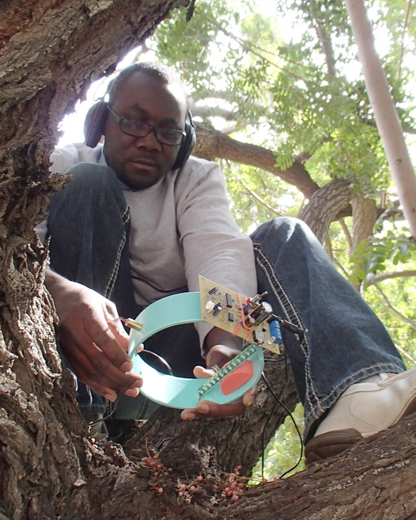  Phytotelmata (small water bodies held by terrestrial plants) are an important breeding ground for many insect vectors. Here a technician is placing one of our sensors over a water-filled tree hollow. The sensor can be left unattended for up to two weeks on battery power.
Minor Concerns:
(1) Based on the results presented here, the device seemed to produce reliable classification in laboratory setting. But there is always inertia in using new technologies. In order for researchers to adopt this device, the authors need to provide more information about time and cost requirements. In section 3.1 and 3.2, the authors described the method for their detection algorithm and data processing for each 0.1 second long sliding window. To process 3 days of data (which is what they showed in section 2.2.2), how much time is necessary to actually process the data if the researcher has to process 0.1 second at a time. Can they give an estimate? Is it a feasible amount of time?
Done. We have added a note paragraph to explain the time cost. The detection algorithm is much faster than real-time. It takes less than 3 hours (typically around 2.5 hours) to process 3 days data on a standard machine with 2GHz CPU and 8GB RAM. Thanks.
(2) Another aspect that new users will consider is the cost. In line 395 - the authors mentioned inexpensive and scalable. They should provide the estimate cost of building one of these system.
Done. We added the text to explain the cost. The sensor prototype is made of LEGOs, a 99-cent laser pointer, and part of a TV remote, so a set up could be manufactured for less than $10.
(3) The manuscript needs to be edited for spelling mistakes, etc. There is one even in the first sentence of the abstract (line 55, 75, 82, 91).
Done. We also made a pass through the paper to check for spelling mistakes. Thanks.
Additional Comments to Authors:
(1) The feature of adding additional "classifier" is great and especially exciting.
Thanks for your kind words.
Reviewer #2:
Manuscript Summary:
Fascinating use of optical approach for detecting insects in the field. Thanks!
Major Concerns:
Grandiose in places where it doesn't need to be: "vastly superior" (line 60) vs "superior" or critique of microphones (line 75, 76) "sparse, low-1quality data" vs "have noise rejection challenges" or similar. And then "this work demonstrates that these problems have been solved." vs "Major steps towards addressing these challenges are solved with our approaches." Thanks!

- We have changed : "vastly superior" to “superior”

- As regards “critique of microphones”, we do say “Such devices are extremely sensitive to wind noise and to ambient noise in the environment, resulting in very sparse and low-quality data”. However these words are just slightly paraphrased from the original authors that used microphones to record insects. We are just reporting their words.

- We have replaced “This work demonstrates that all these problems have been largely solved.” with “This work addresses all three issues.”
Work appears to be based solely on lab-recordings. The claims are that this system is far superior to others (some of which have been tested and developed in field environments), yet this device has not been subject to field testing. It would be good to present the data for what it is.
As noted above, we have done some field tests. However we want to have a narrow, tightly focused scope for this work.

Note that if even if we assumed that our sensor ONLY works in the lab, it still would be a very useful tool, as it would allow...
The accurate determination of circadian rhythms.
Below right is a typical circadian rhythm plot, averaged over a few hundred data points. Below left is our circadian rhythm plot, averaged over about 100 times more data. Our sensor allows us to collect such data two or three orders of magnitude more cheaply than current methods.

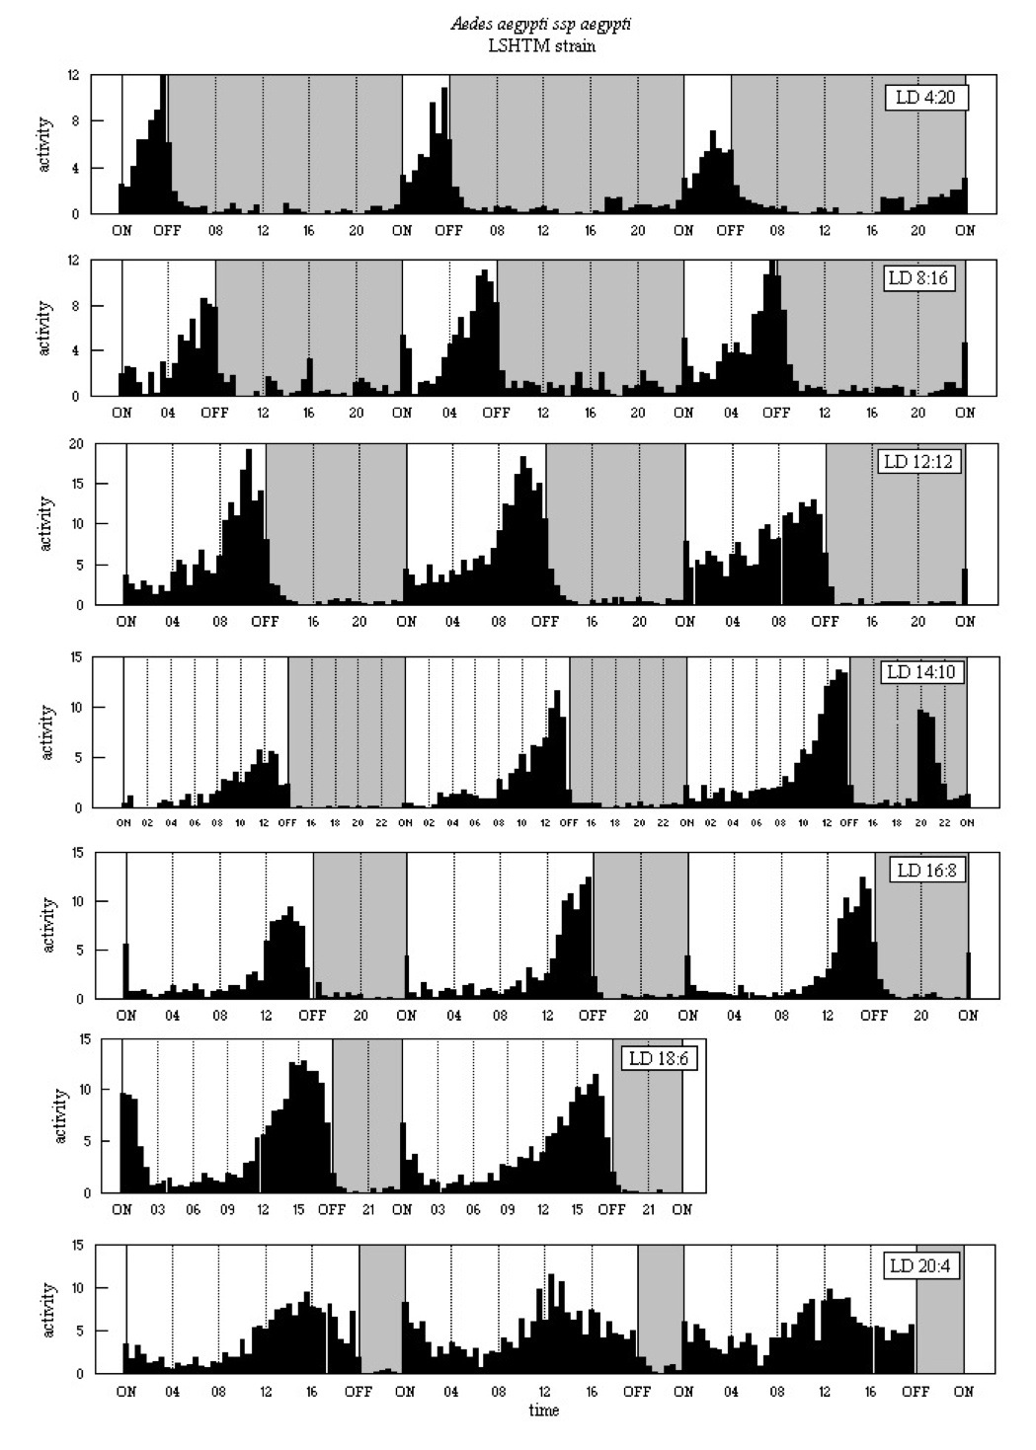

Again, even if we assume that our sensor ONLY works in the lab, it can be used for sexing mosquitoes. Dr. Stephen Dobson of the University of Kentucky is currently using our sensor for (in-lab) sex discrimination.

We could write a long description of the five or six projects our sensor IS being used for, and speculation as to the many things it might be used for. However, we are up against tight page limits
Minor Concerns:
"Sanity check" needs to be revised. What specifically was done?
Done. We have added some text to explain what was done. Thanks.

Reviewer #3:
My preference is to call them laser vibrometer sensors than pseudo-acoustic optical sensors. The term pseudo seems a little confusing in this context.
We ran this idea by the optical engineers in our College; they believe that would cause confusion. The term “laser vibrometer” is generally used to mean a “Laser Doppler vibrometer”. However our device is not a Laser Doppler vibrometer [a].

[a] http://en.wikipedia.org/wiki/Laser_Doppler_vibrometer
Line 86. the particular problems mentioned have been largely solved, I agree, but there are others associated with the getting the insects to fly in the chamber. The authors should mention that not all insects may be as cooperative as the ones successfully tested.
Of all the insects we tested, they are all cooperative to fly in the chambers. It’s true that some big insects may refuse to fly in the confined environment as in the chambers. However, the chambers are designed only for use in the lab to test and demonstrate the ideas. The final goal is to classify insects in the field, where the insects will not be confined, but live in nature, in which case, we will not have the problem of getting insects to fly.
Line 227. I like this section. It is a how-to recipe on to add important circadian rhythm and geographic distribution information to that received from the sound feature comparisons when conducting automated species identification studies. Thanks for your kind words!
Line 265 "flying generated" should be "wingbeat signals generated"
We meant “flying sound generated”. The missing word “sound” is now added. Thanks for pointing this out.
Figs. 3, 4, 6, and possibly 8 could be combined into a single figure.
The multiple figures are used to show how to add features incrementally. In the video version, we will use an animation to show this process dynamically. We have added the animation to the supplementary materials. Thanks.
Fig. 5 The problem with this is that the circadian rhythm is based on the laboratory conditions. This may not be the circadian rhythm in nature.
Yes, all the circadian rhythms shown in this work are based on the lab conditions, and may not be the circadian rhythms in nature. However, in this work, we do not claim that we have learned the circadian rhythms in nature, rather, our goal is to show that it is a good feature to improve the classification performance. In nature, insects’ circadian rhythms depend on the time of dawn and dusk, but all insects to be classified are typically at the same location, and thus have the same dusk and dawn time. In our lab, we made sure that the lab conditions are the same for all the testing insects, and thus, we believe the classification improvement made by the circadian rhythms learned in the lab approximates well to those learned in nature would do.
Line 413 "dry towers" ? I don't think that is what the authors mean.
The typo is fixed. It should be “dry towels”. Thanks for pointing this out.
My preference would be to include more outside references such as, Potamitis, Ilyas, Classifying insects on the fly, Ecological Informatics (2013), and to move some of the broad claims in the introduction to a section in the discussion.
We have included the suggested references, thanks. However, since the other idea you have is just a ‘preference’ we respectfully ask that we be allowed to decline. It would take a significant effort and the other reviewers might then object. Moreover, we simply prefer the current presentation, which we converged on after reading some of the most highly cited similar papers in JOVE.

