Submission ID #: 51776

Editor Name: Brigid Stadinski

Videographer name: TBD

Film Date: TBD

Authors and Affiliations:

Rick Pleijhuis¹, Arwin Timmermans¹, Johannes De Jong¹, Esther De Boer¹, Vasilis Ntziachristos², and Gooitzen Van Dam¹

¹ Department of Surgery, University Medical Center Groningen, Groningen, NETHERLANDS
² Helmholtz Zentrum Munich, Technical University of Munich, Munich, GERMANY

Title: Tissue-simulating Phantoms for Assessing Potential Near-Infrared Fluorescence Imaging Applications in Breast Cancer Surgery

Corresponding Author:

Pleijhuis, Rick
Department of Surgery
University Medical Center Groningen
Groningen, NETHERLANDS
r.g.pleijhuis@umcg.nl (please use r.g.pleijhuis@gmail.com in cc due to a recent change in institutions!)

Authors, please fill out the brief questionnaire below.

- Will you require JoVE to record video microscopy, such as filming a complex dissection or microinjection technique? (Y/N) ___NO___ If yes, please list make and model of your microscope:
**Note: This question is to get at whether or not you will need a camera hook-up to look into the microscope. However, if your microscope has a digital camera attached to a computer, you can gather these shots by collecting screen capture movies.
Does your protocol include microscopy steps that are visualized through a microscope with a digital camera/computer attached? (Y/N) ___ NO____
B. Does your protocol include detailed, step-by-step, descriptions of software usage? (Y/N)__NO___
C. Which steps of your protocol will viewers benefit most from having filmed? Please list 4-6 steps__2.3, 3.4, 4.4, 4.5, 6.3___
D. What is the single most difficult aspect of this procedure and what do you do to ensure success? The most difficult aspect of the procedure is the removal of irregular-shaped fluorescent inclusions from their mold. We solve this by manually restoring the inclusion by locally applying melted agarose mixture to restore the preferred shape.

1. Introduction (Schematic Overview and Interview)

A. Schematic Overview (read by voice talent at JoVE):

Procedural Narrative:

The overall goal of this procedure is to simulate near-infrared fluorescence imaging applications in breast-conserving surgery using tissue-like breast phantoms. (Intro)

This is accomplished by first creating tumor-like fluorescent inclusions of different size and shape. (P1)
Editors, please sequentially (from top to bottom) bring in the 3 photographs of the tumor-like fluorescent inclusions in P1.

The second step is to integrate the fluorescent inclusions in breast-shaped phantoms with optical characteristics similar to human breast tissue. (P2)
Editors, please sequentially (from top to bottom) bring in the 2 photographs in P2.

Next, the near-infrared fluorescence imaging system is applied to guide the surgeon intraoperatively in localizing and removing the fluorescent tumor-like inclusion. (P3)
Editors, please sequentially (from left to right) bring in the 2 photographs in P3.

The final step is to scan the surgical cavity margin for the presence of residual disease following removal of the fluorescent tumor-like inclusion. (P4)
Editors, please show the photographs in P4. This can be done sequentially, by starting with the top row and then the bottom row.

If applicable, the surgeon can then excise remaining tumor tissue guided by the near-infrared fluorescence imaging system. (P5)
Editors, please show the photographs in P5. This can be done sequentially, by starting with the top row and then the bottom row.

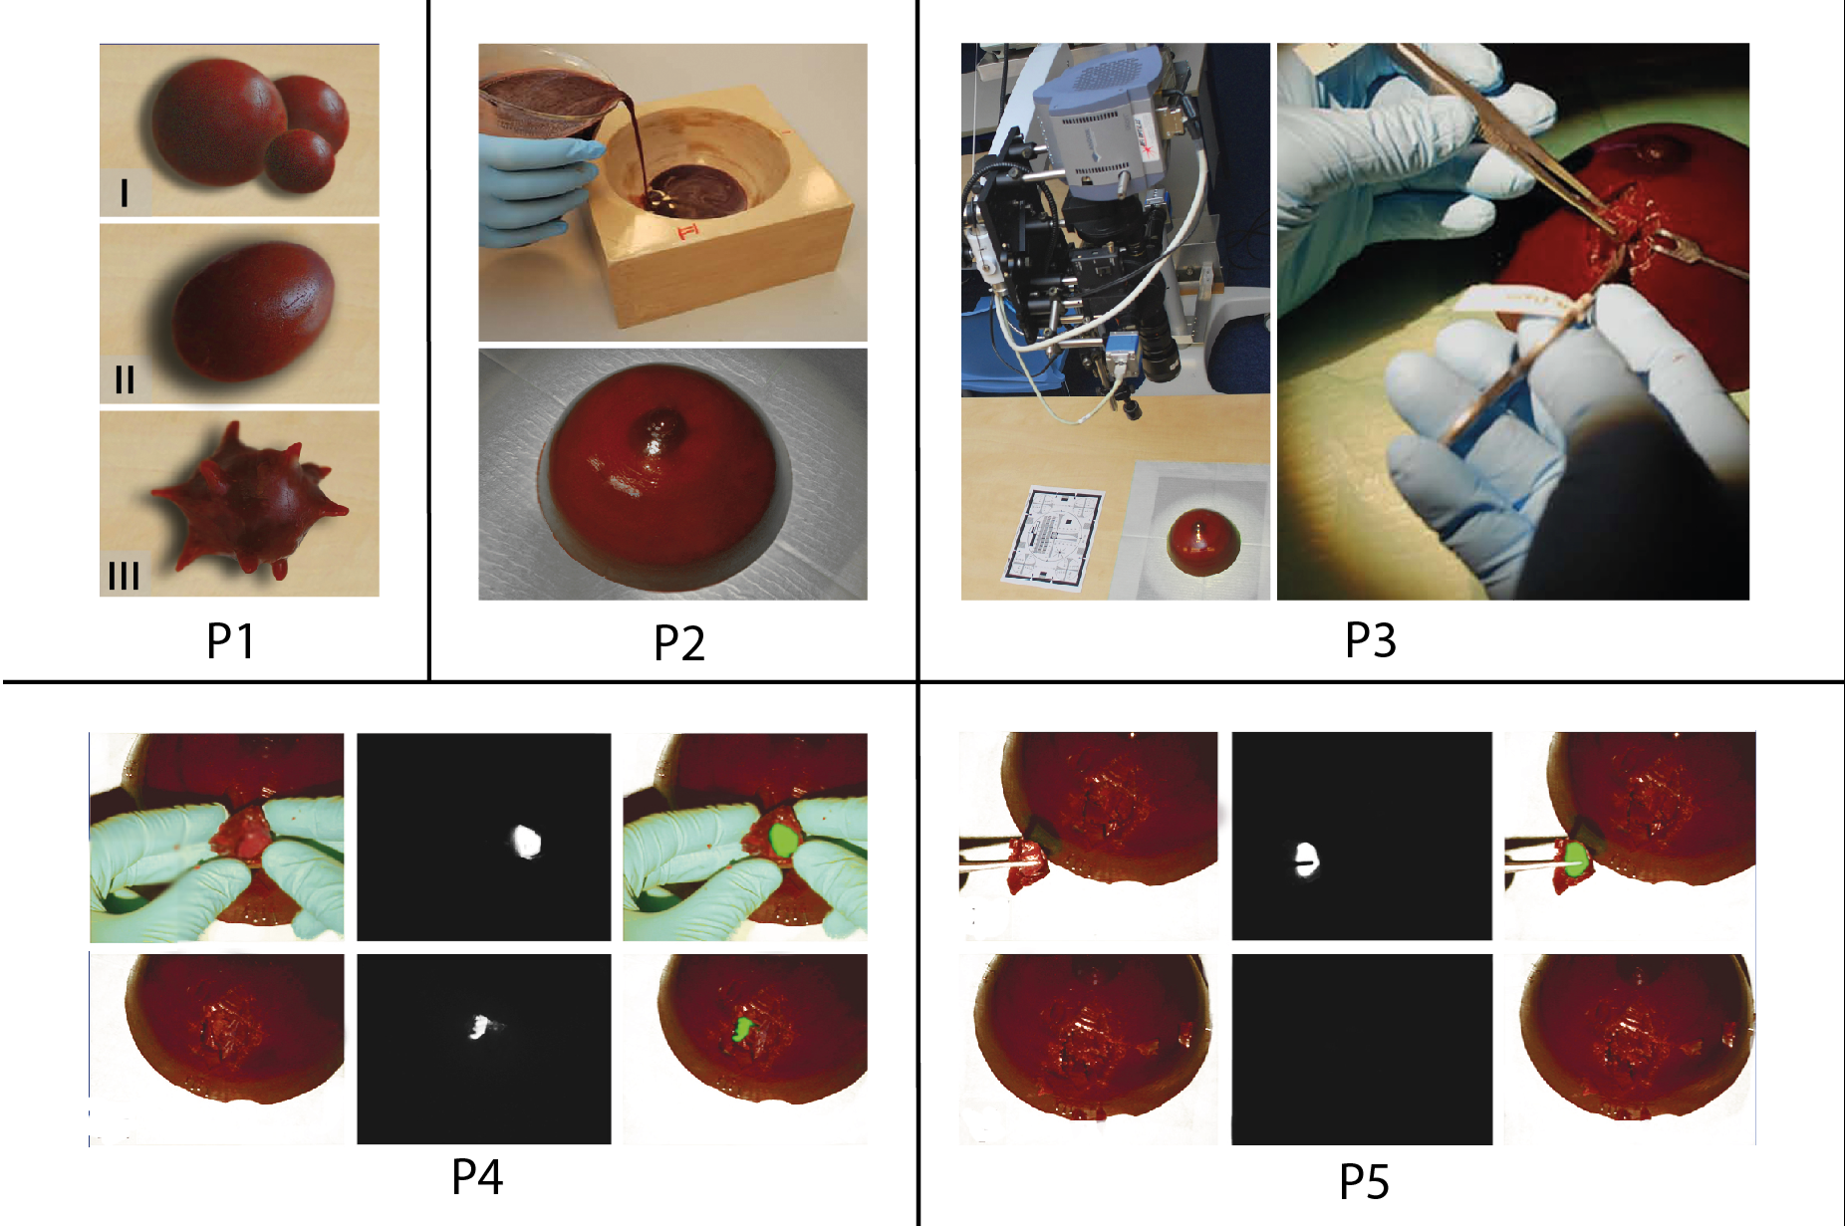
Paste a copy of your graphic overview here. The original file should be Adobe Illustrator (preferred) or Powerpoint (see instructions) and should be uploaded through your online submission on the JoVE website. Please keep all layers in the file (i.e., do not flatten the file).

B. Interview: (Said by you on camera. Don’t forget to smile!)
  - Rick: The main advantage of this technique over existing methods, like CT, PET, and MRI, is that near-infrared fluorescence imaging provides high resolution images in real-time and can easily be applied in an intra-operative setting. Moreover, the technique is inexpensive and makes use of non-ionizing radiation.
    - MED: Rick looks toward camera, interview style.
  - Rick: Demonstrating the procedure will be Arwin Timmermans, a graduate student from our research group.
    - MED: Rick looks toward camera, interview style.
    - MED: Arwin looks up from workbench and acknowledges the camera.

Protocol (read by voice talent at JoVE):
- Create Silicone Molds for Tumor-simulating Inclusions
  - To begin, collect solid items of the desired shape and size that can serve as models for tumor-simulating inclusions, such as beads or marbles. Thoroughly clean the tumor models and remove any irregularities.
    - CU: Talent displays models for tumor-simulating inclusions, such as beads or marbles, in hand.
    - MED-over the shoulder: Talent cleans the tumor models and removes any irregularities.
  - Place each model in a separate thin-walled square plastic box with a smooth surface. If necessary, fixate the model to the bottom of the box to keep it in position.
    - CU: Thin-walled square plastic box with a smooth surface as talent fixates the model to the bottom of the box.
  - Then, pour the required amount of silicone component A into a mixing bowl and add silicone component B in a 10 to 1 ratio by weight. Mix both components thoroughly. Gently pour the silicone mixture in the plastic box to prevent trapping air bubbles.
    - MED: Talent pours the required amount of silicone component A into a mixing bowl and adds silicone component B in a 1 10 to 1 ratio by weight.
    - MED-over the shoulder: Talent mixes the two components in the bowl.
    - CU: Plastic box as talent gently pours the silicone mixture into it.
  - Let the silicone mixture solidify for at least 6 hours before cutting the mold and removing the tumor model. Optionally, the silicone mold can be cut in a zigzag pattern to allow it to fit back together cleanly.
    - MED-over the shoulder: Solidified mixture as talent begins to cut the mold in a zigzag pattern Match action in next shot.
    - CU: Solidified mixture as talent begins to cut the mold in a zigzag pattern
- Create Fluorescent Inclusions
  - To create fluorescent inclusions, add 2 grams of agarose to 50 ml of Tris-buffered saline, or TBS, which has been prepared with sodium azide as described in the text protocol. Heat the agarose slurry using a microwave until the boiling point is reached. Stir thoroughly until the agarose is completely dissolved.
    - MED: Talent adds 2 grams of agarose to 100 50 ml of TBS with sodium azide.
    - MED-over the shoulder: Talent places the container of buffer and agarose into the microwave.
    - CU: Agarose mixture as talent stirs thoroughly.
  - Add 1.1 grams of hemoglobin and 5 ml of intralipid 20% to 50 ml of TBS and add this to the agarose mixture under constant stirring to resemble the optical characteristics of the surrounding breast phantom tissue.
    - (3.2.1 A) MED-over the shoulder: Talent adds 1.1 grams of hemoglobin and 5 ml intralipid 20% to 50 ml of TBS under constant stirring.

3.2.1 B Added: Talent adds the TBS/hemoglobin/intralipid mixture to the hot agarose mixture.
  - Add 20.0 mg of the fluorescent dye indocyanine green to 83.8 ml of deionized water. Pipet 5 ml from this solution and add it to the agarose mixture to obtain a final concentration of 14 µM.
    - MED: Talent adds 20.0 mg of the fluorescent dye indocyanine green to 83.8 ml deionized water.
    - CU: Agarose mixture as talent pipets 5.00 ml of the fluorescent dye indocyanine green to it.
  - Gently fill the silicone molds with the hot agarose mixture using a syringe. Let the fluorescent inclusions solidify at room temperature for approximately one hour. Protect the inclusions from light by covering the entire mold with aluminum foil.
    - MED-over the shoulder: Talent gently fills the silicone molds with the hot agarose using a syringe. Match action in next shot.
    - CU: Silicone molds as talent gently fills them using a syringe.
    - MED: Talent covers the molds with aluminum foil.
  - After solidification, gently open the mold and press out the inclusion. Protect the agarose inclusions from light and dehydration by wrapping them in aluminum foil and store them in a humidified storage container at 4ºC.
    - CU: Molds as talent gently opens and presses out the inclusion.
    - MED: Talent wraps the agarose inclusions in foil and places them into a humidified storage container.
- Create Breast Phantoms
  - Obtain a cup-shaped mold to create breast phantoms of the desired size and volume. To create a breast phantom with a volume of 500 ml, add 50 g of gelatin 250 bloom to 500 ml of TBS. Heat the gelatin slurry to 50 ºC under constant stirring.
    - CU: Cup-shaped mold as talent displays to the camera.
    - MED: Talent adds 50 g of gelatin 250 bloom to 500 ml of TBS.
    - CU: Gelatin slurry as it stirs on a heat plate with a thermometer reading 50 ºC.
  - Once the gelatin is completely dissolved, let the gelatin mixture gradually cool down and maintain it at a constant temperature of 35 ºC using a hot water bath.
    - MED-over the shoulder: Talent adjusts the settings of the hot water bath, reducing the temperature to 35 ºC.
  - Under constant stirring, add 5.5 g of bovine hemoglobin to simulate the absorption of photons and 25 ml of intralipid 20% to simulate the scattering of photons in the tissue.
    - CU: Gelatin mixture as it stirs and talent adds 5.5 g of bovine hemoglobin and 25 ml intralipid 20%.
  - Pre-chill the cup-shaped mold at 4 ºC for at least 1 hour. Once cool, pour the gelatin mixture in the mold to a level that corresponds to the predefined depth of the agarose tumor-simulating inclusion. Let the gelatin mixture solidify at 4 ºC for 30 minutes to one hour.
    - MED-over the shoulder: Talent leaves the cup-shaped mold at 4 ºC to chill.
    - CU: Mold as talent pours the gelatin mixture in to a level that corresponds to the predefined depth of the agarose tumor-simulating inclusion.
  - After solidification, position a tumor-simulating fluorescent agarose inclusion on the surface of the phantom and temporarily fixate the inclusion with a small needle.
    - MED-over the shoulder: Talent positions a tumor-simulating fluorescent agarose inclusion on the surface of the phantom and temporarily fixates the inclusion with a small needle.
  - Pour the remainder of the warm gelatin mixture in the remaining mold volume, allowing for adherence of both layers without creating refraction artifacts. Mark the location of the fluorescent tumor-simulating inclusions on the mold before letting the phantom solidify overnight at 4 ºC.
    - CU: Mold with agarose inclusion as talent pours the remainder of the warm gelatin mixture in the remaining mold volume.
    - MED-over the shoulder: Talent marks the location of the fluorescent tumor-simulating inclusions on the mold.
  - Once solidified, remove the needles used for temporary fixation of the inclusions and gently remove the breast phantom from its mold. Protect the breast phantom from light and dehydration by wrapping it in aluminum foil and store it in a humidified storage container at 4 ºC.
    - CU: Talent removes the needles.
    - MED-over the shoulder: Talent gently removes the breast phantom from its mold.
    - MED: Talent wraps the phantom in aluminum foil and places in a humidified storage container.
- Simulation of NIRF Imaging Applications in Breast Cancer Surgery
  - A near-infrared fluorescent camera system for intraoperative application is required for simulating targeted fluorescence imaging in breast cancer surgery. See the text protocol for set up of the fluorescent camera system.
    - BROLL: NIRF camera system.
  - Take the tissue-simulating breast phantom from its container and place it on a flat non-fluorescent surface. Next, position the fluorescence imaging device above the breast phantom, leaving a sufficient working distance for excision of the tumor-simulating inclusions.
    - MED-over the shoulder: Talent places the tissue-simulating breast phantom onto a flat non-fluorescent surface.
    - CU: NIRF imaging device/breast phantom as talent positions the imaging device in the correct place.
  - Localize the tumor-simulating fluorescent inclusion using palpation and/or fluorescence imaging of the phantom breast. In case no fluorescent signal can be detected, the inclusion is either positioned too deep in the phantom for detection or the image acquisition time should be increased.
    - MED: Talent palpates the phantom breast to try to localize the inclusion.
    - MED-over the shoulder: Talent localizes the tumor-simulating fluorescent inclusion using NIRF imaging.
  - Once the inclusion is localized, incise the phantom breast and remove the tumor-simulating inclusion under real-time fluorescence-guidance using conventional surgical equipment.
    - CU: Phantom breast as it is incised and the tumor-simulating inclusion is removed under real-time NIRF-guidance using conventional surgical equipment.
  - Directly after removal of the tumor-simulating inclusion, image the surgical cavity for any remaining fluorescent activity indicating inadequate excision.
    - MED-over the shoulder: Talent images the surgical cavity for any remaining fluorescent activity.
  - In case of any remaining fluorescent activity, excise the inclusion remnant under direct fluorescence guidance until no fluorescent signal is left.
    - CU: Phantom breast as talent excises the inclusion remnant under direct NIRF guidance.
  - Image the excised phantom fragments to simulate for fluorescence-guided macroscopic margin status assessment.
    - MED: Talent images the excised phantom fragments.
- Results: Different applications of NIRF imaging in breast-conserving surgery as assessed on tissue-like breast phantoms
  - Representative results of fluorescence-guided intraoperative tumor localization are shown here. Fluorescent tumor-like inclusions were detected up to a depth of approximately 2 centimeters. Deeper-seated inclusions were detected after incision of overlaying phantom tissue.
    - LAB MEDIA: 51776_PleijhuisRG_Figure1.tif. Editors, first show the top row of images of figure 1. Then bring in the bottom row of images as the last sentence is narrated.
  - The surgeon was continually guided by the fluorescence signal originating from the fluorescent tumor-like inclusion during breast-conserving surgery on the phantoms.
    - LAB MEDIA: 51776_PleijhuisRG_Figure2.tif. Editors, first show the top row of images of figure 2.
  - After removal of the tumor-like inclusion, the surgeon evaluated the extent of surgery by scanning the surgical cavity. Any remaining fluorescence signal indicated incomplete tumor excision and the tumor remnant was removed during the same surgical procedure.
    - LAB MEDIA: 51776_PleijhuisRG_Figure2.tif. Editors, please bring in the bottom row of images of figure 2 as this point is narrated.
  - Following excision of the tumor-like inclusion, the excised lump was imaged to evaluate gross surgical margin status. Fluorescence imaging might aid evaluation of microscopic margin status by a pathologist through pinpointing areas that are suspect for close or positive margins.
    - LAB MEDIA: 51776_PleijhuisRG_Figure3.tif.
- Conclusion (said by authors on camera)
  - Rick: The implications of this technique extend toward better outcomes for breast-conserving surgery. By conjugating near-infrared fluorescent dyes to tumor-targeted moieties, such as monoclonal antibodies, targeted delivery of fluorescent dyes can be obtained for intraoperative imaging applications.
    - MED: Rick speaks toward camera, interview style.

Provided Media

Authors, Please list all images, movie files, or 3-D rendered animations that can be included in the video per editor’s request. The step in the script/video where these images will be inserted should be specified. For example:

6.2 – 0123_PIname_Figure1.tif - dual color imaging of tumor angiogenesis at 40X
6.2 – 0123_PIname_Figure2.tif - dual color imaging of tumor angiogenesis at 100X

Formats: For static images we prefer .tiff, .eps, Illustrator, Powerpoint or Photoshop files at dimensions of at least 720X480 pixels and 300 dpi. The higher resolution, the better. Likewise any exported movie files should have at minimum these dimensions and be rendered to .mov, .mp4, or .avi files.

51776_PleijhuisRG_Schematic overview.eps

51776_PleijhuisRG_Figure1.tif

51776_PleijhuisRG_Figure2.tif

51776_PleijhuisRG_Figure3.tif

General Preparation

It’s critical for a smooth and organized shoot that all reagents are accounted for, in advance.

Any overnight or long incubation steps should be recognized and specimens/samples be prepared in advance so that prior steps can be recorded and shooting can continue with pre-prepared specimens/samples.

All tubes/flasks should be pre-labeled neatly before we arrive.

Ex. Luciferase assay done in 96 well plates should be labeled with negative/positive control wells and experimental samples are labeled accordingly.

You will receive more detailed preparation instructions, as well as an introduction to your videographer, closer to your filming date.

