Dear Author,
This document is divided into a number of sections in which you can add your comments to the video, voiceover, online text, and .pdf. Please be aware that our policy is to do a single complementary revision, so it is critical that all participants in this project offer their comments collectively. In addition, please make sure that your comments are easily interpreted, transparent, and where appropriate, specifically reference a time-point in the video or step in the written section.
Have fun!
Project Name: Reduced-Gravity Environment Hardware Demonstrations of a Prototype Miniaturized Flow Cytometer and Companion Microfluidic Mixing Technology.
Date:6/23

Authors and Affiliations
Please fill in any missing author information not included in the video.
Order | Author | Affiliation | Email

Video Comments:
Please fill in any comments you wish to make in the “comment” column and insert the time-code that references the video at the time of the mistake in the “time-code” column. Also, please make suggestions to correct the mistake. For example it is not enough to say that 0.25 mM Fluo-4 is incorrect. You must suggest the correct concentration. If you need more space to write, please do so below the table. DO NOT ADD CORRECTIONS TO THE VOICEOVER HERE. PLEASE DO THIS IN THE NEXT SECTION.
Time-code |  | Comment | Suggestion
1. | 00:41 – 00:46 | It would be good to include a more accurate image of the flight path of the airplane. | Use a fixed view, showing the plane’s trajectory relative to the ground, with corresponding numbers.  Something like:  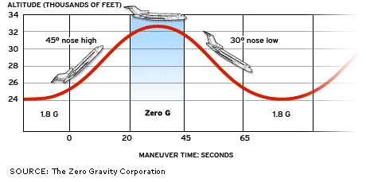
2. | 0:47 – 0:59 | 3 effects are described in the text, but only 1 (‘weightlessness’) is shown with gravity and no gravity. | Animate each of the ‘weightlessness’ (as shown gravity vs no gravity), ‘gravity changes’ (object with changing acceleration), and ‘vibrations’ (vibrating object). Either show these individually to match the audio or show them simultaneously on the screen.
3. | 2:05 | The photo is poorly cropped. The pressure system is visualized on the right-hand side of the actual photo (components on the yellow electronics board) but is cropped out partially in the video. | Re-crop the photo to focus on the pressure system, which is on the right (the yellow electronics board with components on it). Zooming closer might help. The stuff on the left in the current video (seated on the black surface) is not part of the pressure system. See suggestion below:

“Connect a… …miniaturized air pump to… …a differential pressure sensor”.
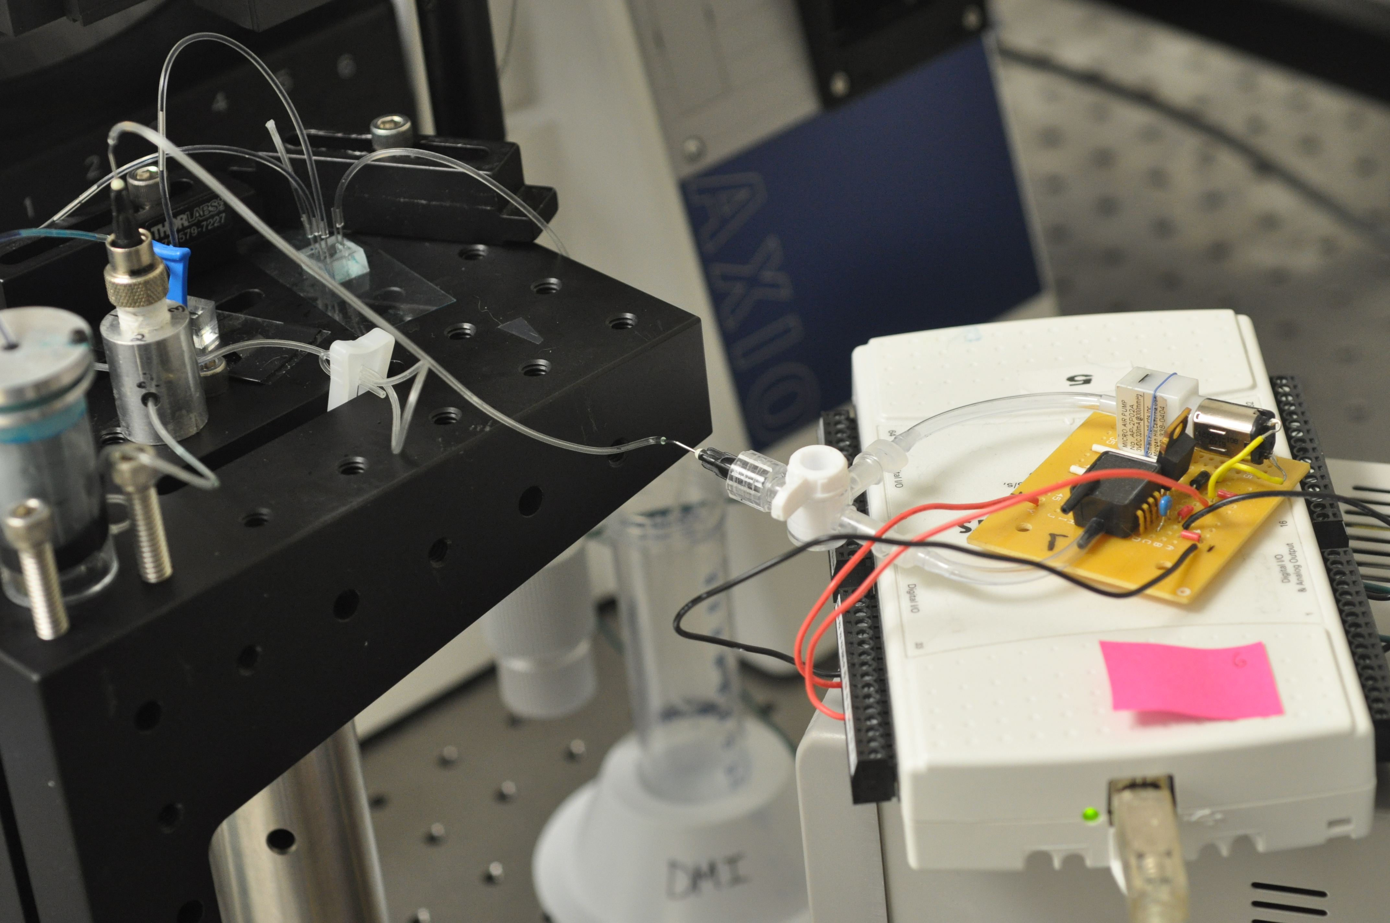
4. | 2:09 – 2:26  and  9:49 - 10:37 | Both time blocks describe the sample vials. Some information is redundant, and it would be clearer in the video if these sections are merged.  See Audio Comment 1 for a merged audio. | Merge and recut the video that currently appears 2:09 - 2:26 and 9:49 - 10:37 using the suggestion below the table, and put the new version at the current 2:09 location (eliminating the segment from 9:49 to 10:37). In the suggestion below this table, the revised audio (see Audio Comment 1), is matched to {time stamped} video segments currently in the video that can be moved to line up with the new version of the audio.

(From Audio Comment 1…)
“Next, assemble a fluid source container that can be loaded without trapping air. Fit a rigid plastic vial with an elastic rubber diaphragm folded over the upper rim, a firmly securable cap, and inlet air tubing at the vial base. Seal in the inlet air tubing connection with optical adhesive {2:09 to 2:24}. Place a temporary slide clamp over the cap exit tubing to prevent fluid expulsion during and after cap insertion. {10:09 to 10:15, then show still shot of completed vial currently at 2:25-2:26}. To load the vial, expand the diaphragm with a syringe connected to the air inlet {10:16 to 10:22 – I think KJ got other footage of the expansion that is better than what I see here}, pour in fluid to the top, and insert the cap at an angle such that no air is trapped underneath {10:23-10:30… I think KJ got other footage of the cap being inserted without much spilling that I’m not seeing in the current video and would be good to include somehow}. Briefly remove the slide clamp to prime the outlet tubing and release collapsing pressure exerted by the diaphragm {10:31 – 10:37}. Ensure the pump pressurizes the vial without air or fluid leaks, compressing the diaphragm to drive fluid flow out of the cap exit tubing {2:27-2:35}.”

5. | 2:39 | Some labels in the diagram are incorrect, and capitalization usage in the labels is inconsistent | -“foam inlet” should be “waste inlet”  -“foam” line should go to the grey foam  (See Figure 1B for correct labels)  -T in “Top” should be lowercased to “top”  -“Inlet” should be “inlet”
6. | 3:01 – 3:06 | The still shot of the sample loader doesn’t actually show the capillary within a ‘sheath’ as described in the audio. | Show the still shot currently @ 3:01 to 3:06 for a shorter length (maybe 1-2 seconds). When the audio says “such that it reliably clamps a sheath-fitted capillary…”, show Fig 1D.
7. | 3:07 – 3:15 | Wrong footage is shown – capillary is in place (with red ink), but the audio is describing flow through the loader when the capillary is not in place. | Instead show the footage where the capillary is removed, and then blue dye is pushed through the loader without any capillary in place (KJ filmed this after the footage that appears in the current video)
8. | 3:22/3:25 | Audio description of the micromixer mixing architecture should line up with the zoom in image of the mixer. | Flip the time order of the photos shown at 3:22 and 3:25. The chip photos currently at 3:25 should line up with “Using the rapid prototype…” The closeup shot of the chip channels (currently at 3:23) should line up with “A two-inlet spiral vortex micromixer…”
9. | 3:29 – 3:43 | The audio describing aligning the optical block should match the photo of the block being mounted. | At 3:35 switch from the photo of the palm-sized block to the photo of the alignment (currently @ 3:40). The dialogue about aligning single-photon counting modules should be dropped (see Audio Comment 2).
10. | 4:05 | Because of the video that precedes it, there is no reason to show Fig. 2E. | Instead, just use the video for the whole part of that audio (“Code and program a custom software to operate rig devices and synchronize all data.”)
11. | 4:13-4:29 | The still shots are too long here | Recut the scenes in this time block using the following 3 changes:  1 – Transition to the power strip video at what is currently 4:13 instead of 4:16 (i.e., match the transition between the battery scene and the power strip scene with the word “reasons” in the audio).  2 – After “…for quick and complete electronics shutdown” (currently ends @ 4:21) transition to the newly uploaded photo, ‘power strip 1.pdf’  3 –For the audio that follows… “In flight, a single power strip with a single on-off button is connected to the aircraft power distribution panel.” … split the time between the newly uploaded photos ‘power strip 1.pdf’ and ‘power strip 2.pdf’
12. | 7:07-7:17 | Video segment of the tubing leak goes on too long, and doesn’t quite show what is being said in the audio. | Split time (4-5 seconds each) between the current video showing leakage out the tubing and the segment 0:04 to 0:09 in the newly uploaded video ‘1 button int.mp4’, which shows Eugene trying to operate the rig in the chaotic environment. Audio for this segment changed (see Audio Comment 7)
13. | 7:18-7:45 | Video should include highlights/animation matching what is said in the audio with regard to the sample loader demo. | See below for example of how this could look.

“The sample loader demonstration includes loading a sample and driving the sample to the optical block for detection…
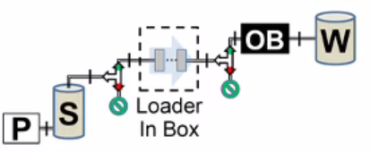
The setup utilizes two valves…

one before…

and one after…
the loader…
During loading, both valves are set to off, preventing fluid movement as the loader is utilized…
Turning the valves on opens the fluidics pathway extending from the saline vial…
…to the waste vial…, allowing the..
[Maybe animate the arrows moving forward…]
…pump to drive the sample for analysis”

14. | 7:46 – 8:03 | -Needs highlights/animation  -can leave out the diagram of the ‘manual’ intervention setup | (See below for example of how this could look.) Note – audio is revised

“The optical block demonstration includes sequential detection of three different sample types…
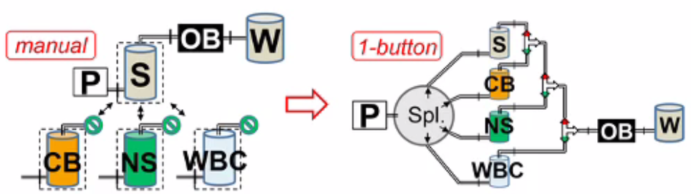
[Highlight the samples/pathways in sequence]

without needing to manually change tubing connections.
Saline is able to flush the system between samples…”
[Animate arrow movement]

15. | 8:04 – 8:25 | -Needs highlights/animation | (See below for example of how this could look.)
“The micromixer demonstration includes blood-saline mixing and blue yellow dye mixing segments...
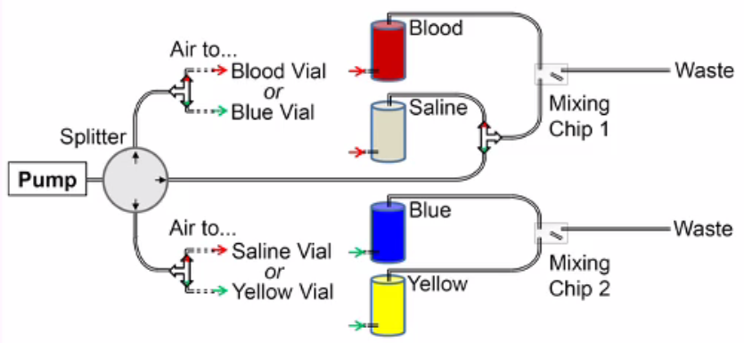
The setup uses two valves…

to guide pressure to either the blood and saline vials…
[Animate fluid movement into chip]

or the dye vials…
[Animate fluid movement into chip]

so that only 1 mixing demonstration is active at a time. An additional valve enables air bubble injection into the blood-saline mixing chip…”
[Animate air movement into chip]
The next set of the Video Comments (16– 23) apply to Section VII, which requires some restructuring. For clarity I have included a summary of Section VII here:
Section VII in Current Video:
Time block in Current Video Draft | Content
9:40 - 9:48 | Sample prep
9:49 – 10:37 | Vial Loading
10:38 – 10:43 | Rig preparation at flight location
10:43 – 10:47 | Rig loading to aircraft
10:48 – 11:00 | Operator Positioning
11:01 – 11:10 | Warning – Don’t apply body forces
11:11 – 11:50 | Mixer Demo
11:51- 12:21 | Sample Loader Demo

In the revised version (as per Video Comments 16-23), the order/ contents switch:
Order | Content
1 | Rig preparation at flight location
2 | Rig loading onto aircraft
3 | Sample prep
4 | Sickness Prep
5 | Operator Positioning
6 | Warning – Don’t apply body forces
7 | Sample Loader Demo
8 | Optical Block Demo
9 | Mixer Demo

16. | 9:39 (Beginning of Section VII) | A section should be inserted here to improve transition to the flight location setting, where the rig is checked/prepared prior to being loaded onto the plane. | Begin Section VII with a segment on rig preparation at the flight location and loading of the rig onto the aircraft.  Match revised audio (see Audio Comment 9) to the following video/photos:  -‘rack_closeup.3gpp’ (newly uploaded)  -‘hooking in vials 2.jpg’  -‘loading 1.jpg’  -‘loading 3.jpg’  -‘loading 4.jpg’  -‘loading 5.jpg’
17 | 9:40 – 9:49 | Move sample preparation away from the beginning of Section VII to after the segment described in Video Comment 16. | After discussing rig prep / loading onto aircraft, then mention sample prep.  Match revised audio (see Audio Comment 10) to the following video/photos:  -Video currently at 09:40 to 9:49  -‘onboard_vials.jpg’  This section belongs after the section described in Video Comment 16.
18. | 9:49 - 10:37 | See Video Comment 4 and Audio Comment 1. This section can left out if merged in with the earlier vial section. | Cut out what is currently in 9:49 - 10:37, and make the changes described in Video Comment 4.
19. | (New -- put new segment after the segment described in Video Comment 17) | It would be good to talk about how not to get sick on the airplane:  -Take provided medications, such as scopolamine and dextroamphetamine.  -Use several parabolas to acclimate to the gravity transitions. | Insert new segment.  Match new audio (see Audio Comment 12) to the ‘avoid sickness’ series of photos and videos newly uploaded.  This segment belongs after the segment described in Video Comment 17.
20. | 10:48 - 11:10 | This segment is unchanged and should now follow the segment described in comment 19. | Should follow the segment described in comment 19. No other changes.
21. | 11:11 – 12:22 | The demonstration order here - micromixer then sample loader doesn’t match the order the demos were presented in Section V. | Reorder demos to match the previous order: Loader then micromixer.
22. | 11:10 – 11:50 | Micromixer demo footage could be improved.  See Audio Comment 13 | 2 suggestions:  1. Halfway through current footage shown 11:10 – 11:28 switch to newly uploaded photo: ‘micromixing_microscope.pdf’  2. Show longer footage of the actual blood-saline mixing at different pressures. The more the better.

Section VIII:
23. | 12:24 | Capitalize “c” in “Cytometry” 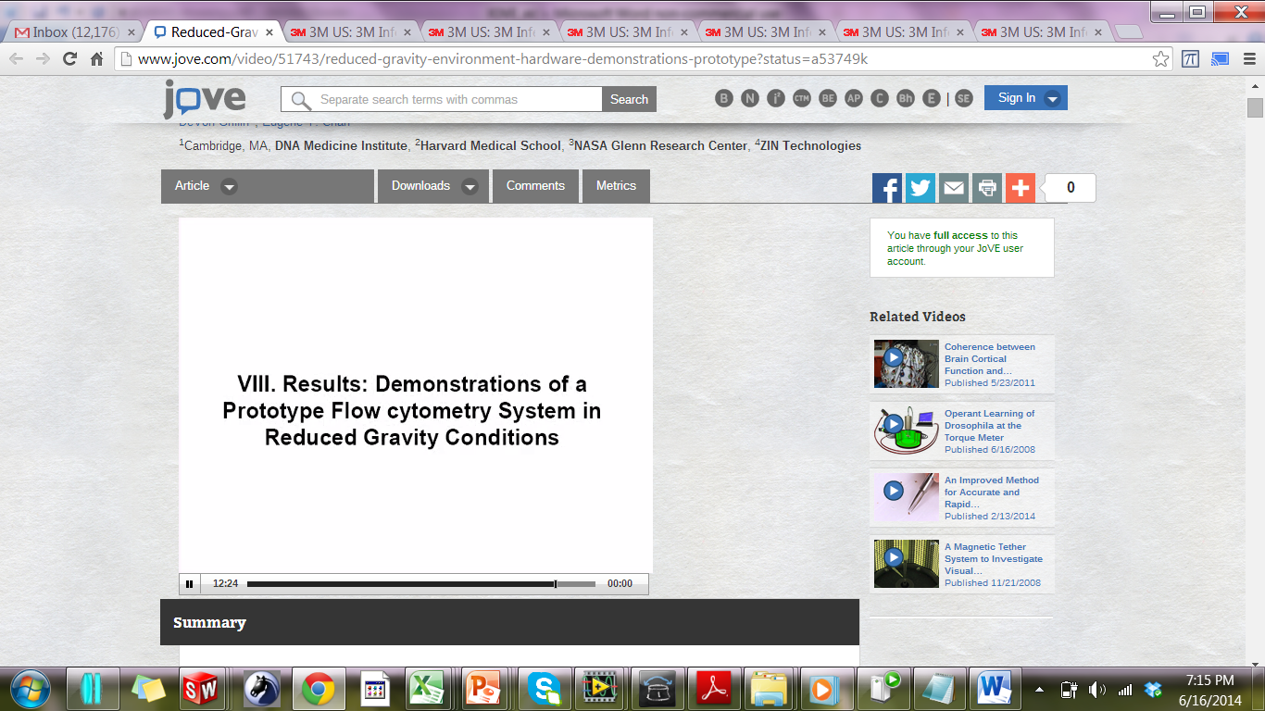 | Fix c to C

Audio Comments:
This section is used to specify the changes that need to be made to the voiceover. Please specify time code where each mistake in the voiceover occurs, your comment, the step in the script that needs to be changed, and the corrected text. Please include the entire step from the script in last column with the corrected text in bold. If there is a pronunciation change, please provide a phonetic pronunciation key.
EX:
Restinosis – (Reese-tin-oh-sis)
Time code |  | Comment | Step in Script (ex 4.2) | Rewritten Text or Corrected Pronunciation
1. | 2:09 to 2:24  and  09:50 to 10:37 | Revised audio to replace the audio @ 2:09 – 2:24 and 9:49 - 10:37  In other words, revised audio from 7.1 to 7.4 should be moved to follow the audio corresponding to 2.3.  2.4 would then come next. | 2.3, 7.1 – 7.4 | Next, assemble a fluid source container that can be loaded without trapping air: fit a rigid plastic vial with an elastic rubber diaphragm, firmly securable cap, and inlet air tubing at the vial base. Seal the inlet air tubing connection using optical adhesive.  [Merged from 7.1 to 7.4] Place a temporary slide clamp over the cap exit tubing to prevent fluid expulsion during and after cap insertion. To load the vial, expand the diaphragm with a syringe connected to the air inlet, pour in fluid to the top, and insert the cap at an angle such that no air is trapped underneath. Briefly remove the slide clamp to prime the outlet tubing and release collapsing pressure exerted by the diaphragm.
2. | 3:49 – 3:43 | Eliminate this sentence from the spoken audio:  "Align fiber coupled single photon counting modules" | 2.10 | To detect individual flowing particles, mount a custom fabricated, palm-sized miniature optical block to a microscope breadboard plate using commercially available optomechanical components. Align fiber-coupled single photon counting modules.
3. | 3:44 – 3:59 | -Add: “to commercially available”  -Eliminate: “or DAQ” | 2.11 | The final step in prototype assembly is to design electronics and software for device control and data acquisition. For convenience in early prototyping, utilize hand-soldered pieces connected to commercially available data acquisition or DAQ, cards
4. | 5:41 – 5:56 | -First sentence is too wordy  -Should be “a loader demonstration,” since there has been no mention thus far of which demos are going to be performed. | 4.2 | These include a custom acrylic box to contain the electronics, and a custom acrylic ‘glove’ box with arm access holes to provide a cubic space in which to perform a loader demonstration without risking contamination of the flight cabin.
5. | 5:57-6:04 | -The microscope hasn’t been mentioned yet, so it’s not otherwise clear why one would need to be bolted to the breadboard plate | 4.3 | To record a micromixer demonstration, bolt a stereomicroscope to the breadboard plate, fitted with a custom acrylic chip holder, and CCD camera.
6. | 06:04-6:12 |  | 4.4 | To allow safe demonstration of the optical block, use a custom opaque acrylic box to block ambient light and control laser hazards.
7. | 07:07- 07:17 | Audio needs to better match what is shown | 5.4 | Program the software to proceed through the demonstrations using single-button interventions, such as a single click on the laptop to switch valve states or change pump driving pressure. This avoids the need for manual tubing adjustments that may incur leakages into the environment and the loss of experiment time in a chaotic environment.
8. | 7:45 – 8:04 | -Could be shorter.  -Transition from manual to 1-button can be condensed for the video | 5.6 | The optical block demonstration includes sequential detection of three different sample types, without needing to manually change tubing connections. Saline is able to flush the system between samples.
9 | 9:39 (Whatever is the beginning of Section VII) | See Video Comment 16 | 7.5 | Check the rig after transport to the flight location, making any necessary fixes and setting tubing connections before loading onto the aircraft.
10 | N/A  This should come after the audio in 9 | See Video Comment 17 | 7.1 | On each flight day, prepare and hook in sample vials corresponding to the day’s demonstrations. Prepare for possibly long intervals between setup and experimentation as well as high ambient temperatures depending on flight location. On flight day, source vials containing samples and solutions for the demonstrations must be prepared and hooked into the system prior to takeoff as part of the setup process. To prepare a vial for loading, apply a fresh, powder-free latex or nitrile diaphragm to the vial. Make sure the diaphragm is long enough to extend from the vial floor and fold over the top outer rim. Slide the vial ring over the folded portion.
11 | 9:49 - 10:37 | See Video Comments 4 and 18  This Audio should be eliminated because it is merged with previous audio – see Audio Comment 1 and Video Comment 4 | 7.1 to 7.4 | [Audio merged with earlier section – See Audio Comment 1]
12 | New – this should come after the audio in 10 | See Video Comment 19 | New | Avoid sickness in flight by taking provided medications such as scopolamine with dextroamphetamine, and use several early parabolas to adjust to the gravity transitions by rising slowly, parallel with the floor, and lying flat during high gravity.
13. |  | Video of the micromixer demo could be refined and would be better if it included more of the actual inflight mixing video. | 7.8 | Perform the microfluidic mixer demonstrations setup beneath the microscope: mix blood and saline in a 1:1 ratio at 1.5, 2, 3, 4, 5, and 6 psi, for at least 2 parabolas each, recording video data synchronized to other readings. Actual in-flight footage of a mixer demonstration is shown here.
14. | 12:03 | “Use an unrealistically large drop…” We can delete the word “unrealistically” since that drop looks like it is realistic. | 7.11 | To perform the sample loader demonstration, when the plane enters reduced gravity, use a sample syringe to place a drop of the counting bead dye mixture on a fingertip to simulate a finger prick sample. Use an unrealistically large drop to test the limits of keeping a finger prick sample on a finger during reduced gravity.

Text Protocol:
Please use this table to address changes that need to be made to the text. List the step in the text protocol where there is an issue, your comments pertaining to that issue, and how we should resolve it. For drastic changes to the protocol (major structural changes or more than 10 spelling or grammatical mistakes), we will require re-upload of the entire document.

1. | Step in Protocol | Comment | Suggestion
2. | Author section | Current Affiliations are not listed in the online versions. | Consistency in putting affiliations. Either put affiliations at time of this work or current affiliations
3. | 1.1 |  | “Assemble prototype components (fluidics, optical, control/ data acquisition electronics”
4. | 1.1) -2 - 1 |  | Change text to “firmly securable cap”
5. | 1.4) -1 -2 | Extra word (‘structure support structure’) | “Determine which components are more appropriately accessed at a standing, kneeling, or floor height, as well as considering which components will benefit most from the protection attained within a support structure.”
6. | 1.4) -2 -4 | Leg straps are not necessarily unavailable on all sides. | “NOTE: The leg straps to secure test operators are at a fixed distance from the rig and may not be available on all sides.”
7. | 2.3) -6 | Extra period (‘.’) | “Test stabilities of samples and reagents when subjected to an extended break (hours or more) between pre-flight procedures and in-flight activity. Note also that temperatures may be significantly higher at flight location”
8. | 3.9) -2 |  | “Drive fluorescent counting beads through the optical block for 3 parabolas. Flush system with saline for at least 1 parabola between sample types.”
9. | 3.9) -3 | “3.8.1” is no longer correct | Should be “Repeat 3.9.2 for the fluorescent hydrogel particles and WBCs”
10. | 3.9) -6 | Wrong Figure Panel indicated – should be 1D not 1B | “When the plane enters reduced gravity, use a sample syringe to place a drop of the counting bead dye mixture on a fingertip to simulate a finger prick sample. Use an unrealistically large drop (Fig. 1D) to test the limits of keeping a finger prick sample on a finger during reduced gravity.”

.PDF
Please use this table to address changes that need to be made to the pdf. List the step in the text protocol where there is an issue, your comments pertaining to that issue, and how we should resolve it. For drastic changes to the protocol, we will require re-upload of the entire document.
See Text Protocol changes for changes to the PDF
**All changes described for the Text Protocol also apply to the PDF**
Additionally: On page 10 in the PDF, text in for Suppl. Fig 1 caption is not displaying properly. ‘#’ symbols appear where other symbols should be appearing (see Supp. Fig 1 or the online text version for how it should look)

***ONE LAST THING: There was an error in Supp. Fig 1. I have uploaded a new version. See – ‘NEW Supp Fig 1.pdf’

