Submission ID #: 51712

Editor Name: Renee Choi

Videographer Name: Vito DeFilipo

Film Date: 3/18/14

Authors and Affiliations: Moshiri, Houtan *^{1,2}; Mehta, Vaibhav ^{1,2}; Salavati, Reza ^{1,2.3}
¹Department of Biochemistry, McGill University, McIntyre Medical Building, 3655 Promenade Sir William Osler, Montreal, H3G1Y6 Quebec, Canada; ²Institute of Parasitology, McGill University, 21111 Lakeshore Road, Ste. Anne de Bellevue, H9X 3V9 Quebec, Canada; ³McGill Centre for Bioinformatics, McGill University, Bellini Building, 3649 Promenade Sir William Osler, Montreal, H3G0B1 Quebec , Canada

Title: RNA Catalyst as a Reporter for Screening Drugs Against RNA Editing in Trypanosomes

Corresponding Author:

Reza Salavati

reza.salavati@mcgill.ca

514-398-7721
Additional Contacts: Houtan Moshiri: houtan.moshiri@mail.mcgill.ca; Vaibhav Mehta vaibhav.mehta@mail.mcgill.ca

A. Will you require JoVE to record video microscopy, such as filming a complex dissection or microinjection technique? (Y/N) ___N______ If yes, please list make and model of your microscope:
B. Does your protocol include detailed, step-by-step, descriptions of software usage? (Y/N)__N______
C. Which steps of your protocol will viewers benefit most from having filmed? Please list 4-6 steps.
2.1, 4.2, 5.1, 6.1, 7.3.
D. What is the single most difficult aspect of this procedure and what do you do to ensure success? The single most difficult aspect of this procedure is maintaining an RNase-free (sterile) environment. Routine bench and equipment clean-up with careful reagent handling is recommended.

1. Introduction (Schematic Overview and Interview)

A. Schematic Overview (read by voice talent at JoVE):

Procedural Narrative:
The overall goal of this procedure is to assay RNA editing using functional editosomes extracted from Trypanosoma brucei (http://novellaqalive2.mhhe.com/sites/dl/free/007283031x/64773/audio_pronunciation_guide_updated.html. Just ‘Ctrl + F’ for Trypanosoma brucei.) for rapid identification of the editosomes’ inhibitors. (Intro)

This is accomplished by first isolating mitochondria and the target editosomes from T. brucei. (P1: Display the image of the T. brucei cells with text, then show the arrow and display the figure of the tube to the right, then add the arrow and the text, then show the editosome image with text. Shots 3.6.2 & 4.3.1)

The second step is to prepare the synthetic RNA editing reporter substrate. (P2: Show the images provided one by one with all text, and adding the arrow each time (as divided by the arrows) in quick succession to keep up with the pace of the voice over. Shot 5.1.1)

Next, compounds are subjected to incubation and binding to purified editosomes. (P3: Show the images provided one by one with all text, and adding the arrow each time (as divided by the arrows) in quick succession to keep up with the pace of the voice over. Shot 6.1.2)

The final step is to add the FRET substrate and monitor for compounds’ ability to selectively and specifically inhibit the editosomes’ function. When an inhibitory compound is bound to the editosome, RNA editing is blocked and a reduced or no fluorescent signal will be detected. (P4: Show the images provided for P4 and P5 one by one with all text, and adding the arrow each time (as divided by the arrows) in quick succession to keep up with the pace of the voice over. Shot 6.6.2)

Ultimately, a real-time PCR machine is used to monitor the fluorescence emitted from the FRET substrate as a function of time. (P5: Figure 2)

Paste a copy of your graphic overview here. The original file should be Adobe Illustrator (preferred) or Powerpoint (see instructions) and should be uploaded through your online submission on the JoVE website. Please keep all layers in the file (i.e., do not flatten the file).

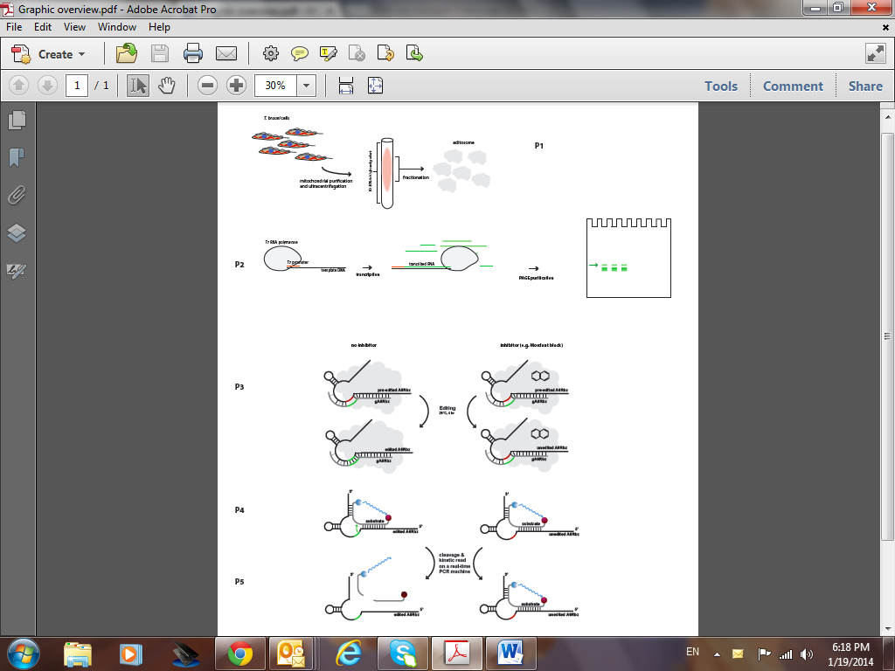

B. Interview: (Said by you on camera. Don’t forget to smile!)
  - Vaibhav Mehta: The main advantage of this technique over _conventional in vitro editing assays is that it is a simple and rapid mix and measure fluorescent–based reporter assay that can be used for high throughput screening of chemical compounds against RNA editing.

Protocol (read by voice talent at JoVE):
- T. brucei Cell Culture
  - To begin, prepare growth medium for T. brucei procyclic form cells as described in the accompanying text protocol.
    - MED/WIDE: Talent gathers materials to prepare growth medium.
    - MED: Talent prepares growth medium. (TEXT: See accompanying text protocol for formulas and abbreviations)
  - Next, grow 300 mL of T. brucei 1.7A wild type procyclic form cells at 28 ºC while shaking them at 70 rpm for 48 hours.
    - MED: Talent adds cell solution to medium.
    - MED: Talent places flask on shaker.
  - Once the cells have reached a density of 1.5 x 10⁷ cells/mL, centrifuge the cells at 6,000 x g for 10 minutes at 4 ºC.
    - MED: Talent checks cell density.
    - MED: Talent places cells in centrifuge, capture the settings entered if possible.
  - Then, wash the pellet with 50 mL of chilled phosphate buffer saline glucose, or PBSG, buffer and spin down the cells at 10,000 x g for 10 min at 4 ºC.
    - MED – Over the Shoulder: Talent washes pellet with buffer.
    - MED – Over the Shoulder: Talent places cells in centrifuge to spin them down.
- Crude Mitochondria Isolation
  - First, resuspend the harvested cells in 30 mL of DTE buffer. Disrupt the cell membrane using a 40 mL pre-chilled, sterile dounce homogenizer 10 times on ice.
    - MED: Talent adds DTE buffer to cells. (TEXT: See accompanying text protocol for formulas and abbreviations)
    - MED: Talent disrupts membrane with a homogenizer on ice.
  - Next immediately add 4.3 mL of 60% sucrose to the homogenate and centrifuge the solution at 15,800 x g for 10 min at 4 ºC to bring down the mitochondria.
    - MED: Talent performs last disruption of membrane then immediately adds sucrose solution to the homogenate.
    - MED: Talent places mixture in centrifuge, capture the settings if possible.
  - Resuspend the mitochondrial pellet in 4.6 mL of STM buffer. Then add 13.8 μl of 0.1 M CaCl₂ and 4 μl of RNase-free DNase I and incubate the mixture for 1 h on ice.
    - MED – Over the Shoulder: Talent resuspends pellet in STM buffer.
    - MED: Talent adds CaCl₂ and RNase-free DNase I, then places the mixture on ice.
  - Next, inactivate the DNase by adding 4.6 mL of STE buffer and centrifuge the mixture at 15,800 x g for 10 min at 4 ºC. Then, resuspend the pellet in 400 μl of lysis buffer and transfer the mixture to a microfuge tube.
    - MED: Talent adds STE buffer then centrifuges the mixture.
    - MED: Talent resuspends the pellet in lysis buffer, then transfers the mixture to a microfuge tube.
  - Add 10% Triton X-100 to the tube at a final concentration of 1% and incubate the lysate at 4ºC on a tube rotator for 15 min.
    - MED: Talent adds triton X-100 to the tube.
    - MED: Talent places lysate on refrigerated tube rotator.
  - Then, clear the mitochondrial lysate by centrifuging the solution two times at 17,000 x g for 15 min at 4 ºC and retain the cleared supernatant each time.
    - MED – Over the Shoulder: Talent places tube in centrifuge.
    - MED – Over the Shoulder: Talent removes supernatant and stores it in a separate tube.
- Editosome Purification
  - Pour a 10 mL 10%-30% linear glycerol gradient in an ultracentrifuge tube using 2X HHE gradient buffer and a gradient marker following the instructions in the manual.
    - MED: Talent pours linear glycerol gradient layers the 10 and 30% glycerol stock solutions into the ultracentrifuge tube carefully. (LAB MEDIA: Table 1. Video Editor: Show this table in a split screen with the footage)
    - MED: Talent consults instruction manual starts running the protocol.
  - Next carefully remove 500 μl of solution from the top of the glycerol gradient and gently load 500 μl of the cleared mitochondrial lysate into the ultracentrifuge tube. Spin the tube at 178,000 x g for 6 h at 4 °C.
    - CU/ECU: Talent removes solution from top of glycerol gradient.
    - CU/ECU: Talent gently loads lysate into ultracentrifuge tube.
    - MED: Talent places tube in ultracentrifuge and enters settings.
  - Collect 500 µl fractions sequentially from the top to the bottom of the gradient at 4 ºC. Then snap-freeze the fractions using liquid nitrogen and store them at -80 ºC.
    - MED: Talent collects fraction from the top of the gradient.
    - MED: Talent collects fraction from the bottom of the gradient.
    - MED: Talent snap-freezes the fractions in liquid nitrogen.
    - MED/WIDE: Talent places fractions in the freezer.
- RNA Preparation
  - Anneal the respective DNA template containing the T7 complementary sequence in a 1:1 molar ratio.
    - MED: Talent combines solutions. (LAB MEDIA: Table 2. Video Editor: Show this video in a split screen with the footage)
    - MED: Talent places sample in PCR machine and enters program. (TEXT: 90 ºC for 3 min cooling at RT for 10 min)
  - Next, transcribe the RNA using an in vitro transcription kit and follow the instruction manual.
    - MED: Talent processes RNA using transcription kit.
  - Stop the transcription reaction by adding an equal volume of 7 M urea dye run on a filter-sterilized 9% denaturing polyacrylamide gel.
    - MED – Over the Shoulder: Talent adds urea dye run on gel.
  - Then, use a shortwave UV lamp to locate and excise respective RNA. Place the excised gel piece in a microfuge tube and add 400 µl of gel elution buffer. Elute the RNA overnight at room temperature on a tube rotator.
    - MED – Over the Shoulder: Talent uses UV lamp to locate RNA.
    - CU: Talent excises RNA and places it into the tube.
    - MED: Talent adds gel elution buffer.
    - MED: Talent places tube on tube rotator.
  - Next, precipitate the eluted RNA by adding 1 mL of cold 100% ethanol and incubating at -80 °C for 30 minutes.
    - MED: Talent adds cold ethanol to the tube.
    - MED: Talent places the tube into the freezer.
  - Centrifuge the mixture at 16,000 x g for 30 minutes at 4 °C to pellet down the RNA. Then wash the pellet with 1 mL of 75% ethanol and centrifuge the tube at 16,000 x g for 20 minutes at 4 °C.
    - MED: Talent places the tube in the centrifuge, capture the settings if possible.
    - MED: Talent washes pellet with ethanol, then approaches the centrifuge with the tube.
  - Next, resuspend the RNA pellet in RNase free water to achieve the desired concentrations using the proportions listed.
    - MED: Talent resuspends RNA pellet in water. (LAB MEDIA: Table 2. Video Editor: Show this in a split screen with the footage)
- Fluorescence-based RNA Editing Assay
  - Start the assay by combining 1 µl of preA6Rbz and 1 µl of gA6Rbz in a microfuge tube. Incubate the solution at 70 ºC for 3 min and let it sit at room temperature for 10 min.
    - CU: Talent combines preA6Rbz and gA6Rbz in microfuge tube.
    - MED – Over the Shoulder: Talent places solution in incubator for 3 minutes.
    - MED: Talent removes solution from incubator and lets sit at room temperature.
  - Next prepare a master mix, and add the annealed preA6Rbz and gA6Rbz to the mix last.
    - MED: Talent prepares master mix. (LAB MEDIA: Table 3)
    - MED: Talent adds annealed preA6Rbz and gA6Rbz to the mix last.
  - Then, dispense 18 µl of the master mix into the wells.
    - MED – Over the Shoulder: Talent dispenses master mix into wells.
  - Next, seal the plate with a plate sealer and spin it down to remove any air bubbles. Then incubate the plate at 28 ºC for 4 h.
    - MED: Talent seals the plate, then briefly spins the plate.
    - MED: Talent places the plate in the incubator.
  - After incubation, add 2 µl of gA6Rbz competitor to each well. Place a fresh seal onto the plate, then spin it down and perform real-time PCR with the following program.
    - MED: Talent removes plate from incubator then adds gA6Rbz competitor to each well.
    - MED: Side view talent reseals plate then spins it down briefly.
    - MED – Over the Shoulder: Talent places plate in RT-PCR machine. (TEXT: Step 1. 85°C for 5 min., Step 2. 24°C for 10 min, Step 3. Stop.)
  - Once the program is completed, add 1 µl of FRET substrate to each well to a final volume of 23 µl and seal the plate with a fresh seal. Quickly spin the plate and place it back into the real-time PCR machine.
    - MED – Over the Shoulder: Talent removes plate from RT-PCR machine.
    - MED: Talent adds FRET substrate to each well, then seals the plate.
    - MED: Talent quickly spins the plate down, then places it back in the RT-PCR machine.
  - Next, program a new experiment with the following steps.
    - MED – Over the Shoulder: Talent enters the program. (TEXT: Step 1. 37°C for 1 min, Step 2. Read, Step 3, Go to Step 1, 40 times, Step 4. Stop)
  - Then, setup the plate by selecting all the wells that require reading and choose the FAM filter. Set the input volume as 23 μl and start the run.
    - MED – Over the Shoulder: Talent selects wells that require reading and chooses the FAM filter. Talent then sets input volume as 23 ul.
  - Finally, calculate the slope of the values obtained from each sample to obtain a kinetic measurement by plotting the slopes on a bar graph for analysis.
    - MED – Over the Shoulder: Talent calculates slope of values from each sample and plots them on a bar graph.
- Results: Determining the Assay Quality
  - In order to determine the quality of this assay, the signal-to-noise ratio of different substrates was calculated. FRET substrates with the TAMRA quencher, and the Iowa Black dark quencher are both viable options for use in a high throughput screen.
    - LAB MEDIA: Figure 2 (Video Editor: Box the column containing the gray bar with text A6Rbz_F/T when “TAMRA” is said. Then remove the box and box the column with the black bar with the text A6Rbz_F/Ib when “Iowa Black FQ” is said.)
  - The glycerol gradient fractions were tested for in vitro editing activity using the fluorescence-based assay. The most active fractions can be combined when more editosome is required.
    - LAB MEDIA: Figure 3 (Video Editor: Display figure 3 with all text. Box or highlight with light shading columns F7-F12 when “most active” is said, if possible highlight the columns one by one from left to right to give a more animated effect. )
  - Different control samples were used to analyze the variables in the assay. Reactions missing any RNA editing components do not cleave the substrate. Cleavage is observed in the presence of all components of the editing reactions, in the absence of an inhibitor, or in the presence of all editing components and an inactive compound. In contrast, an inhibitory compound can block RNA editing and is used as a positive control.
    - LAB MEDIA: Figure 5 (Video Editor: Show the entire figure with all text. Box or zoom in on the text to the left of the chart with the plus and minus symbols (FRET substrate to Drug) when “variables” is said. Highlight the columns 1-4 including the chart below when “missing” is said. Highlight column 5 including the chart below when “absence of an inhibitor” is said. Highlight column 6 including the chart below when “inactive” is said. Highlight column 7 including the chart below when “positive” is said.)

- Conclusion (said by authors on camera)
  - Vaibhav Mehta: While attempting this procedure, it’s important to remember to maintain an RNase free environment and protect the FRET substrate and light sensitive compounds from light as much as possible.

Provided Media

Insert your media filenames here.

General Preparation

It’s critical for a smooth and organized shoot that all reagents are accounted for, in advance.

Any overnight or long incubation steps should be recognized and specimens/samples be prepared in advance so that prior steps can be recorded and shooting can continue with pre-prepared specimens/samples.

All tubes/flasks should be pre-labeled neatly before we arrive.

Ex. Luciferase assay done in 96 well plates should be labeled with negative/positive control wells and experimental samples are labeled accordingly.

You will receive more detailed preparation instructions, as well as an introduction to your videographer, closer to your filming date.

