Submission ID #: 51693

Editor Name: Laifong Lee

Videographer name: Ben Long

Film Date: Feb 18th, 2014

Authors and Affiliations:

Teresa A. Hudock
Bacteriology and Parasitology
Tulane National Primate Research Center
Covington, LA, USA
thudock@tulane.edu

Deepak Kaushal
Microbiology and Immunology
Tulane National Primate Research Center
New Orleans, LA, USA
dkaushal@tulane.edu

Title: A novel microdissection approach to recovering Mycobacterium tuberculosis specific transcripts from formalin fixed paraffin embedded lung granulomas

Corresponding Author: Deepak Kaushal

Authors, please fill out the brief questionnaire below.

A. Will you require JoVE to record video microscopy, such as filming a complex dissection or microinjection technique? (Y/N) _____Yes_(but no need to film through microscope)___ If yes, please list make and model of your microscope: _MeSectr Dissection System. Microscope is part of this system. I have included images of the system.
B. Does your protocol include detailed, step-by-step, descriptions of software usage? (Y/N)____YES____
C. Which steps of your protocol will viewers benefit most from having filmed? Please list 4-6 steps_
Sections 2 and 4
D. What is the single most difficult aspect of this procedure and what do you do to ensure success? _The most difficult aspect is aligning the tissue for dissection with the reference slide.

1. Introduction (Schematic Overview and Interview)

A. Schematic Overview (read by voice talent at JoVE):

Procedural Narrative:

Video editor: Graphics are in ‘Dissection Schematic.ai’

The overall goal of this procedure is to microdissect tissue from formalin-fixed, paraffin-embedded slides. (Intro)

This is accomplished by first creating a reference image from a representative hematoxylin and eosin stained slide. (Video editor: show P1 cartoon) (P1)

The second step is to place a corresponding unstained formalin-fixed paraffin-embedded slide onto the instrument stage (Video editor: show the topmost image from P2) and align the desired dissection area with the reference image. (Video editor: show the left screen shot followed by the right screen shot) (P2)

Next, the dissection area is annotated (Video editor: show the screen shots with the areas delineated by the green border) and a consumable mill bit is loaded with buffer and loaded into the instrument. (Video editor: show the picture of the mill bit) (P3)

The final step is to dissect the annotated tissue. (Video editor: show the P4 images) (P4)

Ultimately, a combination of RNA extraction, amplification, and RT-PCR is used to show how the dissected tissue can be used for global gene expression analysis of Mycobacterium tuberculosis within lung granulomas from infected rhesus macaques. (Video editor: show the P5 images) (P5)

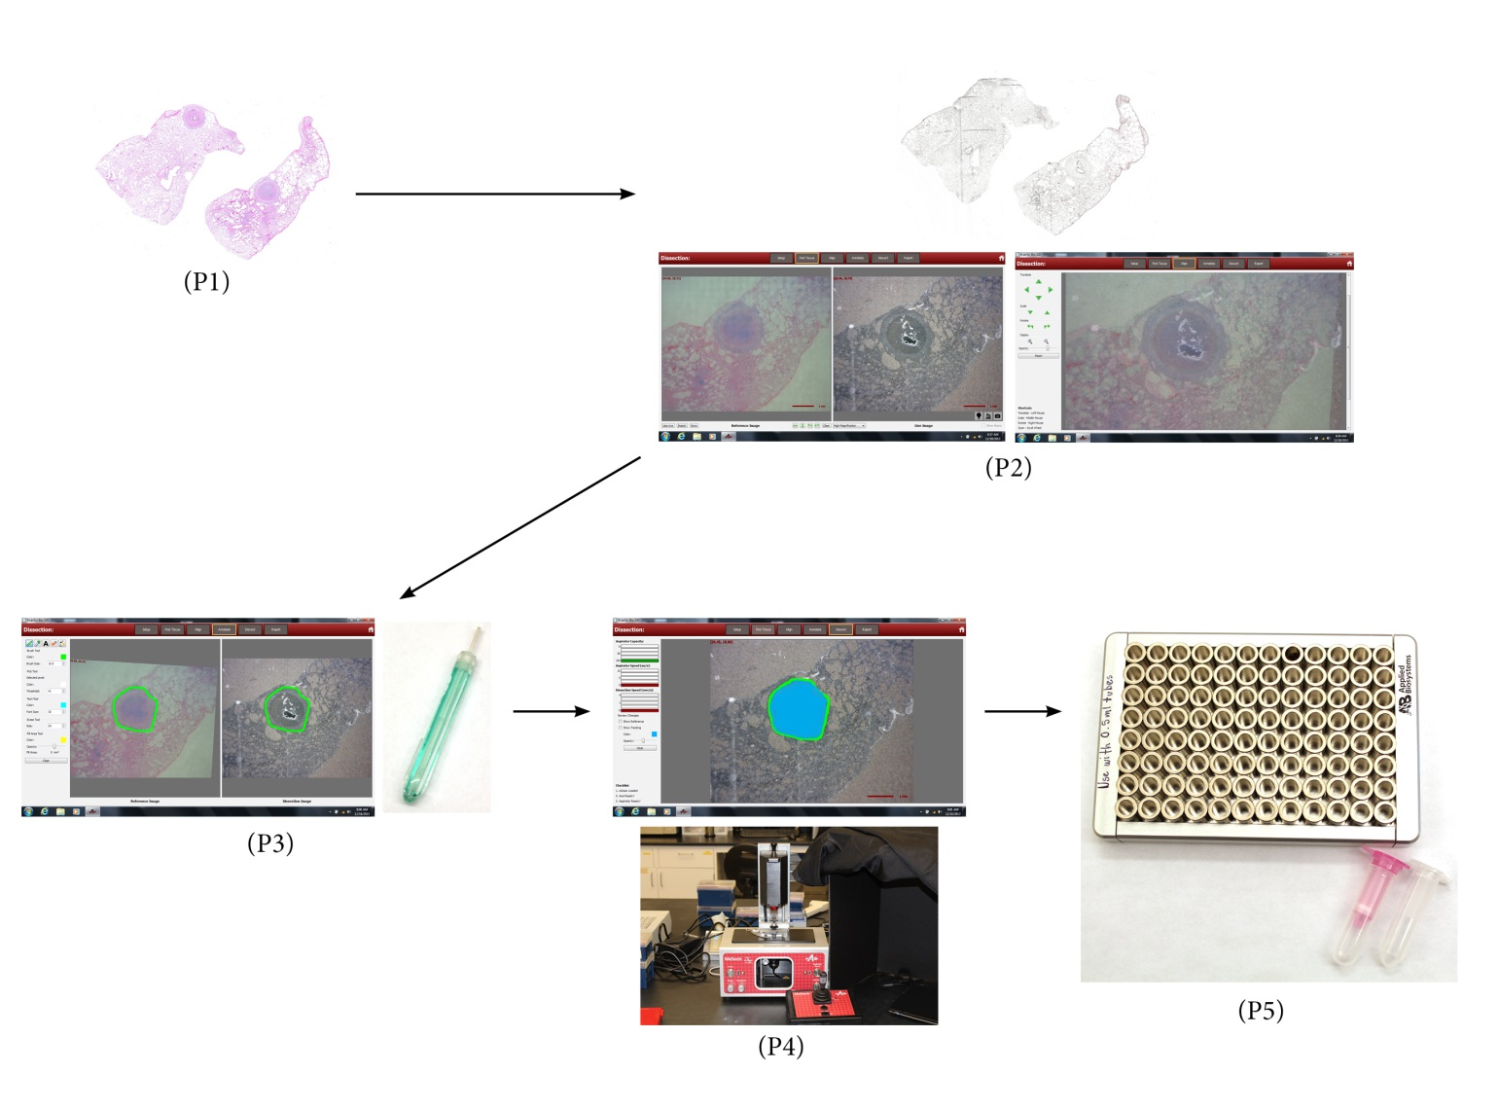

B. Interview: (Said by you on camera. Don’t forget to smile!)

  - Teresa Hudock (If you need to say my name at some point it is pronounced: ter-eSS-a who-doc): This method can help answer key questions in the Tuberculosis research field, such as the identity of genes Mycobacterium tuberculosis expresses within human-like in-vivo niches during different infective states of tuberculosis. Furthermore, this data will help to explain the regulation of the pathogen’s metabolism and physiologic differences within these distinct disease states, thus generating specific drug targets.
  - **Author name _____Deepak Kaushal___: Demonstrating the procedure will be Teresa Hudock a Ruth L. Kirchstein National Research Service Award recipient post-doctoral fellow (technician, post doc, grad student) from my laboratory. (Add additional mention of demonstrators as necessary). Author: Dr. Kaushal does not have to introduce Teresa because she will already be speaking to the camera in 1.1.

Protocol (read by voice talent at JoVE):

- Creating a reference image, aligning tissue for dissection, and annotating slide

  - The mesodissection instrument is equipped with a digital microscope integrated with the 2iD imaging software, and a joystick for controlling X-Y stage positions.

Shots:
    - MED: talent sitting down by the instrument and getting ready to calibrate it with the imaging software. Videographer: please include footage of the instrument and joystick.

  - Prior to starting this procedure, calibrate the instrument with the imaging software, as described in the accompanying manuscript.

Shots:
    - MED: general footage of talent at the computer performing the calibration.

  - To create a reference image, first place a hematoxylin and eosin stained, or H&E, slide on the stage, and place an opaque cover on top of the slide.

Shots:
    - MED/CU: A H&E slide being placed on the stage.
    - CU: An opaque cover being placed on top of the slide.

  - Then drive the instrument by moving the joystick to the desired area of the H&E slide. Save the image generated by using the “capture reference” tab. (Figure 8.docx)

Shots:
    - MED: Talent using joystick to drive the instrument.
    - SCREEN: Image being generated and then saved using “capture reference” tab.

  - To align the tissue to be dissected, click the “dissect tissue” option on the home screen.

Shots:
    - SCREEN: “dissect tissue” option being selected on the home screen to align tissue.

  - In the “setup” tab, fill out the “operator,” “dissection accession number,” “reference accession number,” “xScisor barcode number,” “dissection fluid lot number,” “xScisor size” and “description.” (Figure 9.docx)

Shots:
    - SCREEN: “operator,” “dissection accession number,” “reference accession number,” “xScisor barcode number,” “dissection fluid lot number,” “xScisor size” and “description” being filled out.

  - Click on the “find tissue” tab. (Figure 10.docx)

Shots:
    - SCREEN: “find tissue” tab being selected.

  - Import the previously saved reference image. (from 2.4)

Shots:
    - SCREEN: previously saved reference image being imported.

  - Place an unstained formalin-fixed paraffin-embedded, or FFPE, slide of 5 micron thickness on the stage. Move the stage to the same area as the one depicted in the reference image.

Shots:
    - MED: Talent placing an unstained FFPE slide on the stage.
    - CU: Stage being moved to same area as the one depicted in the reference image.

  - Click on the “align” tab. (Figure 11.docx) Use the mouse and associated arrows to align the reference image to the unstained image.

Shots:
    - SCREEN: “align” tab being clicked and reference image is aligned to the unstained image.

  - Lastly, annotate the slide by clicking on the “annotate” tab. Use the mouse to draw a circle around the desired area of the slide that will be microdissected.

Shots:
    - SCREEN: “annotate” tab being clicked and then a circle is drawn around the desired area of the slide that will be microdissected.

- Loading consumable mill bit

  - Begin this procedure by filling the consumable mill bit with the desired buffer, in this example, PKD buffer, by pulling the plunger up and down in a fluid motion several times. Make sure to exclude air bubbles.

Shots:
    - MED: Talent setting out the consumable mill bit and the PKD buffer.
    - CU: consumable mill bit being filled wth PKD buffer: plunger being pulled up and down several times.

  - Raise the Z-axis by pressing the “Z-axis button”.

Shots:
    - MED: Talent at the instrument pressing the “Z-axis button”.
    - CU: match action above: Z-axis being raised as button is pressed.

  - Load the consumable mill bit into the instrument: slide the consumable mill bit into the top of the machine so that the white line on the instrument lines up with the black line on the consumable mill bit. Press the “aspiration reset” button to allow the plunger to be lowered into the correct position.

Shots:
    - CU: talent sliding the consumable mill bit into the top of the machine so that the white line on the instrument lines up with the black line on the consumable mill bit.
    - CU: “aspiration reset” button being pressed and plunger is lowered into correct position.

  - Lower the Z-axis by pressing the “Z-axis” button again.

Shots:
    - MED: Talent pressing the “Z-axis” button to lower the Z-axis.

- Dissecting tissue

  - To start tissue dissection, first open the “dissect” tab.

Shots:
    - MED/over the shoulder: talent opening the “dissect” tab in software.

  - Next turn the motor and aspiration speeds to 1.

Shots:
    - MED: Talent turning the motor and aspiration speeds to 1 on the instrument.

  - Check the “show tracking” box. This allows the user to visualize the dissected area during the dissection process.

Shots:
    - SCREEN: “show tracking” box being checked.

  - To dissect, hold the “engage” button as well as the “aspirate” button while moving the joystick in a counterclockwise direction.

Shots:
    - MED: Talent holding the “engage” and “aspirate” buttons while moving the joystick in a counterclockwise direction.
    - SCREEN: Image during dissection.

  - Continue to dissect in a counterclockwise direction until the aspirate is “full” and the tab turns red.

Shots:
    - CU: Joystick being moved in counterclockwise direction.
    - SCREEN: Aspirate becoming full as indicated by the bars lighting up and turning red.

- Emptying and removing consumable mill bit

  - To collect the dissected sample, first press the “z-axis” button to raise the axis. Then place a 0.5-µl microfuge tube under the tip of the consumable mill bit and press the “aspiration” control rod quickly to eject the sample into the microfuge tube. The tissue fragment will now be contained within the microfuge tube.

Shots:
    - MED: Talent placing a 0.5-µl microfuge tube under the tip of the consumable mill bit and pressing the “aspiration” control rod quickly.
    - CU: Sample being ejected into microfuge tube.

  - Press the “aspiration” control rod with increased force to eject the used consumable mill bit.

Shots:
    - MED: Talent pressing the “aspiration” control rod with increased force and the consumable mill bit is ejected.
.

- Results: granulomas caused by Mycobacterium tuberculosis can be microdissected for RNA extraction

  - (Figure 4: video editor – show the images and the labels right below each image, but not the additional text below) The protocol demonstrated in this video was used to microdissect lung granulomas from rhesus macaques infected with Mycobacterium tuberculosis, or Mtb, in various infective stages.

Shots:
    - LAB MEDIA: Figure 4.docx

  - (Figure 4) The reference image (Video editor: highlight image on the left) shows an H&E stained granuloma from an actively infected rhesus macaque with the area of interest to be dissected outlined in green. The middle image shows the corresponding unstained FFPE slide of 5 micron thickness before dissection. The areas were aligned using the software and the correlating area of interest is outlined in green. The image on the right depicts the same unstained FFPE slide post-dissection with the area dissected represented in blue.

Shots:
    - LAB MEDIA: Figure 4.docx

  - (Table 1) RNA was subsequently extracted from the mesodissected granulomas at each infective state, and this table shows the results. RNA concentration was obtained using a Nanodrop.

Shots:
    - LAB MEDIA: Table 1.xlsx

  - (Table 2) The RNA was then amplified, purified, and reverse transcribed to cDNA.

Shots:
    - LAB MEDIA: Table 2.xlsx

  - (Table 3) RT-PCR results with respect to the 16s ribosomal subunit confirm the presence of Mtb ribosomal subunit 16s, and thus Mtb, in the microdissected samples. (Video editor: draw a box around the HB12, HP41 and EB23 rows) Genomic DNA from CDC1551 strain Mtb was used as a standard.

Shots:
    - LAB MEDIA: Table 3 Corrected.xlsx (uploaded 12/19/13)

- Conclusion (said by authors on camera)

  - Teresa Hudock: Following this procedure, other methods like _DNA, RNA, and protein extraction can be performed in order to answer additional questions about genomics, transcriptomics, and proteomics.

  - Deepak Kaushal: After watching this video, you should have a good understanding of how to microdissect FFPE samples from lung granulomas. This procedure is not solely limited to Mtb infected lung granulomas, but can be applied to lesions from other pathogens as well.

Provided Media

1A. Dissection Schematic.ai’

6.1. – 6.2. Figure 4.docx

6.3. Table 1.xlsx

6.4. Table 2.xlsx

6.5. Table 3 Corrected.xlsx (uploaded 12/19/13)

General Preparation

It’s critical for a smooth and organized shoot that all reagents are accounted for, in advance.

Any overnight or long incubation steps should be recognized and specimens/samples be prepared in advance so that prior steps can be recorded and shooting can continue with pre-prepared specimens/samples.

All tubes/flasks should be pre-labeled neatly before we arrive.

Ex. Luciferase assay done in 96 well plates should be labeled with negative/positive control wells and experimental samples are labeled accordingly.

You will receive more detailed preparation instructions, as well as an introduction to your videographer, closer to your filming date.

