Submission ID #: 51681

Editor Name: Renee Choi

Videographer Name: Jens Tomat

Film Date: 2/3/14

Authors and Affiliations: Andriy S. Yatsenko¹, April K. Marrone, Mariya M. Kucherenko¹, Halyna R. Shcherbata¹

¹Max Planck Research Group of Gene Expression and Signaling, Max Planck Institute for Biophysical Chemistry, Am Fassberg, 11 37077 Goettingen, Germany

Title: Measurement of Metabolic Rate in Drosophila Using Respirometry

Corresponding Author:
Halyna R Shcherbata, Ph.D
Max Planck Institute for Biophysical Chemistry

Goettingen, Niedersachsen GERMANY

halyna.shcherbata@mpibpc.mpg.de

Additional Contacts: Andriy S. Yatsenko: ayatsen@gwdg.de, April K. Marrone: amarron@gwdg.de, Mariya M. Kucherenko: mkucher@gwdg.de

Authors, please fill out the brief questionnaire below.

A. Will you require JoVE to record video microscopy, such as filming a complex dissection or microinjection technique? (Y/N) Yes If yes, please list make and model of your microscope: Zeiss Stemni 2000
B. Does your protocol include detailed, step-by-step, descriptions of software usage? (Y/N) Yes.
C. Which steps of your protocol will viewers benefit most from having filmed? Steps 2-3
D. What is the single most difficult aspect of this procedure and what do you do to ensure success? 2.5

1. Introduction (Schematic Overview and Interview)

A. Schematic Overview (read by voice talent at JoVE):

Procedural Narrative:
The goal of this procedure is to determine the relative metabolic rates of flies by measuring their CO₂ production. (Intro)

This is accomplished by first placing the flies into specially prepared respirometers. (P1: If possible, show the figure provided with all text, but show the image without the flies in the top layer, then add the flies as they are seen in the provided image when “placing” is said. Shot 3.2.2)

Next, the respirometers containing flies are inserted into a chromatography chamber, making contact with a colored aqueous solution. (P2: If possible, show the chamber in the provided image without the respirometers (thin columns) or text, then add the respirometers one by one when “inserted” is said, and show all of the text provided. Zoom in on the red portion of the figure when “making contact” is said. Shots 3.5.2, 3.6.1)

Over time the liquid migrates into the respirometer due to decreasing pressure caused by the removal of expelled CO₂ from the gas environment. Before and after images of the experiment are used to calculate the amount of CO₂ produced based on the dimension of the respirometer's capillary. (P3: Leave the figure for P2 on the screen then show an arrow to the right of the box with the text “2 hours” on top of it. Then show the image provided for P3. If possible, add animation to show the red going up the thin tube up to the levels seen in the image. Shots 3.9.1, 4.3.1).

Ultimately, the data obtained in this assay will allow the comparison of the relative metabolic rates between experimental and control flies (P4: Figure 2).

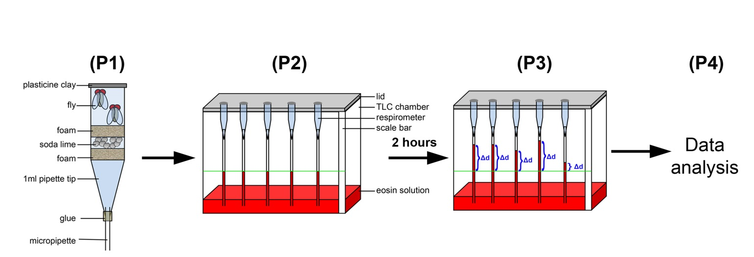

B. Interview: (Said by you on camera. Don’t forget to smile!)
  - Andriy Yatsenko: This video describes a relatively simple method, which enables the study of the metabolic rate in flies by measuring their CO₂ production.

NO INTERVIEW. TALENT ASKED, IF THIS COULD BE DONE BY THE NARRATIVE VOICE.

Protocol (read by voice talent at JoVE):
- Respirometer and Measurement Chamber Preparation
  - To begin, cut a 1000 μl pipette tip with a razorblade as straight as possible and insert the micropipette into the 1000 μl pipette tip.
    - MED: Talent organizes materials on bench.
    - CU: Side view, talent cuts pipette tip with razor blade.
    - CU: Side view, talent inserts the micropipette into the 1000 ul pipette tip.
  - Next, place a piece of foam into the pipette and push it down.
    - CU: Talent inserts piece of foam into pipette tip and pushes it down into the pipette tip.
  - Then, add a small amount of soda lime and secure it with a second piece of foam.
    - MED: Talent adds small amount of soda lime.
    - CU: Talent secures the soda lime with a second piece of foam.
  - Apply glue where the micropipette is inserted into the pipette tip and allow the glue to dry overnight.
    - CU: Side view, talent applies glue. (LAB MEDIA: Figure 1A (Video Editor: Show this image in a split screen next to the prepared pipette tip))
    - MED: Talent stores pipette tip to allow the glue to dry overnight.
  - Prepare the chamber solution by mixing water with eosin in a 1:5 ratio, which will result in visible colorization.
    - MED: Talent mixes solutions.
    - CU: Talent shows that the mixture has visible colorization.
  - Next, pour the eosin-water solution into the chamber. Then, label one of the sides of the chamber with a centimeter scale.
    - MED: Talent pours the solution into the chamber.
    - MED: Talent shows one of the chambers with a centimeter scale.
    - CU: Capture the construction of the chamber.
- Placing Flies into Respirometers
  - Prepare the respirometers by labeling them individually with a marker.
    - MED: Talent labels respirometers with a marker.

3.1.1.3 CU Labels respirometers
    - CU: Capture an image of one or several labeled respirometers.
  - If you are analyzing several genotypes, do not forget to make a note of the respirometer number and corresponding genotype. Next, immobolize flies using a pre-cooled metal plate and place 3-5 flies of the desired genotype inside each respirometer.

3.2.0 CU: Talent notes the genotype of flies to the corresponding number of. respirometers
    - MED: Talent immobilizes flies on metal plate.
    - CU: Talent places flies inside respirometer.
  - Seal the respirometers tightly at the top using plasticine putty and allow the flies to recover from anesthetization for 15 minutes.
    - CU: Talent seals respirometer at the top with putty.
    - MED: Talent places flies aside to recover from anesthitization and sets a timer for 15 min.
  - Then, prepare one respirometer without flies to be used as the atmospheric control.
    - MED: Talent prepares an additional respirometer.
  - Next, attach a 1.5 mL Eppendorf tube holder open on both sides at the top of the chamber and hang the respirometers in the chamber with the tips submerged in the colored solution.
    - CU: Talent attaches tube holder at the top of the chamber.
    - CU: Talent hangs the respirometers in the chamber.
    - CU Respirometer tips submerging colored solution
  - Then, insert respirometers with the micropipette tip down into the chamber submerging the tip in the colored solution.
    - CU: Respirometers are inserted into the chamber, the tips submerged in the solution.
  - Add Vaseline between the lid cover and the chamber to provide stronger isolation from temperature and pressure fluctuations.
    - CU: Talent adds Vaseline between the lid cover and the chamber. And closes the lid
  - Next close the lid and allow the system to equilibrate for 15 minutes.
    - MED: Talent closes the lid, and sets a timer for 15 minutes.
  - Then, take a photograph of the chamber, making sure that the level of liquid within each micropipette and the scale are in frame. After 1-2 hours, take another picture.
    - MED: Talent takes a photo of the chamber. LAB MEDIA: Figure 1B_new. (Video Editor: Show this image on the screen alone after this shot for a beat)
    - MED: Talent checks time, then takes another photo.
  - When the experiment is finished, remove the flies from the respirometers and transfer them back to the vial.
    - MED: Talent removes the flies from the respirometers.
    - MED: Talent transfers them back to vials.
- Analysis
  - To begin analysis, open acquired images using ImageJ software.
    - SCREEN: Talent opens ImageJ software and images acquired from the experiment. (Uploaded file: 4.1.1_Open.avi)
  - Next, set the pixel scaling in the software using each picture as a reference.
    - SCREEN: Talent sets pixel scaling. (Uploaded file: 4.2.1_Set_scale.avi)
  - Then, measure the distance, or Δd, that the liquid traveled from a determined reference spot in images taken at the beginning and end of the experiment.
    - SCREEN: Talent measures the distance traveled by the liquid. (Uploaded file: 4.3.1_Measure.avi)
      - LAB MEDIA: Figure 1C (Video Editor: Only display the image of the chamber on the right with text next to each thin column)
  - Finally, calculate the amount of CO₂ produced. (TEXT: 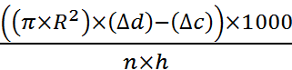)
    - SCREEN: Talent calculates CO₂ produced. (Uploaded file: 4.4.1_CO2_calc.avi)

- Results: Increased CO₂ Production in Dystroglycan Mutant Flies

(VO, please record 6.1 below as well)
  - Using this method, it was observed that the flies’ CO₂ production positively correlates with housing temperature. These results contrast with Dystroglycan, or Dg, mutants whose CO₂ production significantly increased compared to wild-type flies.
    - LAB MEDIA: Figure 2 (Video Editor: Show the entire figure with all text. Box the yellow bars when “positively” is said. Remove the box, then box the red bar when “Dystroglycan” is said. Remove the box on the red bar, then trace the line on top connecting the 25 ºC bars when “significantly” is said.)

- Conclusion (said by authors on camera VOICE TALENT):

6.1 Andriy Yatsenko: The described above method allows primary identification of genetic mutations in flies that can lead to changes in metabolism.

NO INTERVIEW. TALENT ASKED IF THIS COULD BE DONE BY THE NARRATIVE VOICE.

Provided Media

Authors, Please list all images, movie files, or 3-D rendered animations that can be included in the video per editor’s request. The step in the script/video where these images will be inserted should be specified. For example:

6.2 – 0123_PIname_Figure1.tif - dual color imaging of tumor angiogenesis at 40X
6.2 – 0123_PIname_Figure2.tif - dual color imaging of tumor angiogenesis at 100X

Formats: For static images we prefer .tiff, .eps, Illustrator, Powerpoint or Photoshop files at dimensions of at least 720X480 pixels and 300 dpi. The higher resolution, the better. Likewise any exported movie files should have at minimum these dimensions and be rendered to .mov, .mp4, or .avi files.

Insert your media filenames here.

General Preparation

It’s critical for a smooth and organized shoot that all reagents are accounted for, in advance.

Any overnight or long incubation steps should be recognized and specimens/samples be prepared in advance so that prior steps can be recorded and shooting can continue with pre-prepared specimens/samples.

All tubes/flasks should be pre-labeled neatly before we arrive.

Ex. Luciferase assay done in 96 well plates should be labeled with negative/positive control wells and experimental samples are labeled accordingly.

You will receive more detailed preparation instructions, as well as an introduction to your videographer, closer to your filming date.

