Submission ID #: 51581

Editor Name: Renee Choi

Videographer Name: Chris Gegax

Film Date: 12/3/13

Authors and Affiliations: Lee J. Pribyl¹, Kathleen A. Coughlin¹, Thanasak Sueblinvong¹, Kristin Shields², Yoshie Iizuka^{1,3}, Levi S. Downs^{1,3}, Rahel G. Ghebre^{1,3}, Martina Bazzaro^{1,3}

¹Department of Obstetrics, Gynecology, and Women’s Heath and ³Masonic Cancer Center
University of Minnesota Minneapolis, MN USA, ²Department of Obstetrics and Gynecology
Maricopa Medical Center and St Josephs Hospital and Medical Center Phoenix, AZ USA

Title: Method for Obtaining Primary Ovarian Cancer Cells from Solid Specimens

Corresponding Author:

Martina Bazzaro

Department of Gynecological Oncology

Malcolm Moos Tower Building 12-280

515 Delaware Street S.E.

Minneapolis, Minnesota 55455

Tel: 612-625-2889

Fax: 612-626-0665

E-mail: mbazzaro@umn.edu

Additional Contacts: Lee J Pribyl: priby025@umn.edu; Kathleen A Coughlin: coug0124@umn.edu; Thanasak Sueblinvong: sueb1005@umn.edu; Kristin Shields: Kirtin.Shields@mihs.org; Yoshie Iizuka: iizuk003@umn.edu; Levi S. Downs: downs008@umn.edu; Rahel G. Ghebre: ghebr004@tc.umn.edu

A. Will you require JoVE to record video microscopy, such as filming a complex dissection or microinjection technique? (Y/N) _No_____ If yes, please list make and model of your microscope:
B. Does your protocol include detailed, step-by-step, descriptions of software usage? (Y/N)__N/A____
C. Which steps of your protocol will viewers benefit most from having filmed? Please list 4-6 steps___ Actual tissue processing: cutting tissue into pieces, adding proper digestion reagents, filtering digested tissue and plating cells for incubation.
D. What is the single most difficult aspect of this procedure and what do you do to ensure success? Transferring cut tissue pieces into conical tube for digestion. To ensure success I make sure I get all of the pieces.

1. Introduction (Schematic Overview and Interview)

A. Schematic Overview (read by voice talent at JoVE):

Procedural Narrative:
The overall goal of this procedure is to isolate and characterize primary ovarian cancer cells from solid clinical specimens. (Intro)

This is accomplished by first collecting the ovarian tumor specimen and placing it in a Petri dish. (P1: Show the image provided and zoom in on the specimen in the Petri dish. Then place an arrow to the right of the image. Shots 2.3.1 & 2.4.1)

The second step is to cut the sample into pieces and transfer the pieces into a conical tube with digestion reagents for incubation. (P2: Show the image provided to the right of the arrow. Zoom in on the pieces of tissue in the Petri dish, zoom out, then zoom in on the text on the conical in the image. Then place an arrow to the right of the image. Shots 3.2.1, 3.3.1, 3.3.2, 3.3.3)

Next, the cell slurry is run through a filter where only cells are collected for centrifugation. (P3: Show the entire image to the right of the arrow. If possible, when “filter” is said, zoom in and box the filter sitting on top of the tube, then zoom out. Place an arrow to the right of the image. Shots 3.5.2, 3.5.3, 3.6.2, 3.7.1)

The final step is to discard the supernatant and resuspend the cells in media for incubation overnight. (P4: Show the entire image after the arrow. Shots 3.8.2, 3.8.3, 3.9.2)

Ultimately, the epithelial ovarian cancer cells will grow in culture for weeks, which allows for downstream applications. (P5: Figure 7 & 8)

Paste a copy of your graphic overview here. The original file should be Adobe Illustrator (preferred) or Powerpoint (see instructions) and should be uploaded through your online submission on the JoVE website. Please keep all layers in the file (i.e., do not flatten the file).
P1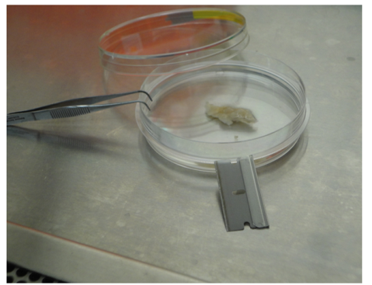P2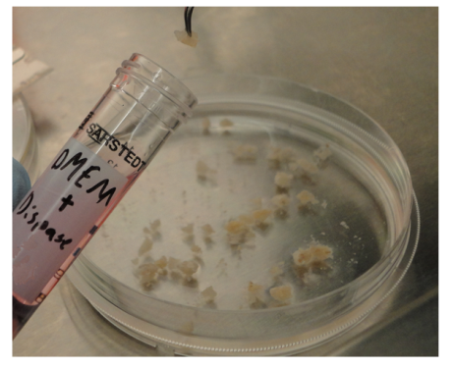P3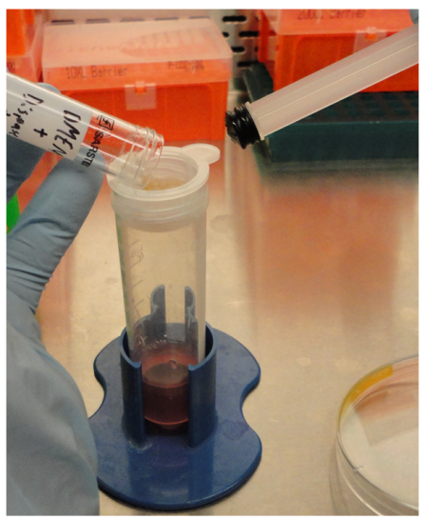P4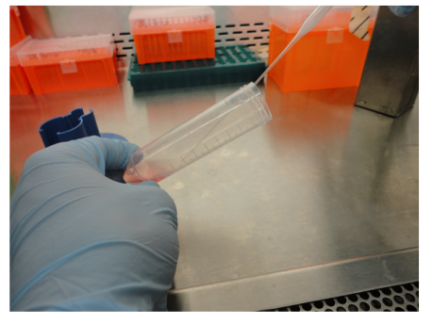

B. Interview: (Said by you on camera. Don’t forget to smile!)
  - Martina Bazzaro: This method can help answer key questions in the ovarian cancer field, such as what the best treatment option is for each individual patient.
  - Lee Pribyl: The implications of this technique extend toward treatment of ovarian cancer, because it allows us to use more realistic cell cultures which are highly susceptible to genetic manipulation and are more useful in drug screening tests.

Protocol (read by voice talent at JoVE):
- Reagent Setup & Tissue Collection
  - To begin, supplement 500 mLs of Dulbecco’s Modified Eagle’s Medium, or DMEM, with 10% Fetal Bovine Serum, or FBS, and 1% penicillin-streptomycin, or P/S. Store the medium at 4 ºC.
    - MED/WIDE: Talent approaches bench with DMEM, FBS, and P/S.
    - MED: Talent adds FBS and P/S to DMEM.
    - MED/WIDE: Talent places the medium in the refrigerator.
  - Next, aliquot dispase II into volumes of 5-10 mL to avoid multiple freeze thaws and store the aliquots at -20◦C.
    - MED: Talent acquires dispase II and prepares materials for it to be aliquoted.
    - MED – Over the Shoulder: Talent aliquots dispase II into 5-10 mL aliquots.
    - MED: Talent places the aliquots in the freezer.
  - Then, collect 5 g of solid specimens of ovarian cancer at the time of surgery from areas macroscopically identified as cancer by a pathologist.
    - MED: Talent quickly collects solid specimens of ovarian cancer (Videographer: This may be shot in OR room)
  - Place specimens in a sterile, screw lid, polypropylene specimen container filled with 30 mL of ice-cold PBS. Transport the specimens on ice from the surgical pathology laboratory to the research laboratory for processing within 30 minutes of collection. (TEXT: See Discussion for post 30 minute collection processing)
    - MED/CU: Talent places specimens in container filled with 30 mL PBS.
    - MED/WIDE: Talent transports the specimens on ice to the research laboratory.
    - LAB MEDIA: Figure 1 (Video Editor: Use this figure only if necessary) [All of these steps were either unnecessary to show on film or we were unable to film them due to not having access to OR.]
- Tissue Processing
  - Collect the sample from the OR and transport it on ice to the lab. Still inside the transported container, place the sample in a biological safety hood. Transfer the sample from a 50ml conical tube onto a 60 mm x 60 mm Petri dish containing 10 mL of fresh, ice-cold PBS.
    - MED: Talent transfers sample onto Petri dish containing ice-cold PBS.
  - Next, using a sterile razor blade, further cut the sample into 2 mm or smaller pieces.
    - CU/ECU: Talent cuts tissue with a razor blade into small pieces.
    - CU/ECU: Talent shows the cut tissue pieces to the camera.
    - LAB MEDIA: Figure 2A and B (Video Editor: Use this images only if necessary).
  - Then, treat DMEM with dispase II in a 15 mL conical tube.
    - MED: Talent adds dispase II to 10 mLs of DMEM in a 15 mL conical tube.
    - MED – Over the Shoulder: Talent places the solution in an incubator and sets a timer for 30 min.
  - Transfer the minced tissues to the DMEM/Dispase II mixture tube, then incubate the sample at 5% CO₂ and 37 °C for 30 minutes. Manually agitate the cell slurry every 5 minutes to ensure optimal digestion.
    - MED: Talent adds DMEM with dispase II to 15 mL conical tube.
    - CU: Talent transfers minced tissues to 15 mL conical tube.
    - MED: Talent agitates sample and places the sample in an incubator and sets a timer for 30 min. If possible, capture the settings of the incubator of 5% CO₂ and 37 °C.
    - CU/ECU: Side view of talent manually agitating the cell slurry.
  - After incubation, transfer cell slurry through a 70 μm mesh cell strainer placed on top of a 50 mL conical tube. Gently apply pressure against the mesh using a syringe plunger.
    - MED: Talent uses a pipette to collect the cell slurry from the previous step.
    - CU: Talent transfers the slurry through a mesh cell strainer on top of a 50 mL conical tube.
    - [combined with 3.6.1] CU: Side view of talent gently applying pressure against the mesh with a syringe plunger.
  - Discard any un-dissociated tissue remaining on the top of the mesh and collect the obtained cell suspension in the 50 mL sterile conical tube.
    - MED: Talent discards un-dissociated tissue from the top of the mesh.
    - CU: Talent collects shows the remaining cell suspension in the tube to the camera.
  - Next, centrifuge the conical at 320 x g for 7 minutes at 4 °C.
    - MED – Over the Shoulder: Talent centrifuges the conical. Capture the parameters set for the centrifuge if possible.
    - LAB MEDIA: Figure 3 (Video Editor: Use this image only if necessary to cover voice over).
  - Discard the supernatant and resuspend the cell pellet in 10 mL of DMEM containing 10% FBS and 1% P/S.
    - MED: Talent removes the tube from the centrifuge.
    - MED: Talent discards the supernatant.
    - CU: Talent resuspends the pellet in DMEM with FBS and P/S. If possible, capture the label of the DMEM containing FBS and P/S in the shot.
  - Then, transfer the cell suspension to a Petri dish and incubate the suspension at 5% CO₂ and 37 °C.
    - CU: Talent transfers cell suspension to a Petri dish.
    - MED: Talent places the Petri dish in an incubator.
    - LAB MEDIA: Figure 4 (Video Editor: Use this image only if needed).
  - Change the medium 24 hours after the initial plating to remove the cellular debris and the majority of the erythrocytes present in the culture.
    - MED: Talent changes the medium.
    - CU: Talent shows the camera the cellular debris and erythrocytes removed to the camera.
  - Finally, change the medium every 3 days for the following 2 weeks, after which the cultures of primary EOC cells are ready for downstream applications.
    - MED: Talent shows schedule to change media to camera.
    - MED: Talent changes the medium.
- Results: Cell Culture Profile
  - Immediately after plating, the epithelial ovarian cancer cells, or EOC cells, appear as single cell suspensions and in clumps with erythrocytes and cell debris abound.
    - LAB MEDIA: Figure 5 (Video Editor: If possible, show the image without arrows, then add the arrows when “clumps” is said.)
  - EOC cell culture 3 days after plating shows semi-adherent EOC cell clusters and less erythrocyte contamination.
    - LAB MEDIA: Figure 6 (Video Editor: If possible, show the image without the arrow. Then add the arrows as seen in the image provided by the authors when “semi-adherent” is said.)
  - One week after initial plating, the EOC cell culture becomes a swirl-like cluster of cells spreading on the tissue culture plastic.
    - LAB MEDIA: Figure 7 (Video Editor: Show the entire figure)
  - The typical epithelial cobblestone morphology can be seen in a confluent monolayer of EOC cells after 14 days in culture.
    - LAB MEDIA: Figure 8 (Video Editor: Show the entire figure).

- Conclusion (said by authors on camera)
  - Lee Pribyl: After watching this video, you should have a good understanding of how to isolate and characterize primary ovarian cancer cells from solid clinical specimens.

Provided Media

Authors, Please list all images, movie files, or 3-D rendered animations that can be included in the video per editor’s request. The step in the script/video where these images will be inserted should be specified. For example:

6.2 – 0123_PIname_Figure1.tif - dual color imaging of tumor angiogenesis at 40X
6.2 – 0123_PIname_Figure2.tif - dual color imaging of tumor angiogenesis at 100X

Formats: For static images we prefer .tiff, .eps, Illustrator, Powerpoint or Photoshop files at dimensions of at least 720X480 pixels and 300 dpi. The higher resolution, the better. Likewise any exported movie files should have at minimum these dimensions and be rendered to .mov, .mp4, or .avi files.

Insert your media filenames here.

General Preparation

It’s critical for a smooth and organized shoot that all reagents are accounted for, in advance.

Any overnight or long incubation steps should be recognized and specimens/samples be prepared in advance so that prior steps can be recorded and shooting can continue with pre-prepared specimens/samples.

All tubes/flasks should be pre-labeled neatly before we arrive.

Ex. Luciferase assay done in 96 well plates should be labeled with negative/positive control wells and experimental samples are labeled accordingly.

You will receive more detailed preparation instructions, as well as an introduction to your videographer, closer to your filming date.

