Submission ID #: 51549

Editor Name: Brigid Stadinski

Videographer name: Nicolas Bilder

Film Date: 1/08/2014

Authors and Affiliations:

Joe Dragavon¹, Carolyn Sinow², Alexandra D. Holland¹, Abdessalem Rekiki¹, Ioanna Theodorou³, Chelsea Samson⁴, Samantha Blazquez¹, Kelly L. Rogers⁵, Régis Tournebize^{1,6,7}, Spencer L. Shorte¹

¹Plate-Forme d’Imagerie Dynamique, Imagopole, Institut Pasteur, 25-28 Rue du Dr. Roux, 75724 Paris cedex 15, France
²Stanford School of Medicine, Department of Radiation Oncology, 875 Blake Wilbur Dr, Stanford, CA USA 94305
³CEA, Institut d’Imagerie Biomédicale, Service Hospitalier Frédéric Joliot, Orsay Cedex, France
⁴Vanderbilt School of Medicine, 215 Light Hall, Nashville, TN USA 37232
⁵The Walter & Eliza Hall Institute of Medical Research, 1G Royal Parade, Parkville Victoria 3052, Australia
⁶Unité INSERM U786, Institut Pasteur, 28 rue du Dr Roux, 75724 Paris cedex 15, France
⁷Unité de Pathogénie Microbienne Moléculaire, Institut Pasteur, 25-28 Rue du Dr. Roux, 75724 Paris cedex 15, France

Title: A Step Beyond BRET: Fluorescence by Unbound Excitation from Luminescence (FUEL)

Corresponding Author:
Joe Dragavon - joseph.dragavon@pasteur.fr
Spencer L. Shorte - spencer.shorte@pasteur.fr

Authors, please fill out the brief questionnaire below.

- Will you require JoVE to record video microscopy, such as filming a complex dissection or microinjection technique? (Y/N) ___N______ If yes, please list make and model of your microscope: ______________________________
**Note: This question is to get at whether or not you will need a camera hook-up to look into the microscope. However, if your microscope has a digital camera attached to a computer, you can gather these shots by collecting screen capture movies.
Does your protocol include microscopy steps that are visualized through a microscope with a digital camera/computer attached? (Y/N) ___N____
B. Does your protocol include detailed, step-by-step, descriptions of software usage? (Y/N)__N______
C. Which steps of your protocol will viewers benefit most from having filmed? Please list 4-6 steps____2, 3, 4 ______________________
D. What is the single most difficult aspect of this procedure and what do you do to ensure success? ______Freshly grow bacteria from overnight cultures.________________________

1. Introduction (Schematic Overview and Interview)

A. Schematic Overview (read by voice talent at JoVE):

Conceptual Narrative:

The overall goal of the following experiment is to demonstrate the simplicity of FUEL and observe the generation of red photons due to radiative excitation-emission events. (Intro)

This is achieved by combining bioluminescent bacteria and luminescent nanoparticles for the production of FUEL. (P1)
Editors, please zoom into the left-most black plate in “A” of “51549_Dragavon_Video_Figure_1.tiff.” Staying zoomed into the left-most black plate, please highlight the second column of 3 colored wells and the label “Bac+OD705.”

Next, a bioluminescence plate reader is used to observe the resulting red photons that arise from FUEL. (P3)
Editors, please show the other 2 images of the black plates showing the emission at 470-490nm and the 695-770nm along with the plot shown in B.

Results are obtained that show a substantial quantity of red photons can be produced when the bioluminescent bacteria… and quantum dots… are maintained within the same solution, based on the observed increase in red photon flux. (P4)
Editors, please highlight the blue circles as “bioluminescent bacteria” is narrated and the black circles as “quantum dots” is narrated. Then highlight the blue light around the hv and to the black circle, causing a red glow as “based on the observed increase in red photon flux” is narrated.

Paste a copy of your graphic overview here. The original file should be Adobe Illustrator (preferred) or Powerpoint (see instructions) and should be uploaded through your online submission on the JoVE website. Please keep all layers in the file (i.e., do not flatten the file).

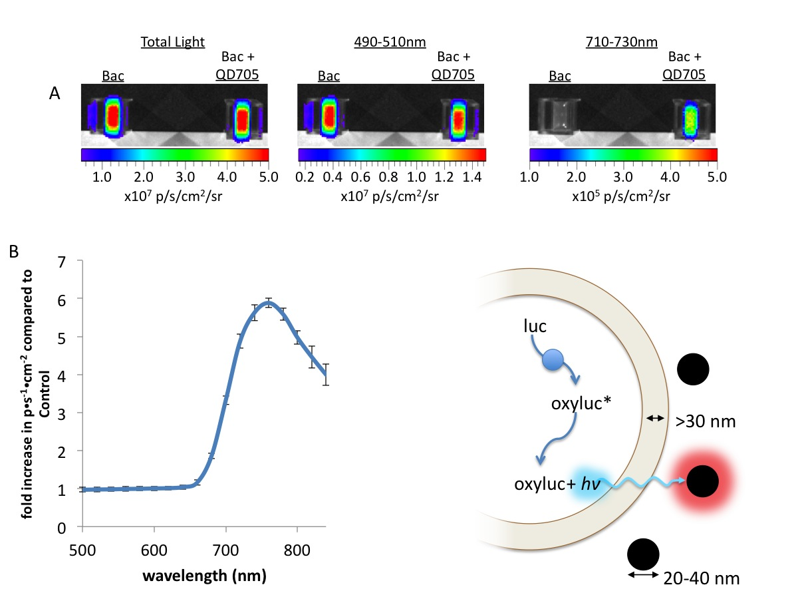
B. Interview: (Said by you on camera. Don’t forget to smile!)
  - Joe Dragavon: The implications of this technique extend toward questioning the paradigm of bioluminescence resonance energy transfer, or BRET, that is often reported within the literature.
    - MED: Joe speaks toward camera, interview style.

Protocol (read by voice talent at JoVE):
- Basic recapitulation of FUEL
  - Starting from individual colonies on standard culture plates, start overnight cultures of luminescent bacteria. Here, Vibrio fischeri (pronounced “vib-Rio fish-er-eye”) were used.
    - MED: Talent starts an overnight culture for Vibrio fischeri.
  - The day of experimentation, initiate fresh subcultures. Allow them to progress until an optical density, or OD, at 600 nm of 1 to 1.5 is achieved; use bacteria in similar growth states in which they produce intense signals to achieve comparable results.
    - MED-over the shoulder: Talent places fresh subcultures into the incubator.
    - CU: Spectrometer screen showing that the OD₆₀₀ is 1-1.5.
  - Combine aliquots of 100 µL from each with either 5 µL of the fluorescent probe QD705 (pronounced as “Q-D-7-0-5”) or physiological saline.
    - MED-over the shoulder: Talent combines 100 µL from each of the subcultures with 5 µL of the fluorescent probe QD705 or physiological saline. TEXT overlay: see text protocol for reagent preparation
  - Then add the mixture to 895 µL of physiological saline in standard spectroscopic cuvettes. Place the filled cuvettes into a whole animal bioluminescence imager and take the measurements under the appropriate filter sets. Here, the 710 to 730 nm emission filter was used.
    - CU: Standard spectroscopic cuvettes containing 895 µL of physiological saline as talent pipettes the cell mixtures into them. Take 2: ++
    - MED: Talent places the filled cuvettes into a whole animal bioluminescence imager.
    - MED-over the shoulder: Screen as talent takes measurements using a 710-730 nm emission filter.
- FUEL over varying distances
  - To perform FUEL over varying distances, fill two reduced volume plastic photometric cuvettes with either 50 µL of QD705… or 97.2 µL of non-fluorescent 48 nm polystyrene microspheres, in a total volume of 1 mL of physiological saline. This ensures similar solid surface area per total volume between the two entities.
    - CU: 2 reduced volume plastic photometric cuvettes as talent fills one with 50 µL of QD705 from a labeled container, and then the other with 97.2 µL of non-fluorescent 48 nm polystyrene microspheres from a labeled container.
    - MED-over the shoulder: Talent brings the total volume of each sample up to 1 mL with physiological saline.
  - Prepare a light source cuvette by encasing a third cuvette with standard black tape or some other opaque material capable of blocking light. Carefully prepare two identical optical windows on opposite sides of the cuvette.
    - CU: Third cuvette as talent encases it with standard black tape.
    - ECU: Taped cuvette as talent carefully prepares the second of 2 identical optical windows on opposite sides of the cuvette.
  - Next, place the previously filled cuvettes directly onto either side of the light source cuvette in the imager. Add a 1 mL aliquot of Vibrio fischeri, or other culture, from a fresh subculture into the light source cuvette and cover it with an opaque material, such as black paper to reduce any light contamination.
    - CU: Light source cuvette as talent adds a 1 mL aliquot of Vibrio fischeri and covers it with black paper.
    - MED-over the shoulder: Talent places the previously filled cuvettes directly onto either side of the light source cuvette in the imager.
  - Visualize the three cuvettes under the appropriate emission filters such as the Total Light and 710 to 730 nm emission filters, with exposure times of 10, 30, and 30 seconds, respectively.
    - MED: Talent visualizes the three cuvettes at the spectrometer under the appropriate emission filters with the appropriate exposure times.
  - Acquire a fluorescence image at 450 to 480 nm excitation and 710 to 730 nm emission to validate the QD705 location.
    - MED-over the shoulder: Spectrometer screen as talent acquires a fluorescence image at 450 – 480 nm excitation and 710 – 730 nm emission to validate the QD705 location.
  - Reposition both external cuvettes at equivalent further distances from the central cuvette. Then visualize and acquire a fluorescence image before repeating this process again until a final face-to-face distance of 3 centimeters is achieved.
    - CU: Cuvettes as talent repositions both external cuvettes at equivalent further distances from the central cuvette.
    - WIDE: Talent at the spectrometer visualizes and acquires the fluorescence image.
- Investigating potential FUEL pairs
  - Fill two reduced volume cuvettes with 1 mL solutions containing either a fluorophore or a fluorescent nanoparticle of interest in one, and physiological saline with non-fluorescent nanoparticles as the negative control in the other.
    - MED: Talent fills a reduced volume cuvette with 1 mL of a solution containing either a fluorophore or a fluorescent nanoparticle.
    - CU: Talent fills a second reduced volume cuvette with physiological saline with non-fluorescent nanoparticles as the negative control.
  - Add a 1 mL aliquot of fresh Vibrio fischeri or other luminescent bacteria to a blacked-out third cuvette containing two physically equal optical windows situated on opposite sides. Cover the cuvette with an opaque substance, such as a piece of black paper.
    - CU-over the shoulder: Talent adds a 1 mL aliquot of fresh Vibrio fischeri or other luminescent bacteria to a blacked-out third cuvette containing two physically equal optical windows situated on opposite sides. Merged with 4.2.2: Cuvette as talent covers it with black paper. COMMENT: This is the same action as 3.3.1 and 3.3.2.
    - CU: Cuvette as talent covers it with black paper.
  - At a short but equal distance, place the two reduced volume cuvettes on either side of the blacked-out cuvette and visualize under the appropriate filters. Here, a distance of 0.7 cm was used. Repeat with the other fluorophores.
    - MED-over the shoulder: Talent places the cuvettes into the imager in the proper orientation.
    - CU: Spectrometer screen as talent visualizes the samples under the appropriate filters.
- Targeted FUEL: Not done because appropriate bacteria were unavailable
  - First, prepare biotinylated antibodies specific to the luminescent bacteria; here primary antibodies specific to K. pneumoniae were biotinylated.
    - MED: Talent uses EZ-Link Sulfo-NHS-LC-Biotin to biotinylate antibodies specific to luminescent bacteria.
  - Remove excess reagent from the antibodies using desalting columns under centrifugation for 2 minutes.
    - CU: Desalting column as talent pipettes the antibody solution in.
  - Then, use a standard Bradford assay to determine the protein concentration and determine the degree of antibody biotinylation by a biotin binding assay.
    - MED-over the shoulder: Lab notebook as talent writes the protein concentration and the degree of antibody biotinylation (that were obtained from the assays).
  - Next, obtain the alpha-K-pneumonia-biotin biotinylated antibody batches by mixing 100 µL of the biotinylated antibody with 40µL of alpha-K-pneumonia antibody, resulting in a final degree of substitution of 16 biotin residues per antibody and a final protein concentration of 10 mg per mL.
    - MED-over the shoulder: Talent pipettes 100 µL of the biotinylated antibody to a new tube.
    - CU: New tube with 100 µL of the biotinylated antibody as talent pipettes 40µL of alpha-K-pneumonia antibody to the tube. Use labeled tubes.
  - Using multiple overnight replicate cultures, resuspend washed K. pneumoniae in 1 x phosphate buffered saline, or PBS. For each replicate, incubate 100 µL of PBS, alpha-K-pneumonia-biotin biotinylated antibodies, and 100 µL cells for 90 min at 30 °C.
    - MED-over the shoulder: Talent resuspends washed K. pneumonia in 1 x PBS. TEXT Overlay: resuspend to OD₆₀₀=4
    - CU: Labeled tubes as talent places in a 30 °C water bath and starts an adjacent timer counting down from 90min.
  - Following incubation, wash the cells three times in 1x PBS before resuspending in 196 µL PBS.
    - MED: Talent pipettes 1xPBS to the cells.
  - Next, label the cells with the QD705 streptavidin conjugate by adding the streptavidin conjugate and allowing them to interact for several minutes.
    - CU: Cells as talent pipettes QD705 streptavidin conjugate into the cells.
  - Divide the labeled cells into two equivalent volumes. Wash one labeled cell solution three times before resuspending it into the appropriate volume.
    - MED-over the shoulder: Talent divides the labeled cells into 2 equivalent volumes.
    - MED: Talent resuspends the washed cells in the appropriate volume.
  - Distribute 100 µL of the washed and unwashed solutions into individual wells of a black 96-well plate.
    - CU: Black 96-well plate as talent distributes 100 µL of the washed and unwashed solutions from labeled containers into individual wells.
  - Measure the resulting luminescence under the Total Light, 490 to 510 nm, and 710 to 730 nm filters. Fluorophore concentration can be determined using 450 to 480 nm excitation and 710 to 730 nm emission.
    - MED-over the shoulder: Spectrometer screen as talent measures the resulting luminescence under the Total Light, 490-510 nm, and 710-730 nm filters.
    - CU: Spectrometer screen as talent acquires the fluorescence images using 450-480 nm excitation and 710-730 nm emission.
- Results: Analysis of the various FUEL demonstrations
  - Upon addition of the QD705 to the bacteria, a substantial increase in the number of red photons is observed compared to the bacteria-only control.
    - LAB MEDIA: 51549_Dragavon_Video_Figure_2.tiff
  - FUEL can occur over long distances in the absence of any absorber. This distance dependence can be characterized by the inverse square law for point sources.
    - LAB MEDIA: 51549_Dragavon_Video_Figure_3.tiff
  - The targeting of the fluorophores to the bacterial membrane appears to have little to no effect on the overall amount of FUEL signal generated. In this context, targeted FUEL is maintained even after several washing steps.
    - LAB MEDIA: 51549_Dragavon_Video_Figure_4.tiff. Editors, please highlight the bars in the “Targeted Washed” column as the last sentence is narrated.

- Conclusion (said by authors on camera)
  - Joe Dragavon: After watching this video, you should have a good understanding of how to reconstitute FUEL under multiple modalities as a means to generate red photons from radiative excitation-emission events.
    - MED: Joe speaks toward camera, interview style.

Provided Media

Authors, Please list all images, movie files, or 3-D rendered animations that can be included in the video per editor’s request. The step in the script/video where these images will be inserted should be specified. For example:

6.2 – 0123_PIname_Figure1.tif - dual color imaging of tumor angiogenesis at 40X
6.2 – 0123_PIname_Figure2.tif - dual color imaging of tumor angiogenesis at 100X

Formats: For static images we prefer .tiff, .eps, Illustrator, Powerpoint or Photoshop files at dimensions of at least 720X480 pixels and 300 dpi. The higher resolution, the better. Likewise any exported movie files should have at minimum these dimensions and be rendered to .mov, .mp4, or .avi files.

Insert your media filenames here.

51549_Dragavon_Video_Figure_1.tiff (schematic figure)

6.1 - 51549_Dragavon_Video_Figure_2.tiff – Increase in red photon production due to FUEL

6.2 - 51549_Dragavon_Video_Figure_3.tiff – The distance dependence of FUEL

6.3 - 51549_Dragavon_Video_Figure_4.tiff – The targeting dependence of FUEL

General Preparation

It’s critical for a smooth and organized shoot that all reagents are accounted for, in advance.

Any overnight or long incubation steps should be recognized and specimens/samples be prepared in advance so that prior steps can be recorded and shooting can continue with pre-prepared specimens/samples.

All tubes/flasks should be pre-labeled neatly before we arrive.

Ex. Luciferase assay done in 96 well plates should be labeled with negative/positive control wells and experimental samples are labeled accordingly.

You will receive more detailed preparation instructions, as well as an introduction to your videographer, closer to your filming date.

