Submission ID #: 51516

Editor Name: Brigid Stadinski

Videographer name: Sean Glavey

Film Date: 03/06/2014

Authors and Affiliations:

Jelle Caers¹, Katleen Peymen¹, Nick Suetens¹, Liesbet Temmerman¹, Tom Janssen¹, Liliane Schoofs¹, and Isabel Beets¹

¹Naamsestraat 59, Department of Biology, KU Leuven, Leuven, Belgium

Title: Characterization of G Protein-Coupled Receptors by a Fluorescence-Based Calcium Mobilization Assay

Corresponding Author:

Beets, Isabel
Naamsestraat 59
Department of Biology
KU Leuven
Leuven, Belgium
Isabel.Beets@bio.kuleuven.be
+3216323965 or +3216324260

Authors, please fill out the brief questionnaire below.

- Will you require JoVE to record video microscopy, such as filming a complex dissection or microinjection technique? (Y/N) No If yes, please list make and model of your microscope: N/A
**Note: This question is to get at whether or not you will need a camera hook-up to look into the microscope. However, if your microscope has a digital camera attached to a computer, you can gather these shots by collecting screen capture movies.
Does your protocol include microscopy steps that are visualized through a microscope with a digital camera/computer attached? (Y/N) No
B. Does your protocol include detailed, step-by-step, descriptions of software usage? (Y/N) Yes, in section 4. Assay on the station device contains detailed, step-by-step, descriptions of software usage.
C. Which steps of your protocol will viewers benefit most from having filmed? Please list 4-6 steps_ 2.6 – 3.1 - 3.2 – 3.3 – 3.7 – 3.8 – 3.10 – 3.11 – 3.13 – 3.14 – 3.16 – 3.17 and 4 (of which most essential is 4.4). Most steps are linked with each other, which makes it hard to pick only 4-6 steps… The indicated numbers correspond to the protocol below.
D. What is the single most difficult aspect of this procedure and what do you do to ensure success? Obtaining a healthy monolayer of transfected cells in the cell plate, and maintaining the cell layer during washing steps (3.8 – 3.10 – 3.11 – 3.16 and 3.17 of the protocol below).

1. Introduction (Schematic Overview and Interview)

A. Schematic Overview (read by voice talent at JoVE):

Conceptual Narrative:

The overall goal of the following experiment is to identify functionally activating ligands of orphan G protein-coupled receptors, or GPCRs. (Intro)

This is achieved by transiently transfecting a GPCR of interest and co-transfecting a promiscuous G_{α16} (pronounced as “G-alpha-sixteen”) construct in a cellular expression system to obtain temporary heterologous expression of both proteins. (P1)
Editors, as this point is narrated, please show the 3 images in the top row of “Animation_panel 1.pdf.” Please do so by fading from one image to the next to result in an animation. The last image should be showing as “to obtain temporary heterologous expression of both proteins” is narrated.

As a second step, the transfected cells are loaded with the calcium-sensitive dye Fluo-4 (pronounced as “fluo-four”), which detects the release of calcium from intracellular stores through an increase in fluorescent signal upon calcium interaction. (P2)
Editors, as this point is narrated, please show the 2 left-most images in the bottom row of “Animation_panel 1.pdf.” Please animate the movement of the green hexagons into the cell.

Next, the fluorescence-based calcium mobilization assay is performed by challenging the heterologous expressed receptor with a compound library of candidate ligands to determine compounds that activate the receptor by measuring changes in cytoplasmic levels of the second messenger molecule, calcium. (P3)
Editors, as this point is narrated, please start with the right-most image in the bottom row of “Animation_panel 1.pdf.” Please animate the movement of the orange circles onto the GPCR as represented in the top left most image in “Animation_panel 2.pdf. Then continue to animate the image by fading into the images in “Animation_panel 2.pdf.” Top left top middle top right bottom left bottom middle.

Results are obtained that show a concentration-response curve with half maximal effective concentration of an activating ligand based on the detection of varying fluorescent signals caused by the interaction of the reporter with intracellular calcium levels, dependent on ligand concentration. (P4)
Editors, as this point is narrated, please show the results in the right-most image in the bottom row of “Animation_panel 2.pdf.”

Paste a copy of your graphic overview here. The original file should be Adobe Illustrator (preferred) or Powerpoint (see instructions) and should be uploaded through your online submission on the JoVE website. Please keep all layers in the file (i.e., do not flatten the file).

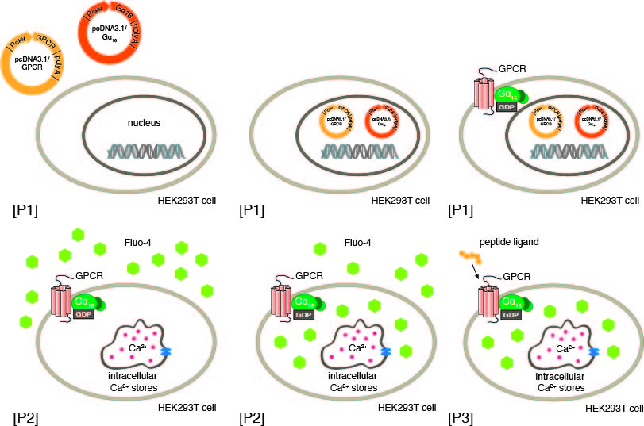

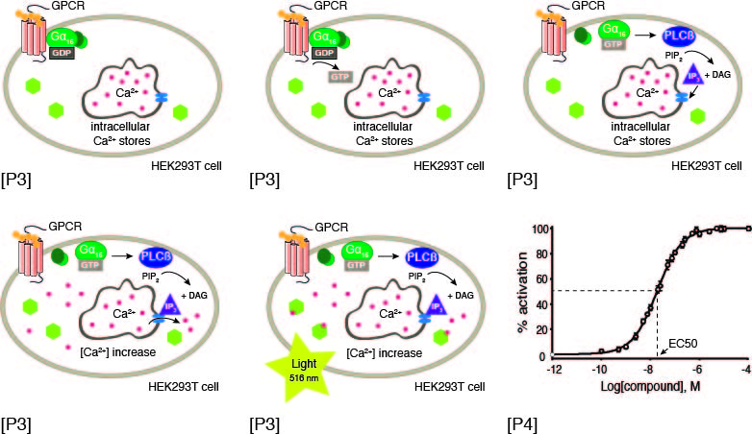
B. Interview: (Said by you on camera. Don’t forget to smile!)

  - Isabel Beets: The main advantage of performing transient transfections to obtain temporary expression of your GPCR over the use of stable clonal cell lines, is that it does not require the time-consuming establishment of such stably transfected cell lines.
    - MED: Isabel speaks toward camera, interview style.
  - Isabel Beets: Co-transfection of the promiscuous Gα₁₆ subunit can redirect the intracellular signaling pathway of most GPCRs toward the release of calcium, regardless of the native signaling pathway in endogenous settings. As such, the setup allows a medium-throughput screening of hundreds of compounds on GPCRs of interest in a short time span.
    - CU: Isabel speaks toward camera, interview style.
  - **Isabel Beets: Demonstrating the procedure will be Jelle Caers, a PhD student… and Nick Suetens, a technician from our laboratory.
    - MED: Isabel speaks toward camera, interview style.
    - MED: Jelle looks up from workbench or desk or microscope and acknowledges the camera.
    - MED: Nick looks up from workbench or desk or microscope and acknowledges the camera.

Protocol (read by voice talent at JoVE):
- Transient transfection of HEK293T cells
  - Grow the HEK293T cells in T-75 flasks 3 days before the actual calcium mobilization assay takes place. Passage the cells when a confluence of 80% is reached. Use one T-75 flask for transfection with the receptor construct and one for transfection with an empty expression vector, as a negative control.
    - MED-over the shoulder: Talent removes the HEK293T cells in T-75 flasks from the incubator that have been growing for 3 days. TEXT overlay: see text for HEK293T cell maintenance
    - MED: Talent at hood as talent removes old media from the cells in order to passage the cells.
    - CU: 2 T-75 flasks containing 14 ml fresh growth medium as talent transfers 1 ml of the cell culture into each of them.
  - Incubate the flasks at 37°C in a 5% CO₂ humidified incubator for 20 to 24 hours until the cell cultures approach 50 to 70% confluence, as shown here.
    - LAB MEDIA: Figure1.1.tif
  - [moved] Label one population of cells as transfected with the expression vector encoding the GPCR of interest and the Gα₁₆ construct…and the second flask with the empty vector and the Gα₁₆ construct.
    - MED-over the shoulder: Talent labels the first population of cells with the appropriate label to reflect cells transfected with the expression vector encoding the GPCR of interest and the Gα₁₆ construct.
    - CU: Flasks on bench as talent labels the second population of cells with the appropriate label to reflect cells with the empty vector and the Gα₁₆ construct.
  - Next, add 3.9 µg of the receptor construct or empty vector, and 3.9 µg of the Gα₁₆ expression construct, to a 1.5 ml microcentrifuge tube. Add 500 µl of the JetPRIME buffer. Mix well by vortexing the tube, followed by a short spin.
    - MED: Talent pipettes 3.9 µg of the receptor construct or empty vector, and 3.9 µg of the Gα₁₆ expression construct to a 1.5 ml microcentrifuge tube.
    - CU: Tube as talent pipettes 500 µl of the JetPRIME buffer into the tube.
    - MED-over the shoulder: Talent vortexes the tube.
  - Then, add 37.5 µl of the JetPRIME reagent, vortex and spin down for one minute at 14,000 x g. Incubate the transfection mix for 10 minutes at room temperature.
    - MED: Talent places the tube with reagent into the microfuge, shuts lid and starts spin.
    - MED-over the shoulder: Tube on benchtop as talent starts and adjacent timer to count down from 10 minutes.
  - [moved] Label one population of cells as transfected with the expression vector encoding the GPCR of interest and the Gα₁₆ construct…and the second flask with the empty vector and the Gα₁₆ construct.
    - MED-over the shoulder: Talent labels the first population of cells with the appropriate label to reflect cells transfected with the expression vector encoding the GPCR of interest and the Gα₁₆ construct.
    - CU: Flasks on bench as talent labels the second population of cells with the appropriate label to reflect cells with the empty vector and the Gα₁₆ construct.
  - Following incubation, add the transfection mix drop-wise to the cell culture medium, making sure to pipette directly into the medium and avoid contact with the walls of the culture flask. Incubate the flasks at 37°C in a 5% CO₂ humidified incubator for 20 to 24 hours.
    - CU or ECU: Cell culture medium in the culture flask as talent adds the transfection mix drop-wise directly into the cell culture medium.
    - MED: Talent leaves the flasks to incubate in the incubator.
- Calcium mobilization assay
  - For the calcium mobilization assay, the transfected cells are collected and seeded into 96-well black-walled, clear-bottom plates.
    - MED or WIDE: Talent approaches the hood with a bottle of PBS and the 96-well plates.
  - First, coat the plates with 60 µl per well of room temperature phosphate buffered saline with fibronectin.
    - CU: Plates as talent coats the wells with 60 µl per well of room temperature PBS with fibronectin. Use labeled containers. TEXT overlay: see text for PBS with fibronectin recipe
  - Incubate the plates at room temperature for 1 hour with the lid on. Remove the solution from the wells and incubate the plates again for 1 hour without the lid at room temperature.
    - MED-over the shoulder: Talent places the lid on the plate and starts a timer counting down from 1 hour.
    - CU: Plate as talent removes the lid and then removes the solution from the cells.
  - Meanwhile, take off the old growth medium from the cells, rinse dead cells off with 3 ml of PBS, and remove the PBS. Then, add 3 ml of room temperature PBS-Trypsin-EDTA. Incubate for 1 minute before removing the solution.
    - MED: Talent removes the old growth medium from the cells and rinses the dead cells off with 3 ml of PBS.
    - CU: Flask of cells as talent adds 3 ml of room temperature PBS-Trypsin-EDTA from labeled container. TEXT overlay: see text for PBS-Trypsin-EDTA recipe
    - MED-over the shoulder: Talent removes the solution.
  - At this point, the morphology of the cells changes from star-shaped… to sphere-shaped.
    - LAB MEDIA: Figure1.2.tif
    - LAB MEDIA: Figure1.3.tif. Editors, please fade into this figure from the previous figure at the pause.
  - Loosen the cells from the bottom of the flask by gentle tapping, and collect them by rinsing several times with 10 ml of room temperature DMEM transfer medium. Transfer the cells into a 50 ml falcon tube.
    - MED: Talent loosens the cells from the bottom of the flask by gentle tapping.
    - MED-over the shoulder: Talent collects the cells by rinsing them with 10 ml of DMEM transfer medium from a labeled container. TEXT overlay: see text for DMEM transfer medium recipe
    - CU: 50 mL falcon tube as talent transfers the cells there.
  - To count the number of cells per ml, add 100 µl of the cell culture to a 1.5 ml microcentrifuge tube. Then add 100 µl of lysis buffer and mix by tapping the tube. Finally add 100 µl of stabilizing buffer and mix by tapping.
    - MED: Talent pipettes 100 µl of the cell culture in a 1.5 ml microcentrifuge tube.
    - CU: Tube as talent pipettes 100 µl of lysis buffer into the tube and taps the tube to mix. Use labeled containers.
    - MED-over the shoulder: Talent pipettes in 100 µl of stabilizing buffer and mixes by tapping. Use labeled containers.
  - Fill a NucleoCassette with the cell suspension and count the cells with the counter. The Nucleoview software automatically multiplies the number of cells by three, as the cells were diluted by a factor of three when adding the lysis and stabilizing buffer.
    - CU: NucleoCassette as talent fills with the cell suspension and places the NucleoCassette in the NucleoCounter and starts the counting.
    - MED-over the shoulder: Lab notebook as talent multiplies the number of cells by three to come up with the cell total. SCREEN: Screen capture movie as the number of cells appears on the screen.
  - Dilute the cells to a final concentration of 600,000 cells per milliliter and seed 150 µl of the cells per well in the coated plates to obtain a cell density of about 90,000 cells per well. Avoid air bubbles and tap the plate to spread the cells evenly in order to get a contiguous cell layer. Incubate the plates at 37°C in a 5% CO₂ humidified incubator for 16 to 24 hours.
    - CU: Coated plate as talent seeds the diluted cells there, avoiding air bubbles.
    - MED-over the shoulder: Talent taps the plate to spread the cells evenly.
    - CU: Plates as talent leaves to incubate in a 37 °C in a 5% CO₂ humidified incubator.
  - To load the cells with the fluorescent dye and prepare the compound plate, first prepare the solutions as described in the text protocol.
    - MED: Talent working at the bench to prepare the loading buffer. Include all labeled buffers/solutions prepared at this point in view.
  - Discard the medium from the cells… wash the cells with 200 µl of PBS per well… and remove the PBS.
    - MED-over the shoulder: Talent discards the medium from the cells.
    - CU: Plate as talent washes the cells with 200 µl PBS per well.
    - MED: Talent removes the PBS.
  - Note that all the following steps that involve operations with the cells should be performed in the dark. Add 55 µl of loading buffer per well. Wrap the plate in aluminum foil to prevent exposure of the plate to light and incubate for 1 hour at room temperature.
    - MED-over the shoulder: Talent pipettes 55 µl of loading buffer per well. Use labeled containers. TEXT overlay: see text for loading buffer recipe.
    - CU: Plate as talent wraps with aluminum foil.
  - Next, use wash buffer to solubilize the dried peptides in siliconized 1.5 ml microcentrifuge tubes.
    - MED: Talent dissolves the dried peptides in wash buffer from a labeled container. Match action in next shot. TEXT overlay: see text for wash buffer recipe.
    - CU: Labeled, siliconized 1.5 ml microcentrifuge tubes as talent dissolves the peptides in wash buffer from labeled container.
  - Prepare a dilution series to perform a concentration-response analysis and determine the EC₅₀ value of a ligand. Keep in mind that 50 µl of a ligand from the compound plate will be transferred into a well with 100 µl of wash buffer on the cell plate during the assay, so prepare the compounds at 3 times their desired final concentration.
    - MED-over the shoulder: Talent makes a dilution series from one of the compounds. Match action in next shot.
    - CU: Tubes (or volumetric flasks) as talent makes a dilution series.
  - Next, add 70 µl of the ligand in the corresponding well of the compound plate, in triplicate. Include positive and negative controls on each plate.
    - MED-over the shoulder: Talent adds 70 µl of the ligand in the corresponding well of the compound plate.
  - Discard the loading buffer from the cell plate and add 100 µl of wash buffer to each well. Preventing exposure to light, incubate the plate for 15 minutes at room temperature.
    - CU: Cell plate as talent discards the loading buffer and adds 100 µl of wash buffer to each well.
    - MED-over the shoulder: Talent wraps the plate with foil and leaves to incubate.
  - Discard the wash buffer from the cell plate and add 100 µl of new wash buffer to each well. Incubate the cell plate, the compound plate, and a tip rack for 15 minutes at 37°C.
    - MED: Talent removes the foil, discards the wash buffer and adds 100 µl of new wash buffer to each well.
    - CU: Incubator as talent leaves the cell plate, the compound plate and the tip rack to incubate.
- Assay on the station device

Editors, in the screen capture movies, please use a zoom bubble to highlight the action being performed and try to correlate it with the narration.
  - Create and load the desired protocol file with the software, and activate the temperature control unit for the reading chamber. Here, calcium responses are measured at 37°C… for 2 minutes… one row at a time… with a 1.52 second interval between successive readings… at 525 nm.
    - MED-over the shoulder: SCREEN: Talent loads the protocol file with the software and activates the temperature control unit.
    - SCREEN: Screen capture movie as talent enters the following settings or uses the cursor to point them out if the already are entered in the protocol file: 37 °C for 2 minutes, one row at a time with a 1.52 second interval between successive readings at 525 nm.
  - Set the excitation of Fluo-4 to 488 nm… and transfer a total volume of 50 µl of compound to the cell plate… 18 seconds after the reading start… with the dispense speed set to 26 µl per second… and a pipette height of 135 µl.
    - SCREEN: Screen capture movie as talent sets the excitation of Fluo-4 to 488 nm and the instrument to transfer a total volume of 50 µl of compound to the cell plate, 18 sec after the reading start, with the dispense speed set at 26 µl per sec and a pipette height of 135 µl.
  - Position the compound and cell plate... and the tip rack in the appropriate drawers of the station device.
    - MED-over the shoulder: Talent positions the compound and cell plate in the appropriate drawer of the station device.
    - CU: Tip rack as talent sets in the appropriate drawer of the station device.
  - Perform a single read of the cell plate at the same excitation and emission wavelength in the ENDPOINT mode, before starting the actual screen in FLEX mode. Start the assay, and proceed to analyze the data using the software.
    - SCREEN: Screen capture movie as talent performs a single read of the cell plate at the same excitation and emission wavelength in the ENDPOINT mode.
    - SCREEN: Screen capture movie as talent starts the assay in FLEX mode.
- Results: Concentration dependent activation of the Drosophila short neuropeptide F receptor by sNPF peptides
  - Depicted here are graphs corresponding to one of three replicas of the Drosophila short NPF 1 concentration series.
    - LAB MEDIA: Figure2.tif.
  - The negative control did not induce a fluorescent signal, while the positive control elicited strong activation of the endogenous protease-activated receptor-1, leading to a high fluorescent signal.
    - LAB MEDIA: Figure2.1.tif. Editors, please transition to this figure by zooming into the top graph. Then highlight the flat curve (padded triangles) as “The negative control did not induce a fluorescent signal” is narrated. Then highlight the highest curve that peaks at 30,000 RFU (padded rhombs) as “while the positive control elicited strong activation of the endogenous protease-activated receptor-1, leading to a high fluorescent signal” is narrated.
  - The software allows entering of formulas to determine the percentage of activation or the standard errors of the different concentrations among others. The resulting data are used to compose preliminary concentration-response curves to estimate the EC₅₀ values, as shown for the four Drosophila short NPF 1 peptides.
    - LAB MEDIA: Figure3.tif. Editors, please highlight the blue curves and the EC₅₀ = “value” as the second sentence is narrated. [LAB MEDIA: Figure3.1.tif, Figure3.2.tif, Figure3.3.tif and Figure3.4.tif are the individual panels]
  - The curves also include the data for the negative control where the concentration series of the Drosophila short NPF peptides were tested on cells transfected with an empty vector. The results indicate that the addition of the peptides to these cells have no effect on endogenous receptors, but indeed activate the receptor of interest.
    - LAB MEDIA: Figure3.tif. Editors, please highlight the red curves.
  - Preliminary concentration-response curves of the fluorescence-based calcium mobilization assay were performed and the tested concentrations were adapted to cover the dynamic range of the curve.
    - LAB MEDIA: Figure4.tif
  - The EC50 values of Drosophila short NPF-1… -2… -3… and -4 are similar, indicating that they are equally potent to activate the receptor.
    - LAB MEDIA: Figure4.tif Editors, please highlight the EC50 values as narrated (first the EC₅₀ value in the top left panel, then in the top right panel, then in the bottom left panel and finally in the bottom right panel). [LAB MEDIA: Figure4.1.tif, Figure4.2.tif, Figure4.3.tif and Figure4.4.tif are the individual panels.]

- Conclusion (said by authors on camera)

  - Isabel Beets: Following this procedure, other methods like structure-activity relationship (SAR) studies can be performed in order to answer additional questions like which amino acids of a ligand are crucial for receptor activation.

    - MED: Isabel speaks toward camera, interview style.
  - Jelle Caers: After watching this video, you should have a good understanding of how to perform a fluorescence-based calcium mobilization assay for identifying functionally activating ligands of G protein-coupled receptors.
    - MED: Jelle speaks toward camera, interview style.
  - Jelle Caers: This includes the maintenance of cellular expression systems, followed by the transient transfection of this cell system with your receptor of interest after which the actual calcium mobilization assay can be performed.
    - CU: Jelle speaks toward camera, interview style.

Provided Media

Authors, Please list all images, movie files, or 3-D rendered animations that can be included in the video per editor’s request. The step in the script/video where these images will be inserted should be specified. For example:

6.2 – 0123_PIname_Figure1.tif - dual color imaging of tumor angiogenesis at 40X
6.2 – 0123_PIname_Figure2.tif - dual color imaging of tumor angiogenesis at 100X

Formats: For static images we prefer .tiff, .eps, Illustrator, Powerpoint or Photoshop files at dimensions of at least 720X480 pixels and 300 dpi. The higher resolution, the better. Likewise any exported movie files should have at minimum these dimensions and be rendered to .mov, .mp4, or .avi files.

Insert your media filenames here.

2.2 - Figure1.1.tif

3.5 - Figure1.2.tif

Figure1.3.tif

5.1, 5.2 -Figure2.tif

[Figure2.1.tif

Figure2.2.tif]

5.3, 5.4 - Figure3.tif

[Figure3.1.tif

Figure3.2.tif

Figure3.3.ti

Figure3.4.tif]

5.5, 5.6 -Figure4.tif
Figure4.1.tif
Figure4.2.tif
Figure4.3.tif
Figure4.4.tif

SCREEN Capture Movies:

51516_Beets_SCREEN_4.1.2: Screen capture movie as talent enters the following settings or uses the cursor to point them out if the already are entered in the protocol file: 37 °C for 2 minutes, one row at a time with a 1.52 second interval between successive readings at 525 nm.

51516_Beets_SCREEN_4.2.1: Screen capture movie as talent sets the excitation of Fluo-4 to 488 nm and the instrument to transfer a total volume of 50 µl of compound to the cell plate, 18 sec after the reading start, with the dispense speed set at 26 µl per sec and a pipette height of 135 µl.

51516_Beets_SCREEN_4.4.1: Screen capture movie as talent performs a single read of the cell plate at the same excitation and emission wavelength in the ENDPOINT mode.

51516_Beets_SCREEN_4.4.2: Screen capture movie as talent starts the assay in FLEX mode.

General Preparation

It’s critical for a smooth and organized shoot that all reagents are accounted for, in advance.

Any overnight or long incubation steps should be recognized and specimens/samples be prepared in advance so that prior steps can be recorded and shooting can continue with pre-prepared specimens/samples.

All tubes/flasks should be pre-labeled neatly before we arrive.

Ex. Luciferase assay done in 96 well plates should be labeled with negative/positive control wells and experimental samples are labeled accordingly.

You will receive more detailed preparation instructions, as well as an introduction to your videographer, closer to your filming date.

