Submission ID #: 51512

Editor Name: Peggy Kruse

Videographer name:

Film Date:

Authors and Affiliations: Rouhollah Dermanaki Farahani, Louis Laberge Lebel, and Daniel Therriault
Center for Applied Research on Polymers and Composites (CREPEC), Mechanical Engineering Department, École Polytechnique de Montréal, C.P. 6079, Succ. Centre-Ville, Montreal (QC), Canada

Title: Manufacturing of Three-Dimensionally Microstructured Nanocomposites Through Microfluidic Infiltration

Corresponding Author email: daniel.therriault@polymtl.ca
Co-authors’ email: rouhollah.farahani@polymtl.ca, Louis.Laberge.Lebel@aero.bombardier.com

A. If your protocol involves working under a microscope, for example, a complex dissection or microinjection, does your microscope have an attached (or attachable) camera (Y/N) ___Y____ or should JoVE send a scope camera so that filming can be done through the microscope (Y/N) _N__?
B. Does your protocol include detailed, step-by-step, descriptions of software usage? (Y/N)__N_____
C. Which steps of your protocol will viewers benefit most from having filmed? Please list 4-6 steps: 1.6., 1.7., 1.10., 1.15., 2.6., and 3.3. _________________________
D. What is the single most difficult aspect of this procedure and what do you do to ensure success? This is the presence of the residual ink on the channels wall after the ink removal step. We wash the channels with hexane in which the ink is soluble to make sure the complete ink removal.

1. Introduction (Schematic Overview and Interview)

A. Schematic Overview (read by voice talent at JoVE):

Procedural Narrative:
The overall goal of this procedure is to manufacture 3-D micro-structured composite beams through the directed and localized inﬁltration of nanocomposites into 3D porous microfluidic networks. (Intro)

The microfluidic networks are fabricated by depositing liquid ink, layer-by-layer, then the empty space between the filaments are filled using a low viscosity resin, and the encapsulating epoxy is cured. (P1, Video Editor: Start by showing the Intro figure for “The microfluidic networks are fabricated.” At “by depositing,” remove the Intro figure and show the 1st P1 image, then have it turn into the 2nd image at “layer-by-layer.” Have it turn into the 3rd image at “empty space,” and, if possible, make the grey overlay increase so it covers the entire structure (i.e., so there’s a grey rectangle covering the blue bars))

The fugitive ink is then removed from the structure by liquefying the ink followed by a washing of the channels with hot water and hexane. (P2. Video Editor: If possible, have the entire board start as the purplish color, then have the purple turn to gray starting at the far end and moving down to the closer end.)

Next, the resulting tubular microﬂuidic networks are infiltrated with thermosetting nanocomposite suspensions containing nanofillers, and subsequently cured. (P3. Video Editor: Have the two arrows appear, then, if possible, have the tan color move down the board, changing it from the grey color to the tan color.)

The final step is curing the manufactured beam and cutting the excess parts to the desired dimensions. (P4)

Ultimately, various morphological and mechanical characterization techniques are used to show the capability of the manufacturing technique for the design of functional nanocomposite macroscopic products. (P5)

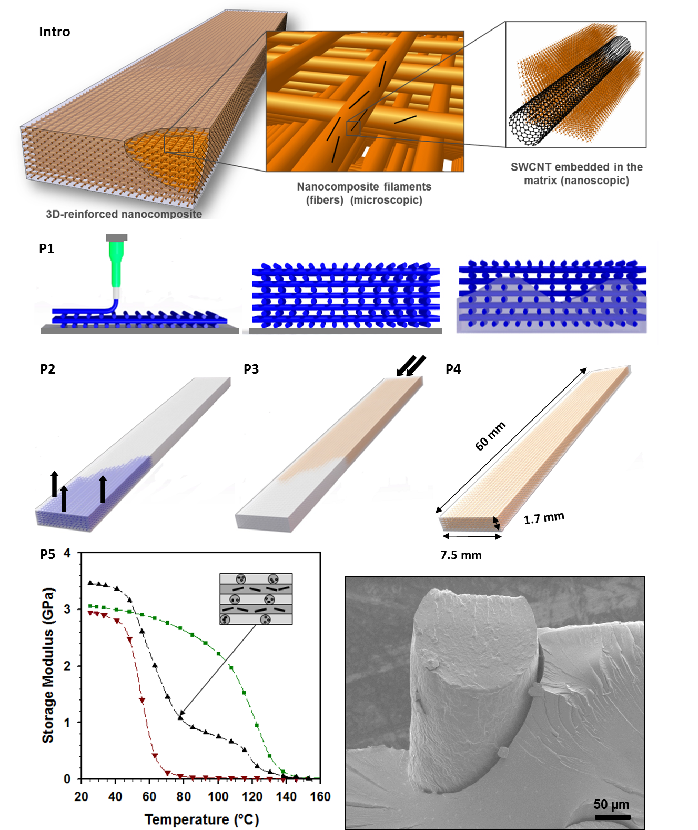

B. Interview: (Said by you on camera. Don’t forget to smile!)

  - Author name Daniel Therriault: We worked several years now on the development of novel materials most specifically polymer-based nanocomposites. We are not only working on the material level, but we also look into new ways to manufacture complex 3D parts.
  - Author name Rouhollah Farahani: The main advantage of this technique over existing methods, like injection molding, is that the present technique allows sufficient control of the three-dimensional orientation and positioning of the nanotube reinforcement during the manufacturing of a product for optimal conditions.
  - Author name Louis Laberge Lebel: The implications of this technique extend toward the utilization of other thermosetting materials and nanofillers because of the flexibility of this manufacturing technique. Several applications include structural health monitoring, vibration absorption products and microelectronics.

Protocol (read by voice talent at JoVE):

- Fabrication of 3D Microfluidic Networks
  - To make the fugitive ink, melt microcrystalline wax and petroleum jelly over a hot plate magnetic mixer at 80 °C. When melted and mixed, load the ink into a 3 cc syringe barrel.
    - WID: Talent walks to the lab bench and sets down wax and/or jelly.
    - MED: Talent adds wax and jelly to a beaker.
    - MED: Talent places the beaker on a hot plate and heats it to 80 C.
    - MED: Talent loads a 3 cc syringe with the melted fugitive ink
  - Install a 150 µm disposition nozzle on the syringe and mount the syringe onto the syringe holder of the dispensing robot.
    - MED: Talent places a 150 µm nozzle on the syringe and mounts the syringe on the syringe holder of the dispensing robot.
  - Use an Excel program to design the moving path of the dispensing robot for the fabrication of the desired 3D scaffold structure. This information should include the structure’s dimensions, the filament spacing, the numbers of layers, and the on/off status of the dispensing at each location during the fabrication.
    - MED over the shoulder: Talent at computer, entering in the path for the dispensing robot into an Excel file.
    - LAB MEDIA: Robot path design-Excel-program-JOVE.xls (Video Editor: Please just show a screen shot from the Design sheet, ~ A1:M29 or so (use your judgment as the entire sheet can’t be shown).
  - In this case, the dimensions are 60 mm in length, 7.5 mm in width and 1.7 mm in thickness with 0.25 mm horizontal spacing between each filament.
    - LAB MEDIA: Figure 2f
  - For a filament diameter of ~150 µm, set the deposition pressure to 1.9 MPa on the pressure regulator, and set the robot dispensing speed to 4.7 mm/s.
    - MED: Talent sets the deposition pressure to 1.9 MPa
    - CU: Talent sets the speed on the dispensing robot to 4.7 mm/s.
  - Next, activate the deposition of the ink-based filaments on an epoxy substrate. This results in a 2D pattern which is the first layer of the microscaffold.
    - ECU: See the ink coming out of the syringe nozzle and forming filaments. (Videographer: Please frame for an inset).
    - SCREEN: A screen capture showing the deposition of the ink in the first layer of the scaffold. Show the beginning and the end of the first layer, don’t need to show the entire layer being formed. (Video Editor: Please inset this in the above). Author note: for this section, I have sent three files: 2-6-2_first layer_entire layer, 2-6-2_first layer_the begining only, and 2-6-2_first layer_the end only. The first one is the entire deposition of the first layer, the second one is the beginning of the deposition of the first layer and the last file is the end of the deposition of the first layer. Please feel free to show any of them.
  - Continue depositing additional layers of the microscaffold by successively incrementing the z-position of the dispensing nozzle by an amount equal to the diameter of the filaments. Each layer takes about 4-5 minutes to make. Self-supporting structures that are a few hundred layers can be built in this fashion.
    - ECU: Show the ink structure with several layers, if possible, capture the ink nozzle finishing one layer and starting on the next. (Videographer: Please frame for an inset).
    - SCREEN: Show the microscaffold continuing to be built, with several layers already down. Show the ink nozzle finishing one layer and beginning the next. (Video Editor: Please inset this in the above). Author note: for this section, I have sent 3 files: 2-7-2_bulding scaffold-option 1, 2-7-2_bulding scaffold-option 2, and 2-7-2_bulding scaffold-option 3. Please choose one of them on your judgment.
  - The next step is to prepare the epoxy that will be used for encapsulation. Begin by mixing the resin and hardener, and then degas the epoxy mixture under vacuum for 30 min.
    - MED: Talent places resin and hardener together in a beaker and mixes them.
    - MED: Talent places the epoxy under vacuum. (TEXT: 0.15 bar, 30 min)
  - After degassing, load the epoxy into a 3 cc syringe barrel by applying negative pressure using a fluid dispenser, then place a nozzle with an ID of 0.51 mm into the syringe barrel.
    - MED: Talent loads epoxy into syringe by using negative pressure using a fluid dispenser.
    - MED: Talent places nozzle into the syringe barrel.
  - Place the ink scaffold at an incline to help the flow of the resin. Then, using the same fluid dispenser and mounted nozzle, place drops of epoxy at the upper end of the inclined scaffold structure.
    - CU: Talent places the scaffolding at an incline (be sure to show the angle of the incline)
    - ECU: Drops of epoxy are placed at the upper end of the scaffold
  - The epoxy then flows into the empty spaces between the filaments, driven by gravity and capillary forces. Continue placing drops of epoxy over the scaffold until the empty space between the scaffold filaments is completely filled.
    - ECU: Epoxy flowing into the empty spaces between the filaments. More drops are added over the scaffold. Finally the scaffolding is full.
  - Let the encapsulating epoxy pre-cure at room temperature for 24 hr and then put the structure in an oven to post-cure at 60 °C for 2 hr.
    - LAB MEDIA: Figure 8b
    - MED: Talent places the epoxy structure aside to pre-cure at room temperature. (TEXT: RT, 24 hr)
    - MED: Talent places the epoxy structure in an oven (TEXT: 60 °C, 2 hr)
  - After curing, use a precision saw to cut the excess parts of the epoxy. Then drill a hole, approximately 1 mm in diameter, at each end of the structure to reach the ink-scaffold. Insert a plastic tube into each of the holes.
    - MED: Talent aligns the precision saw with the epoxy structure.
    - CU: Talent saws away the excess epoxy.
    - MED or CU: Talent drills a hole at one end of the structure
    - MED: Talent places two one plastic tubes, one in each end of the structure.
  - The next step is to remove the fugitive ink from the structure. Begin by putting the samples in an oven at 90 °C for 30 min to liquefy the ink.
    - WID: Talent carries the epoxy/ink structure to an oven and places it in the oven. (TEXT: 90 °C, 30 min)
  - After removing the samples from the oven, wash the channel network by suctioning hot distilled water through the plastic tubes for 5 min. Then suction hexane through the tubes for another 5 min to remove the residual traces of the ink from the channel walls.
    - MED: Talent hooks the sample up to the hot distilled water at one end and a vacuum line at the other end.
    - ECU or SCOPE: Talent activates the suction. Show the ink coming out. Not possible to do.
    - MED: Talent swaps the hot distilled water for hexane (label the container containing the hexane)
    - ECU or SCOPE: Show hexane flowing through and out the network. Author note: Please use the file: 2-15-4_hexane flow for this section.
  - After ink removal, what remains is an interconnected 3D microfluidic network, which can be stored at room temperature until it is needed.
    - CU: Talent tilts the microfluidic structure to show the extent of the network. Please use 2.13.4 take 1 with 2 tubes here before 2.16.1.
    - LAB MEDIA: Figure 5
- Nanocomposite Preparation
  - To prepare the nanocomposites, add 150 mg of carbon nanotubes to a 0.1 mM solution of zinc protoporphyrin IX surfactant in either acetone or dichloromethane, for a final nanotube concentration of 0.5 wt.%.
    - WID: Talent approaching lab bench, carrying surfactant solution.
    - MED: Talent adds 150 mg carbon nanotubes to the surfactant solution.
  - Next, sonicate the suspension in an ultrasonic bath for 30 min to debundle the nanotube aggregates.
    - MED: Talent places the CNT/surfactant solution in an ultrasonic bath and turns it on.
  - Mix the epoxy or urethane resin with the nanotube suspension over a magnetic stirring hot plate at a temperature slightly below the solvent boiling temperature for 4 hr. Then place the nanocomposite mixture into the ultrasonication bath and sonicate while heating at 40-50 °C for 1 hr.
    - MED: Talent adds epoxy or urethane resin to the nanotube suspension.
    - MED: Talent places the nanotube mixture on a magnetic stirring plate and add a stir bar.
    - MED: Talent places the nanotube mixture to ultrasonicate (TEXT: 40-50 °C, 1 hr)
  - Next, heat the nanocomposite at 30 °C for 12 hr and then heat it under vacuum at 50 °C for 24 hr to evaporate the residual solvent.
    - MED: Talent places the nanocomposite in an oven (TEXT: 30 °C, 12 hr)
    - MED: Talent places the nanocomposite under vacuum (TEXT:0.1 bar, 50 °C, 24 hr)
  - The next day, set aside a portion of the nanocomposite at room temperature for use as a baseline comparison.
    - MED: Talent removes some of the nanocomposite and sets it aside.
  - To break any large nanotube aggregates, set the speed of the apron roll of a three-roll mixer to 250 RPMs. Beginning with a gap of 25 µm between the rolls, pass the remaining nanocomposite mixture through the rolls 5 times.
    - MED: Talent adjusts the speed of the apron roll.
    - CU: Show the three-roll mixer (Videographer, please frame for an inset)
    - LAB MEDIA: Figure 6 (middle right image of 3 rollers) (Video Editor: Please inset this into the above shot)
    - CU: Talent activates the flow of the nanocomposite mixture through the rollers. Show the mixture passing through the rollers. (TEXT: 5X, 25 µm)
  - Then adjust the gap between the rolls to 10 µm and perform 5 more passes. After a final reduction of the gap to 5 µm, do an additional 10 passes.
    - CU: Talent adjusts the gap between the rollers via the control panel of the three-roll machine.
    - MED: Talent brings the nanocomposite from the output of the rollers and places it back at the inlet to the rollers to begin a new pass. (TEXT: 5X, 10 µm)
    - CU: Fluid flowing through the rollers. (TEXT: 10X, 5 µm)
  - The nanocomposites before and after passing through the rollers are shown here.
    - LAB MEDIA: Figure 6 (Video Editor: just show the lower two images with the black dots)
  - Next, degas the final mixture under vacuum for 24 hr using a dessicator to remove the air bubbles trapped during the mixing.
    - MED: Talent places the mixture under vacuum using a dessicator (TEXT: ~0.1 bar, 24 hr)
- Nanocomposite Infiltration
  - The next step is to inject the nanocomposite into the microfluidic device. After placing the nanocomposites into the fluid dispenser, apply a negative pressure to the fluid dispenser which causes the nanocomposites to be loaded into a 3 cc syringe barrel.
    - WID: Talent carries the nanocomposite from the vacuum dessicator to the bench or hood with the microfluidic device.
    - MED: Talent applies negative pressure to the fluid dispenser.
    - CU: Show the nanocomposites being loaded into the 3 cc syringe.
  - Attach a fine nozzle into the syringe barrel, and insert the nozzle into the tubes in the microfluidic device. Then set the pressure on the fluid dispenser to 400 kPa.
    - MED: Talent attaches a fine nozzle to the syringe barrel, and inserts the nozzle into the tubes in the microfluidic device (TEXT: ID = 0.51 mm).
    - MED: Talent sets the pressure on the pressure dispenser to 400 kPa.
  - If needed to assist the network filling, apply a negative pressure to the outlet side of the microfluidic network using another fluid dispenser. Once the pressure is applied, the microfluidic network is filled by the nanocomposite suspension, which enters the network through the plastic tubes.
    - CU: Talent applies a negative pressure to the outlet side of the microfluidic network via another fluid dispenser.
    - CU: Show the nanocomposite suspension flowing into the network through the plastic tubes. I am sending a video taken by a microscope, named: 4-3-2_nanocomposite infiltration. Please see if the video is useful to be used as an inset??
  - Shortly after the injection, expose the nanocomposite-filled composite beams to UV illumination for 30 min for pre-curing. Then post-cure the manufactured beams in the oven at 80 °C for 1 hr followed by 130 °C for another 1 hr.
    - MED: Talent places the composite beams under UV illumination. (TEXT: 30 min 80 °C, 1 hr)
    - MED: Talent places the composite beams into an oven (TEXT: 80 °C, 1 hr followed by 130 °C,1 hr)
  - After cutting the excess epoxy parts using a saw, polish the beams to the desired dimensions.
    - MED: Talent saws off the excess epoxy.
    - CU: Talent polishes the beams to the desired dimensions. (TEXT: 60 mm x 6.8 mm x 1.6 mm)
    - MED: Talent holds polished beam out to the camera (camera can zoom in).
- Results: Imaging and Mechanical Testing of Nanocomposite-Injected Beams
  - Microstructures manufactured by the direct-write assembly can be used for biomedical applications and as MEMS components.
    - LAB MEDIA: Figure 4
  - An isometric view and an SEM image of the 3D-connected microfluidic empty network is shown here.
    - LAB MEDIA: Figure 5
  - An isometric image of a manufactured 3D-reinforced beam is shown here. This cross-section shows nine layers of the nanocomposite filaments.
    - LAB MEDIA: Figure 8a and 8b (Video Editor: 1st sentence, show 8a. 2nd sentence, show 8b)
  - This figure shows an SEM image of a manufactured beam’s fracture surface, and a higher magnification image of one of the channels embedded with nanocomposite microfibers. Since no debonding is seen at the channel wall, the surrounding epoxy and the infiltrated materials appear to be well adhered, presumably as a result of proper cleaning of the channels with hexane after the ink removal.
    - LAB MEDIA: Figure 8c and 8d (Video Editor: Start with 8c, add 8d at “and a higher magnification …”)
  - In contrast, shown here are beams broken during the mechanical testing in which hexane was not used during the ink removal. Fiber debonding, as a result of a poor mechanical interface, is observed which might be due to fugitive ink traces remaining after network cleaning.
    - LAB MEDIA: Figure 9
  - The storage modulus of molded bulk epoxy samples, used as benchmarks, and the 3D-reinforced beams are shown here. The manufactured beams, which are the combination of the embedded and surrounding epoxy materials, show superior temperature-dependent properties with the presence of only ~0.18 wt. % carbon nanotubes.
    - LAB MEDIA: Figure 10 (Video Editor: Show 10a first. At “and the 3D-reinforced beams …” overlay 10b (the red and green curves should line up) and remove the two grey-box labels from 10a so as not to clutter the image. 2nd sentence: highlight (mark more prominent) the arrow pointing to the black curve”)
  - A three-point bending test shows that, as a result of the positioning of the carbon nanotubes, the flexural modulus of the 3-D reinforced beams showed an increase of 34% compared to the pure epoxy-infiltrated beams. The molded bulk epoxy samples are shown for reference.
    - LAB MEDIA: Figure 11 (Video Editor: Please start with 11b, but please remove the green and red curves (that is, subtract 11a from 11b). At “3-D reinforced beams,” point to the upper (black) curve. At “pure epoxy-infiltrated beams,” point to the blue curve. For the final sentence, add back in the green and red curves, and replace 11b’s grey box-labels with 11a’s grey box-labels.)

- Conclusion (said by authors on camera)

  - Author name Rouhollah Farahani: This patterning approach could be used for a wide variety of applications, ranging from flexible microelectronics to 3D nanocomposite microstructures for MEMS.
  - Author name Daniel Therriault: So, right now, we are working toward pushing the boundaries of this method with other material systems, and we also are also looking at new ways to manufacture in three dimensions, such as freeform manufacturing of MEMS components through 3D printing, either using thermoset-based or thermoplastic-based nanocomposites. We are hoping this video will enable you to implement this technique in your laboratory to build innovative mechanical systems. Thank you for watching.

Provided Media

Authors, Please list all images, movie files, or 3-D rendered animations that can be included in the video per editor’s request. The step in the script/video where these images will be inserted should be specified. For example:

6.2 – 0123_PIname_Figure1.tif - dual color imaging of tumor angiogenesis at 40X
6.2 – 0123_PIname_Figure2.tif - dual color imaging of tumor angiogenesis at 100X

Formats: For static images we prefer .tiff, .eps, Illustrator, Powerpoint or Photoshop files at dimensions of at least 720X480 pixels and 300 dpi. The higher resolution, the better. Likewise any exported movie files should have at minimum these dimensions and be rendered to .mov, .mp4, or .avi files.

Insert your media filenames here.

If possible, I would like to have all the figures in “All-figures” PPT file in the video.

General Preparation

It’s critical for a smooth and organized shoot that all reagents are accounted for, in advance.

Any overnight or long incubation steps should be recognized and specimens/samples be prepared in advance so that prior steps can be recorded and shooting can continue with pre-prepared specimens/samples.

All tubes/flasks should be pre-labeled neatly before we arrive.

Ex. Luciferase assay done in 96 well plates should be labeled with negative/positive control wells and experimental samples are labeled accordingly.

You will receive more detailed preparation instructions, as well as an introduction to your videographer, closer to your filming date.

