Submission ID #: 51502
Editor Name: William Hoston
Videographer name:
Film Date:

Authors and Affiliations: Silke R. Kirchner, Michael Fedoruk, Theobald Lohmüller, Jochen Feldmann

Photonics and Optoelectronics Group
Ludwig-Maximilians-Universität, Munich, Germany

Title: Analyzing the Movement of the Nauplius 'Artemia Salina' by Optical Tracking of Plasmonic Nanoparticles

Corresponding Author: Theobald Lohmüller (T.Lohmuller@physik.uni-muenchen.de)

A. Will you require JoVE to record video microscopy, such as filming a complex dissection or microinjection technique? (Y/N) ___Y___ If yes, please list make and model of your microscope: Axiotech 100, Zeiss GmbH. (Update possible. Have asked if this is necessary.-wh)
B. Does your protocol include detailed, step-by-step, descriptions of software usage? (Y/N)___N_____
C. Which steps of your protocol will viewers benefit most from having filmed? Please list 4-6 steps: 4
D. What is the single most difficult aspect of this procedure and what do you do to ensure success? To proper analyze the gold nanoparticle movement in the optical trap.

1. Introduction (Schematic Overview and Interview)

A. Schematic Overview (read by voice talent at JoVE):

Procedural Narrative:

The overall goal of this procedure is to analyze the frequencies of the movement of an aquatic microorganism using an optically trapped plasmonic nanoparticle. (Intro)

This is accomplished by first observing a Nauplius larvae in water under a microscope equipped with an optical tweezer and a camera. (P1)

(Video editor: I have asked authors to submit a file “Graphic Overview” with the images shown below, but with all layers accessible. For this sentence, use image A without the red lines, and image B with only the swimming Nauplius and arcs indicating motion in the blue background (everything else should be removed). Indicate that image B is what is seen with the microscope in image A.)

The second step is to add gold nanoparticles of 60 nm diameter to the Nauplius environment. (P2)

(Video editor: Now add the gold particle of image B. If possible, show it drifting randomly)

Next, the optical tweezer is used to trap a single gold nanoparticle near the Nauplius. (P3)

(Video editor: Add the red lines back to image A, and add the red trapping region back to B. Stop the drift of the gold particle.)

The final step is to observe the diffusion of the trapped nanoparticle as it is influenced by the motion of the Nauplius. Video data is captured and analyzed by particle tracking software. (P4)

(Video editor: Please transition to use an excerpt of shot 4.1.3)

Ultimately, the time dependent nanoparticle position is transformed into Fourier space to extract the movement frequencies of the Nauplius. (P5)

(Video editor: Please use “JoVE_Video_panels.pptx,” slides 3 and 4)

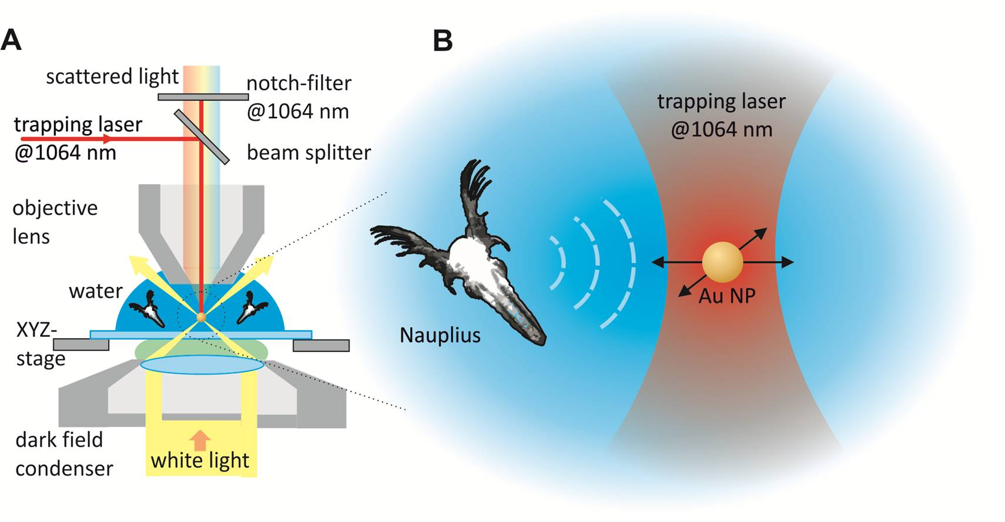

B. Interview: (Said by you on camera. Don’t forget to smile!)
  - Author name Silke Kirchner: The main advantage of this technique over existing methods, like common microscopy, is that fluidic vibrations are analyzed and therefore this method is not restricted to any optical resolution.
  - Author name Theobald Lohmüller: This method can help answer key questions in environmentalism, such as water analysis of aquatic ecosystems.

Protocol (read by voice talent at JoVE):
- Experiment Setup
  - Begin by preparing an up-right microscope equipped for dark field illumination. Provide the microscope with both a water immersion and an air objective. (TEXT: See manuscript for details) In addition, couple a 1064 nm continuous wave optical tweezer to the microscope.
    - WIDE: Microscope with talent inspecting the objectives
    - MED CU: Objectives, Microscope as talent rotates from a water immersion objective to an air objective. Note: Please identify water/air objective.
    - MED: Talent checking/indicating elements of the optical tweezer setup
2.1.4. Added shot: MED: Microscope. Note: Laser beam entering microscope.
  - Next, mount a camera with a notch filter at 1064 nm to detect and image gold particle and Nauplius motion. Use a power meter after the objective to set the laser power to 100 mW. Turn off the laser until needed.
    - MED: Talent mounting/checking camera
    - MED: Talent setting power for laser
    - MED: Talent switching off laser
- Sample Preparation
  - Sample preparation begins with pipetting a water droplet of 180 µl on a microscope glass slide. Position the sample on the dark field microscope. At this point, pipette a Nauplius from a water tank. Transfer it to the water droplet.
3.1.0. Added shot: talent at microscope putting oil drop onto dark field condenser.
    - MED: Talent at microscope pipetting a water droplet onto a glass slide
    - CU: Slide being put into position on microscope
    - MED: Talent pipetting a Nauplius
    - CU: Nauplius being placed in water droplet
  - Select the 10x air objective. Observe the movement of the Nauplius in the solution and record a 10 second video stream at 25 frames/second. When this is done, prepare for the next step.
    - MED: Talent selecting air objective and starting observation
    - LAB MEDIA/SCOPE: Video of Nauplius in water droplet
    - MED: Talent turning attention to preparing nanoparticles
  - Dilute one part stock solution of 60 nm diameter gold nanoparticles in one hundred parts water. Return to the microscope and measure out 5 µL of this solution. Add this to the water droplet with the Nauplius.
    - MED: Talent preparing solution and at microscope measuring 5 µL of solution
    - CU: Solution being added to droplet
  - When ready, change to a 100x water immersion objective to view the water droplet. Proceed when approximately one gold nanoparticle can be seen in the field of view.
    - MED: Talent changing objective and observing droplet
    - LAB MEDIA/SCOPE: Please capture video of observed environment as one nanoparticle comes into view
- Particle Tracking Experiment
  - To trap a particle, turn on the laser of the optical trap and observe the droplet. Move the microscope stage to bring the laser beam close to a gold nanoparticle. The particle will be attracted towards the focal point of the laser beam and will stop diffusing. Take a video of the trapped nanoparticle at 50 frames per second for 30 seconds.
    - MED: Talent turning on laser for optical trapping and returning to microscope use
    - LAB MEDIA/SCOPE: Video showing nanoparticle as laser beam is brought close and nanoparticle is trapped (Video editor: This will accompany the second and third sentences) Note: IR laser beam is invisible. Particle is trapped and confined in three dimensions.
    - LAB MEDIA/SCOPE: Video of trapped nanoparticle as it moves Note: moving AuNP can be seen from sec 16.
  - Turn off the laser of the optical tweezer to release the particle from the trap. The next step is to analyze the video on a computer. Use particle tracking software to determine the particle's x-y position as a function of time and find the frequency spectrum with a fast Fourier transform of this data.
    - MED: Talent leaving eyepiece and turning off laser
    - WIDE: Talent moving to computer
    - MED over the shoulder: Talent at computer in the middle of analyzing data (for example, video from experiment playing, using image tracking software, Fourier transforms)
- Results: Analysis of Gold Nanoparticle Motion in the Presence of Nauplius
  - This plot shows the x-y displacement of a trapped gold nanoparticle which is only undergoing Brownian motion. The distribution is Gaussian.
    - LAB MEDIA: “JoVE_Video_panels.pptx,” slide 1
  - After adding a Nauplius to the water, the x-y displacement of the particle changes due to fluidic vibrations. The microfluidic flow generated by the animal causes a frequency dependent distortion in the y direction.
    - LAB MEDIA: “JoVE_Video_panels.pptx,” slide 2
  - These plots show the frequency spectra in the x and y directions. In black are reference spectra for an optically trapped particle that is not in the presence of a Nauplius. The red curves show the spectra of a trapped particle with a swimming Nauplius. The spectrum in the x-direction does not show a strong signal due to the position of the Nauplius relative to the trapped particle. The flow is primarily in the y direction, as indicated in the inset.
    - LAB MEDIA: “JoVE_Video_panels.pptx,” slides 3 and 4 (Video editor: Please show these side by side–slide 3, then 4–for the first three sentences. For the fourth sentence, bring slide 3 to the foreground. Highlight the “creature” in the inset during “...position of the Nauplius...” Keep highlighted and add highlighting to the gold particle in the inset during “...position of the trapped particle.” Remove highlighting on both. In some way indicate the direction of flow during the last sentence. The direction is along the y axis; an arrow along that direction coming from the creature and crossing the semi-circular arcs would be good.)
  - The spectrum in the y direction taken with the swimming Nauplius shows a response. The broad frequency response in the measurement is consistent with the organism motility. For example, the time scale of motion for the two main antennas is about 150 µs, or a frequency of about 6.75 Hz. The motion of other body parts contribute as well. Frequency maxima across all measurements were found to be between 3.0 and 7.2 Hz, in good accordance with directly observed frequencies.
    - LAB MEDIA: “JoVE_Video_panels.pptx,” slides 3 and 4 (Video editor: Switch to having slide 4 in the foreground)

- Conclusion (said by authors on camera)
  - Author name Silke Kirchner: Once mastered, this technique can be done in 30 min if it is performed properly.
  - Author name Michael Fedoruk: While attempting this procedure, it’s important to remember to have a stable three dimensional trapping of the gold nanoparticle using optical forces.

Provided Media

Authors, Please list all images, movie files, or 3-D rendered animations that can be included in the video per editor’s request. The step in the script/video where these images will be inserted should be specified. For example:

6.2 – 0123_PIname_Figure1.tif - dual color imaging of tumor angiogenesis at 40X
6.2 – 0123_PIname_Figure2.tif - dual color imaging of tumor angiogenesis at 100X

Formats: For static images we prefer .tiff, Illustrator, Powerpoint or Photoshop files at dimensions of at least 720X480 pixels and 300 dpi. The higher resolution, the better. Likewise any exported movie files should have at minimum these dimensions and be rendered to .mov, .mp4, or .avi files.

Insert your media filenames here.

General Preparation

It’s critical for a smooth and organized shoot that all reagents are accounted for, in advance.

Any overnight or long incubation steps should be recognized and specimens/samples be prepared in advance so that prior steps can be recorded and shooting can continue with pre-prepared specimens/samples.

All tubes/flasks should be pre-labeled neatly before we arrive.

Ex. Luciferase assay done in 96 well plates should be labeled with negative/positive control wells and experimental samples are labeled accordingly.

You will receive more detailed preparation instructions, as well as an introduction to your videographer, closer to your filming date.

