Submission ID #: 51501

Editor Name: Steven Nilsen

Videographer name: Chris Gegax

Film Date: January 8, 2012

Authors and Affiliations:
Nathan J. Wittenberg 1, Timothy W. Johnson 1, Luke R. Jordan 2, Xiaohua Xu 3, Arthur E. Warrington 3, Moses Rodriguez 3,4, and Sang-Hyun Oh 1,2

1. Department of Electrical and Computer Engineering
2. Department of Biomedical Engineering
University of Minnesota
Minneapolis, MN USA

3. Department of Neurology
4. Department of Immunology
Mayo Clinic College of Medicine
Rochester, MN USA

Corresponding Authors:
Nathan J. Wittenberg, witt0092@umn.edu
Sang-Hyun Oh, sang@umn.edu

Title: Formation of biomembrane microarrays with a squeegee-based assembly method

- Will you require assistance with video microscopy, such as filming a complex dissection or microinjection technique (Y/N, please specify steps by number. Also, please list make and model of your microscope)? No

- Does your protocol include detailed, step-by-step, descriptions of software usage (Y/N, please specify steps by number)? No

- Which steps of your protocol will viewers benefit most from having filmed? (use the numbering below) Step 4

- What is the single most difficult aspect of this procedure and what do you do to ensure success? Step 4. Use gentle force when sliding the squeegee across the substrate.

- Will the shoot take place in more than one location? (Y/N, specify travel time between locations) No

Schematic Overview (read by a voice talent at JoVE)

The overall goal of this procedure is to create biomembrane microarrays using a simple preparation method. (Intro)
This is accomplished by first coating silica beads with lipid bilayer membranes. (P1)
The second step of the procedure is to deposit the lipid-coated beads on a silicon microwell substrate. (P2) The third step is to remove beads not in microwells using a polydimethylsiloxane squeegee. (P3) The final step is to image the lipid-coated bead arrays with fluorescence microscopy. (P4)
Ultimately, this method can be used to determine binding constants for toxin-lipid interactions using an array imaging approach. (P5)

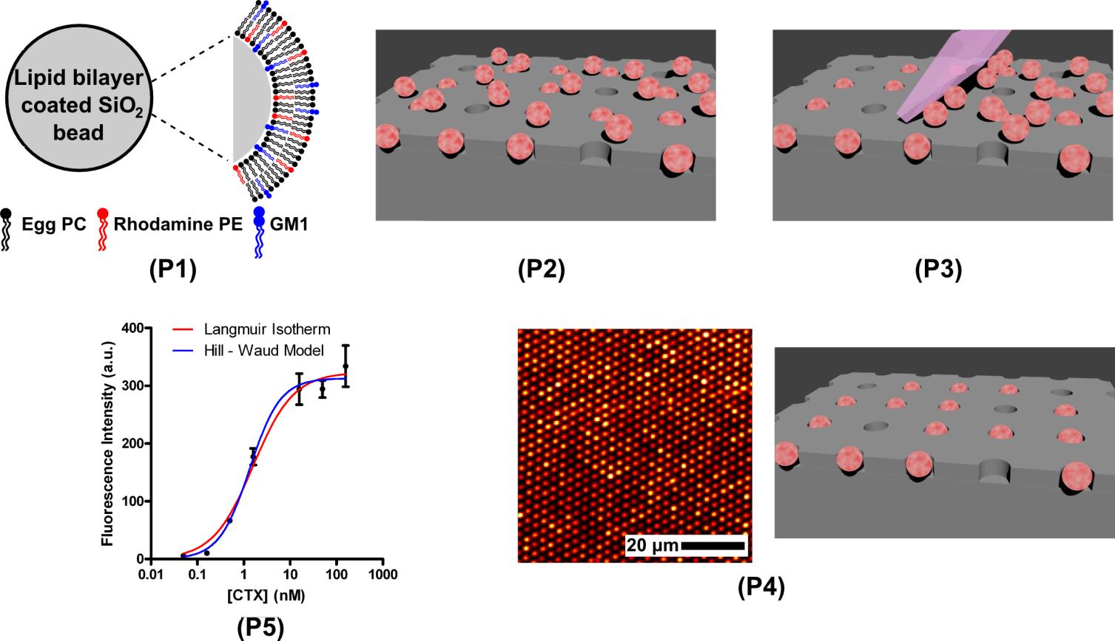
Video editor:
P1 – begin with the gray circle with text and zoom into its curvature. Then fade to the right part of the graphic, including the legend for the squiggle colors.
P2 – Zoom back out, show the gray circle and have it turn pink as you zoom out further. Get to the point where it would fit as one of the circles in P2 and then fade in P2.
P3 – Animate the pink-eraser shape lower down and slide along the grey surface (left to right) moving pink circles, either into grey holes or off the grey surface until the image on the right side of P4 is arrived at.
P4 – fade to the image on the left side of P4.
P5 – fade to P5.
- Introductory Interview (spoken by you on camera. Don’t forget to smile!)
  - Luke Jordan: This method can be used to create arrays of spherical supported lipid bilayers and natural membrane particles derived from cells.
  - Nathan Wittenberg: The main advantage of this technique over existing methods, is that apart from the fabrication of the microwells, the technique requires no chemical modification of either the substrate or the lipid membranes to create spatially defined biomembrane arrays.
  - Timothy Johnson: The applications of this technique can extend to label-free detection of lipid-protein interactions using surface plasmon resonance based on nanometric holes in metallic films.
  - Nathan Wittenberg: Though this method can provide insight into lipid-protein interactions, it can also be applied to other systems, such as studies of cellular focal adhesion.

Protocol Chapters (read by a voice talent at JoVE):
- Preparation of Vesicles
  - Microwell arrays and squeegee preparations are detailed in the text protocol. This video begins with vesicle preparation. First, in a small glass vial, mix the component lipids for the vesicles. A total of half a milligram of lipid is in this solution. (TEXT: 97 mol% PC, 2 mol% GM1, 1 mol% Rho-DPPE)
    - WID: talent at bench, mixing solutions
    - CU: small glass vial being loaded with one of mix components
    - MED: talent finishing up with third component – PC, GM1 and Rho-DPPE are the three and should each be clearly labeled and in view
  - See the supplementary materials for a spreadsheet to make volumetric calculations.
    - LAB MEDIA: the supplementary materials contains a spreadsheet, make a video of panning over the spreadsheet for this narrative – to be done by video editor
  - Under vacuum, desiccate the mixture for six hours.
    - WID: talent closes the vial into a vacuum desiccator and starts vacuum
  - Next, make a 0.1 Molar sodium chloride solution and add half a milliliter to the dried lipids. Allow the mixture to incubate overnight at room temperature. (TEXT: O/N, RT, no agitation)
    - ECU: tube content after desiccated – dried lipids
    - MED: talent at finishing making salt solution and adds some to the glass vial, then talent sets vial aside to incubate and walks off the scene
  - The next day, vortex the mixture to suspend the vesicles.
    - WID: talent arrives to tube, looking like a day has passed (dressed differently), then vortexes the tube
    - CU: tube on vortex
  - Then, sonicate the mixture for 20 minutes in a bath sonicator at room temperature.
    - MED: moving tube from the vortex to the sonication bath – adding to bath must be seen
  - After the sonication, extrude the suspension through a 100-nanometer polycarbonate membrane filter. Pass the suspension through the extrusion filter a total of 17 times, then store the extruded vesicles in a glass vial at 4 ºC. (TEXT: filter 17X, store 4 ºC)
    - MED: talent loading suspension through to pass through filter, show all required steps, then pushing it through
    - CU: solution as it is extruding from the filter – first of the 17 extrusion steps
    - CU: solution as it is extruding from the filter – late during extrusion steps, showing any change (make any note of the extrusion step in the audio)

Video editor: integrate a clock wipe from 2.7.1 to 2.7.3 or show them side by side with subtitles: 1st extrusion for 2.7.2 and 17th extrusion for 2.7.3
- Formation of Spherical Supported Lipid Bilayers (SSLB)
  - First, using 700 nanometer diameter silicon dioxide beads (TEXT: 1.4 x 10¹¹ beads / ml) make a suspension of 15 billion beads in 0.1 Molar sodium chloride. Vortex the suspension and then centrifuge it at 1,700 G for 20 minutes and discard the supernatant.
    - WID: talent at bench, making dilution of stock beads
    - MED: adding aliquot of stock solution to tube with 0.1 M NaCl, then capping and moving tube to vortex and using vortex
    - MED: talent unloading the centrifuge and removing supernatant from the sample tube, removed from centrifuge
  - Repeat the wash by resuspending the beads in another milliliter of salt solution and spinning them down for another 20 minutes. Then, repeat the process a third time. (TEXT: Wash 3X)
    - Reuse 3.1.2
    - Reuse 3.1.3
    - ECU: mixing solution into pellet of bead, in tube
  - To form the spherical supported lipid bilayers, or SSLBs, mix 25 microliters of the silicon dioxide bead suspension with 200 microliters of the vesicle suspension from the previous section. Vortex the mixture and let it incubate at room temperature for an hour.
    - MED: taking aliquots of vesicles and adding to new tube
    - MED: taking aliquots of beads and mixing into new tube
    - MED: vortexing the mix and setting aside to incubate on bench
  - Later, centrifuge the mixture at 1,700 G for 20 minutes.
    - WID: talent loading and running the centrifuge
  - Discard the supernatant. The pellet is pink due to ruptured vesicles with Rho-DPPE on the beads. Resuspend it in 225 microliters of PBS at pH 7.4.
    - MED: removing and ejecting supernatant from centrifuged tube
    - ECU: pellet of pink beads – solution is added to it and the beads are mixed into the solution
  - Repeat the spin and re-suspension steps twice to remove the unruptured vesicles and complete the creation of the SSLBs. (TEXT: Wash 3X)
    - Reuse 3.5.1
    - ECU: like 3.5.2, but after third wash
- Assembling the SSLB Array
  - Divide wafers of microwell arrays into rectangular pieces with four to six arrays each.
    - WID: talent with microwell arrays, dividing them into rectangles
    - CU: making a 4x6 array piece. {Comment: The rectangular piece of the wafer cut in this step had 6 arrays total in a 3 × 2 layout.}
  - Next, vortex the SSLB suspension from the previous section, and transfer 10 microliters to each microwell array. Wait an hour for the SSLBs to settle.
    - MED: vortexes the SSLB solution and transfers a small volume to array
    - CU: adding an aliquot of bead solution to each array in a rectangle OR show that each 4x6 rectangle gets only one addition of beads, whichever is the case. {Comment: This shot shows each array with a single drop of bead solution. We also took a still photograph of the chip showing each array with a single drop of bead solution.}
  - Later, wash the array chips with PBS gently and submerge the array into PBS.
    - MED: talent sprays rectangle with wash bottle and dips it into shallow dish of solution
  - Using the squeegee, glide over the surface of the submerged chips five times. This removes SSLBs not inside the microwells.
    - CU: squeegee applied to a rectangle
    - ECU: gliding squeegee over a rectangle 5 times
  - Next, grip each array chip with tweezers and gently shake off the PBS. Then, transfer it to a fresh PBS bath. The top surfaces of the chips must remain wet.
    - CU: using tweeezers - gripping and shaking off rectangle
    - [combined with 4.5.1] CU: setting rectangle into bath, top side clearly submerged
- Cholera Toxin Binding Assay
  - Remove a chip from the bath and wick away most of the PBS with a lab wipe. Leave enough PBS to keep the array hydrated.
    - WID: talent at bench, using tool to lift rectangle from bath
    - CU: drying rectangle with paper – show that it does not get completely dried
  - Now, add 200 µL of BSA solution (TEXT: 2 mg BSA / ml) to the array to block non-specific binding. Allow the array to incubate for an hour in a humidified box.
    - MED: adding BSA to the rectangle
    - MED: preparing a humidified box and transferring rectangle to box
  - Later, remove the BSA with a micropipette and add 200 µL of cholera toxin solution. Then, return the array to the humidified chamber.
    - CU: sucking up solution from chip
    - MED: adding “cholera toxin” to chip and placing it back into humidified box
  - Wait another hour, then wash the array with PBS and wick away excess PBS with a lab wipe.
    - WID: talent returns to work on the rectangle
    - MED: removes rectangle from box, rinses off with spray bottle and dries with paper
  - Then, place the array chip on a standard microscopy slide and attach a 18 24 × 40-mm square coverslip to the array and proceed with imaging.
    - CU: attaching a coverslip to the rectangle, show all steps involved, use wider angle if needed
  - Image analysis can be done with the ImageJ automated particle analysis functions. Then, for each array, summarize the mean intensities of the individual SSLBs as histograms.
    - MED: talent opening ImageJ, seated at computer
    - SCREEN CAPTURE: using “particle analysis” function on data in ImageJ
    - SCREEN CAPTURE: producing a histogram of mean values from array in spreadsheet or statistical analysis software

- Typical Microwell Intensities and Array Applications

Authors, to limit the length of this results section, I chose to eliminate the “array overview” as it was redundant to previous sections and inconsistent with the purpose of this section. Now, we have a long, but not overly-long section.
  - After using the outlined methods, a 100-micron square area on an array shows 936 SSLBs.
    - LAB MEDA: Fig 3a
  - Well occupancy data was calculated and a histogram of SSLB fluorescent intensities was generated.
    - LAB MEDIA: Fig 4a
  - After a week in storage, the same array was reanalyzed in the same manner and there was no change in fluorescent intensities or array occupancy.
    - LAB MEDIA: Fig 4b
  - Sequential deposition of different SSLBs with different identifying markers was also possible with the outlined methods. The second SSLBs were deposited at one-tenth the concentration of the first SSLBs deposited. An overlay of both markers is shown.
    - LAB MEDIA: Fig 3e
  - For an experiment, arrays were made with SSLBs with various concentrations of GM1 and exposed to a fixed concentration of cholera toxin.
    - LAB MEDIA: Fig 5a
  - The inverse was also performed to determine the equilibrium dissociation constant for GM1/cholera toxin binding.
    - LAB MEDIA: Fig 5c
  - Arrays can also be made from natural biomembranes, such as this array made of neuronal lipid rafts. It is labeled with lipophilic fluorophore FM1-43.
    - LAB MEDIA: Fig 6a
  - Lipid rafts are enriched in cholesterol and gangliosides such as GM1; thus, Alexa 488-conjugated cholera toxin binds strongly to lipid raft microarrays.
    - LAB MEDIA: Fig. 6b
  - By contrast, fluorescently labeled streptavidin does not bind to these arrays.
    - LAB MEDIA: Fig. 6c
  - An array was made by delivering myelin and lipid rafts to the microwells via a microfluidic chip with 250-micron channels. It was labeled with anti-oligodendrocyte IgM, and the sulfatide found in myelin was labeled, but the lipid rafts were not.
    - LAB MEDIA: Figure 7

- Conclusion Interview (spoken by you on camera)
  - Luke Jordan: Once the lipid-bilayer coated beads are prepared, this technique can be used to prepare arrays in an hour, if performed properly.
  - Timothy Johnson: Following creation of natural membrane particle arrays, other methods like nanohole surface plasmon resonance can be performed for label-free sensing of biomolecular interactions. {Comment: We let the video run for a long time while Timothy Johnson was speaking his lines. His final attempt at this section is probably the best and should be used in the video.}
  - Nathan Wittenberg: After watching this video, you should have a good understanding of how to create biomembrane arrays using lipid bilayer coated beads and natural membrane particles.

List of Provided Media Filenames and Descriptions

6.1- Wittenberg_Fig 3a.tif

6.2- Wittenberg_Fig 4a.tif

6.3- Wittenberg_Fig 4b.tif

6.4- Wittenberg_Fig 3e.tif

6.5- Wittenberg_Fig 5a.tif

6.6- Wittenberg_Fig 5c.tif

6.7- Wittenberg_Fig 6a.tif

6.8- Wittenberg_Fig 6b.tif

6.9- Wittenberg_Fig 6c.tif

6.10- Wittenberg_Fig 7.tif

General Preparation

It’s critical for a smooth and organized shoot that all reagents are accounted for, in advance.

Any overnight or long incubation steps should be recognized and specimens/samples be prepared in advance so that prior steps can be recorded and shooting can continue with pre-prepared specimens/samples.

All tubes/flasks should be pre-labeled neatly before we arrive.

Ex. Luciferase assay done in 96 well plates should be labeled with negative/positive control wells and experimental samples are labeled accordingly.

