Submission ID #: 51465

Editor Name: Linda DiBella

Videographer name:

Film Date:

Authors and Affiliations:

Mattinzoli Deborah, Renal Research Laboratory, Fondazione IRCCS Ca' Granda Ospedale Maggiore Policlinico & Fondazione D'Amico per la Ricerca sulle Malattie Renali, Milano, Italy. deborah.mattinzoli@gmail.com

Messa Piergiorgio, Department of Nephrology, Dialysis and Renal Transplant, Fondazione IRCCS Ca' Granda Ospedale Maggiore Policlinico, Milano, Italy. pmessa@policlinico.mi.it

Corbelli Alessandro, Renal Research Laboratory, Fondazione IRCCS Ca' Granda Ospedale Maggiore Policlinico & Fondazione D'Amico per la Ricerca sulle Malattie Renali, Milano, Italy. alecorbelli@hotmail.com

Ikehata Masami, Renal Research Laboratory, Fondazione IRCCS Ca' Granda Ospedale Maggiore Policlinico & Fondazione D'Amico per la Ricerca sulle Malattie Renali, Milano, Italy. aquamarine0321@libero.it

Mondini Anna, Renal Research Laboratory, Fondazione IRCCS Ca' Granda Ospedale Maggiore Policlinico & Fondazione D'Amico per la Ricerca sulle Malattie Renali, Milano, Italy. anna.mondini@gmail.com

Zennaro Cristina, Renal Physiopathology Laboratory, Department of Medical, Surgical and Health Sciences, University of Trieste, Trieste, Italy. czennaro@units.it

Armelloni Silvia, Renal Research Laboratory, Fondazione IRCCS Ca' Granda Ospedale Maggiore Policlinico & Fondazione D'Amico per la Ricerca sulle Malattie Renali, Milano, Italy. armellonis@libero.it

Li Min, Renal Research Laboratory, Fondazione IRCCS Ca' Granda Ospedale Maggiore Policlinico & Fondazione D'Amico per la Ricerca sulle Malattie Renali, Milano, Italy. li_min@libero.it

Giardino Laura, Renal Research Laboratory, Fondazione IRCCS Ca' Granda Ospedale Maggiore Policlinico & Fondazione D'Amico per la Ricerca sulle Malattie Renali, Milano, Italy. giardinolaura@gmail.com

Rastaldi Maria Pia, Renal Research Laboratory, Fondazione IRCCS Ca' Granda Ospedale Maggiore Policlinico & Fondazione D'Amico per la Ricerca sulle Malattie Renali, Milano, Italy. mariapia.rastaldi@policlinico.mi.it

Title: Application of Retinoic Acid to Obtain Osteocytes Cultures from Primary Mouse Osteoblasts

Corresponding Author:

Maria Pia Rastaldi, MD, PhD
Renal Research Laboratory
Fondazione IRCCS Ca’ Granda Ospedale Maggiore Policlinico
Via Pace 9 – 20122 – Milano
Phone 0039 02 55033879 – Fax 0039 02 55033878 –
E-mail: mariapia.rastaldi@policlinico.mi.it

A. Will you require JoVE to record video microscopy, such as filming a complex dissection or microinjection technique? (Y/N) ___N____ If yes, please list make and model of your microscope: ______________________________
B. Does your protocol include detailed, step-by-step, descriptions of software usage? (Y/N)__N______
C. Which steps of your protocol will viewers benefit most from having filmed? Please list 4-6 steps: 1.4; 2.10; 2.11; 2.12; 2.13.__________________________
D. What is the single most difficult aspect of this procedure and what do you do to ensure success? To ensure success of the procedure it is crucial to plate the correct number of cells, re-plate them in case of excessive proliferation, and daily assess morphological changes. _

1. Introduction (Schematic Overview and Interview)

A. Schematic Overview (read by voice talent at JoVE):

Conceptual Narrative:
The overall goal of this procedure is to obtain mature, ramified osteocytes from primary osteoblasts. (Intro)

This is achieved first by isolating primary osteoblasts from bones of newborn mice and culturing them to allow osteoblast maturation. (P1, Editor, begin with the top left hand round structure in P1, then scroll to the middle panel of the plates with red liquid, then scroll to the bottle with the +AA and +GP, then zoom in on the panel of gray cells.)

Next, confluent osteoblasts are trypsinized, then counted and re-plated at a defined density to ensure the success. (P2, Editor, begin with the top left gray panel, then for counting, scroll to the top right panel with the grid, then for the replating at a defined density, zoom in on the bottom gray panel of cells.)

Then, All Trans Retinoic Acid, or ATRA (pronounce ATRA) is added to the cell medium to reduce cell proliferation and induce complete differentiation towards osteocyte morphology. (P3, Editor, with P2, remove the ATRA and mRNA text. Then add in the ATRA with the arrow and then add in the mRNA with the arrow.)

Results are obtained that show that in the presence of ATRA, cells rapidly acquire a ramified morphology, stop producing extracellular matrix, and differentiate towards a mature osteocyte phenotype, as shown by expression of osteocyte markers. (P4, Editor, begin with the gray panel of cells on the left, then one by one, add in the three panels on the right as shown.)

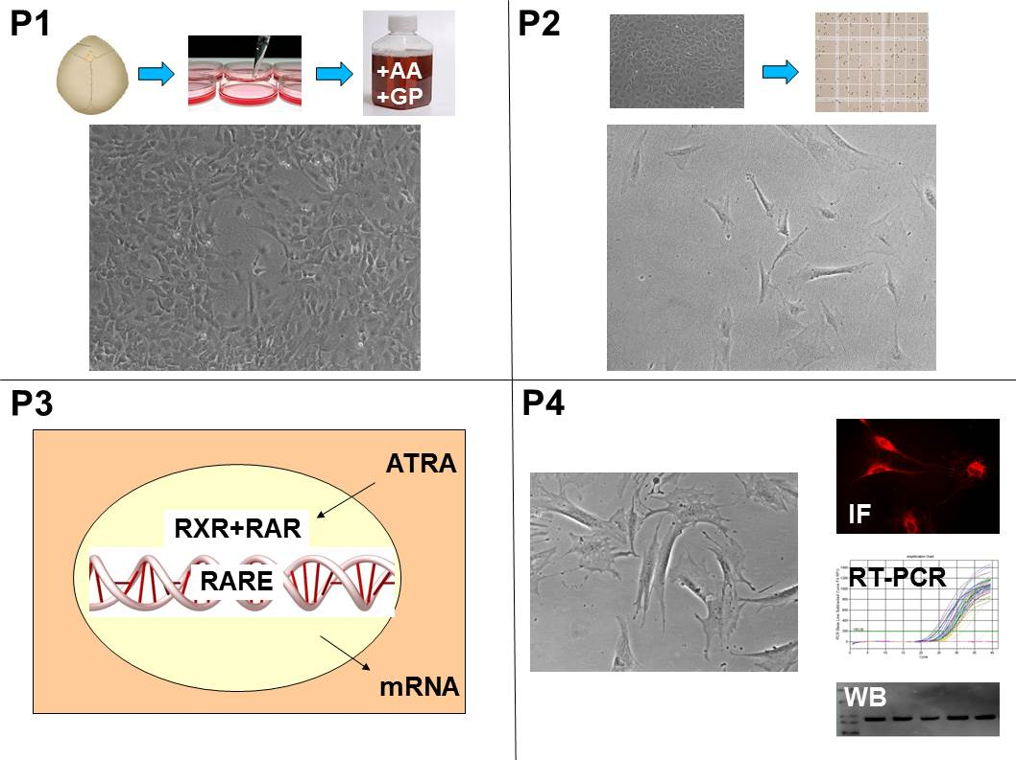

Paste a copy of your graphic overview here. The original file should be Adobe Illustrator (preferred) or Powerpoint (see instructions) and should be uploaded through your online submission on the JoVE website. Please keep all layers in the file (i.e., do not flatten the file).

B. Interview: (Said by you on camera. Don’t forget to smile!)

  - Author name Maria Pia Rastaldi: The main advantage of this technique over existing methods, such as the isolation of primary osteocytes, or the differentiation of osteoblasts in a three-dimensional matrix, is that it provides sufficient numbers of osteocytes in a few days. The absence of a surrounding matrix facilitates the use of these cells in any cell biology and molecular biology assays. Furthermore, the method can be applied to transgenic mice, allowing functional studies on molecules of interest.
  - **Author name Maria Pia Rastaldi: Demonstrating the procedure will be Deborah Mattinzoli a PhD_from my laboratory.
    - Interview style: Author saying the above
    - The named technician, post doc, student looks up from workbench or desk or microscope and acknowledges the camera.

Protocol (read by voice talent at JoVE):

- Isolation of Primary Osteoblasts

  - TEXT ON WHITE BACKGROUND: All animal experiments were performed according to the National and European current regulations regarding the protection of animals used for scientific purposes and were reviewed and approved by the ethical committee of Milan University.
    - Text of the above statement

  - To begin, prepare digesting medium by adding 0.1% collagenase P and 0.05% Trypsin to Hanks Balanced Salt Solution, or HBSS (spell it).
    - WIDE Talent at bench begins to prepare digesting medium
    - MED/CU Collagenase P and trypsin labeled and lined up on bench – talent picks up collagenase and adds aliquot to HBSS

  - After sacrificing and decapitating 3-4 day old mice, use 70% ethanol to spray the head and place it on ice. Then with tweezers and dissecting scissors, remove the skin and muscle layers.
    - MED/CU Talent sprays mouse heads on bench and places on ice
    - CU Talent uses tweezers and dissecting scissors to remove skin and muscle layers

  - Gently remove the parietal bones and separate them in two halves by following the sagittal suture. After removing any sutures and adherent tissue, place the individual bone pieces in HBSS medium.
    - CU Talent removes parietal bones and separates them by following the sagittal suture

  - Next, discard the HBSS and add the digesting medium to each well, then incubate at 37 °C for 15 minutes. After discarding the supernatant, add fresh digesting medium and repeat the incubation.
    - CU Talent finishes discarding the HBSS then adds digesting medium to each well
    - WIDE Talent places plate into incubator; B need another version for 3.2.3 below
    - FREEZE FRAME of 2.5.1, talent adding digesting medium
    - FREEZE FRAME of 2.5.2, talent placing plate in incubator, Editor, bring 2.5.4 in side-by-side with 2.5 3 as a split frame with ‘repeat the incubation’

  - After the second incubation, collect the supernatant and combine it with alpha-MEM (pronounce alphamem) supplemented with FBS (spell it) and pen/strep (TEXT: refer to text protocol for details).
    - CU Talent picks up tube of collected supernatant and combines with alpha-MEM

  - Repeat the digestion two more times, combining the supernatant with the medium. Then centrifuge the pooled fractions at 425 x g for 5 minutes, discard the supernatant and resuspend the pellet in supplemented alpha-MEM, before transferring the cell suspension to a 25 cm² flask.
    - FREEZE FRAME from 2.6.1 of talent combining supernatant with alpha-MEM
    - MED Talent places fractions in centrifuge (shot 7.2.BIS contains the correct centrifuge values)
    - CU Talent aspirates supernatant with pipette
    - CU Talent finishes resuspending pellet then transfers suspension to flask

  - After incubating at 37°C for 24 hours, remove the debris and dead cells. Then, add alpha-MEM followed by 50µg/ml ascorbic acid, or AA and 3mM glycerol 2-phosphate disodium salt hydrate, or GP to the culture before returning to the incubator (TEXT: change medium every other day).
    - MED Talent approaches hood with plate just removed from incubator
    - CU/ECU Talent removes debris and dead cells from flask, then adds again alpha-MEM.
    - CU Talent adds AA and GP (shots 8.2 and 8.3 are all in 8.1).
- All-trans Retinoic Acid Protocol

  - TEXT ON WHITE BACKGROUND: Conduct all experiments with All Trans Retinoic Acid in a darkened room to prevent inactivation.
    - TEXT of above statement

  - After removing the medium from sub-confluent cells and using HBSS to wash them, add freshly prepared trypsin (TEXT: 37°C) and incubate for 3 minutes at 37°C.
    - MED/CU Talent washing cells with HBSS
    - CU Talent adds trypsin to cells
    - WIDE Use 2.5.2B here

  - When the cells have detached (TEXT: check under inverted microscope), add 3 ml of alpha-MEM medium to inactivate the trypsin. Recover the cells and centrifuge at 425 g for 15 minutes before resuspending the cell pellet in fresh medium.
    - MED/CU Talent adds medium to inactivate trypsin
    - B [added shot] Cells are transferred in a tube
    - MED Talent places tube of cells into centrifuge
    - CU Talent adds fresh medium to cell pellet and resuspends

  - Place a drop of the suspension in a hemocytometer, allow it to settle for a few minutes, and count the cells.
    - ECU Talent places a drip of suspension in hemocytometer
    - MED Talent at scope places hemocytometer on stage and begins counting cells

  - Using alpha-MEM plus AA/GP, transfer the cells to 25 cm² flasks at a density of 10,000 cells/cm². A higher cell density will impair proper development of cell processes, and lower cell numbers can result in cell death due to the absence of intercellular contacts.
    - CU Talent adds medium to arrive at 10,000 cells/cm².

Shot 5.1.BIS added with some more medium.
    - LAB MEDIA Fig. high density.tif: example of cells re-plated at too high density
LAB MEDIA Fig. low density.tif: example of cells re-plated at too low density, Editor, place side-by-side with high density.tif fig with ‘lower cell numbers can result in cell death…’

  - While incubating, add ATRA to the medium at a concentration of 5 µM every 24 hours. Morphological changes are generally observed after 48 hours. A homogeneous population of mature osteocytes should be present after 4-5 days. The cells can be used for up to 12-15 days (TEXT: refer to text protocol for staining protocols).
    - MED Talent adds ATRA to medium
    - LAB MEDIA Figure 1A
    - LAB MEDIA LAB MEDIA Figure 1C, Editor, show 1A and 1C side-be-side as a before and after ATRA treatment
- Results: Osteocytes Generation using Retinoic Acid

  - As shown here, AA/GP treated primary cells have mostly cobblestone-like features, characteristic of mature osteoblasts. Interspersed ramified cells, indicated by the red arrows, likely represent some osteocytes.
    - LAB MEDIA Figure 1a

  - After 2 days of ATRA treatment, cells rapidly start displaying ramifications. As seen in this figure, ramified cells require space to extend their dendrites (Fig 1b). As the treatment with ATRA proceeds, ramifications progressively increase in number and complexity (Fig 1c-d). Staining of filamentous actin by rhodamine-labeled phalloidin highlights cell processes.
    - LAB MEDIA Figure 1b
    - Figure 1c-d
    - LAB MEDIA Figure 2, Editor, bring in Figure 2 as a fourth panel with 1b, c, and d

  - Primary osteoblasts produce large amounts of calcified matrix, which accumulates over and among cells and can be visualized by alizarin red staining. In contrast, osteocytes do not produce calcified extracellular matrix, and alizarin red staining is completely negative in ATRA-incubated cells. Accordingly, none or minimal alizarin red can be measured after the extraction procedure.
    - LAB MEDIA Figure 3a, Editor, bring in for first sentence
    - LAB MEDIA Figure 3b, Editor, bring in next to 3a for, ‘In contrast’
    - LAB MEDIA Figure 3c, Editor, under the two images, bring in the graph with ‘Accordingly…’

  - As shown here, immunostaining for sclerostin reveals intense cytoplasmic expression and the presence of positive dots along cell processes. In addition, FGF23 (pronounce FGF twenty three) is highly detectable in ATRA-treated cells (Fig 5), in both the cell body and along cell processes.
    - LAB MEDIA Figure 4
    - LAB MEDIA Figure 5, Editor, bring in next to Figure 4 with ‘In addition, FGF23…’

- Conclusion (said by authors on camera)

  - Author name Deborah Mattinzoli: While attempting this procedure, it’s important to remember that you are dealing with primary cells. Therefore, adjustments of ATRA concentration and re-plating of the cells if proliferation remains elevated after ATRA addition have to be taken in consideration, especially when dealing with transgenic animals. Remember that cell morphology is critical in guiding all steps of this method; therefore check the cells every day under an inverted microscope.

Provided Media

Authors, Please list all images, movie files, or 3-D rendered animations that can be included in the video per editor’s request. The step in the script/video where these images will be inserted should be specified. For example:

6.2 – 0123_PIname_Figure1.tif - dual color imaging of tumor angiogenesis at 40X
6.2 – 0123_PIname_Figure2.tif - dual color imaging of tumor angiogenesis at 100X

Formats: For static images we prefer .tiff, Illustrator, Powerpoint or Photoshop files at dimensions of at least 720X480 pixels and 300 dpi. The higher resolution, the better. Likewise any exported movie files should have at minimum these dimensions and be rendered to .mov, .mp4, or .avi files.

Insert your media filenames here.

3.5 - Fig. high density.tif – brightfield image of cells that were plated at too high density 20X

3.5 - Fig. low density.tif – brightfield image of cells that were plated at too low density 20X

General Preparation

It’s critical for a smooth and organized shoot that all reagents are accounted for, in advance.

Any overnight or long incubation steps should be recognized and specimens/samples be prepared in advance so that prior steps can be recorded and shooting can continue with pre-prepared specimens/samples.

All tubes/flasks should be pre-labeled neatly before we arrive.

Ex. Luciferase assay done in 96 well plates should be labeled with negative/positive control wells and experimental samples are labeled accordingly.

You will receive more detailed preparation instructions, as well as an introduction to your videographer, closer to your filming date.

