Submission ID #: 51459

Editor Name: Steven Nilsen

Videographer name: Jens Tomat

Film Date: December 12, 2013

Authors and Affiliations:
Mandy Stubbendorff^{1,2*}, Xiaoqin Hua^{1,2*}, Tobias Deuse^{1,2,3}, Ziad Ali^{4,5}, Hermann Reichenspurner^{2,3}, Lars Maegdefessel⁶, Robert C. Robbins⁷, Sonja Schrepfer^{1,2,3,4}

*M.S. and X.H. share first authorship

1. Transplant and Stem Cell Immunobiology Lab, Cardiovascular Research Center, University Hospital Hamburg, Germany.
2. Cardiovascular Research Center (CVRC) and DZHK University Hamburg, Germany.
3. Cardiovascular Surgery, University Heart Center Hamburg, Germany.
4. Center for Interventional Vascular Therapy, Division of Cardiology, Columbia University, New York, NY.
5. Cardiovascular Research Foundation, New York, NY.
6. Karolinska Institute, Stockholm, Sweden.
7. Department of Cardiothoracic Surgery, Stanford University School of Medicine, Falk Cardiovascular Research Center, Stanford, CA.

Corresponding Author: Sonja Schrepfer, schrepfer@stanford.edu

Title: Inducing Myointimal Hyperplasia Versus Atherosclerosis in Mice

- Will you require assistance with video microscopy, such as filming a complex dissection or microinjection technique (Y/N, please specify steps by number. Also, please list make and model of your microscope)?
Yes, the surgery needs filming through the surgical microscope, Steps 2.8 to 2.18.

- Does your protocol include detailed, step-by-step, descriptions of software usage (Y/N, please specify steps by number)?
No

- Which steps of your protocol will viewers benefit most from having filmed? (use the numbering below)
Steps 1.7 to 1.18 and 2.6 to 2.13

- What is the single most difficult aspect of this procedure and what do you do to ensure success?
For the intima hyperplasia model: It is important that the Aorta shows a nice pulse after the surgery, therefore the stitches have to be performed very carefully not to involve the back wall of the aorta.

Schematic Overview (read by a voice talent at JoVE)

The overall goal of the following experiment is to introduce two valid animal models leading to narrowing of the aorta via different mechanisms. (Intro) The first model is balloon catheterization of the aorta to create the development of myointimal hyperplasia. (P1) First, the infrarenal abdominal aorta is exposed and clamped. (P3) Then, the aorta is opened with a transverse incision and the balloon catheter is introduced. (P4) The endothelium of the aorta is then denuded with the inflated catheter (P5) and the surgery is completed. (P6) The second model is a dietary manipulation of transgenic ApoE null mice to create atherosclerotic plaques. (P7) These mice are housed under standard conditions and fed a high lipid western diet for 4 to 6 months (P8). Ultimately, histological analysis of the surgically induced, myointimal hyperplasi and (P9) the dietary restriction model shows that they result in different luminal narrowing. (P10)

Video editor:
The authors have created several illustrations and “slides” for this section. The illustrations are shown at the end of this document because they are large and that text bubbles label their P-numbers. The bubbles are sitting above the graphics – be sure that they are not included in the animation.
P1 – just show P1
P2 – skipped, tied to P3.
P3 – start with P2 and fade to P3. In P3, you can add the yellow blob and scissors with associated labels and arrows after bringing everything else.
P4 – Notice that this is a blow up, animate the zoom in and change to P4
P5 – also a blow up, animate the zoom in and arrive at P5.
P6 – zoom out and out and out back to P2 and fade to P6.
P7, P8, P9 and P10 – just show the provided graphics. No animation needed.

Introductory Interview (spoken by you on camera. Don’t forget to smile!)

  - Sonja Schrepfer: Today we will show you two different mouse models to induce luminal narrowing: The vessel injury model using a balloon and the atherosclerosis model using transgenic mice and the western diet.
  - Mandy Stubbendorff: The balloon catheter model can help answer key questions in the re-stenosis field.
  - Xiaoqin Hua: The transgenic homozygous ApoE mutant mouse model is used to study the pathophysiology of atherosclerosis.

Protocol Chapters (read by a voice talent at JoVE):
- Inducing Myointimal Hyperplasia
  - For the intimal hyperplasia model, obtain C57 black 6J mice that weigh about 25 grams. Maintain them under normal conditions with a normal diet.
    - WID: talent with cage of mice
    - MED: moving mouse to a scale, recording its weight and returning it the cage
  - After anesthetizing the mouse with 2% isoflurane, trim off the abdominal hair. During the surgery, provide Carprofen by subcutaneous injection, for analgesia. (TEXT: 4 – 5 mg Carprofen / kg)

    - MED CU: talent positions mouse to shave hair and shaves, puts mask on mouse, should then shroud the mouse’s face
    - MED: loading syringe with Carprofen and placing it at the ready next to surgical instruments
    - ECU: shaving the abdomen, avoid showing mouse face
  - Next, alternately disinfect the skin with provo-Iodine and 80% ethanol, in two cycles.
    - CU: scrubbing the abdomen clean, alternating between two solutions
  - Now, check for an absence of reflexes using a toe pinch.
    - ECU: pinching toe, no movement in leg in response to pinch
  - During the surgery, provide Carprofen by subcutaneous injection, for analgesia. (TEXT: 4 – 5 mg Carprofen / kg)
    - MED: loading syringe with Carprofen and placing it at the ready next to surgical instruments
  - Start the surgery by separating the skin and muscle along the linea alba.
    - ECU: two cuts made into animal, exposing intestines – make sure the linea alba is identified for the viewer
  - Next, wrap the intestines in a glove moistened with saline.
    - ECU: moving intestines to the side
  - Then, attentively clear away the fatty tissue, sheeting the abdominal aorta.
    - SCOPE: (could be ECU, but scope more likely) digging up the tissue to expose aorta
  - Now, expose the infrarenal aorta down to its bifurcation, taking care not to injure any branch vessels.
    - SCOPE: exposing the infrarenal aorta to the bifrucation – must be clearly seen
  - Now clamp the aorta. First, place a microsurgical clamp on the proximal, infrarenal aorta to shut down the blood flow.
    - SCOPE: placing 1st clamp on aorta
  - Second, apply a second distal clamp next to the aortic bifurcation.
    - SCOPE: placing 2nd clamp on aorta
  - When the blood flow is interrupted, make a small incision into the aorta close to the proximal clamp.
    - SCOPE: making cut in aorta near clamp closet to heart
  - Insert the catheter towards the distal clamp of the aorta.
    - CU: wetting the catheter with towel
    - SCOPE: inserting the catheter
  - To make an endothelial injury, denude the aorta by inflating the catheter balloon carefully and slowly pulling the catheter into the direction of the proximal clamp. Repeat this maneuver twice for a total of three aorta inflations.
    - CU: action associated with pumping air into animal
    - SCOPE: catheter balloon inflated, moving it, then deflating it – repeated twice more
  - Sonja Schrepfer: It is important to remove the endothelium by inflating the balloon to adequate pressure that removes the endothelium layer without rupturing the vessel wall.
    - MED: talent at scope, gives interview segement
  - Now, remove the catheter and close the aortic incision using 10-0 prolene running sutures.
    - SCOPE: remove catheter
    - [split shot] SCOPE: and sewing the aorta closed
  - With sutures in place, carefully open the distal clamp. If there is bleeding at the aortotomy site, close the clamp again, locate the bleeding and stop it with additional interrupted stitches.
    - SCOPE: releasing one of two clamps – bleeding dealt with if any noted
  - When there is no bleeding, slowly open the proximal clamp. An aortic pulse should be visible, distal to the incision.
    - SCOPE: releasing the second of two clamps, pulse in aorta should be seen next
  - Now, arrange the intestines in situ.
    - SCOPE: putting intestines back into abdomen
  - Then, rinse the abdominal cavity with warm saline.
    - SCOPE/ECU: rinsing the abdomen out
  - Next, close the abdominal wall beginning with the muscle layer using 6-0 prolene running sutures.
    - ECU: sewing the abdomen wall shut (WAS SHOT ACCIDENTLY AS 2.20.1.)
  - Then, close the skin with 5-0 sutures and transfer the mouse back to its cage.
    - ECU: sewing the skin shut
    - MED: moving mouse to its home cage, try not to show face
  - Over the first three post-operative days, provide Metamizol to the drinking water (TEXT: 50 mg Metamizol / 100 ml H₂0) for pain control. Monitor the animal throughout its recovery, which takes about 28 days.
    - MED: talent with mouse cage and water bottle, adding Metamizol-dosed water to water bottle and attaching bottle to cage
    - CU: mouse, post-operative, active in cage, eating/drinking/preening
- Modeling Atherosclerosis: Sudan Red Staining
  - For the atherosclerosis model, obtain four week-old apo-E-deficient mice (TEXT: B6.129P2-Apoe^{tm1Unc} / J). House these mice under standard conditions with a high lipid western diet for 4 to 6 months, maintaining this diet throughout the experiment.
    - WID: talent with mouse cage, food tray in cage empty
    - MED: adding food to cage from “high lipid western diet” supply (clearly labeled)
    - CU: mouse in cage, feasting on tasty food
  - After dieting on high fat food for months, prepare the animal to harvest tissue by injecting 1 ml of 3% Thioglycollate Broth, intra-peritoneal and wait three days.
    - WID: talent arrives at bench with mice that have eaten a lot of high-fat food, hopefully they are noticeably fat
    - MED/CU: loading syring with Thioglycollate Broth, clearly labeled stock solution in view
  - Six hours before harvesting the aorta, take away access to food.
    - WID: talent arrives to mouse on bench, talent looks different (days later) and takes food away from mouse
  - Then, prepare the mouse for surgery as described in the previous section. Start the surgery by opening the chest.
    - MED: talent with mouse all laid out for surgery, face of mouse draped, all needed tools at the ready (if this is to be filmed under the scope, be sure that the scope is in the shot)
    - ECU: opening the chest
  - Next, cut off the apex of the heart and perfuse it under gentle pressure with three milliliters of 4% paraformaldehyde through the aortic root to fix the aorta.
    - ECU/SCOPE: heart apex slit open and solution ejected from syringe into heart (scope shots are preferred for this section, but authors may not use scope – in which case ask if the scope can be used just to get better video and the scope doesn’t need to be shown in the set up)
  - Then, free the aorta from the root to its bifurcation. Try to remove as much of the fatty tissue as possible.
    - ECU/SCOPE: isolating the heart and removing surrounding tissue
  - Next, cut off the aortic arch and store it in 4% paraformaldehyde.
    - CU: submerging the aortic arch heart (and root?) into soluton
  - Now, transfer the heart and aortic tree to a silicone-lined dish with PBS.
    - CU: setting the heart aortic tree into dish with solution
    - [added shot] CU: putting aortic tree in PBS
  - In the dish, cut one end of the aortic tree and fix it onto the silicone layer with fine pins.
    - ECU/SCOPE: cutting one end of tissue and pinning it to the dish
  - Open the aorta longitudinally and allow the aortic tissue to lie in PBS at room temperature for a few minutes.
    - ECU/SCOPE: cutting open the aorta
    - MED: talent backing off from dish, holding instrument, sets it down and takes note of time on phone/watch/clock
  - Then, rinse the tissue once with 50% ethanol and immerse it into a bath of Sudan III staining solution for about 15 minutes.
    - CU: rinsing the tissue with ethanol, briefly
    - MED: moving the tissue from ethanol to Sudan III stain bath, then starting a timer
  - After staining, quickly rinse the tissue with 50% ethanol for a few seconds, to remove just the excess Sudan III – over-rinsing will remove too much stain. Immediately rinse the tissue with distilled water, and proceed with imaging.
    - CU: moving the tissue to ethanol, then removing
    - CU: rinsing tissue with water directly after removing from ethanol
    - MED: mounting the tissue for imaging
- Analysis Options
  - For the myointimal hyperplasia model, denuded mouse aortas were harvested, paraffin-embedded and stained with trichrome.
    - LAB MEDIA: Figure 1A – just the trichome stain, no title
  - I/M ratios were calculated from the trichrome stained sections by measuring intima and media thickness using computer analysis followed by calculation of the ratio.
    - LAB MEDIA: Figure1A+I/M – the trichome stain left and the I/M cartoon right
  - Maximum plaque thickness was measured as the maximum intimal thickness in the lumen by computer morphometry.
    - LAB MEDIA: Figure1A+thickness – the trichome stain left and the plaque thickness cartoon right
  - The percentage of luminal obliteration was calculated as the ratio of the new inner lumen from the former lumen.
    - LAB MEDIA: Figure1A (as 4.4.1)?
    - LAB MEDIA: Figure1C – just the luminal obliteration cartoon

Video editor: fade 1C_luminal_area over 1A and dim 1A, at “subtracting”
  - The plaque area was calculated by subtracting the new inner lumen from the former lumen.
    - LAB MEDIA: Figure1A
    - LAB MEDIA: Figure1C – just the plaque area cartoon

Video editor: fade 1C_plaque_area over 1A and dim 1A, at “subtracting”
  - The same analyses were performed on trichome stained cross sections of the atherosclerosis model at the aortic valve …
    - LAB MEDIA: Figure1E – aortic valve panel
  - … the aortic arch ….
    - LAB MEDIA: Figure1E – aortic arch panel
  - …. and the descending aorta.
    - LAB MEDIA: Figure1E – descending aorta panel
  - For just the athersclerosis model, the descending aorta was opened longitudinally and stained with sudan red. The plaque area and the total aortic area were measured with the aid of a computer.
    - LAB MEDIA: Figure1D

Video editor: pan over this than blow it out to show whole structure – all black background.

- Conclusion Interview (spoken by you on camera)

  - Xiaoqin Hua: For analysis of both models, other methods such as histolopathology and confocal immunofluorescence microscopy can be performed in order to answer questions like luminal obliteration, morphology, and cellularity.

5.2. Sonja Schrepfer: Thank you for watching and good luck with your experiments.

List of Provided Media Filenames and Descriptions (fill this in)

In this space, please list all images, movie files, or 3-D rendered animations that can be included in the video per editor’s request. The step in the script/video where these images will be inserted should be specified. For example:

6.2 – 0123_PIname_Figure1.tif - dual color imaging of tumor angiogenesis at 40X
6.2 – 0123_PIname_Figure2.tif - dual color imaging of tumor angiogenesis at 100X

Formats: For static images we prefer .tif files at dimensions of at least 720X480 pixels and 300 dpi. Higher resolutions are better. Likewise any exported movie files should have at minimum these dimensions and be rendered to .mov, .mp4, or .avi files.

Authors, please fill in a list here according to the boxed directions above. You created many different image files for this and making the file name list that associates the files to each shot number will be immensely valuable to the video editor. Thanks. START TYPING THEM UP HERE.

General Preparation

It’s critical for a smooth and organized shoot that all reagents are accounted for, in advance.

Any overnight or long incubation steps should be recognized and specimens/samples be prepared in advance so that prior steps can be recorded and shooting can continue with pre-prepared specimens/samples.

All tubes/flasks should be pre-labeled neatly before we arrive.

Ex. Luciferase assay done in 96 well plates should be labeled with negative/positive control wells and experimental samples are labeled accordingly.

Supplement: Schematic Images

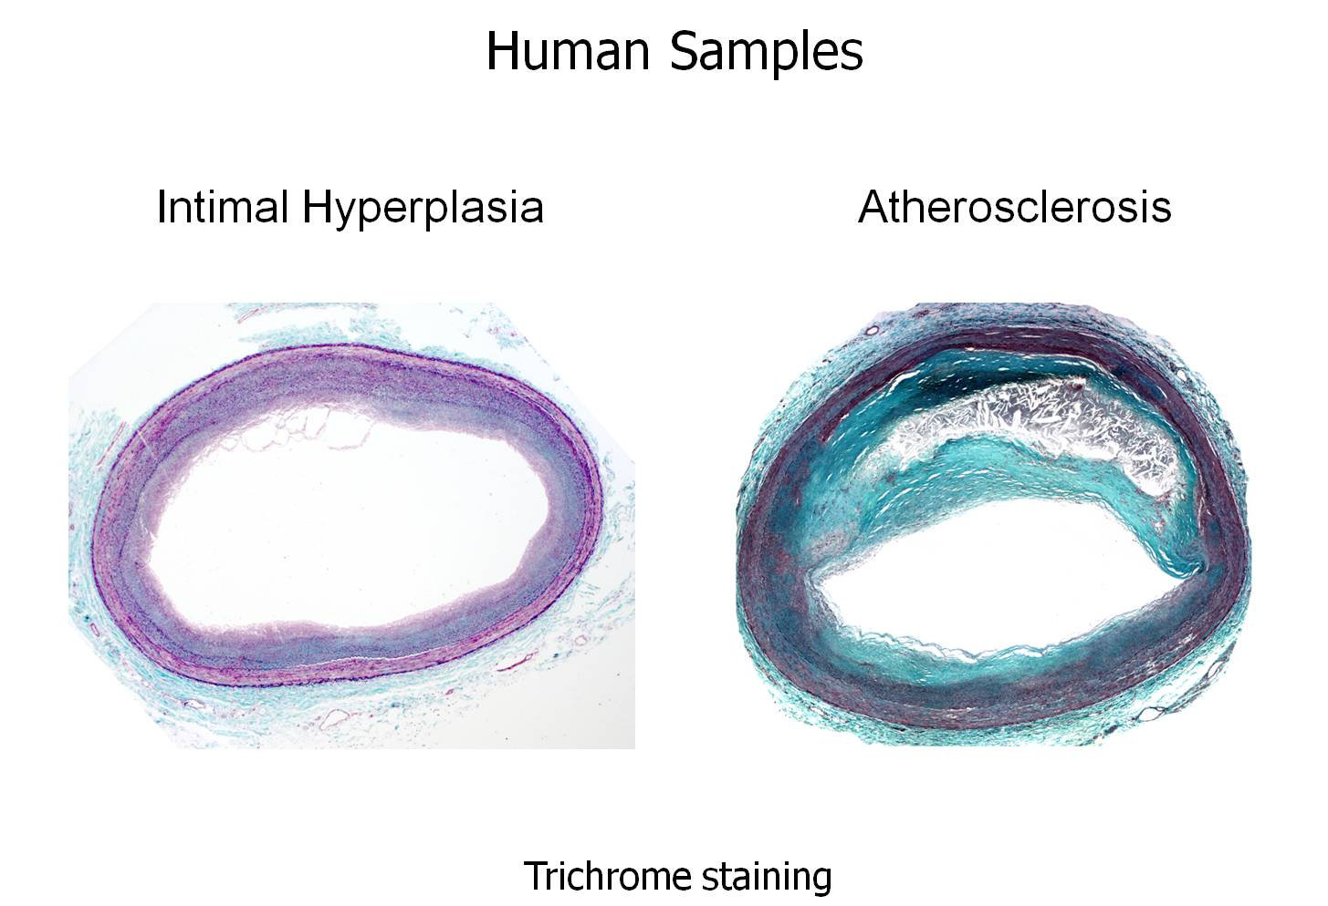
Intro

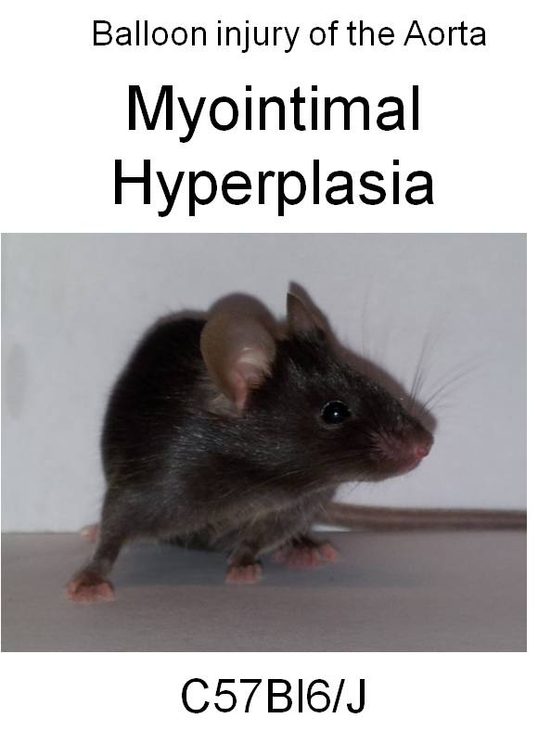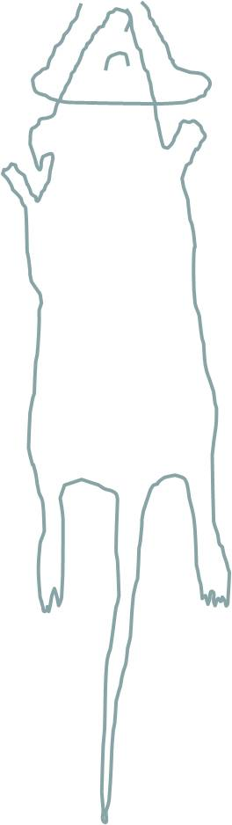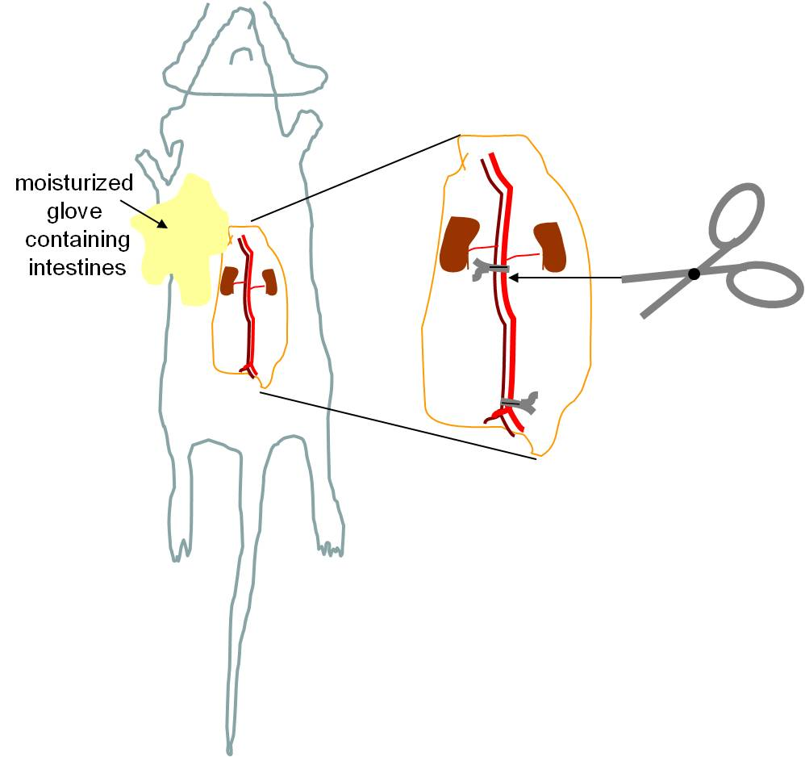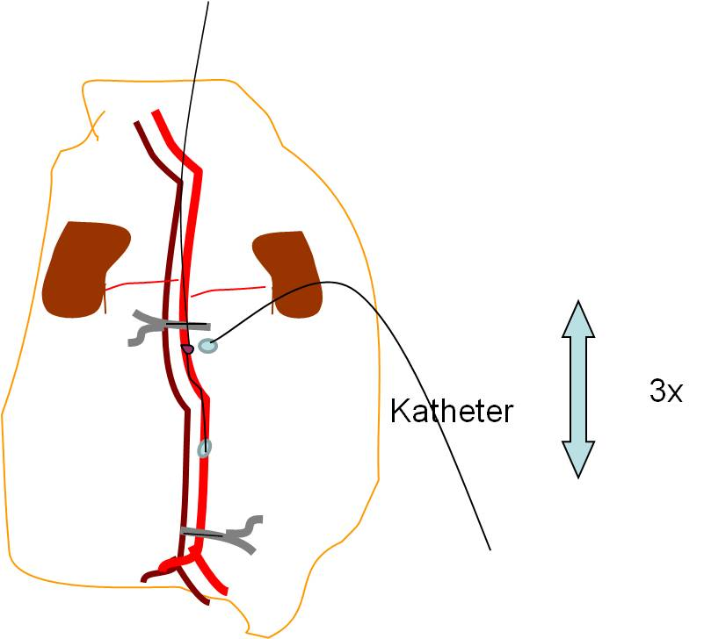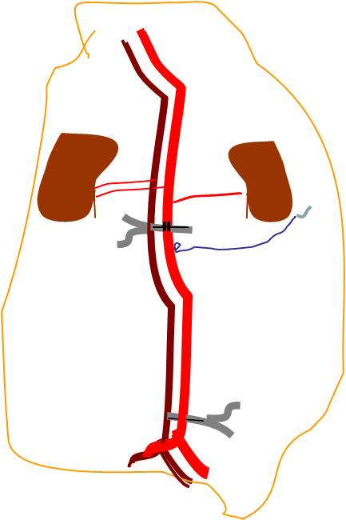
P1
P3
P2 we
P5
P4

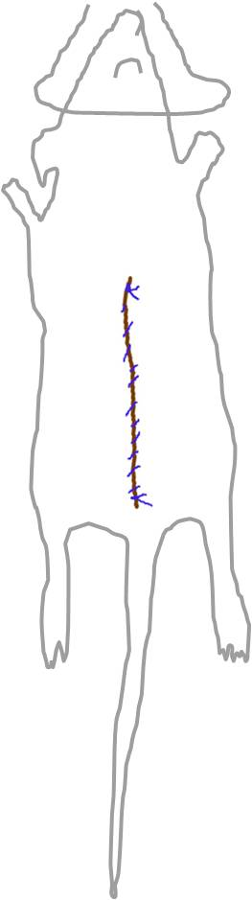
P6

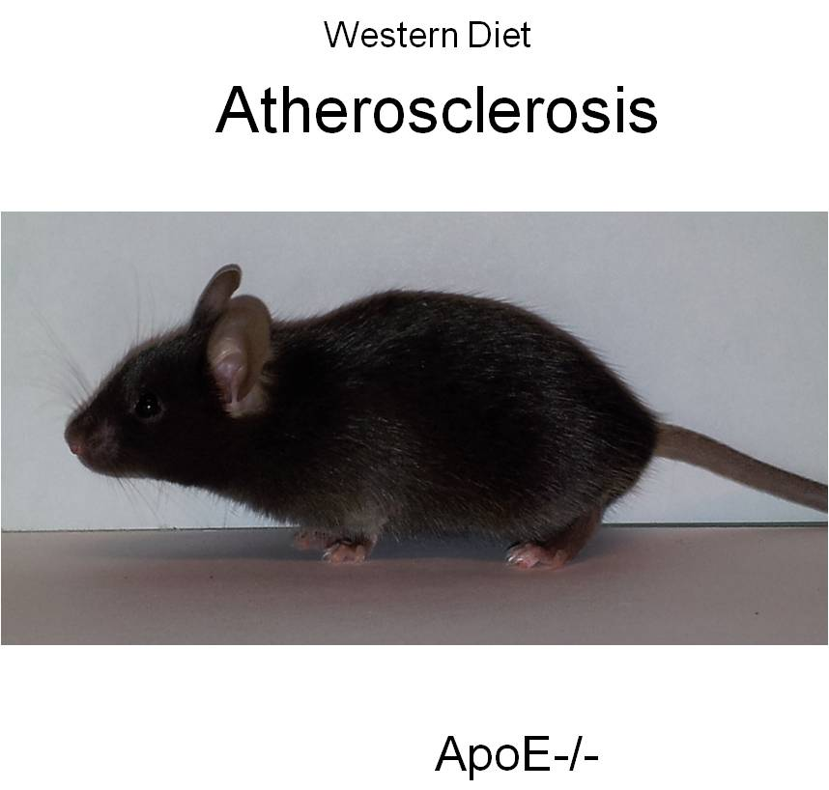
P7

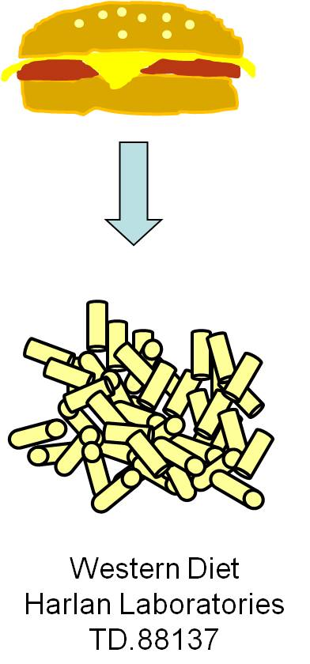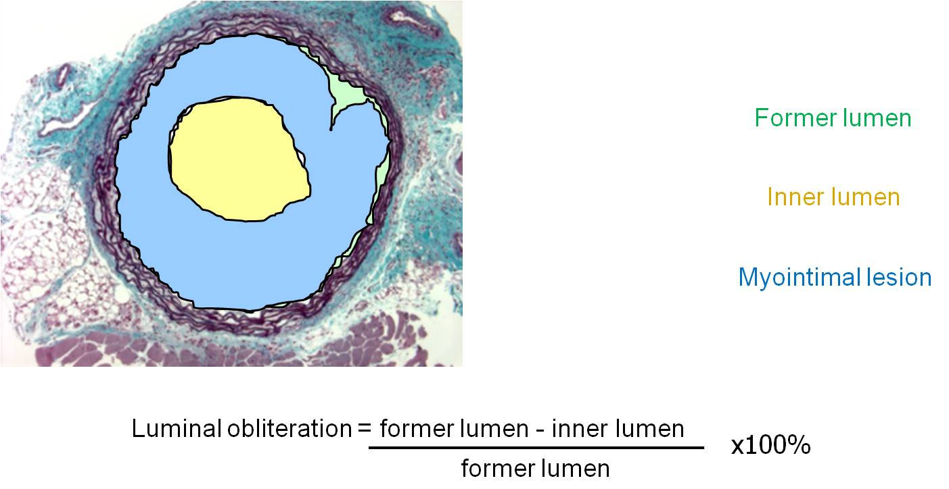
P9
P8

P10

