Colony growth tracking

The purpose of the applications described below is first to prepare the raw images for convenient image analysis, then to analyze each Petri dish and finally to reconstruct the statistics of appearance time and growth rates of all dishes that belong to the same strain/condition.

Image analysis

- Pre-Processing: Each scanner produces an image of up to 6 Petri dishes. Each Petri dish is analyzed separately (because each dish may contain a different condition). The preprocessing stage purpose is to align all the images of a specified scanner, and to separate the 6 Petri dishs. It is assumed that the raw images are similar to the example shown below, namely that each scanner monitors up to 6 standard Petri dishes, that are placed in a fixed position on the scanner.

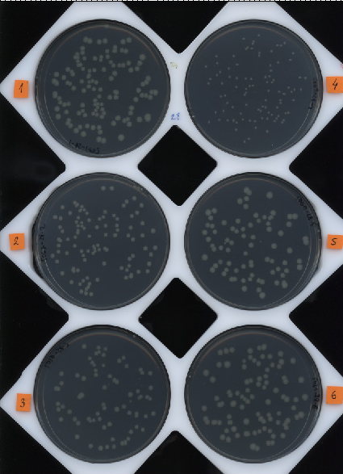

Typical raw image of 6 standard Petri dishes on one of the scanners. The 6 plates are placed inside a "Scanning board" – a rigid board with 6 round slots that keeps the plates in a fixed position on the scanner.

PreparePictures(DestDirName, board, plateVec, SourceDirName)
Purpose | Cut the image into 6 separate Petri dishes
Parameters | DestDirName | Destination library. The resulting files will be placed in that library.
 | board | The number of the "Scanning board"
 | [plateVec] | An array of the wanted Petri dishes (default – all 6)
 | [SourceDirName] | Original images library (if not mentioned, you will be asked to choose)
Description | The software aligns the images, finds the Petri dishes in the image, and cuts each Petri dish. The images of the separate Petri dish are placed in DirName_#\Pictures (where # is the number of the dish). The images are named P#_*****.tif (where # is the number of the dish, and ***** are 5 digits representing the time in minutes passed from the beginning of the experiment).
Example | PreparePictures('D:\scans\Images',2, [2 3 5], 'F:\scans\Images');

createBoardDefinitionFile(Img, Board)
Purpose | Defining a new "Scanning board". A "Scanning board" is a rigid board with 6 round slots for the Petri dishes, as shown in the picture above.
Parameters | Img | A grayscale image of the board, taken by the scanner at 300 dpi (as shown above)
 | Board | The number of the "Scanning board"
Description | Copy an existing "Scanning board" file and rename it to the number of the new board: BoardDefinitionFile_##.mat, and then activate this function. The function finds the appropriate parameters for the locations of the Petri dishes on that board, and saves it. The function does up to 15 trails to find a good match, and can be activated over and over again till the circles of the plate locations match well with the image.
Example | createBoardDefinitionFile (GrayScaleImage, 23);

- Analyzing the images: The purpose of this stage is to identify colonies in the images of the dishes, and to track them in time. This is done for each Petri dish separately using TimeLapse or sequentially for several Petri dishes using TLAllPlates.

TimeLapse(DirName, Description)
Purpose | Analyzing one Petri dish
Parameters | DirName | Library name of the images. (the same as DirName_# in bullet 1)
 | [Description] | Text description of the experiment (that will appear in the headings of the graphs)
Description | The application creates three sub folders under the directory DirName (in addition to the subfolder created earlier \Pictures). The labeled images are under DirName\LRGB and called L#_##### according to the image it was created from. DirName\TmpCleanImg places the images after processing as jpg for a quicker movie rendering and for quicker display of the plate. This sub folder can be erased if needed. DirName\Results places the results of the analysis, the PlateMovie.avi and the log file.
Example | TimeLapse('D:\scans\Images1', 'description 1');

TLAllPlates(DirVec, DescriptionVec)
Purpose | Analyzing all Petri dishes at once (please add a word on how it separates different conditions)
Parameters | DirVec | {'DirName1';'DirName2';' ... '} a vertical cell array of folder names
 | [DescriptionVec] | {'Plate1 description'; '';…} a vertical cell array of descriptions
Description | The application performs TimeLapse for all the DirNames in DirVec.  Each Petri dish is analyzed separately, and the analysis results are stored in separate directories.
Example | TLAllPlates ({'D:\scans\Images1'; 'D:\scans\Images2'}, {'description 1'; 'description 2'});

Data analysis
The purpose of this stage is to extract the statistics of appearance time and growth rates of all dishes that belong to the same strain/condition. Some functions works on one Petri dish (e.g. ShowAreaGraph, ShowPlate, WhichColony, makePlateMovie, FilterBacteria, set/getPlateCentre), while other functions use the data from all Petri dishes with the same condition (e.g. AddHistograms, plotDeathCurve, GetAppearanceTimes, getStatistics ).
Major functions list:
ScanLagApp(DirName)
Purpose | A tool for investigation of the automatic analysis
Parameters | DirName | The root directory of the Petri dish (full path)
Description | Displaying the Petri dish alongside with the graph of the colony size versus time. Using this tool you can associate a colony with its curve on the area graph, you can locate a colony, and exclude analysis defects (or include). Using the time slider you can scroll through the experiment at different times and learn about the development of the colonies. When show analysis in on, the colonies are painted with their colour, similar to the colour of their curves (as shown on ShowPlate). The RGB/BW mode switches between the original plate image and the black and white image after background subtraction. Colour coding of the text IDs of the colonies: The ID number is red for new identified colonies, blue for something identified (dirt) that doesn't appear in the next frame, yellow for manually screened colonies, and purple for colonies that are on the rim of the analyzable area of the plate.
Example | ScanLagApp ('D:\scans\Images1')
Result

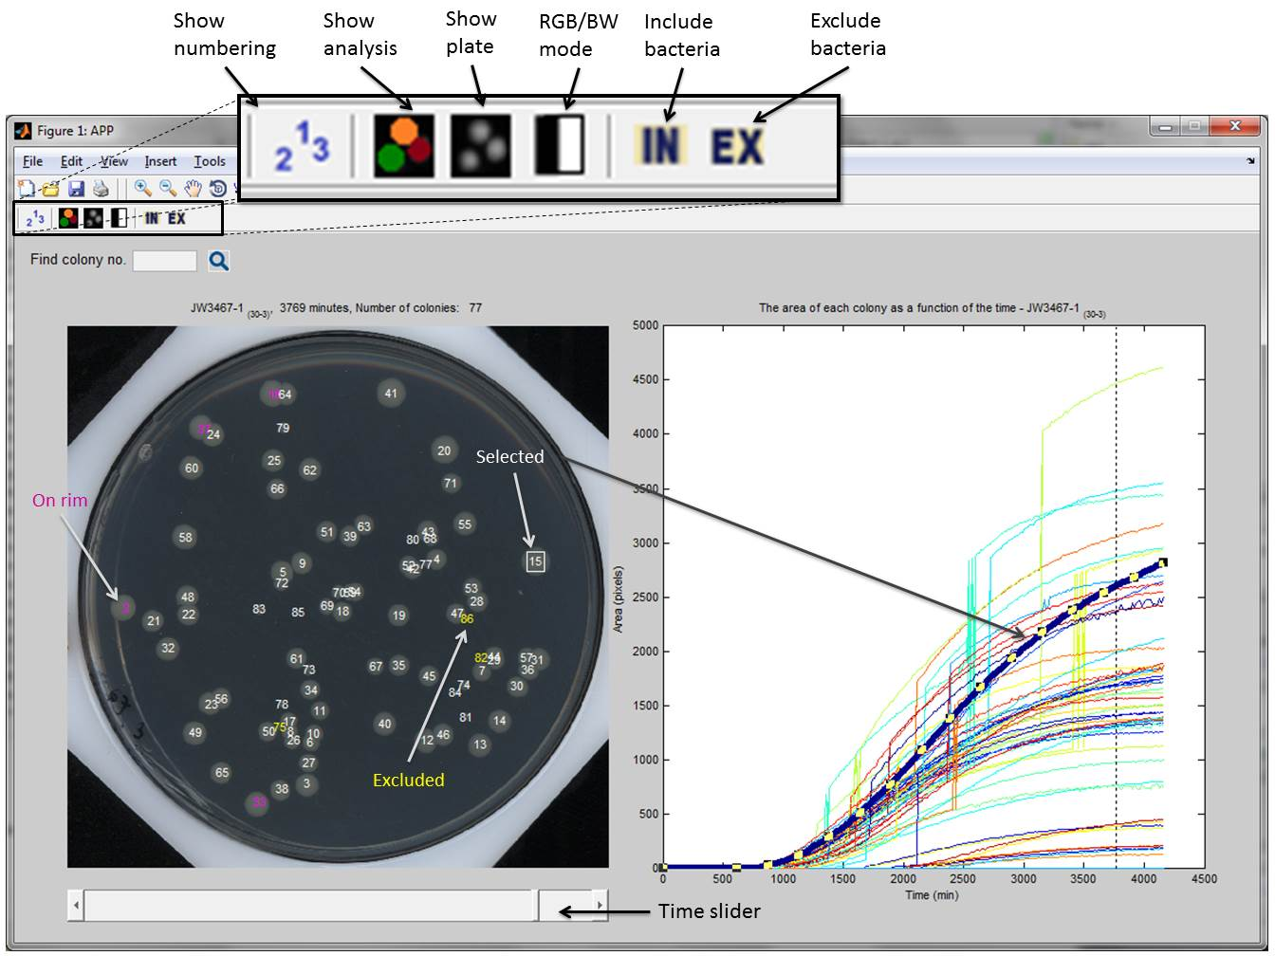
ShowAreaGraph(FileDir)
Purpose | Display a graph of the colony size versus time for one Petri dish
Parameters | FileDir | The root directory of the Petri dish (full path)
Description | Displaying the area in pixels of each colony in the Petri dish vs. time (in minutes). When colonies merge, their common area is rising together, and it seems like a spike in the area curve.
Example | ShowAreaGraph('D:\scans\Images1')
Result

ShowPlate(TimeGap,DirName,forMovie)
Purpose | Displaying the Petri dish at the specified time
Parameters | TimeGap | Time in minutes from the beginning of the experiment
 | DirName | The root directory of the Petri dish (full path)
 | [forMovie] | Boolean, default - 0. Use 0 to see the plate in a good resolution
Description | Displaying the Petri dish at the specified time, marking the identified colonies with arbitrary colours, and with the colony IDs on top (the colour of each colony is the same as the colour of the curve that represents this colony in the Area vs. Time graph). The ID number is red for new identified colonies, blue for something identified (dirt) that doesn't appear in the next frame, and yellow for manually screened colonies. If the sub-folder DirName\TmpCleanImg exists, the function will run faster, because the images after processing are saved there.
Example | ShowPlate (1993,'D:\scans\Images1',0)
Result

[CM, ColonyNum] = WhichColony(TimeGap, Area, DirName)
Purpose | Identifying a specific curve from the Area vs. Time Graph by retrieving its colony ID and center-of-mass coordinates.
Parameters | TimeGap | Time in minutes from the beginning of the experiment
 | Area | The area of the colony at that time
 | DirName | The root directory of the Petri dish (full path)
Returns | CM | The coordinates of the centre of the colony
 | ColonyNum | The colony ID
Description | Gets the colony ID and centre coordinates according to the area at a specified time. After ShowPlate write impixelinfo, and at the lower left corner of the figure the coordinates and the RGB value of the cursor will be displayed. Sometimes several colonies have the same size at that specified time, and then a list will be returned. The colour of the curve matches the colour of the colony when using ShowPlate. An easier way to get the colony ID of a certain curve is to look at its "Y Data Source" in the "Property Editor".
Example | [CM, Num] = WhichColony(1993, 849, 'D:\scans\Images1')

F = makePlateMovie(DirName)
Purpose | Creating a movie of the colonies' growth in time, for a specified dish
Parameters | DirName | The root directory of the Petri dish (full path)
Returns | F | A structure of all the frames
Description | The function uses ShowPlate to display all frames of the Petri dish. The result is DirName\Results\PlateMovie.avi. NOTE: A)Matlab captures the figure as it is displayed on screen to create a frame, therefore while rendering a movie you cannot use the computer. B) The resolution of a single frame is better than the resolution of the movie.
Example | makePlateMovie('D:\scans\Images1')
Result | DirName\Results\PlateMovie.avi

FilterBacteria(DirName, FilterBact)
Purpose | Filtering out dirt or reflections that were mistakenly counted as colonies
Parameters | DirName | The root directory of the Petri dish (full path)
 | [FilterBact] | An array of the colony IDs to filter out
Description | The function creates a file of filtered colonies DirName\Results \ExcludedBacteria.txt. and adds to the file the specified IDs. If FilterBact was not specified, a picture of the dish will appear and then you can insert the colony IDs at the prompt line, until inserting -1. Then you can take out of the filtering list colony IDs until inserting -1. Once those colonies are filtered, they will be excluded from all calculations – no curve will appear for them in the Area vs. Time graph, they will not be counted in the histogram, and will be marked yellow when using ShowPlate.
Example | FilterBacteria('D:\scans\Images1',[116 126 225])

setPlateMask(DirName)
Purpose | Changing the parameters of the area on the dish to analyze.
Parameters | DirName | The root directory of the Petri dish (full path)
Description | Sometimes the area to analyze includes reflections of the Petri dish borders, and the area of interest has to be moved or shrank. This function allows you to change the analyzable area by changing the radius and the location of a circle while looking at the latest clean image of the plate.
Example | setPlateCentre('D:\scans\Images1',526,526,436)
Result | Result is written to: DirName\Results\CircParams.mat  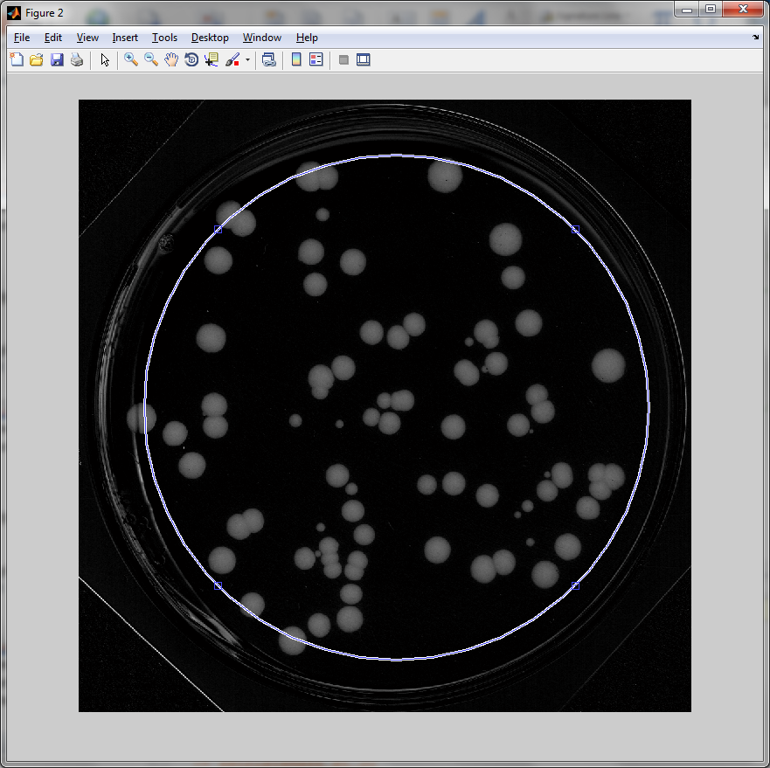

[TimeAxis, Histogram] = AddHistograms(DirVec, bin)
Purpose | Creates a histogram of appearance times
Parameters | DirVec | A vertical cell array of the directory names
 | bin | Size of bins in minutes
Returns | TimeAxis | An array of the bins
 | Histogram | Amount of colonies in each bin
Description | Uses GetAppearanceTimes to create a histogram
Example | [TA,Histo]= AddHistograms ({'D:\scans\Images1'; 'D:\scans\Images2'},30)  figure; bin(TA, Histo)
Result

[Time, DC, Hist] = plotDeathCurve(DirVec, TimeLimit, bin)
Purpose | Plots 1-CDF representation of the distribution
Parameters | DirVec | A vertical cell array of the directory names
 | TimeLimit | Calculate the 1-CDF till this time
 | bin | Size of bins in minutes
Returns | Time | An array of the bins
 | DC | 1-CDF
 | Hist | Amount of colonies in each bin
Description | Uses GetAppearanceTimes to create a histogram
Example | [TA,DC]= plotDeathCurve  ({'D:\scans\Images1'; 'D:\scans\Images2'},4500,30)  figure; semilogy(TA, DC)
Result

[TimeAxis,TotalAppearanceTime]=GetAppearanceTimes(DirVec)
Purpose | Getting the appearance time all colonies in the experiment
Parameters | DirVec | A vertical cell array of the directory names
Returns | TimeAxis | Times of the images
 | TotalAppearanceTime | An array of appearance times
Description | Adds the appearance time of each colony into an array
Example | [TA,AppTimes]=GetAppearanceTimes({'D:\scans\Images1'; 'D:\scans\Images2'})

Stat = getStatistics(TimeAxis, TotalAppearenceTime)
Purpose | Getting statistical parameters on the experiment
Parameters | TimeAxis | Times of the images
 | TotalAppearenceTime | An array of appearance times
Returns | Stat | A structure that contains: total – total amount of bacteria, Avg – average, std – standard deviation, skw – skewness, max – histogram peek, median and stdMed – median and standard deviation from the median.
Description | Calculates all statistical parameters from the array of appearance times.
Example | Stat = getStatistics(TA, AppTimes)

