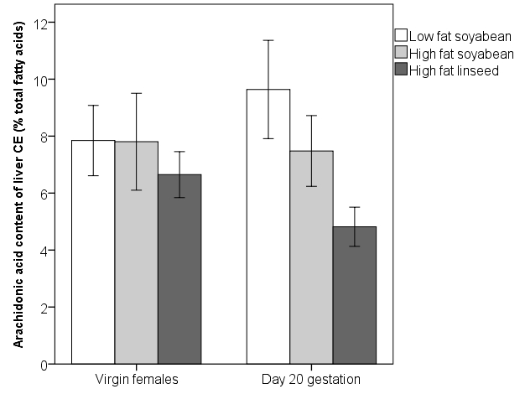
Condition of Rats
a
b
*
c

