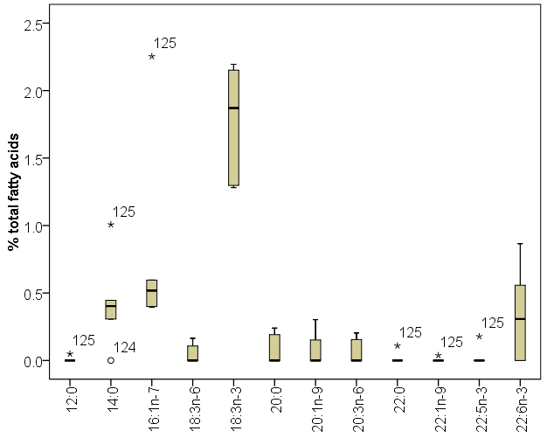
Fatty Acid
125 is identified as an outlier in the data set.

