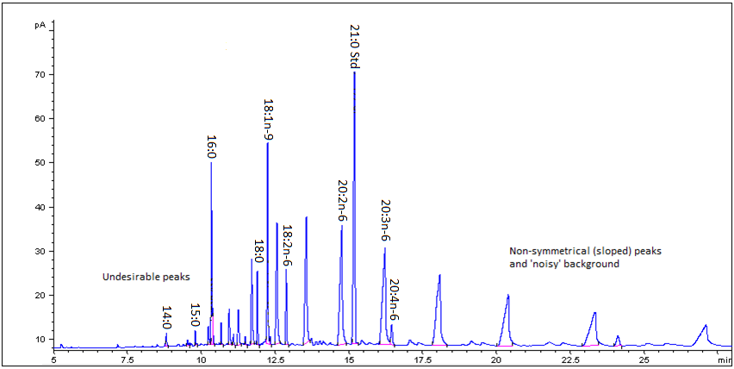
Response (pA)
Retention Baseline (minutes)

