Response (pA)
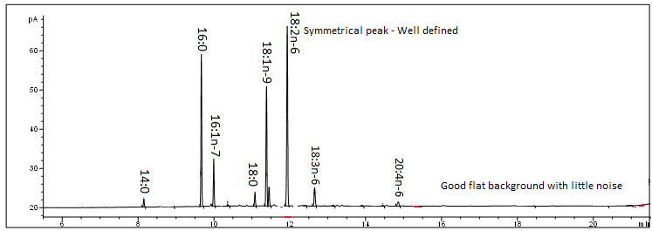
Retention Time (minutes)

