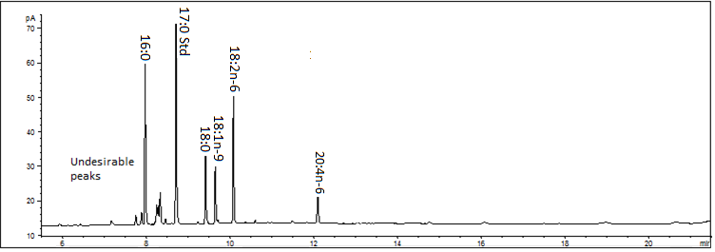
Response (pA)
Untreated sample
Sample with free cholesterol removed
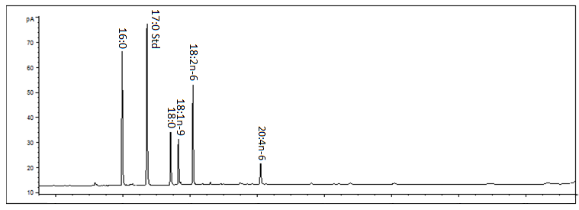
Retention Time (minutes)

