Step # | Text | Visual representation
1.5 | “Prepare the electron microscope for imaging by cryo-cycling at least overnight, and load...” | Videographer footage of lab member operating the microscope and loading grids.
1.6 | “Carefully perform direct alignment of the microscope, including coma free alignment...” | Videographer footage of lab member operating the microscope
1.7 | “Take images on films or using a direct electron detector either manually (with low dose) or …” | Videographer footage of images being taken using the automation software.
2.4 | “Examine the ctf of each image. Images that are well outside the defocus target value set while imaging…” | Manuscript Figure 2
2.5 | “Examine the real space image. Any image with apparent ice contamination can be ignored henceforth.” | Manuscript Figure 2
3.1.1 | “For all particles picked, run AutoOrtElim to generate a list of “good” particles with initial orientation…” | Screenshots of computer program labeled: Visual 1 and Visual 2
3.1.2 | “Run hrefine program to refine the orientation and center parameters for all particles…” | Screenshots of computer program labeled:  Visual 3
3.1.3 | “Run batch_reconstruct_ISAF or a GPU-accelerated 3D reconstruction program, g3d (Ref. 18), to…” | Screenshots of computer program labeled:  Visual 4 and Visual 5
3.2.1.1 | Box the particles using the helixboxer command of EMAN | Visual 6
3.2.1.4 | Boxed-out particles. | Visual 7
3.2.1.8 | Class-averages of particles that was aligned “vertically” | Visual 8
3.2.1.9 | “an averaged fourier transform of the final iteration of class averaging.” | Visual 9
3.2.2.1 | “Use the make3d command from EMAN to create a preliminary 3D density map” | Visual 10
3.2.2.3 | “Use himpose of IHRSR package ²⁰ to apply the helicity” | Visual 11
3.2.3.1 | “Map before and after helicising” | Visual 13&16 (Before)
3.2.3.1 | “Map before and after helicising” | Visual 12&15(After)
3.2.3.2 | “EMAN style ctf parameter” | Visual 18.0
3.2.3.3 | “Use bfactor (Nikolaus Grigorieff group) program to boost high resolution factors” | Visual 14&17
3.2.3.6 | “A sample Refinement script” | Visual 18
4.1.2 | “Trace C-alpha backbone” | Visual 19 (Red line)
4.1.4 | “Mutate the backbone model into full atomic model” | Visual 19 (Green line)
4.2.2 | “Use simulated annealing to boil down… Use 20 as constant” | Visual 20 (Red line refined to Green line)
4.2.3 | “In Coot, manually fit any misfit residue” | Visual 21-24 (Red line manually fitted to Green line)
4.2.5 | “Minimize the structure with reduced (10) harmonic constant” | Visual 25 (Red line minimized to Green line, still some misfit)
4.2.8 | Final refined model | Visual 26 (Green line is the final refined model)

Visual 1:
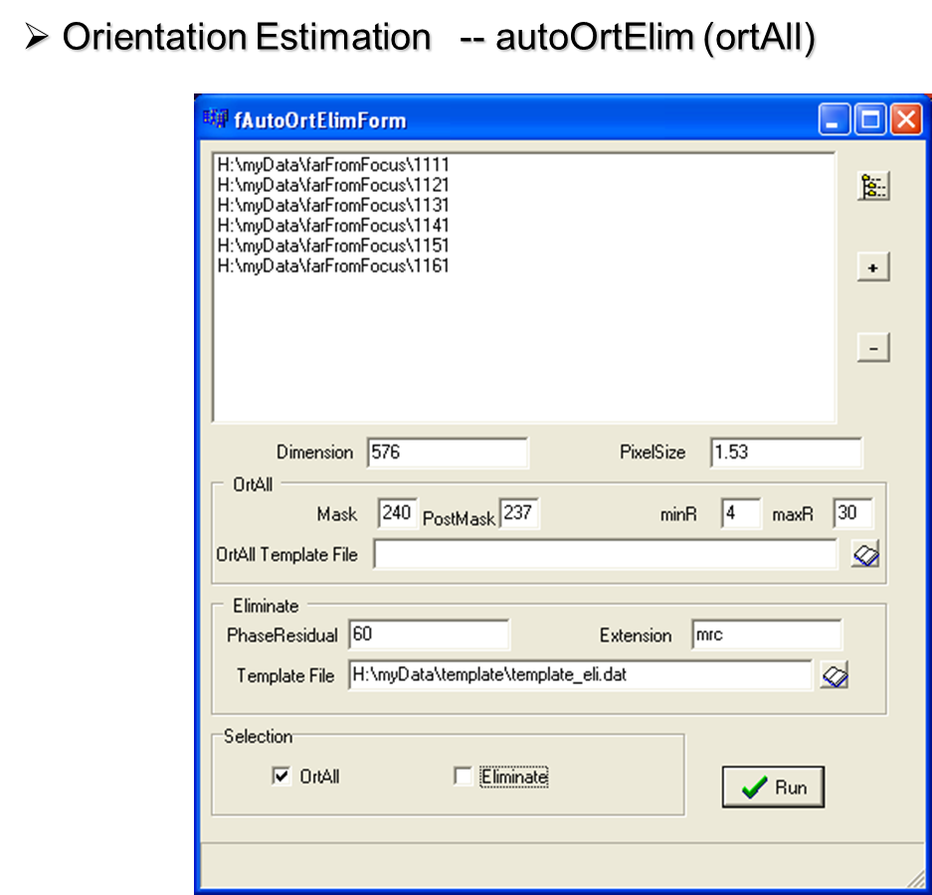

Visual 2:

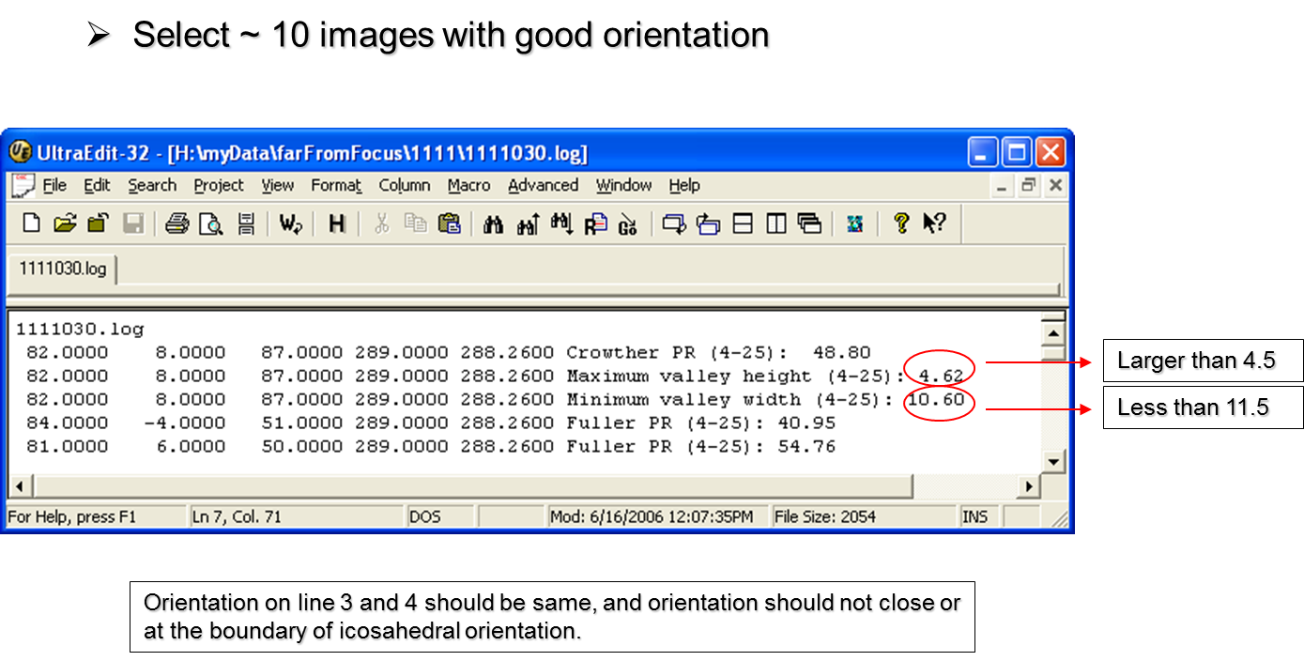

Visual 3:
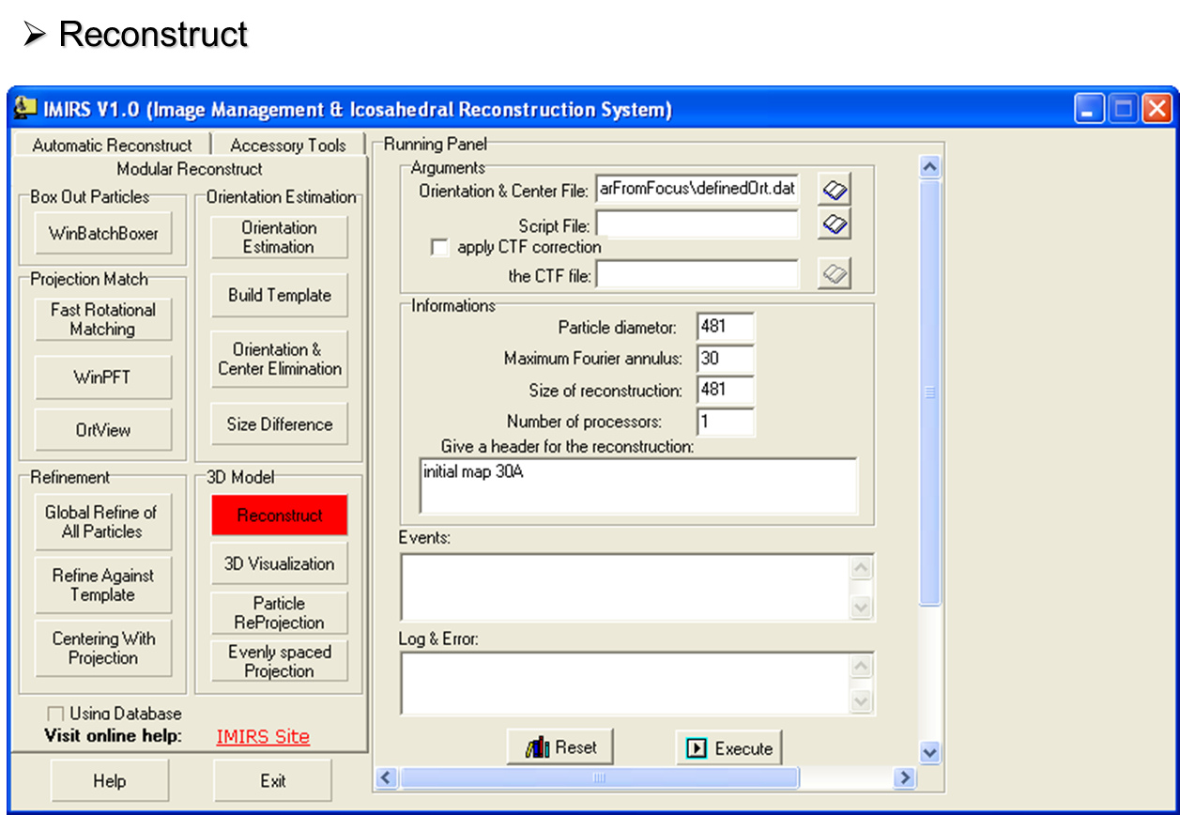
Visual 4:
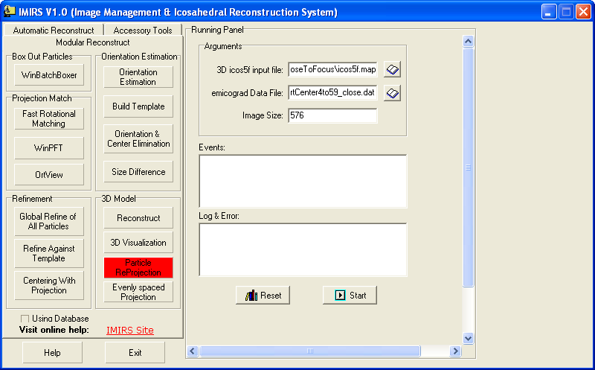
Visual 5:
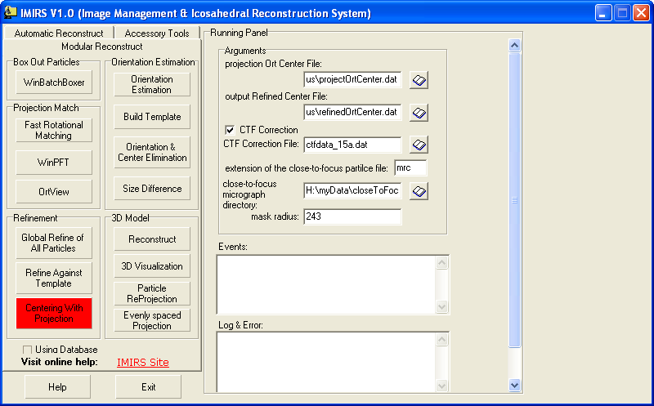
Visual 6:
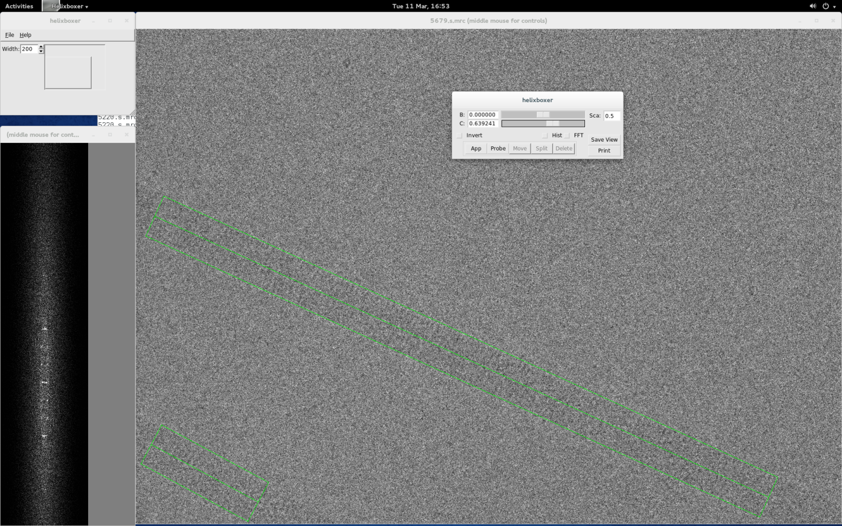
Visual 7:
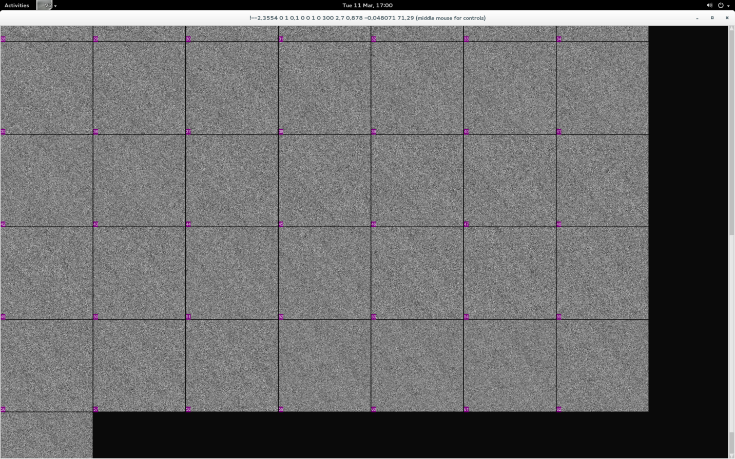
Visual 8:
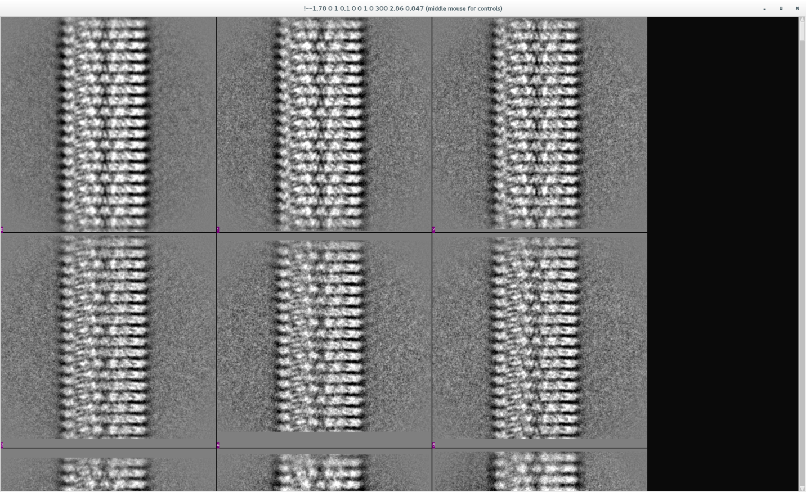
Visual 9:
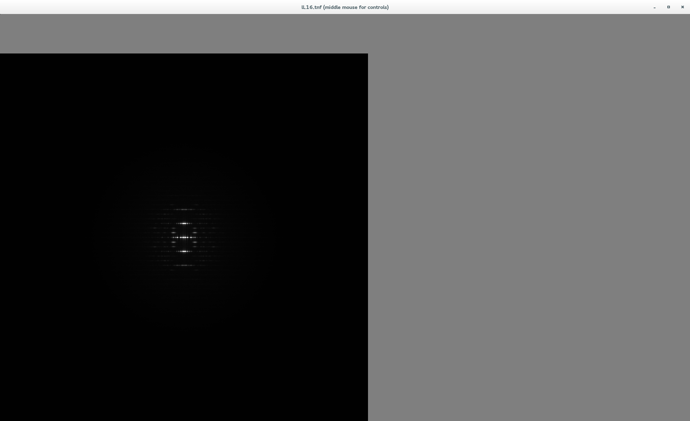
Visual 10:
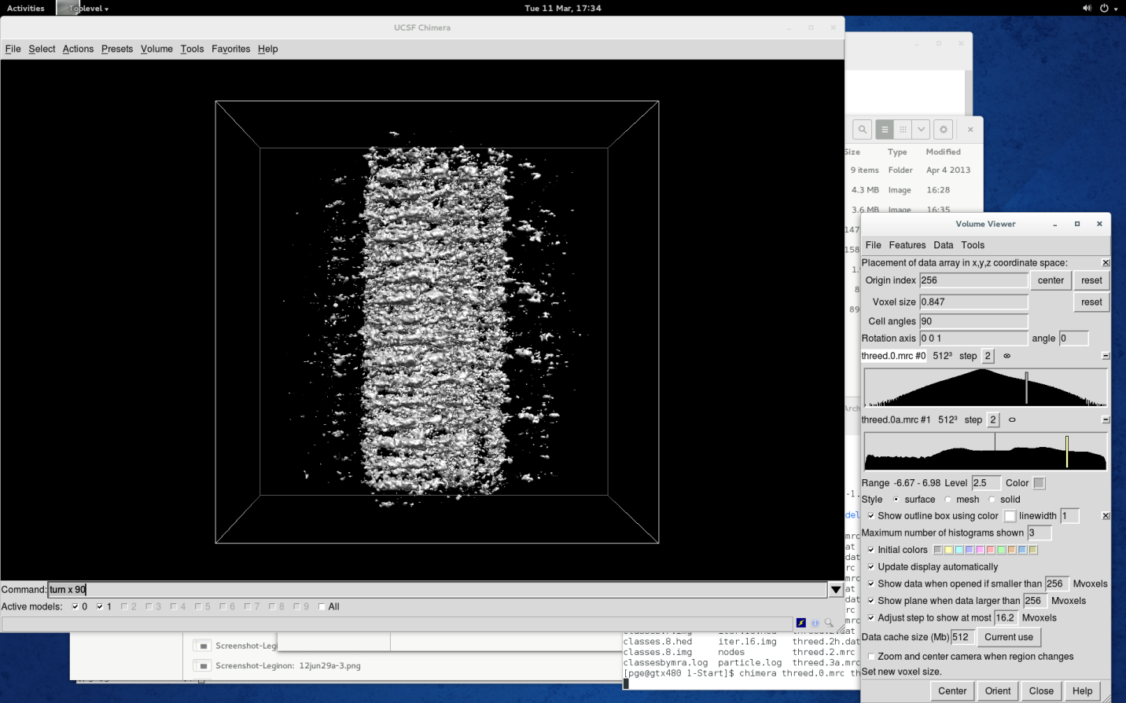
Visual 11:
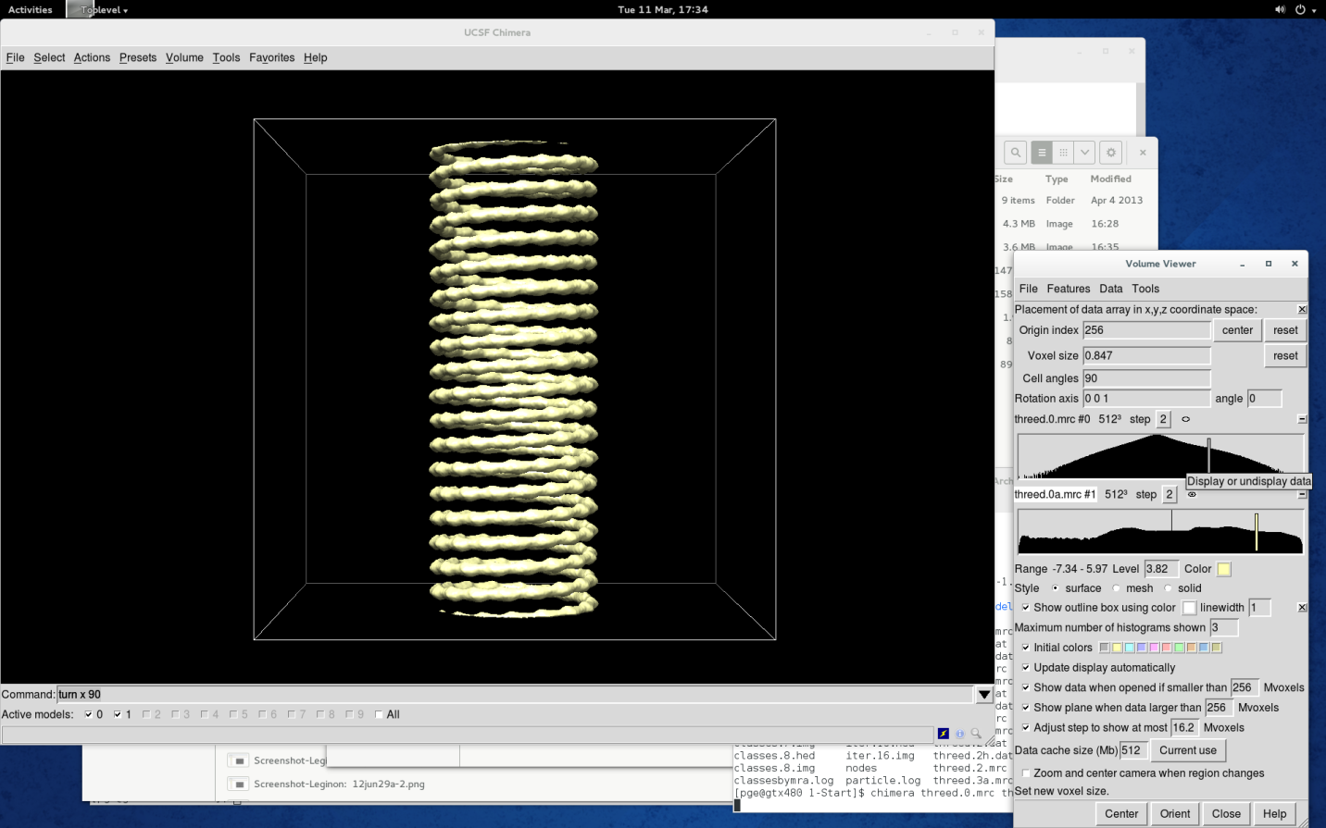
Visual 12:
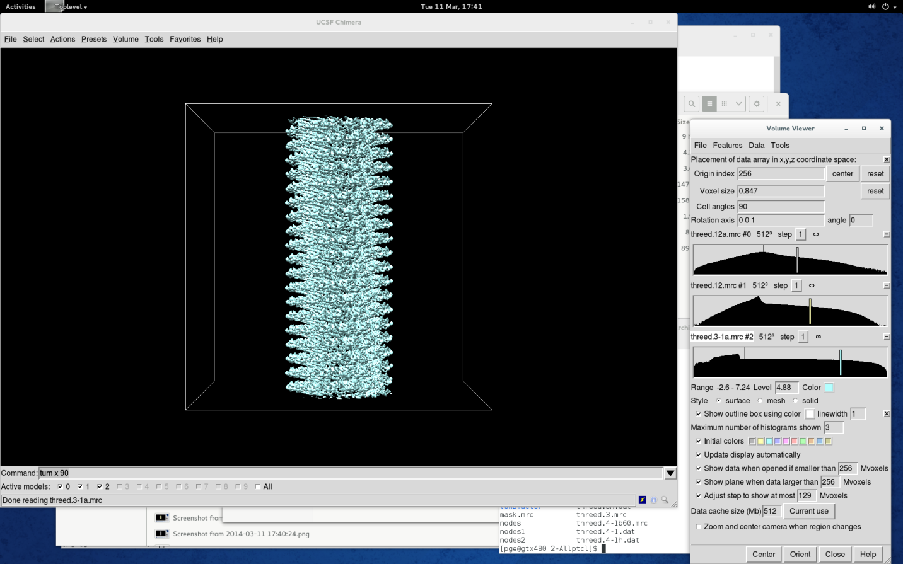
Visual 13:
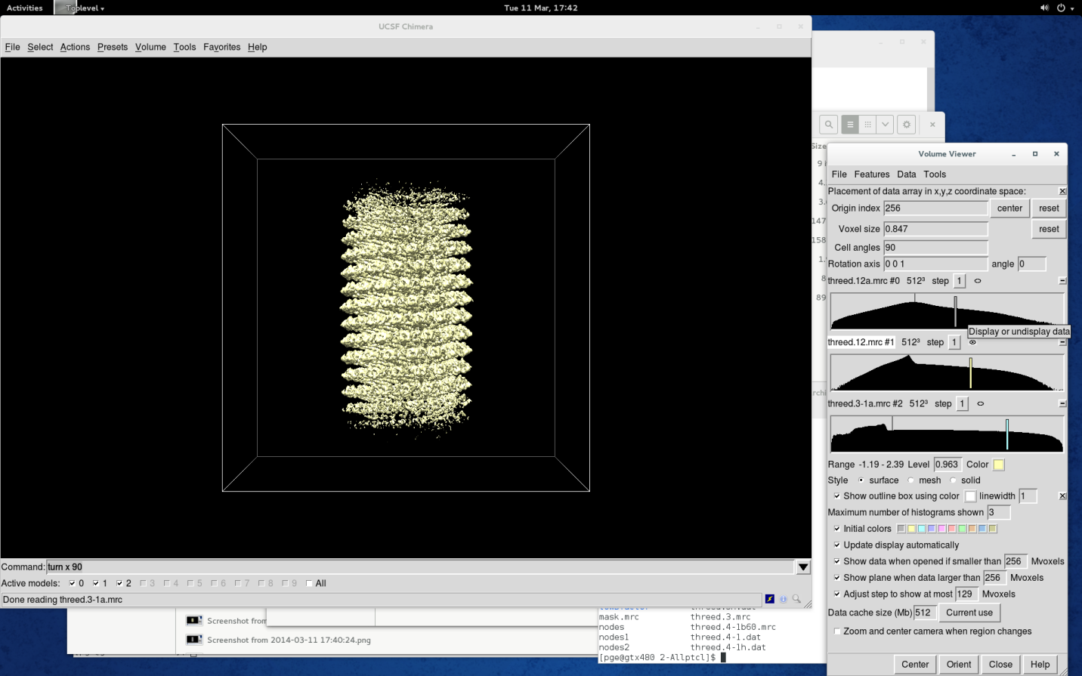
Visual 14:
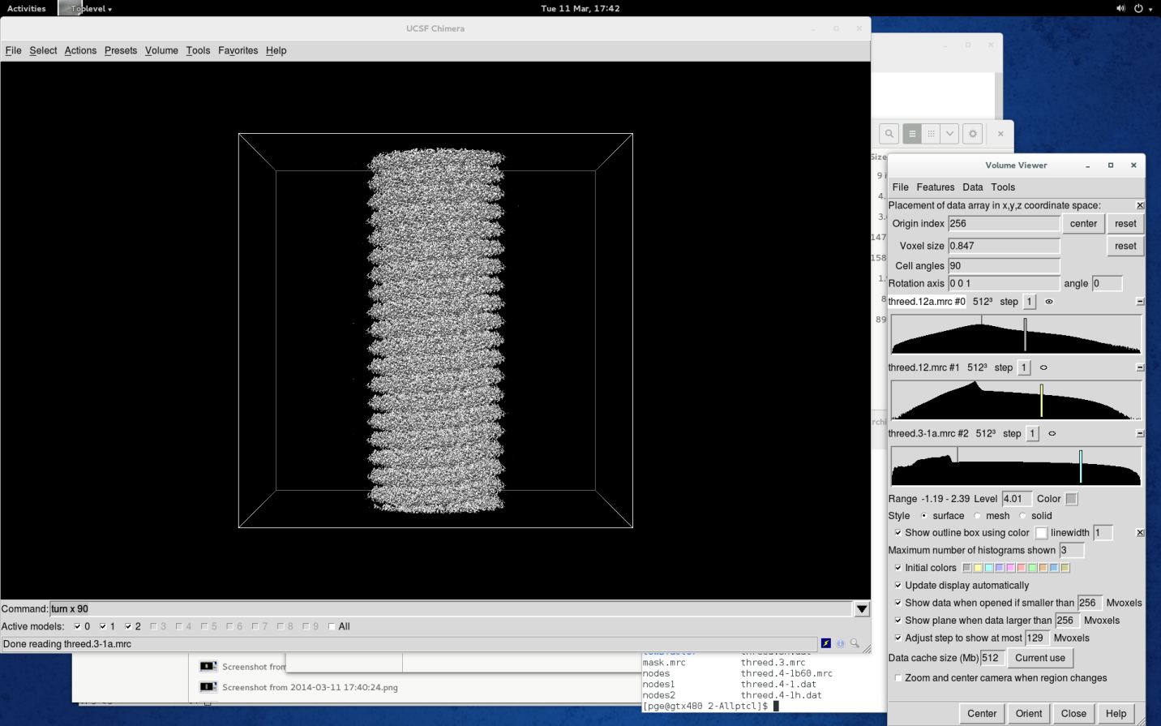
Visual 15:
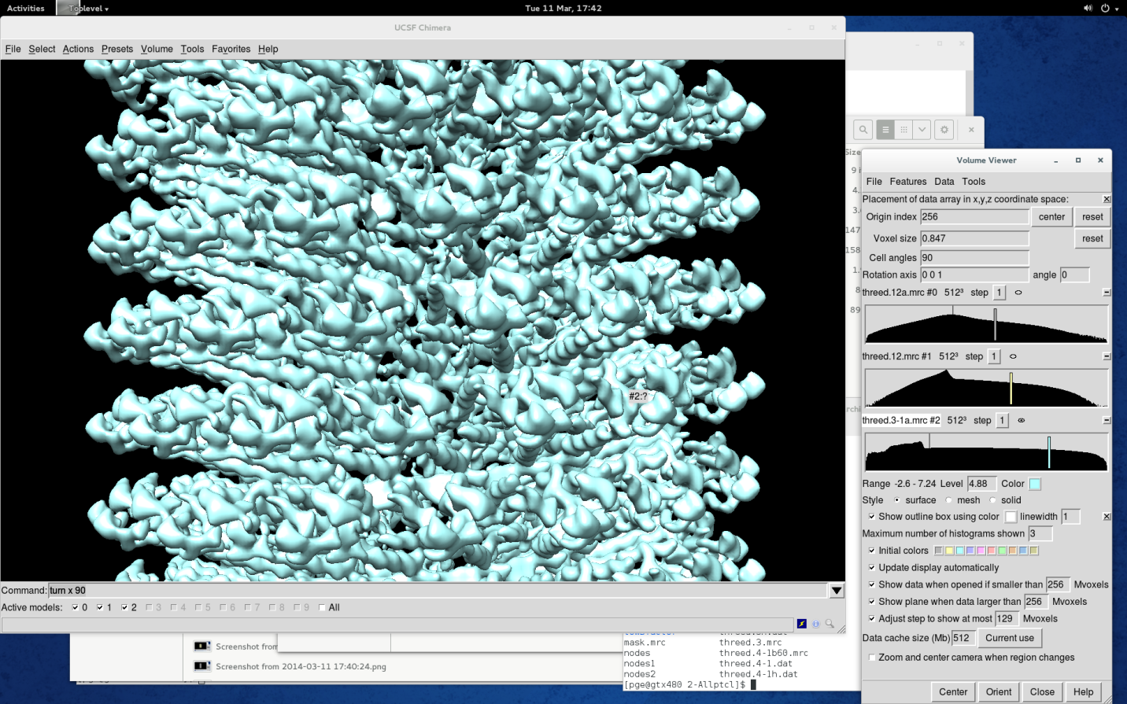
Visual 16:
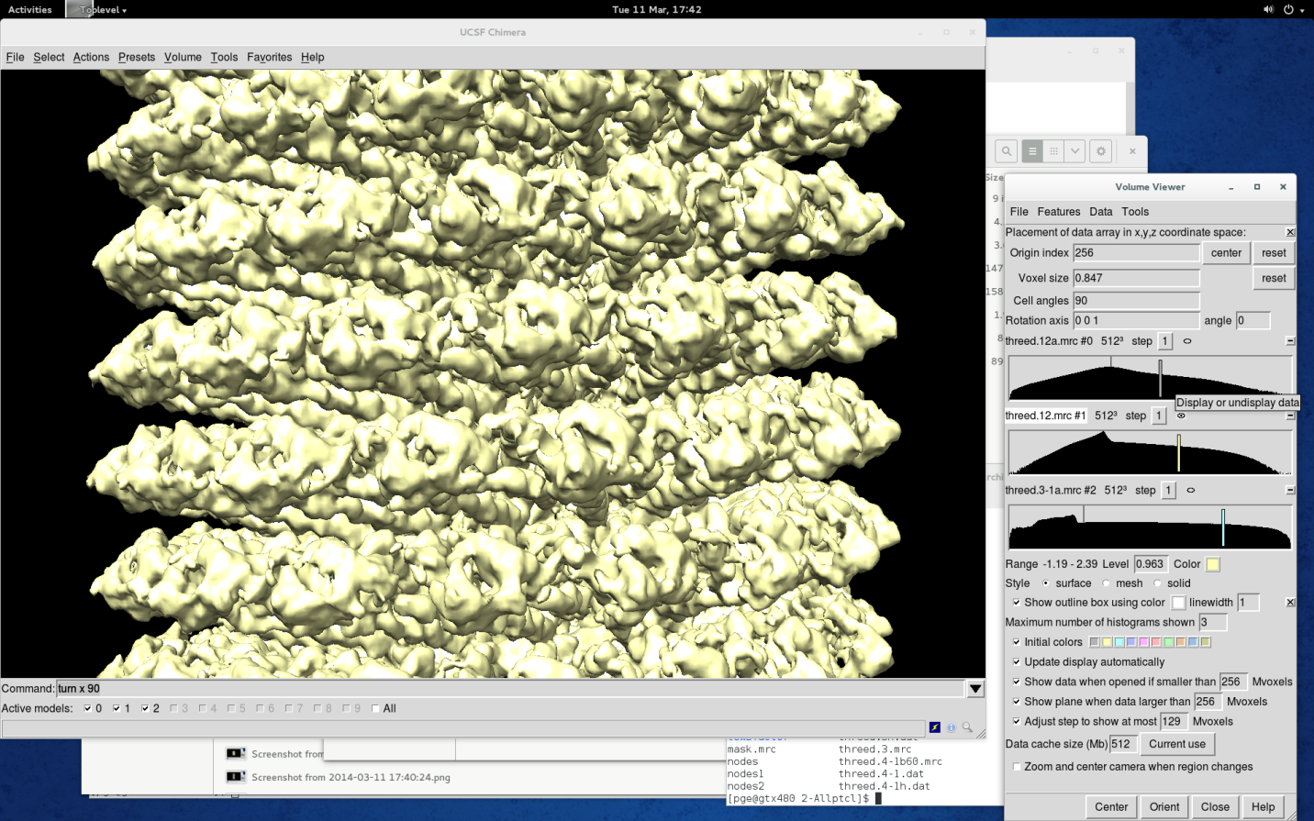
Visual 17:
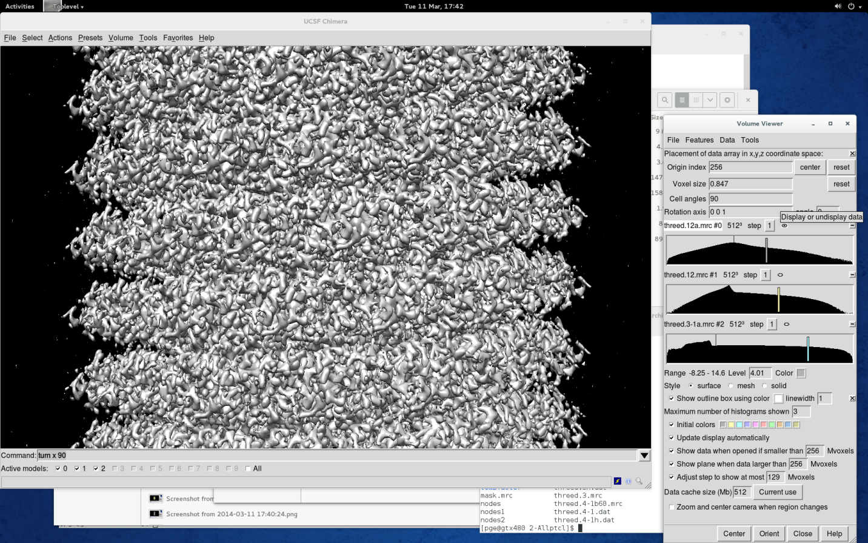
Visual 18.0
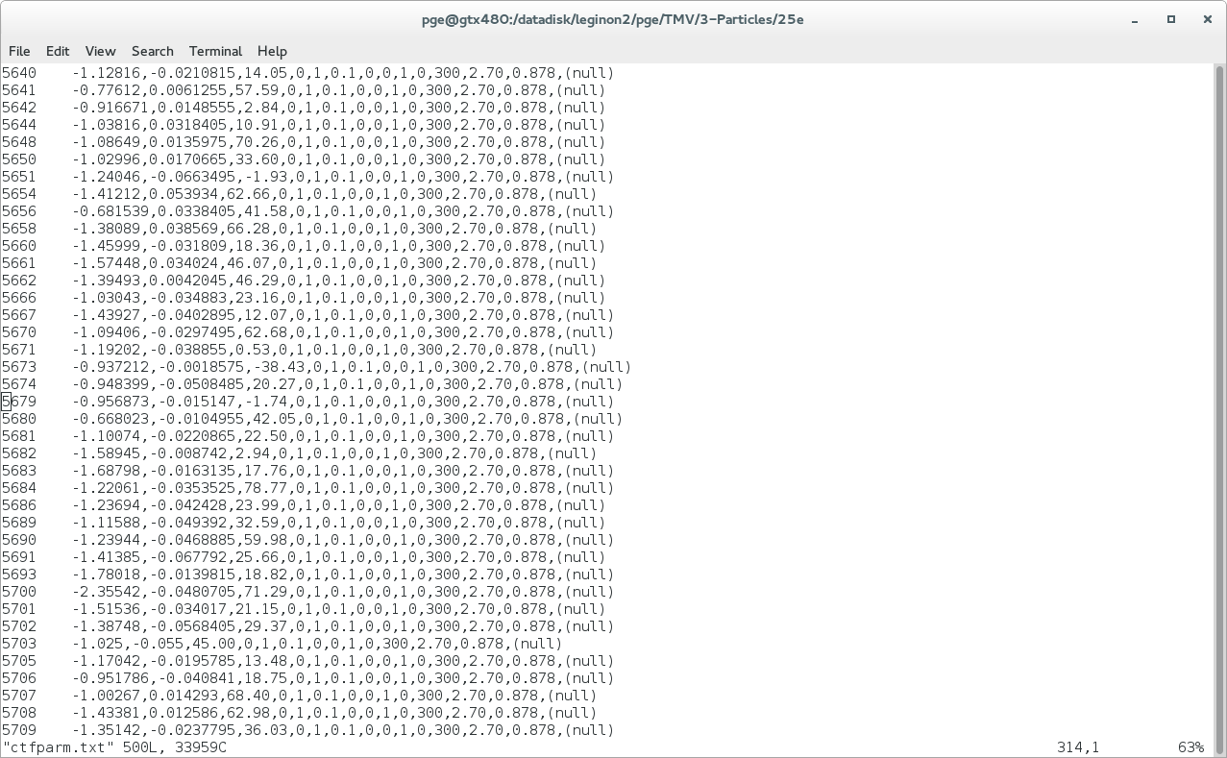
Visual 18:
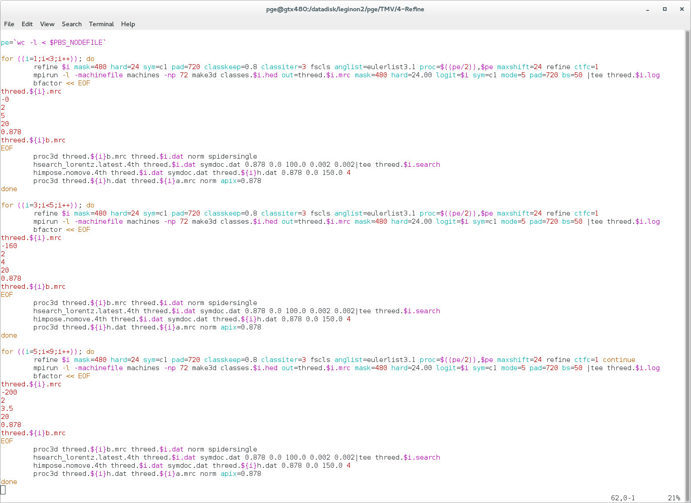
Visual 19:
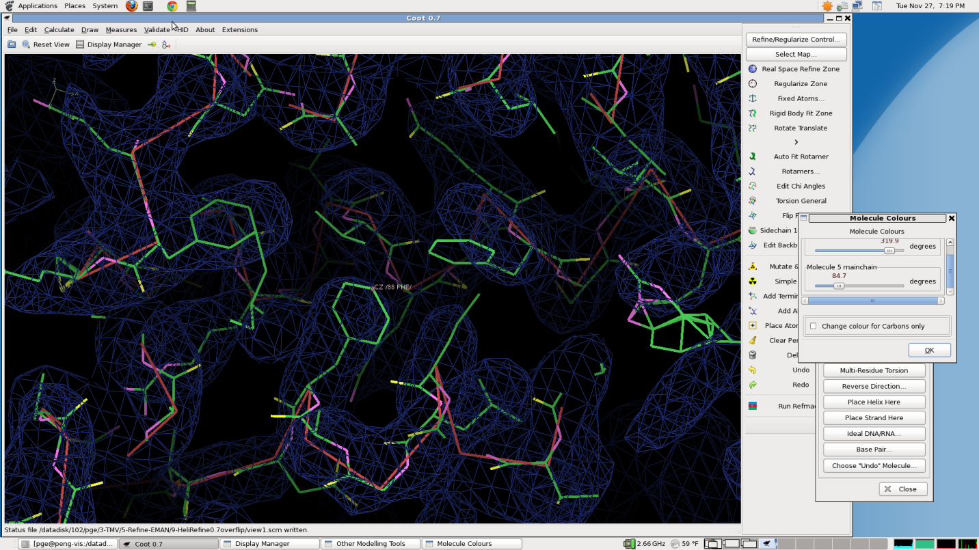
Visual 20:
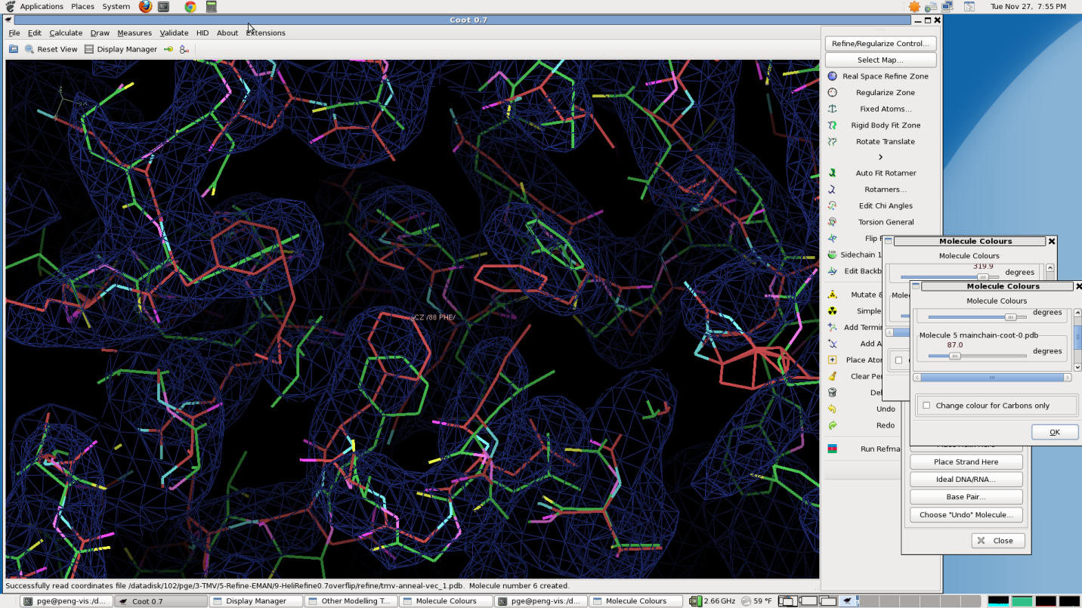
Visual 21:
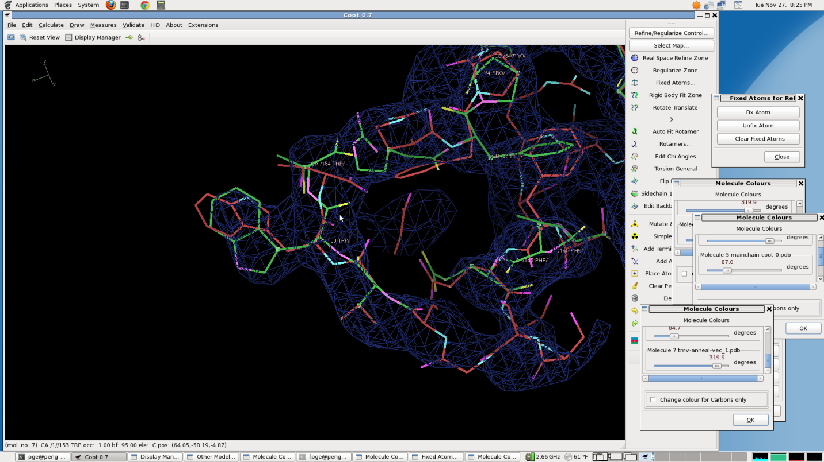
Visual 22:
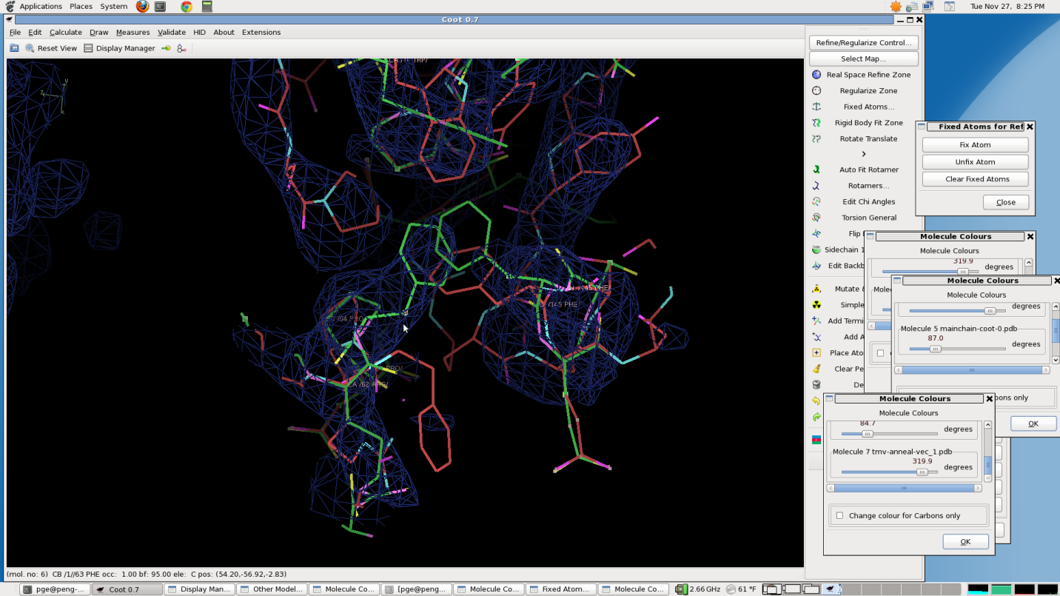
Visual 23:
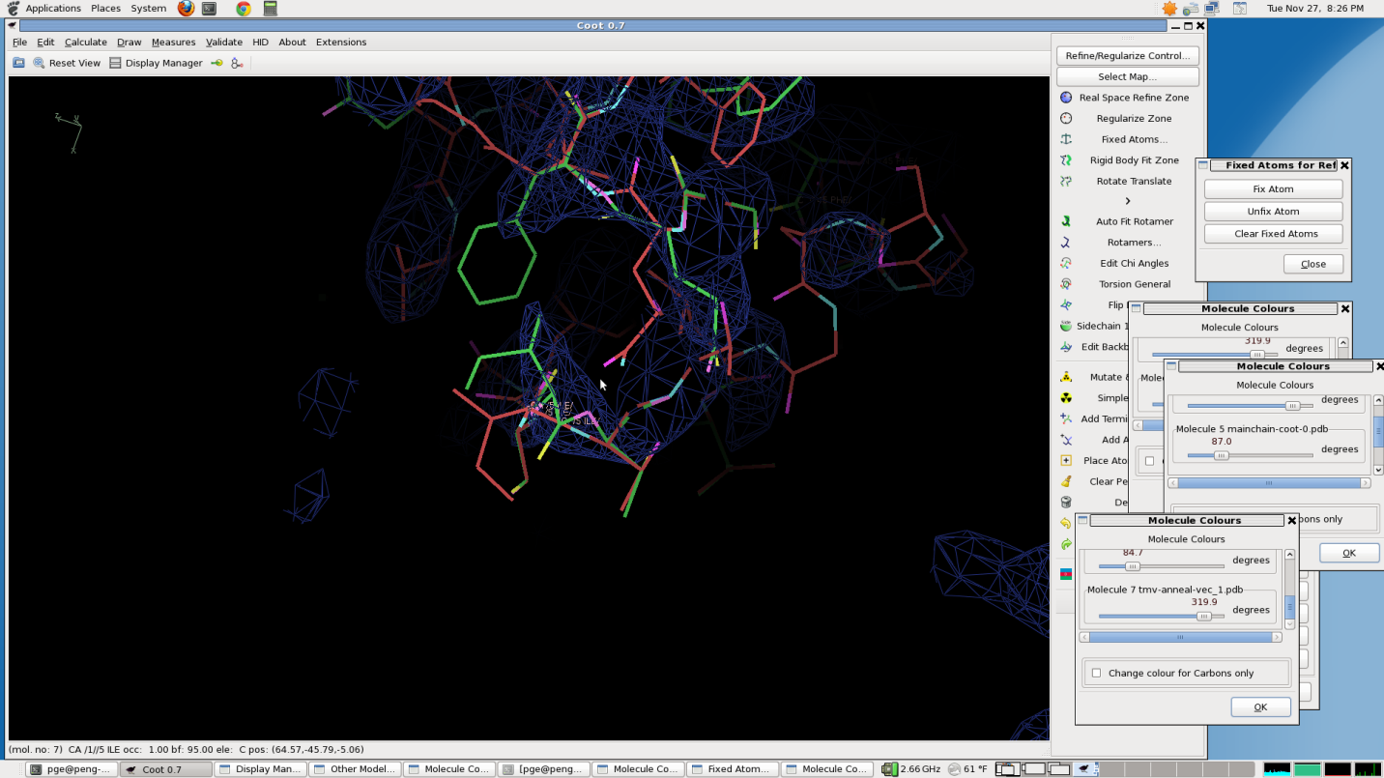
Visual 24:
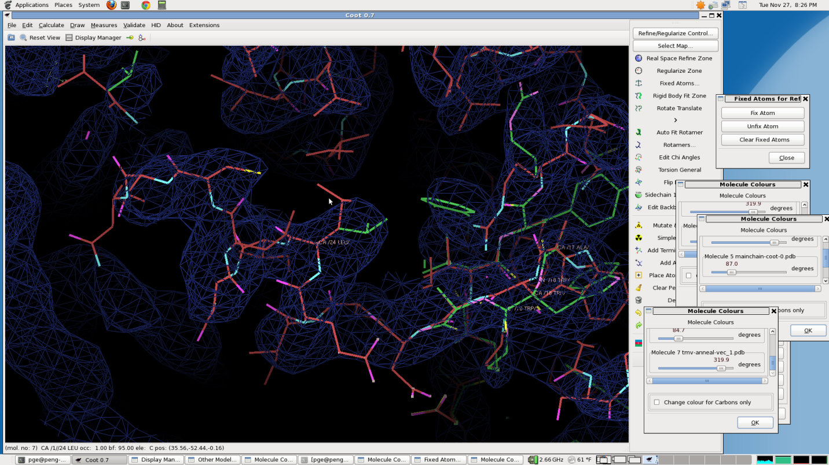
Visual 25:
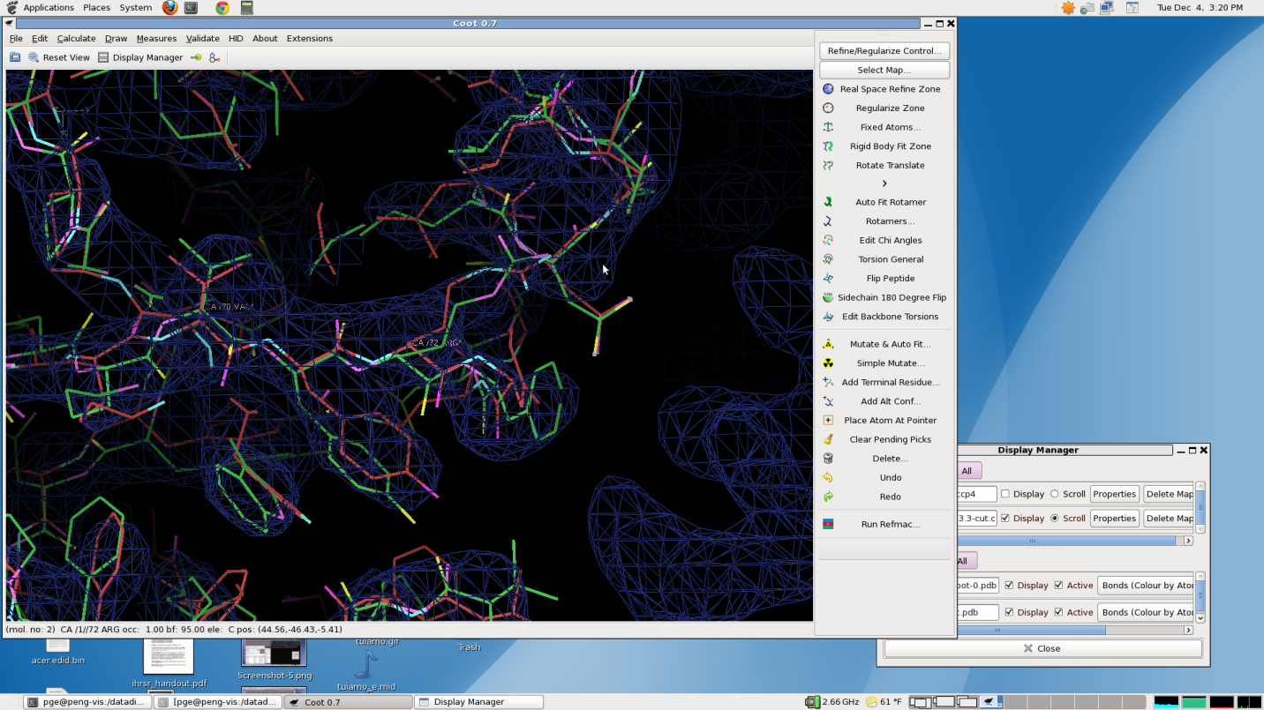
Visual 26:
