Submission ID #: 51429

Editor Name: Renee Choi

Videographer Name: Jens Tomat

Film Date: 1/7/14

Authors and Affiliations: Iris Adam¹, Constance Scharff¹, Mariam Honarmand¹

¹Department of Animal Behavior, Freie Universität Berlin, Berlin, Germany

Title: Who Is Who? Non-invasive Methods to Individually Sex and Mark Altricial Chicks

Corresponding Author:
Iris Adam
Department of Animal Behavior
Freie Universität Berlin
Berlin, Germany
iris.adam@fu-berlin.de
+493083855067
Additional Contacts: Constance Scharff: scharff@zedat.fu-berlin.de; Mariam Honarmand: m.honarmand@fu-berlin.de

Authors, please fill out the brief questionnaire below.

A. Will you require JoVE to record video microscopy, such as filming a complex dissection or microinjection technique? (Y/N) N If yes, please list make and model of your microscope:
B. Does your protocol include detailed, step-by-step, descriptions of software usage? (Y/N)___N____
C. Which steps of your protocol will viewers benefit most from having filmed? Please list 4-6 steps
1. Taking buccal swabs.
2. Cutting down feathers
3. Recognizing down feather cut after 10 days
4. Pipetting of PCR reaction without Chelex carry-over.

D. What is the single most difficult aspect of this procedure and what do you do to ensure success?
The most critical aspect of the entire protocol is the actual sampling of epithelial cells. People tend to be too cautious and not thorough enough. So far hands on one on one teaching was the most successful method to teach a new person how to take the samples. Success relies on a long enough sampling time and making sure that the paper gets in contact with a lot of soft tissue in the beak.

1. Introduction (Schematic Overview and Interview)

A. Schematic Overview (read by voice talent at JoVE):

The overall goal of this procedure is to enable noninvasive, economic, and efficient sexing and marking of altricial chicks as early as possible after hatching. (Intro)

This is accomplished by first taking buccal samples from newly hatched chicks. (P1: Show the image of the chick hatching out of the egg. If possible, have the egg show first, then add animation to show the chick hatching out of the egg. Then show the image below of the chick with its mouth open. If possible, add animation so the piece of paper (parallelogram) moves across the chick’s mouth (mouth is swabbed with the paper), then only show the tube and the paper and have the paper go into the tube shown in the figure. Shots 3.2.2, 3.2.3, 3.2.4)

The second step is to trim the down feathers in a specific pattern, which stays recognizable until ten days after hatching. (P2: Remove the previous figure, then show the figure provided for P2. If possible show the chick alone with longer feathers as seen in P1 and add animation to the scissors, showing the scissors shorten the hair on top of the chick’s head (Show the chick with longer feathers as in P1 then animate the scissors, and show the chick with shorter hair in P2). Shot 3.6.2)

Next, the DNA is extracted from the buccal samples using the Chelex-DNA-extraction method (P3: Show the figures on top of the tube with the paper then have add arrow to the right of the figure and show the tube below with the graphic of the DNA double helix in the tube. If possible, zoom in on the tube’s contents. Shots 4.1.2, 5.2.1, 5.2.2)

The final step is to perform PCR using primers that amplify a sexually dimorphic region on the Z and W chromosome of birds and load the samples on a gel to visualize the band pattern. (P4: Leave the figure from P3 of the tube with DNA on the screen, then add an arrow to the right of the tube with the text “PCR” above it pointing to the image of the gel provided in the graphic. Shots 5.3.1, 5.5.2, 5.5.3, 5.6.4)

Ultimately, on day ten after hatching, each chick in a nest is identified by its unique haircut and a leg band is applied. (P5: If possible, show the entire graphic provided of the chick and move the graphic of the band (small cylinder) onto the leg of the chick. Shot 6.4.4)

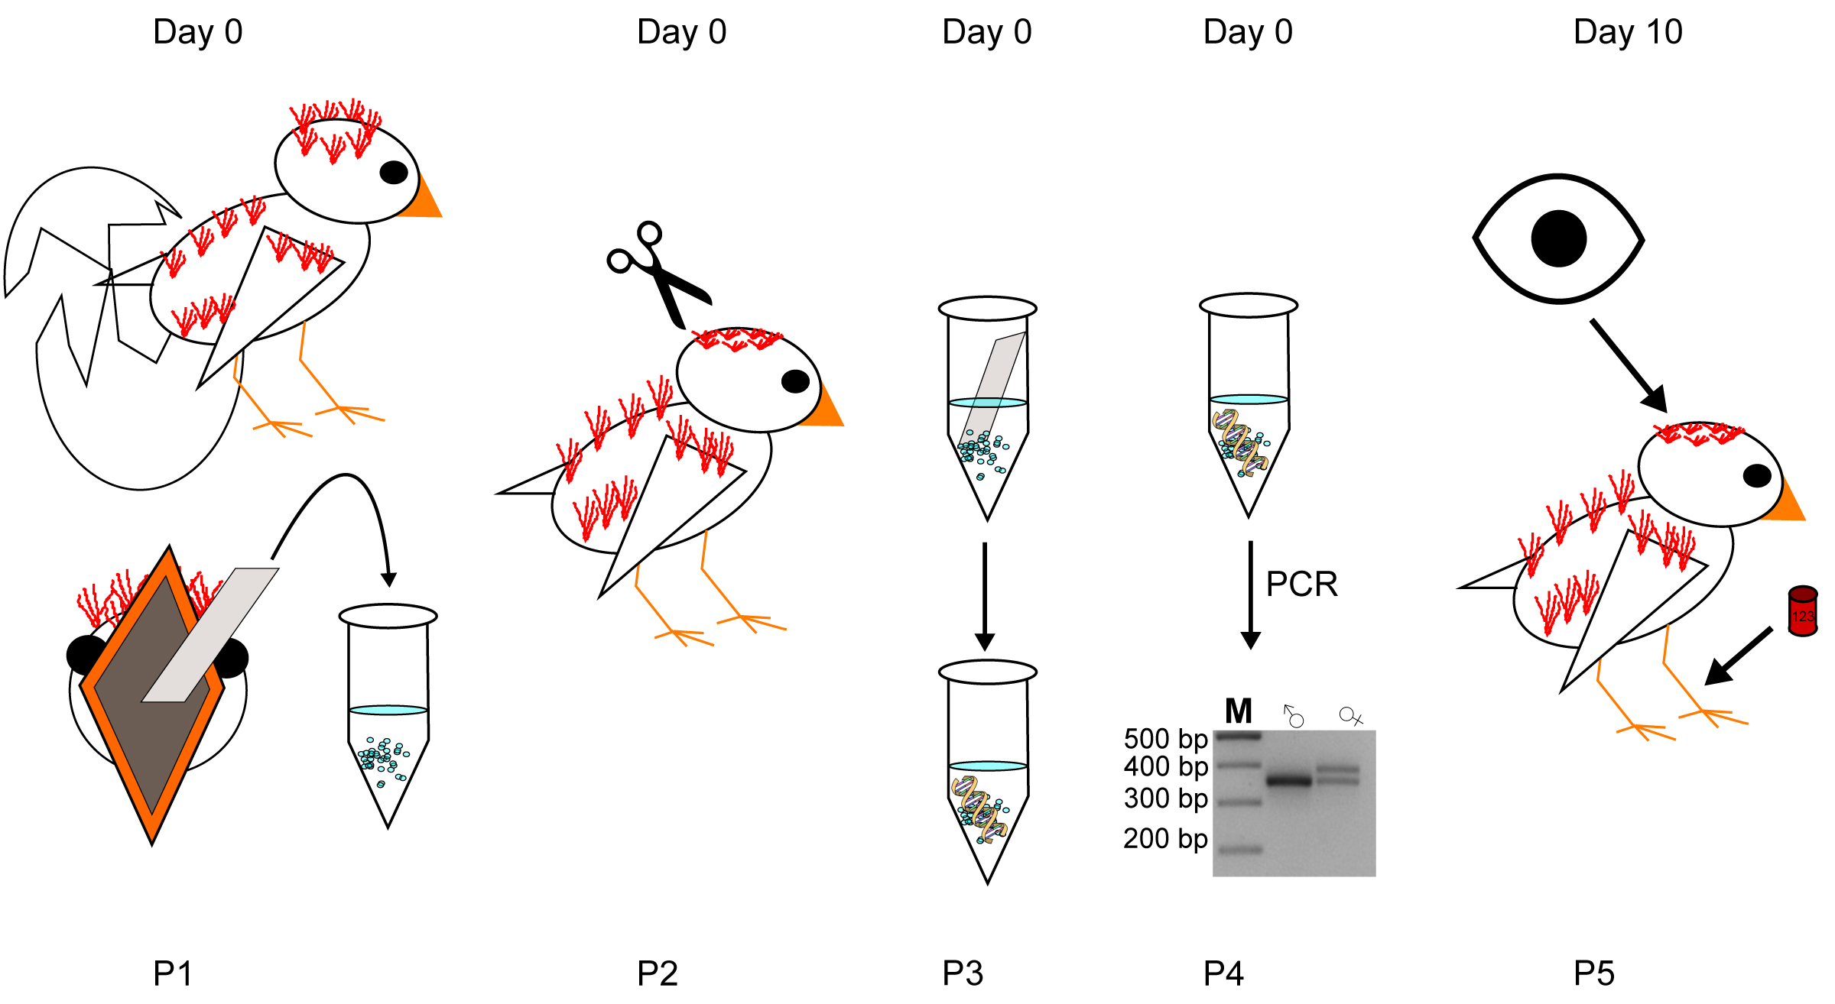

B. Interview: (Said by you on camera. Don’t forget to smile!)
  - Constance Scharff: The main advantage of this technique over existing methods, like sexing from blood samples using conventional DNA extraction techniques, is that the DNA sampling is non-invasive and very fast.
  - Iris Adam: Generally, individuals new to this method will struggle because they are usually not thorough when taking the buccal swab, which is the key step to a successful result.

Protocol (read by voice talent at JoVE):
- Reagents and Consumables Preparation
  - To begin, prepare 50 mL of 5 % Chelex-100 solution in molecular grade water.
    - MED/WIDE: Talent approaches bench with reagent.
    - MED: Talent prepares 5% chelex-100 solution with molecular grade water.
  - Constantly re-homogenize the suspension with a magnetic stirrer to prevent the Chelex resin from precipitating while aliquotting 200 µL of the solution in a standard 1.5 mL reaction tube.
    - MED CU: Talent places solution in beaker with magnetic stirrer, then turns on the stirrer.
    - MED_OS: Talent sets volume on pipetteman, then aliquots solution into reaction tubes.
  - Next, cut Whatman paper into pieces smaller than the width of the bird’s beak. The piece should be long enough to enable sample collection without the forceps being inserted into the beak of the bird.
    - MED: Using bird’s beak for reference, talent estimates the paper size needed. Talent cuts paper
    - MED – Over the Shoulder CU: Talent cuts Whatman paper into small pieces.
    - CU/ECU: Get a shot of the sizes of the cut pieces of paper.
  - Prepare one aliquot of PCR premix as described in the accompanying text protocol for each sample to be analyzed.
    - MED: Talent gathers reagents to prepare PCR premix.
    - MED – Over the Shoulder: Talent combines ingredients to prepare the PCR premix.
- Sample Collection
  - Capture the bird of interest and gently hold it in one hand using the ringer’s grip. Do not squeeze the bird.
    - MED/WIDE: Talent captures bird of interest.
    - CU: Side view talent shows bird using the ringer’s grip to the camera.
  - Next, hold a piece of Whatman paper with forceps and swipe the paper several times across the inside of the bird’s cheeks. Sampling from hatchlings or nestlings is especially easy using this technique, as their begging behavior provides easy access to the inside of the beak.
    - CU: Talent holds Whatman paper with forceps.
    - CU: Talent then swipes the paper across the inside of the bird’s cheeks.
    - CU: Talent swipes paper across tongue.
    - CU: Talent swipes paper across choana.
  - Immediately store the paper in a reaction tube containing 200 µL of previously prepared 5 % Chelex-100-solution.
    - MED: Talent stores paper in reaction tube with chelex solution.
    - CU/ECU: Side view of tube with sample paper immersed in solution.
  - Store samples at -20 °C. Samples can be stored for more than 3 years.
    - MED/WIDE: Talent places sample in freezer.
- DNA Extraction
  - To begin DNA extraction, remove the stored samples from the freezer and thaw the sample at room temperature. Ensure that the Whatman paper is submerged in the Chelex-100-solution on the bottom of the tube.
    - MED/WIDE: Talent removes sample from freezer.
    - MED/CU: Talent shows the tube to the camera to show the paper is submerged in the solution on the bottom of the tube.
    - MED CU: Talent places sample on bench to thaw.
    - CU: Talent shows the tube to the camera to show the paper is submerged in the solution on the bottom of the tube.
  - Incubate the samples for 15 min at 56 °C. Then briefly vortex the sample and spin the tube.
    - MED CU: Talent places the samples in the incubator.
    - MED: Talent removes the samples from the incubator, vortexes the samples, then spins the tube.
  - Next, incubate the samples at 100 °C for 8 min. Then spin the samples at 15,000 x g for 3 min. Then store the supernatant sample for subsequent genotyping at -20 °C.
    - MED – Over the Shoulder: Talent places samples in the incubator and sets a timer for 8 minutes.
    - MED: Talent removes the sample from the incubator, then spins the sample. If possible capture the time and temperature used to spin the sample.
    - MED: Talent removes the supernatant and stores it stores sample in the freezer.
- Molecular Sex Determination
  - Prepare one PCR tube with 6 µL of premix per sample and two additional tubes for the negative and positive control.
    - MED: Talent prepares three separate PCR tubes and adds premix to each one.
  - Next, add 19 µL of the supernatant from the DNA extraction to the PCR premix. Make sure to pipet from the surface of the solution to avoid carryover of Chelex beads.
    - MED – Over the Shoulder CU: Talent adds supernatant from the DNA extraction to the PCR tubes.
    - ECU: Side view of talent repeating the pipetting of the supernatant and avoiding carryover of the Chelex beads.
  - Then, run the PCR program. (TEXT: 94°C for 3 min, 45 cycles of 30 s at 94°C, 30 s at 55°C, 45 s at 72°C, 5 min at 72°C)
    - MED WIDE: Talent places sample in PCR machine and enters program.
  - Next, prepare a 2 % standard TBE agarose gel to separate the PCR products.
    - MED: Talent gathers materials and combines solutions to prepare agarose gel. (EDITOR: you can use 5.5.1 as well)
  - Then, load the gel with the PCR sample and run the agarose gel with appropriate voltage settings.

5.5.0. CU: Talent removes PCR sample from machine, adds dye.
    - MED CU: Talent removes PCR sample from machine, adds dye. prepares gel. (NOTE: This one was clapped wrong. It belongs to 5.4.)
    - MED – Over the Shoulder: Talent loads PCR sample into the agarose gel.
    - MED – Over the Shoulder: Talent checks voltage settings then turns on the voltage to run the gel.
  - Once the gel has finished running, visualize the bands under UV-light and take a picture. Make sure the two bands in the samples originating from females are well separated.
    - MED WIDE: Talent turns off voltage and removes gel from apparatus.
    - MED/WIDE: Talent takes gel to UV-light box.
    - MED – Over the Shoulder: Talent takes picture of the gel.
    - MED – Over the Shoulder: Talent analyzes the photo to make sure the bands are separated in female samples.
  - Distinguish male from female samples. The presence of one band indicates a male, two bands indicates a female.
    - MED – Over the Shoulder: Talent further analyzes the gel and points to single bands and double bands.

- Marking Nestlings
  - Check nests in the morning daily for newly hatched chicks.
    - MED/WIDE CU: Talent checks for newly hatched chicks.
  - Cut the down feathers of each chick within a nest. In zebra finches tufts of down grow at four characteristic and distinct areas across the nestling´s body. For each chick cut one area.
    - MED: Talent removes a chick within the nest.
    - CU: Side view talent cuts down feather of one chick in the nest (cut B is shown here).
    - LAB MEDIA: Figure 4 (Video Editor: If possible, make a split screen of this image, with the footage acquired from the shoot)
  - If there are more than four chicks within one nest, the unique four ‘haircuts’ can be combined.
    - MED: Side view talent holds chick.
    - CU: Talent cuts one area of chick.
    - LAB MEDIA: Figure 5 (Video Editor: If possible, make a split screen of this image with the footage acquired from the shoot)
  - Apply leg bands at ten days post-hatching when down feathers become hard to detect and nestling size allows ringing.
    - MED CU: Talent inspects chick for down feathers. (SHOT accidently as 6.1.1)
    - CU: Talent shows chick to camera, demonstrating the down feathers are gone. (Videographer: If possible, have the talent show a chick without down feathers, and one with down feathers)
    - CU: Talent applies leg bands on chick.
- Results: Successful Identification of Sex in Birds
  - Sexing results from buccal swabs were obtained from various avian species. One band appears in male samples and two bands appear in female samples. Similar amounts of DNA-bearing material are gained from all ages demonstrated by the comparable intensity of the bands on the gel.
    - LAB MEDIA: Figure 1 (Video Editor: Show the entire figure with all text. Highlight the bird names above the image when “various” is said by boxing, or zooming on the text. Frame all of the columns except Bengalese finch when “one band” is said, then frame the column under Bengalese finch when “two” is said. Show the entire figure again for a beat and box all of the bands seen in the figure.)
  - Chelex carryover into the PCR reaction inhibits the amplification of DNA as seen in the column where a small amount of Chelex beads were added to the PCR reaction. The presence of beads can be readily identified as dark staining in the pocket of the gel and an absence of primer dimer formation in the contaminated sample.
    - LAB MEDIA: Figure 2A & 2B (Video Editor: Show the entire figure (2A) with all text. Frame the column under zebra finch Chelex when “column” is said. Then show figure 2B alone with the header text, but without the text below the figure. If possible, when “primer” is said reveal the text and the arrow beneath the figure, then place a box of the same size as the band above the primer dimer text next to the empty spot under zebra finch chelex to indicate the lack of a primer dimer in the column.)
  - Successful extraction can be performed after long storage due to the use of Chelex. Samples of two animals were stored under different conditions as indicated in the table.
    - LAB MEDIA: Figure 3 (Video Editor: Show the entire figure with all text. Zoom in on the entire text below the figure, then zoom out and leave the image up for a beat.)

- Conclusion (said by authors on camera)
  - Iris Adam: Once mastered, this technique can be done in approximately 3 hours, if it is performed properly.
  - Constance Scharff: After watching this video, you should have a good understanding of how to label and sex altricial chicks noninvasively as early as the day of hatching, by combining the down feather haircuts and the fast and easy to perform buccal swabs in combination with the Chelex based DNA-extraction.

Provided Media

Authors, Please list all images, movie files, or 3-D rendered animations that can be included in the video per editor’s request. The step in the script/video where these images will be inserted should be specified. For example:

6.2 – 0123_PIname_Figure1.tif - dual color imaging of tumor angiogenesis at 40X
6.2 – 0123_PIname_Figure2.tif - dual color imaging of tumor angiogenesis at 100X

Formats: For static images we prefer .tiff, .eps, Illustrator, Powerpoint or Photoshop files at dimensions of at least 720X480 pixels and 300 dpi. The higher resolution, the better. Likewise any exported movie files should have at minimum these dimensions and be rendered to .mov, .mp4, or .avi files.

Figure 1.png
Figure 2.png
Figure 3.png

General Preparation

It’s critical for a smooth and organized shoot that all reagents are accounted for, in advance.

Any overnight or long incubation steps should be recognized and specimens/samples be prepared in advance so that prior steps can be recorded and shooting can continue with pre-prepared specimens/samples.

All tubes/flasks should be pre-labeled neatly before we arrive.

Ex. Luciferase assay done in 96 well plates should be labeled with negative/positive control wells and experimental samples are labeled accordingly.

You will receive more detailed preparation instructions, as well as an introduction to your videographer, closer to your filming date.

