Submission ID #: 51395

Editor: Steven Nilsen

Videographer: Yves Bourgeios

Film Date: January 30, 2014

Authors and Affiliations:

Fabrice Lucien, Kelly Harper, Pierre-Paul Pelletier, Leonid Volkov* and Claire M. Dubois,

Department of Pediatrics

Faculty of Medicine and Health Sciences

Université de Sherbrooke

*Biophotonics Core Facility

Centre de Recherche Clinique Etienne-Le Bel

Corresponding author:

Dubois, Claire M.

claire.dubois@usherbrooke.ca

Tel : (819) 564-5289

Title: Simultaneous pH Measurement in Endocytic and Cytosolic Compartments in Living Cells using Confocal Microscopy

- Will you require assistance with video microscopy, such as filming a complex dissection or microinjection technique (Y/N, please specify steps by number. Also, please list make and model of your microscope)? No.

- Does your protocol include detailed, step-by-step, descriptions of software usage (Y/N, please specify steps by number)? No.

- Which steps of your protocol will viewers benefit most from having filmed? (use the numbering below) 4.1 to 4.7

- What is the single most difficult aspect of this procedure and what do you do to ensure success? The single most difficult aspect of this procedure is to obtain good calibration curves. To ensure success, confocal microscope settings have to be identical every time an experiment is performed.

- Will the shoot take place in more than one location? (Y/N, specify travel time between locations) No.

Schematic Overview (read by a voice talent at JoVE)

The overall goal of the following experiment is to simultaneously measure vesicular and cytosolic pH in living cells by confocal microscopy. (Intro) This is achieved by first incubating the cells with the pH-sensing probes HPTS and SNARF-1, which label the endosomal and lysosomal compartments and the cytosol, respectively. (P1) Next, the cells are placed in an environmentally controlled chamber under a confocal microscope and the software is set to measure the fluorescence of the probes. (P2) In the chamber, the cells are incubated with different pH calibrated solutions. (P3) A pH standard curve is constructed using a non-linear regression; exponential equations are determined for both probes and are subsequently used to convert fluorescence intensities of samples into pH values. (P3’) This method allows the determination of vesicular and cytosolic pH from samples after various treatments and can enable the study of the regulation of intracellular pH during biological processes. (P4)

Video editor:
P1 – Fade through the three panel series provided for P1. Animate the green and red pipette tips approaching and leaving the plate area.
P2 – Show just the right side first then switch to just the two “phase” panels when the narration goes to “set”.
P3 – Return to the first panel showed in P2 and zoom into the orange circle on the platform and then fade to the image on the left side for P3 (dish and label)
P3’ – Fade to right side of P3, start with just the graph then add the equations after “exponential” in the narrative.
P4 – Start with left side (4 panels with labels) and fade to right side (graph) at “enable” in the narrative.

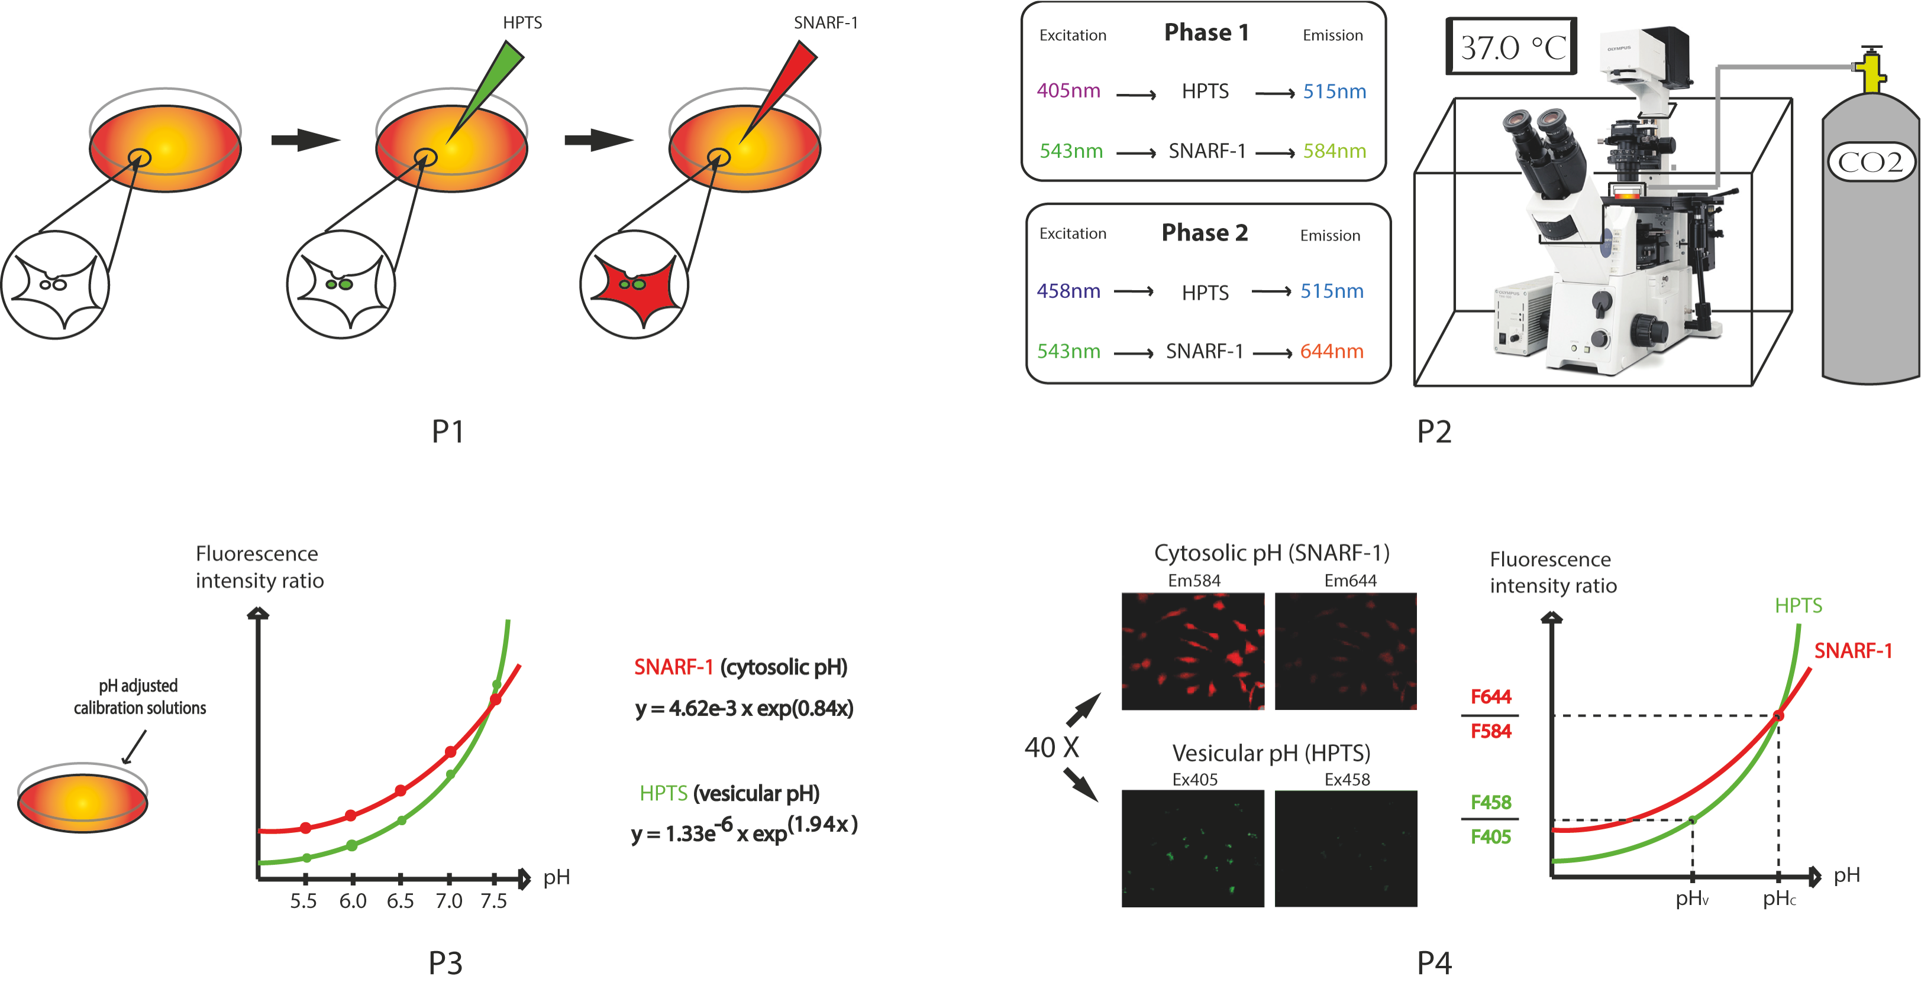

- Introductory Interview (spoken by you on camera. Don’t forget to smile!)

  - KH: The main advantage of this technique over existing methods for intracellular pH measurement, is that our method enables the measurement of intracellular pH dynamics in living cells while eliminating artifacts and background noise during imaging.
  - KH: Demonstrating the procedure will be Fabrice Lucien the Ph.D student_who has developed the method.

(comment: shot 1.1 take 3 is both 1.1 & 1.2 together)

Protocol Chapters (read by a voice talent at JoVE):
- Preparing Solutions and Cells
  - For cellular pH calibration, it is necessary to create a series of five 50-ml solutions from pH 5.5 to 7.5 in 0.5 increments. Add one normal potassium hydroxide or hydrochloric acid, drop wise, to set the pH values.
    - WID: talent with meter and solutions, mixing pH-control solution
    - MED: adding potassium hydroxide drops to beaker of solution, stirring an pH meter in use
    - MED: labeling a storage container for the solution and loading it with the standard
  - Then, to each pH-calibrated solution, add 0.05 ml of the ionophore nigericin at 10 millimolar for a final concentration of 10 micromolar. Nigericin will increase cell membrane permeability in the presence of depolarizing concentrations of extracellular potassium.
    - CU: taking aliquot of nigericin (all bottles in video are clearly labeled and visible to camera whenever possible)
    - MED: adding aliquot to one of the pH-calibrated solutions
    - MED: taking aliquot of nigericin and adding it to next solution and repeating
  - Under a hood, seed cells in 35-mm culture dishes with 2 milliliters of medium containing 10% fetal bovine serum and antibiotics, with the goal of achieving 50% confluence in 24 hours of incubation at 37 ºC.
    - WID: talent brings culture dishes to hood, unwraps them
    - MED: adds medium to dishes
    - CU: loading a dish, and adding lid
  - After seeding all the required plates for the experiment, seed an additional five plates for the calibration. Incubate these plates for 24 hours.
    - MED: group of dishes for the experiment completed, five more are then loaded
    - WID: loading plates into incubator
  - 24 hours later and sixteen hours before imaging, add two microliters of the organelle label HPTS at one Molar for a final concentration of one millimolar HPTS in solution. (comment: This step is supposed to be performed without light (as HPTS needs to be protected from light) however it was filmed with the lights on because we could not film in the dark)
    - CU: taking aliquot of HPTS (comment: this shot was filmed as MED not CU)
    - MED: loading a dish with HPTS and then loading another dish with HPTS (comment: this shot was filmed as CU not MED)
  - On the next morning, about three hours before imaging, remove the HPTS by performing two washes with PBS. Then, add two milliliters of serum-free medium and allow the cells to incubate for at least two more hours.
    - WID: unloading plates from the incubator
    - MED: at hood, washing solution from dish using PBS, repeats for next dish, or on same dish if done in this order (comment : multiple takes in MED & CU from different angles to be used for 2.6.2 & 2.9.1)
    - MED: loading plates with media
  - Just before imaging, incubate the cells with five micromolar SNARF-1 by adding ten microliters of one millimolar SNARF-1.
    - WID: returning to hood with plates (comment: takes 3 & 4 were done at MED because the next shot was changed to CU)
    - MED: taking aliquots of SNARF-1 and adding them to plates, show at least two plates loaded (comment: shot was filmed in CU)
  - The incubation time for SNARF-1 varies with the cell line and is conducted under dim light. For HT-1080 cells, the required incubation period is twenty minutes.
    - MED: preparing light in incubator
    - CU: setting plates under dim light, showing how each is exposed(comment: these shots were not filmed because SNARF1 needs to be protected from light not used under dim light)
  - Following the SNARF-1 incubation period, wash the cells twice with PBS and add two milliliters of serum-free medium. Then proceed with imaging the cells.
    - Reuse 2.6.2
    - Reuse 2.7.2 2.6.3
- Imaging the Cells
  - Imaging of the cells should be accomplished with a spectral inverted scanning, confocal microscope equipped with a motorized stage and environmental chamber.
    - WID: talent arrives at confocal scope and turns on lasers (comment: take 1 is CU showing the lasers being turned on, take 2 is the WID shot)
    - MED: turns on the environmental chamber heater (comment: this shot was filmed in CU)
  - When using plastic Petri dishes, a 40X objective is the most appropriate.
    - ECU: lower power objective in use, then switched to the 60X objective – get the 60X label in focus (comment: in this shot objective is switched to the 40X objective also the slating was done at the end of this shot)
  - The software should be adjusted for two virtual channel sets. In the software, adjust the excitation wavelength and emission wavelengths for HPTS and SNARF-1.
    - LAB MEDIA: table for 3.3
  - The confocal aperture is set to 175 microns by default and optimal aperture needs to be manually set at 300 microns
    - CU: SCREEN CAPTURE: setting the confocal aperture (comment: this shot was not filmed but will be replaced by a screen capture to depict was is written in 3.4)
  - Then, manually set the optimal aperture at 175 microns.
    - CU: setting the optimal aperture
  - Once the chamber has warmed to 37 ºC, start the calibration. Wash a plate of cells twice more using PBS and, then, replace the medium with the first calibration solution.
    - ECU: reading on environmental chamber showing 37 ºC (comment: the slating was done at the end of this shot)
    - MED: washing plate with PBS, two times, then adding calibration solution (comment: multiple takes in MED and CU takes 1-4 for 3.6.2 (pH 6) , takes 5 (CU)& 6 (MED) can be used for 3.11.2 because they show a pH 7.5 being used)
    - CU: setting plate into environmental chamber on scope (comment: this shot should be under 3.7 just before 3.7.1)
  - Now, set the cells into the chamber and calibrate both pH-sensitive dyes. Acquire up to thirty time-lapse images at one-minute intervals.
    - MED: talent sits down at computer attached to the scope
    - SCREEN CAPTURE: setting imaging parameters to capture every minute for thirty minutes
  - Each image-stack can be collected at 0.4 microns thick and 800 square pixels; and, between images, the shutter must be programmed to remain closed.
    - SCREEN CAPTURE: setting the stack thickness and size of image (pixels) then shutter is programmed to be shut between images
  - Note the fluorescence intensity every minute, which will typically stabilize around twenty minutes.
    - MED: talent at screen, taking note of fluorescence in notebook
  - Once fluorescence stabilizes, take images from four or five fields containing fifteen to twenty cells and both probes. These images are used for the curve calculations.
    - SCREEN CAPTURE: screen showing stabilized fluorescence cell image
    - ECU: stage movement, demonstrating the field of view on cells changes
    - SCREEN CAPTURE: new field of view, image taken
  - Repeat this process for each calibration solution. Then, proceed with imaging the experimental condition plates, for which no washes are needed.
    - MED: talent remove cell plate from the stage
    - MED: washing plate of cells and adding next pH-calibrated solution to plate (comment: reuse 3.6.2 , takes 5 or 6)
- Data Analysis
  - In analyzing each image, first digitally subtract out the background extracellular fluorescence.
    - MED: talent at computer where image analysis is performed (comment: there are multiple takes of this shot that could be inserted with other screen captures if necessary )
    - SCREEN CAPTURE: removing background signal
  - Then, select labeled vesicles and cytosol from stored images using a binary mask.
    - SCREEN CAPTURE: selecting the labeled vesicles on an image
  - For each pH-sensing probe, fluorescence intensities are measured on a scale from 0 to 4095. Calculate the mean intensity for all pixels in the organelle or cytoplasm.
    - SCREEN CAPTURE: collecting intensity values on selected regions of image, entering values into a spreadsheet, then taking mean values of compiled data.
  - Using these values, calculate fluorescence ratios for HPTS… (TEXT: RHTPS RHPTS= (F458 nm / F405 nm))
    - SCREEN CAPTURE: show formula for calculating HTPS HPTS ratio
  - … and for SNARF-1 (TEXT: RSNARF-1 = (F644 nm / F584 nm))
    - SCREEN CAPTURE: show formula for calculating SNARF-1 ratio
  - For calibration curves, plot the fluorescence ratios obtained for each calibration solution as a function of pH. Calibration curve fitting should be done using an exponential equation.
    - SCREEN CAPTURE: plotting a calibration curve from the data, then setting the curve fit to an exponential equation to show how the plot changes
  - Lastly, use the calibration curves to transform the ratios into pH values and thus obtain cytosolic and organelle pH values in living cells under experimental conditions.
    - SCREEN CAPTURE: demonstrate the use of the standard curve formula to transform ratios into pH values
- Intercellular pH Changes in HT-1080 Cells
  - Clear evidence was obtained that HPTS labels both endosomal and lysosomal compartments by co-staining with Alexa 546-conjugated transferrin, to stain endosomes, or with a fluorescent lysotrophic probe, Lysotracker Deep Red.
    - LAB MEDIA: Figure 2A
  - Time-lapse images were collected for each probe, as described, in HT-1080 cells. Five calibration solutions were tested. Fluorescence approached stability after 15 minutes in the solutions, such as with pH 6 and pH 7.5 solutions.
    - LAB MEDIA: Figure 2B
  - In the calibration curve for a given pH, the data represents the ratio of fluorescence intensities at 458 to 405 nanometers for HPTS or 644 to 584 nanometers for SNARF-1. Both curves were fitted with an exponential equation.
    - LAB MEDIA: Figure 2C
  - The efficiency of the method, in live HT-1080, was evaluated using ammonium chloride, a weak base that increases intracellular pH. The base increased the pH of both the cytosol …
    - LAB MEDIA: Figure 3A – NH4Cl data highlighted
  - … and the vesicles.
    - LAB MEDIA: Figure 3B – NH4Cl data highlighted
  - The method was also evaluated using bafilomycin A1, an inhibitor of V-ATPases. Bafilomycin A1 induced alkalinization of both endosomal and lysosomal compartments, but did not alter cytosolic pH.
    - LAB MEDIA: Figure 3A – bafilomycin A1 data highlighted
    - LAB MEDIA: Figure 3B – bafilomycin A1 data highlighted

Video editor: fade between images, even with narration.
  - Lastly, EIPA, an inhibitor of NHE-1, was tested. It acidified the cytosol, down to a pH of 6.62 but did not affect vesicular pH.
    - LAB MEDIA: Figure 3A – EIPA data highlighted
    - LAB MEDIA: Figure 3B – EIPA data highlighted

Video editor: fade between images, even with narration.
- Conclusion Interview (spoken by you on camera)
  - KH: So far, the study of cellular pH homeostasis has been limited both by the rapid pH changes occurring within cells and by the lack of tools to study pH in living cells. We described today a simple step-by-step approach to simultaneously measure cytosolic and endosomal pH values in single living cells. (comment: take 1 & 2 is both shots 6.1 & 6.2 together, other takes are 6.1 alone)
  - KH: This is especially important for the study of pH homeostasis in cells where mutations or drugs can affect efflux and influx of protons within the endosomal compartment.

List of Provided Media Filenames and Descriptions (fill this in)

Screen Captures :
3.4.1
3.7.1
3.8.1
3.10.1
3.10.3
4.1.2
4.2.1
4.3.1
4.4.1
4.5.1
4.6.1
4.7.1

General Preparation

It’s critical for a smooth and organized shoot that all reagents are accounted for, in advance.

Any overnight or long incubation steps should be recognized and specimens/samples be prepared in advance so that prior steps can be recorded and shooting can continue with pre-prepared specimens/samples.

All tubes/flasks should be pre-labeled neatly before we arrive.

Ex. Luciferase assay done in 96 well plates should be labeled with negative/positive control wells and experimental samples are labeled accordingly.

