Submission ID #: 51358

Editor Name: Melissa Ceo

Videographer name:

Film Date:

Authors and Affiliations:
Xiaojing Liu¹, Zheng Ser¹, Ahmad A. Cluntun^{1,2}, Samantha J. Mentch^{1,2}, and Jason W. Locasale^{1,2}

¹Division of Nutritional Sciences
²Field of Biochemistry, and Molecular Cell Biology
Cornell University
Ithaca NY, 14853

Title: A strategy for Sensitive, Large Scale Quantitative Metabolomics

Corresponding Author:

Jason W. Locasale: locasale@cornell.edu

Co-authors email: Xl296@cornell.edu

Co-authors email: zs73@cornell.edu

Co-authors email: aac92@cornell.edu

Co-authors email: sjb343@cornell.edu

A. Will you require JoVE to record video microscopy, such as filming a complex dissection or microinjection technique? (Y/N) ____N____ If yes, please list make and model of your microscope: ______________________________
**Note: This question is to get at whether or not you will need a camera hook-up to look into the microscope. However, if your microscope has a digital camera attached to a computer, you can gather these shots by collecting screen capture movies.
Does your protocol include microscopy steps that are visualized through a microscope with a digital camera/computer attached? (Y/N) __N__
B. Does your protocol include detailed, step-by-step, descriptions of software usage? (Y/N)___Y___
C. Which steps of your protocol will viewers benefit most from having filmed? Please list 4-6 steps 2.4, 2.5, 3.2, 3.3, 5.2, 5.3
D. What is the single most difficult aspect of this procedure and what do you do to ensure success? An untargeted data analysis can be time consuming and labor intensive when a very low intensity threshold is used. Using appropriate filters could simplify the analysis.

1. Introduction (Schematic Overview and Interview)

A. Schematic Overview (read by voice talent at JoVE):

Procedural Narrative:
The overall goal of this procedure is to study metabolic profiling in cultured cells. (Intro)

This is accomplished by first extracting polar metabolites from cells. (P1, show petri dish and tube and make white and red objects move from dish into tube).

The second step is to reconstitute the cell extracts in water and transfer the samples to LC vials. (P2, show tube from P1 and make white and red objects blend together to form solution in tube. Then show black arrow followed by image of vials above [P2]).

Next, the samples are injected into the LC-QE-MS (TEXT: LC-QE-MS: Liquid Chromatography Q-Exactive Mass Spectrometry) instrument, which has been calibrated, and raw data is recorded in the computer. (P3, show multicolored curves in bottom right corner and make red curve move into open black circle. Then have red curve move onto computer screen).

In the final step, metabolite peaks are extracted from the raw data using commercial software, and unknown peaks are searched against a high resolution mass database. (P4, show Table 2A or 2B).

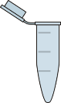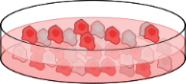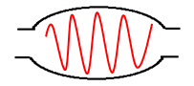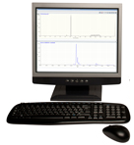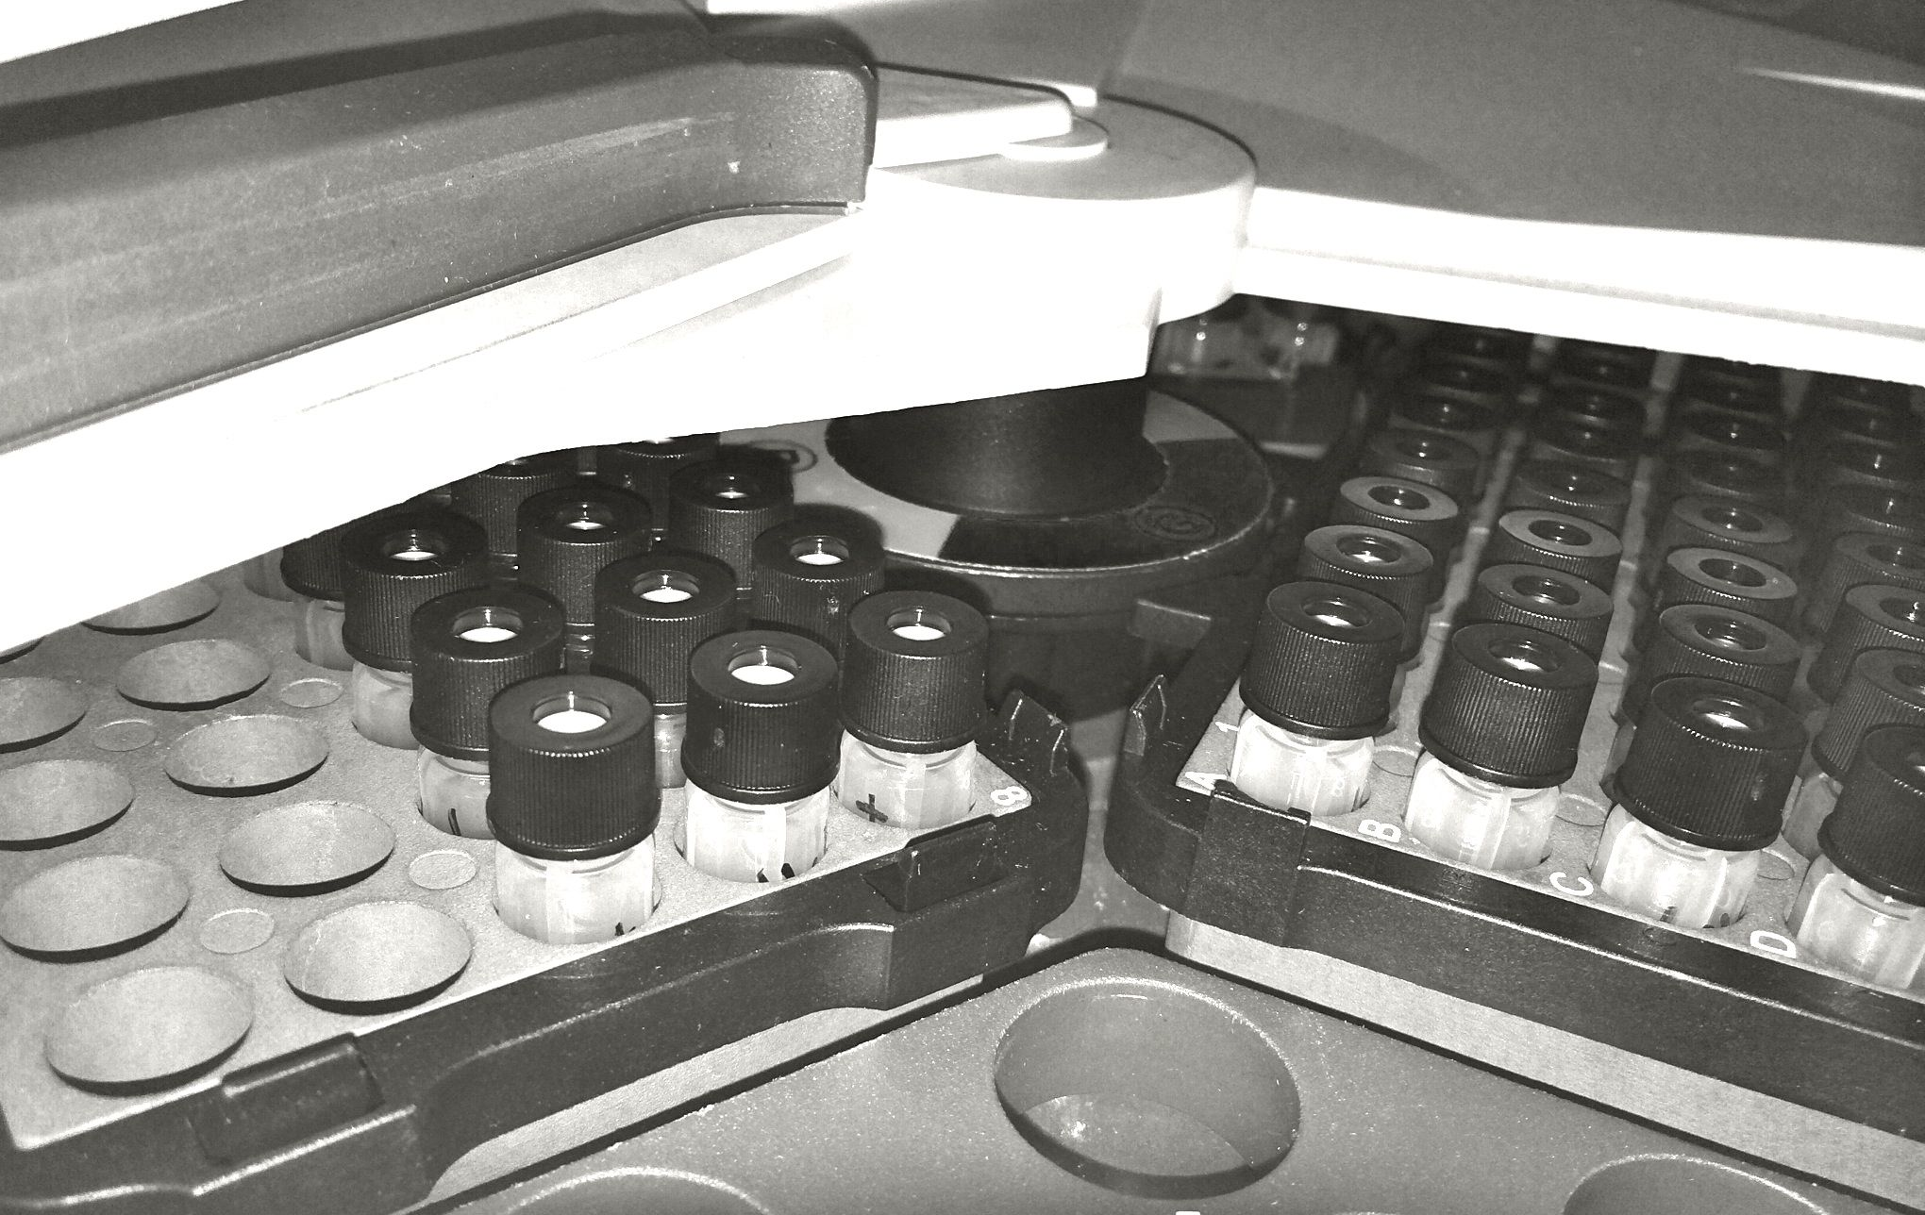
(P1)
(P2)
(P3)
(P4)

B. Interview: (Said by you on camera. Don’t forget to smile!)
  - XIAOJING LIU: Though this method can provide insight into relative metabolite expression levels in cells, it can also be applied to other systems, such as serum or tissues.

Protocol (read by voice talent at JoVE):
- Preparation of LC-MS Reagents and Establishment of a Chromatography Method and Instrument Operating Procedures
  - First, prepare 500 ml of mobile phase A, which is 20 mM ammonium acetate and 15 mM ammonium hydroxide in 3% acetonitrile and water (TEXT: Mobile phase A: 20 mM ammonium acetate and 15 mM ammonium hydroxide in 3% acetonitrile/water, pH 9.0). After loosely capping the bottle, sonicate the solution in a water bath sonicator for 10 min without heating.
    - MED: Talent prepares mobile phase A in a bottle.
    - MED-over the shoulder: Talent places bottle in water bath sonicator and turns it on.
  - Following this, dissolve 5 mg of both sodium fluoroacetate and homovanillic acid in 5 ml of water to make a final concentration of 1 mg/ml. Then, dissolve diazinon in methanol to make a final concentration of 10 μg/ml.
    - CU: Tube containing sodium fluoroacetate and homovanillic acid as talent adds water to it.
    - MED: Talent adds methanol to tube containing diazinon.
  - To prepare 1 ml of negative low mass calibration solution, mix 960 μl of thermo negative calibration solution with 20 μl of the sodium fluoroacetate and homovanillic acid solution. To make 1 ml of positive low mass calibration solution, mix 990 μl of thermo positive calibration solution and 10 μl of the diazinon solution.
    - MED-over the shoulder: Talent mixes thermo negative calibration solution with fluoroacetate/homovanillic solution in tube.
    - MED: Talent mixes thermo positive calibration solution with diazinon solution in tube.

2.6 [moved] Equip the QE-MS instrument with a Heated electrospray ionization, or H-ESI, probe by fixing it at level C and then connecting it to the nitrogen gas inlets, vaporizer cable and voltage cables.

2.6.1 MED: Talent fixes ionization probe at level C of the instrument.

2.6.2 MED-over the shoulder: Talent connects probe to nitrogen gas inlets, vaporizer cable and voltage cables.

  - After carrying out a standard mass calibration in positive mode, adjust the scan range to 60-900 m/z (pronounced mass to charge ratio) in the instrument control panel and apply a source collision-induced dissociation of 25 eV. Input customized calibration ions, and once the ion source is stable, start the customized calibration in the tuning page.
    - SCREEN: Computer screen as talent adjusts scan range in instrument control panel, applies appropriate source collision-induced dissociation values and starts customized calibration in tuning page.

  - Switch the polarity to negative mode. After carrying out a standard mass calibration in negative mode, adjust the scan range to 60-900 m/z in the instrument control panel and apply a source collision-induced dissociation of 35 eV. Input customized calibration ions, and once the ion source is stable, start the customized calibration in the tuning page.
    - SCREEN: Computer screen as talent adjusts scan range in instrument control panel, applies appropriate source collision-induced dissociation values and starts customized calibration in tuning page.

  - [moved] Equip the QE-MS instrument with a Heated electrospray ionization, or H-ESI, probe by fixing it at level C and then connecting it to the nitrogen gas inlets, vaporizer cable and voltage cables.
    - MED: Talent fixes ionization probe at level C of the instrument.
    - MED-over the shoulder: Talent connects probe to nitrogen gas inlets, vaporizer cable and voltage cables.

  - In the computer tuning page, set the relevant tuning parameters for the probe (TEXT: heater temperature: 120 °C, sheath gas: 30, auxiliary gas: 10, sweep gas: 3, spray voltage: 3.6 kV for positive mode and 2.5 kV for negative mode). Set the capillary temperature at 320 °C, and the S-lens at 55.
    - SCREEN: Computer screen as talent sets relevant tuning parameters in computer turning page.
    - [combined with 2.7.1] SCREEN: Computer screen as talent sets capillary temperature and S-lens.
  - Next, in the method program, build a full scan method using the following values (TEXT: full scan range: 60 to 900 (m/z), resolution: 70,000, maximum injection time: 200 ms, automatic gain control: 3,000,000 ions).
    - SCREEN: Computer screen as talent inputs appropriate values in the method program.
  - Establish the chromatography method by inputting the linear gradient information. Employ an amide column for compound separation at room temperature (TEXT: See text protocol for chromatographic conditions).
    - SCREEN: Computer screen as talent inputs linear gradient information.
    - MED-over the shoulder: Talent attaches amide column to instrument.
- Preparation of Metabolite Samples
  - At this point, prepare an extraction solvent by manually mixing 40 ml of methanol and 10 ml of water in a 50 ml tube (TEXT: Keep solvent in -80 °C freezer for at least 1 hour before use).
    - CU: Tube as talent mixes methanol and water in it.
  - When previously cultured colon cancer HCT 8 cells reach 80% confluence, quickly aspirate the medium, and place the 6-well plate on top of dry ice. Then, immediately add 1 ml of extraction solvent to each well, and transfer the plate to a -80 °C freezer.
    - MED-over the shoulder: Talent removes media from each well and places plate on top of dry ice.
    - CU: Plate as talent adds extraction solvent to each well.
    - MED: Talent places plate in freezer.
  - After removing the plate from the freezer 15 minutes later, place it on top of dry ice and scrape the cells into the solvent. Transfer the solution from each well to three 1.7 ml Eppendorf tubes, and centrifuge the samples with a speed of 20,000 × g at 4 °C for 10 min.
    - MED: Talent places plate on top of dry ice.
    - CU: Plate as talent scrapes cells into solvent in each well.
    - MED-over the shoulder: Talent transfers solution from each well to three Eppendorf tubes.
    - MED: Talent places tubes in centrifuge, programs appropriate settings and turns it on.
  - Following centrifugation, transfer the supernatant to two new Eppendorf tubes. Then, dry the samples in a speed vacuum. Once the samples are dry, store them in the -80 °C freezer.
    - MED-over the shoulder: Talent adds supernatant to new Eppendorf tubes.
    - MED: Talent places tubes in speed vacuum and turns it on.
    - MED-over the shoulder: Talent places samples in freezer.
  - After removing the samples from the freezer for analysis, allow them to reach ice temperature. Then, add 20 μl of ice cold water and vortex the samples to dissolve metabolites.
    - MED: Talent places samples on lab bench to warm to ice temperature.
    - MED-over the shoulder: Talent adds ice cold water to samples and briefly places them on vortex mixer.
  - Next, centrifuge the samples at 20,000 × g at 4 °C for 2 min. Transfer the supernatant to LC vials and inject 5 μl of the samples into the LC-QE-MS instrument for analysis.
    - Reuse shot 3.3.4 – use the part that shows turning the centrifuge on.
    - CU: LC vials as talent adds supernatant to them.
    - MED-over the shoulder: Talent injects samples into instrument.
- Setup of Sample Sequence
  - Once the calibration has been properly carried out on the QE-MS instrument, equilibrate the LC column for five minutes with 85% of mobile phase B at a flow rate of 0.15 ml/min.
    - SCREEN: Computer screen as talent sets up equilibration.
  - Next, set up the sample sequence in a random order to distribute the fluctuations introduced by the LC-MS to each sample and ensure a more accurate comparison between different samples. After every 6 samples, add a wash run followed by a blank sample to assess the system background and carry over levels.
    - SCREEN: Computer screen as talent sets up sample sequence.
    - MED-over the shoulder: Talent at computer adds a wash run and blank sample to sequence.
  - Save the sequence and start the sequence run once the LC column shows stable pressure close to 400 psi.
    - SCREEN: Computer screen as talent saves the sequence and starts sequence run.
- Analysis of LC-MS Data
  - After the first two samples of the sequence have run, check the peaks in these chromatograms for unknown metabolites to ensure the sample sequence runs smoothly (TEXT: If peak shape is abnormal or mass error is off by more than 5 ppm, stop rest of sequence and troubleshoot).
    - SCREEN: Computer screen as talent checks peaks in one of the sample chromatograms.
  - After all of the samples in the sequence are finished, perform data analysis on a separate computer. Choose the method of “peak alignment and frame extraction” for small molecule on commercially available software. Then, load the LC-MS raw data and group them based on sample types. Pick samples in the middle of the run sequence as a chromatography reference sample for peak alignment and pick a group as the ratio group for the fold change calculation.
    - MED: Talent walks up to another computer, sits down, and opens appropriate program on computer.
    - SCREEN: Computer screen as talent chooses appropriate method.
    - SCREEN: Computer screen as talent loads raw data and groups them. Computer screen as talent picks chromatography reference sample for peak alignment and a group for fold change calculation.
  - Then, upload a frame seed including known metabolites for the targeted metabolite analysis with data collected in positive mode and a frame seed of metabolites for negative mode.
    - SCREEN: Computer screen as talent picks chromatography reference sample for peak alignment and a group for fold change calculation.
    - 5.3.1 SCREEN: Computer screen as talent uploads appropriate frame seeds.
  - Next, choose full spectra scan either in the positive or negative mode and save this data processing file in the same folder as the raw data.
    - SCREEN: Computer screen as talent chooses full spectra scan and saves data processing file.
  - Turn off the database search function and run the workflow. Then, export the processed data as an Excel sheet containing the peak area of every frame.
    - SCREEN: Computer screen as talent turns off database search function and runs the workflow.
    - SCREEN: Computer screen as talent exports processed data as an excel sheet.
  - For an untargeted metabolite analysis, choose the method of “component extraction”. Load the sample raw data and three blank samples for background subtraction.
    - SCREEN: Computer screen as talent chooses appropriate method.
    - SCREEN: Computer screen as talent loads sample raw data and blank samples.
  - Following this, group the raw data and set the reference samples as described previously. Set the component intensity threshold to 10⁵.
    - SCREEN MED-over the shoulder: Talent at computer groups raw data and sets reference samples.
    - SCREEN: Computer screen as talent sets component intensity threshold.
  - Use a human metabolome database for unknown compound identification. After saving this processing file, turn off the database search function and start the workflow.
    - SCREEN: Computer screen as talent opens human metabolome database.
    - MED-over the shoulder: Talent at computer turns off database search function and starts the workflow.
  - Once the data processing is finished, use coefficients of variation, or CV, filters to remove components with large CV within replicate samples, and intensity filters to remove components detected at noise level.
    - SCREEN: Computer screen as talent uses CV filter and intensity filters to remove appropriate components.
  - Manually go through each component, and pick those with a well-defined peak or relatively big difference in different samples types for the database search. Finally, export the data with hits in the database.
    - SCREEN: Computer screen as talent picks most suitable components.
    - [added shot] SCREEN: Computer screen as talent searches database.
    - 5.10.3 SCREEN: Computer screen as talent exports data with hits in database.

Results: Evaluation of Instrument Accuracy, Sensitivity and Untargeted Metabolomics Based on Current LC-QE-MS Platform
  - The accuracy of metabolomics data highly depends on the LC-QE-MS instrument performance. To assess whether the instrument is operating in good condition, and whether the method applied is proper, several known metabolite LC peaks are extracted from the total ion chromatography, as shown here. Polar metabolites, including amino acids, glycolysis intermediates, TCA intermediates, nucleotides, vitamins, ATP, and NADP⁺, have good retention on the column, and good peak shapes under the current LC conditions.
    - LAB MEDIA: Figure 1
  - Meanwhile, a mass error test is done within 24 hrs after low mass calibration, as illustrated here. The mass error is assessed by comparing the detected m/z to the theoretical m/z of targeted metabolites. Here the targeted metabolites have a m/z ranging from 74 to 744. The Y-axis here represents the accumulative percentage of metabolites within a certain mass error range. The red curve shows the results in positive mode, while the blue colored curve shows the data collected in negative mode. More than 90% of the metabolites are within 5 ppm mass error in both positive and negative mode, which means the low mass range calibration method developed here is sufficient to maintain 5 ppm mass error for low mass range detection.
    - LAB MEDIA: Figure 2 (Video Editor: Please highlight red and blue curves when mentioned in 5th sentence).
  - Another issue to be addressed is the sensitivity of the instrument with the current method and instrument setup. A serial dilution of triplicate samples from a 10 cm Petri dish was performed 5 times with a dilution factor of 6, resulting in 6 different concentrations of samples. A targeted list is used to assess the number of metabolites detected at differing concentrations of sample. The results shown here indicate that the optimal number of targeted metabolites detected is between 2.78×10⁵ and 1.67×10⁶ cells, while 1×10⁷ cells give a fewer number of detected metabolites, which is due to ion suppression effects. This result indicates that the optimal amount of cells to extract for this analysis is roughly that of a well in a 6-well plate.
    - LAB MEDIA: Figure 3
  - For untargeted metabolite analysis, a CV cutoff of 20% and an average intensity value of 10⁷ are used to filter the components table. CV cutoff values can be increased while the average intensity values need to be decreased to include more peaks. After manually checking the peaks, components with good shapes are selected and searched for in the human metabolome database. The results from data collected in positive mode are listed here, while the results from the negative mode are listed here. Some of the metabolites identified here overlap with the metabolites in the targeted list, such as glutathione and proline. Additional metabolites absent from the targeted list are also explored, such as methylglyoxal, which can be derived from glycolysis, and 1-palmitoyl-2-oleoyl-sn-glycero-3-phosphocholine, which is detected in the positive mode with a retention time of 3.2 min.
    - LAB MEDIA: Table 2 (Video Editor: Please show Table 2A for first part of 4th sentence and Table 2B for second part of 4th sentence. Highlight “glutathione” and “proline” in one of the tables when mentioned in 5th sentence. Highlight “methylglyoxal” in Table 2B when mentioned in 6th sentence).

- Conclusion (said by authors on camera)
  - XIAOJING LIU: After watching this video, you should have a good understanding of how to extract polar metabolites from cultured cells and then use LC-QE-MS to measure metabolite relative levels in different samples.

Provided Media

Authors, Please list all images, movie files, or 3-D rendered animations that can be included in the video per editor’s request. The step in the script/video where these images will be inserted should be specified. For example:

6.2 – 0123_PIname_Figure1.tif - dual color imaging of tumor angiogenesis at 40X
6.2 – 0123_PIname_Figure2.tif - dual color imaging of tumor angiogenesis at 100X

Formats: For static images we prefer .tiff, Illustrator, Powerpoint or Photoshop files at dimensions of at least 720X480 pixels and 300 dpi. The higher resolution, the better. Likewise any exported movie files should have at minimum these dimensions and be rendered to .mov, .mp4, or .avi files.

Insert your media filenames here.

SchematicFig – authors, please include a schematic figure to correlate with the narrative
overview text in section 1A. See attached instructions.

General Preparation

It’s critical for a smooth and organized shoot that all reagents are accounted for, in advance.

Any overnight or long incubation steps should be recognized and specimens/samples be prepared in advance so that prior steps can be recorded and shooting can continue with pre-prepared specimens/samples.

All tubes/flasks should be pre-labeled neatly before we arrive.

Ex. Luciferase assay done in 96 well plates should be labeled with negative/positive control wells and experimental samples are labeled accordingly.

You will receive more detailed preparation instructions, as well as an introduction to your videographer, closer to your filming date.

