Submission ID #: 51349

Editor Name: Melissa Ceo

Videographer name:

Film Date:

Authors and Affiliations:
M. C. Gilbert Lee and Bingyun Sun

Department of Chemistry
Simon Fraser University
Burnaby, Canada

Title: Glycopeptide Capture for Cell Surface Proteomics

Corresponding Author:

Bingyun Sun: Bingyun_sun@sfu.ca

A. Will you require JoVE to record video microscopy, such as filming a complex dissection or microinjection technique? (Y/N) __N__ If yes, please list make and model of your microscope: ______________________________
**Note: This question is to get at whether or not you will need a camera hook-up to look into the microscope. However, if your microscope has a digital camera attached to a computer, you can gather these shots by collecting screen capture movies.
Does your protocol include microscopy steps that are visualized through a microscope with a digital camera/computer attached? (Y/N) ___Y___
B. Does your protocol include detailed, step-by-step, descriptions of software usage? (Y/N)___N___
C. Which steps of your protocol will viewers benefit most from having filmed? Please list 4-6 steps ___trypsin digestion, column purification, capture, rinse___
D. What is the single most difficult aspect of this procedure and what do you do to ensure success? ___trypsin digestion, use SDS-PAGE gel for characterization of the digestion efficiency___

1. Introduction (Schematic Overview and Interview)

A. Schematic Overview (read by voice talent at JoVE):

Procedural Narrative:
The overall goal of this procedure is to enrich low-abundance cell-surface membrane proteins. (Intro)

This is accomplished by first denaturing and digesting membrane proteins. (P1, show top left image and separate black squiggly lines into smaller sections so it looks like the image under the Proteolysis arrow).

The second step is to oxidize the glycans and capture the glycosylated peptides on a resin surface. The non-glycopeptides are then washed off the resin. (P2, show image under Proteolysis arrow followed by top blue arrow and right chemical equation. Then show half circle/resin surface under Capture, wash arrow and make small black squiggly lines move onto half circle/resin surface so it looks like image under Capture, wash arrow. Then make Capture, wash label appear underneath image).

The final step is release of the N-linked glycopeptides off the resin for LC-MS analysis. (TEXT: LC-MS: Liquid Chromatography-Mass Spectrometry) (P3, make black squiggly lines move away from red circles on half circle/resin surface so it looks like image under Release arrow).

Ultimately, the identified peptide sequence can be mapped back to proteins for identification and quantification purposes. (P4, show Figure 3).

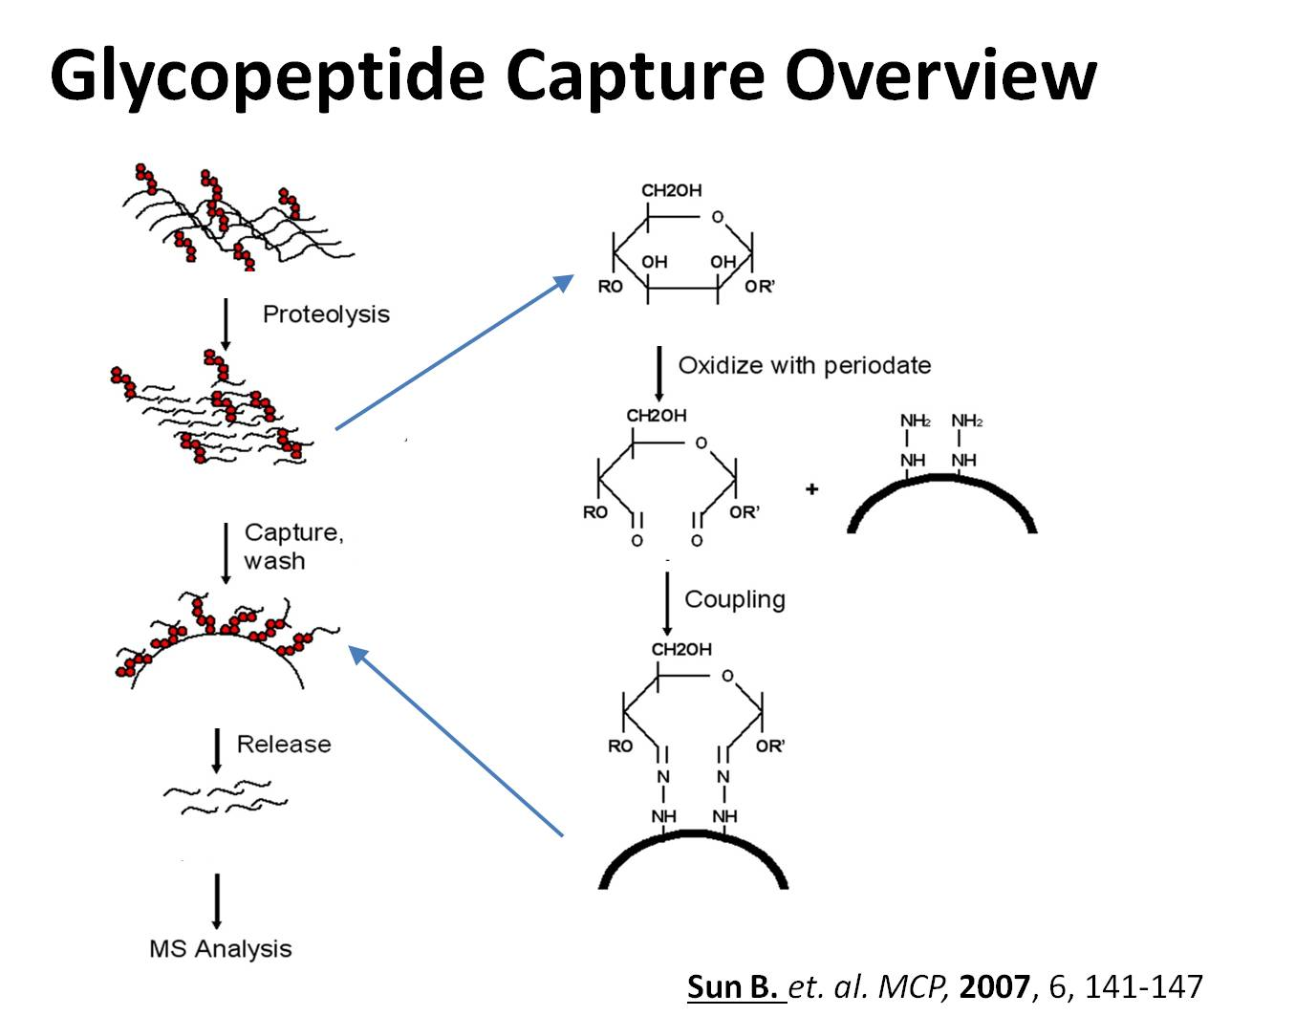

B. Interview: (Said by you on camera. Don’t forget to smile!)

Authors: The purpose of this section is to introduce you to the viewers, but we want to move quickly to the protocol, so we limit each person to one statement each. Since Gilbert will be the only author making interview statements, I’ve selected two statements for him below, but please feel free to switch the statements if you’d prefer different ones.
  - Gilbert Lee: I am the second year graduate student in Dr. Sun’s lab and I will be demonstrating to you how the glycopeptides-capture method works today. The main advantage of this technique over existing methods, like glycoprotein capture, is that membrane proteins will be first digested, and the capture of glycopeptides will be conducted in one pot.
  - GL: This method can help answer key questions in the molecular and cellular field, such as the constitution of membrane proteins and their dynamics during physiological and pathophysiological processes, such as oncogenesis, stem-cell self-renewal and differentiation.
  - GL: The applications of this technique can also extend to disease blood biomarker discoveries, because glycosylated membrane proteins can be shed into blood or other body fluids, and the circulating glycoproteins in blood that are specific to a pathological process can thus be used as diagnosis and prognosis markers.
  - GL: Though this method can provide insight into membrane glycoproteins, it can also be applied to other systems, such as blood proteins or proteins in other body fluids as most secreted proteins are also glycosylated.
  - GL: Generally, individuals new to this method will struggle because this protocol is lengthy and we recommend you start from pure glycoproteins and benchmark the technique before applying to complex samples.

Protocol (read by voice talent at JoVE):
- Harvest Membranes
  - First, prepare 4 ml of hypotonic buffer (TEXT: Hypotonic buffer: 10 mM Tris-HCl, 10 mM KCl, 1.5 mM MgCl₂, pH 8.0) with 1:100 protease inhibitor cocktail, add 1 ml of hypotonic buffer onto a cell pellet containing approximately 108 cells, and incubate the mixture for 15-30 min on ice.
    - MED: Talent adds hypotonic buffer and protease inhibitor cocktail into tube containing cell pellet.
    - MED-over the shoulder: Talent places tube on ice.
  - Transfer the cells into a 2ml vial and lyse the cells by passing the sample 5-10 times through a syringe needle. Then, use a hemocytometer and trypan blue staining to check the efficiency of lysis.
    - CU: Syringe needle as talent passes sample through it.
    - SCREEN: Microscope image of sample showing efficiency of lysis.
  - Combine the 1ml lysate with 3 ml of leftover hypotonic buffer. Spin the tube at 3,000 x g for 15 min, transfer the supernatant to an ultracentrifuge tube, and store the pellet in a -80 °C freezer. Spin the ultracentrifuge tube at 100,000 x g for 2 hours. (TEXT: first centrifugation: nuclear fraction pellet, second centrifugation: microsomal fraction pellet, final supernatant: cytosolic fraction).
    - MED: Talent places tube in centrifuge, programs appropriate settings and turns it on.
    - A. MED-over the shoulder: Talent removes tubes from centrifuge.

2.3.2 B. MED: Talent transfers the supernatant in to an ultracentrifuge tube.

2.3.2. C. MED: Talent put the ultracentrifuge tube into ultracentrifuge, and turns it on. pellet and places tube containing supernatant in centrifuge.
    - MED: Talent places tube with nuclear pellet in -80 °C freezer.
- Dissolve, Denature, and Digest Membrane Proteins
  - Next, dissolve the microsomal fraction in 200 μL of denaturation buffer (TEXT: Denaturation buffer: 40 mM Tris, 10 mM EDTA, 10 mM TCEP, 0.5% Rapigest, pH 8) and incubate the solution at 100 °C for 10 min.
    - CU: Tube containing microsomal fraction as talent adds denaturation buffer to it.

(note: #7939, cut the camera @ 57 before cap being placed on if possible)
    - A MED: Talent transfers the sample into a 1.7ml tube.

3.1.2. B. MED: Talent places tube in pre-heated water bath and turns on temperature control.
  - After cooling the heated solution to room temperature, add ultra-high purity urea powder to give an 8 M final concentration and incubate the sample at 37 °C for 30 min.
    - MED-over the shoulder: Talent adds urea powder to tube.
    - MED: Talent places tube in incubator.
  - After incubation, add 500 mM iodoacetamide stock solution to the sample to give a final concentration of 15 mM. Then, incubate the solution in the dark for 30 min at room temperature to alkylate the free thiols in the sample.
    - CU: Tube as talent adds iodoacetamide stock solution to it.
    - MED: Talent wraps tube in aluminum foil and places it on lab bench.
  - Following this, add 1M DTT stock solution to the sample to give a final concentration of 10 mM and incubate the solution for another 10 min at room temperature to quench the excessive iodoacetamide.
    - MED-over the shoulder: Talent adds DTT stock solution to tube.
    - MED: Talent sets tube on lab bench.

(note: 3.4.2 is combined into 3.4.1.)
  - Dilute the obtained solution 10 times with 40 mM Tris buffer at pH 8, and subsequently add trypsin to the sample at a 1:20 ratio of trypsin to total protein quantity. Obtain the quantity of total protein using the Bradford assay. Maintain the digestion reaction in a 37 °C oven overnight to ensure the reaction is completed.
    - CU: Tube as talent adds Tris buffer to it.
    - MED-over the shoulder: Talent adds trypsin to tube.
    - MED: Talent places tube in oven.
  - When finished, terminate the digestion by acidifying the sample solution to pH 1 with 10 mM hydrochloric acid, a condition which also degrades the detergent, or Rapigest. Then, degrade the Rapigest at 37 °C for 1 h in an incubator. After incubation, remove the developed precipitation by centrifugation.
    - MED: Talent adds hydrochloric acid solution to tube.
    - MED-over the shoulder: Talent places tube in incubator.
    - Reuse shot 2.3.1. – use the part that shows turning the centrifuge on.
  - Following centrifugation, clean the supernatant that contains the sample peptides by a C-18 solid phase extraction cartridge and dry the obtained sample by speedvac.
    - MED-over the shoulder: Talent collects sample from C-18 solid phase extraction cartridge into tube.
    - MED: Talent places tube containing purified sample in speedvac and turns it on.
  - Perform a SDS-PAGE analysis of samples before and after trypsin digestion to confirm the digestion efficiency.
    - CU: SDS-PAGE gel as talent adds sample to it.
- Glycopeptide Capture
  - At this point, dissolve the cleaned peptides in 200 μl of coupling buffer (TEXT: Coupling buffer: 100 mM sodium acetate, pH 5.5). After adding sodium periodate to the peptide solution to give a 10 mM final concentration, incubate the sample for 30 min in the dark at room temperature. When the incubation is complete, quench the excessive periodate with sodium sulphite to give a final concentration of 20 mM and pH of 5.
    - MED: Talent adds coupling buffer to tube containing cleaned peptides.
    - MED-over the shoulder: Talent wraps tube in aluminum foil and places it on lab bench.
    - CU: Tube as talent adds sodium sulphite to tube.
  - Following incubation for 10 minutes at room temperature, introduce 200ul of hydrazide-derivatized resins pre-equilibrated in coupling buffer into the peptide solution. Incubate the reaction at 37 °C for 1-2 days with end-to-end rotation for complete coupling.
    - MED-over the shoulder: Talent adds hydrazide-derivatized resin to peptide solution.
    - MED: Talent places tube in incubator and turns on rotation device.

(note: reuse 3.2.2)
  - When finished, remove the unbound peptides by washing the resin twice with 1 ml of deionized water, 1 ml of 1.5 M sodium chloride, 1 ml of methanol and 1 ml of 80% acetonitrile (TEXT: 1 ml DI water, 1 ml 1.5 M NaCl, 1 ml methanol and 1 ml 80% acetonitrile). Then wash the resin 3 times with 1 ml of 100 mM ammonium bicarbonate at pH 8. Finally, add 300ul of ammonium bicarbonate into the sample vial.
    - A CU: talent transfers the supernatant into a collecting tube, adds 1ml deionized water to the resin, washes the resin by vertex, and spins the resin.

4.3.1. B. MED-over the shoulder: Talent stops the spin, remove the supernatant to the collecting tube. washes resin with appropriate reagents.
    - CU: Resin as talent add 300ul ammonium bicarbonate into the resin.
  - Next, collect the supernatant and the washes for the analysis of unbound peptides. Store the samples in a -80 °C freezer until analysis.
    - MED-over the shoulder: Talent collects supernatant and washes into tubes.

(note: combined into the 4.3.1)
    - MED: Talent places samples in -80 °C freezer.
  - To release the N-glycopeptides from the resin, add PNGase F and incubate the sample at 37 °C with an end-to-end rotation.
    - CU: Tube as talent adds PNGase F to it.
    - MED-over the shoulder: Talent places tube in incubator and turns on rotation device.
  - Following this, collect the released peptides by centrifugation and add an 80% acetonitrile wash to the supernatant. Finally, dry the obtained solution in the speedvac for LC-MS analysis.
    - Reuse shot 2.3.1. – use the part that shows turning the centrifuge on.

(shoot this scene: MED: Talent put the vials into minicentrifuge and turns it on.)
    - MED CU: Talent adds acetonitrile wash to tube containing supernatant.
    - MED-over the shoulder: Talent places tube in speedvac and turns it on.
- Results: LC-MS Based Proteomic Analysis of Cell Surface Proteins
  - A typical glycopeptide spectrum taken after the enrichment method is shown here. In the obtained glycopeptide, the N-glycan was removed and the glycan-attached asparagine was converted to an aspartic acid by PNGase F; therefore, the spectrum can be readily searched by any proteomics search engine against common protein sequence databases.
    - LAB MEDIA: Figure 2
  - A typical LC-MS result of the captured N-glycopeptides is shown here, in which more than 100 glycoproteins can be identified from a single LC-MS run of a cell microsomal fraction. The enrichment selectivity to both glycoproteins and glycopeptides is generally more than 90%. A successful analysis can have an enrichment selectivity of 95%. Using an SCX (TEXT: SCX: Strong Cation Exchange) column and step gradient to further fractionate the samples prior to LC-MS analyses will usually double the number of glycoprotein identifications. Sometimes, when the quantity of the obtained glycopeptides is low, the impurity accumulated from the vials can be observed in the final sample. These contaminants can be removed by the previously described method.
    - LAB MEDIA: Figure 3

- Conclusion (said by authors on camera)

Authors: As in the interview section, we limit each person to one statement each or in this case, two statements. I’ve selected two suggested statements for Gilbert, but please feel free to switch the statements if you’d prefer different ones.
  - GL: Once mastered, this technique can be done in 4 days if it is performed properly.
  - GL: While attempting this procedure, it’s important to remember to set aside samples after each step to troubleshoot.
  - GL: Following this procedure, other methods like gagQP can be performed in order to answer additional questions relating to the non-glycoyslated proteins in the sample.
  - GL: After its development, this technique paved the way for researchers in the field of proteomics to explore diverse biological systems from cells to tissues, organs, and whole organisms.
  - GL: After watching this video, you should have a good understanding of how to use our glycopeptide capture approach to study cell-surface membrane proteins. While attempting this procedure, it’s important to remember to set aside samples after each step for troubleshooting. The volumes of each reagent might be optimized for your specific study system.
  - GL: Don't forget that working with chemicals such as DTT and hydrazide derivatized resins can be hazardous so precautions should always be taken while performing this procedure. In addition, human contamination, such as karatin from our skin cells, can severely interfere with the final results, so gloves are required in the entire protocol.

Provided Media

Authors, Please list all images, movie files, or 3-D rendered animations that can be included in the video per editor’s request. The step in the script/video where these images will be inserted should be specified. For example:

6.2 – 0123_PIname_Figure1.tif - dual color imaging of tumor angiogenesis at 40X
6.2 – 0123_PIname_Figure2.tif - dual color imaging of tumor angiogenesis at 100X

Formats: For static images we prefer .tiff, Illustrator, Powerpoint or Photoshop files at dimensions of at least 720X480 pixels and 300 dpi. The higher resolution, the better. Likewise any exported movie files should have at minimum these dimensions and be rendered to .mov, .mp4, or .avi files.

Insert your media filenames here.

SchematicFig – authors, please include a schematic figure to correlate with the narrative
overview text in section 1A. See attached instructions. (please see our powerpoint file uploaded in previous submission.)

General Preparation

It’s critical for a smooth and organized shoot that all reagents are accounted for, in advance.

Any overnight or long incubation steps should be recognized and specimens/samples be prepared in advance so that prior steps can be recorded and shooting can continue with pre-prepared specimens/samples.

All tubes/flasks should be pre-labeled neatly before we arrive.

Ex. Luciferase assay done in 96 well plates should be labeled with negative/positive control wells and experimental samples are labeled accordingly.

You will receive more detailed preparation instructions, as well as an introduction to your videographer, closer to your filming date.

