Submission ID #: 51344

Editor Name: Melissa Ceo

Videographer name:

Film Date:

Authors and Affiliations:
Grant E. Johnson, K. Don Dasitha Gunaratne, and Julia Laskin

Physical Sciences Division
Pacific Northwest National Laboratory
P.O. Box 999, MSIN K8-88
Richland, WA 99352 USA

Title: In Situ SIMS and IR Spectroscopy of Well-Defined Surfaces Prepared by Soft Landing of Mass-Selected Ions

Corresponding Author:

Julia Laskin: julia.laskin@pnnl.gov

Co-authors email: grant.johnson@pnnl.gov

Co-authors email: don.gunaratne@pnnl.gov

A. Will you require JoVE to record video microscopy, such as filming a complex dissection or microinjection technique? (Y/N) ___No___ If yes, please list make and model of your microscope: ___________NA___________________
**Note: This question is to get at whether or not you will need a camera hook-up to look into the microscope. However, if your microscope has a digital camera attached to a computer, you can gather these shots by collecting screen capture movies.
Does your protocol include microscopy steps that are visualized through a microscope with a digital camera/computer attached? (Y/N) ___Yes, alignment of surfaces in SIMS instrument for analysis.___
B. Does your protocol include detailed, step-by-step, descriptions of software usage? (Y/N)__Yes__
C. Which steps of your protocol will viewers benefit most from having filmed? Please list 4-6 steps__3.1, 3.2, 4.4, 4.6, 5.1, and 5.2________________________
D. What is the single most difficult aspect of this procedure and what do you do to ensure success? Achieving reliable and repeatable alignment of surfaces with the ion beam for soft landing and the primary ion beam and infrared beams for in situ analysis by SIMS and IRRAS, respectively. Proper alignment is confirmed by obtaining SIMS line profiles across the deposited spot of material and by the observation of increasing IR signal of the soft landed analyte with deposition time.

1. Introduction (Schematic Overview and Interview)

A. Schematic Overview (read by voice talent at JoVE):

Conceptual Narrative:
The overall goal of the following experiment is to prepare extremely pure and precisely-defined organometallic molecules on surfaces so that structure-reactivity relationships and ion-surface interactions may be characterized using a combination of in situ SIMS and IR spectroscopy techniques. (Intro)

This is achieved by first preparing a solution of the organometallic compound in methanol and loading it into a syringe pump for injection into an electrospray ionization source. (C1, make pink solution move out of tube and into gray bar above “Electrospray Ionization” followed by the multicolored circles coming out of it. Alternatively, make the pink solution gradually decrease as the multicolored circles come out of gray bar).

As a second step, collision induced dissociation is performed in the high pressure source region of the soft landing instrument, which removes one bipyridine ligand from each Ru(bpy)₃²⁺ (pronounced doubly charged ruthenium tris-bipyridine) ion, forming highly reactive undercoordinated Ru(bpy)₂²⁺ (pronounced doubly charged ruthenium bis-bypridine) ions. (C2, show left structure of C2 and make “Collision Induced Dissociation” appear below it. Then make left part of structure disappear so that it becomes right structure).

Next, mass-selection is achieved using a quadrupole mass-filter followed by soft landing in order to prepare surface-bound organometallic ions without any contamination from unwanted species, solvent molecules or counterions. (C3, make red squiggly arrow gradually appear from left to right followed by tan colored circles and make them move toward the Soft Landing blue bar)

Results are obtained that show organometallic ions immobilized on self-assembled monolayer surfaces by soft landing of mass-selected ions. (C4, show Soft Landing blue bar of C3 with tan colored circles followed by C4)

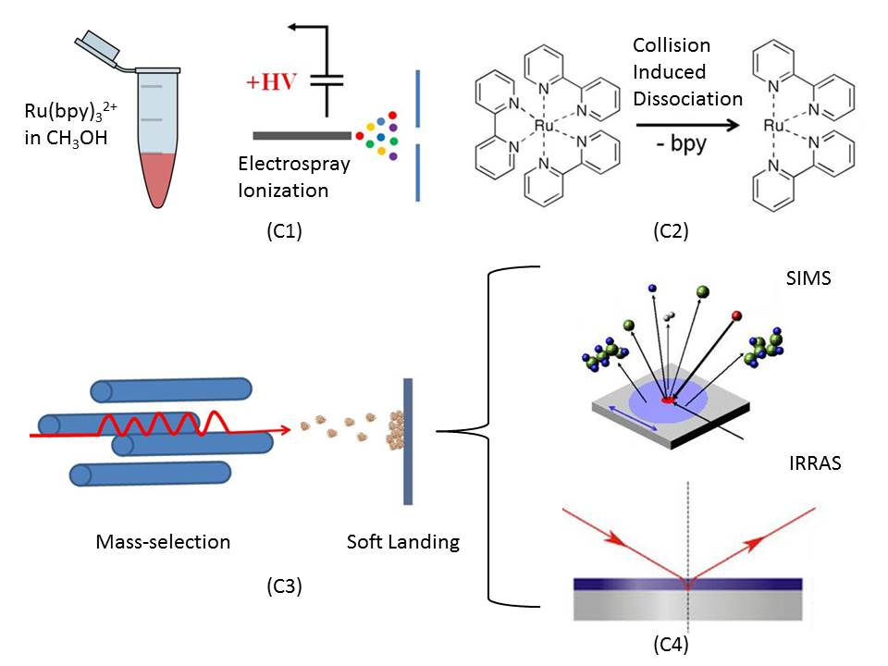

B. Interview: (Said by you on camera. Don’t forget to smile!)
  - Grant Johnson: The main advantage of this technique over existing methods, like drop casting, spin coating and chemical vapor deposition, is that mass-selection provides atomically-precise control over the composition, charge state and surface coverage of material delivered to a substrate.
  - Don Gunaratne: This method can help answer key questions in the energy storage field, such as whether the size and ionic charge state of redox-active metal oxide clusters controls their structure and stability on surfaces.
  - Julia Laskin: Though this method can provide insight into the sensitivity of catalytic and energy storage materials to size and composition, it can also be applied to other systems, such as peptides, proteins and viruses that have broad applications as biological sensors and diagnostic devices.

Protocol (read by voice talent at JoVE):

[There are some random survey shots and pans of the main rig at 01:00:00 on Reel A.]
- Preparation of COOH-SAM Surfaces on Gold for Soft Landing of Mass-Selected Ions
  - First, place a previously prepared self-assembled monolayer, or SAM, surface onto one of three metal sample mounts. Open the sample introduction door and secure the sample holder firmly to the manipulator inside of the instrument.
    - MED: Talent places SAM surface onto metal sample mount.
    - MED-over the shoulder: Talent opens sample introduction door and secures sample holder to manipulator. [also Reel A 00:26:30]
  - Following this, close the door and open the valve to the foreline mechanical vacuum pump. When the sample introduction chamber reaches a pressure of 10⁻³ Torr, turn on the turbomolecular vacuum pump and ionization pressure gauge.
    - MED: Talent closes sample introduction door and opens valve to foreline mechanical vacuum pump.
    - [combined with 2.2.1] MED-over the shoulder: Talent turns on turbomolecular vacuum pump and ionization pressure gauge.
  - When the sample introduction chamber reaches a pressure of 10⁻⁵ Torr, open the gate valve to the soft landing chamber. Use the magnetic manipulator or xyz-stage to position the SAM surface in line with the ion beam to begin soft landing.
    - MED: Talent opens gate valve to soft landing chamber.
    - MED-over the shoulder: Talent positions SAM surface in line with ion beam.
- Soft Landing of Mass-selected Ru(bpy)₃²⁺ onto COOH-SAM Surfaces
  - For each instrument, load 0.5 mL of previously prepared 0.01 mM tris(2,2’-bypyridyl)dichloro-ruthenium(II) hexahydrate solutions into a 1 mL glass syringe. Mount the syringe into a syringe pump and apply +2 to +3 kV to the capillary to generate positive ions. Then, adjust the syringe pump flow rate to between 20 - 40 μl/hr to obtain optimum ion current and stability at the surface.
    - CU: Syringe as talent loads ruthenium solution into it.
    - MED: Talent mounts syringe into syringe pump and increases voltage setting on high-voltage power supply.
    - MED-over the shoulder: Talent adjusts syringe pump flow rate.
  - Adjust the quadrupole mass-filter to the mass of the Ru(bpy)₃²⁺ soft ion. Then, adjust the voltage settings of the ion optics and radiofrequency ion guides to maximize the ion current and stability of Ru(bpy)₃²⁺ measured at the SAM surface.
    - MED: Talent adjusts quadrupole mass-filter to appropriate mass.
    - MED-over the shoulder: Talent adjusts voltage settings of ion optics and radiofrequency ion guides on appropriate power supplies.
  - Following this, increase the potential gradient in the high-pressure collision quadrupole region of the soft landing instrument to enable gas-phase ligand stripping from the organometallic ion through collision-induced dissociation.
    - MED: Talent increases potential gradient in high-pressure collision quadrupole region of instrument.
- Analysis by in situ TOF-SIMS Before and After Exposure to Reactive Gases
  - Upon completion of the deposition, turn off the syringe pump and the high voltage to the ESI emitter. Use the magnetic manipulator to move the prepared surface from the soft landing chamber to the analysis stage inside the TOF-SIMS (TEXT: TOF-SIMS: Time-of-Flight Secondary Ion Mass Spectrometry) part of the instrument.
    - MED-over the shoulder: Talent turns off syringe pump and high voltage to ESI emitter.
    - MED: Talent moves prepared surface from soft landing chamber to analysis stage.
  - Next, disengage the manipulator from the sample and retract it fully from the SIMS analysis chamber. Close the gate valve between the soft landing and SIMS parts of the instrument.
    - MED-over the shoulder: Talent disengages manipulator from sample and retracts it fully from SIMS analysis chamber.
    - MED: Talent closes gate valve between soft landing and SIMS parts of instrument.
  - To conduct the TOF-SIMS experiment, load the instrument control file in the software and ensure that the Ga⁺ (pronounced gallium ion) source is producing a sufficiently stable current of primary ions.
    - SCREEN: Computer screen as talent loads instrument control file in software.
    - MED-over the shoulder: Talent adjusts voltages applied to Ga⁺ source.
  - Acquire x- and y-axis line profiles across the surface to determine the center of the deposited spot of ions on the substrate. Position the surface so that the Ga⁺ primary ion beam is incident on the center of the deposited spot of ions. Then, acquire a TOF-SIMS mass spectrum for 5 minutes.
    - SCREEN: Computer screen as talent acquires x- and y-axis line profiles across surface. [Reel A 00:18:40]
    - SCOPE: Image of surface as talent positions it. [Reel A 00:27:35-00:28:58]
    - SCREEN: Computer screen as talent acquires TOF-SIMS mass spectrum.
  - Following this, turn off the primary Ga⁺ ion beam and the high voltages of the TOF-SIMS instrument. Use the magnetic manipulator to move the sample back into the soft landing part of the instrument.
    - SCREEN: Computer screen as talent turns off primary Ga⁺ ion beam and high voltages of instrument. [Reel A 00:23:55]
    - MED: Talent moves sample back into soft landing part of instrument using magnetic manipulator.
  - Use a high-vacuum leak valve to introduce a controlled flow of ultra-high purity oxygen gas from a cylinder into the instrument. Use the adjustable gate valve to throttle the pumping speed of the pump to achieve a steady-state pressure of 10⁻⁴ Torr of oxygen inside the soft landing chamber.
    - MED-over the shoulder: Talent turns the high-vacuum leak valve to introduce controlled flow of oxygen gas to instrument.
    - MED: Talent uses gate valve to throttle pumping speed of pump. [Reel A 00:27:05]
  - Repeat the previous steps to characterize the soft landed ions following exposure of the surface sequentially to oxygen and ethylene for 30 min.
    - SCREEN: Computer screen as talent acquires TOF-SIMS spectrum of oxygen or ethylene.
- Analysis by in situ FT-ICR-SIMS and IRRAS During and After Soft Landing
  - Position a circular SAM surface at the rear trapping plate of the ICR cell located inside of the 6-Tesla magnet. Then, use a cesium ion source to create a continuous beam of 8 kV Cs⁺ (pronounced cesium) primary ions. During this, trap and analyze the secondary ions ejected from the surface using FT-ICR-MS.
    - MED-over the shoulder: Talent positions circular SAM surface at rear trapping plate of ICR cell. [Loading this machine starts at Reel A 00:07:52, several takes and re-framings]
    - MED: Talent applies current to a filament to generate beam of cesium ions.
    - SCREEN: Computer screen as talent traps and analyzes secondary ions ejected from surface.
  - For IRRAS (TEXT: IRRAS: Infrared Reflection Absorption Spectrometry Analysis), direct the infrared light from the spectrometer onto the COOH-SAM (pronounced carboxylic acid terminated monolayer) surface positioned inside the vacuum chamber. Utilize a gold-coated flat mirror to direct the light exiting the FTIR spectrometer onto a parabolic gold mirror. Next, reflect the light from the parabolic mirror through a mid-infrared zinc selenide wire grid polarizer and into the vacuum chamber through a viewport.

[There is a good overview of the IRRAS set up at 00:56:00 to give an intuitive guide for assembling the individual shots.]
    - MED: Talent directs light from spectrometer onto COOH-SAM surface using adjustable mirrors on breadboard.
    - MED-over the shoulder: Talent directs light exiting spectrometer onto parabolic gold mirror using gold-coated flat mirror. [ends at Reel A 00:53:46]
    - MED: Talent directs light from parabolic mirror through grid polarizer and through zinc selenide viewport into vacuum chamber.
  - Position the reflective SAM on gold surface inside the vacuum chamber at the focal point of the first parabolic mirror using the motor-driven z-translator.
    - MED-over the shoulder: Talent positions reflective SAM on gold surface using motor-driven z-translator. [Reel A 00:16:59]
  - Then, reflect the IR light exiting the vacuum chamber from the surface of the SAM through a second viewport. Use a second parabolic gold mirror to focus the reflected light from the surface onto an MCT (TEXT: MCT: Mercury Cadmium Telluride) detector. Finally, acquire spectra at set intervals during the deposition process.
    - MED: Talent directs IR light from surface through second selenide viewport.
    - MED-over the shoulder: Talent uses second parabolic gold mirror to focus reflected light from surface onto MCT detector.
    - SCREEN: Computer screen as talent acquires spectra.
- Results: Characterization of Organometallic Ions Soft Landed onto COOH-SAMs by In Situ SIMS and IR Spectroscopy
  - A peak corresponding to a Ru(bpy)₂-thiol⁺ (pronounced covalent adduct) at a mass to charge ratio of 700 is observed here, which indicates very strong binding between the undercoordinated ion and the monolayer surface. The peaks corresponding to this species are featured prominently here.
    - LAB MEDIA: Laskin_Figure_2.jpg
  - Presented here are the in situ TOF-SIMS spectra obtained directly following exposure of the COOH-SAM surfaces containing soft landed Ru(bpy)₃²⁺ and Ru(bpy)₂²⁺ ions to gaseous oxygen. The peak is consistent with the addition of atomic and molecular oxygen to the organometallic surface adduct, respectively. Moreover, this adduct appears to be oxidized with close to 50 % conversion efficiency.
    - LAB MEDIA: Laskin_Figure_3.jpg (Video Editor: Please highlight, or point to, middle set of peaks when “atomic” is mentioned in 2nd sentence and right set of peaks when “molecular” is mentioned in 2nd sentence).
  - The TOF-SIMS spectrum following exposure to ethylene indicates a decrease in the relative abundance of the singly oxidized organometallic adduct at a mass to charge ratio of 716.
    - LAB MEDIA: Laskin_Figure_4.jpg
  - A scheme describing what is achieved for this representative system through the combination of ion soft landing and analysis by in-situ TOF-SIMS is presented here.
    - LAB MEDIA: Laskin_Figure_5
  - Representative results for Ru(bpy)₃²⁺ landed onto the COOH-SAM surface are presented here. During soft landing the doubly charged Ru(bpy)₃²⁺ ion exhibits a linear increase in abundance on the COOH-SAM surface. The measured abundance reaches a maximum at the end of soft landing and is followed by an extended plateau on the COOH-SAM surface. The singly charged ions, in comparison, are depleted more rapidly following the end of soft landing.
    - LAB MEDIA: Laskin_Figure_6.jpg (Video Editor: Please highlight first part of black curve (where it increases) for 2nd sentence and first part of 3rd sentence. Highlight second part of black curve (where it plateaus) when “followed by an extended plateau” is mentioned in 3rd sentence. Highlight overlapping blue and red curves for last sentence).
  - The infrared spectrum obtained following soft landing of 5x10¹² Ru(bpy)₃²⁺ ions onto the COOH-SAM surface is presented here. Nine vibrational features are noted with an asterisk in the IR spectrum as unique spectroscopic signatures of Ru(bpy)₃²⁺.
    - LAB MEDIA: Laskin_Figure_7.jpg

- Conclusion (said by authors on camera)

  - Julia Laskin: Once mastered, this technique can be done in an hour if it is performed properly.
  - Don Gunaratne: Following this procedure, other methods like AFM, TEM, and STM can be performed in order to answer additional questions like surface coverage, shape and secondary structure of soft landed ions.
  - Grant Johnson: After its development, this technique paved the way for researchers in the field of catalysis to explore structure-reactivity relationships in supported nanoparticles and clusters.

Provided Media

Authors, Please list all images, movie files, or 3-D rendered animations that can be included in the video per editor’s request. The step in the script/video where these images will be inserted should be specified. For example:

6.2 – 0123_PIname_Figure1.tif - dual color imaging of tumor angiogenesis at 40X
6.2 – 0123_PIname_Figure2.tif - dual color imaging of tumor angiogenesis at 100X

Formats: For static images we prefer .tiff, Illustrator, Powerpoint or Photoshop files at dimensions of at least 720X480 pixels and 300 dpi. The higher resolution, the better. Likewise any exported movie files should have at minimum these dimensions and be rendered to .mov, .mp4, or .avi files.

Insert your media filenames here.

Laskin_Figure_1.jpg

Laskin_Figure_ 2.jpg

Laskin_Figure_3.jpg

Laskin_Figure_4.jpg

Laskin_Figure_5.jpg

Laskin_Figure_6.jpg

Laskin_Figure_7.jpg

SchematicFig – authors, please include a schematic figure to correlate with the narrative
overview text in section 1A. See attached instructions.

Laskin_Graphic.jpg

General Preparation

It’s critical for a smooth and organized shoot that all reagents are accounted for, in advance.

Any overnight or long incubation steps should be recognized and specimens/samples be prepared in advance so that prior steps can be recorded and shooting can continue with pre-prepared specimens/samples.

All tubes/flasks should be pre-labeled neatly before we arrive.

Ex. Luciferase assay done in 96 well plates should be labeled with negative/positive control wells and experimental samples are labeled accordingly.

You will receive more detailed preparation instructions, as well as an introduction to your videographer, closer to your filming date.

