
Dr. Vitaly Citovsky

Department of Biochemistry and Cell Biology

Stony Brook, NY 11794-5215

Tel: 631.632.9534
Fax: 631.632.8575

vitaly.citovsky@stonybrook.edu

July 15, 2013

Dr. Larissa Jarzylo, Science Editor
JoVE
17 Sellers St.
Cambridge, MA 02139

Dear Dr. Jarzylo:

Enclosed please find our revised manuscript “Assaying proteasomal degradation in a cell-free system in plants”. The revision addresses all comments of the Editor as detailed in our specific point-by-point response and in a marked copy of the revised paper.

I hope that our revisions will meet the high publication standards of JoVE.

Sincerely yours,
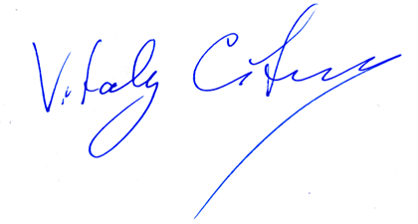
Vitaly Citovsky,
Professor of Biochemistry and Cell Biology

__________________________________________________________________________

STATE UNIVERSITY OF NEW YORK
Editorial comments

1. All sections marked by the Editor in red have been re-written to avoid use of text from our previous publications. Sorry and thanks.

2. Protocol was completely re-written to focus on the specific procedures and imperative tense was used throughout this part of the paper.

3. Discussion was also re-written to include critical points and information for success of the assay, potential expansion of the assay, and its technical alternatives.

