Submission ID #: 51256

Editor Name: Steven Nilsen

Videographer name: Kevin McRoberts

Film Date: Jan 17, 2014

Authors and Affiliations:
Yvonne Linger, Alexander Kukhtin, Julia Golova, Alexander Perov, Peter Qu, Christopher Knickerbocker, Christopher G. Cooney, and *Darrell P. Chandler

Akonni Biosystems, Inc., 400 Sagner Avenue, Suite 300, Frederick MD 21701

Corresponding Author:
dchandler@akonni.com
Tel: 734-428-0713
Fax: 301-698-0202

Title: Demonstrating a Multi-Drug Resistant Mycobacterium tuberculosis Amplification Microarray

- Will you require assistance with video microscopy, such as filming a complex dissection or microinjection technique (Y/N, please specify steps by number. Also, please list make and model of your microscope)? No

- Does your protocol include detailed, step-by-step, descriptions of software usage (Y/N, please specify steps by number)? 4.4, 4.5

- Which steps of your protocol will viewers benefit most from having filmed? (use the numbering below) 2.2 – 2.4, 3.1 – 3.6, 4.3 – 4.6

- What is the single most difficult aspect of this procedure and what do you do to ensure success? Manipulating the chamber assembly: 1.) applying cover seal without bubble formation and 2.) removing the gasket assembly without damaging the microarray. With experience in the technique, these incidents occur with lesser frequency.

- Will the shoot take place in more than one location? (Y/N, specify travel time between locations) All procedures are in one facility, but occur in 3 adjacent rooms.

Schematic Overview (read by a voice talent at JoVE)

The overall goal of the following experiment is to genotype multi-drug resistant Mycobacterium tuberculosis using an amplification microarray. (Intro) This is achieved by performing a multiplex asymmetric PCR over the top of a microarray within a single microfluidic reaction chamber. (P1) There, the sample is simultaneously amplified, labeled, size-selected, made single-stranded, and hybridized to the microarray. (P2) Next, after the microarray is washed, a reader shows if Mycobacterium tuberculosis is present and if it contains a DNA mutation known to confer resistance to rifampin, isoniazid, ethambutol or streptomycin. (P3)

Video editor:
P1 – We start with the tube of “purified nucleic acid in master mix” and then animate the arrow of it to the Amplification micorarray.
P2 – fade to the panel titled “Cycle 0” and fade to the panel titled “Later Cycles”. This is a bit too complicated to animate, so we shall leave it at that. Remove the outer grey border, the inner border is okay, and keep all the labels. If there is space, the Amplification Microarray image should be shrunk to the upper right corner of the screen, with no border on it.
P3 – fade to the table in the lower right, showing the detected and not detected. Do not have those detection bubbles filled in initially. Have them light up one by one, top to bottom.
If time permits, throughout this animation, change all the fonts from Times to a sans-serif.

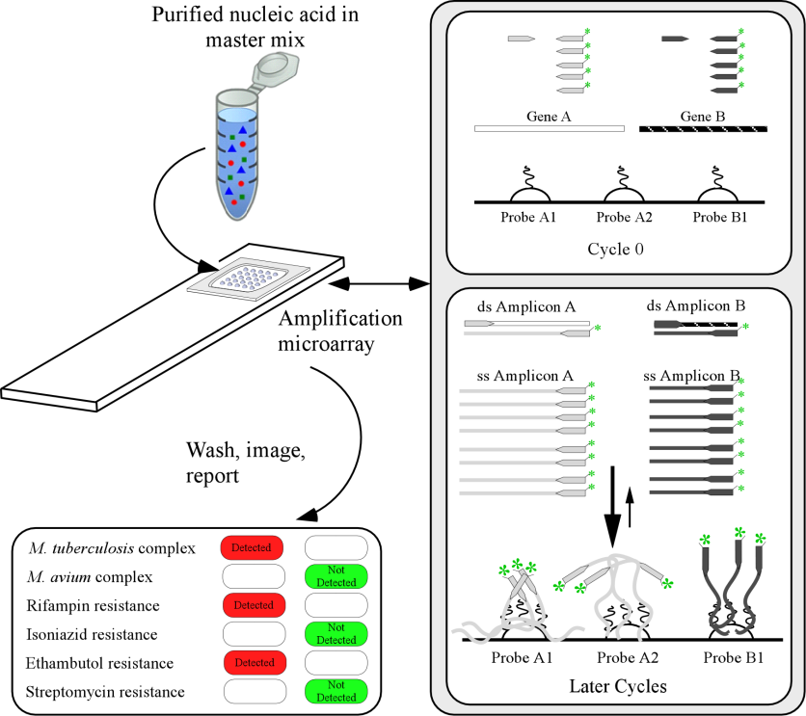

- Introductory Interview (spoken by you on camera. Don’t forget to smile!)

  - Yvonne Linger: The main advantage of this method over existing microarray, line probe, or nucleic acid hybridization methods is that an amplification microarray significantly simplifies user interaction with the test, while providing the analytical sensitivity of PCR and the multiplexing capacity of a microarray.

Protocol Chapters (read by a voice talent at JoVE):

- Loading and Amplifying
  - For this procedure, have a clean workspace wiped down with decontaminant solution, and have nucleic acids pure enough for multiplex PCR.
    - WID: talent wiping down workplace then leaving
    - WID: talent arriving back to workplace carrying ice bucket or cold block loaded with reagents
  - After thawing and mixing all the stock solutions, assemble the PCR master mix. When preparing this mix, make at least one extra volume of mixture.
    - MED: talent starting the master mix, first getting a tube ready and adding first reagent
    - CU: taking next reagent from ice bucket, removing aliquot, returning reagent to ice
  - For the TB test shown here, also add extra Taq polymerase to the master mix, in addition to the amount of Taq provided with the stock reagents.
    - ECU: bottle of Taq polymerase in hands of talent, label clear, talent takes an aliquot
    - MED: vortexing the master mix
  - Mix 1 microliter aliquots of sample DNA to 49 microliters of master mix.
    - MED: aliquoting 49 µL of mix to tube, then adding 1 µL of DNA to tube
  - Carefully add 48 microliters of each reaction mixture to the center of the appropriate microarray. Do not touch the microarray itself. Then, carefully cover and seal the microarray.
    - MED: mixing DNA/reaction mix combo tube, then drawing up aliquot of 48 µL
    - [combined with 2.5.2] CU: ejecting the solution onto the microarray chip
    - ECU: covering and sealing the microarray – no bubbles are formed (2 takes - #1 good; #2 intentionally bubbled)
  - Yvonne: Improperly applying the cover slip can introduce bubbles that may lead to amplification artifacts, evaporation, poor amplification, or non-uniform hybridization. Any of these conditions could lead to an erroneous result.
    - MED: interview shot with Yvonne
  - Next, load the microarray into the thermal cycler, with the substrates against the heat block. The heated lid option must be off.
    - WID: talent arrives to thermocycler, or if already at bench, MED: opens lid on themocycler
    - [combined with 2.7.1] CU: loading microarray into themocycler, coverslip against heat block
  - For laboratories that follow universal PCR precautions, it is more efficient to include several amplification microarrays per slide and process multiple tests simultaneously.
    - [use 2.7.1-2] MED: talent loading several more microarray chips onto the themocycler
    - [use end of 2.7.1-2] CU: showing final arrangement of chips on heat plate, before closing, then closing the lid.
  - Now, run the appropriate thermal cycling program. This program has 50 amplification cycles, which may seem high, but needed because of the predominantly single-stranded amplicon population created by the reaction.
    - CU: programming the PCR cycle, show the display
    - [combined with 2.9.1] MED: finishing the programming, checking the lid is secure, starting the cycle
    - WID: talent walks away from PCR machine
- Washing the Microarray
  - When the reaction is complete, remove the microarrays and shut down the thermal cycler.
    - WID: talent returns to PCR machine
    - [combined with 3.1.1] MED: removing chips, turning off machine
  - Carefully open the microarray chamber with flat-end forceps. Remove the slipcover and gasket. The microarray can be damaged by this step, so be careful.
    - ECU: opening the chip lid with forceps
    - [combined with 3.2.1 (same action) 3 takes; #3 done improperly] ECU: peeling off gasket with forceps
  - Yvonne: Improperly removing the gasket assembly can lead to physical damage of the microarray itself. Be careful not the bend or flex the cover slip and take great care to avoid scratching the surface of the microarray with the forceps.
    - MED: interview shot

Video editor: cut to the next shot during the interview narrative
    - ECU: combo of 3.2.1 and 3.2.2 performed again
  - Now, transfer the microarray substrates to a histology slide holder.
    - CU: loading a slide holder with several microarray substrates
  - Bathe the substrates in the wash buffer for ten minutes at room temperature with gentle agitation. (TEXT: 10 min, RT)
    - MED: dipping the slide holder into bath of buffer
    - CU: starting rotator, see the swirling of solution in slide holder
  - Follow the wash solution bath with two or three more washes all in de-ionized water. (TEXT: 2X or 3X in DI H₂O)
    - MED: removing the slide holder and bath from rotator and moving slide holder from first bath to next bath
    - MED: placing next bath on rotator and starting agitation
  - Dry the microarrays before proceeding to imaging. A gentle stream of compressed air can be used for this purpose.
    - CU: removing an array from last bath
    - [combined with 3.7.1] CU: gently drying array with compressed air
- Imaging the Microarray
  - In this demonstration, parameters are specific to the MDR-TB test and an Akonni Dx2100 field-portable imager. A blue light on the imager indicates that it is ready.
    - MED: pan over Akonni imager, talent turns it on
    - CU: light on Akonni goes to blue
  - Turn on the computer; open the system software provided by Akonni and wait for the software to announce that it has established a connection with the camera.
    - WID: talent turns on computer and opens the operating software for Akonni
    - SCREEN CAPTURE: Akonni software announces that connection with camera is established

Authors, using commercially available screen capture software, make movies of what goes on the screen when the action is being executed. Name the movie files for the shot number an upload them to your project folder.
  - Next, insert the dried microarray into the imager with the microarray towards the lens and away from the user.
    - CU: talent inserts microarray into imager
    - [combined with 4.3.1] MED: Closes the access door.
  - The software will now provide a preview image. From the drop-down menu, select the MDR-TR analysis script. Enter an exposure time between 100 and 500 seconds. Overexposed pixels will be red - adjust the exposure to minimize them.
    - SCREEN CAPTURE: preview image of MDR-TB grid – then selecting analysis script – then, exposure time – then, adjusting exposure
  - When the saturation is set to minimize overexposure, start the analysis. The software places an MDR-TB grid on the image, scores samples and background intensities and then, reports drug resistance and genotyping results.
    - SCREEN CAPTURE: starting the analysis of 1st microarray – grid placed over image and scores reported (flip though all the data) – data is saved (“Sample 1”)
  - Once the analysis is complete and saved, remove the chip from the imager and start a new analysis session to analyze the next array.
    - CU: removing the array chip
    - [combined with 4.6.1] MED: inserting the next array chip
    - (added) SCREEN CAPTURE: starting the analysis of the 2nd microarray – grid placed over image and scores reported– data is saved (“Sample 2”)
  - (added) Continue the analysis for each of the processed microarrays, saving the data each time.
    - (added) SCREEN CAPTURE: flip though all the data

- Artifact Detection and Microarray Sensitivity

  - Qualitative image analysis can provide insight into sources of experimental noise or variability that is challenging to identify in data tables generated by automated image analysis software. A high-quality array, lacking artifacts, is seen here.
    - LAB MEDIA: Figure 1a
  - Several artifacts can lead to the introduction of bubbles, which create halos. Despite array artifacts, the software will still retrieve values from being scanned. A diagnostic reporting algorithm would, despite getting values, recognize this array as invalid.
    - LAB MEDIA: Figure 1b
  - A dilution series of wildtype H37Ra gDNA was used as on a microarray PCR template. [video editor: I did 3 different takes of this sentence as it didn’t quite sound right the way it was written] At 6.25 picograms, the equivalent of 1,250 cells, all probes were detected. An SNR value above 3 is a positive result, and registered values were much higher.
    - LAB MEDIA: Table 2
  - Next, World Health Organization reference isolates were genotyped. Single nucleotide polymorphisms present on the array were detected as the corresponding mutation in the MDR-TB genome.
    - LAB MEDIA: Table 3
  - Several examples of detecting near neighbor mutations were also evident. A discussion is provided in the text protocol.
    - LAB MEDIA: Table 3 – highlight examples of near neighbor mutations detected

- Conclusion Interview (spoken by you on camera)

  - Yvonne: Once mastered, this technique can be done in about 3.5 to 6.5 hours, depending on the concentration of DNA, the specific assay, the efficiency and uniformity of the thermal cycler and the desired analytical or clinical sensitivity and specificity.
  - Yvonne: Also, the number of amplification cycles and post-amplification hybridization times can be readily shortened or lengthened to get the desired performance characteristics.

List of Provided Media Filenames and Descriptions (fill this in)

In this space, please list all images, movie files, or 3-D rendered animations that can be included in the video per editor’s request. The step in the script/video where these images will be inserted should be specified. For example:

6.2 – 0123_PIname_Figure1.tif - dual color imaging of tumor angiogenesis at 40X
6.2 – 0123_PIname_Figure2.tif - dual color imaging of tumor angiogenesis at 100X

Formats: For static images we prefer .tif files at dimensions of at least 720X480 pixels and 300 dpi. Higher resolutions are better. Likewise any exported movie files should have at minimum these dimensions and be rendered to .mov, .mp4, or .avi files.

Please insert your media filenames here.

Akonni_51256_4.2.2.avi

Akonni_51256_4.4.1.avi
Akonni_51256_4.5.1.avi
Akonni_51256_4.6.3.avi
Akonni_51256_4.7.1.avi

General Preparation

It’s critical for a smooth and organized shoot that all reagents are accounted for, in advance.

Any overnight or long incubation steps should be recognized and specimens/samples be prepared in advance so that prior steps can be recorded and shooting can continue with pre-prepared specimens/samples.

All tubes/flasks should be pre-labeled neatly before we arrive.

Ex. Luciferase assay done in 96 well plates should be labeled with negative/positive control wells and experimental samples are labeled accordingly.

