New York, June 25th, 2013

Re: Journal of Visualized Experiments - Decision on manuscript JoVE51227
17 Sellers Street Cambridge, MA 02139 USA
Dear Dr. Jarzylo,
Thank you for re-considering our manuscript entitled "Induction of a Brain Metastasis Mouse Model Using an Internal Carotid Artery Injection Route." for publication in Journal of Visualized Experiments. Please find enclosed a revised version of the manuscript. We would like to thank reviewers for their detailed and useful comments and believe that they have helped strengthen this paper. We have addressed and incorporated all their comments. We hope that this revised manuscript is now suitable for publication in Journal of Visualized Experiments.
Thank you for your time and consideration.
Conflict of interest: The authors declare no conflict of interest.
Sincerely,
Youssef Zaim Wadghiri, Ph.D.
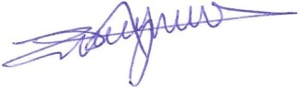
Assistant Professor
Department of Radiology,
New York University School of Medicine

