Submission ID #: 51215
Editor Name: Pallavi R. Devchand
Videographer name: KJ Wang
Film Date: 10 January, 2014
Authors and Affiliations: Caroline N. Jones*, Anh N. Hoang*, Laurie Dimisko, Bashar Hamza, Joseph Martel, and Daniel Irimia
The BioMEMS Resource Center, Department of Surgery, Massachusetts General Hospital, Harvard Medical School, Shriners Burns Hospital, Boston, U.S.A.
Title: Microfluidic platform for measuring neutrophil chemotaxis from unprocessed whole blood
Corresponding Author: DIRIMIA@partners.org

Authors, please fill out the brief questionnaire below.

A. Will you require JoVE to record video microscopy, such as filming a complex dissection or microinjection technique? (Y/N) ____Y_____ If yes, please list make and model of your microscope: Nikon TiE Inverted Microscope with Perfect Focus with In Vivo Scientific Incubating Enclosure
or
Nikon TiE Inverted Microscope with Perfect Focus with Incubating Stage
B. Does your protocol include detailed, step-by-step, descriptions of software usage? (Y/N)__Y, Elements, Image J_____
C. Which steps of your protocol will viewers benefit most from having filmed? Please list 4-6 steps_Microfluidic device fabrication (2.5), Neutrophil Sample Preparations (3.2), Microfluidic Assay Preparation (4.3, 4.4, & 4.5), Microscopy (5.1&5.2)_________________________
D. What is the single most difficult aspect of this procedure and what do you do to ensure success? _Priming the device and loading whole blood. This is done slowly and carefully to ensure success Microfluidic Assay Preparation (4.3, 4.4, & 4.5)_____________________________

1. Introduction (Schematic Overview and Interview)

A. Schematic Overview (read by voice talent at JoVE):
Authors, please select from “Procedural Narrative” or “Conceptual Narrative” and complete the statements below. Please do not add additional steps. Then, attach your finished graphic overview. See accompanying instructions for details and examples.

Conceptual Narrative:

This microfluidic technology aims to measure the functionality of human neutrophils directly from one droplet of blood, on a platform that can be multiplexed. The central loading chamber serves as a whole blood source (LAB MEDIA: C1, upper left Show drop of blood from finger to well in plate) and also acts as a sink for the chemoattractant gradients that form from the 16 focal chemotactic chambers (LAB MEDIA: C2). The unique mechanical filtration of red blood cells enables probing the function of neutrophils in the natural context of blood cellular and biochemical components (LAB MEDIA: C3 lower part showing RBC filtration comb on WBLC). The bifurcation between a channel leading to the focal chemotactic chamber and a channel exiting the device, allows quantification and modulation of the directionality of migrating neutrophils. (LAB MEDIA: add remaining of C3 showing bifurcation and directionality including green FCC box). Thus results can demonstrate how actively migrating neutrophils easily migrate past trapped red blood cells and accumulate in numbers over time (C4).

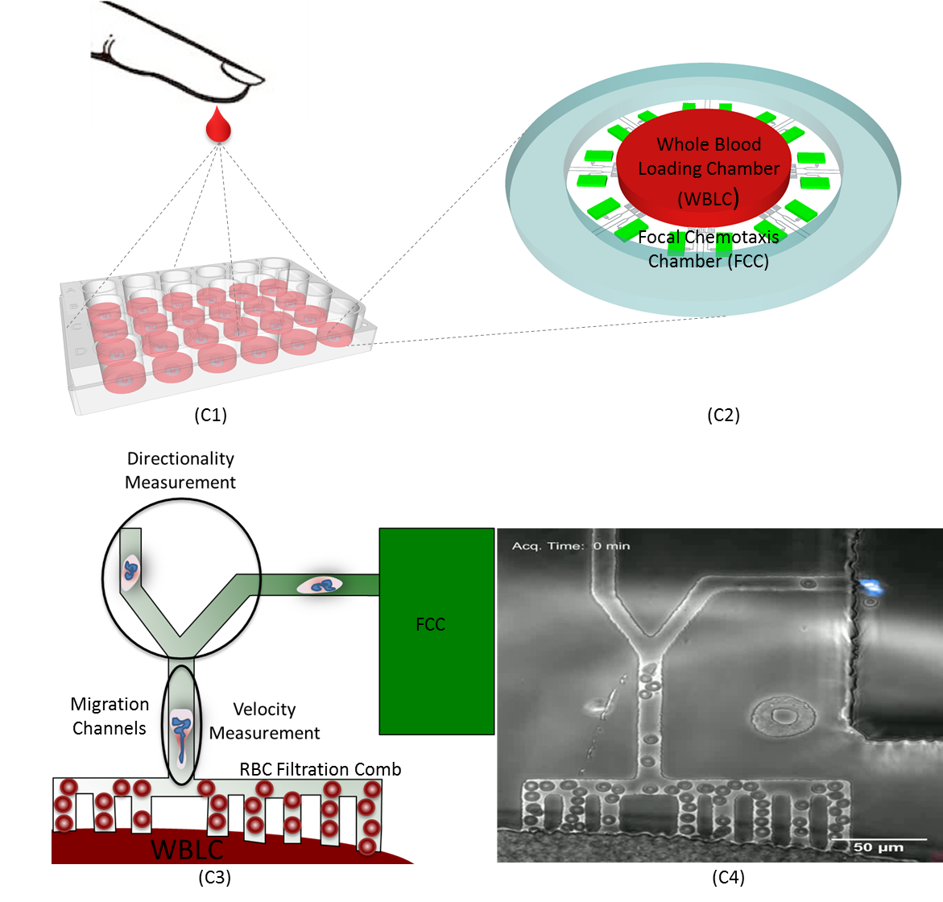

B. Interview: (Said by you on camera. Don’t forget to smile!)

Authors: Below are statements we would like you to complete that are complementary to the information contained within the schematic overview.
- Only one statement should be chosen and completed per author who will be on camera demonstrating the protocol.
- Enter the name of the individual who will say each line.
- Please choose and fill out the statement(s) that convey the most important fact(s) about your protocol. You may revise the given prompts as necessary to improve the sentence flow.
- If any individuals will be doing demonstrations on camera but are not assigned a speaking part in this interview section, please use statement 1.8 to introduce these demonstrators (for example, the PI introduces students)

  - Bashar Hamza: One unique feature of the microfluidic devices is that they are very easy to manufacture and set-up, consisting of a layer of PDMS cast on a microfabicated wafer that is bonded on a glass-bottom, single or multi-well plate.
  - Laurie Dimisko: The main advantage of this technique is that it requires only a droplet of whole blood. The devices could be used with standard pipettes, have no moving parts, require no tubing or external syringe pumps.
  - Caroline Jones: The implications of this technique extend into clinical applications. Compared to hours required with traditional techniques, our approach takes minutes from the time of blood collection to the neutrophil migration assays.
  - Anh Hoang: The novel red blood cell filtration comb prevents RBCs from blocking the active migration of neutrophils and sets this method apart from other microfluidic methods that require removing the blood before the chemotaxis assay is performed.
  - Joe Martel: The mechanical jamming of RBCs in channels distinguishes our technology and enables testing the neutrophils in their physiologic environment of whole blood, including serum and platelets.
  - Daniel Irimia: The precision of this technology can significantly advance our understanding of the role of the innate immune system from the perspective of altered neutrophil states in health and disease.

Protocol (read by voice talent at JoVE):

Authors: In order to ensure that your protocol can be filmed in a single day, the protocol text must be limited to 30 steps – each step being defined as 3 lines of 12 pt text in our formatting style below. This amounts to 3 pages of protocol text. The scope of the scripted protocol text should include only those aspects of the procedure that require visualization in order to be well understood.

- Microfluidic device fabrication
  - Fabricate the master mold wafer [Text over video: class 1000 clean room] to define the migration channels according to the instructions from the manufacturer. First pattern the first 3-micron epoxy-based negative photoresist layer.
    - MED/CU: Talent approaches workbench in the clean room and positions a wafer..
    - ECU: Talent shows pattern of the first 3-micron epoxy-based negative photoresist layer.

  - Then pattern the second 50-micron layer to define the cell-loading and chemokine chambers.
    - CU: Talent show the pattern of the second 50-micron layer.

  - Now to the cast polydimethylsiloxane devices, vigorously mix 20 g of PDMS with 2 g of initiator for 5 minutes.
    - MED/CU: Talent vigorously mix 20 g of PDMS with 2 g of initiator for 5 minutes using plastic fork in large plastic weighing tray.

  - Carefully pour the PDMS onto the patterned wafer, and de-gas in a vacuum desiccator for 1 hour. Then bake and cure the PDMS microfluidic devices in a 65 ˚C oven for at least 3 hours.
    - CU/ECU: Talent carefully pours the PDMS onto the patterned wafer.
    - MED: Talent places the wafer in a vacuum desiccator.
    - CU/ECU: Talent places the devices in a 65 ˚C oven.

  - Punch out the central whole blood loading chambers of 1.5 mm diameter. Also punch out whole donut-shaped devices of 5.0 mm diameter. Remove the particles from the donut devices using adhesive tape.
    - CU: Talent punches out the central whole blood loading chambers of 1.5 mm diameter.
    - ECU: Talent punches out the whole donut-shaped devices of 5.0 mm diameter.
    - CU/ECU: Talent remove the particles from the donut devices using adhesive tape.

  - Next, rinse a 12-well plate with deionized water and dry with nitrogen. After placing the plate in 60˚C oven for 5 minutes, oxygen plasma treat for 35 seconds. Then add the donut devices and oxygen plasma treat again for another 35 seconds.
    - MED/CU: Talent rinses a 12-well plate with deionized water.
    - ECU: Talent passes nitrogen stream over the plate.
    - MED/CU: Talent treats the plate with oxygen plasma
    - ECU: Talent positions the donut devices, and treats with oxygen plasma

  - Carefully transfer the devices into the wells of the plate, and bake with bonded devices on a 80˚C hot plate for 10 minutes.
    - ECU: With tweezers, Talent transfers the devices in the wells of the plate.
    - MED/CU: Talent places the fabricated device on a 80 ˚C hot.

- Microfluidic Assay Preparation
  - After oxygen plasma treatment, the device is hydrophilic and capillary effects can promote the priming of the small channels in the device.
    - SECTION TITLE.

  - For the chemoattractant solution, mix 5 µL of 10 µM fMLP with 5 µL of 1 mg/mL fibronectin and 490 µL of HBSS.
    - CU: In a microfuge, Talent adds 5 µL of 10 µM fMLP, 5 µL of 1 mg/mL fibronectin and 490 µL HBSS.

  - Slowly pipet the chemoattractant solution into the WBLC. Pipet an additional 20µL of the chemoattractant around the outside of the device.
    - ECU: Using a gel loading tip, Talent slowly pipets the chemoattractant solution into the WBLC.
    - ECU: Talent pipets 20µL of the chemoattractant around the outside of the device.

  - Place the plate in a dessicator for 15 minutes. Apply a vacuum to the device, to permeate the device with chemoattractant solution.
    - MED/CU: Talent places the plate in a dessicator.
    - MED: Talent applies a vacuum to the device.

  - Remove the plate from the dessicator, and confirm wetting of the device channel by gradual decrease in size of the air bubble. Then wash the WBLC and the outside of the device thoroughly to remove excess chemoattractant solution.
    - CU: Talent removes the plate from dessicator.
    - MED: Talent examines the plate under a microscope. INSERT MOVIE OF DEVICE PRIMING (BUBBLE LEAVING DEVICE FCC/Channels)
    - CU/ECU: Talent washes the WBLC and outside of the device thoroughly.

  - Next, to generate a gradient of chemoattractant from each of the focal chemotactic chambers to the device center, gently inject 100 uL of PBS into the hole so that a droplet of PBS forms on top of the device.
    - ECU: Using a 1ml syringe, Talent gently injects 100 uL of PBS into the hole so a droplet of PBS forms on top of the device.

  - Tilt the plate and pipette 1 mL of PBS around the device, to collect at the bottom of the well. Aspirate the liquid and repeat the PBS wash three times.
    - CU/ECU: Talent tilts the plate and pipettes 1 mL of PBS around device, to collect at the bottom of the well.
    - CU: Talent aspirates the liquid and adds PBS wash again.

  - Next, fill each well with media to submerge the devices, and allow 15 minutes for the gradient to stabilize. Then slowly pipette 2 µL of isolated neutrophils into each WBLC.
    - ECU: Talent fills last few wells with media to submerge the devices, and then sets the plate aside
    - ECU: Using gel loading tips, Talent slowly pipettes 2 µL of isolated neutrophils into each WBLC.

- Neutrophil Sample Preparations
  - For finger prick blood collection, wash hands with soap and water. Dry the skin. As an anti-coagulant/stain solution, add 1 mL of 0.2% HSA and 10 µL of 32.4 μM Hoechst stain to a heparin blood collection tube.
    - MED: Talent washes hands with soap and water and then dries the skin.
    - CU: Talent adds 1 mL of 0.2% HSA and 10 µL of 32.4 μM Hoechst stain to a heparin blood collection tube.
  - Prick the healthy donor’s finger and wipe away the first drop of blood. Collect 50 µl of blood into the anti-coagulant/stain solution and gently mix and incubate for 10 minutes.
    - CU/ECU: Talent pricks the healthy donor’s finger with a SurgiLance safety lancet, wipes away the first drop of blood, and collects 50 µl of blood into the anti-coagulant/stain solution.
    - CU: Talent gently mixes the blood in tube and sets it aside for incubation.
  - For human neutrophils preparations from venous blood [Text over video: 10ml], add 50 µL of venous blood to the anti-coagulant/stain solution and incubate for 10 minutes to for nucleus fluorescent staining.
    - MED/CU: From 10ml of venous blood, Talent transfers 50 µL to the anti-coagulant/stain solution.
    - CU: Talent sets tube on rack and puts timer for 10 minutes.
  - As a positive control, separate the 10ml of venous blood on a 6%Hetastarch density gradient, followed by a negative selection magnetic bead isolation kit following the manufacturers protocol.
    - MED/CU: Talent rempves tube from centrifuge after density gradient.
    - CU/ECU: Talent places sample tube on magnet rack .
  - Re-suspended the final aliquot of neutrophils at a concentration of 4,000 cells/µL and maintain the cells at 37 °C.
    - ECU: Talent re-suspendeds the final aliquot of neutrophils at a concentration of 4,000 cells/µL.
    - 4.3.2 MED/CU: Talent places the isolated cells at 37 °C.

- Microscopy and image analysis for neutrophil chemotaxis measurements
  - Set up the biochamber to 37°C, 80% humidity, and 5% CO₂. Immediately start the time-lapse imaging at 10X or higher magnification.
    - MED-over-the-shoulder: Talent sets up biochamber settings to 37°C, 80% humidity, and 5% CO₂.
    - SCREEN: Talent starts the time-lapse imaging at 10X or higher magnification.

  - For meaningful statistical analysis, manually track at least 50 neutrophils in each sample. Count the cells entering the FCC over time. Then using ImageJ, calculate neutrophil velocities in the channel between the WBLC and FCC.
    - SCREEN: Talent manually tracks a few neutrophils in a sample.
    - SCREEN: Talent counts the cells and enters the FCC over time.
    - SCREEN: In ImageJ, Talent calculates neutrophil velocities in the channel between the WBLC and FCC. INSERT MOVIE of ImageJ analysis.

  - Then to quantify directionality of the neutrophils, count the number of cells that pass the bifurcation, and calculate the ratio between the number of cells that turn toward the FCC and cells that exit the device.
    - SCREEN: Talent counts the number of cells that pass the bifurcation.
    - SCREEN: Talent calculates the ratio between the number of cells that turn toward the FCC and cells that exit the device.

  - Cells that are not directional do not follow the chemotactic gradient and therefore migrate in equal numbers toward the FCC and the exit channel.
    - SCREEN: Talent evaluates a sample where cells are not directional in chemotaxis, and enters approx. equal numbers toward the FCC and the exit channel.

- Results: Chemotaxis and chemokinesis
  - In this experiment, the whole blood neutrophil chemotaxis assay was validated by measuring the accumulation of neutrophils towards an fMLP gradient.
    - LAB MEDIA: Movie S1.

  - Results confirm that the red blood cells are trapped by the filtration comb, while the neutrophils are able to actively migrate out of whole blood.
    - LAB MEDIA: Figure 3A (without inset – indicate blue neutrophils)

  - The stable linear chemoattractant gradient formed by the whole blood microfluidic device was confirmed using FITC-labeled dextran and measured the fluorescence levels over time.
    - LAB MEDIA: Figure 3A (add inset)

  - Results obtained using the novel WB chemotaxis platform reveal that neutrophils from from all blood sources migrate with consistent velocity and with similar total migratory cells. Importantly, this system allows quantitation of the neutrophils, therefore differentiates chemotaxis from chemokinesis [Text over video: directionality index of 0.9]
    - LAB MEDIA: Figure 3B (blue line, then add shaded bars)

INSTRUCTIONS FOR AUTHORS:
Please ensure that the representative results narration is appropriate and correctly describes your images, movies, or figures. Our editors have ensured that the results are written in our format.

We consider this section a critical aspect of the video, because here is where you provide validation for your experiments. For example, if this is a cell culture preparation, this section is where the video will show your cells at various time points following culturing. If this is an imaging prep, then this part is where you will show examples of your imaging experiments.

Please limit the extent of narration to no more than 2-3 lines of text per image or movie file being described. Figures with multiple panels submitted with the original protocol should be broken up so that each panel is a separate image. Like the schematic, each image or movie file supplied in the results should be referenced by annotation in parenthesis, however for the results, the specific filename should be given in parenthesis.

Below is an example of results text:

EXAMPLE REPRESENTATIVE RESULTS

5. Evaluation of Morpholino Injection and Knockdown
5.1 Representative results of both morpholino injection and mRNA injection are shown here. The
uninjected control at 48 hours post fertilization looks normal, as expected
-LAB MEDIA: 0123_PIname_Figure1.tif (Replace 0123 with your jove video #)

5.2 However, embryos injected with the morpholino heg_e3i3_egfr1, which knocks down Heg isoforms
containing the first of two EGF-like repeats, exhibit brain edema.
-LAB MEDIA: 0123_PIname_Figure2.tif

5.3 Injection of heart of glass mRNA also produced an obvious phenotype. At 24 hours post fertilization,
the heads of the uninjected controls look normal
-LAB MEDIA: 0123_PIname_Figure3.tif

5.4 Conversely, some of the embryos injected with the mRNA exhibit cyclopia
-LAB MEDIA: 0123_PIname_Figure4.jpg

Please visit the following URL to see an example of how the results will look when complete:
http://www.jove.com/video/1597/results-example-mably?access=ksw0bprj

- Conclusion (said by authors on camera)
Authors: Below are statements we would like you to complete that summarize and conclude the video. Only one statement should be chosen and completed per author who will be on camera demonstrating the protocol. In addition to choosing and filling out the appropriate statement, please enter the name of the individual who will say each line. You may revise the given prompts if necessary to better fit your protocol.

  - Laurie Dimisko: Once mastered, this technique can be done in less than 10 minutes, if it is performed properly.
  - Bashar Hamza: The incorporation of our device in a multi-wellplate using standard clean room techniques facilitates the screening of multiple conditions simultaneously.
  - Joe Martel: Using this technique we are able to measure neutrophil velocity and directionality at the single cell level, unlike traditional methods that measure bulk end-point cell migration.
  - Caroline Jones: Remember to carefully prime the microfluidic device and load blood sample slowly so that RBCs will not be pushed past the comb of the device.
  - Anh Hoang: The protocol described is particularly useful for measuring transient neutrophil chemotactic deficiencies allowing repeated sampling over multiple time-points, but could also be adapted to measure migration of other cell types from different model organisms.
  - Caroline Jones: This method can provide insight into temporary alterations of neutrophil functionality in patients with various conditions associated with higher incidence of infections, including burn and trauma patients, patients after major surgery, and cancer patients receiving chemotherapy.

Provided Media

Authors, Please list all images, movie files, or 3-D rendered animations that can be included in the video per editor’s request. The step in the script/video where these images will be inserted should be specified. For example:

6.2 – 0123_PIname_Figure1.tif - dual color imaging of tumor angiogenesis at 40X
6.2 – 0123_PIname_Figure2.tif - dual color imaging of tumor angiogenesis at 100X

Formats: For static images we prefer .tiff, Illustrator, Powerpoint or Photoshop files at dimensions of at least 720X480 pixels and 300 dpi. The higher resolution, the better. Likewise any exported movie files should have at minimum these dimensions and be rendered to .mov, .mp4, or .avi files.

Insert your media filenames here.

5.3 Jones_Figure 2

6.1.1- Jones_Movie S1.

6.2.1/6.3.1/6.4.1- Jones_Figure 3

Intro- Jones_Move S2

General Preparation

It’s critical for a smooth and organized shoot that all reagents are accounted for, in advance.

Any overnight or long incubation steps should be recognized and specimens/samples be prepared in advance so that prior steps can be recorded and shooting can continue with pre-prepared specimens/samples.

All tubes/flasks should be pre-labeled neatly before we arrive.

Ex. Luciferase assay done in 96 well plates should be labeled with negative/positive control wells and experimental samples are labeled accordingly.

You will receive more detailed preparation instructions, as well as an introduction to your videographer, closer to your filming date.

