Video editor: This was so heavily edited, I could not tell what the original was, so if anything got lost in translation, that’s why - Bree

Submission ID #: 51211

Editor Name: Brigid Stadinski

Videographer name: Brandon Hutchinson

Film Date: 01/18/2014

Authors and Affiliations:

Anna Eslami
Product Manager, Rheumatology
INOVA Diagnostics, Inc.
San Diego, CA USA
aeslami@inovadx.com

Gabriella Lakos, MD, PhD
Medical Director
INOVA Diagnostics, Inc.
San Diego, CA USA
glakos@inovadx.com

Title: Anti-nuclear antibody screening and anti-neutrophil cytoplasmic antibody screening using NOVA Lite assays

Corresponding Author:

Anna Eslami aeslami@inovadx.com

- Will you require JoVE to record video microscopy, such as filming a complex dissection or microinjection technique? (Y/N) __No If yes, please list make and model of your microscope: ______________________________
**Note: This question is to get at whether or not you will need a camera hook-up to look into the microscope. However, if your microscope has a digital camera attached to a computer, you can gather these shots by collecting screen capture movies.
Does your protocol include microscopy steps that are visualized through a microscope with a digital camera/computer attached? (Y/N) _No______
B. Does your protocol include detailed, step-by-step, descriptions of software usage? (Y/N)___No_____
C. Which steps of your protocol will viewers benefit most from having filmed? Please list 4-6 steps___Sample dispensing, incubating, proper washing, proper coverslipping. Most importantly, identification of positive and negative results.______________________
D. What is the single most difficult aspect of this procedure and what do you do to ensure success? _________________________Since interpretation of patterns is somewhat subjective, it is important to start off with high quality reagents. Correctly performing the steps as outlined in question “C” will eliminate any unwarranted ambiguity and result in the most optimal patterns._____

1. Introduction (Schematic Overview and Interview)

A. Schematic Overview (read by voice talent at JoVE):

Conceptual Narrative:
The overall goal of the following experiment is to use an indirect immunofluorescent assay to screen for anti-nuclear antibodies (ANA).
(Intro)

This is achieved by incubating patient serum with HEp-2 substrate slides. (P1)
Editors, using slide 2 of “51211_Inova_schematic_ideas_1217.pptx,” please show an image of the purple slide on the left side as “For ANA detection, HEp-2 substrate slides are used” is narrated. As the HEp-2 slide is shown, animate the addition of two drops of serum with a pipette to several of the wells on the slide.

The bound autoantibodies are then incubated with specific fluorescein labeled conjugate and the unbound reagent is washed off. (P2)
Then animate the addition of one drop of liquid with a pipette to each of the wells on the slide. Zoom into the well and within the liquid, illustrate Y’s with a star or green circle on the bottom to represent the fluorescein labeled conjugate. (Something like RS3155, or RS168 except with the yellow ball made green)

When viewed through a fluorescence microscope, autoantibody positive samples will exhibit an apple green fluorescence corresponding to areas of the cell or nuclei where autoantibody has bound in a pattern of fluorescence indicative of the antigen being present. (P3)
Editors, please show the image of the NOVA View instrument with cells showing green fluorescence on screen that can be found on page 3 of the “51211_Inova_schematic_ideas_1217.pptx” file. As the second half of the sentence is narrated, show the circle of the zoomed in cells.

Ultimately, the presence of ANAs can be used to aid in the diagnosis of systemic lupus erythematosus or other connective tissue or rheumatic diseases. (P4)
Editors, please start with figure 1 as the first part of the sentence is narrated and then bring in figure 6 for the second half of the sentence.

B. Interview: (Said by you on camera. Don’t forget to smile!)
  - Gabriella Lakos: The main advantage of the indirect immunofluorescent method over other methods, like solid phase ELISA, is that the HEp-2 cell substrate contains over 100 antigens expressed in their native configuration. This allows the identification of almost all clinically relevant autoantibodies, which is not possible with solid phase techniques.
    - MED: Gabriella speaks toward camera, interview style.
  - Gabriella Lakos: As the indirect immunofluorescent method is a very specialized technique, individuals new to this method need time and practice to become proficient in the procedure of slide processing. Interpreting the microscopic images and learning to identify relevant patterns is also a skill that takes time to master. With the right reagents and tools, the results are more consistent and easier to interpret.
    - CU: Gabriella speaks toward camera, interview style.
  - **Gabriella Lakos: Demonstrating the procedure will be Cassandra Bryant,, a technologist from the Immunofluorescent Assays Development Laboratory.
    - MED: Gabriella speaks toward camera, interview style.
    - MED: Cassandra looks up from workbench and acknowledges the camera.

Protocol (read by voice talent at JoVE):
- Sample preparation and substrate selection
  - Remove reagents from packaging and allow each item to come to room temperature. Prepare reagents and dilute patient sera according to the direction insert. NOVA Lite slides are barcoded and can be easily integrated into automated systems in conjunction with the Laboratory Information System. This procedure illustrates manual slide processing; high throughput laboratories, however, may opt for automated slide processing equipment.
    - MED: Talent removes the reagents from the packaging and places them on the bench.
    - ECU: Please obtain a few takes, including at least one in which the NOVA Lite packaging is clearly visible.
- Addition of controls and samples
  - Dispense 1 drop of positive control and 1 drop of negative control onto the appropriate slide wells. Pipette 20-25 uL of diluted patient serum to the remaining wells. Process one slide at a time
    - MED over the shoulder: Talent places the slide in a container with a damp paper towel on the bottom.
    - MED-over the shoulder: Slide as talent deposits 1 drop of the undiluted positive and negative control from labeled containers to the slide wells.
  - Place the slides in a staining container with a damp paper towel on the bottom. Cover the container and incubate the slides for 30 minutes. Set and start the timer. The humid conditions will prevent the substrate from drying out. Drying of the wells could result in artifactual staining. During this incubation period, the antinuclear antibodies in the patient’s serum will bind to antigens of the cells that are fixed onto each well.

    - CU: Slide as talent deposits 25 uL of patient serum to the remaining wells.
    - CU: Container with slide and paper towel as talent covers the container and starts an adjacent timer to countdown from 30 minutes.
  - After the incubation period, rinse off the serum using a gentle stream of wash buffer. In order to avoid damaging the substrate, angle the slide slightly to avoid directing the stream directly onto the wells. This orientation of the slides will also help to prevent cross-over of samples between wells. Tap off excess wash buffer and place the slide into a Coplin jar containing wash buffer. The incubation time for the wash step should be approximately 5 minutes.
    - MED: Talent gently washes the serum with PBS from a labeled container.
    - CU or ECU: Slide and wells as talent washes avoiding a direct stream onto the wells.
    - MED: Tap off excess wash buffer and place into a Coplin jar.

- Addition of fluorescent conjugate
  - Remove the slides from the wash buffer and gently tap to remove the excess wash buffer. Then, apply 1 drop of fluorescent conjugate on each well. For ANA testing, the use of an Fc specific conjugate is recommended as it is specific only for IgG isotypes. Incubate the slides for 30 minutes in the humidified container, and be sure to replace the staining container cover. Set and start the timer. The conjugate is light sensitive, and the cover will protect the slides from exposure to light in addition to maintaining the humidified environment. During this incubation period, the conjugate will bind to the patient’s antinuclear antibodies that have bound to the cell antigens. This conjugate binding results in the presence of fluorescence in the wells.
    - MED-over the shoulder: Talent taps the slide gently to remove the excess PBS buffer.
    - CU: Slide as talent applies 1 drop of fluorescent conjugate onto each well.
    - MED: Talent starts a timer to count down from 30 minutes and leaves it adjacent to the slide.
  - Following incubation, wash the slide with wash buffer as before.
    - MED-over the shoulder: Talent gently washes the slide with PBS from a labeled container.
  - Place a coverslip on a paper towel and apply mounting medium in a continuous line to the bottom edge of the coverslip.
    - CU: Slide as talent places a coverslip on a paper towel.
    - ECU: Coverslip as talent applies the mounting medium in a continuous line to the bottom edge of the coverslip.
  - Remove each slide from the wash buffer and tap the slide gently to remove the excess wash buffer. Touch the lower edge of the slide to the edge of the coverslip.
    - MED-over the shoulder: Talent taps off excess wash buffer and touches the lower edge of the slide to the edge of the coverslip.
  - Gently lower the slide onto the coverslip in such a way that the mounting medium on the coverslip flows to the top edge of the slide without air bubble formation. Coverslipping, including using the optimal amount of mounting medium, is a technique that takes practice to perfect.
    - CU or ECU: Talent gently lowers the slide onto the coverslip in such a way that the mounting medium flows to the top edge of the slide without air bubble formation.
- Identification of positive and negative results
  - View slides with a fluorescent microscope, located in a dark room. Scanning of the entire well should be performed with a 20x or 25x objective, to assess cell distribution and uniformity of fluorescence.
    - CU: Fluorescent microscope as talent places the slide there.

  - Switch to a 40x objective to make the final interpretation regarding positivity and pattern.
    - MED: Talent adjusts the magnification to 40X and then looks at the control wells.
  - Look at the positive and negative controls. The negative control may not appear completely dark, but will often display low level non-specific fluorescence. The positive control will display bright apple green fluorescence in the nucleus. Positivity can be graded by using a reactivity grading scale from 1+ to 4+.
    - LAB MEDIA: Negative-control microscope image.
    - LAB MEDIA: Positive-control microscope image.
    - LAB MEDIA: Negative-control microscope image and positive-control microscope image. Editors, please shrink the positive control image to half the screen and bring in the negative control image adjacent to it for comparison for the final sentence.
  - In addition to manual interpretation, slides can be loaded and scanned by a NOVA View Automated Fluorescence Microscope, or other automated digital imaging instrument; no darkroom is necessary. After creating a project by selecting the appropriate slide type, the instrument acquires and stores high resolution digital images of cells in each well. Additionally, NOVA View measures fluorescent light intensity, and categorizes results as positive or negative, and provides pattern recognition for positive samples. Images are viewed by the operator on a high resolution computer monitor, allowing for final interpretation, revision and confirmation of NOVA View result. Reports can be generated on confirmed results.
    - MED or WIDE: Shot of NOVA view instrument.VIDEOGRAPHER: Please obtain several takes and/or b-roll of the instrument. Talent walks towards the NOVA View and loads a slide.
    - Talent creates a project on the screen
    - Talent views cell images and a patient report on the screen.

- Results: Cell staining patterns for HEp-2
  - Autoantibody binding on the constituent protein structures within the nucleus results in four major nuclear patterns including homogenous, speckled, centromere, and nucleolar.
    - Title Card.
  - To identify a homogenous pattern, as shown here, identify mitotic or dividing cells. Mitotic cells show solid uniform fluorescence which is often more pronounced than in resting cells. The resting cells should be uniform with diffuse staining. This characteristic pattern is most likely the result of anti-double stranded DNA antibodies.
    - LAB MEDIA: Figure 1. Editors, please highlight the white arrow as “mitotic cells show solid fluorescence” is narrated. Then highlight the orange arrow “resting cells should be uniform with diffuse staining” is narrated.
  - The speckled pattern is associated with the mitotic cells showing no staining of the condensed chromosomal region and distinct, intermediate sized particles in conjunction with large speckles throughout the nuclei of the resting cells. The speckling can be defined as coarse or fine. Coarse speckling is the result of several types of autoantibodies such as anti-Smith and anti-ribonuceoprotein.
    - LAB MEDIA: Figure 2. Editors, please highlight the white arrow as “no staining of the condensed chromosomal region” is narrated and the orange arrow as “distinct, intermediate sized particles in conjunction with large speckles throughout the nuclei of the resting cells. ” the last sentence is narrated describing course speckling.
  - Fine speckling can be due to a number of autoantibodies, including anti-Sjögren's syndrome A and B, as well as anti-RNA polymerase.
    - LAB MEDIA: Figure 3. Editors, please highlight the white arrow as this point describing fine speckling is narrated.
  - Shown here is a pattern suggestive of fine speckling indicative of samples positive for anti-dense fine speckles autoantibodies. Mitotic cells show a fine granular solid staining while resting cells show a very fine, diffuse speckled stain. In these cases confirmatory tests should be performed as isolated anti-dense fine speckles 70 antibodies are more prevalent in healthy individuals vs. patients with connective tissue disease.
    - LAB MEDIA: Figure 4. Editors, please highlight the orange arrow as “mitotic cells” is narrated. Then highlight the white arrow as “resting cells” is narrated.
  - To identify the centromere pattern, scan the wells and identify mitotic or dividing cells. The resting cells will show approximately 40-60 discrete speckles distributed throughout the nuclei. The dividing cells also have numerous discrete speckles in close association with one another, often called the metaphase bar. The centromere pattern is the result of anti-centromere protein A, B, and C autoantibodies.
    - LAB MEDIA: Figure 5. Editors, please highlight the white arrow as “resting and dividing cells” is narrated.
  - The nucleolar pattern shown here is associated with homogenous or speckled staining of the nucleoli along with weak speckled or homogenous staining of the nucleoplasm. As seen here, some nucleolar patterns are associated with diffuse cytoplasmic staining of the mitotic cells and negative chromosomal region. This pattern is associated with anti-ribonucleoprotein III, anti-fibrillarin, anti-Th/To, and anti-polymyositis/scleroderma antibodies.
    - LAB MEDIA: Figure 6

- Conclusion (said by authors on camera)
  - Gabriella Lakos: Antinuclear antibody detection and pattern recognition serves as an important tool to aid in patient diagnosis. Understanding the significance of various patterns enables clinicians and laboratory personnel to perform appropriate follow-up testing. The most important factors to correctly identify antinuclear antibody patterns are selecting a high quality cell substrate, and processing the slides with consistent good technique.
    - CU: Gabriella speaks toward camera, interview style.
  - Gabriella Lakos: Slide reading is traditionally performed by fluorescent microscopy in dark rooms, and is done by trained technologists who are familiar with the various patterns, in the context of cell cycle and cell morphology. In the last few years, digital imaging systems have been developed for the automated reading of the slides. Such instruments automate the workflow, and increase the consistency of reading and interpretation. Moreover, with the use of barcoded slides, sample traceability throughout the process eliminates potential transcription errors, and increases data integrity and patient safety.
    - MED: Gabriella speaks toward camera, interview style.
  - Gabriella Lakos: After watching this video, you should have a good understanding on how to perform each step of the indirect immunofluorescent procedure, and how to identify clinically relevant antinuclear antibody patterns.
    - MED: Gabriella speaks toward camera, interview style.

Provided Media

Authors, Please list all images, movie files, or 3-D rendered animations that can be included in the video per editor’s request. The step in the script/video where these images will be inserted should be specified. For example:

6.2 – 0123_PIname_Figure1.tif - dual color imaging of tumor angiogenesis at 40X
6.2 – 0123_PIname_Figure2.tif - dual color imaging of tumor angiogenesis at 100X

Formats: For static images we prefer .tiff, .eps, Illustrator, Powerpoint or Photoshop files at dimensions of at least 720X480 pixels and 300 dpi. The higher resolution, the better. Likewise any exported movie files should have at minimum these dimensions and be rendered to .mov, .mp4, or .avi files.

Insert your media filenames here.

Negative-control microscope image 

Positive-control microscope image 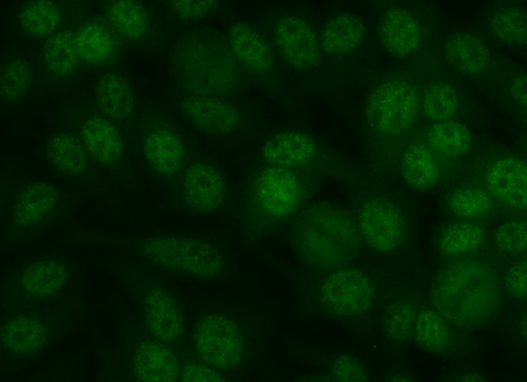

Figure 1
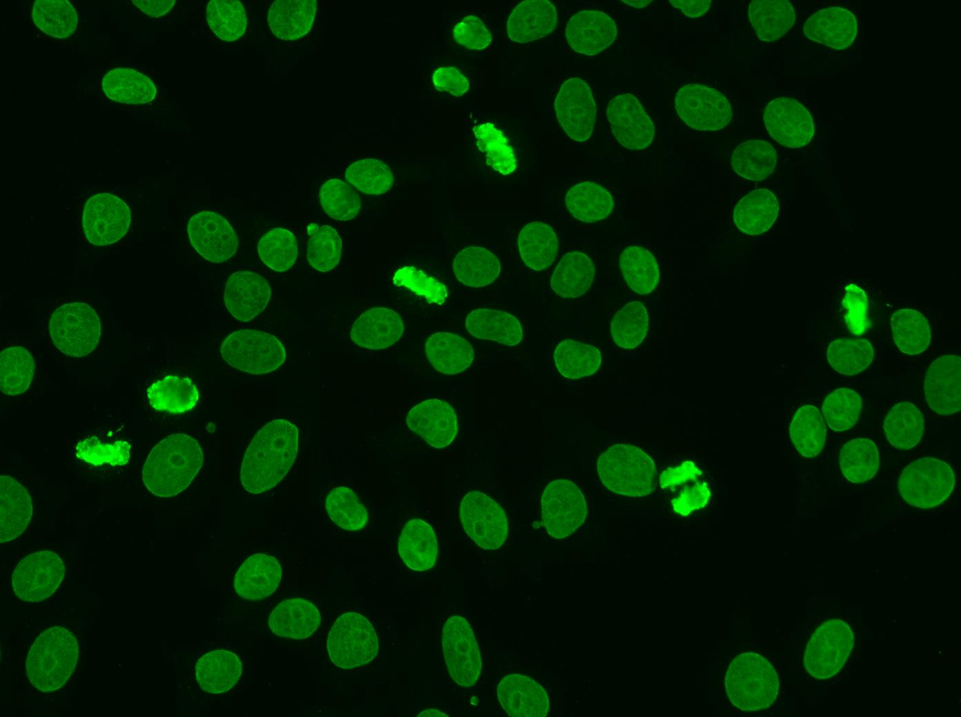

Figure 2
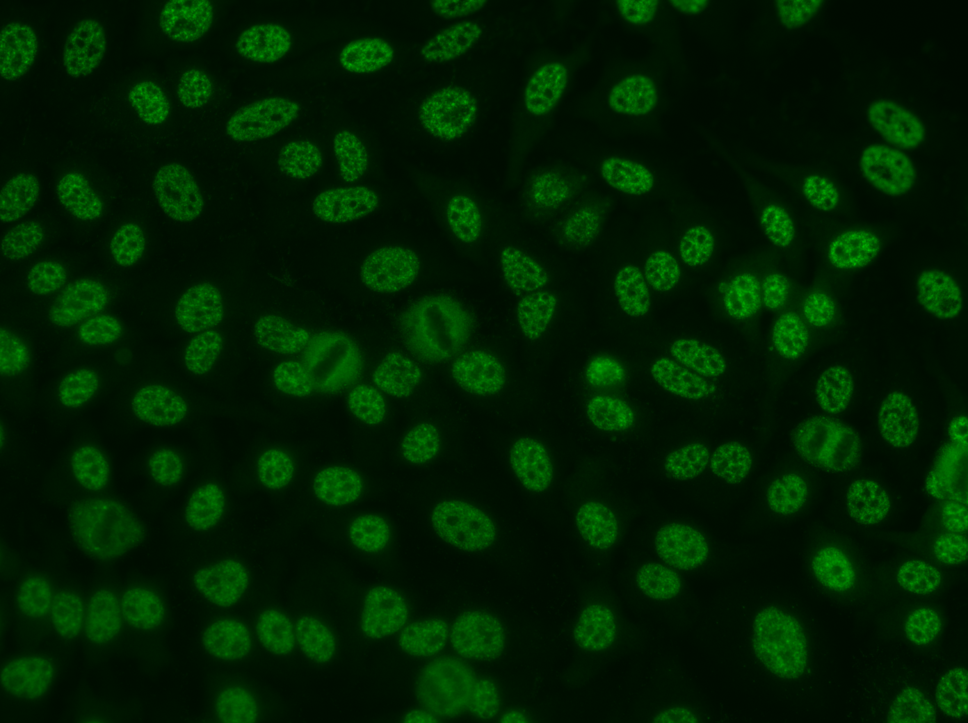

Figure 3
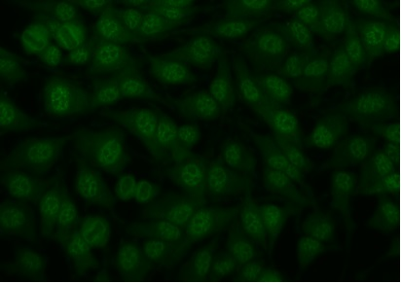

Figure 4
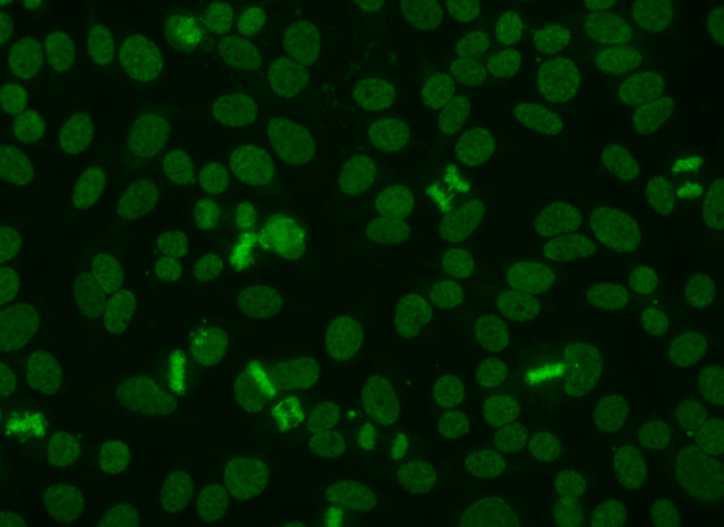

Figure 5
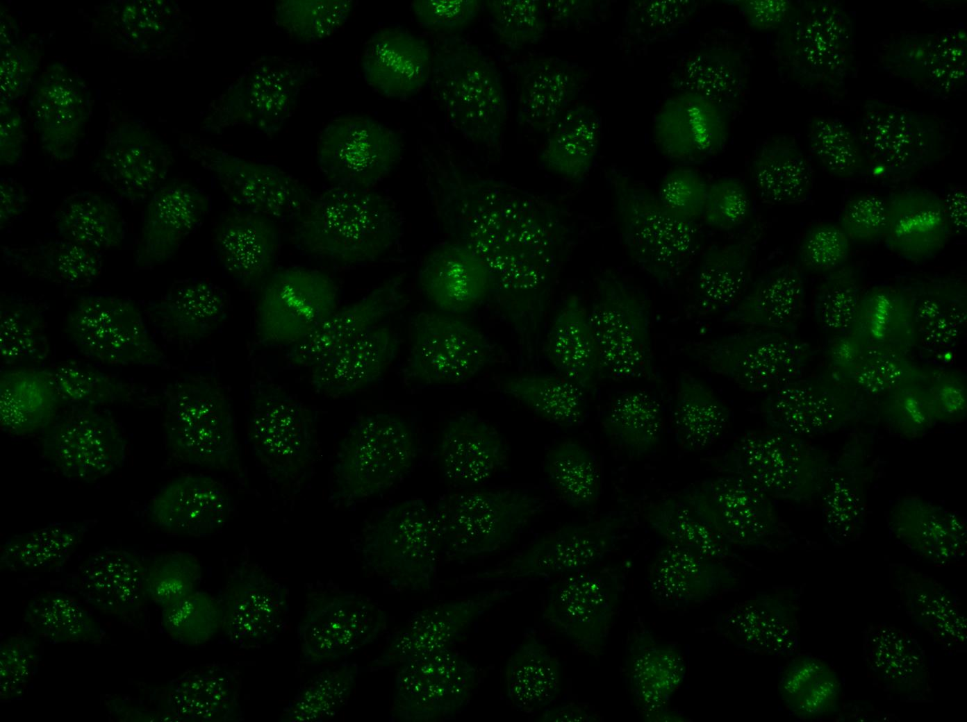

Figure 6

General Preparation

It’s critical for a smooth and organized shoot that all reagents are accounted for, in advance.

Any overnight or long incubation steps should be recognized and specimens/samples be prepared in advance so that prior steps can be recorded and shooting can continue with pre-prepared specimens/samples.

All tubes/flasks should be pre-labeled neatly before we arrive.

Ex. Luciferase assay done in 96 well plates should be labeled with negative/positive control wells and experimental samples are labeled accordingly.

You will receive more detailed preparation instructions, as well as an introduction to your videographer, closer to your filming date.

