Submission ID #: 51091

Editor Name: Steven Nilsen

Videographer name: Nicolas Bilder

Film Date: Oct 10, 2013

Authors and Affiliations:

Frédéric Catez^{1,2,5}, Antoine Rousseau⁴, Marc Labetoulle⁴, and Patrick Lomonte^{1,2,3}.

1. Virus and Centromere team. Centre de Génétique et Physiologie Moléculaire et Cellulaire. CNRS, UMR5534.

2. Université de Lyon 1, F-69000 Lyon, France;

3. Laboratoire d’excellence, LabEX DEVweCAN, F-69000 Lyon, France

4. Institut de Virologie Moléculaire et Structurale, CNRS-UPR-3296, Gif-sur-Yvette, France;

5. Current address: INSERM U1052, CNRS UMR5286, Centre de Recherche en Cancérologie de Lyon, F-69000, Lyon, France.

* Correspondence to: patrick.lomonte@univ-lyon1.fr

Title: Detection of the genome and transcripts of a persistent DNA virus in neuronal tissues by fluorescent in situ hybridization combined to immuno-staining.

Authors, general notes to you are provided in these grey boxes. Notes specific to your protocol will appear as highlighted text. Please begin by filling out this brief questionnaire below. Type your answers below each question.

- Will you require assistance with video microscopy, such as filming a complex dissection or microinjection technique (Y/N, please specify steps by number. Also, please list make and model of your microscope)?
YES – 2.4, 3.1, 3.2 and 3.3. We will have a Zeiss binocular; however it doesn’t have a camera port.

- Does your protocol include detailed, step-by-step, descriptions of software usage (Y/N, please specify steps by number)? NO

- Which steps of your protocol will viewers benefit most from having filmed? (use the numbering below) Steps 2.4, 3.1, 3.2, 3.3, 4.6, 5.6 to 5.10, 5.14, 5.15, 5.19

- What is the single most difficult aspect of this procedure and what do you do to ensure success? Steps 5.6 to 5.10

- Will the shoot take place in more than one location? (Y/N, specify travel time between locations) NO

Schematic Overview (read by a voice talent at JoVE)

An illustrated overview begins the video. For this section:
1. First READ the instructions in the attached document that accompanied this script.
2. Then, please select from “Procedural Narrative” or “Conceptual Narrative” and complete the statements below. You may reword the phrases, but please do not add additional steps.
3. Insert an image of your finished graphic overview below the narrative.
4. Upload the original schematic file through your online submission on the JoVE website. It should be Adobe Illustrator (preferred) or Powerpoint. Please keep all layers in the file (do not flatten the file).

NOTE: The schematic should NOT be a flow-chart of text bubbles. The schematic should also NOT be photographs. The schematic should be made up of simple cartoons and drawings. Thanks.

Procedural Narrative:
The overall goal of this procedure is to detect the genome of herpes simplex virus type 1, by fluorescent in situ hybridization, in sections of trigeminal ganglia from latently infected mice. (Intro)

This is accomplished by first inoculating the virus in the animal lip, followed by a 28 days incubation period, for the virus to establish latency in the trigeminal ganglia. (P1)

Next the mouse trigeminal ganglia are harvested, cryo-embedded and then cut as serial sections. (P2)

Then, the sections are subjected to several treatments to prepare tissues for fluorescent in situ hybridization. This includes a key step of heating sections in a sodium citrate buffer, using a microwave oven. (P3)

Finally, fluorescent in situ hybridization is performed using herpes specific fluorescent probes. (P4)

Ultimately, results can show the positioning of the viral genome inside the nucleus of individually infected neurons_ through _the use of light microscopy such as a confocal microscope (P5)

Conceptual Narrative:
The overall goal of the following experiment is to __(e.g. observe the effect of your treatment on cell migration using wound healing assays)____. (Intro)

This is achieved by (1st step of protocol e.g. add NGF to cells) to _(goal of 1st step - e.g. induce cell differentiation)__. (P1)

As a second step, _(insert 2nd step)__, which __(insert goal of 2nd step)_________ . (P2)

Next, __(insert 3rd step)_____in order to___(insert goal of 3rd step)_________. (P3)

Results are obtained that show _(effect of treatment - e.g. differences in protein expression in NGF treated cells_ based on ___(method of analysis - e.g. Western blotting analysis)__. (P4)

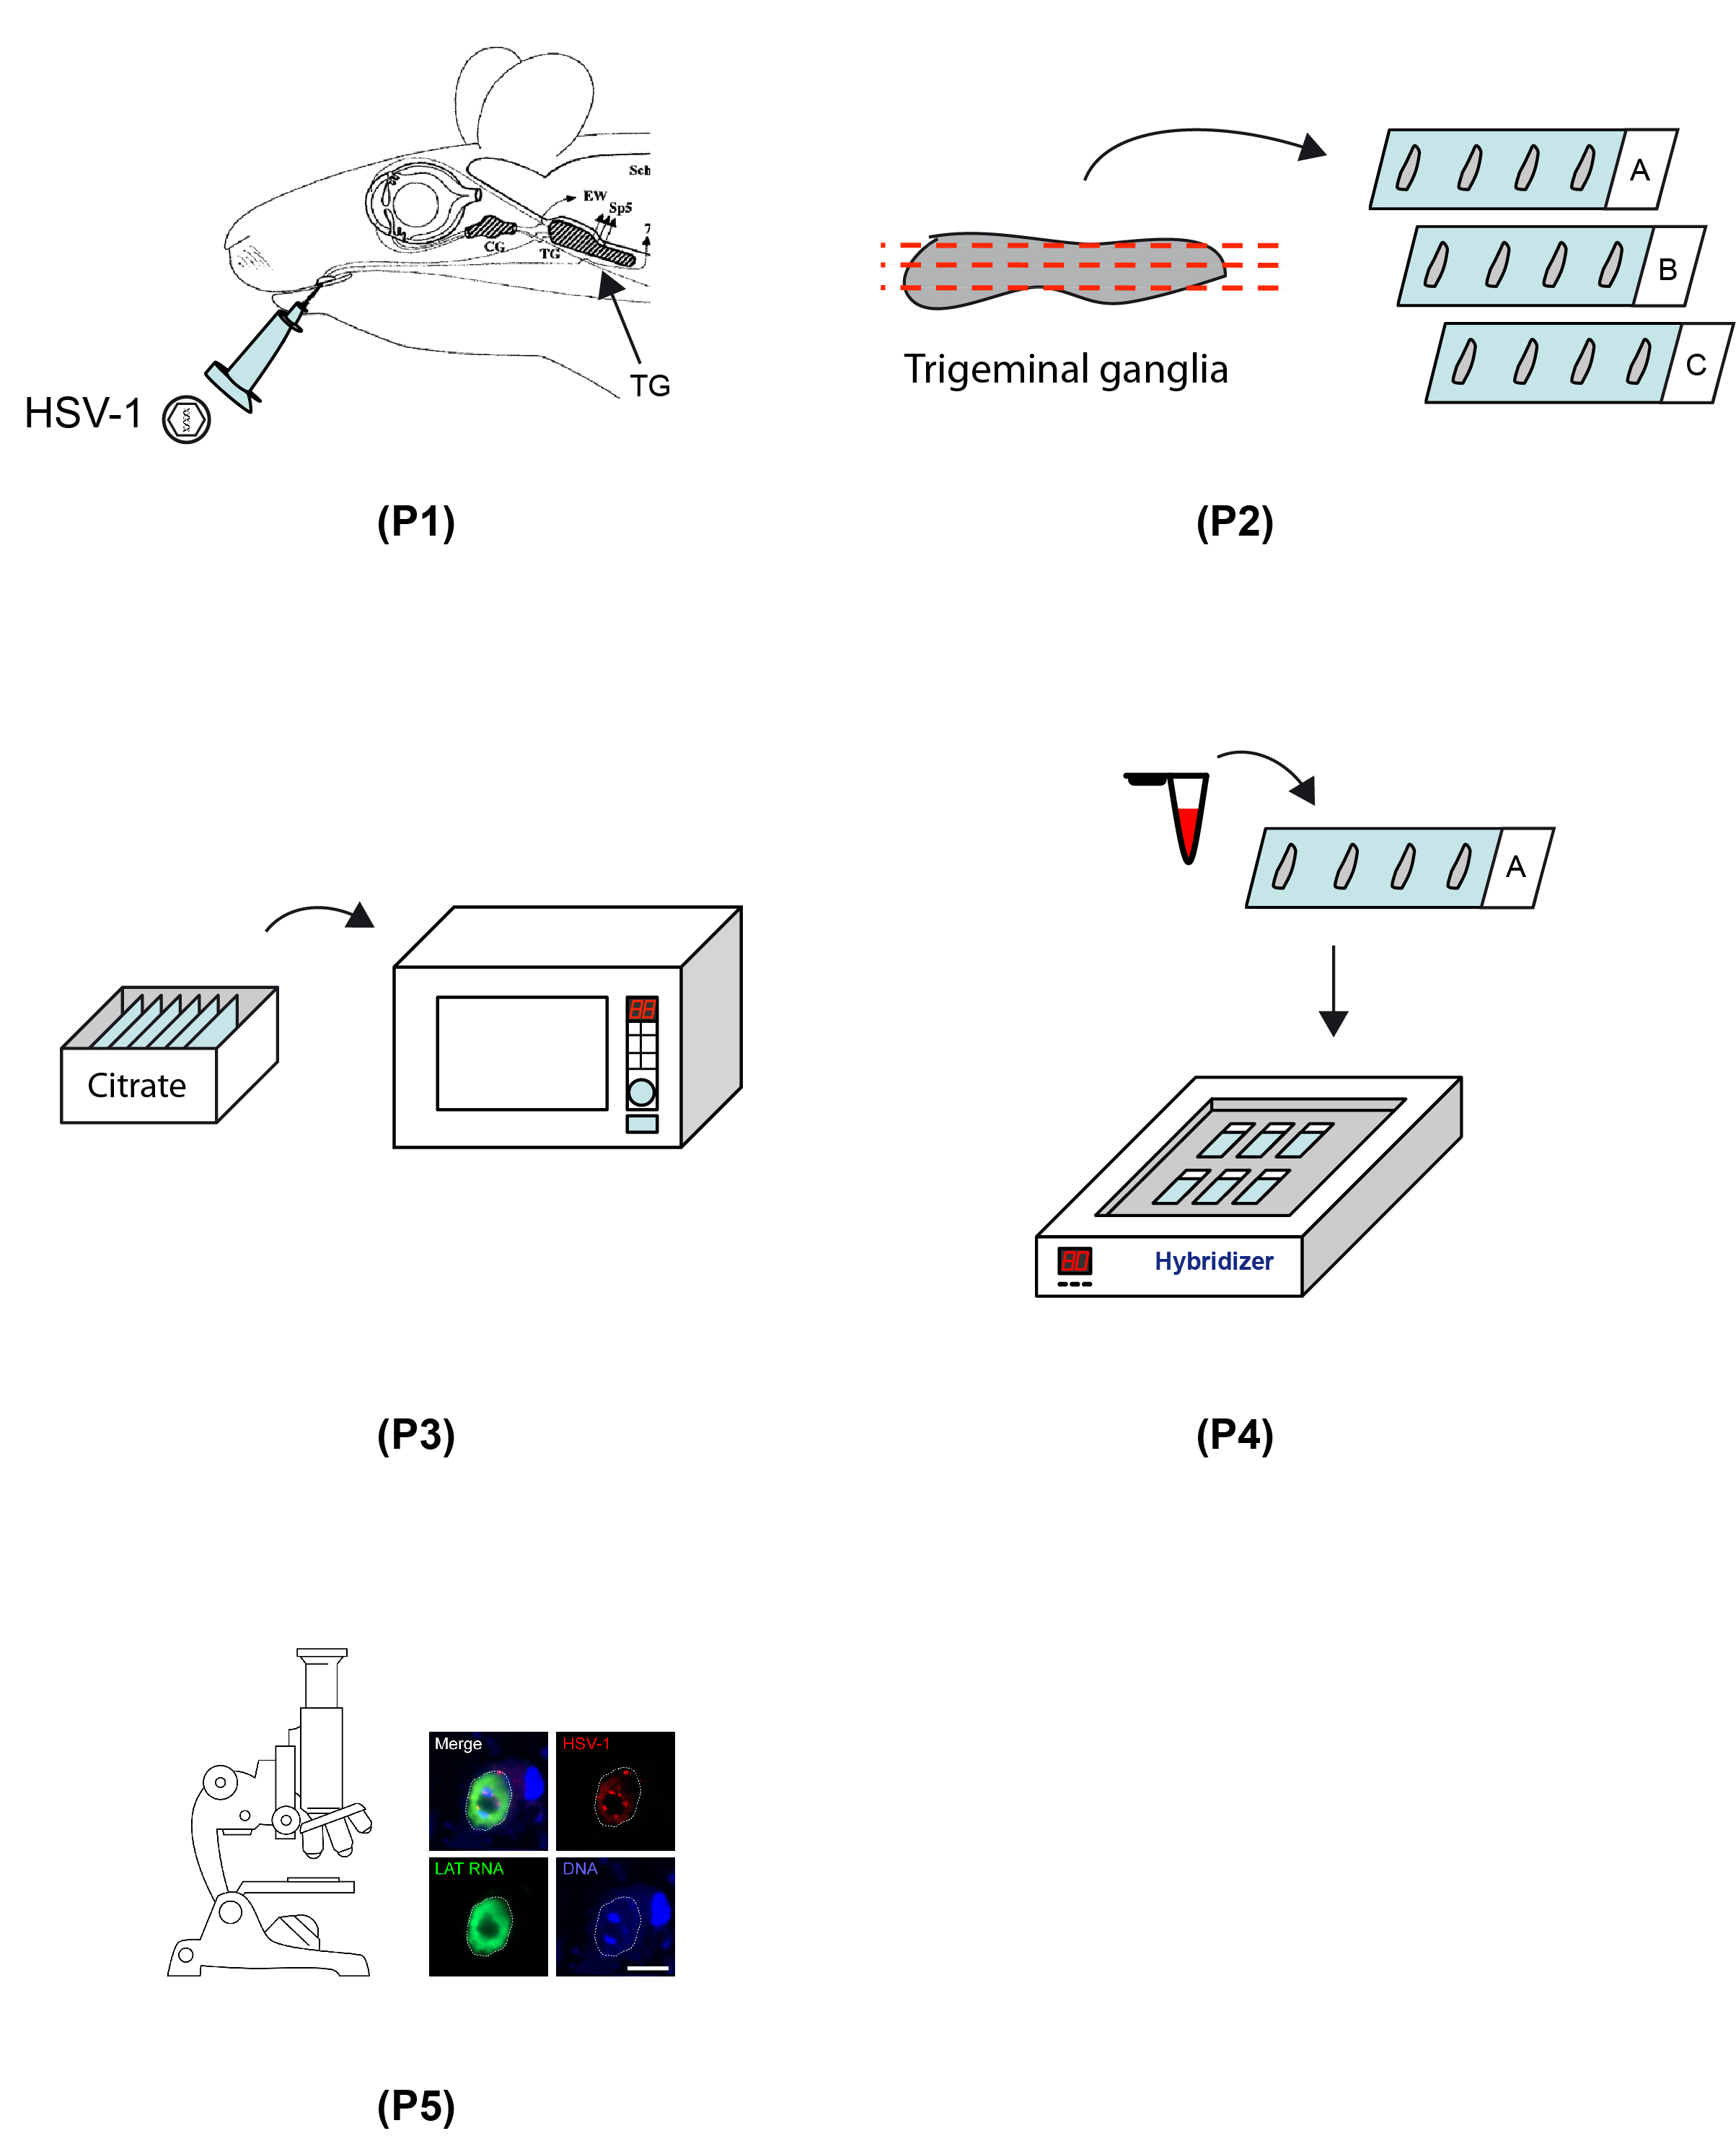

- Introductory Interview (spoken by you on camera. Don’t forget to smile!)

Below are statements we would like you to complete that are complementary to the information contained within the schematic overview. Only one statement should be chosen and completed per author who will be on camera demonstrating the protocol. In addition to choosing and filling out the appropriate statement, please enter the name of the individual who will say each line. **If individuals will be doing the demonstrations but not speaking in the introduction, please use statement 1.8 to introduce these demonstrators (e.g. PI introducing students).

  - Author name Frédéric CATEZ: In many cases the study of virus life cycle requires the use of animal models such as mice or rabbits. The main benefit of the method that we developed is to detect the viral genome within the tissues of infected animals by an in situ approach. This approach provides data at the single cell level. This is important because viral infection is a heterogeneous process, and information collected with our method will be complementary to biochemical approaches currently used, such as PCR, western blot or chromatin immunoprecipitation.
  - Author name: Marc LABETOULLE: The mouse oro-ocular model of HSV-1 infection takes advantage of reproducing most of the aspects of the natural history of HSV-1 infection in human, the only natural host of this virus. As this is the case in human, the primary infection in made in the oro-pharyngeal tissues, namely the lip in our case. We have shown that the virus goes from the site of primary infection to the trigeminal ganglia, the main site of HSV-1 latency in human.
  - Author name Patrick LOMONTE: In addition, this method can be combined to fluorescent in situ detection of cellular and viral RNA, and to immunofluorescence for the detection of cellular and viral proteins. As such, this method can help answer key questions concerning herpesvirus latency such as how the viral genome interacts with nuclear components and how these interactions would influence the maintenance of latency and eventually reactivation of the virus.
  - Author name _________: The implications of this technique extend toward therapy (or diagnosis) of_______, because ________.
  - Author name ________: Though this method can provide insight into ____________, it can also be applied to other systems (model organisms, studies of disease, organ systems), such as ____________. Other DNA viruses
  - Author name _______: Generally, individuals new to this method will struggle because ______________.
  - Author name ________: I/We first had the idea for this method, when I/we ___________.
  - Author name _________: Visual demonstration of this method is critical, as the ______________ steps are difficult to learn, because _______________.
  - **Author name ________: Demonstrating the procedure will be ________ a _______ (technician, post doc, grad student) from my laboratory. (Add additional mention of demonstrators as necessary).

Protocol Chapters (read by a voice talent at JoVE):

In order to ensure that your protocol can be filmed in a single day, the protocol text must be limited to about 50-55 lines of text (in the format below), which is often about 30 steps. The scope of the scripted protocol text should include only those aspects of the procedure that require visualization in order to be well understood. Computational analysis, for instance, is inappropriate.

After you review the script I will add instructions for the videographer. I may add questions about the appearance of objects, rooms and equipment to better meet this goal. Then, the script will be submitted for a final overview and returned to you again before filming.

Authors, there too much to show here given the length limits (read above). After removing the perfusion section I still need your suggestions on what to eliminate. I have left the perfusion steps for you to look over, as you may prefer to have those shown to remove something different instead.

NOTE CONCERNING FILMING CONDITIONS: For obvious safety reasons, animal infection will be "fake", using pathogen free solutions.
- Animal Infection
  - To begin, have an anesthetized mouse (TEXT: 100 mg Ket + 10 mg Xlz / kg) and an HSV-1 virus stock solution resuspended in phenol red-free medium.

i.p. injection? => YES Any repeated additions of anesthetics? => NO
  - Take up 1µL of virus (10⁶ pfu) into a 5µL glass micro-syringe connected to a micro-syringe pump device delivering 0.1µL/sec.
  - Watch the limit between the red oil present in the capillary and the virus solution and to avoid air injection at the site of virus inoculation.
  - Position the anesthetized mouse head under a binocular stereo-microscope and insert the needle in the sub-epithelial layer of the left upper lip at the muco-cutaneous border.
  - Inject 0.5 µL of virus solution over 5 seconds, wait 10 seconds and then make a second injection of virus at the same site.
  - Transfer the mouse in a 37°C incubator until it awakens and then return its home cage for the required recovery time. At this point perfuse-fix the mouse according to the text protocol.

Mouse Perfusion-Fixation

This may be the best perfusion protocol I’ve ever read, it’s a shame we need to cut it.

Prepare the perfusion tubing: connect the needle to a capillary, which is connected to a peristaltic pump.

After anesthetizing the mouse (TEXT: 100 mg Ket + 10 mg Xlz / kg), under a fume hood, use scissors to cut the skin from the belly up to the throat. Avoid cutting the guts, lungs or large vessels.

Tear away the thin tissue layer covering the organs. Open the rib cage by cutting the ribs on one side of the sternum.

Remove the skin by tearing off. Move away from each other the right and left parts of the rib cage to reveal the heart.

What tool tears the skin off? Just hands?

Insert the needle in the left ventricle and incise the right atrium with the scissors. Be careful to not puncture the other chambers.

Then, proceed with exsanguination by injecting 20 ml of physiological saline in the blood vessels through the heart. Let the blood flow in the tray.

Next, perfuse the mouse with 150 ml of 4% paraformaldehyde in 1X PBS over the course of 15 minutes at 10 ml per minute.

A good perfusion is noticeable when the mouse’s tail stiffens up, lifts up then falls down again.

Follow the paraformaldehyde with 60 ml of 20% sucrose in 1X PBS perfused over 6 minutes. Once complete, the mouse is ready for TRIGEMINAL GANGLIA harvesting.

At what point will the tail movement be visilble? During the initial addition of PFA?
- Trigeminal Ganglia Harvesting and Sectioning
  - Remove the mouse’s head, level to the neck. Then, cut the tip of the nose just behind the incisors to reveal the nose cavity. Incise the palate in two with scissors and move away each side of the palate.
  - The trigeminal ganglia are visible just beneath the palate, as two white and oblong masses of 2-3 mm in length located on the right and left side and connected to the trigeminal nerve.
  - Cut the trigeminal nerve branches on each side of the trigeminal ganglia to release them from the brainstem. Remove one of the two trigeminal ganglia with surgical pliers and transfer it to 20% sucrose in PBS. Allow it to incubate there for 24 hours.

Incubation temp? Room temperature
  - Collect the opposite side trigeminal ganglion from an uninfected mouse, to avoid confusion between the experiment and control.

Control and infected in the same block? YES. But each TG cut separately
  - The next day, embed both trigeminal ganglia in a single block of cryo-sectioning embedding medium.
  - Freeze the block at -80 °C until it is sectioned.
  - On a negative 20 ºC cryostat, cut the trigeminal ganglion lengthways as 10 µm sections and place them on superfrost slides warmed to 30 ºC. Four to five sections can fit a single slide.
  - Giving the slide multiple series labels can be useful if several downstream applications are planned.
  - Let the slices dry for 5 to 10 minutes before storing them at -80 °C.

NOTE: Steps 3.5 to 3.9 should be read but do not require to be shot on video.

- HSV-1 Probe Labeling NOTE: There is no benefit to shoot the probe labeling. Showing the pink color of the labeled probe would be sufficiently informative. Consequently we reduced part 4 as a single step.
  - The fluorescent probe is prepared by labeling Cosmids which contain 30kb portions of HSV-1 genome, with Cy3-dCTP by nick translation. The probe is purified and suspended in deionized formamid. The probe solution should be pink due to Cy3 incorporation.
  - Prepare entire cosmids which collectively containin the 30kb portions of HSV-1 genomes, or use another library that covers a large portion of the HSV-1 genome. (TEXT: Cosmids #14, 28 and 56 - see reference material.)
  - Using a nick-translation kit label 2 µg of each cosmid with only Cy3-dCTP, not unlabeled dCTP.
  - Stop the reaction by adding 3 µL of 500 mM EDTA in the mixture and heating it to 70 °C for 10 minutes. Then, cool the probe on ice.
  - Next, purify the probe on a G50 gel exclusion mini-column.
  - Then, add 150 µg of salmon sperm DNA to the probe and precipitate the probe by ethanol precipitation.
  - The DNA pellet should be pink due to Cy3 incorporation.
  - Wash the pellet with 70% ethanol and remove as much ethanol as possible with a pipette. Do not let the pellet dry.
  - Then, dissolve the pellet with 100 µL of deionized formamide under a fume hood. Estimate the concentration at 20 ng per µL, based on 2 µg of DNA template.
- DNA-FISH
  - On day 1, place the slides on a slide holder at room temperature, and let the sections dry for 10 minutes. (TEXT: RNA-DNA FISH and Immuno DNA FISH are detailed in the text protocol.)
  - Circle the sections with a hydrophobic pen.
  - Then, re-hydrate the sections in 1X PBS for 10 minutes.
  - Incubate the sections 20 min with 0.5% Triton X-100 in 1X PBS to permeabilize the tissue.
  - Wash 3 times 10min with 2X SSC, and keep in 2X SSC until the unmasking buffer is heated.
  - For unmasking, pre-heat 10mM sodium citrate buffer (pH 6.0) in the microwave oven until the buffer reaches boiling, then prepare a 20-slide, glass tray filled with 200 mL of buffer.
  - Place the tray in a larger container filled with 500mL of distilled water and transfer the slides to the tray. Verify that they are completely covered with buffer.
  - Heat for about 20 seconds, until the buffer reaches boiling, but do not let the buffer over boil. => TEXT: do not let the buffer over boil.
  - Cool down the slides at room temperature for 2 minutes and repeat the heating cycle six more times. When finished, transfer the slides in 2X SSC for 5min.
  - Frédéric CATEZ: It is critical to empirically determine the optimal number and duration of heating cycles. For the reproducibility of the unmasking step, the microwave oven, the tray, the container and the volume of buffer in the tray and water in the container should be kept identical. It is also critical to watch carefully for start of boiling during the heating steps.

An author should read this narrative, please make a selection.
  - Next, incubate the slides in a methanol:acetic acid:PBS mix (3:1:4) for 15 minutes.
  - Then, under a fume hood, incubate the slides in freshly prepared methanol:acetic acid mix (3:1) for 15 minutes.
  - Now, dehydrate the sections through successive 10 minute incubations in 70% ethanol followed by two 10 minute incubations in pure ethanol. Let the slides dry at room temperature for 10 minutes and keep them dry until the probe is applied.
  - Apply 80 µL of probing solution onto the dried sections, drop-wise, and cover them with a coverslip. Check that the probing solution spreads over the entire surface of the coverslip and that there are no bubbles.
  - Seal the coverslip with rubber cement, as opposed to nail polish, and let it dry.
  - Keep the slides in the dark at room temperature for at least two hours for optimal hybridization signal throughout the slide.
  - Proceed with denaturation by placing the slides on an 80 °C slide incubator for five minutes.
  - Then, quickly transfer the slides onto a metallic tray placed on ice for 5 minutes and then to 37 °C for overnight hybridization.
  - On the next day, remove the rubber cement with forceps, while maintaining the slide onto the heater to keep the section at 37 °C. Remove the coverslip gently with the tip of a scalpel blade.
  - Wash the sections three times with warmed 2X SSC at 37 °C for 5 minutes per wash. Follow this with three similar washes using 0.2X SSC. Then, wash once more with 2X SSC at room temperature. (TEXT: 7 Washes: 3 with 2 X SSC at 37 ºC, 3 with 0.2 X SSC at 37 ºC, 1 with 2 X SSC at RT)
  - Now, stain the samples for 10 minute with the appropriate dye, like DAPI or Hoechst 33342, at 0.5 µg per mL in 1X PBS for 10 minutes.
  - Then, wash the slides three times with 1X PBS for 10 minutes per wash.
  - After the third wash, drain as much liquid as possible from the slide. Then, drop 80 µL of mounting medium containing an anti-fading agent on one end of the slide.
  - Select a high optical quality coverslip (TEXT: n°1.5 glass) and set it down slowly onto the medium to avoid bubble formation. Then seal the slide with nail polish and store it in the dark at 4 ºC.

Special Interview Parts (spoken by you on camera during the Protocol sections)
Authors: In this section, please submit a brief statement stressing the required technique for the single most critical step of the procedure. This will be an interview style shot, interjected into the appropriate point of the protocol section of the video. If there is no single critical step, then there is no need to fill this out. If there are two critical steps, please fill out two statements, but this is the maximum. Each statement, should three lines or less. Please specify who will speak these parts and which step(s) in the protocol the statement pertains to. Use the step numbers given above.

Author name Frederic CATEZ , Step(s) 5-10 : (text already inserted as 5-10)
- Protocol Development and Applications
Authors, you will need to break the figures up into their component graphs and individual images for this section and also for previous sections. For each LAB MEDIA image called for, create a new image file containing only what is described there (the panel, graph, photo or sub-panel). Wherever needed, copy over the legend or key that may be otherwise omitted. Then, upload these files to your project folder and list them by file name in the appropriate section of the script, below.
  - In developing this protocol, several salt buffers were tested for unmasking. While EDTA buffers tended to damage the tissue, sodium citrate, Tris-HCl and distilled water were suitable to HSV-1 detection.
    - LAB MEDIA: Figure 2A
  - To verify that the protocol would work with commercial probes, HSV-1 latent genome detection was performed using a pan-HSV-1 biotinylated probe obtained from Enzo Biochem. Both single and multiple spot patterns for HSV-1 genome could be detected.
    - LAB MEDIA: Figure 2B
  - Furthermore, the DNA-FISH protocol was tested on mice and rabbit infected with three commonly used HSV-1 strains. . In all cases HSV-1 genomes show as a spotty signal, of brightness and intensity that varies from cell to cell.
    - LAB MEDIA: Figure 3A
  - In addition, we extended the applicability of the protocol to the replicative cycle of HSV-1, by performing DNA-FISH on tissues from mice undergoing a general herpes infection. In these animals large and bright aggregates of HSV-1 genomes could be detected in various tissues including dorsal root ganglia, eyes, and spinal cord. .
    - LAB MEDIA: Figure 3B
  - The DNA-FISH protocol is very versatile It allows for co-detection of HSV-1 genome and viral or cellular RNAs and proteins. For example, co-detection of HSV-1 genome together with the HSV-1 LAT RNA is feasible.
    - LAB MEDIA: Figure 4A
  - Co-detection of HSV-1 genome with cellular proteins such as the centromeric protein CENP-A was performed.
    - LAB MEDIA: Figure 4B
  - Also done was co-detection of HSV-1 with the chromatin and PML-Nuclear Bodies associated protein ATRX, as seen in this triple stain showing HSV-1 DNA in red, its RNA product LAT in blue and ATRX in green.
    - LAB MEDIA: Figure 4C

Please ensure that the representative results narration is appropriate and correctly describes your images, movies, or figures. Our editors have ensured that the results are written in our format.

We consider this section a critical aspect of the video, because here is where you provide validation for your experiments. For example, if this is a cell culture preparation, this section is where the video will show your cells at various time points following culturing. If this is an imaging prep, then this part is where you will show examples of your imaging experiments.

Please limit the extent of narration to no more than 2-3 lines of text per image or movie file being described. Figures with multiple panels submitted with the original protocol should be broken up so that each panel is a separate image. Like the schematic, each image or movie file supplied in the results should be referenced by annotation in parenthesis, however for the results, the specific filename should be given in parenthesis.

Below is an example of results text:

EXAMPLE REPRESENTATIVE RESULTS

5. Evaluation of Morpholino Injection and Knockdown
5.1 Representative results of both morpholino injection and mRNA injection are shown here. The
uninjected control at 48 hours post fertilization looks normal, as expected
-LAB MEDIA: 0123_PIname_Figure1.tif (Replace 0123 with your jove video #)

5.2 However, embryos injected with the morpholino heg_e3i3_egfr1, which knocks down Heg isoforms
containing the first of two EGF-like repeats, exhibit brain edema.
-LAB MEDIA: 0123_PIname_Figure2.tif

5.3 Injection of heart of glass mRNA also produced an obvious phenotype. At 24 hours post fertilization,
the heads of the uninjected controls look normal
-LAB MEDIA: 0123_PIname_Figure3.tif

5.4 Conversely, some of the embryos injected with the mRNA exhibit cyclopia
-LAB MEDIA: 0123_PIname_Figure4.jpg

Please visit the following URL to see an example of how the results will look when complete:

http://www.jove.com/video/1597/results-example-mably?access=ksw0bprj

- Conclusion Interview (spoken by you on camera)

Below are statements we would like you to complete that summarize and conclude the video. Only one statement should be chosen and completed per author who will be on camera demonstrating the protocol. In addition to choosing and filling out the appropriate statement, please enter the name of the individual who will say each line.

  - Author name Frederic CATEZ________: Once unmasking is set-up this DNA-FISH procedure is very robust. It can be done in less than 24h, by batch of 20 slides or more depending on available equipment.
  - Author name ________: While attempting this procedure, it’s important to remember to ___________.
  - Author name ________: Following this procedure, other methods like _____________ can be performed in order to answer additional questions like _____________.
  - Author name _LOMONTE PATRICK_______: After its development, this technique paved the way for researchers investigating herpesviruses and other persistent viruses to explore at the single cell level how cellular components and more particularly nuclear architecture would control the biology of their favorite virus. (subdivision of field, disease, natural phenomenon) in __________( model organism, patient demographic, organ system).
  - Author name _________: After watching this video, you should have a good understanding of how to _____________ (restate overall goal of the procedure mention specific steps).
  - Author name _________: Don't forget that working with _____________(reagent, pathogen, instrumentation) can be extremely hazardous and precautions such as ____________ should always be taken while performing this procedure.

List of Provided Media Filenames and Descriptions (fill this in)

In this space, please list all images, movie files, or 3-D rendered animations that can be included in the video per editor’s request. The step in the script/video where these images will be inserted should be specified. For example:

6.2 – 0123_PIname_Figure1.tif - dual color imaging of tumor angiogenesis at 40X
6.2 – 0123_PIname_Figure2.tif - dual color imaging of tumor angiogenesis at 100X

Formats: For static images we prefer .tif files at dimensions of at least 720X480 pixels and 300 dpi. Higher resolutions are better. Likewise any exported movie files should have at minimum these dimensions and be rendered to .mov, .mp4, or .avi files.

Please insert your media filenames here.

6.1 – 51091_Lomonte_Figure2A
6.2 – 51091_Lomonte_Figure2B
6.3 – 51091_Lomonte_Figure3A
6.4 – 51091_Lomonte_Figure3B
6.5 – 51091_Lomonte_Figure4A
6.6 – 51091_Lomonte_Figure4B
6.7 – 51091_Lomonte_Figure4C

General Preparation

It’s critical for a smooth and organized shoot that all reagents are accounted for, in advance.

Any overnight or long incubation steps should be recognized and specimens/samples be prepared in advance so that prior steps can be recorded and shooting can continue with pre-prepared specimens/samples.

All tubes/flasks should be pre-labeled neatly before we arrive.

Ex. Luciferase assay done in 96 well plates should be labeled with negative/positive control wells and experimental samples are labeled accordingly.

