Submission ID #: 51087

Editor: Steven Nilsen

Videographer: Jeff Piccinini

Film Date: May 30, 2014

Authors and Affiliations:
Matthew Rames
Lawrence Berkeley National Laboratory
The Molecular Foundry
1 Cyclotron Road, MS 67R3207
Bldg. 67, Rm 1235G
Berkeley CA 94720
Email: mjrames@lbl.gov

Yadong Yu
Lawrence Berkeley National Laboratory
The Molecular Foundry
1 Cyclotron Road, MS 67R3207
Bldg. 67, Rm 2232
Berkeley CA 94720
Email: yadongyu@lbl.gov

Gang Ren
Lawrence Berkeley National Laboratory
The Molecular Foundry
1 Cyclotron Road, MS 67R2206
Bldg. 67, Rm 2220
Berkeley CA 94720
Phone: (510) 495‐2375; Fax: (510) 486‐7268
Email: gren@lbl.gov

Corresponding Author:
Gang Ren, Ph.D.

Title: Optimized Negative‐Staining: a High‐throughput Protocol for Examining Small and Asymmetric Protein Structure by Electron Microscopy

- Will you require assistance with video microscopy, such as filming a complex dissection or microinjection technique (Y/N, please specify steps by number. Also, please list make and model of your microscope)? Yes. The TEM sample will be installed in a Zeiss Libra 120 Plus transmission electron microscope for searching a target area before imaging under a desired defocus.
- Does your protocol include detailed, step-by-step, descriptions of software usage (Y/N, please specify steps by number)? No. Although the microscope imaging is controlled by TEM software which is pre-installed on a controlling computer, the procedure for using this software is pretty standard; we can display the results in ppt slides.
- Which steps of your protocol will viewers benefit most from having filmed? (use the numbering below) Section 3 is the most beneficial, as viewers can see the staining process entirely and we can emphasize the need to complete the staining quickly.

- What is the single most difficult aspect of this procedure and what do you do to ensure success? Completing the water wash and staining steps as quickly as possible is the most difficult, as these strongly affect the protein’s structure and thickness of stain.

- Will the shoot take place in more than one location? (Y/N, specify travel time between locations) No. Shoot will take place in a sample preparation room for preparing the sample, and adjacent TEM room for imaging.

Schematic Overview (read by a voice talent at JoVE)

The overall goal of this procedure is to image small and asymmetric protein using a high‐throughput optimized protocol of negative-staining electron microscopy. (Intro) This is accomplished by first incubating the protein in a prepared incubation station while preparing a negative staining workstation. (P1) The second step of the procedure is to quickly wash the sample on three water droplets, sequentially. (P2) The third step is to carefully stain the sample on three stain droplets, sequentially. (P3) The final step is to remove the excess solution by blotting from the backside of the EM grid and then gently drying under nitrogen gas. (P4) Ultimately, results can show high resolution images of small proteins through TEM imaging under a low defocus condition. (P5)

Video editor:
The lab has provided OUTSTANDING images. The animation for each step should be fairly clear but I will elaborate on what is intended.
P1 – the pointed V-shape (pipette) enters the tube, touches solution, retreats, then drops solution onto orange disc. The disc then rotates to become the disc in the blow-out box. Then, zoom out to show the full image (right side). Keep all labels.
P2 – Fade to the blow out box (left side P2) and have the grey triangle touch the disc. Now, zoom out to show the grey triangle moving away and show the tweezer move the disc between three silver half-domes (water). Then zoom out further to show the far right image.
P3 – At first handle this like P2. For the third image animate the disc being set onto a silver half-dome, then zoom out to the fourth image.
P4 – Show the left image and rotate it to arrive at the center image. Then rotate/fade to the right image and bring in the cylinder and animate the wavy line emanating from it (moving gas).
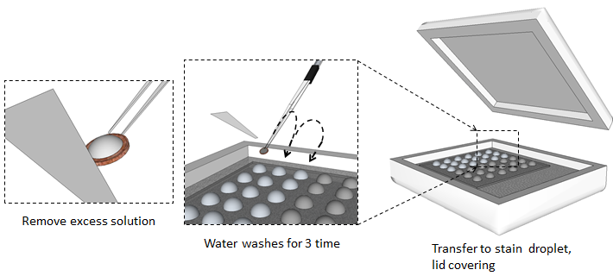P5 – Show the upper left image first then zoom into to show upper right. Then fade to lower right set of six images.
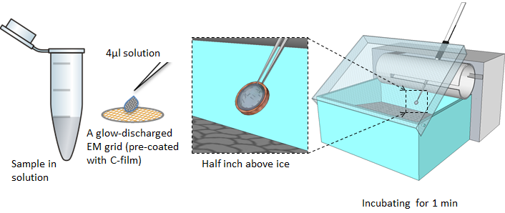
(P4)

(P2)
(P1)
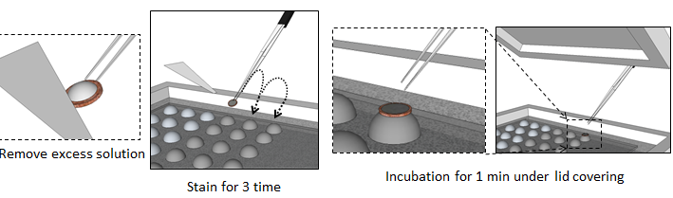
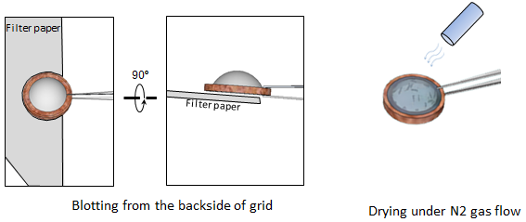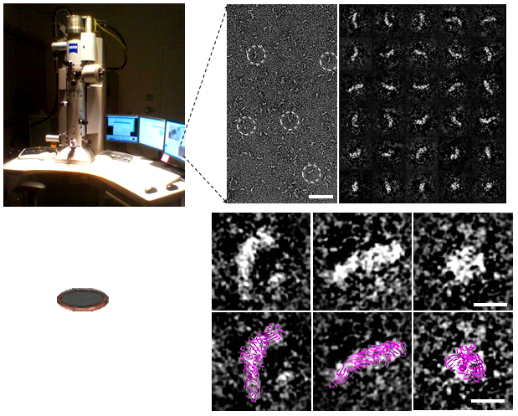

(P3)

(P5)
- Introductory Interview (spoken by you on camera. Don’t forget to smile!)
  - Gang Ren: The main advantages of this technique over cryo-electron microscopy is that it allow for high-throughput examination and high-contrast imaging of small and asymmetric protein structures, while reducing the structural artifacts from conventional negative staining.
  - Yadong Yu: Though this method can provide insight into the structural basis of small protein mechanisms, like the cholesteryl ester transfer protein, it can also be applied to other proteins, such as IgG1 antibody, high-density lipoprotein, GroEL and protesome which vary widely in size.
  - Matthew Rames: Visual demonstration of this method is critical, as the washing and staining steps are difficult to learn, because variation in timing, and even sample blotting, can cause dramatic effects in the finished stained protein.
  - Gang Ren : Demonstrating the procedure will be Meng Zhang, a research fellow from my laboratory.

Protocol Chapters (read by a voice talent at JoVE):

- Preparations
  - When preparing for this protocol it is necessary to make 1% Uranyl formate solution with utmost attention paid to minimizing its exposure to light. This includes wrapping the syringe and 0.2 micron filter parts in foil when it is time to first filter the solution.
    - WID: dissolving the Uranyl formate solution, wrapped container
    - MED: wrapping the syringe and loading
    - MED: wrapped filter and setting up filtration
  - After filtering, store two milliliter, foil-wrapped vial aliquots at negative 80 degrees Celsius.
    - MED: collecting filtrate to wrapped vials
  - On the day of the experiment, thaw an aliquot in a room temperature water bath.
    - WID: talent arrives to bench with aliquot of foil-wrapped Uranyl formate working solution, puts it into the water bath
  - Once completely thawed, filter it again through a 0.02 micron filter with parts wrapped in foil. The collection vial should also be wrapped in foil.
    - MED: loading the aliquot into a wrapped syringe
    - CU: filtering the aliquot through wrapped filter into a wrapped collection vial
  - Transfer the negative-stain to an ice box, until it is used.
    - MED: capping and transferring wrapped collection vial to an ice box, covering lid
  - Make a droplet-holding sheet by pressing an 8 inch length of Parafilm onto a pipet tip supporter. This makes rowed indentations that serve as 5-millimeter diameter wells.
    - MED: cutting a length of Parafilm
    - CU: pressing Parafilm onto rack and showing the row of indentations
  - After making six rows of wells, flatten the ice on the surface of a Styrofoam tray. Then, position the sheet onto the ice.
    - MED: flattening ice in tray
    - CU: setting sheet of Parafilm with six rows of indentations onto the ice
  - Next, add 35 microliters of DI water into the first three wells of the sheet, on the left side.
    - MED: loading pipette with water
    - CU: depositing water onto indentations on left side
  - Then, load the three right wells in the sheet with 35 microliters of the prepared negative-stain solution. Cover the tray to minimize light exposure to the solution. This will serve as a staining station.
    - MED: loading pipette with neg. stain solution
    - CU: loading other indentations/wells with neg. stain solution
    - MED: covering up the ice tray
  - Now, prepare an EM-grid incubation station from an empty pipette-tip box (TEXT: 4” x 6” x 3”) with an attachment onto which tweezers can be mounted.
    - CU: assembling the incubation station
    - CU: demonstrating how tweezers can be mounted
  - Fill the box half-way with ice, so that the ice surface is close to the tip of the tweezers when they are mounted.
    - MED: loading the box up with ice
    - CU: setting the tweezers in position and showing that their tip is just above the ice
- Optimized Negative-Staining
  - First, glow-discharge the thin, carbon-coated, 300-mesh, copper EM grids for about 10 seconds.
    - WID: setting up grids for glow-discharging
      - [added] CU: showing grid transfer
    - MED: running the glow-discharge for 10 seconds
  - Next, pick up a grid with tweezers that hook onto the EM-grid incubation station.
    - CU: picking up a grid with tweezers
  - Hang the tweezers with grid so the grid is at a 45-degree tilt, a half inch above the ice.
    - MED: positioning tweezers onto hanger
    - CU: showing grid above ice, held by tweezer
  - Now, dilute the protein sample in DPBS at 50 to 100 micrograms of protein per milliliter solution. Immediately apply about 4 microliters of the dilution to the EM grid. Allow the sample to incubate for about a minute. (TEXT: DPBS can be substituted, if necessary.)
    - MED: making protein dilution in DPBS
    - MED: taking aliquot of dilution with pipette
    - CU/ECU: applying droplet onto grid held by tweezers, over ice
  - After one minute, quickly dab the mesh with filter paper to remove excess solution and, then, at the staining station, touch the mesh to the first drop of water on the Parafilm.
    - MED: removing tweezers from mount
    - ECU: dabbing the mesh with paper

3.5.3-3.8.1. This section of the protocol happens much faster than the time it takes to describe it, and corresponding shots in this section all continue to the beginning of 3.8.2, because this step must be completed quickly. Ideally this repeated footage at different angles and starting points can visually portray this section
    - CU: dipping the mesh into drop of water
  - Quickly repeat the process of drying the filter and rewetting it with the next droplet. Use a total of three water droplets and do this as quickly as possible. (TEXT: For samples that are very sensitive to water, skip these washes.)
    - CU: dabbing grid with filter paper then setting in next drop of water
    - ECU: as above, closer angle
  - Yadong Yu: Washing the grid with water must be done rapidly to avoid adverse effects of buffer change to the protein.
    - MED/WID: interview at bench
  - After dabbing off the last wash, within three seconds start floating the grid on the first drop of negative-staining solution. Let it float there for 10 seconds.
    - CU: dabbing off last water wash and setting the grid on negative stain drop
    - ECU: grid on staining solution droplet
  - Meanwhile, clean the tweezers by pressing the tips into filter paper a few times.
    - CU: cleaning the tweezers on filter paper, pressing in tips a few times
  - After the 10 second float, blot off the solution with filter paper and start another float in the next droplet of stain for 2 seconds. Clean the tweezers during the two seconds.
    - CU: picking grid off droplet of stain and drying with paper
    - ECU: setting grid on second droplet of stain for 2 secs (cleaning the tweezers briefly) and then lifting it off
  - Next, blot the grid dry and put it onto the third droplet for a full minute. Cover the staining station during this step.
    - CU: picking grid off second droplet of stain and drying with paper
    - MED: setting grid on third droplet of stain and covering the staining station
  - Matthew Rames: Removing the stain must be done by touching the backside of the EM grid for a precise amount of time to ensure the grid is dried evenly. If the filter paper touches the stain too long, then too much stain could be removed leading to poor imaging.
    - MED/WID: interview at bench

3.12.1.1 [added] to cover the second half of Matthew Rames interview at bench
    - ECU: another demonstration by Matthew of how to blot off the stain
  - Next, proceed with drying the grid. First, touch the entire non-carbon side to the filter paper until the solution transfers off. Second, apply a gentle stream of nitrogen gas.
    - MED: removes grid from last stain drop and prepares to dry
    - ECU: blotting off stain
    - MED: applying nitrogen gas to grid
  - Now, transfer the grid to a dish lined with filter paper and partially cover the dish. Allow the grid to dry in the dish for 30 minutes, at room temperature.
    - CU: setting the grid in a filter-paper line dish, then partially covering dish
    - MED: talent starts a timer and walks away
  - Alternatively, lipid-containing samples can be baked at 40 ºC for an hour.
    - MED: loading sample into oven and starting a timer
  - Once fully dried, transfer the EM grid to an EM grid storage box.
    - CU: removing grid from dish and setting it into a storage box
- EM-Grid Analysis
  - Before beginning, first align the TEM. Check the resolution of the highest visible Thon-ring with the power-spectrum of a carbon-film area of the negatively stained grid, which should be better than the targeted resolution.
    - WID: talent arriving to TEM
    - CU: loading carbon film an EM grid. to view Thon-rings
    - SCREEN CAPTURE: resolving the Thon-ring (video of the TEM screen was obtained instead of a screen capture program)

Authors, if a screen capture is not available from the TEM, the videographer can film the screen used to view the sample. If this is not how your TEM operates (if there is only an ocular view) then we will use standard image (as Fig 5 and Fig 6).
    - MED: talent adjusting focus, look
  - Then, to adjust the alignment, carefully check the power-spectrum on the carbon film area of the specimen.
    - MED: adjusting TEM conditions to check the power-spectrum on the carbon film area of the specimen
  - Under a properly aligned condition, more than 20 Thon-rings can be visualized, which corresponds to visualization better than five angstroms. The rings were made by Fourier transfer of an amorphous carbon image under a defocus of 1.6 microns and a dose of 20.4 electrons per square-angstrom.
    - LAB MEDIA: Fig 5
  - Now, bring the focus back to a near Sherzer-focus condition, ~0.1μm for small proteins imaging during examination of the EM grid.
    - MED: adjusting to focus back to Sherzer-focus conditions

4.4.1.1[added] screen image of comparison
    - CU: changing specimen to EM grid finding an ideal area of the specimen where the protein particles and stain are well distributed
  - Ideally, stained areas are usually near the edge of thicker stained “cloudy” areas at low magnification.
    - LAB MEDIA: Fig 6

SCREEN CAPTURES: Authors, if we are going to show how techniques are performed on computers, you will be asked to make movie files of the software in use. Filming screens from a video camera often results in artifacts due to the screen refresh. Screen capture software, which is very affordable and probably available on all platforms, can be used to make full screen resolution movie files of any screen output sequence. More details on software options can be provided, if you need them.
When you get the final script, and a shot is listed a “SCREEN CAPTURE” you will need to make a movie file of the actions required. Make exactly one file per requested SCREEN CAPTURE containing only the requested actions. Do not bundle several action sequences into one large file. Name the file according to the shot number. Then, upload each of these files to your project folder.
- Examples of Optimized Negative-Staining (OpNS)
  - The structure of lipoprotein specimens were viewed with OpNS. Examples include recombinant HDL …
    - LAB MEDIA: Fig 2C
    - LAB MEDIA: Fig 2D
  - … human plasma LDL …
    - LAB MEDIA: Fig 2H
  - … human plasma IDL …
    - LAB MEDIA: Fig 2I
  - … and human plasma VLDL.
    - LAB MEDIA: Fig 2J
  - Smaller structures, like 53 kiloDalton CETP were also viewed. This is one of the smallest proteins successfully imaged by EM.
    - LAB MEDIA: Fig 3A
    - LAB MEDIA: Fig 3B
    - LAB MEDIA: Fig 3C – left panel

Video editor: these three are progressive levels of resolution
  - Superimposition of the CETP crystal structure matches the image very well.
    - LAB MEDIA: Fig 3D
  - Very dynamic, heterogeneous proteins were also viewed. In 160 kiloDalton Immunoglobin G antibodies, three subdomains were clearly visible.
    - LAB MEDIA: Fig 4A
  - Closer examination of the IgG1 antibody was used to make a comparison to its crystal structure.
    - LAB MEDIA: Fig 4B – 1st example molecule
    - LAB MEDIA: Fig 4B – 2nd example molecule
  - The crystal structure of the IgG1 antibody matches with the EM view of these antibodies in many ways, such as in the domain positions and their shapes.
    - LAB MEDIA: Fig 4D
  - Other viewed molecules include 28 kiloDalton lipid-free apolipoprotein A-1 …
    - LAB MEDIA: Fig. 2L
  - … GroEL …
    - LAB MEDIA: Fig. 2M
  - … and Proteasomes. Essentially, the OpNS method significantly advances the boundary of EM imaging for small, asymmetric structures as well as associated mechanistic studies.
    - LAB MEDIA: Fig. 2N

- Conclusion Interview (spoken by you on camera)

  - Matthew Rames: While attempting this procedure, it’s important to remember to reduce light exposure to the stain reagent as much as possible, to quickly wash the specimen and to use near Scherzer-focus for imaging.
  - Yadong Yu: Following this procedure, other methods like electron tomography can be performed in order to answer additional questions like the nanometer resolution structures of single molecules and the conformational changes among them.
  - Gang Ren: After its development, this technique paved the way for researchers in the field of structural biology to explore the mechanism of cholesteryl ester transfer among the human plasma lipoproteins.

List of Provided Media Filenames and Descriptions (fill this in)

5.1.1._LAB MEDIA_Fig_2C.tif – micrograph and selected particles for 8.4nm rHDL bar: 50nm

5.1.2._LAB MEDIA_Fig_2D.tif – micrograph and selected particles for 9.6nm rHDL bar: 50nm

5.2.1._LAB MEDIA_Fig_2H.tif – micrograph and selected particles for human plasma LDL bar: 50nm

5.3.1._LAB MEDIA_Fig_2I.tif – micrograph and selected particles for human plasma IDL bar: 50nm

5.4.1._LAB MEDIA_Fig_2J.tif – micrograph and selected particles for human plasma VLDL bar: 50nm

5.5.1._LAB MEDIA_Fig_3A.tif – overview micrograph with CETP (dashed circles) bar: 50nm

5.5.2._LAB MEDIA_Fig_3B.tif – windowed select raw particles bar: 10nm

5.5.3._LAB MEDIA_Fig_3C.tif – single raw CETP particle bar: 10nm

5.6.1._LAB MEDIA_Fig_3D.tif – superimposing crystal structure comparison bar: 10nm

5.7.1._LAB MEDIA_Fig_4A.tif – overview micrograph of IgG1 antibody (clear particles circled)

5.8.1._LAB MEDIA_Fig_4B-1st.tif – Individual unconjugated antibody #1

5.8.2._LAB MEDIA_Fig_4B-2nd.tif – Individual unconjugated antibody #2

5.9.1._LAB MEDIA_Fig_4D.tif – crystal structure comparison for both 4B antibodies

5.10.1._LAB MEDIA_Fig_2L.tif – micrograph and selected particles for lipid-free apoA-I bar: 50nm

5.11.1._LAB MEDIA_Fig_2M.tif – micrograph and selected particles for GroEL bar: 50nm

5.12.1._LAB MEDIA_Fig_2N.tif – micrograph and selected particles for Proteasome bar: 50nm

General Preparation

It’s critical for a smooth and organized shoot that all reagents are accounted for, in advance.

Any overnight or long incubation steps should be recognized and specimens/samples be prepared in advance so that prior steps can be recorded and shooting can continue with pre-prepared specimens/samples.

All tubes/flasks should be pre-labeled neatly before we arrive.

Ex. Luciferase assay done in 96 well plates should be labeled with negative/positive control wells and experimental samples are labeled accordingly.

