Holographic imaging of nanometric vibrations

Authors
Francois Bruno, Nicolas Verrier, Michael Atlan
Institut Langevin. Fondation Pierre-Gilles de Gennes. Centre National de la Recherche Scientifique (CNRS) UMR 7587, Institut National de la Santé et de la Recherche Médicale (INSERM) U 979, Université Pierre et Marie Curie (UPMC), Université Paris 7. Ecole Supérieure de Physique et de Chimie Industrielles - 1 rue Jussieu. 75005 Paris. France
Corresponding author
Michael Atlan, michael.atlan@espci.fr

Keywords
laser Doppler, holography, vibrometry, optical imaging. Imaging. Nanometer. Non destructive testing.
Short Abstract
We report video-rate imaging of surface acoustic waves. Narrowband frequency-tunable detection is performed by time-averaged heterodyne holographic interferometry. Image rendering is made numerically. This method enables robust and quantitative mapping of out-of-plane vibrations of nanometric amplitudes at radiofrequencies.
Abstract
We report quantitative video-rate optical imaging of out-of-plane surface vibrations of nanometric magnitude with a parallel laser Doppler measurement scheme on a sensor array. Our approach is based on time-averaged heterodyne holography in off-axis and frequency-shifting conditions.
Small sinusoidal optical phase modulations are recorded and imaged with a frame exposure time much longer than the modulation period by time-averaged holography, which enables narrowband detection with a high spectral resolution. In practice, sinusoidal out-of-plane surface motion generates side bands at the harmonics of the modulation frequency in the radiofrequency spectrum of the reflected laser beam.
The heterodyne detection variant of time-averaged holography benefits from a frequency-shifted optical local oscillator to shift the first optical modulation sideband within the temporal bandwidth of the sensor, which increases the detection sensitivity - a requirement for optical screening of surface waves of nanometer magnitudes at radiofrequencies.
Robust measurements of small vibration amplitudes can be achieved in experimental conditions by forming the amplitude ratio of the first modulation side band and the non-shifted band. For that purpose, a coherent frequency-division multiplexing technique with a dual local oscillator to measure both sidebands simultaneously is used. This method enables quantitative mapping of local optical path length modulation depths.
The proposed imaging technique is single-frequency (i.e. narrowband), but tunable throughout the bandwidth of the acousto-optic modulators used for optical frequency modulation. Experimental images of out-of-plane mechanical vibration amplitudes versus excitation at audio frequencies are reported, showing the frequency response of a musical box in a sympathetic resonance regime. Maps of steady-state surface acoustic waves on a thin metal plate at ultrasound frequencies in the kilohertz range are also presented.
Introduction
Non-destructive testing, in which it is proposed to verify the integrity of structures without damaging the sample, is of increasing importance in many industrial fields. In aeronautics, for instance, the safety of flying machines must be regularly reviewed to avoid accidents, by thorough screening of cracks, the precursors of potential structural failures. In particular, plates are present in many industrial sectors, such as aerospace, civil engineering, and coatings. A common screening technique consists in the generation of acoustic waves in the material and their detection. Laser Doppler interferometric methods are often used for non-contact measurements of such mechanical vibrations. These optical probing methods exhibit high reliability and enable either narrowband or wideband single point vibration measurements [1-4]. However, imaging requires time-consuming scanning of the tested sample [5]. Full-field measurements of out-of-plane mechanical vibrations are permitted by time-averaged homodyne [6-8] or heterodyne [9-12] holographic recordings in an off-axis configuration. Time-averaged holography occurs when a phase-modulated optical field is recorded with a much longer exposure time than the modulation period. Optical heterodyning, a frequency-conversion process aimed at shifting a given radiofrequency optical side band in the sensor bandwidth, is performed with an off-axis and frequency-shifted optical local oscillator. Quantitative measurements of vibration amplitudes that are much smaller than the optical wavelength were achieved with holography, by sequential measurements of the first optical side band and the non-shifted light component [12].
To improve the robustness of quantitative laser vibrometry, time-averaged heterodyne holography in a frequency-division multiplexing regime was proposed [13, 14]. The originality of the reported scheme is to make use of a multiplexed local oscillator to address several optical side bands into the temporal bandwidth of the sensor array. It enables simultaneous recording and pixel-to-pixel division of two side band holograms, which permits quantitative mapping of the modulation of local optical path lengths at a given frequency. By combining two LOs, both the fundamental and the first-order optical side bands can be recorded simultaneously (figure 6). This approach has its roots in frequency-division multiplexing [15], a technique by which the total bandwidth available is divided into non-overlapping frequency sub-bands, each of which is used to carry a separate signal. The proposed method is shown to be suitable for the detection of the complex ratio of modulated light side bands, which permits narrowband vibration imaging at nanometer scales at video rates.

Protocol
- Design of the frequency-shifted holographic interferometer. The purpose of this step is to describe the optical apparatus used for the vibrometry experiments.
  - Build a Mach-Zehnder interferometer (Figure 3) to perform the measurement of optical holograms. Mirrors mounted on tilt platforms are used when necessary to create optical paths.
  - Use a long coherence length laser to provide the main optical beam. Eg. a 150 mW, single-mode laser (wavelength = 532 nm, Cobolt Samba-TFB-150).
  - Use a beamsplitter cube to separate the reference beam from the illumination beam. Ninety percent of the optical power goes to the object channel, while ten percent goes to the reference (local oscillator, LO) channel. Send both beams into single mode fibers to facilitate the tuning of the object and reference beams.
  - Introduce a set of two acousto-optic modulators – or Bragg cells (AA-electronics, MT200-BG9-532-FIO-SM) in the reference channel to shift the optical frequency of the LO beam. The optical frequency of the LO beam is shifted by the difference between the driving frequencies of the acousto-optic modulators by selecting alternate diffraction orders (orders +/-1 in Figure 3). Radio frequency electrical signals sent to the acousto-optic modulators are amplified by two broadband amplifiers (Minicircuits ZHL-1A).
  - Illuminate the object with the laser beam in wide field. Attach a piezo-electric actuator (PZT, Thorlabs AE0505D08F) to the object to induce vibrations.
  - Make use of a beamsplitter cube (Edmund #47-571) to combine the backscattered object beam (in reflective geometry) with the frequency-shifted LO beam. The beams propagation axes must exhibit a small angle of about 1 degree to ensure off-axis configuration and hence appropriate spatial modulation of the signal (figure 3, figure 5).
  - Use the bare (lensless) sensor array of a camera to detect the interference pattern of the LO beam beating against the diffracted object beam. The camera used for detection is an Andor IXON 885+ EMCCD.
- Generation of the radiofrequency electrical signals used to drive the acousto-optic modulators, the piezo-electric actuator used as acoustic wave source, and to set the camera frame rate.
  - All frequency synthesizers (or alternatively arbitrary function generators, such as Agilent 33250A Function / Arbitrary Waveform Generator, 80 MHz or Tektronix AFG3000C) must be phased-locked to avoid phase drifts. Lock the synthesizers with a 10 MHz signal provided by a quartz clock (10 MHz Streamline Crystal Oscillator, Wenzel), used as input reference.
  - Five synthesizers are used in these experiments. Each of them provides a sine wave at angular frequencies ω_{S} (20 Hz), ω (DC to 1 MHz), ω_{C} (200 MHz), ω_{C} – ω_{S}/4 (200 MHz – 5 Hz), and ω_{C} + ω + ω_{S}/4 (200 MHz + 1kHz + 5 Hz). 200 MHz is the peak frequency response of the acousto-optic modulators used to shift the optical frequency of the laser beam.
  - Use the TTL signal oscillating at ω_{S} (20 Hz) to trigger the camera readout rate.
  - Use the signal oscillating at ω (tunable from DC to 1 MHz) to drive the piezo-electric actuator to shake the object and generate surface acoustic waves.
  - Use the signal oscillating at the carrier frequency ω_{C} (200 MHz) to drive one acousto-optic modulator. Select the diffracted beam of order -1.
  - Combine the signals at ω_{C} – ω_{S}/4 and ω_{C} + ω + ω_{S}/4 with an RF power splitter/combiner (Minicircuits ZFSC-4-3). Use the resulting signal to drive the other acousto-optic modulator. Select the diffracted beam of order +1. Hence a part of the laser wave passing through the successive modulators is detuned by -5 Hz. The other part is detuned by the piezo-electric actuator’s frequency plus 5 Hz.
- Hologram recording, numerical image rendering and signal processing.
  - Record interferograms in a lensless configuration: the camera lens should be removed (Figure 4). Both the amplitude and the phase of the optical field scattered from the object are measured from the beating of the diffracted object beam against a reference beam. The frequency shift of the LO beam and the tilt between the object and the reference beam provokes temporal and spatial modulation of the interference pattern recorded by the camera. This double modulation (Figure 5, [16]) permits imaging with a photon-noise-limited sensitivity in low-light conditions [17].
  - Image rendering is made numerically, with a deterministic light propagation algorithm. Instead of a physical lens, image formation relies on calculations. In one of its simplest forms, the numerical propagation of the optical field from the sensor array to the image plane is performed with a discrete Fourier transform of the recorded optical field multiplied by a quadratic phase factor depending on one reconstruction parameter (the focus distance); this procedure is well-documented [18]. This image rendering method is suited to macroscopic imaging of objects located more than a few centimeters away from the sensor.
  - Manual numerical focus is performed. The focus distance parameter is determined experimentally by assessing the quality of the rendered image. When found, this parameter is kept constant throughout the experiment.
  - Measure complex-valued holograms of both light components at – 5 Hz and + 5 Hz in the beating frequency spectrum of a sequence of 4 successive interferograms, via a discrete Fourier transform. The LO formed with a dual frequency signal is used to down-convert, simultaneously, two optical modulation sidebands within the camera bandwidth. Divide the two complex holograms pixel-by-pixel, yielding a quantitative map of the local optical path length modulation at the excitation frequency ω.
- Vibrometry experiments. They consist of finding the resonance frequencies of the objects under investigation by sweeping ω, appearing in the piezo-electric actuator’s and the LO beam frequencies.
  - The out-of-plane nanometric vibration maps of two objects are investigated. Both objects are excited with a piezo-electric actuator driven sinusoidally.
  - Place a thin metal plate in the object channel. Sweep the excitation and LO detuning frequencies accordingly, via ω. The voltage of the actuator should be about 1V to 10V. Under these conditions, the plate builds up steady-state out-of-plane vibration modes of nanometric amplitude, observed in the kilo Hertz to Mega Hertz range (Figure 1).
  - Place the lamellophone of a standard musical box in the object channel. Sweep the excitation and LO detuning frequencies accordingly, via ω. The voltage of the actuator should be about 10 mV to 100 mV. Sympathetic flexural responses of individual cantilevers should be observed at nanometric scales, from 500 Hz to 2000 Hz (Figure 2).

Representative Results
Experimental images of surface acoustic waves on metallic objects were sought. The amplitude of the out-of-plane vibrations of a metal plate is measured for different excitation frequencies, yielding its contour modes (Figure 1). We swept the excitation and LO detuning frequencies accordingly, via ω, from 127 kHz to 152 kHz (video). The voltage of the actuator was chosen to ensure constant vibration amplitudes of about a few nanometers throughout the frequency range. Under these conditions, the plate builds up steady-state out-of-plane vibration modes of nanometric amplitude, observed in Figure 1.
A quantitative characterization of the out-of-plane vibration of the lamellophone of a musical box was performed. Excitation of the lamellophone in sympathetic resonance regime, was excited by the piezo electric actuator. Sympathetic vibration is a harmonic phenomenon according to which a vibratory body responds to external vibrations in the neighborhood of a resonance frequency. Spectra of the out-of-plane vibration amplitude versus excitation at audio frequencies show resonances of the flexural responses of individual cantilevers. Flexural responses of individual cantilevers are observed from 500 Hz to 2000 Hz (Figure 2 and video). Playing-back the original song of the musical box, “Ménilmontant” by Charles Trénet, provokes sequential cantilevers flexural responses, which are imaged at video rate (video).
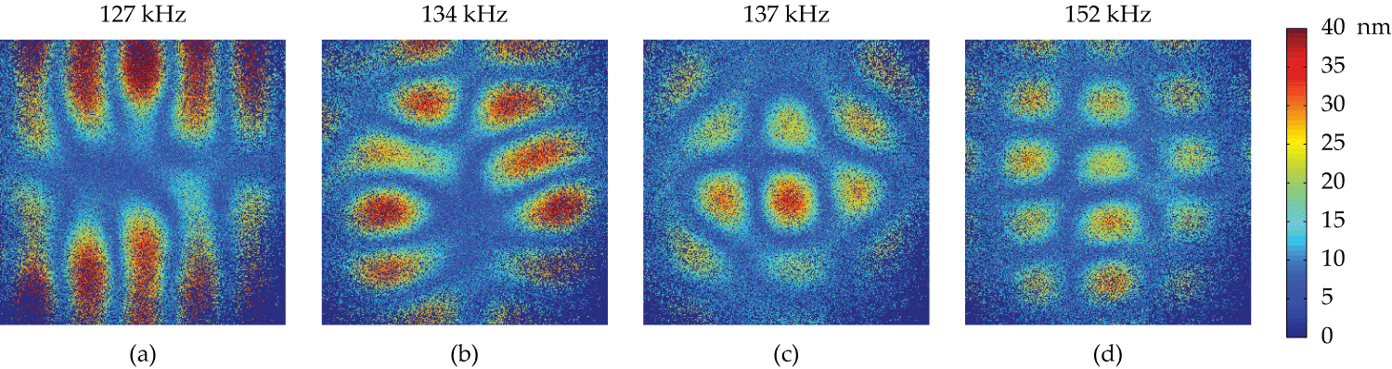
Figure 1 : Amplitude of the out-of-plane vibration of the metal plate versus excitation frequency.
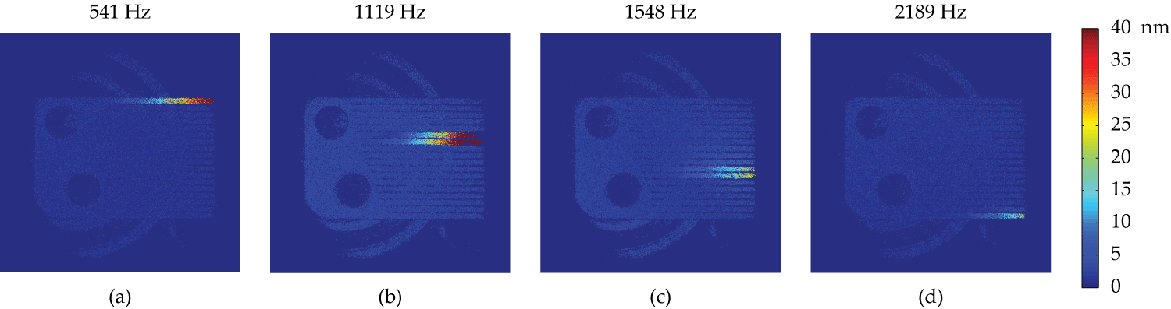
Figure 2 : Amplitude of the out-of-plane flexural responses of the cantilevers of the metallic comb as a function of the excitation frequency.

Tables and Figures
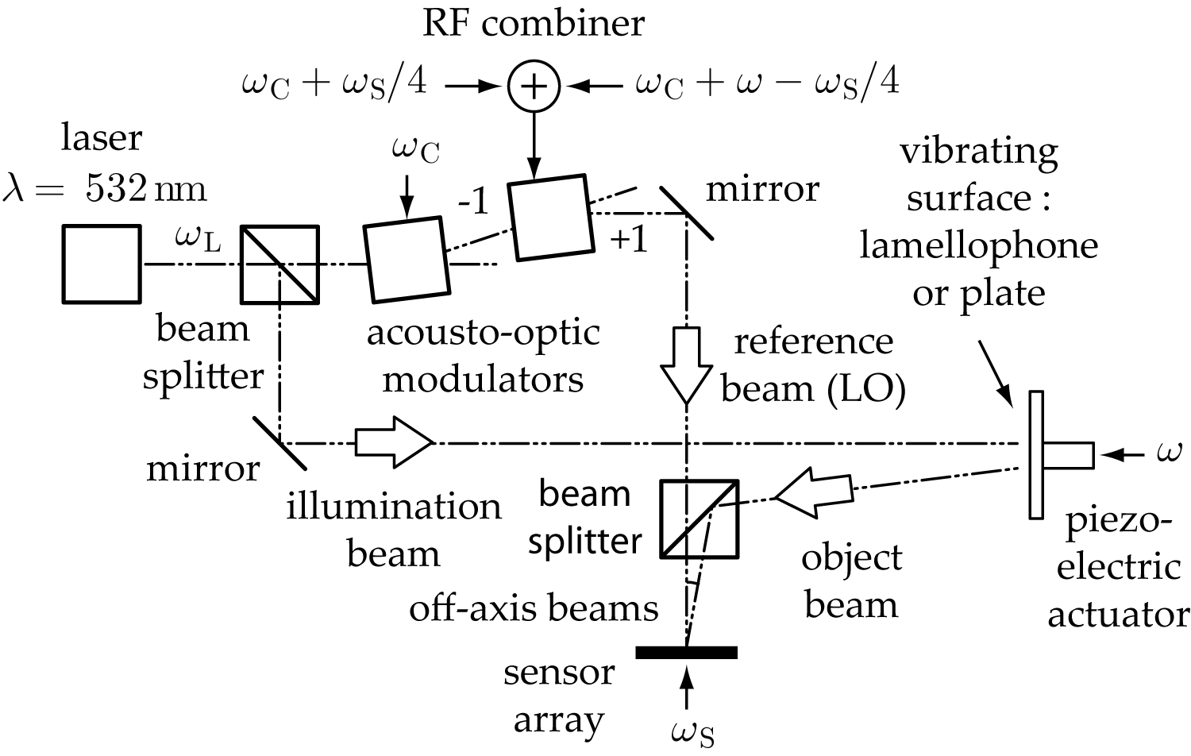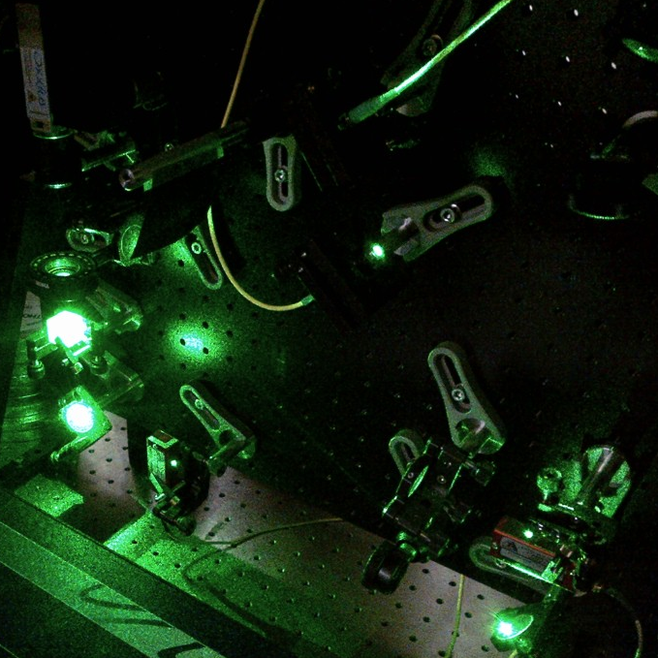
Figure 3 : Sketch of the experiment (left); picture of the frequency-tunable Mach-Zehnder interferometer (right).
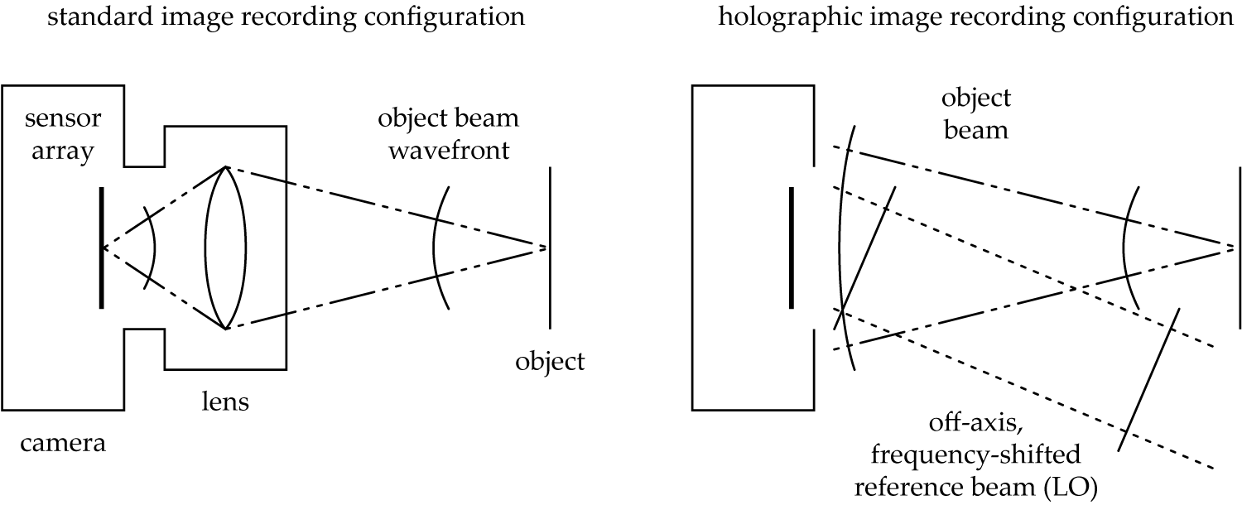
Figure 4 : standard image recording (left) versus lensless hologram recording (right).

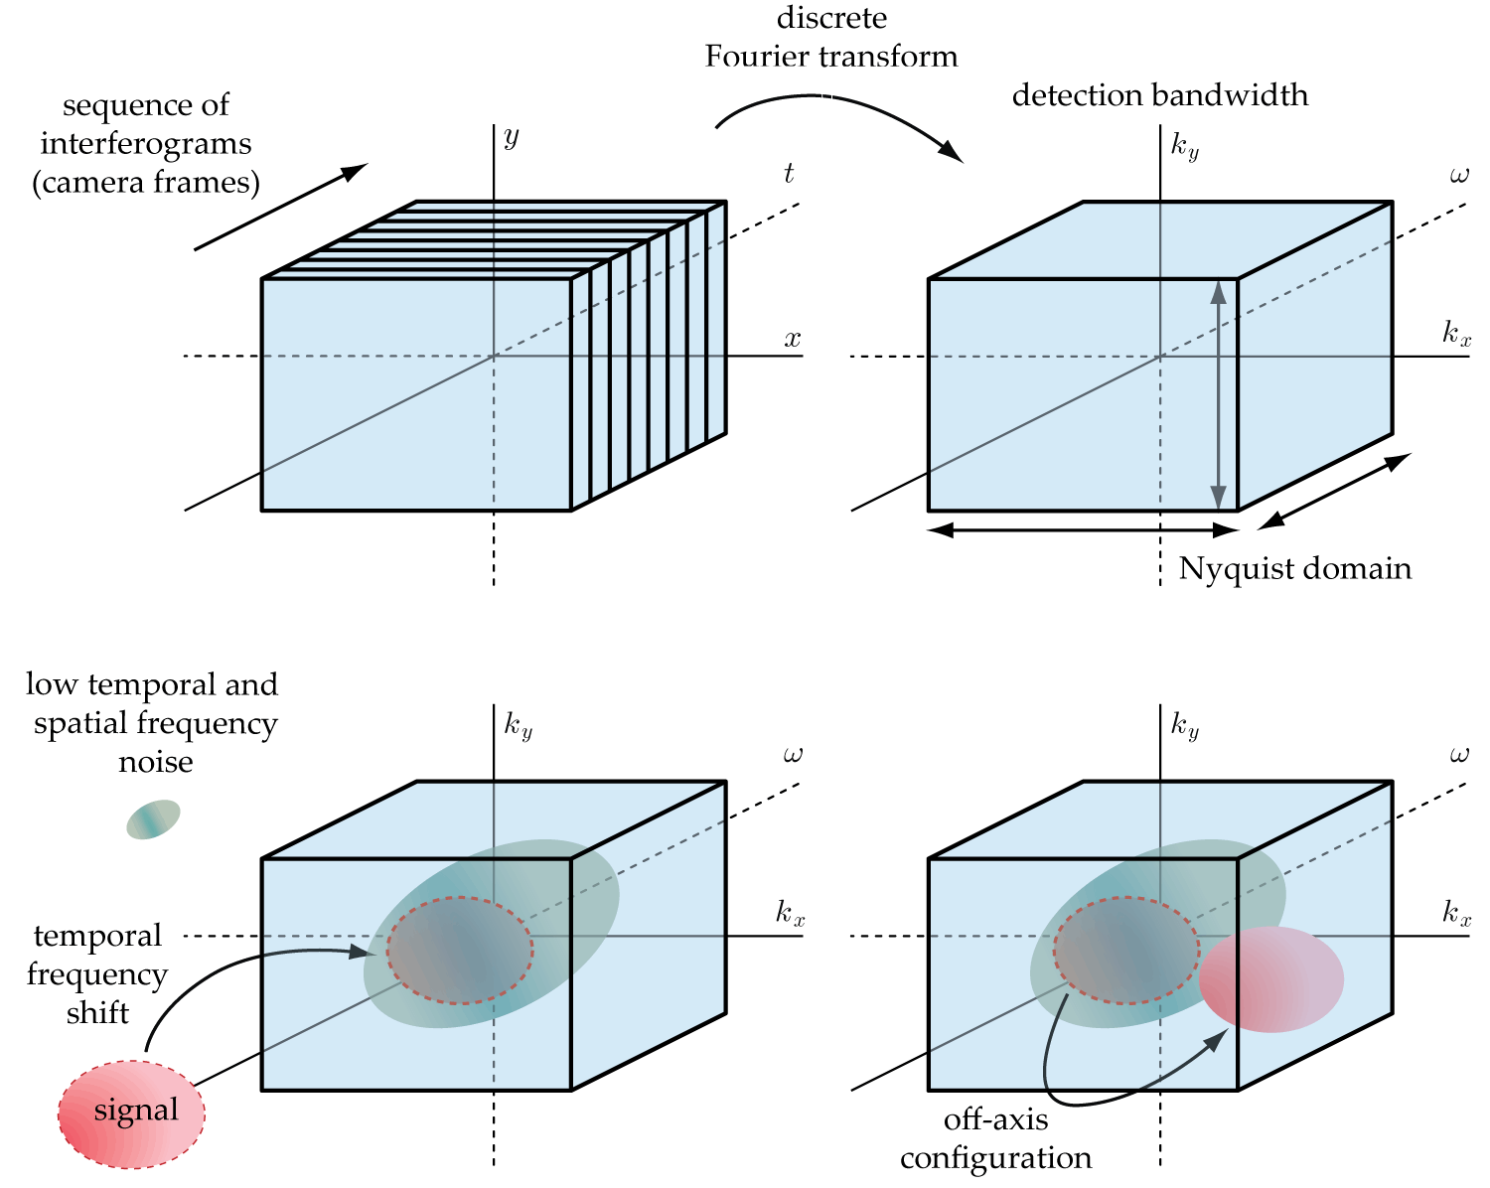
Figure 5 : Spatial and temporal signal modulation to achieve high sensitivity measurements.
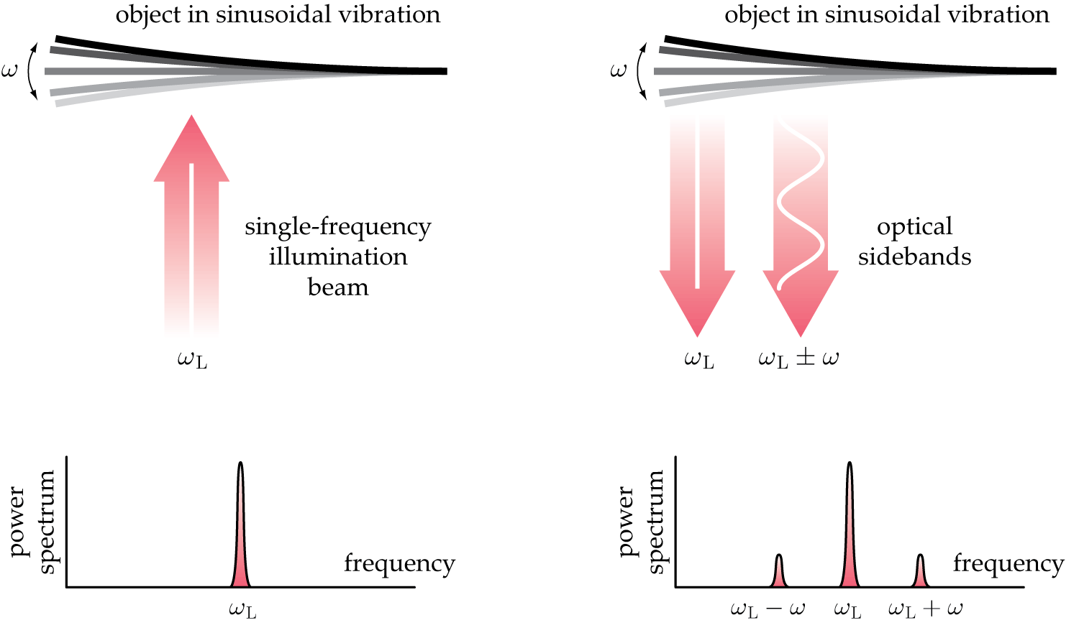
Figure 6 : Generation of optical sidebands by sinusoidal path length modulation.

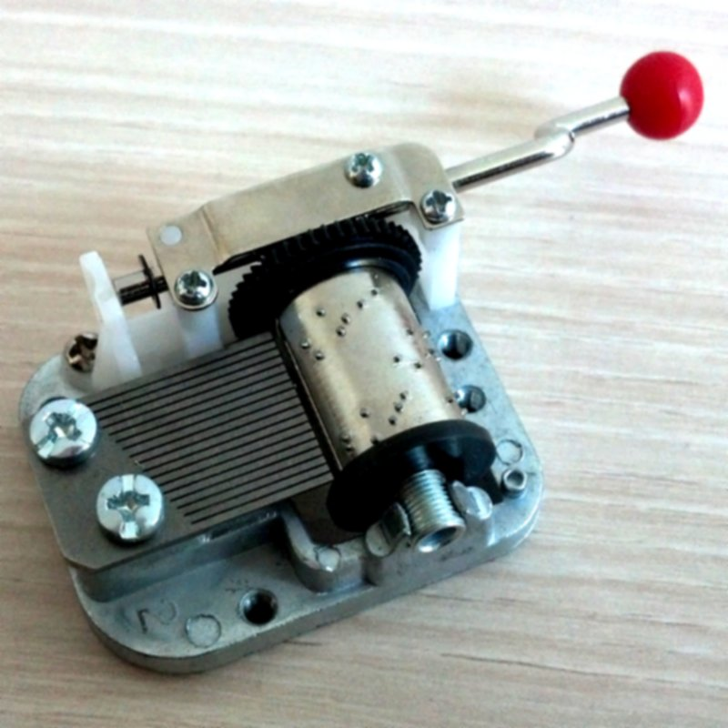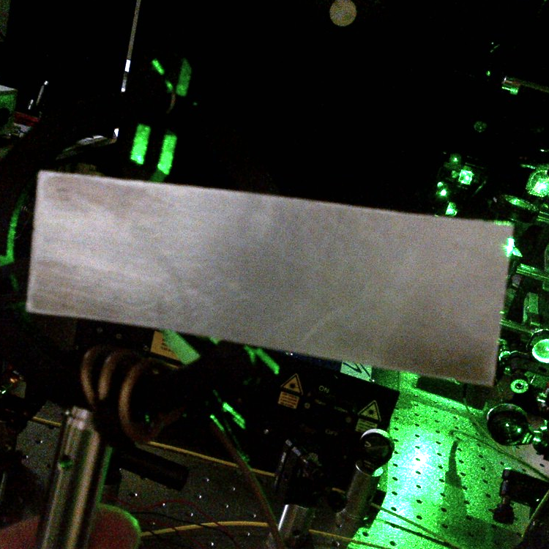
Figure 7 : Objects under investigation. Lamellophone of a musical box drum (left). Metal plate (right).
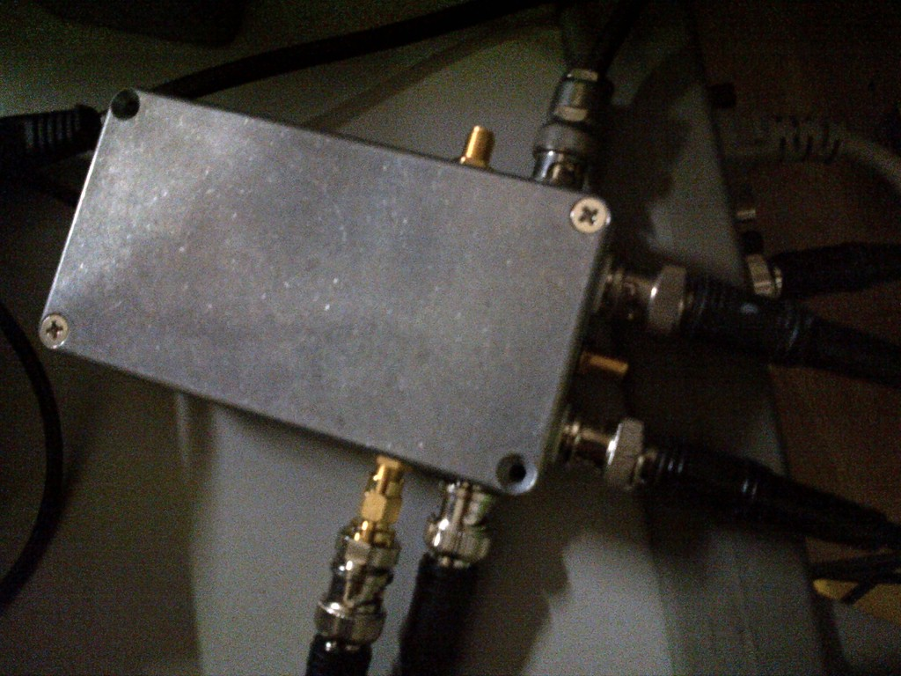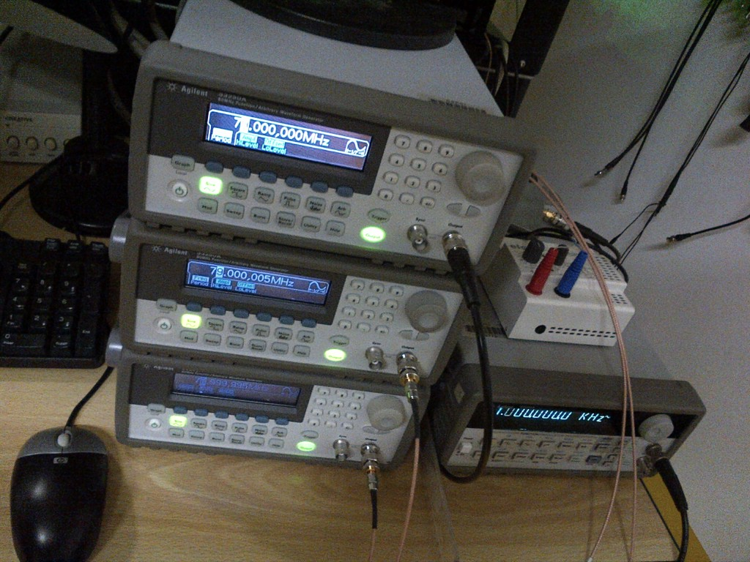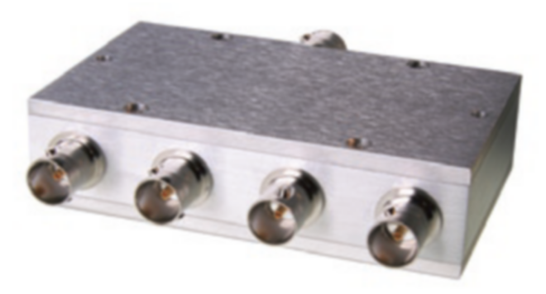
Figure 8 : The generation of radiofrequency signals is performed with a 10 MHz reference clock (a), frequency synthesizers (b) a power splitter/combiner (Minicircuits ZB4PD1-500-75) (d).
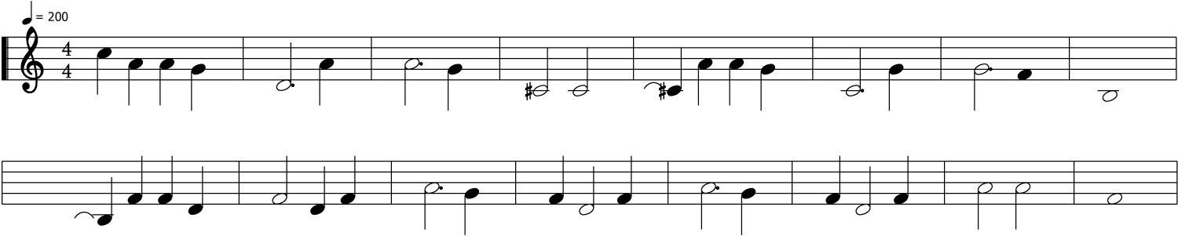
Figure 9 : Partition of the music tune “Ménilmontant” by Charles Trénet.
Pitch | A | Bb | B | C | C# | D | Eb | E | F | F# | G | G#
Octave 5 (Hz) |  |  |  | 1046.50 | 1108.73 | 1174.66 | 1244.51 | 1318.51 | 1396.91 | 1479.98 | 1568.00 | 1661.22
Octave 6 (Hz) | 1760.00 | 1864.66 | 1975.53
Table 1: Frequency gamut of the fifth and sixth octaves pitches used to induce sympathetic flexural responses of the lamellophone.

Discussion
The reported protocol enables robust and quantitative imaging of out-of-plane vibrations with a laser and a camera. Quantitative images of narrowband vibrations are achieved at video rate. The range of measurement frequencies depends on the optical modulator used in the reference channel to shift the optical frequency. With conventional Bragg cells, this range is about DC - 1 MegaHertz. The measurable vibration amplitude resolution is noise-limited. Nanometer sensitivity is easily achieved in practical conditions.
Future investigations may include:
- High speed/broadband imaging: The reported imaging method is limited to the detection of single frequency vibrations. Transient vibrations are not observable with the presented narrowband time-averaged holographic recording process with long exposure times with respect to the vibration period. Faster readout rates would enable the observation of transient phenomena, and also enable Fourier-transform spectroscopy.
- Imaging of local mechanical phase shifts.
- The dynamic range of vibration amplitudes might be increased by screening higher order sidebands.
- Investigate the method’s applications to the imaging of phenomena inducing small non-linear optical phase modulations.
- Standard scanning laser Doppler vibrometers can achieve wideband radiofrequency measurements but such devices are not adapted to video rate imaging of narrowband (single frequency) vibrations. State-of-the art laser vibrometers enable imaging at a throughput of tens of pixels per second, typically. With the reported method, a throughput of millions of pixels per second can easily be met.

Disclosures
The authors declare that they have no competing financial interests.

Acknowledgments

We gratefully acknowledge support from Fondation Pierre-Gilles de Gennes (FPGG014), Agence Nationale de la Recherche (ANR-09-JCJC-0113, ANR-11-EMMA-046), région Ile-de-France (C'Nano, AIMA), and LABEX WIFI (ANR-10-LABX-24 and ANR-10-IDEX-0001-02 PSL*).

References
[1] Jean-Pierre Monchalin. “Heterodyne interferometric laser probe to measure continuous ultrasonic displacements”. Review of scientific instruments, 56(4):543–546, 1985.
[2] C. Barriere and D. Royer. “Optical measurement of large transient mechanical displacements”. Applied Physics Letters, 79(6):878–880, (2001).
[3] S. Bramhavar, B. Pouet, and T. W. Murray, Applied Physics Letters 94, 114102 (2009).
[4] Kimmo Kokkonen and Matti Kaivola. “Scanning heterodyne laser interferometer for phase-sensitive absolute amplitude measurements of surface vibrations”. Applied Physics Letters, 92(6):063502–063502, 2008.
[5] Christian Rembe and Alexander Drabenstedt. Laser-scanning confocal vibrometer microscope: Theory and experiments. Review of scientific instruments, 77(8):083702–083702, 2006.
[6] R. L. Powell and K. A. Stetson. “Interferometric vibration analysis by wavefront reconstruction”. J. Opt. Soc. Am., 55:1593, 1965.
[7] P. Picart, J. Leval, D. Mounier, and S. Gougeon. “Time-averaged digital holography”. Opt. Lett., 28:1900–1902, 2003.
[8] Giancarlo Pedrini, Wolfgang Osten, and Mikhail E. Gusev. “High-speed digital holographic interferometry for vibration measurement”. Appl. Opt., 45(15):3456–3462, May 2006.
[9] C. C. Aleksoff. “Temporally modulated holography”. Applied Optics, 10:1329–1341, 1971.
[10] M. Ueda, S. Miida, and T. Sato. ”Signal-to-noise ratio and smallest detectable vibration amplitude in frequency-translated holography: an analysis”. Applied Optics, 15(11):2690–2694, 1976.
[11] F. Joud, F. Laloe, M. Atlan, J. Hare, and M. Gross. “Imaging a vibrating object by sideband digital holography”. Opt. Express, 17(4):2774–2779, 2009.
[12] P. Psota, V. Ledl, R. Dolecek, J. Erhart, and V. Kopecky. “Measurement of piezoelectric transformer vibrations by digital holography”. Ultrasonics, Ferroelectrics and Frequency Control, IEEE Transactions on, 59(9):1962–1968, 2012.
[13] Nicolas Verrier and Michael Atlan. "Absolute measurement of small-amplitude vibrations by time-averaged heterodyne holography with a dual local oscillator". Optics Letters, 38(5):739–741, (2013).
[14] Francois Bruno, Jean-Baptiste Laudereau, Max Lesaffre, Nicolas Verrier, Michael Atlan. "Quantitative imaging of nanometric optical path length modulations by time-averaged heterodyne holography in coherent frequency-division multiplexing regime". arXiv:1301.7532.
[15] S. Weinstein and P. Ebert. “Data transmission by frequency-division multiplexing using the discrete Fourier transform”. Communication Technology, IEEE Transactions on, 19(5):628–634, 1971.
[16] Michael Atlan, Michel Gross. "Spatiotemporal heterodyne detection". Journal of the Optical Society of America A. Vol. 24, Issue 9, pp. 2701-2709 (2007).
[17] Michel Gross and Michael Atlan. “Digital holography with ultimate sensitivity”. Optics letters 32 (8), 909-911. (2007).
[18] J. Goodman, “Introduction to Fourier Optics”. Roberts & Company Publishers, (2005).

