Submission ID #: 51058

Editor Name: Renee Choi

Videographer Name: Bill Schweikert

Film Date: 9/13/2013

Authors and Affiliations: Poojitha Sitaram, Sarah G. Hainline, and Laura A. Lee;

Department of Cell and Developmental Biology, Vanderbilt University Medical Center

Title: Cytological Analysis of Spermatogenesis: Live and Fixed Preparations of Drosophila Testes

Corresponding Author:
Laura A. Lee
laura.a.lee@vanderbilt.edu.
Tel no: 615-322-1331

Additional Contacts:
poojitha.sitaram@vanderbilt.edu
sarah.g.hainline@vanderbilt.edu

Authors, please fill out the brief questionnaire below.

A. Will you require JoVE to record video microscopy, such as filming a complex dissection or microinjection technique? (Y/N) ____Y_____ If yes, please list make and model of your microscope: _Zeiss Stemi 2000-CS Dissection microscope with Diagnostic Instruments 0.63X DD63ZNC attachment for camera__
B. Does your protocol include detailed, step-by-step, descriptions of software usage? (Y/N)___N_____
C. Which steps of your protocol will viewers benefit most from having filmed? Please list 4-6 steps__Steps 2.5, 3.2, 3.4, 4.1, 4.2, 4.11___
D. What is the single most difficult aspect of this procedure and what do you do to ensure success? _Step 3.4 of the squashing step is the most difficult to get right for a novice. Success can be ensured with practice and by determining the optimal amount to buffer needed for squashing. ____

1. Introduction (Schematic Overview and Interview)

A. Schematic Overview (read by voice talent at JoVE):
Authors, please select from “Procedural Narrative” or “Conceptual Narrative” and complete the statements below. Please do not add additional steps. Then, attach your finished graphic overview. See accompanying instructions for details and examples.

Procedural Narrative:
The overall goal of this procedure is to _dissect and prepare Drosophila testes for microscopy. (Intro)

This is accomplished by first _dissecting out testes pairs from abdomen of male flies. (P1)

The second step is to _squash the testes to release the cells within and to fix the squashed tissue. (P2)

Next, the _squashed and fixed tissue is incubated in primary and secondary antibodies. (P3)

The final step is _to mount the tissue on a slide. (P4)

Ultimately, _phase contrast or Immunofluorescence microscopy_is used to observe _cells at various stages of spermatogenesis for defects in morphology and to observe the subcellular localizations of various proteins. (P5)

Conceptual Narrative:
The overall goal of the following experiment is to __(insert overall goal here; e.g. observe the effect of your treatment on cell migration using wound healing assays)____. (Intro)

This is achieved by (1st step of protocol e.g. adding NGF to cells) to _(goal of 1st step - e.g. induce cell differentiation)__. (P1)

As a second step, _(insert 2nd step)__, which __(insert goal of 2nd step)_________ . (P2)

Next, __(insert 3rd step)_____in order to___(insert goal of 3rd step)_________. (P3)

Results are obtained that show _(effect of treatment - e.g. differences in protein expression in NGF treated cells_ based on ___(method of analysis - e.g. Western blotting analysis)__. (P4)

Paste a copy of your graphic overview here. The original file should be Adobe Illustrator (preferred) or Powerpoint (see instructions) and should be uploaded through your online submission on the JoVE website. Please keep all layers in the file (i.e., do not flatten the file).

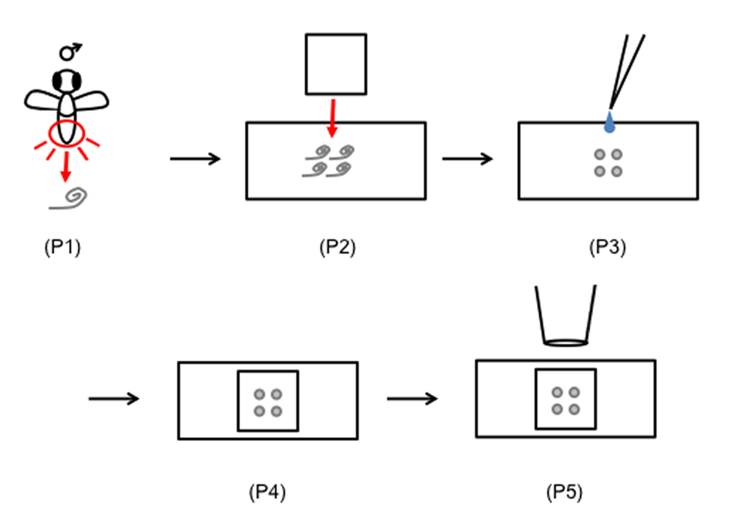
B. Interview: (Said by you on camera. Don’t forget to smile!)

Authors: Below are statements we would like you to complete that are complementary to the information contained within the schematic overview.
- Only one statement should be chosen and completed per author who will be on camera demonstrating the protocol.
- Enter the name of the individual who will say each line.
- Please choose and fill out the statement(s) that convey the most important fact(s) about your protocol. You may revise the given prompts as necessary to improve the sentence flow.
- If any individuals will be doing demonstrations on camera but are not assigned a speaking part in this interview section, please use statement 1.8 to introduce these demonstrators (for example, the PI introduces students)

  - Author name _________: The main advantage of this technique over existing methods, like __________, is that ___________.
  - Author name _Sarah Hainline_: This method can help answer key questions in the _developmental biology_ field, such as _the identification of critical roles played by certain proteins during the progression of spermatogenesis_.
  - Author name _________: The implications of this technique extend toward therapy (or diagnosis) of_______, because ________.
  - Author name ________: Though this method can provide insight into ____________, it can also be applied to other systems (model organisms, studies of disease, organ systems), such as ____________.
  - Author name _______: Generally, individuals new to this method will struggle because ______________.
  - Author name ________: I/We first had the idea for this method, when I/we ___________.
  - Author name _Poojitha Sitaram_: Visual demonstration of the dissection and squashing of Drosophila testes is critical as a novice in this method may initially experience difficulty in finding the testes within the fly abdomen; additionally, it is easier to demonstrate rather than to describe in words the most successful way to perform the squashing of the tissue.
  - **Author name ________: Demonstrating the procedure will be ________ a _______ (technician, post doc, grad student) from my laboratory. (Add additional mention of demonstrators as necessary).
    - Interview style: Author saying the above
    - The named technician, post doc, student looks up from workbench or desk or microscope and acknowledges the camera.

Protocol (read by voice talent at JoVE):

Authors: In order to ensure that your protocol can be filmed in a single day, the protocol text must be limited to 30 steps – each step being defined as 3 lines of 12 pt text in our formatting style below. This amounts to 3 pages of protocol text. The scope of the scripted protocol text should include only those aspects of the procedure that require visualization in order to be well understood.

- Testes Dissection

  - To begin dissection, anesthetize flies in a bottle or vial using a stream of CO₂, then transfer the anesthetized flies to a fly pad.

  - Sort flies under a dissecting microscope using a small paintbrush to collect approximately xx-xxx Drosophila males of the desired genotype.

(Authors: How many flies will be collected for this experiment? What genotype will you be collecting? ) 6-8 flies will be collected per genotype. Wild-type flies of the CantonS genotype as well as transgenic flies carrying the β-tubulin-GFP transgene will be used.

  - Next, remove the wings from each fly with forceps. This will prevent the flies from floating in the liquid during dissection.

  - Add 500 μl of phosphate-buffered saline, or PBS, in a single drop onto a silicone-coated dissection dish on a black background. Then, point forceps towards the anterior end of one of the de-winged flies, grasp it by the thorax, and immerse it in the PBS drop.

  - Identify the dark brown structure located at the posterior end of the ventral abdomen and use another pair of forceps to grasp and pull the external genitalia posteriorly until it detaches from the abdomen. In most cases, the testes, seminal vesicles, and accessory gland will be removed from the abdomen along with the external genitalia; if not, insert a single pair of forceps into the abdomen and tease out the testes.

    - LAB MEDIA: 51058_LauraLee_Figure2A.psd and 51058_LauraLee_Figure2A’.psd
- Figure 2A and 2A’ (Video Editor: Place Fig. 2A on the left and Fig 2A’ on the right. Label the testes, seminal vesicles, and accessory gland on 2A).

(Authors: Will the alternative case (teasing out the testes) be able to be demonstrated during the shoot?) Yes

  - Separate testes from accessory glands and external genitalia using two pairs of forceps. Distinguish wild-type testes from neighboring white tissues by their yellow color.

- Sample Preparation and Live Imaging

  - To prepare the sample for live imaging, use a pair of forceps to gently place 2-3 pairs of testes in a of 4-5 μl drop of PBS on a square glass cover slip. Adjust the ratio of testes number to PBS volume appropriately as too much liquid will prevent cells from spreading properly when squashed and too little liquid will cause cells to burst.

(Authors: Will there be images of the result of too much and too little liquid?) No

  - Next, tear open each testis with a pair of forceps at an appropriate position to maximize the presence of the desired germline cell types in the preparation. The contents of the testis will mostly egress from the torn region onto the slide during the squashing step.

  - To enrich for spermatogonia and spermatocytes, tear open the testis adjacent to its apical tip. To enrich for spermatocytes and spermatids, tear open the testis at a position slightly basal to level 1. To enrich for more mature germline cells, tear open the testis closer to where the curvature begins.

    - LABMEDIA: 51058_LauraLee_Figure2B.psd
- Figure 2B (TEXT: 1 - Spermatogonia and Spermatocytes, 2 – Spermatocytes and Spermatids, 3 – Mature Germline Cells) (Video Editor: Highlight the various regions when mentioned)

  - The next step is to squash the testes by gently placing a poly-L-lysine coated microscope slide over the cover slip; do not apply pressure manually and avoid trapping air bubbles.

(Authors: Will poly-L-lysine coated microscope slides be used on the day of the shoot?) No

  - Use the sample within 15 min of preparation to observe live cells by phase-contrast microscopy. Gently wick any excess liquid from under the coverslip using a cleaning wipe to allow flattening of the preparation until the germ cells are clearly in focus.

- Formaldehyde Fixation and Antibody Staining

  - Snap-freeze prepared slides containing squashed testes by immersing them with a pair of metal tongs in liquid nitrogen until the liquid stops bubbling.

  - Remove the cover slip immediately using a razor blade. Then, transfer slides with metal tongs to a pre-chilled glass slide rack filled with ice-cold 95% ethanol and store the sample at -20°C for 10 min.

  - Transfer the equilibrated slides to a glass slide rack filled with 4% formaldehyde in PBS plus 0.1% Triton X-100 (PBS-T) and store at room temperature for 7 min.

  - Then, transfer the slides to a rack filled with PBS. Wash the slides in PBS for 5 min at room temperature by discarding solution in the rack and replacing it with fresh solution. Repeat the wash once.

  - Discard the PBS and immerse slides in PBS-T for 30 min at room temperature to permeabilize cell membranes. Then wash slides three times in PBS for 5 min at room temperature.

  - Block the sample by immersing slides in PBS plus 1% BSA for 45 min at room temperature.

(Authors: Will this blocking step be performed on the day of the shoot?) No, this step will not be performed as this is an optional step and our lab has not found this step necessary for this protocol.

  - Draw a circle around squashed tissue with a hydrophobic barrier pen on the slide in order to confine the antibody solutions and to help keep the tissue moist at all times while performing immunostaining.

  - Add 30-40 μl of primary antibody, diluted in PBS-T, to tissue within the circle. Incubate in a moist, dark chamber for 2 hr at room temperature or overnight at 4°C.

  - Wash slides three times in PBS for 5 min at room temperature. Then add 30-40 μl of fluorophore-conjugated secondary antibody diluted in PBS to the tissue and incubate in the dark for 1-2 hr at room temperature.

(Authors: Will the post-block wash be performed on the day of the shoot?) No

  - Wash slides three times in PBS for 5 min at room temperature. Then add 30-40 μl of DAPI solution to the tissue within the circle.

  - Gently place a glass cover slip over the tissue and avoid trapping air bubbles. If air bubbles should appear, carefully move around the cover slip without destroying the sample until the bubbles escape from the sides of the cover slip.

(Authors: Will the process of removing bubbles be demonstrated?) Yes

  - Blot excess DAPI from the edges of the slide with a cleaning wipe. Then seal the cover slip using clear nail polish.

  - Use this preparation within the next 3-4 hr to view immunostained cells by fluorescent microscopy. For longer-term storage of slides, up to several weeks, use a glycerol-based hard mount media with DAPI, and store slides at -20˚C.

(Authors: What mounting medium will you use on the day of the shot.?) We will use DAPI solution diluted in PBS for mounting. We will NOT be using a glycerol-based hard mount media.

- Results: Microscopic Images of Drosophila Testes
(Authors: Please submit additional images of the figures used below without the arrows or labels “A”,”B”, ect.. so that we are able to animate the figures and provide the best quality image for the video results section. Instructions on labeling are included below in the greyed-out section.)

  - This cartoon depicts the types of cells released from various levels of the testes ranging from younger cells released when the testes are torn at level 1 to more mature cells released at level 3.

    - LAB MEDIA: 51058_LauraLee_Figure2B’.psd
- Figure 2B’ (Video Editor: Show Figure 2B’ )

  - This is a corresponding phase-contrast image showing the release of spermatogonia, early late primary spermatocytes when the testis is torn at level 1. On the right is a fusion of two or more interconnected cells from incomplete cytokinesis, an artifact of the squashing procedure.

    - LAB MEDIA: 51058_LauraLee_Figure3A.psd
- Figure 3A (Video Editor: Show Figure 3A. With the word “spermatogonia” add the white arrow to the screen, with the words “early primary spermatocytes” add the yellow arrow to the screen, with the words “late primary spermatocytes” add the red arrow to the screen.

  - This is a corresponding phase-contrast image showing the release of late primary spermatocytes and post-meiotic cells, including round spermatids, elongating spermatids and mature sperm, when the testes is torn at level 2.

    - LAB MEDIA: 51058_LauraLee_Figure3B.psd
- Figure 3B (Video Editor: Show Figure 3B. With the word “spermatids” add the green arrow, with the words “late primary spermatocytes” add the red arrow, with the words “spermatids with partial cyst” add the orange arrow, and with the words “mature sperm” add the blue arrow.)

  - Phase-contrast imaging of squashed testes can also be used to readily identify defects in the abundant round spermatids. Phase-light, wild-type spermatids with one nucleus are shown here attached to a phase-dark, single mitochondrial aggregate of roughly equal size.

    - LAB MEDIA: 51058_LauraLee_Figure3C.psd
- Figure 3C (Video Editor: With the words “phase-light” add the purple arrowhead, and with the words “phase-dark” add the purple arrow.)

  - Spermatids from asun testes contain multiple small nuclei and one large mitochondrial aggregate as a result of failed cytokinesis and errors in chromosome segregation.

    - LAB MEDIA: 51058_LauraLee_Figure3D.psd
- Figure 3D

  - These grayscale images show a preparation of squashed testes stained with reagents that identify the microtubules, DNA, and centrosomes. In color, the images combined show a dividing spermatocyte, a large field of round spermatids, and a bundle of mature sperm.

    - LAB MEDIA: 51058_LauraLee_Figure4A.psd, 51058_LauraLee_Figure4B.psd, 51058_LauraLee_Figure4C.psd and 51058_LauraLee_Figure4D.psd
- Four panel of Figures 4A, 4B, 4C, 4D (Video Editor add “β-tubulin” above 4A, “DAPI” above 4B, “γ-tubulin” above 4C, and “Merge” above 4D. Add the arrowhead to the screen with “dividing spermatocyte,” add the white arrow with “spermatids,” and add the yellow arrow with “mature sperm.”)

INSTRUCTIONS FOR AUTHORS:
Please ensure that the representative results narration is appropriate and correctly describes your images, movies, or figures. Our editors have ensured that the results are written in our format.

We consider this section a critical aspect of the video, because here is where you provide validation for your experiments. For example, if this is a cell culture preparation, this section is where the video will show your cells at various time points following culturing. If this is an imaging prep, then this part is where you will show examples of your imaging experiments.

Please limit the extent of narration to no more than 2-3 lines of text per image or movie file being described. Figures with multiple panels submitted with the original protocol should be broken up so that each panel is a separate image. Like the schematic, each image or movie file supplied in the results should be referenced by annotation in parenthesis, however for the results, the specific filename should be given in parenthesis.

Below is an example of results text:

EXAMPLE REPRESENTATIVE RESULTS

5. Evaluation of Morpholino Injection and Knockdown
5.1 Representative results of both morpholino injection and mRNA injection are shown here. The
uninjected control at 48 hours post fertilization looks normal, as expected
-LAB MEDIA: 0123_PIname_Figure1.tif (Replace 0123 with your jove video #)

5.2 However, embryos injected with the morpholino heg_e3i3_egfr1, which knocks down Heg isoforms
containing the first of two EGF-like repeats, exhibit brain edema.
-LAB MEDIA: 0123_PIname_Figure2.tif

5.3 Injection of heart of glass mRNA also produced an obvious phenotype. At 24 hours post fertilization,
the heads of the uninjected controls look normal
-LAB MEDIA: 0123_PIname_Figure3.tif

5.4 Conversely, some of the embryos injected with the mRNA exhibit cyclopia
-LAB MEDIA: 0123_PIname_Figure4.jpg

Please visit the following URL to see an example of how the results will look when complete:
http://www.jove.com/video/1597/results-example-mably?access=ksw0bprj

- Conclusion (said by authors on camera)
Authors: Below are statements we would like you to complete that summarize and conclude the video. Only one statement should be chosen and completed per author who will be on camera demonstrating the protocol. In addition to choosing and filling out the appropriate statement, please enter the name of the individual who will say each line. You may revise the given prompts if necessary to better fit your protocol.

  - Author name _Sarah Hainline_: Once mastered, preparation of samples for phase contrast microscopy can be done in 20-30 minutes and preparation of samples for immunopluorescence microscopy can be done in __6 hours_ if it is performed properly.
  - Author name ________: While attempting this procedure, it’s important to remember to ___________.
  - Author name _Poojitha Sitaram_: In addition to the processing of Drosophila testes for microscopy, dissected testes can be alternatively used for biochemical analysis of proteins.
  - Author name ________: After its development, this technique paved the way for researchers in the field of __________ to explore _____________ (subdivision of field, disease, natural phenomenon) in __________( model organism, patient demographic, organ system).
  - Author name _________: After watching this video, you should have a good understanding of how to _____________ (restate overall goal of the procedure mention specific steps).
  - Author name _________: Don't forget that working with _____________(reagent, pathogen, instrumentation) can be extremely hazardous and precautions such as ____________ should always be taken while performing this procedure.

Provided Media

Authors, Please list all images, movie files, or 3-D rendered animations that can be included in the video per editor’s request. The step in the script/video where these images will be inserted should be specified. For example:

6.2 – 0123_PIname_Figure1.tif - dual color imaging of tumor angiogenesis at 40X
6.2 – 0123_PIname_Figure2.tif - dual color imaging of tumor angiogenesis at 100X

Formats: For static images we prefer .tiff, Illustrator, Powerpoint or Photoshop files at dimensions of at least 720X480 pixels and 300 dpi. The higher resolution, the better. Likewise any exported movie files should have at minimum these dimensions and be rendered to .mov, .mp4, or .avi files.

Insert your media filenames here.
2.5 - 51058_LauraLee_Figure2A.psd – image of testes pair with accessory gand
- 2.5 - 51058_LauraLee_Figure2A’.psd – cartoon of testes pair with accessory gland
- 3.3 - 51058_LauraLee_Figure2B.psd – image of testes pair
- 5.1 - 51058_LauraLee_Figure2B’.psd – cartoon of testes pair
- 5.2 - 51058_LauraLee_Figure3A.psd – phase contrast image of cells released when testes is torn at level 1
- 5.3 - 51058_LauraLee_Figure3B.psd– phase contrast image of cells released when testes is torn at level 2
- 5.4 - 51058_LauraLee_Figure3C.psd – phase contrast image of wild-type round spermatid
- 5.5 - 51058_LauraLee_Figure3D.psd – phase contrast image of asun round spermatid
- 5.6 - 51058_LauraLee_Figure4A.psd – fluorescent image of cells within wild-type testes expressing GFP-tagged β-tubulin
- 5.6 - 51058_LauraLee_Figure4B.psd – fluorescent image of cells within wild-type testes stained for DAPI
- 5.6 - 51058_LauraLee_Figure4C.psd – fluorescent image of cells within wild-type testes stained for
- γ-tubulin
- 5.6 - 51058_LauraLee_Figure4D.psd – merged fluorescent image of cells within wild-type testes expressing GFP-tagged β-tubulin, and stained for DAPI and γ-tubulin

General Preparation

It’s critical for a smooth and organized shoot that all reagents are accounted for, in advance.

Any overnight or long incubation steps should be recognized and specimens/samples be prepared in advance so that prior steps can be recorded and shooting can continue with pre-prepared specimens/samples.

All tubes/flasks should be pre-labeled neatly before we arrive.

Ex. Luciferase assay done in 96 well plates should be labeled with negative/positive control wells and experimental samples are labeled accordingly.

You will receive more detailed preparation instructions, as well as an introduction to your videographer, closer to your filming date.

