Submission ID #: 51030

Editor Name: Steven Nilsen

Videographer name: Shari Baron

Film Date: November 28, 2013

Authors and Affiliations:

Adi Kliot 1,2, Svetlana Kontsedalov 1, Galina Lebedev 1, Marina Brumin 1, Pakkianathan Britto Cathrin 1, Julio Massaharu Marubayashi 1, Marisa Skaljac 1,3, Eduard Belausov 4, Henryk Czosnek 5 and Murad Ghanim1

1. Department of Entomology

Volcani Center

Israel

2. Institute of Plant Sciences and Genetics in Agriculture

Robert H. Smith Faculty of Agriculture, Food and Environment

Hebrew University of Jerusalem

Israel

3. Department of Applied Sciences

Institute for Adriatic Crops and Karst Reclamation

Croatia

4. The Institute of Plant Sciences

Volcani Center

Israel

5. Institute of Plant Sciences and Genetics in Agriculture

Robert H. Smith Faculty of Agriculture, Food and Environment

Hebrew University of Jerusalem

Rehovot

Israel

Correspondence authors: Murad Ghanim, Ph.D., ghanim@volcani.agri.gov.il

Title: Fluorescence in situ Hybridizations (FISH) for the Localization of Viruses and Endosymbiotic Bacteria in Plant and Insect Tissues

- Will you require assistance with video microscopy, such as filming a complex dissection or microinjection technique (Y/N, please specify steps by number. Also, please list make and model of your microscope)?

Yes. Steps 4.4-4.10. Stereomicroscope Olympus SZX12 and viewing samples under a confocal microscope model IX81 Olympus FluoView 500

- Does your protocol include detailed, step-by-step, descriptions of software usage (Y/N, please specify steps by number)?

No.

- Which steps of your protocol will viewers benefit most from having filmed? (use the numbering below)

3 and 4.

- What is the single most difficult aspect of this procedure and what do you do to ensure success?

Dissections, fixation and hybridizations. Practice for the dissections and use fresh solutions and probes for the hybridization.

- Will the shoot take place in more than one location? (Y/N, specify travel time between locations)

No.

Schematic Overview (read by a voice talent at JoVE)

The overall goal of this procedure is to demonstrate simple and rapid methods for performing FISH on endosymbiotic bacteria and viruses in tomatoes and in the whitefly Bemisia tabaci. (Intro) This is accomplished by first fixing the tissue and sectioning plants by hand or dissecting the internal organs of insects. (P1) After the fixative works on the prepared tissue (P2), the samples are washed and hybridized overnight with the respective probes. (P3) The final step is to mount the samples and view them using confocal microscopy. (P4) Ultimately, virus and endosymbiotic bacteria can be localized in plant and insect tissue via a simple hybridization and use of highly specific, short, fluorescent probes. (P5)

Video editor:
None of the titles in the provided schematic illustration are needed for our animation made from it.
P1 – Start with the image of the plant (replace the gray background and maybe clean up the art so it matches the other art better). Then, animate some of the green of the tissue being torn out as strips. Fade out the original plant images and slide the strips to the side. Fade on the insect image and then fade it out replacing it with the insect organ image.
P2/P3 – Add two test tubes and animate the green strips moving into one and the insect organs moving into the other. Also add in the depression slide and have the organs move into it as well. There should now be two loaded test tubes and one loaded depression slide on screen.
P4 – Fade out the tubes and depression slide, replacing each with the appropriate image form the schematic.
P5 – show figures provided by the lab: 4C followed by 6A.

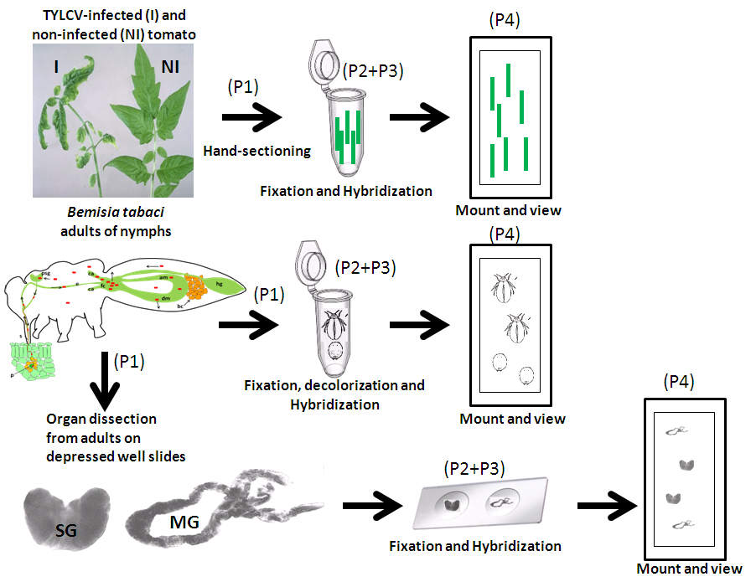

- Introductory Interview (spoken by you on camera. Don’t forget to smile!)

  - Murad Ghanim: I first had the idea for this method, when I localized endosymbiotic bacteria in Bemisia tabaci. The main advantage of this technique over existing methods, like using riboprobes or antibodies, is that the hybridization is simple and there is no need for complex probe design, handling and washing steps.
  - Murad Ghanim: Demonstrating the procedure will be Adi Kliot a grad student from my laboratory.

Protocol Chapters (read by a voice talent at JoVE):

- Whitefly, Plant and Virus Preparations
  - There are three important preparations. First, rear B and Q biotype whiteflies on cotton seedlings of the Acala cultivar in insect-proof cages. (TEXT: 25 ± 2 °C, 60% RH, 14/10 L/D)
    - WID: talent with fly colony, checking their status – inspects one cage under good light
    - CU: flies moving around in the cage being inspected by talent
  - Second, check the endosymbiont infections by PCR with endosymbiont-specific primers.
    - MED: talent loading a PCR machine and programming conditions
  - Third, obtain Beefsteak cultivar Tomato seedlings and rear them under the same conditions as whiteflies until the plants reach the four true-leaf stage, the age most suitable for whitefly-mediated inoculation of TYLCV.
    - WID: talent enters space/room where plants are being grown and shows 4-leaf stage plant to camera
    - CU: salient features of four-leaf stage tomato plant, talent handling plant
    - MED: talent inoculating one of these plants with a viral injection using whiteflies that had acquired the virus from infected plants
CU: take 3
- Whole Mount FISH of Whiteflies
  - Begin by collecting ten adult whiteflies by aspiration from the cotton plants.
    - MED: talent collecting whiteflies with aspirator
  - Alternately, pick ten third or fourth instar nymphs from the cotton leaves.
    - CU: picking nymphs from the leaves
  - Immediately immerse the animals in Carnoy’s fixative in microcentrifuge tubes for at least two hours, but preferably overnight.
    - CU: adding collected fly/nymph to tube with fix solution
    - MED: adding last animals to tube and capping tube
  - Later, completely remove the fixative by aspiration. Then, decolorize the insects in 6% hydrogen peroxide in ethanol for two hours.
    - ECU: pipette enters tube with fixed animals, removes solution and show how little is left behind
    - MED: takes aliquot of 6% hydrogen peroxide (well labeled bottle) and adds it to tube with animal tissue. Show where talent leaves tube to incubate; if on a shaker, show that.
  - Now, it is possible to preserve the insects in absolute ethanol for several days to several weeks at room temperature, otherwise proceed with applying probes.
    - WID: returning to the tissue, removes the hydrogen peroxide
    - ECU/CU: adding ethanol to tube, show tissues/animals floating about in solution
  - Design the RNA probes as complementary, reverse-DNA primers to the 16S ribosomal RNA genes of each bacterium. (TEXT: See text protocol for probe sequence examples.)
    - MED: talent working on computer using a primer design program
    - CU: print out of the primer design spit out by the printer, talent picks it up
  - Now, hybridize the samples overnight in the dark in hybridization buffer containing ten picomols of fluorescent probe per milliliter. Multiple probes with different dyes can be combined.
    - MED: talent takes an aliquot of probe and adds it the hyb buffer
    - CU: replaces the solution on the tissue, show old solution coming out and new solution going in
  - Be sure to include un-infected whiteflies with the targeted bacterium and no-probe samples as negative controls.
    - CU: labels tube lid of probe+buffer, labels second tube lid as no-probe control
    - MED: tubes are set to incubate, protected from light – show how this is done (box, aluminum wrap, shaking or not, etc.)
  - The next day, mount the samples whole, on a microscope slide, in hybridization buffer with a liquid blocker.
    - WID: talent preparing a slide to mount the tissue
    - CU: mounting the tissue/animal(s) on slide, show adding the hyb buffer and tissue
  - Cover the sample with a cover slip and seal it with nail polish. The slides are immediately viewable.
    - CU: covering the slide, show technique of dropping slip
    - CU: finishing the nail polish around the parameter and then inspecting the result by tilting the slide
- Whitefly Dissection followed by TYLCV FISH
  - Collect adult whiteflies, continuously reared on TYLCV-infected tomato plants, by aspiration.
    - WID: talent picking flies with aspirator
    - Reuse 3.1.1
  - Anesthetize the whiteflies with acetone exposure delivered on a paper towel. The upper limit on acetone exposure is two minutes – under a minute is preferable.
    - CU: technique to anesthetize the flies by acetone exposure – show if in a chamber or in the aspirator
    - CU: transferring flies, now anesthetize to surface where they are easily inspected
  - Negative controls include non-viruliferous whiteflies reared on healthy tomato plants and no-probe samples.
    - CU: making another collection of whiteflies from a control plant, show aspirator sucking up flies in detail
  - Under a stereoscope, mount the whiteflies in 1X PBS supplemented with 1% toluidine blue stain on depression microscope slides and begin the dissection.
    - MED: talent setting up at the scope, starts inspecting the flies
    - SCOPE: transferring flies with adding the stain solution on to depression slide
  - First, pull off the insect head to expose the salivary glands. Allow the toluidine blue stain to penetrate the salivary glands for a few minutes, so they become visible.
    - SCOPE: removing head and pointing out exposed salivary glands – wait, the stain gradually darkens them
  - Now, pull the insect apart at the juncture between the thorax and the abdomen to observe and expel out the midgut.
    - SCOPE: breaking thorax from abdomen, guts spill out
  - Next, expel the contents of the abdomen by pushing on the abdomen’s tip with forceps.
    - SCOPE: pushing out all the gut abdomen contents
  - If the dissection was successful, proceed by gently removing the PBS and toluidine blue. Replace those solutions with 300 microliters of Carnoy’s. Add the solution from the side of the well, so the organs are not disturbed.
    - SCOPE: sucking up solution around the tissue and adding back fresh solution
    - CU: adding Carnoy’s to sample under scope – show angle at which the solution is added
  - Once they are in the fixative, the organs will adhere to the glass. Allow the organs to fix for five minutes, at room temperature.
    - SCOPE: focusing on organs adhered to the glass, panning around and inspecting all organs on the slide
  - After removing the fixative by gentle aspiration, add 500 microliters of hybridization buffer supplemented with 10 picomols of the fluorescent DNA probe for a TYLCV coat protein gene.
    - SCOPE: removing solution again
    - MED: loading pipette with hyb buffer plus probe mix and adding aliquot to the slide, show technique
  - Hybridize the probe overnight, at room temperature, in a box lined with a wet towel.
    - MED: preparing overnight box with mist towel and adding slide to box, closing box
  - The next day, pick up the organs with a fine dissection tool and rapidly move them to a microscope slide with liquid blocker containing 30 microliters of freshly prepared hybridization buffer supplemented with DAPI. (TEXT: 1 µg DAPI / ml buffer)
    - WID: talent arrives to box, moves the depression slide therein to the scope to pick the tissues
    - SCOPE: picking the tissue off the slide
    - CU: moving tissues from the slide to a new slide with solution on it
  - Apply a cover slip, seal it with nail polish and proceed with microscopy.
    - Reuse 3.10.1+3.10.2. ECU: covering slide with coverslip and then starting the sealing process with nail polish
- Plant handling, hand-sectioning, fixation and hybridization for TYLCV FISH
  - Inoculate the tomato seedlings with TYLCV using a viruliferous whitefly-mediated inoculation. Use healthy tomato plants and no probe samples for controls to confirm specific hybridization.
    - Reuse 4.1.1. WID: talent working with tomato plants, loading syringe with virus
    - CU: injecting plant with virus dispersing whiteflies that had acquired the virus on healthy tomato plants in a cage for inoculation
    - MED: labeling the injected leaf/inoculated plant
  - One week later, the virus can be detected using the methods described here, in symptomless plants.
    - Reuse 3.1.1, 3.3.1 and 3.10.1 sequence
  - By three weeks post-inoculation, disease symptoms are visible.
    - CU: diseased plant – talent points out salient features of disease state, and picks leaves for next step
  - Using a histological razor blade, hand-cut two to four centimeter long sections of the tomato stems and leaves.
    - MED: talent using blade to cut samples from diseased leaves
    - CU: detail of cutting the strips, showing their dimension
  - In microcentrifuge tubes, fix the sections in Carnoy’s at room temperature for at least two hours, but preferably overnight.
    - CU: adding the sections to small tube(s) of solution
    - MED: setting tubes to incubate, show if shaking is applied
  - After using aspiration to remove the fixative, the sections can be preserved in absolute ethanol at room temperature for several days to weeks.
    - WID: talent finishes removing fix solution and takes an aliquot of ethanol
    - ECU: adding ethanol to plant material in tube
  - Otherwise, wash the sections three times in hybridization buffer for one minute per wash. (TEXT: Wash 3X)
    - MED: taking aliquot of hyb buffer and adding to tube, waiting 60 sec, and then removing solution
  - Hybridize the sections with 500 microliters of hybridization buffer containing 10 picomols of the fluorescent oligonucleotide probe to the TYLCV coat protein gene.
    - Reuse 3.7.1. MED: adding aliquot of probe to hyb buffer and mixing, then removing aliquot of mixed solution and …
    - CU: adding the aliquot to the plant tube – show relative detail of plant tissue floating around in tube
  - When the hybridization period is over, wash the sections three times in hybridization buffer for one minute per wash. (TEXT: Wash 3X)
    - WID: talent arrives to the bench, looking as though it is the next day, and take hold of tube with hyb reaction
    - MED: removes solution in tube and takes aliquot of hyb buffer from clearly labeled bottle, then adds this to the tube
    - CU: show how the tube is handled for the 60 seconds during which the material therein is “washed”
  - Use the same mounting regiment in hyb buffer with DAPI (TEXT: 1 µg DAPI / ml buffer) as previously described.
    - ECU: mounting plant tissue on a slide – show all the steps involved that can be collected from on tight camera angle
- FISH Images
  - Using the described protocols, various FISH of endosymbionts were tested for. Here, double FISH in an adult whitefly was performed on the primary symbiont Portiera and the secondary symbiont Arsenophonus.
    - LAB MEDIA: Figure 2A
  - Closer inspection reveals the Portiera-specific probe in red, conjugated to Cy5, and the Arsenophonus-specific probe, in yellow, conjugated to Cy3.
    - LAB MEDIA: Figure 2B
  - This double FISH in B. tabaci fourth-instar nymph shows the Portiera-specific probe, in red, and the Hamiltonella-specific probe, in green.
    - LAB MEDIA: Figure 3C
    - LAB MEDIA: Figure 3D

Video editor: switch images halfway through narrative.
  - Double FISH can distinguish a probe for Portiera with Cy5, in red, from one for Rickettsia conjugated to Cy3, in blue. These signals can also be combined with bright field or shown in their original dark field format.
    - LAB MEDIA: Figure 4C
    - LAB MEDIA: Figure 4D

Video editor: switch images at the second sentance
  - Combined optical sections nicely displays this dissected whitefly midgut.
    - LAB MEDIA: Figure 5A
  - In the dissected tissue, FISH to TYLCV can be combined with DAPI staining.
    - LAB MEDIA: Figure 5B
  - 48 hours after acquiring virus, an adult female was dissected to view the salivary glands. Here the brightfield image is combined with the FISH image.
    - LAB MEDIA: Figure 6A
  - And under darkfield, both FISH and DAPI staining can be overlayed.
    - LAB MEDIA: Figure 6B

- Conclusion Interview (spoken by you on camera)

  - Murad Ghanim: After watching this video, you should have a good understanding of how to localize your bacteria or viruses of interest using simple and rapid techniques.

List of Provided Media Filenames and Descriptions (fill this in)

6.1 – 0123_MuradGhanim_Figure2A.tif
6.2 – 0123_MuradGhanim_Figure2B.tif
6.3 – 0123_MuradGhanim_Figure3C.tif
6.3 – 0123_MuradGhanim_Figure3D.tif
6.4 – 0123_MuradGhanim_Figure4C.tif
6.4 – 0123_MuradGhanim_Figure4D.tif
6.5 – 0123_MuradGhanim_Figure5A.tif
6.6 – 0123_MuradGhanim_Figure5B.tif
6.7 – 0123_MuradGhanim_Figure6A.tif
6.8 – 0123_MuradGhanim_Figure6B.tif

General Preparation

It’s critical for a smooth and organized shoot that all reagents are accounted for, in advance.

Any overnight or long incubation steps should be recognized and specimens/samples be prepared in advance so that prior steps can be recorded and shooting can continue with pre-prepared specimens/samples.

All tubes/flasks should be pre-labeled neatly before we arrive.

Ex. Luciferase assay done in 96 well plates should be labeled with negative/positive control wells and experimental samples are labeled accordingly.

