Submission ID #: 51023

Editor Name: Brigid Stadinski

Videographer name: Kasey Drzazga

Film Date: 09/20/2013

Authors and Affiliations:

Monica M. Burdick^{1,2}, Nathan M. Reynolds^{1,2}, Eric W. Martin², Jacquelyn V. Hawes¹, Grady E. Carlson¹, Chaz M. Cuckler¹, Michael C. Bates¹, Steven R. Barthel³, Charles J. Dimitroff³

¹Department of Chemical and Biomolecular Engineering, ²Biomedical Engineering Program, Russ College of Engineering and Technology, Ohio University, ³Department of Dermatology, Brigham and Women's Hospital, Harvard Medical School

Title: Isolation and characterization of chimeric human Fc-expressing proteins using protein A membrane adsorbers and a streamlined workflow

Corresponding Author:

Monica M. Burdick
Department of Chemical and Biomolecular Engineering
Biomedical Engineering Program
Russ College of Engineering and Technology
Ohio University
171 Stocker Center
Athens, OH 45701
burdick@ohio.edu
Tel 740-593-0033
Fax 740-593-0873

Authors, please fill out the brief questionnaire below.

- Will you require JoVE to record video microscopy, such as filming a complex dissection or microinjection technique? (Y/N) ____N____ If yes, please list make and model of your microscope: ______________________________
**Note: This question is to get at whether or not you will need a camera hook-up to look into the microscope. However, if your microscope has a digital camera attached to a computer, you can gather these shots by collecting screen capture movies.
Does your protocol include microscopy steps that are visualized through a microscope with a digital camera/computer attached? (Y/N) ___N___
B. Does your protocol include detailed, step-by-step, descriptions of software usage? (Y/N)___N____
C. Which steps of your protocol will viewers benefit most from having filmed? Please list 4-6 steps__2.4, 2.5, 2.6, 3.2, 3.4, 3.5_________
D. What is the single most difficult aspect of this procedure and what do you do to ensure success? Quantification of the protein is the most difficult step. It is repeated multiple times to confirm the findings.

1. Introduction (Schematic Overview and Interview)

A. Schematic Overview (read by voice talent at JoVE):

Procedural Narrative:
The overall goal of this procedure is to efficiently and effectively isolate and characterize chimeric human Fc-expressing proteins using protein A membrane adsorbers and a streamlined workflow. (Intro)

This is accomplished by first clarifying the cell culture supernatant with a 0.22 μm (pronounced “micron”) filter. (P1)
Editors, please show P1 of 51023_Burdick_SchematicFig.pptx as this point is narrated.

The second step is to assemble the flow system and begin perfusion of the cell culture supernatant through the protein A membrane adsorber. (P2)
Editors, please show P2 of 51023_Burdick_SchematicFig.pptx as this point is narrated.

Next, the membrane adsorber is eluted off the human Fc-expressing protein, with the resulting eluate concentrated through ultrafiltration, followed by buffer exchange through dialysis. (P3)
Editors, please show P3 of 51023_Burdick_SchematicFig.pptx as this point is narrated. Start with the illustration on the left side of the figure as “the membrane adsorber is eluted of the human Fc-expressing protein” is narrated. Then show the arrow with the word “Ultrafiltration” over it. Finally show the illustration on the right side of the figure as “followed by buffer exchange through dialysis” is narrated.

The final steps are to use flow cytometry and western blotting to determine the quality and quantity of the concentrated protein. (P4)
Editors, please show P4 of 51023_Burdick_SchematicFig.pptx as this point is narrated. Start with the illustration on the left side of the figure. Then bring in the arrow to flow cytometry as narrated and the arrow to western blotting as narrated.

Ultimately, protein A membrane adsorbers, along with a streamlined workflow show a decrease in processing time and potential increase in protein yield compared to traditional affinity chromatography with protein A agarose bead-packed columns. (P5)
Editors, please show figure 4C here. Perhaps draw a horizontal line from the red unknown marker to the y-axis as this point is narrated.

Paste a copy of your graphic overview here. The original file should be Adobe Illustrator (preferred) or Powerpoint (see instructions) and should be uploaded through your online submission on the JoVE website. Please keep all layers in the file (i.e., do not flatten the file).

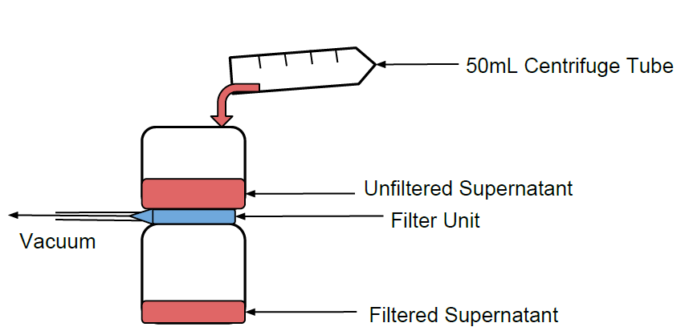
P(1)

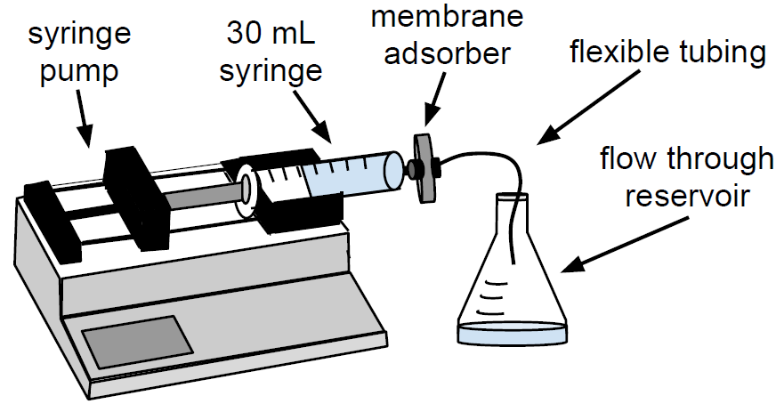
P(2)

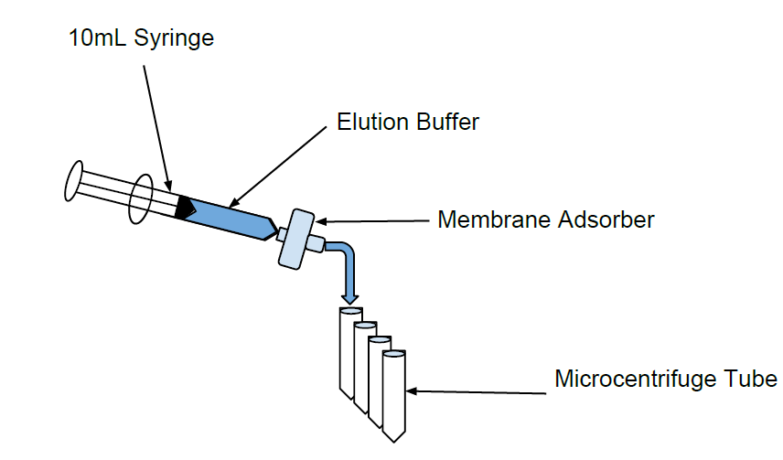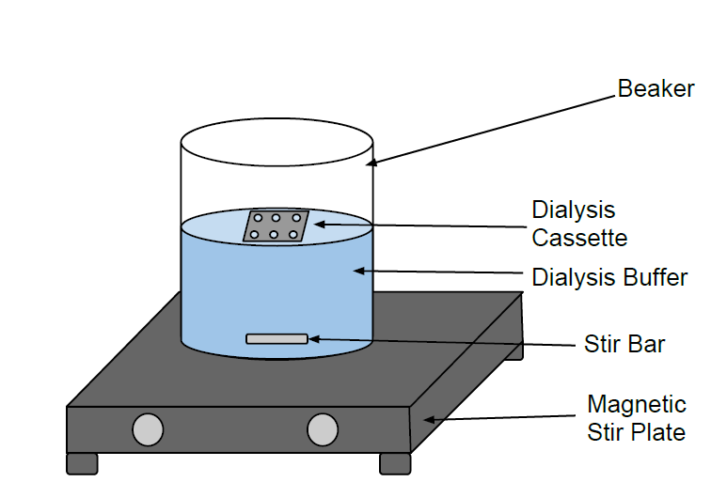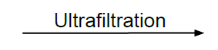
P(3)

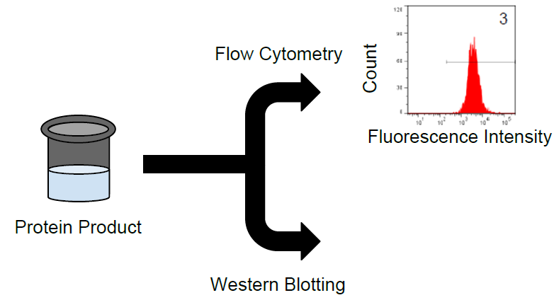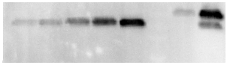
P(4)

B. Interview: (Said by you on camera. Don’t forget to smile!)

  - Nate: The main advantage of this technique over existing methods, like column affinity chromatography, is that the membrane adsorber allows for potentially higher yields of the protein with lower processing time. The selection of appropriate characterization methods can also lower processing time.
    - MED: Nate speaks toward camera, interview style.

Protocol (read by voice talent at JoVE):
- Preparation and loading of protein A membrane adsorber
  - Prepare the membrane adsorber following the manufacturer’s instructions, ensuring that all solutions perfused through are at room temperature and pre-filtered through a 0.22 μm filter.
    - Title Card.
  - To begin, fill a 10 ml syringe with 0.22 μm-filtered Dulbecco’s phosphate buffered saline, or DPBS, and discharge any air bubbles. Ensuring that air never enters the membrane adsorber, perfuse DPBS to remove the storage solution and to equilibrate the membrane adsorber immediately before use.
    - MED: Talent fills a 10 ml syringe with DPBS from a labeled container and discharges the air bubbles.
    - CU: Membrane adsorber as talent perfuses DPBS through using syringe pump.
  - Filter the cell culture supernatant immediately before perfusion through the membrane adsorber, using a vacuum-driven 0.22 μm sterile filtration unit.
    - MED-over the shoulder: Talent filters the cell culture supernatant using a vacuum-driven 0.22 μm sterile filtration unit.
  - To load the protein A membrane adsorber, aspirate the cell culture supernatant into a Luer Lock syringe and discharge any air bubbles.
    - CU: Luer Lock syringe as talent aspirates the cell culture supernatant and discharges any air bubbles.
  - To assemble materials and equipment, first connect the syringe to the inlet of the membrane adsorber. Attach flexible tubing to the membrane adsorber outlet. If desired, place a 0.22 µm syringe filter between the syringe and the membrane adsorber. Use a flask or bottle to catch flow through from the adsorber.
    - MED: Talent connects the syringe to the inlet of the membrane adsorber.
    - CU: Membrane adsorber outlet as talent attaches flexible tubing to it.
    - MED-over the shoulder: Talent places a 0.22 µm syringe filter between the syringe and the membrane adsorber.
    - MED: Talent places a flask or bottle to catch flow through form the adsorber.
  - Set the syringe pump to the desired volumetric flow rate, but do not exceed the manufacturer’s recommended flow rate. Perfuse the cell culture supernatant through the membrane adsorber, collecting flow through. Reload the syringe with supernatant as needed.
    - CU: Syringe pump as talent sets to the desired volumetric flow rate.
    - MED-over the shoulder: Talent perfuses the cell culture supernatant through the membrane adsorber and collects the flow through in a beaker or other container.
    - CU: Syringe as talent reloads with supernatant.
  - If desired, test the flow through for the presence of protein using flow cytometry, Western blotting, or ELISA based on lab preference. It is typically unnecessary to re-perfuse the flow through.
    - MED-over the shoulder/MED: Multiple takes of flow cytometer as talent loads the flow through. Shot will be reused once.
- Eluting, concentrating and dialyzing the protein
  - To elute the protein from the membrane adsorber, first wash the membrane adsorber with 10 ml of DPBS to remove any non-bound protein.
    - CU: Syringe as talent loads syringe with 10 ml of DPBS to wash the membrane adsorber.
  - Elute protein from the membrane adsorber at the desired flow rate using 10-15 ml of elution buffer. Catch the eluate in a tube containing neutralizing buffer at 10% of the elution volume.
    - MED-over the shoulder: Talent loads 10-15 ml of elution buffer onto the membrane adsorber. TEXT overlay: see text protocol for elution buffer recipe
    - CU or ECU: Tube containing neutralizing buffer as the eluate drips in. TEXT overlay: see text protocol for neutralizing buffer recipe
  - After eluting the protein, regenerate the membrane adsorber according to the manufacturer’s instructions. Fill the membrane adsorber with 20% ethanol in DPBS for long-term storage at 4ºC.
    - MED: Talent regenerates the membrane adsorber by loading it with NaOH solution.
    - MED-over the shoulder: Talent leaves the membrane adsorber in ethanol at 4ºC.
  - Deposit all eluate in a 10 kDa molecular weight cut-off centrifugal filter unit. Follow the manufacturer’s instructions for centrifugation.
    - CU: 10 kDa molecular weight cut-off centrifugal filter as talent pipettes all eluate in.
    - MED or WIDE: Talent places the centrifugal filter into the centrifuge.
  - Dialyze the retentate in a small volume dialysis unit with a 10 kDa molecular weight cut-off against the buffer of choice. Buffer may need to be added to the dialyzed material if protein precipitation is a concern.
    - CU: Small volume dialysis unit with a 10 kDa molecular weight cut-off as talent pipettes retentate in.
    - MED-over the shoulder: Talent places the dialysis unit into container filled with buffer.
- Quantify and characterize purified product in an expedited Western blotting procedure
  - Resolve purified protein and Fc standards on the gel of choice by SDS-PAGE, under reducing or non-reducing conditions as desired. Use a mini gel rather than a midi gel to minimize run time.
    - Title Card
    - MED-over the shoulder: Talent assembles the mini gel to prepare for run.
  - Load multiple sample amounts of purified protein, including samples diluted with DPBS, to ensure that the purified protein band signals are within the linear signal range of Fc standards in image analysis.
    - CU: Gel lanes as talent loads the wells with multiple sample amounts of purified protein.
  - After separation on the gel, transfer proteins from the gel to a polyvinylidene fluoride membrane in a discontinuous buffer system using a semi-dry blotter, following the manufacturer’s instructions. Transfer time is typically 5-10 minutes. Coomassie stain the gel after the transfer to verify transfer efficiency.
    - MED-over the shoulder: Talent sets up the transfer in a discontinuous buffer system using a semi-dry blotter.
    - CU: Power unit as talent sets voltage for transfer.
    - MED-over the shoulder: Talent leaves the blot in coomassie stain.
  - Perform immunoblotting with anti-Fc or anti-IgG (pronounced as “anti-F-C or anti-I-G-G”) conjugated to alkaline phosphatase or horse radish peroxidase using a vacuum-assisted protein detection system. Immunoblotting time is typically less than 1 hour.
    - MED: Talent sets up a vacuum-assisted protein detection system to perform immunoblotting.
  - Develop the immunoblot using the substrate and method of choice. Quantify the purified protein by image analysis.
    - CU: Cassette as talent places the immunoblot in.
    - MED-over the shoulder: Talent quantifies the purified protein by image analysis.
  - Perform a linear regression on the band signals from Fc standards. If R squared is greater than 0.90, use the equation for the line to calculate the protein quantity from its band signal, accounting for sample dilution if necessary.
    - SCREEN: Screen capture movie as talent performs a linear regression on the band signals from the Fc Standards. Then talent uses the equation for the line to calculate protein quantity from its band signal
  - Since quantification of the protein is performed on the basis of Fc, adjust the value for molecular weight differences between the protein and Fc. If R squared is less than 0.90, repeat the expedited Western blotting procedure.
    - SCREEN: Screen capture movie as talent adjusts the value for molecular weight differences between the protein and Fc.
  - Finally, validate the protein using functional assays or methods to detect Fc via flow cytometry, Western blotting, or ELISA.
    - Shot 2.7.1 – Talent loading sample onto flow cytometer.
- Results: Characterization of chimeric murine galectin-1 fused to human Fc (Gal-1hFc)
  - Flow cytometry was used to test for the presence of functional Gal-1hFc (pronounced “Gal-one H.F.C.”) in the starting cell culture supernatant as indicated by the blue histogram.
    - LAB MEDIA: Figure 3A
  - Fresh cell culture medium, which is shown here in red, served as the negative control. Overlapping this histogram in green is the flow through, indicating that the membrane adsorber efficiently captured and retained Gal-1hFc.
    - LAB MEDIA: Figure 3A
  - Gal-1hFc was eluted from the membrane adsorber in one milliliter increments at 1 milliliter per minute using an amine-based acidic buffer, and neutralized elution fractions were subsequently tested for the presence of functional Gal-1hFc using flow cytometry.
    - LAB MEDIA: Figure 3B
  - Gal-1hFc signal sequentially increased from elution 1, approximately equal to the negative control, to a maximum at elution 4, and then decreased to a nearly constant level at elutions 9 and 10. The final elution 10 did not reach equivalence to the negative control signal due to some adsorber retention of Gal-1hFc.
    - LAB MEDIA: Figure 3C. Editors, if possible, please trace highlight the curve correlating the trace with the narration.
  - Quantification and characterization of the purified Gal-1hFc was performed in a Western blotting procedure expedited by semi-dry transfer and vacuum-assisted immunoblotting. By comparing Gal-1hFc signal to hFc quantification standards, both the quantity and quality of the purified material were determined.
    - LAB MEDIA: Figure 4A-C.
  - Gal-1hFc… and degraded Gal-1hFc signals… were within the standards range.
    - LAB MEDIA: Figure 4A. Editors, please highlight the band labeled Gal-1hFc in lane 6 as “Gal-1hFc” is narrated. Then highlight the band labeled Gal-1hFc and the band labeled hFc in lane 7 as “degraded Gal-1hFc” is narrated. Finally highlight lanes 1-5 as “the standards range” is narrated.
  - Signal intensities of hFc standard bands were linearly related to the quantity of hFc present. The concentration of purified Gal-1hFc on the basis of hFc was determined to be 450 micrograms per milliliter by image processing. Adjusting for the molecular weight of Gal-1hFc, the concentration of the purified material was 720 micrograms per milliliter.
    - LAB MEDIA: Figure 4C. Editors, please highlight the green points as the first sentence is narrated. Then highlight the red point as the second sentence is narrated.
  - In contrast, too much purified Gal-1hFc was loaded in lanes 6 and 7 of the Western blot shown here, which generated signals that saturated or exceeded the hFc standards range, thereby preventing quantification.
    - LAB MEDIA: Figure 4B.
  - Alternative to Western blotting, Coomassie gel staining can serve as a rapid quality control check and/or quantification method.
    - LAB MEDIA: Figure 4D
  - Note that a band at approximately 10 kDa, in addition to bands at approximately 25 kDa and 40 kDa, were present in the degraded Gal-1hFc sample. This band is degraded Gal-1hFc that was non-reactive with the detection antibody used in Western blots.
    - LAB MEDIA: Figure 4D. Editors, please sequentially highlight the bands in lane 2 from bottom to top as narrated in the first sentence.

INSTRUCTIONS FOR AUTHORS:
Please ensure that the representative results narration is appropriate and correctly describes your images, movies, or figures. Our editors have ensured that the results are written in our format.

We consider this section a critical aspect of the video, because here is where you provide validation for your experiments. For example, if this is a cell culture preparation, this section is where the video will show your cells at various time points following culturing. If this is an imaging prep, then this part is where you will show examples of your imaging experiments.

Please limit the extent of narration to no more than 2-3 lines of text per image or movie file being described. Figures with multiple panels submitted with the original protocol should be broken up so that each panel is a separate image. Like the schematic, each image or movie file supplied in the results should be referenced by annotation in parenthesis, however for the results, the specific filename should be given in parenthesis.

Below is an example of results text:

EXAMPLE REPRESENTATIVE RESULTS

5. Evaluation of Morpholino Injection and Knockdown
5.1 Representative results of both morpholino injection and mRNA injection are shown here. The
uninjected control at 48 hours post fertilization looks normal, as expected
-LAB MEDIA: 0123_PIname_Figure1.tif (Replace 0123 with your jove video #)

5.2 However, embryos injected with the morpholino heg_e3i3_egfr1, which knocks down Heg isoforms
containing the first of two EGF-like repeats, exhibit brain edema.
-LAB MEDIA: 0123_PIname_Figure2.tif

5.3 Injection of heart of glass mRNA also produced an obvious phenotype. At 24 hours post fertilization,
the heads of the uninjected controls look normal
-LAB MEDIA: 0123_PIname_Figure3.tif

5.4 Conversely, some of the embryos injected with the mRNA exhibit cyclopia
-LAB MEDIA: 0123_PIname_Figure4.jpg

Please visit the following URL to see an example of how the results will look when complete:

http://www.jove.com/video/1597/results-example-mably?access=ksw0bprj

- Conclusion (said by authors on camera)
  - Nate: After watching this video, you should have a good understanding of how to isolate chimeric human Fc-expressing proteins using membrane adsobers and how to characterize the protein in as little as 4 hours.
    - MED: Nate speaks toward camera, interview style.

Provided Media

Authors, Please list all images, movie files, or 3-D rendered animations that can be included in the video per editor’s request. The step in the script/video where these images will be inserted should be specified. For example:

6.2 – 0123_PIname_Figure1.tif - dual color imaging of tumor angiogenesis at 40X
6.2 – 0123_PIname_Figure2.tif - dual color imaging of tumor angiogenesis at 100X

Formats: For static images we prefer .tiff, .eps, Illustrator, Powerpoint or Photoshop files at dimensions of at least 720X480 pixels and 300 dpi. The higher resolution, the better. Likewise any exported movie files should have at minimum these dimensions and be rendered to .mov, .mp4, or .avi files.

Insert your media filenames here.

51023_Burdick_SchematicFig

Figure 3A

Figure 3B

Figure 3C

Figure 4A-C

Figure 4A

Figure 4C

Figure 4B

Figure 4D

SCREEN Capture Movies:

51023_Burdick_SCREEN_4.6.1: Screen capture movie as talent performs a linear regression on the band signals from the Fc Standards. Then talent uses the equation for the line to calculate protein quantity from its band signal

51023_Burdick_SCREEN_4.7.1: Screen capture movie as talent adjusts the value for molecular weight differences between the protein and Fc.

General Preparation

It’s critical for a smooth and organized shoot that all reagents are accounted for, in advance.

Any overnight or long incubation steps should be recognized and specimens/samples be prepared in advance so that prior steps can be recorded and shooting can continue with pre-prepared specimens/samples.

All tubes/flasks should be pre-labeled neatly before we arrive.

Ex. Luciferase assay done in 96 well plates should be labeled with negative/positive control wells and experimental samples are labeled accordingly.

You will receive more detailed preparation instructions, as well as an introduction to your videographer, closer to your filming date.

