Submission ID #: 51018
Editor Name: Pallavi R. Devchand
Videographer name: Matt Lenz
Film Date: 6th August, 2013
Authors and Affiliations: Elena Ivanova, Abduqodir H Toychiev, Christopher W Yee and Botir T Sagdullaev
Departments of Ophthalmology and Neurology, Weill Medical College of Cornell University, Burke Medical Research Institute, White Plains, NY 10605.
Title: Optimized protocol for retinal wholemount preparation for imaging and immunohistochemistry
Corresponding Author: bos2005@med.cornell.edu

Authors, please fill out the brief questionnaire below.

A. Will you require JoVE to record video microscopy, such as filming a complex dissection or microinjection technique? Yes.
If yes, please list make and model of your microscope: Nikon SMZ-1 (steps 1.1 - 1.5, 2.5 - 2.6), Nikon FN-S2N (steps 3.4-3.6), Nikon Nikon Eclipse Ti-U (steps 3.8).
B. Does your protocol include detailed, step-by-step, descriptions of software usage? No.
C. Which steps of your protocol will viewers benefit most from having filmed? Steps 1.3, 1.4, 2.6, 2.7, and 3.4.
D. What is the single most difficult aspect of this procedure and what do you do to ensure success? The retinal dissection is the most difficult aspect of the procedure. Success requires steady hands and practice.

1. Introduction (Schematic Overview and Interview)

A. Schematic Overview (read by voice talent at JoVE):
Authors, please select from “Procedural Narrative” or “Conceptual Narrative” and complete the statements below. Please do not add additional steps. Then, attach your finished graphic overview. See accompanying instructions for details and examples.

Conceptual Narrative:

This procedure uses mouse retinal tissue to demonstrate how to stabilize delicate neural tissue to preserve structural integrity during several steps of immunohistochemical staining (Intro).
First, enucleate the eye, remove the cornea, and separate the retina from the sclera (P1).
Make incisions into the retinal eyecup to flatten the tissue (P2).
Then attach the retina to a ring-enforced membrane, using a suction transfer without direct manipulation to preserve the integrity of the tissue (P3).
Now, transfer the ring to a multi-well plate for staining (P4).
Our results show that this technique can be used effectively in live tissue and provides a superior substrate for the imaging of synaptic proteins (P5).

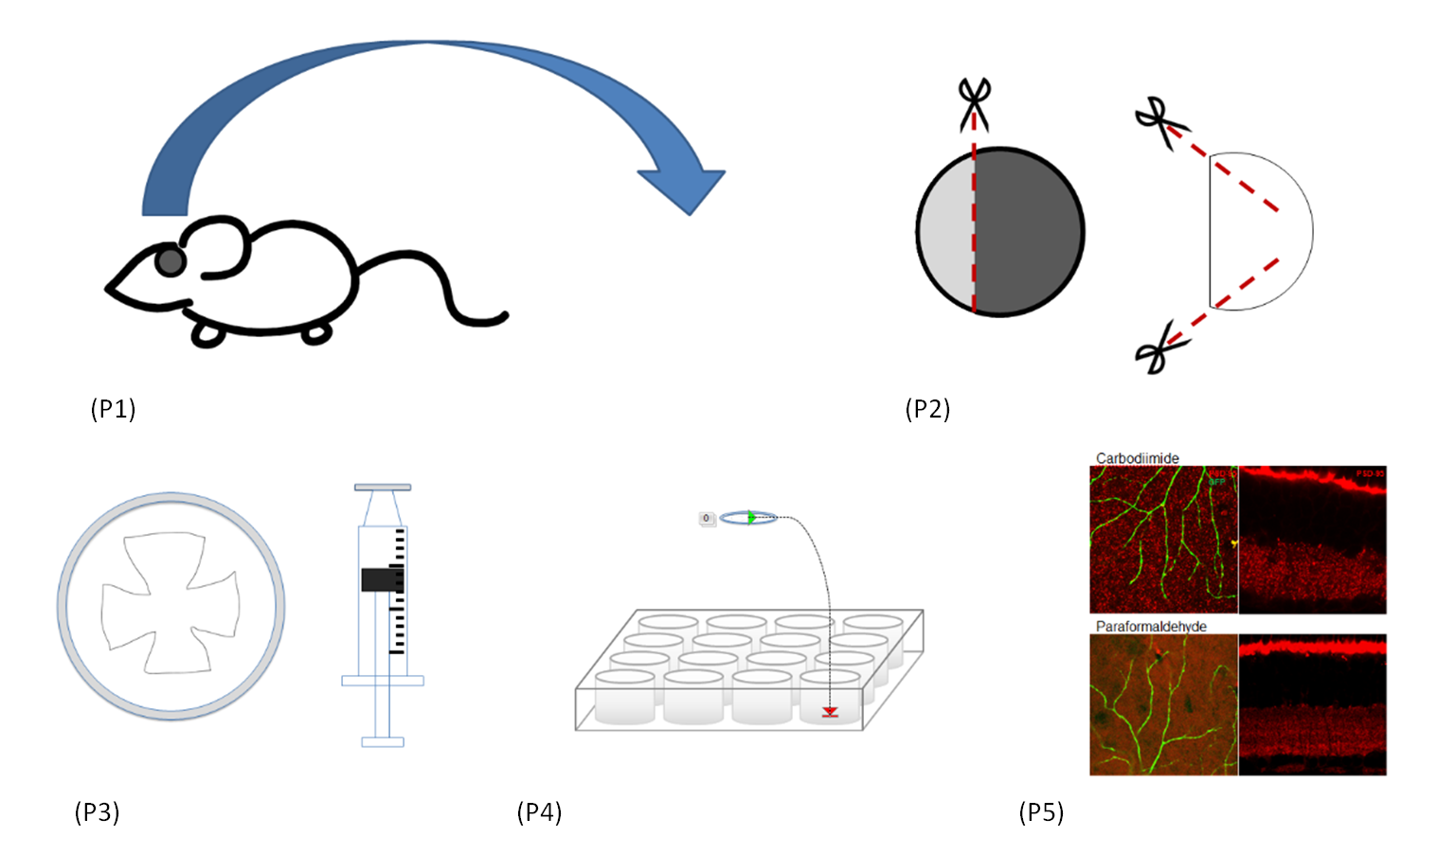

B. Interview: (Said by you on camera. Don’t forget to smile!)

Authors: Below are statements we would like you to complete that are complementary to the information contained within the schematic overview.
- Only one statement should be chosen and completed per author who will be on camera demonstrating the protocol.
- Enter the name of the individual who will say each line.
- Please choose and fill out the statement(s) that convey the most important fact(s) about your protocol. You may revise the given prompts as necessary to improve the sentence flow.
- If any individuals will be doing demonstrations on camera but are not assigned a speaking part in this interview section, please use statement 1.8 to introduce these demonstrators (for example, the PI introduces students)

  - Elena Ivanova: Compared to existing methods of handling dissected retina, this technique allows for the transfer of delicate tissue with minimal physical manipulation of the tissue. This reduces the chance of distortion and damage.
  - Botir Sagdullaev: We first had the idea for this method when we needed to record from flat-mounted retinal tissue from rd1 mouse, a model of retinal degeneration. Retinas from these mice are extremely fragile due to the extensive cell death caused by the mutation.
  - Elena Ivanova: Kadir Toychiev, a post doc in the laboratory, will join me in demonstrating the procedure.
    - Interview style: Author saying the above
    - The named technician, post doc, student looks up from workbench or desk or microscope and acknowledges the camera.

Protocol (read by voice talent at JoVE):

Authors: In order to ensure that your protocol can be filmed in a single day, the protocol text must be limited to 30 steps – each step being defined as 3 lines of 12 pt text in our formatting style below. This amounts to 3 pages of protocol text. The scope of the scripted protocol text should include only those aspects of the procedure that require visualization in order to be well understood.

- Dissection of whole-mount retina
  - First, enucleate the eyes of an aneasthetized mouse, and transfer the eyes into oxygenated HEPES-buffered Ringer’s solution.
    - CU: Talent removes the eyes of an aneasthetized mouse, and transfer them into oxygenated HEPES-buffered Ringer’s solution.

  - To remove the cornea, hold the eye at the limbus with forceps and then cut a circular path along the ora serrata. Pull out the lens with forceps.
    - SCOPE: Talent holds the eye at the limbus with forceps, cuts a circular path along the ora serrata with small scissors, and then pulls out the lens with forceps.

  - For bolus injections and electrophysiological recordings, use blunted-edge forceps to remove as much vitreous as possible.
    - SCOPE: Talent takesa pair of blunted-edge forceps and start to remove vitreous.

  - Now stabilize the eye cup by holding the sclera firmly with forceps. Position a second set of forceps between the retina and the eyecup, move the forceps slowly around the circumference, cut the optic nerve between the retina and the eyecup, and remove the eyecup.
    - SCOPE: Talent stabilize the eye cup by holding the sclera firmly with forceps.
    - SCOPE: Talent positions a second set of forceps between the retina and the eyecup, moves the forceps slowly around the circumference, cuts the optic nerve between the retina and the eyecup, and remove sthe eyecup.

  - With scissors, make incisions from the retinal periphery all the way down to the optic nerve. Alternatively, to use the entire retina, make incisions from the periphery halfway to the optic nerve.
    - SCOPE: With scissors, Talent makes incisions from the retinal periphery all the way down to the optic nerve.
    - SCOPE: Talent make incisions from the periphery halfway to the optic nerve on another retina.

- Mounting onto hydrophilized PTFE membrane insert
  - To shorten the holder, remove the excessive part with a lathe. Then polish down rough surfaces with fine sandpaper [Text over video: >300 grit]. Remove the feet from underneath the ring.
    - Added shot: CU: Talent uses the lathe to cut the excessive portion of the filter.
    - 3.1.2 MED/CU: Talent polishes down rough surfaces with fine sandpaper.

3.1.2 3.1.3 MED/CU: Talent uses scissors to remove the feet from underneath the ring.

  - Now rinse the polytetrafluoroethylene membrane in distilled water for 2 to 3 minutes.
    - CU: Talent submerges the PFE membrane in distilled water, and places on shaker

  - Cut off the narrow tip of a plastic pipette, then transfer the tissue with some solution to the membrane. Gradually remove the solution while spreading the retina, and unfold the tissue. Now, attach the retina to the membrane, with the ganglion cells facing up.
    - MED/CU: Talent cuts off the narrow tip of a plastic pipette.
    - ECU: Talent transfers the tissue with some solution to the membrane, gradually removes the solution while spreading the retina, and unfolds the tissue with forceps.
    - ECU: Talent attaches the retina to the membrane, with the ganglion cells facing up.

  - Cut off the holding tip of a 1-ml syringe, and position it directly underneath the tissue. Pull back on the plunger to a volume of about 0.3 ml to physically enmesh the tissue within the membrane.
    - MED/CU: Talent cuts off the holding tip of a 1ml syringe.
    - ECU: Talent positions the syringe directly underneath the tissue, pulls back on the plunger to a volume –(end with focus on the tissue within the membrane)

- Bolus injection of isolectin Alexa 488
  - Pull some borosilicate capillary pipettes using a resistance of ~1 MΩ. Then gently break the tip of each patch pipette.
    - MED-over-the-shoulder: Talent pulls a patch pipettes using a resistance of ~1 MΩ on a Flaming/Brown puller.
    - ECU: Talent gently breaks the tip of a patch pipette.

  - Next, add 0.3 μl of isolectin stock stain solution [Text over video: Alexa 488] to 10 μl of the HEPES-buffered Ringer’s solution.
    - MED/CU: Talent adds 0.3 μl of isolectin stock stain solution to 10 μl of the HEPES-buffered Ringer’s solution.

  - Now place the membrane into the recording chamber perfused with warm [Text over video: 37 °C] oxygenated HEPES-buffered Ringer’s solution.
    - CU/ECU: Talent places the membrane into the recording chamber perfused with warm oxygenated HEPES-buffered Ringer’s solution.

  - Position the pipette containing dye against the inner limiting membrane.
    - LAB MEDIA: Figure 2A.

  - Using a micromanipulator, further advance the pipette to penetrate the inner limiting membrane. Then inject the staining solution into the single or multiple targeted locations [Text over video: 10–20 psi for 1 sec].
    - LAB MEDIA: Figure 2B.
    - MED/CU: Talent injects the staining solution with a pressure 10–20 psi for 1 sec using a picospritzer.

  - Now allow 10 minutes for the tissue to recover from the injection while viewing it under epifluorescence illumination, if desired. Transfer the insert to a glass-bottom culture dish, placing it retina side down.
    - LAB MEDIA: Figure 2C.
    - ECU: Talent transfers the insert to a glass-bottom culture dish, placing retina side down.

  - Add one drop of HEPES solution to keep the specimen moist. Also place three spots of vacuum grease around the perimeter of the plastic ring to firmly secure the insert to the culture dish. Transfer the dish to the microscope stage.
    - ECU: Talent adds one drop of HEPES solution to keep the specimen moist.
    - ECU: Talent places 3 spots of vacuum grease around the perimeter of the plastic ring.
    - MED/: Talent transfers the dish to the microscope stage.

- Vertical sectioning of membrane-mounted tissue
  - After fixation, submerge the membrane into the sucrose gradient solutions [Text over video: 10% for 30 min@RT, 20% for 1 hr@RT, 30% for overnight@4°C].
    - CU/ECU: Talent submerges the membrane into a sucrose gradient solutions (show the series of solutions in the background) .

  - Excise the membrane from the plastic insert ring, remove as much solution as possible with Kimwipes, and place it onto Parafilm with the retina facing up.
    - CU/ECU: Using scissors, Talent cuts the membrane from the plastic insert ring.
    - ECU: Talent removes solution with kimwipes, and places the membrane onto parafilm with the retina facing up.

  - Transfer the Parafilm with the tissue to the cryostat chamber, and add a drop of OCT medium. Use the quick freezer device to accelerate the freezing. Detach the frozen sample and flip it over.
    - MED-over-the-shoulder: Talent places the parafilm with the tissue into the cryostat chamber, and adds a drop of OCT medium.
    - MED-over-the-shoulder:: Talent places sample in the quick freezer device.
    - CU/ECU: Talent detaches the frozen sample and flips it over.

  - Now cut off the excess frozen OCT. Leave approximately 2 mm around the sample on three sides, and 5 mm from the side which will be attached to the holder.
    - MED/CU: Talent cut off the excess frozen OCT.
    - ECU: Talent indicates ~2 mm around the sample on three sides, and 5 mm from the side which will be attached to the holder.

  - Cover the exposed retinal side with a drop of OCT, leaving the attached area free. Freeze the membrane containing the retinal tissue. Place a drop of OCT onto a cold holder ring. Immediately insert the frozen sample into the drop.
    - CU: Talent covers the exposed retinal side with a drop of OCT.
    - CU: Talent shows frozen the membrane with retinal tissue, places a drop of OCT onto a cold holder ring and inserts the frozen sample into the drop.

  - Cut 10-20 micron sections at -19 °C and position them on warm polysine adhesion slides. Place the slides with the attached sections on a 41 °C heating platform for 2 or 3 minutes, in the dark. Then store the samples at -20 °C.
    - MED-over-the-shoulder: Talent cuts a few 10-20 microns sections at -19 °C .
    - ECU: Talent positions the sections on a warm polysine adhesion slides.
    - MED/CU: Talent places the slides with the attached sections on a 41 °C heating platform in the dark.
    - MED-over-the-shoulder: Talent places samples at -20 °C.

- Results: Hydrophilized PTFE membrane for whole mount retina
  - This experiment illustrates a fast and simple characterization of retinal vasculature as an elaborate network of blood vessels that span across multiple retinal layers.
    - LAB MEDIA: Figure 2.

  - By combining a bolus loading of isolectin with sulforhodamine immersion labeling, living tissue can be visualized and scanned almost immediately.
    - LAB MEDIA: Figure 2C and D.

  - In the retina, blood vessels can be labeled from the superficial to the deep layer. In contrast to relatively well diffusible SRH, isolectin does not permeate well across the inner limiting membrane.
    - LAB MEDIA: Figure 2D box insert and then Figure 2E.

  - There are several advantages of fixation with carbodiimide over conventional fixation with paraformaldehyde when labeling synaptic proteins.

    - LAB MEDIA: Figure 3

  - For example, after a short period of ﬁxation with carbodiimide, immunoﬂuorescence staining for the synaptic marker PSD-95 in the IPL had a bright punctate appearance consistent with distinguishing the individual synapses.

    - LAB MEDIA: Figure 3B

  - In contrast, when using conventional paraformaldehyde fixative, identification of the synaptic components is less clear.

    - LAB MEDIA: Figure 3E

  - Similar results were obtained in the retinal cryostat sections.

    - LAB MEDIA: Figure 3C and 3F.

INSTRUCTIONS FOR AUTHORS:
Please ensure that the representative results narration is appropriate and correctly describes your images, movies, or figures. Our editors have ensured that the results are written in our format.

We consider this section a critical aspect of the video, because here is where you provide validation for your experiments. For example, if this is a cell culture preparation, this section is where the video will show your cells at various time points following culturing. If this is an imaging prep, then this part is where you will show examples of your imaging experiments.

Please limit the extent of narration to no more than 2-3 lines of text per image or movie file being described. Figures with multiple panels submitted with the original protocol should be broken up so that each panel is a separate image. Like the schematic, each image or movie file supplied in the results should be referenced by annotation in parenthesis, however for the results, the specific filename should be given in parenthesis.

Below is an example of results text:

EXAMPLE REPRESENTATIVE RESULTS

5. Evaluation of Morpholino Injection and Knockdown
5.1 Representative results of both morpholino injection and mRNA injection are shown here. The
uninjected control at 48 hours post fertilization looks normal, as expected
-LAB MEDIA: 0123_PIname_Figure1.tif (Replace 0123 with your jove video #)

5.2 However, embryos injected with the morpholino heg_e3i3_egfr1, which knocks down Heg isoforms
containing the first of two EGF-like repeats, exhibit brain edema.
-LAB MEDIA: 0123_PIname_Figure2.tif

5.3 Injection of heart of glass mRNA also produced an obvious phenotype. At 24 hours post fertilization,
the heads of the uninjected controls look normal
-LAB MEDIA: 0123_PIname_Figure3.tif

5.4 Conversely, some of the embryos injected with the mRNA exhibit cyclopia
-LAB MEDIA: 0123_PIname_Figure4.jpg

Please visit the following URL to see an example of how the results will look when complete:
http://www.jove.com/video/1597/results-example-mably?access=ksw0bprj

- Conclusion (said by authors on camera)
Authors: Below are statements we would like you to complete that summarize and conclude the video. Only one statement should be chosen and completed per author who will be on camera demonstrating the protocol. In addition to choosing and filling out the appropriate statement, please enter the name of the individual who will say each line. You may revise the given prompts if necessary to better fit your protocol.

  - Elena Ivanova: After watching this video, you should have a good understanding of how to mount delicate tissue onto a supporting membrane and apply immunohistochemical staining to the preparation. Once mastered, the tissue can be dissected and mounted in 15 minutes.

Provided Media

Authors, Please list all images, movie files, or 3-D rendered animations that can be included in the video per editor’s request. The step in the script/video where these images will be inserted should be specified. For example:

6.2 – 0123_PIname_Figure1.tif - dual color imaging of tumor angiogenesis at 40X
6.2 – 0123_PIname_Figure2.tif - dual color imaging of tumor angiogenesis at 100X

Formats: For static images we prefer .tiff, Illustrator, Powerpoint or Photoshop files at dimensions of at least 720X480 pixels and 300 dpi. The higher resolution, the better. Likewise any exported movie files should have at minimum these dimensions and be rendered to .mov, .mp4, or .avi files.

Insert your media filenames here.

General Preparation

It’s critical for a smooth and organized shoot that all reagents are accounted for, in advance.

Any overnight or long incubation steps should be recognized and specimens/samples be prepared in advance so that prior steps can be recorded and shooting can continue with pre-prepared specimens/samples.

All tubes/flasks should be pre-labeled neatly before we arrive.

Ex. Luciferase assay done in 96 well plates should be labeled with negative/positive control wells and experimental samples are labeled accordingly.

You will receive more detailed preparation instructions, as well as an introduction to your videographer, closer to your filming date.

