Building an Open-Source Robotic Stereotax
Kevin R. Coffey, David J. Barker, Sisi Ma, Mark O. West

Kevin R Coffey
Department of Psychology
Rutgers, the State University of New Jersey
MrCoffey@rutgers.edu

David J Barker, M.S.
Department of Psychology
Rutgers, the State University of New Jersey
djbarker@rci.rutgers.edu

Sisi Ma, M.S.
Department of Psychology
Rutgers, the State University of New Jersey
Sisima@eden.rutgers.edu

Mark O West, Ph.D.
Department of Psychology
Rutgers, the State University of New Jersey
Markwest@Rutgers.edu

Corresponding Author: Kevin R. Coffey
mrcoffey@rutgers.edu
(860)-874-5659

Keywords: Steoreotactic Surgery; Replicability; Open-Source; Robotic Rodent Surgery; CNC; G-Code;

Short Abstract: This protocol includes the designs and software necessary to upgrade your existing stereotax to a robotic (computer numeric controlled; CNC) stereotax for around $1000.

Long Abstract: This protocol includes the designs and software necessary to upgrade your existing stereotax to a computer numeric controlled (CNC) stereotax for around $1000 (excluding a drill), using industry standard stepper motors, and CNC controlling software. Each axis has variable speed control, a resolution of ~10µm, and may be operated simultaneously or independently. Our robot’sflexibilityand open coding system (g-code) make it capable of performing custom tasks that are not supported by commercial systems.Its applications include, but are not limited to, drilling holes, sharp edge craniotomies, skull thinning, and lowering electrodes or cannula. In order to expedite the writing of g-coding for simple surgeries, we have developed programs that allow individuals to design a surgery with no knowledge of programming. However, for users to get the most out of their motorized stereotax, it would be beneficial to be knowledgeable in Matlab® and G-Coding (simple programming for CNC machining).

Introduction:

Stereotactic rodent surgery is used in a wide variety of neuroscience applications, including lesioning¹, iontophoresis², microwire implantation³, stimulation⁴, and thin skull imaging⁵. However, there are major hurdles facing those who wish to apply these techniques,including the steep learning curve for performingaccurate stereotactic surgery, and the high probability of human error.Human errorsinclude measurement and calculation failures, as well as the low accuracy and replicability of human movements. In an effort to reduce these confounding errors, stereotactic surgeons would benefit from a system that ensures that all surgical procedures are performed identically across subjects. The reduction of errors is also one method by which investigators can minimize the use of animal subjects; a primary goal of the National Institutes of Health for animal experimentation⁶. In an ideal world, all stereotactic surgeries would be perfectly replicable within experiments, and between labs. To address this issue, companies have developed new ultra-precise stereotaxics, and digital displays for reading measurements. To remove human movement errors, motorized micro manipulators and stereotaxics were produced commercially, but their high cost can be prohibitive to a laboratory with a limited budget. Also, their software is fully proprietary, and cannot be modified to accommodate a new type of surgery.
Our solution to the human error problem was to build a robotic stereotax from our existing model (Kopf U-Frame Stereotax; Kopf, Germany), using industry standard CNC equipment. Because of a burgeoning CNC hobbyist community, the parts are significantly less expensive than scientific equipment. This allowed us to build a highly accurate CNC stereotax, which is also highly flexible and inexpensive. With a basic knowledge of CNC machining and G-Code, individuals can program any stereotactic surgery that they imagine, without the limitations of proprietary software. And, in order to expedite the production of g-code for simple surgeries, we have developed software that allows the user to design surgeries (sharp edge craniotomy, thin skull windowing, holedrilling & implant lowering) within point and click menus. These programs (source code available as MATLAB® scripts) output a completed g-code that may be run directly from CNC software.
In all, our motorized stereotax upgrade is ideal for those who have an interest in increasing the accuracy and replicability of their surgeries, while retaining the flexibility and low cost of an open source platform.

Parts List:
Name of Part | Company | Purchase Link | Comments
1 x Standard U Frame Stereotax | Kopf®  Stoelting® | Kopf®  Stoelting® | This protocol should work with most existing stereotaxic devices.
3 x 12V, 1.6A, 233 oz-in Geared Bipolar Stepper Motor | Phidgets® | Robot Shop  Mechanical Drawing | Any High torque geared stepper motor should do.
1 x 3 Axis CNC Stepper Motor Driver Board Controller | Toshiba® | Ebay | Any 3 Axis CNC driver should do. Linked Item includes Mach3® CNC software.
2 x Arm Couplers: medial-lateral (ML) & dorsal-ventral (DV) | Custom Machined | Part Drawings  View in Browser | These must be machined by your local machine shop. (costs will vary)
1 x anterior-posterior (AP) Coupler | Custom Machined | Part Drawings  View in Browser | These must be machined by your local machine shop. (costs will vary)
3 x Motor to Stereotax Collar | Custom Machined | Part Drawings  View in Browser | These must be machined by your local machine shop. (costs will vary)
12 x NF10-32 Cup Point Set Screws | McMaster Carr | ½” Length  ¼” Length | You will need 6 of each.
12 x M3 Socket Head Screws (20mm) | McMaster Carr | 20mm Length | You will need 4 for each motor
1 x Micro-Motor Drill | Buffalo Dental® | X50® | Any Micromotor drill will work. At least 38,000 RPM recommended
1 x 12v DC Power Supply | 12VoltAdapters.com® | 12v DC – 7 Amp | Any 12v DC PSU should work (ensure amperage rating is higher than the combination of motors’ amperage).

Software:
Name of Software | Company | Purchase Link | Comments
Mach 3® Mill | ArtSoft USA® | Trial Download  Fully Functioning (Limited to 500 line g-codes) | Any Standard CNC controlling software should work
Surgery Designer | Kevin Coffey & David Barker | MATLAB® File Exchange | These codes are available to modify.  We accept no responsibility for your use or modification of code.

Procedure:
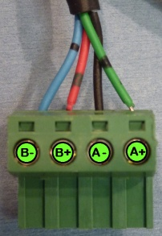
- Wire the bipolar stepper motors to the connectors supplied with the driver board. Wire colors on bipolar stepper motors are standardized.
  - Green = A+
  - Black = A-
  - Red = B+
  - Blue = B-

- Attach Couplers to your stepper motors using the 12 x NF10-32 Cup Point Set Screws.
  - Ensure that the couplers are firmly attached to the motors.
  - Note: The 3D models do not include treads. The parts are labeled with thread size, but they must be tapped after they are manufactured.

- Remove thumb grips from your stereotax.
  - Remove all 3 axes using the hex set-screw in each thumb piece. Keep the Teflon® O-rings (washers) in place.

- Screw the collars onto threaded rod.
  - Tighten down collars with a ¼” set screw.
  - Ensure there is no gap between the collar & Teflon® O-ring. This ensures that coordinates are maintained in both directions.

- Slide each motor & coupler over the collars & stereotax arms. Ensure that the set screw on the collar lines up with the flat portion of the motor shaft. Tighten the ½”set crews on the couplers & ¼” set screws on the collar.

- Prepare CNC Driver Board by setting each of the controller pins to half stepping. There are 6 pins per stepper motor. They must be aligned the same way. Half-stepping allows for double the step resolution (Degrees/step).

  - 1 : On
  - 2 : Off
  - 3 : On
  - 4 : Off
  - 5 : On
  - 6 : Off

Note: This stepper motor driver comes as an exposed circuit board. You may wish to build a case, although it is not necessary. Also, you may use a number of different bipolar stepper motor drivers. If you do, ensure that you follow the setup instructions for the specific board you purchased.

- Plug the motors (X - Y - Z) into the stepper driver, along with the 12v power supply. Also, attach the stepper driver to a computer’s serial port using a DB25 cable.
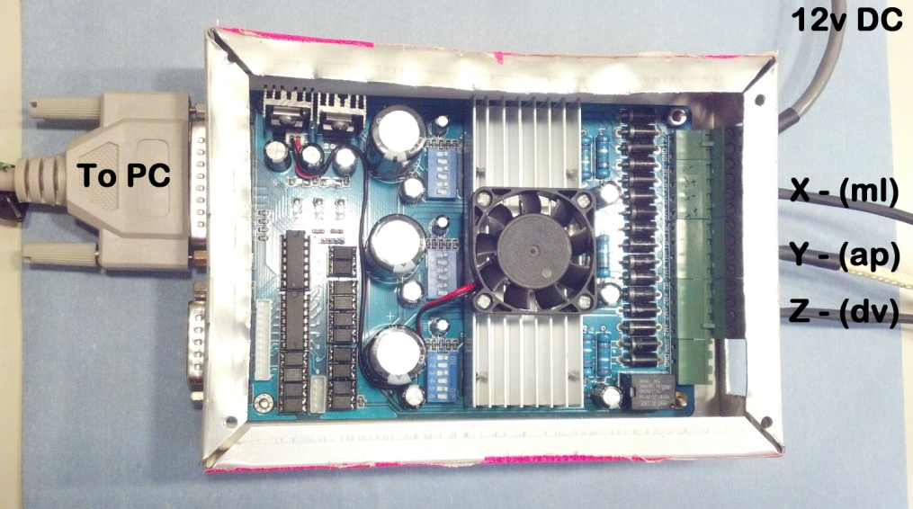

- Install Mach3® onto a personal computer (this will need to be located in your surgical area), following the default instructions. Once installed, openMach3 Mill®to begin configuring the software.

  - Note: The following instruction are intended for use only with a Toshiba TB6560 stepper motor driver.

  - Open Config Ports and Pins Motor Outputs.
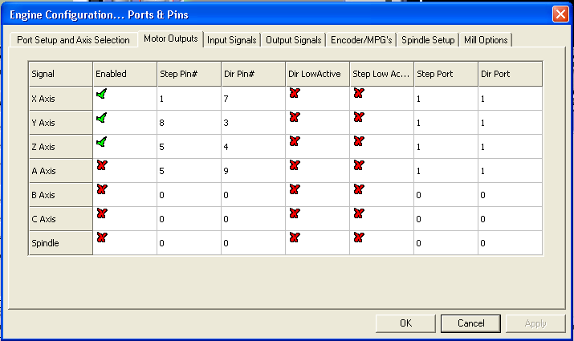
    - Fill in to match, and hit apply

  - OpenConfigPorts and PinsInput Signals.
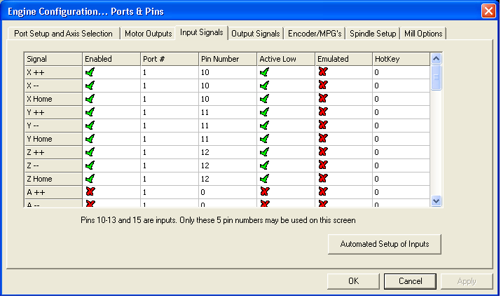
    - Fill in to match and hit apply

  - OpenConfigPorts and PinsOutput Signals.
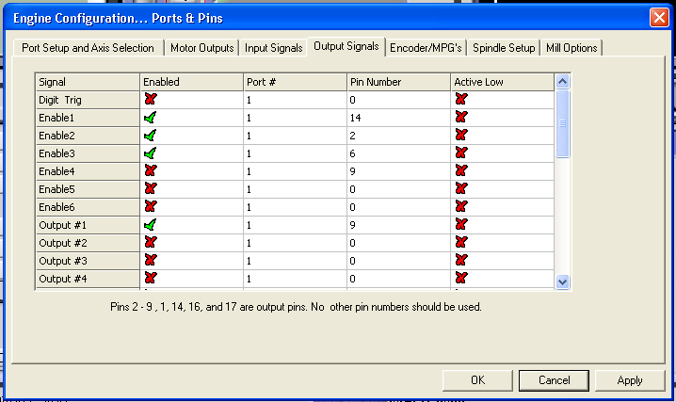
    - Fill in to match and hit apply

  - OpenConfigMotor tuning.
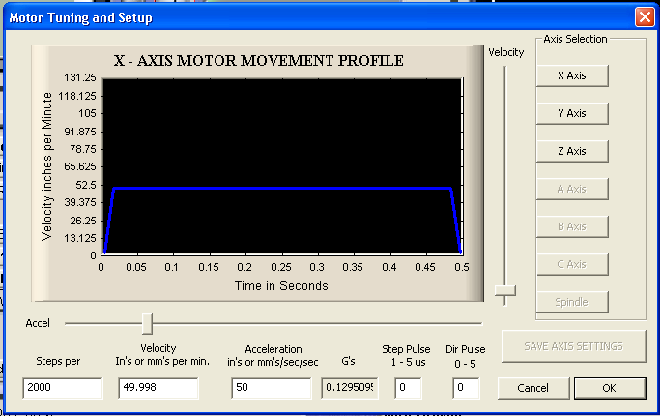
    - Fill in to match and hit SAVE AXIS SETTINGS. Repeat for all 3 axes (same values).

- You are now ready to calibrate your stereotax to the scale of the CNC software. Mach 3 Mill is designed for standard milling machines, so its units of measure are in inches, which will not be proportional to the travel of your stereotax. In order to combat this scaling issue, you must measure the distance traveled in Mach 3® units, per millimeter of stereotax travel.
  - To aid in this process, set your motors’ velocity to 1 inch per minute, and“jog” your stereotax with the arrow keys (X & Y) or PgUp/PgDn (Z) to the nearest millimeter. Then record how far the CNC software travels per 1 mm of stereotax travel. Record this value as the “Scaling constant” for your stereotax. Multiply your skull coordinates by this value to determine the g-code position.
  - It is important that you perform random tests of all 3 axes by programming them to travel some known distances, and ensuring the movements are accurate. If the stereotax travel is too far or short, the scaling constant must be modified accordingly.

- Once scaling is complete, you may use the included Matlab® codes to generate g-code for custom surgeries. However, it is highly recommended that you become familiar with g-code before attempting to auto-generate surgeries. This is imperative for troubleshooting and modifying g-code.

Example Results

- Auto-generating G-Code Example: Performing a Sharp Edge Craniotomy with 3 Skull Screw Holes.

  - OpenSharpEdgeCraniotomy.m& run the code.
  - Select Both to “What Type of Surgery Will You be Performing?”
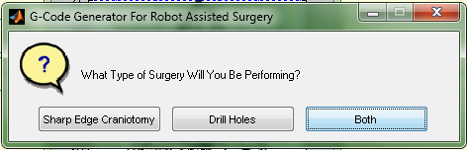

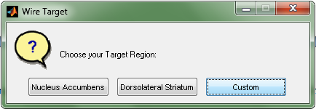
  - Choose Custom, to define the corners of your skull window (Does not need to be square).

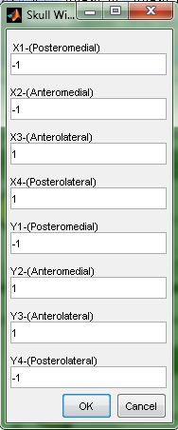
  - Define the X and Y positions of your craniotomy corners.


  - Choose the number of skull holes you wish to drill (3).


  - Choose Define Using Coordinates, and enter the coordinates of each of your holes.

Note: If precise coordinates are not important, you may point and click the holes’ positions onto an image of a rat skull. Positions will be automatically generated.

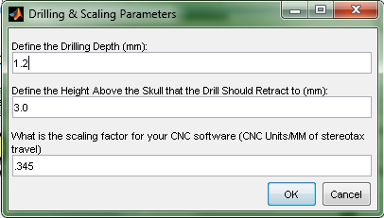
  - Define the drilling parameters. These values are dependent on your stepper motors, and your animal’s skull. The default values should provide a good place to start, but every rat breed and target location has a slightly different skull thickness. For the initial few surgeries using this device, you should be prepared to test the drilling depths and remove any remaining skull pieces manually. The values can then be modified for future surgeries.

  - Name your g-code;it will be automatically generated and saved to your MATLAB® working directory.

- You may now load your g-code into Mach3 Mill®. The code assumes that you will manually position your drill bit on Bregma at the start of the cycle, and that the drill bit will be rotating at speed. Once you press play, the stereotax will perform many passes of the same cut, at different depths. Between each pass, the stereotax will pause, so you may continue or abort cutting. Press “continue cycle” (Alt-R) to continue cutting passes.

  - The final result from the surgery described above should look like this:
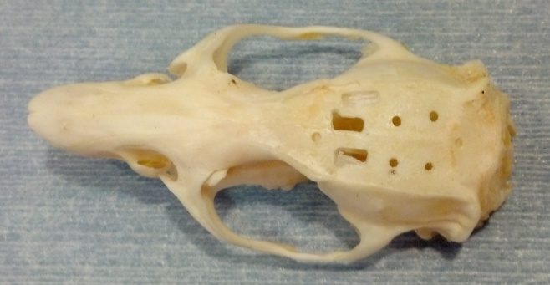

Discussion

The use of automated surgery equipment helps to eliminate some of the most common problems in neuroscience research. First, the tool paths are 100% reproducible. Every cut is guaranteed to be in the same location relative to Bregma. Second, they should reduce experimenter error. Although many researchers are highly skilled surgeons, it takes an exceptional amount of practice to become even a competent surgeon. This device will allow new students to quickly and easily perform highly accurate surgeries. Third, motorized surgery devices should reduce the number of animals needed to perform an experiment⁶. Surgeons will need less training, and mistakes will be made less frequently. Finally, the motorized stereotax is capable of making more precise and accurate movements than the human hand, allowing for more resolution in coordinate choice.
In today’s neuroscience climate, there has been a push to increase the accuracy of surgical methods and techniques. It is no longer enough to target a brain region as a whole when it is clear that smaller sub-regions exist, and that they could be functionally distinct. One example comes from research focusing on microinjections into hippocampus. Not only do individuals desire to target sub-regions, like CA1 and CA3, but they wish to study dorsal and ventral subfields within these regions⁷. However, targeting these regions with manual surgical technique is exceedingly difficult. The benefit of the motorized stereotax approach is that, once the correct coordinates of a target region are identified, every future surgery may be directed to the identical location. However, it’s important to note that morphological differences in the skull and brains of animals will still contribute some error to surgeries.
Another field that would benefit from automating surgeries is chronic microelectrode implantations. Some labs are attempting to lower electrodes into sub-regions of nuclei, such as the sub-regions of globus pallidus or ventral pallidum⁸. Lowering electrodes with a motorized stereotax will not only increase accuracy, but should increase recordable neuron yield. This is due to the fact that microwires cause damage as they are lowered. The robot is capable of lowering the electrodes slower than human hands and at a constant rate, minimizing damage to axons or neurons that very well may be afferent to the target region.
Our robot’s level of accuracy should also be beneficial to thosewho are imaging through skulls, to obtain quantitative measures of optical density⁹. The amount of light that may enter and exit through the skull is dependent on the skull thickness. Our motorized stereotax is capable of ensuring that the entire surface area of the thin skull window has identical depth. This helps light penetrate the window equally across its entire surface.
In all, automating surgeries provides a number of benefits for a modest cost, and as such, is becoming an increasingly popular technique^{10, 11}. But it is important to recognize that the accuracy of the robot depends on quality machining, proper setup, and proper understanding of how CNC machines operate. As long as researchers are willing to take the time to understand the functioning of our motorized stereotax, one may perform surgeries more accurately, with better replicability, and with less training. This makes integrating a motorized stereotax into experiments a smart choice for any lab that performs a large number of stereotactic surgeries.

References:

[1] Yin, H. H., Knowlton, B. J., &Balleine, B. W. (2004). Lesions of dorsolateral striatum preserve outcome expectancy but disrupt habit formation in instrumental learning. European Journal of Neuroscience, 19(1), 181-189.

[2] West, M. O., & Woodward, D. J. (1984). A technique for microiontophoretic study of single neurons in the freely moving rat. Journal of neuroscience methods, 11(3), 179-186.

[3] Peoples, L. L., & West, M. O. (1996). Phasic firing of single neurons in the rat nucleus accumbens correlated with the timing of intravenous cocaine self-administration. The Journal of neuroscience, 16(10), 3459-3473.

[4] Wolske, M., Rompre, P. P., Wise, R. A., & West, M. O. (1993). Activation of single neurons in the rat nucleus accumbens during self-stimulation of the ventral tegmental area. The Journal of neuroscience, 13(1), 1-12.

[5] Bozza, T., McGann, J. P., Mombaerts, P., &Wachowiak, M. (2004). In vivo imaging of neuronal activity by targeted expression of a genetically encoded probe in the mouse. Neuron, 42(1), 9-21.

[6]Pitts, M. Office of Laboratory Animal Welfare, (2002).Institutional animal care and use committee guidebook. Retrieved from website: http://grants.nih.gov/grants/olaw/guidebook.pdf

[7] Yoon, T., & Otto, T. (2007). Differential contributions of dorsal vs. ventral hippocampus to auditory trace fear conditioning. Neurobiology of learning and memory, 87(4), 464-475.

[8] Root, D. H., Ma, S., Barker, D. J., Megehee, L., Striano, B. M., Ralston, C. M., ...& West, M. O. (2012). Differential roles of ventral pallidum subregions during cocaine self‐administration behaviors. The Journal of Comparative Neurology.

[9] Yang, G., Pan, F., Parkhurst, C. N., Grutzendler, J., &Gan, W. B. (2010). Thinned-skull cranial window technique for long-term imaging of the cortex in live mice. Nature protocols, 5(2), 201-208.

[10] Feng, L., Sametsky, E. A., Gusev, A. G., &Uteshev, V. V. (2012). Responsiveness to nicotine of neurons of the caudal nucleus of the solitary tract correlates with the neuronal projection target. Journal of Neurophysiology.

[11] Babaei, P., SoltaniTehrani, B., &Alizadeh, A. (2012). Transplanted Bone Marrow Mesenchymal Stem Cells Improve Memory in Rat Models of Alzheimer's Disease. Stem Cells International, 2012.

