Submission ID #: 50991

Editor Name: Peggy Kruse

Videographer name: John Otterbacher (Kevin Larson)

Film Date: 3/5/2014

Authors and Affiliations: Matthew Moore¹*, Yifan Hu¹*, Sarah Woo¹, Dylan O'Hearn¹, Alexandru D. Iordan^{2,3}, Sanda Dolcos¹, & Florin Dolcos^{1,2,3}
¹Psychology Department, ²Neuroscience Program, ³Beckman Institute for Advanced Science & Technology, University of Illinois Urbana-Champaign, Urbana, IL, USA
* denotes shared first authorship

Title: A Comprehensive Protocol for Manual Segmentation of the Medial Temporal Lobe Structures

Corresponding Author: Florin Dolcos, fdolcos@illinois.edu
Co-authors’ emails: mmoore16@illinois.edu, yifanhu2@illinois.edu, sswoo2@illinois.edu, ohearn1@illinois.edu, iordan2@illinois.edu, sdolcos@illinois.edu

A. If your protocol involves working under a microscope, for example, a complex dissection or microinjection, does your microscope have an attached (or attachable) camera (Y/N) __N_____ or should JoVE send a scope camera so that filming can be done through the microscope (Y/N) __N__?
B. Does your protocol include detailed, step-by-step, descriptions of software usage? (Y/N)___Y____
C. Which steps of your protocol will viewers benefit most from having filmed? Please list 4-6 steps_Viewers will most benefit from the filming of tracing guidelines for 1) the amygdala, 2) the hippocampus, 3) the entorhinal and perirhinal cortices, 4) the parahippocampal cortex.
D. What is the single most difficult aspect of this procedure and what do you do to ensure success? The single most difficult aspect of this procedure is ensuring that the anatomical structures are correctly traced in a 3D space, by checking progress concurrently in all three visual planes (coronal, axial, and sagittal).

1. Introduction (Schematic Overview and Interview)

A. Schematic Overview (read by voice talent at JoVE):

Procedural Narrative:
The overall goal of this procedure is to illustrate how to manually trace the human medial temporal lobe structures on high resolution magnetic resonance images. (Intro)

This is accomplished by first identifying the amygdala in the brain, and tracing it systematically from the anterior to the posterior borders. (P1: Video Editor: Please start by showing P5, then overlay P1 onto the red and have everything P1 fade out. In other words, so P1 emerging from P5. )

The second step is to locate the longitudinal extent and the general borders of the hippocampus, and then trace it slice-by-slice in the anterior-posterior direction. (P2: Video Editor: Have P2 show up underneath P1 (use P5 as a guide), then have P1 fade out, leaving just P2.)

Next, trace the anterior structures of the parahippocampal gyrus, namely the entorhinal and perirhinal cortices, in parallel, to better accommodate variations in their mutual borders. (P3: Video Editor: As above, have P3 appear underneath P2, then have P2 fade out leaving P3.)

The final step is to trace the posterior segment of the parahippocampal gyrus, namely the parahippocampal cortex proper, in the same anterior-posterior fashion. (P4: Video Editor: Have P4 show up behind P3 (use P5 as a guide), then have P3 fade out leaving P4.)

Ultimately, this manual tracing procedure can be used to obtain a 3D rendering and volumetric statistics of all medial temporal lobe structures. (P5)

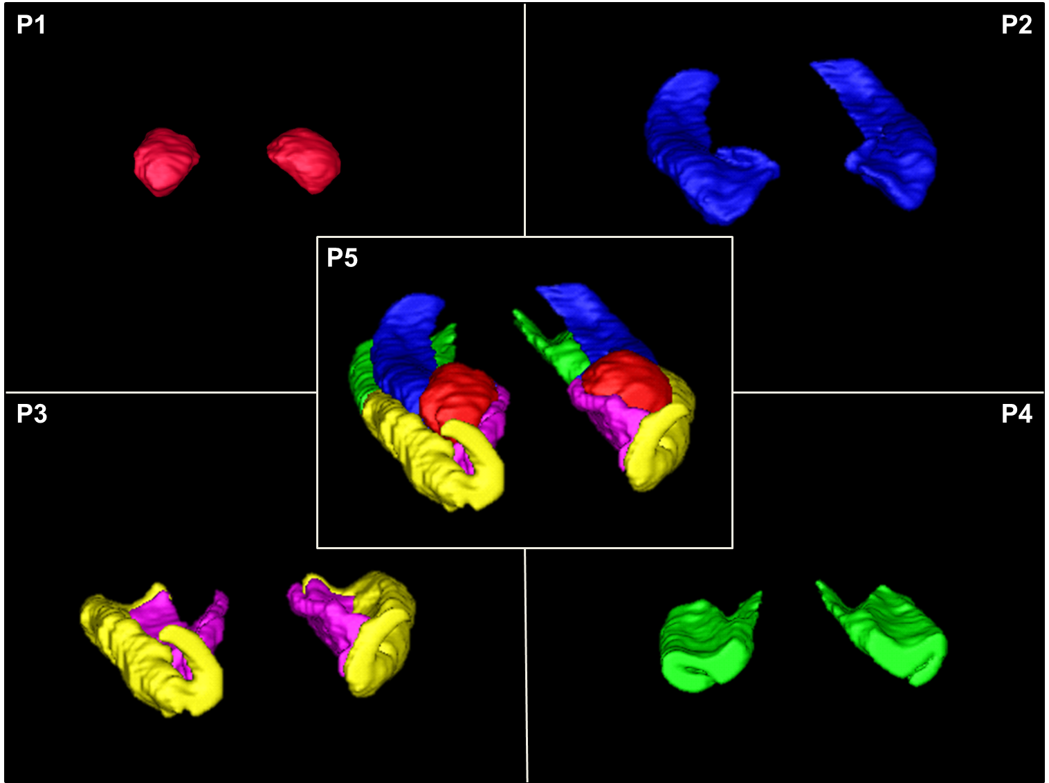
B. Interview: (Said by you on camera. Don’t forget to smile!)

  - Author name _Matt Moore___: The main advantage of this protocol over existing tracing protocols or automatic segmentation algorithms is that it identifies all of the medial temporal lobe structures and their boundaries relative to their neighboring structures, which will increase localization accuracy in manual segmentations and help with evaluation and correction of automatic segmentations in a brain region that can have considerable variability.
  - Author name _Yifan Hu___: The current protocol is useful not only for anatomical investigations in the medial temporal lobe, but can also be applied to other imaging modalities, such as functional Magnetic Resonance Imaging, to identify functional regions of interest with high accuracy.
  - Author name _Florin Dolcos__: This protocol provides unique visual illustration of the medial temporal lobe that can help both advanced and novice researchers accurately identify and localize these structures in the human brain..

Protocol (read by voice talent at JoVE):

Voice Talent: Please do not read the blue text sprinkled throughout the voiceover; e.g., do not read (1st click).”

Video Editor: The authors have added notation in the VO to indicate when to advance in their animation. In other words, the (1st click) notation is guidance for you.

Note from the authors: To illustrate the following steps, we’ve created animated PowerPoint slides that are triggered by mouse clicks. The timing of the animations can also be adjusted to match the speed of narration.
- Amygdala
  - The first demonstration covers tracing of the amygdala. Begin by localizing the structure in the brain.
    - WID: Talent walks to computer and sits down.
    - MED over the shoulder: Talent brings up the brain slice in the imaging software.
    - LAB MEDIA: 50991_Dolcos_Moore_etal_ForFilming_VisualMaterials.pptx, (1st slide) no click.
  - Identify (1st click) the first slice of the amygdala in which (2nd click) the limen insula appears, that is where the white matter connection between the frontal and temporal lobes is continuous…. (3rd click) The optic chiasm is another important landmark…. Then, use (4th click) the angular bundle as the inferolateral border of the amygdala.
    - LAB MEDIA: 50991_Dolcos_Moore_etal_ForFilming_VisualMaterials.pptx, (1st slide) 1st -4th clicks.
  - To identify (1st click) the last slice of the amygdala, in the coronal view, look for a level where the structure is superior to (2nd click) the medial extension of the temporal horn of the lateral ventricle … and lateral to (3rd click) the uncinate gyrus, the protuberance of the head of the hippocampus.
    - LAB MEDIA: 50991_Dolcos_Moore_etal_ForFilming_VisualMaterials.pptx, (2nd slide).
  - Identify the first slice in which (1st click) the anterior commissure is continuous throughout both hemispheres, where the amygdala is visible in its typical shape.
    - LAB MEDIA: 50991_Dolcos_Moore_etal_ForFilming_VisualMaterials.pptx, (3rd slide), 1st click.
  - On slices anterior to or at the same level with the anterior commissure, trace the amygdala using (2nd click) the entorhinal sulcus as the superomedial border, … (3rd click) the imaginary line from the fundus of the semianular sulcus along the white matter to the inferior tip of the amygdala as the inferomedial border,… (4th click) the temporal stem as the lateral border, … and (5th click) follow the superolateral curvature to complete the tracing.
    - LAB MEDIA: 50991_Dolcos_Moore_etal_ForFilming_VisualMaterials.pptx, (3rd slide) 2nd - 5th clicks
  - On slices posterior to the anterior commissure, (1st click) draw an imaginary line from the level of (2nd click) the fundus of the inferior circular sulcus of the insula, … along the semianular gyrus, … to (3rd click) the optic tract as the superior border of the amygdala. Be sure to exclude (4th click) the uncinate gyrus.
    - LAB MEDIA: 50991_Dolcos_Moore_etal_ForFilming_VisualMaterials.pptx, (4th slide) 1st - 4th clicks
  - (5th click) Use (6th click) the alveus … and (7th click) the temporal horn of the lateral ventricle for the inferolateral delineation, … and (8th click) the temporal stem for the lateral border. (9th click) Follow the curvature superolaterally to complete the tracing.
    - LAB MEDIA: 50991_Dolcos_Moore_etal_ForFilming_VisualMaterials.pptx, (4th slide) 5th – 9th clicks.
  - Pay special attention to distinguish the amygdala in its early slices from the surrounding (1st click) areas, uncus and (2nd click) entorhinal cortex, by using sagittal and axial views as guides. (3rd click).
    - LAB MEDIA: 50991_Dolcos_Moore_etal_ForFilming_VisualMaterials.pptx, (5th slide).
  - Then, systematically perform a slice-by-slice tracing of the amygdala in an anterior-to-posterior direction using these guidelines.
    - MED over the shoulder: Talent is tracing part of the amygdala. [Mislabeled as 3.9.1. 3rd take is the best take]
- Hippocampus
  - The next structure in the medial temporal lobe to be localized is the hippocampus.
    - MED over the shoulder: Talent is looking at monitor, with slide 6 visible on the screen.
    - LAB MEDIA: 50991_Dolcos_Moore_etal_ForFilming_VisualMaterials.pptx, (6th slide).
  - (1st click) Begin tracing the hippocampus when (2nd click) the temporal horn of the lateral ventricle appears along the (3rd click) inferolateral border of the amygdala.
    - LAB MEDIA: 50991_Dolcos_Moore_etal_ForFilming_VisualMaterials.pptx, (7th slide).
  - (1st click) End the tracing of the hippocampus with its last appearance inferomedial to (2nd click) the trigone of the lateral ventricle. Always utilize the alternative viewing orientations to help localize the hippocampus and its borders. (3rd click).
    - LAB MEDIA: 50991_Dolcos_Moore_etal_ForFilming_VisualMaterials.pptx, (8th slide).
  - To define the borders of the hippocampus, begin by delineating (1st click) the alveus and the fimbria at the superior aspect … and (2nd click) the temporal horn at the lateral aspect. … (3rd click) Inferiorly, trace along the angular bundle, to define the inferior border.
    - LAB MEDIA: 50991_Dolcos_Moore_etal_ForFilming_VisualMaterials.pptx, (9th slide).
  - Continue tracing the hippocampus using the same definitions throughout.
    - MED over the shoulder: Talent is tracing the hippocampus. [3.5.1/2 is the best take.]
  - Additionally, include (1st click) the subiculum into the segmentation such that it medially borders the lower intensity region of (2nd click) the parahippocampal gyrus, … superiorly aligns with the curve of (3rd click) the uncus, … and primarily extends horizontally from the hippocampus. (4th click).
    - LAB MEDIA: 50991_Dolcos_Moore_etal_ForFilming_VisualMaterials.pptx, (10th slide).
  - Pay special attention when tracing the following three structures: (1st click) … First, include (2nd click) the posterior uncus in the segmentation. (3rd click).
    - LAB MEDIA: 50991_Dolcos_Moore_etal_ForFilming_VisualMaterials.pptx, (11th slide).
  - (1st click) Second, be sure to omit (2nd click) the choroid plexus above (3rd click) the alveus from the segmentation, although this may not be possible on lower-resolution images. (3rd click).
    - LAB MEDIA: 50991_Dolcos_Moore_etal_ForFilming_VisualMaterials.pptx, (12th slide).
  - (1st click) And third, refer to the two alternative views to avoid the inclusion of (2nd click) the tail of the caudate nucleus.
    - LAB MEDIA: 50991_Dolcos_Moore_etal_ForFilming_VisualMaterials.pptx, (13th slide).
- Parahippocampal Gyrus
  - The next area to be traced is the parahippocampal gyrus, a term being used to include the perirhinal cortex on the lateral side, the entorhinal cortex on the medial side, and the parahippocampal cortex proper.
    - MED: Talent takes a sip of coffee or water or something, then turns back to the monitor which has slide 14 visible on screen.
    - LAB MEDIA: 50991_Dolcos_Moore_etal_ForFilming_VisualMaterials.pptx, (14th slide).
  - (1st click) In the anterior slices, define the first slice of the perirhinal cortex with the appearance of (2nd click) the collateral sulcus. … Before the onset of the entorhinal cortex, trace the perirhinal cortex from the medial edge of the lateral bank of the collateral sulcus to the lateral fundus of (3rd click) the gyrus of Schwalbe (pronounced Shh-walbe), or that of the medial one if two gyri of Schwalbe are present, or the midpoint of the dorsal temporopolar surface in the absence of this gyrus.
    - LAB MEDIA: 50991_Dolcos_Moore_etal_ForFilming_VisualMaterials.pptx, (15th slide).
  - (1st click) Start to trace the entorhinal cortex about 5 mm anterior to the limen insula, using (2nd click) the fundus of the medial temporopolar sulcus as the superior end, … and (3rd click) the pial surface as the inferomedial border…. After the amygdala appears, (4th click) the fundus of the semiannular sulcus becomes the superior border, or the point where the imaginary extension of the angular bundle meets the ventricular cavity, if the semiannular sulcus is indistinguishable.
    - LAB MEDIA: 50991_Dolcos_Moore_etal_ForFilming_VisualMaterials.pptx, (16th slide).
  - The border between the perirhinal and the entorhinal cortex may vary from slice to slice. When (1st click) the collateral sulcus is deep, that is, (2nd click) greater or equal to 1.5 cm, trace the perirhinal cortex from the medial edge of the medial bank of this sulcus, to the midpoint of its lateral bank.
    - LAB MEDIA: 50991_Dolcos_Moore_etal_ForFilming_VisualMaterials.pptx, (17th slide).
  - (1st click) In cases with a regular collateral sulcus, that is, (2nd click) with a depth ranging from 1 to 1.5 cm, trace the perirhinal cortex as the area from the midpoint of the medial bank of the collateral sulcus to the medial end of the lateral bank of the sulcus.
    - LAB MEDIA: 50991_Dolcos_Moore_etal_ForFilming_VisualMaterials.pptx, (18th slide).
  - (1st click) In case of a shallow collateral sulcus, that is, (2nd click) less than 1 cm, trace the perirhinal cortex from the fundus of this sulcus to the midpoint of the crown of the fusiform gyrus.
    - LAB MEDIA: 50991_Dolcos_Moore_etal_ForFilming_VisualMaterials.pptx, (19th slide).
  - (1st click) When the collateral sulcus is interrupted, (2nd click) usually at the level of the uncal apex, by a small gyrus emerging from its fundus, … (3rd click) trace the perirhinal cortex to (4th click) the fundus of the lateral sulcus.
    - LAB MEDIA: 50991_Dolcos_Moore_etal_ForFilming_VisualMaterials.pptx, (20th slide).
  - Trace the entorhinal cortex until ~1.5 mm posterior to the uncal apex.
    - LAB MEDIA: 50991_Dolcos_Moore_etal_ForFilming_VisualMaterials.pptx, (21th slide).
  - (1st click, 2nd click) Extend the tracing of the perirhinal cortex medially to occupy the place of the entorhinal cortex after its termination, (3rd click) where the definitions for the latter continue to apply (4th click) until ~4.5 mm posterior to the end of the gyrus intralimbicus. Beyond this, the perirhinal cortex is substituted by the parahippocampal cortex proper. (5th click).
    - LAB MEDIA: 50991_Dolcos_Moore_etal_ForFilming_VisualMaterials.pptx, (21th slide), 1st, 2nd, 3rd, 4th, 5th clicks.
  - (22st slide, 1st click) Start to trace the parahippocampal cortex on (2nd click) the slice immediately posterior to the end of the perirhinal cortex (3rd click), … (23rd slide, 1st click, 2nd click) and end tracing ~4 mm posterior to the end of the hippocampal tail.
    - LAB MEDIA: 50991_Dolcos_Moore_etal_ForFilming_VisualMaterials.pptx, (22nd slide and 23rd slide).
  - (24th slide) Trace the parahippocampal cortex proper in the same way described for the posterior portion of the perirhinal cortex, until (1st click) the calcarine sulcus appears, (2nd click) restricting it to the inferior edge of the sulcus. … (25th slide, 1st click) Should a mini-sulcus appear at around this level, include it in the segmentation. (3rd click).
    - LAB MEDIA: 50991_Dolcos_Moore_etal_ForFilming_VisualMaterials.pptx, (24th slide and 25th slide).
  - A result of tracing the MTL structures is shown here in the 3D rendering, and in 2D images showing the location of representative slices in the brain, on the right side.
    - LAB MEDIA: 50991_Dolcos_Moore_etal_ForFilming_VisualMaterials.pptx, (26th slide, fade the right-hand six grey/colored rectangles for “shown in the 3D rendering” and fade the left-hand 3D images for “and in 2D images.”).
    - WID: Talent stands up and walks away from the computer. [4.12.2/2 is the best take. Use 2nd part within take.]

- Results: Illustration of Possible Differences between Manual and Automatic Segmentation
  - These coronal images of the amygdala show an extreme example of possible differences between results of manual tracing and automatic segmentation. As seen in the right-side panel, a common automatic segmentation software has only identified a small portion of the left amygdala, while neglecting more than half of the tissue that is identifiable as part of the amygdala to an expert human eye. Similar underestimation, but to a lesser extent, also occurred in the right amygdala.
    - LAB MEDIA: 50991_Dolcos_Moore_etal_ForFilming_Figure3.tif (Video Editor: 1st sentence: At “manual tracing,” highlight 3A. At “automatic segmentation,” highlight 3B. 2nd sentence: During “small portion of the left amygdala,” circle the left-hand red area in 3B. During “while neglecting … to an expert human eye,” circle the left-hand red area in 3A. Final sentence: Circle the right-hand red areas in both A and B.)
  - Shown here are representative volumetric results of the bilateral amygdalae and the hippocampi from a single subject, yielded by manual tracing using the present protocol and automatic segmentation. It can be observed that automatic segmentation has underestimated the volume of each of the four structures compared.
    - LAB MEDIA: 50991_Dolcos_Moore_etal_ForFilming_Table1.tif (Video Editor: At “bilateral amygdalae,” highlight the word Amygdala”. At “hippocampi,” highlight the work “Hippocampus”. At “manual tracing,” highlight the first column that is labeled “Manual.” At “automatic segmentation,” highlight the first column that is labeled “Auto.” For the final sentence, highlight the numbers in both tables under the words “Corrected Volume” – a total of 8 numbers should be highlighted.)

- Conclusion (said by authors on camera)
  - Author name _Yifan Hu_: Following this procedure, volume statistics can be collected in order to answer questions such as whether medial temporal lobe structures show volumetric differences between two age groups, or between healthy and clinical groups.
  - Author name _Matt Moore__: While attempting this procedure, to ensure accuracy and efficiency during tracing, it is important to remember to refer to each of the three different viewing planes: coronal, axial, and sagittal.
  - Author name _ Florin Dolcos__: After watching this video, you should have a good understanding of how to accurately identify and manually trace or adjust results of
automatic segmentation of the human medial temporal lobe structures, based on knowing the anatomical borders of these regions..

Provided Media

Insert your media filenames here.
2.1-4.12 - 50991_Dolcos_Moore_etal_ForFilming_VisualMaterials.pptx – Localizing and tracing MTL substructures
5.1 – LAB MEDIA: Figure 3 – Comparison between manual tracing and automatic segmentation on the amygdala.
5.1 – LAB MEDIA: Table 1 – Volumetric comparison between manual tracing and automatic segmentation of the amygdala and the hippocampus.

General Preparation

It’s critical for a smooth and organized shoot that all reagents are accounted for, in advance.

Any overnight or long incubation steps should be recognized and specimens/samples be prepared in advance so that prior steps can be recorded and shooting can continue with pre-prepared specimens/samples.

All tubes/flasks should be pre-labeled neatly before we arrive.
Ex. Luciferase assay done in 96 well plates should be labeled with negative/positive control wells and experimental samples are labeled accordingly.

You will receive more detailed preparation instructions, as well as an introduction to your videographer, closer to your filming date.

