Submission ID #: 50984
Editor Name: Pallavi R. Devchand
Videographer name:Kevin McRoberts
Film Date: 31 July, 2013
Authors and Affiliations: James I. Andorko IV^{#,1} , Lisa H. Tostanoski^{#,1}, Eduardo Solano¹, Maryam Mukhamedova¹, Christopher M. Jewell*^{,1}
#- These authors contributed equally
1- Fischell Department of Bioengineering, University of Maryland, College Park, MD 20742 USA
Title: Intra-lymph node injection of biodegradable polymer particles
Corresponding Author: cmjewell@umd.edu

A. Will you require JoVE to record video microscopy, such as filming a complex dissection or microinjection technique? (Y/N) NO
B. Does your protocol include detailed, step-by-step, descriptions of software usage? (Y/N) NO
C. Which steps of your protocol will viewers benefit most from having filmed? Section 5: i.LN. Injection of Particles
D. What is the single most difficult aspect of this procedure and what do you do to ensure success? Performing the lymph node injections. Removew fur, add a dye, practice injections.

1. Introduction (Schematic Overview and Interview)

A. Schematic Overview (read by voice talent at JoVE):

Procedural Narrative:

The overall goal of this procedure is to deposit biomaterial vaccine particles into lymph nodes using a direct injection technique. (Intro)
First, synthesize the lipid-stabilized polymer particles using a double emulsion method (P1).
Then wash the particles, and measure the material propeties such as size, cargo loading, or stability (P2).
Next, adminster a tracer dye at the tail base of the mouse to allow visualization after drainage of the dye to the lymph node (P3).
The final step is to identify the dye-labeled lymph node and inject a small volume of polymer particles at this location (P4).
Histology, immunofluorescence, and confocal microscopy can be used to confirm the presence and distribution of particles in the inguinal lymph nodes (P5).
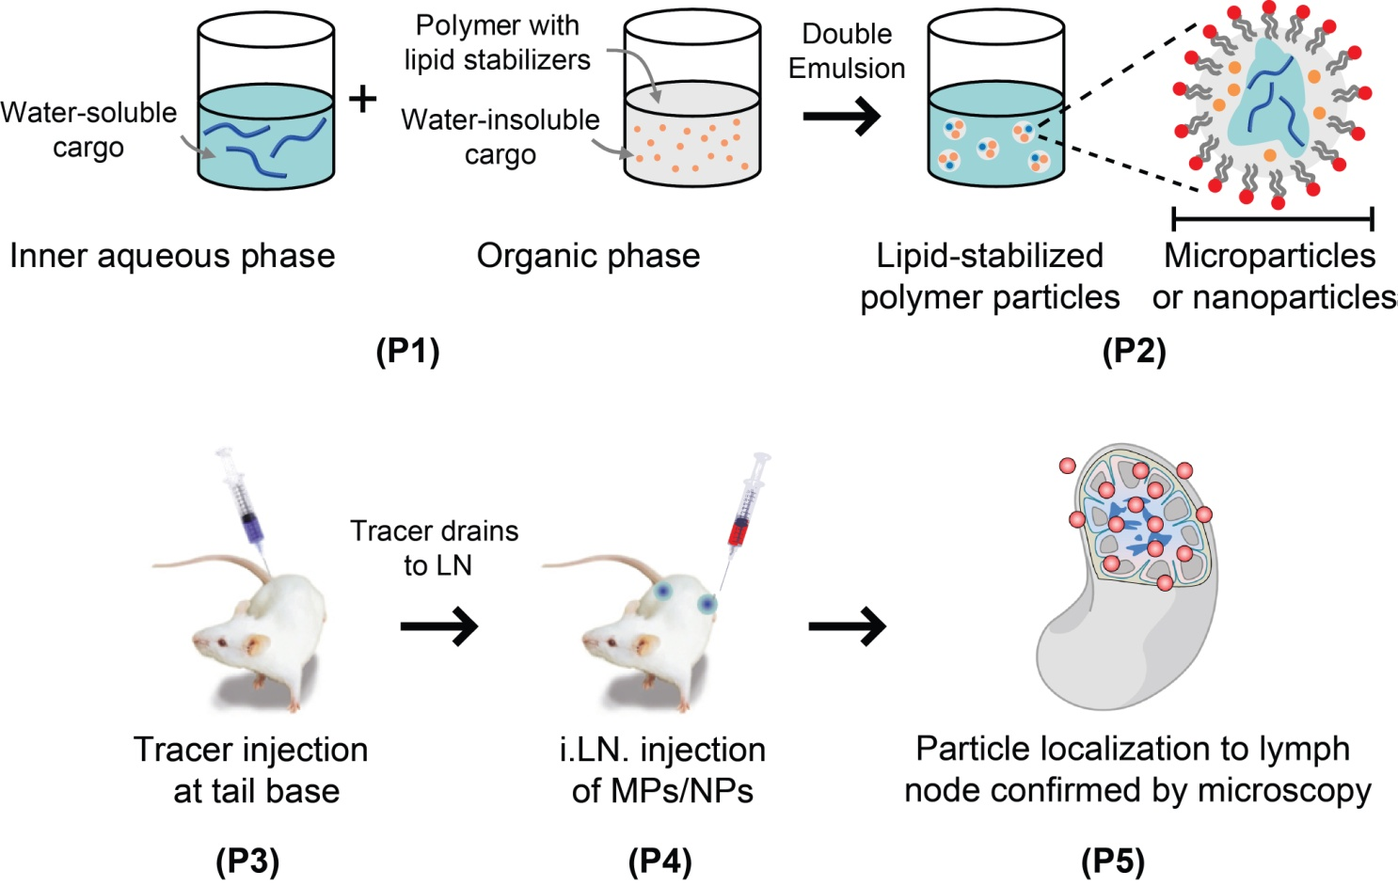

B. Interview: (Said by you on camera. Don’t forget to smile!)
  - Lisa H. Tostonkoski: Combining the direct injection of lymph nodes with biomaterials for vaccination enables tight control over the combinations and doses of vaccine components in the lymph node microenvironment, and allows for the controlled release of cargo in these tissues.
  - Christopher M. Jewell: All vaccines must reach lymph nodes to be effective. So defining how biomaterials and incorporated immune cues impact lymph node signaling is important to link these local events to systemic immune response. This knowledge will help us better understand howbiomaterial vaccines adminstered along traditional routes function.
  - James Andorko: Although intra-lymph node delivery of biomaterials serves as a tool to study the effects of biomaterials on the organization of lymph nodes, this platform also provides an applied opportunity to develop new therapeutic vaccines and immunotherapies aimed at cancer and autoimmune disorders.

Protocol (read by voice talent at JoVE):
- Synthesis of Lipid-Stabilized Micro and Nanoparticles
  - For microparticles, sonicate the organic phase containing the polymer, lipid, and other water-insoluble cargo on ice at 12 W. To create the water-in-oil emulsion, add 500 µL of distilled H₂O, or H₂O containing 1mg of peptide, protein, or other water soluble cargo.
    - MED/CU: Talent sonicates the organic phase containing the polymer, lipid, and other water-insoluble cargo on ice (if possible show 12 W setting).
    - ECU: Talent adds 500 µL of distilled H₂O.

  - Continue sonicating for 30 seconds, gently rocking the vial up and down and side to side around the sonicator tip to ensure complete emulsification.
    - CU/ECU: Talent sonicates while gently rocking the vial up and down and side to side around the sonicator tip.

  - Now prepare the water-in-oil-in-water emulsion by pouring the water-oil emulsion into 40 mL of H₂O. Homogenize for 3 minutes at 16,000 rpm.
    - MED/CU: Talent pours the water-oil emulsion into 40 mL of H₂O in a 150 mL beaker.
    - ECU: Talent homogenizes the sample for at 16,000 rpm.

  - Next, add a magnetic stir bar, and stir the water-in-oil-in-water emulsion overnight to remove the excess solvent.
    - MED-over-the-shoulder: Talent transfers the beaker to a stir plate, and adds a magnetic stir bar, and starts the stirrer.
  - Section 2.5 was cut since it was similar filming to synthesis of microparticle
  - After overnight removal of solvent, pour the emulsion through a 40 micron nylon mesh cell strainer into a 50 mL conical tube. Centrifuge for 5 minutes [Text over video: 5,000x g for microparticles, 24,000x g for nanoparticles].
    - CU: Talent pours the emulsion through a 40 micron nylon mesh cell strainer into a 50 mL conical tube.
    - MED: Talent removes the samples from the centrifuge.

  - Decant the supernatant, re-suspend the pellet of particles in 1 mL of water and transfer the suspended particles to a 1.5 mL microcentrifuge tube. Harvest the particles by a 5-minute centrifugation [Text over video: 5,000x g for microparticles 24,000x g for nanoparticles].
    - MED: Talent decant the supernatant.
    - CU: Talent re-suspends the pellet of particles in 1 mL of water and transfers the suspended particles to a 1.5 mL microcentrifuge tube.
    - MED-over-the-shoulder: Talent places the microfuge tubes into the centrifuge.

- Determination of Particle Size
  - Ensure the volume of water added to the fraction cell is at a sufficient level for alignment and blanking.
  - MED: Talent investigates level of water in cuvette.

3.1.1 SCREEN: On the instrument software interface, Talent aligns and blanks cuvette
  - Pipette 10 µL of particle suspension [Text over video: ~ 0.5 mg] into the fraction cell.
    - CU: Talent pipettes 10 µL of particle suspension into the fraction cell.

  - Close the particle size analyzer compartment door. Then measure particle size using a refractive index of 1.60 for PLGA. (TAKE 2: Rearranged sentence, as “1.60 for” is stupid.)
    - MED: Talent closes the particle size analyzer compartment door.
    - SCREEN: Talent verifies signal strength is in appropriate range, ensures refractive index of 1.60 for PLGA, and measures particle size. (LAB MEDIA: 50984_Jewell_Screen Capture Step 3-3-2.mp4)
  - Use the software interface to calculate particle diameter using a number basis.
    - SCREEN: Talent calculates particle diameter using a number basis. (LAB MEDIA: 50984_Jewell_Screen Capture Step 3-4-1.mp4)
- Preparation of Mice for i.LN. Injection
  - One day prior to injection, anesthetize the mouse [Text over video: isoflurane] according to an IACUC approved animal protocol. Evaluate the depth of anesthesia with a toe pinch reflex test and monitor breathing to ensure a respiratory rate of 100-120 BPM.
    - WIDE/MED: Talent places the anesthetized on working surface.
    - CU: Talent pinches the mouse’s toe with fingers.
    - MED/CU: Talent monitors the mouse’s breathing to ensure a respiratory rate of 100-120 BPM.

  - Shave the hair at the base of the tail and the hindquarter. Remove the hair from the ventral side of the animal, and laterally around to the dorsal side just above the joint of the hind leg.
    - CU: Talent shaves the hair at the base of the tail and the hindquarter- using clippers.
    - CU: Talent removes the hair from the ventral side of the animal, and laterally around to the dorsal side just above the joint of the hind leg.

  - For each dye injection, use a micropipette to transfer 10 μL of dye solution into a microcentrifuge tube, and aspirate the entire 10 μL through a 31 gauge needle into a 1 mL insulin syringe.
    - ECU: Talent uses a micropipette to transfer 10 μL of dye solution into a microcentrifuge tube.
    - CU: Talent aspirates the entire 10 μL through a 31 gauge needle into a 1 mL syringe.

  - Now, inject 10 μL of dye solution subcutaneously on each side of the tail base, reloading in between injections. Apply a mild depilatory cream to remove the remaining hair. Be sure to coat the area in between the hind thigh and the abdomen.
    - CU: Talent injects 10 μL of dye solution subcutaneously on each side of the tail base, using a separate needle containing 10ul of dye for each injection.
    - MED: Talent applies a mild depilatory cream on a cotton swab and starts to remove the remaining hair, coating the area in between the hind thigh and the abdomen.

  - After 3 minutes, use a wet gloved hand with warm H₂O and gently rub the depilatory cream into the skin. Repeat imediately to remove the excess depilatory.
    - CU: Talent uses a wet gloved hand with warm H₂O and gently rubs the depilatory cream into skin.
    - MED: Talent dips a wet gloved hand into warm H₂O and removes the excess depilatory.

  - Next, wet a soft cloth or paper towel with warm water and in a single motion, wipe the lower portion of the mouse. Place the mouse under a heat lamp to recover, and then return to holding for a day.
    - CU: Talent wets a paper towel with warm water and in a single motion, wipe lower portion of mouse.
    - MED: Talent places the mouse under a heat lamp to recover. (Comment: First shot, mouse returned directly to cage, Second shot, a dry paper towel was used to dry the mouse before returning to the cage)

- i.LN. Injection of Particles
  - Examine the aneasthesized mouse to confirm drainage of tracer dye into each inguinal lymph node. The lymph node should be visible as a dark spot near the hind thigh and abdomen.
    - MED/CU: Talent examines the drainage of tracer dye into each inguinal lymph node.
    - ECU: Talent indicates with forceps the lymph node (dark spot ) near the hind thigh and abdomen.

  - Now re-suspend the particles in distilled water at desired injection concentration. For each injection, use a micropipette to transfer 10 µL of particle solution into a microcentrifuge tube.
    - MED:CU: Talent mixes the particle suspension by pipetting up and down with a micropette.
    - ECU: With a micropipette, Talent transfers 10 µL of particle solution into a microcentrifuge tube.

  - Aspirate the entire 10 µL into a 31 gauge insulin needle attached to a 1 mL syringe.
    - MED/CU: Talent aspirates the entire 10 µL into a 31 gauge insulin needle attached to a 1 mL syringe.

  - Pull the skin taut around the dyed lymph node. With the needle at a 90° angle to the skin, penetrate the skin to a depth of 1 mm. Slowly inject the entire volume, monitoring for visible lymph node enlargement.
    - CU/ECU: Using thumb, index finger, and middle finger, Talent pulls the skin taunt around the dyed lymph node.
    - ECU: With the needle at a 90° angle to the skin, Talent penetrate the skin to a depth of 1 mm and slowly injects the entire volume, (if possible end on focus on lymph node enlargement).

  - Allow the mouse to recover under a heat lamp and then return to holding or conduct additional testing.
    - MED: Talent places the mouse under a heat lamp
    - ECU: Talent return to the mouse to it’s cage.

- Results: Particle synthesis, animal preparation and lymph node injection
  - First, confirm the particle synthesis and size distribution. The emulsion/solvent evaporation synthesis protocol can be qualitatively assessed by visual inspection of the final emulsions generated. Emulsions should be a homogenous suspension, free of visibile aggregates.
    - LAB MEDIA: <This should be the video clip of the final emulsion from Step 2.4, as referenced in section MEDIA: 6.2.1.

  - Particle size distribution can be confirmed by laser diffraction or dynamic light scattering. Particle samples should exhibit a mono-modal distribution.
    - LAB MEDIA: Figure 1B.

  - Further qualitative assessment of the particle synthesis can be achieved through modification of the protocol to incorporate one or more fluorescent cargos, such as a fluorescent peptide or lipophilic dye.
    - LAB MEDIA: Figure 1C.

- Injection of the dye at the tailbase will lead to localization in the inguinal lymph nodes

  - Dye can be used to locate and target the lymph node for particle injection. During training, mice may be euthanized and necropsied following dye injection to gain familiarity with lymph node locations. (TAKE 2: Use this one if we don’t really encourage the behavior)

    - LAB MEDIA: Figure 2B.

- Histological processing of excised lymph nodes and immunoflorescent staining can be used to analyze lymph nodes

  - Particle distribution within the T and B cell zones of the injected lymph node is confirmed by confocal microscopy of sectioned and stained lymph nodes.
    - LAB MEDIA: Figure 2C

  - Differences in particle properties, such as size, can be observed in lymph nodes following injection and imaging by fluorescence microscopy.

    - LAB MEDIA: Figure 2D

- Conclusion (said by authors on camera)
  - Maryam Mukhamedova: Once mastered, this technique can be completed over the span of two days. Particle synthesis and animal prepartion occur on the first day. Particle washing,characterization, and intralymph node injection are performed on the second day.
  - Lisa H. Tostanoski: After watching this video, you should have a good understanding of how a tracer dye can be used to visualize and inject the inguinal lymph nodes of mice. This technique enables non-surgical delivery of biomaterial vaccine carriers directly to lymph node with a level of control that was not previously possible.
  - James I. Andorko: Direct lymph node delivery of biomaterials will allow scientists and engineers in immunology and vaccine devleopment to explore the fundamental interactions of biomaterials, vaccines, and immune signals with the lymph node, shedding new light on the mechanisms by which these material stimulate and shape immunity.

Provided Media

6.2.1 <PLEASE INSERT A SHORT VIDEO FROM FILMING Step 2.4> - Video of stable emulsion

Movie was taken during filming of a stable emulsion (First shot recorded).

6.3.1. 50984_Jewell_Figure 1B – Size distribution plot of protein-loaded micro and nanoparticles

6.4.1. 50984_Jewell_Figure 1C – Individual and overaly fluorescenet microscopy images of cargo-loaded microparticles at 600X total magnification

7.1.1. 50984_Jewell_Figure 2B – Photographic images showing external (top image) and internal (bottom image) views of a dyed lymph node

8.1.1. LAB MEDIA: Figure 2C – Composite three color confocal microscopy image of an injected lymph node

8.2.1. LAB MEDIA: Figure 2D – Fluorescent and bright field overlay images of lymph nodes injected with particles of differing size

