Submission ID #: 50985

Editor Name: Roslyn A. Bauer

Videographer name: Danae Mauro

Film Date: 9/27/2013

AUTHORS
Matteo FOSSATI^{1,2,3}
m.fossati@in.cnr.it

Nica BORGESE^{2,3,4}
n.borgese@in.cnr.it

Sara Francesca COLOMBO^{2,3}
s.colombo@in.cnr.it

Maura Francolini^{1,2}
maura.francolini@fondazionefilarete.com

¹Fondazione Filarete, Milan, Italy
²Dept. of Medical Biotechnology and Translational Medicine, University of Milan, Italy
³Institute of Neuroscience, National Research Council (CNR), Milan, Italy
⁴Department of Health Science, ‘‘Magna Graecia’’ University of Catanzaro, Roccelletta di Borgia, Cosenza, Italy

Title: Visualization of endoplasmic reticulum sub-domains in cultured cells

Authors, please fill out the brief questionnaire below.

A. Will you require assistance with video microscopy, such as filming a complex dissection or microinjection technique (Y/N, please specify steps by number. Also, please list make and model of your microscope)? _____N_____
B. Does your protocol include detailed, step-by-step, descriptions of software usage (Y/N, please specify steps by number)? ___N______
C. Which steps of your protocol will viewers benefit most from having filmed? Please list 4-6 steps: P2.6; P3.1; P3.10; P3.11; P4.3; P4.13
D. What is the single most difficult aspect of this procedure and what do you do to ensure success?
Cell viability, transfection efficiency, confocal microscopy set-up. All these aspects are carefully routinely checked in our laboratories

Introduction (Schematic Overview and Interview)

- Schematic Overview (read by voice talent at JoVE):
  - The overall goal of the following experiment is to investigate how transfected fluorescent proteins are distributed and move in the endoplasmic reticulum, and to assess the effect of expression on the ultrastructural architecture.
    - Intro

  - To do this, cultured cells are transiently transfected with GFP-tagged tail-anchored ER-resident proteins.
    - 50985_Fossati_SchematicOverview (C1)

  - Following transfection, live-cell confocal imaging is performed to assess Fluorescence Recovery after Photobleaching -or FRAP- and Fluorescence Loss in Photobleaching -or FLIP.
    - 50985_Fossati_SchematicOverview (C2)

  - Ultrastructural analyses is performed using transmission electron microscopy.
    - 50985_Fossati_SchematicOverview (C3)

  - The resulting data demonstrate that the expression of GFP-tagged b(5) construct dramatically alters the organisation and structure of the endoplasmic reticulum, inducing the formation of aggregates.
    - 50985_Fossati_SchematicOverview (C4)

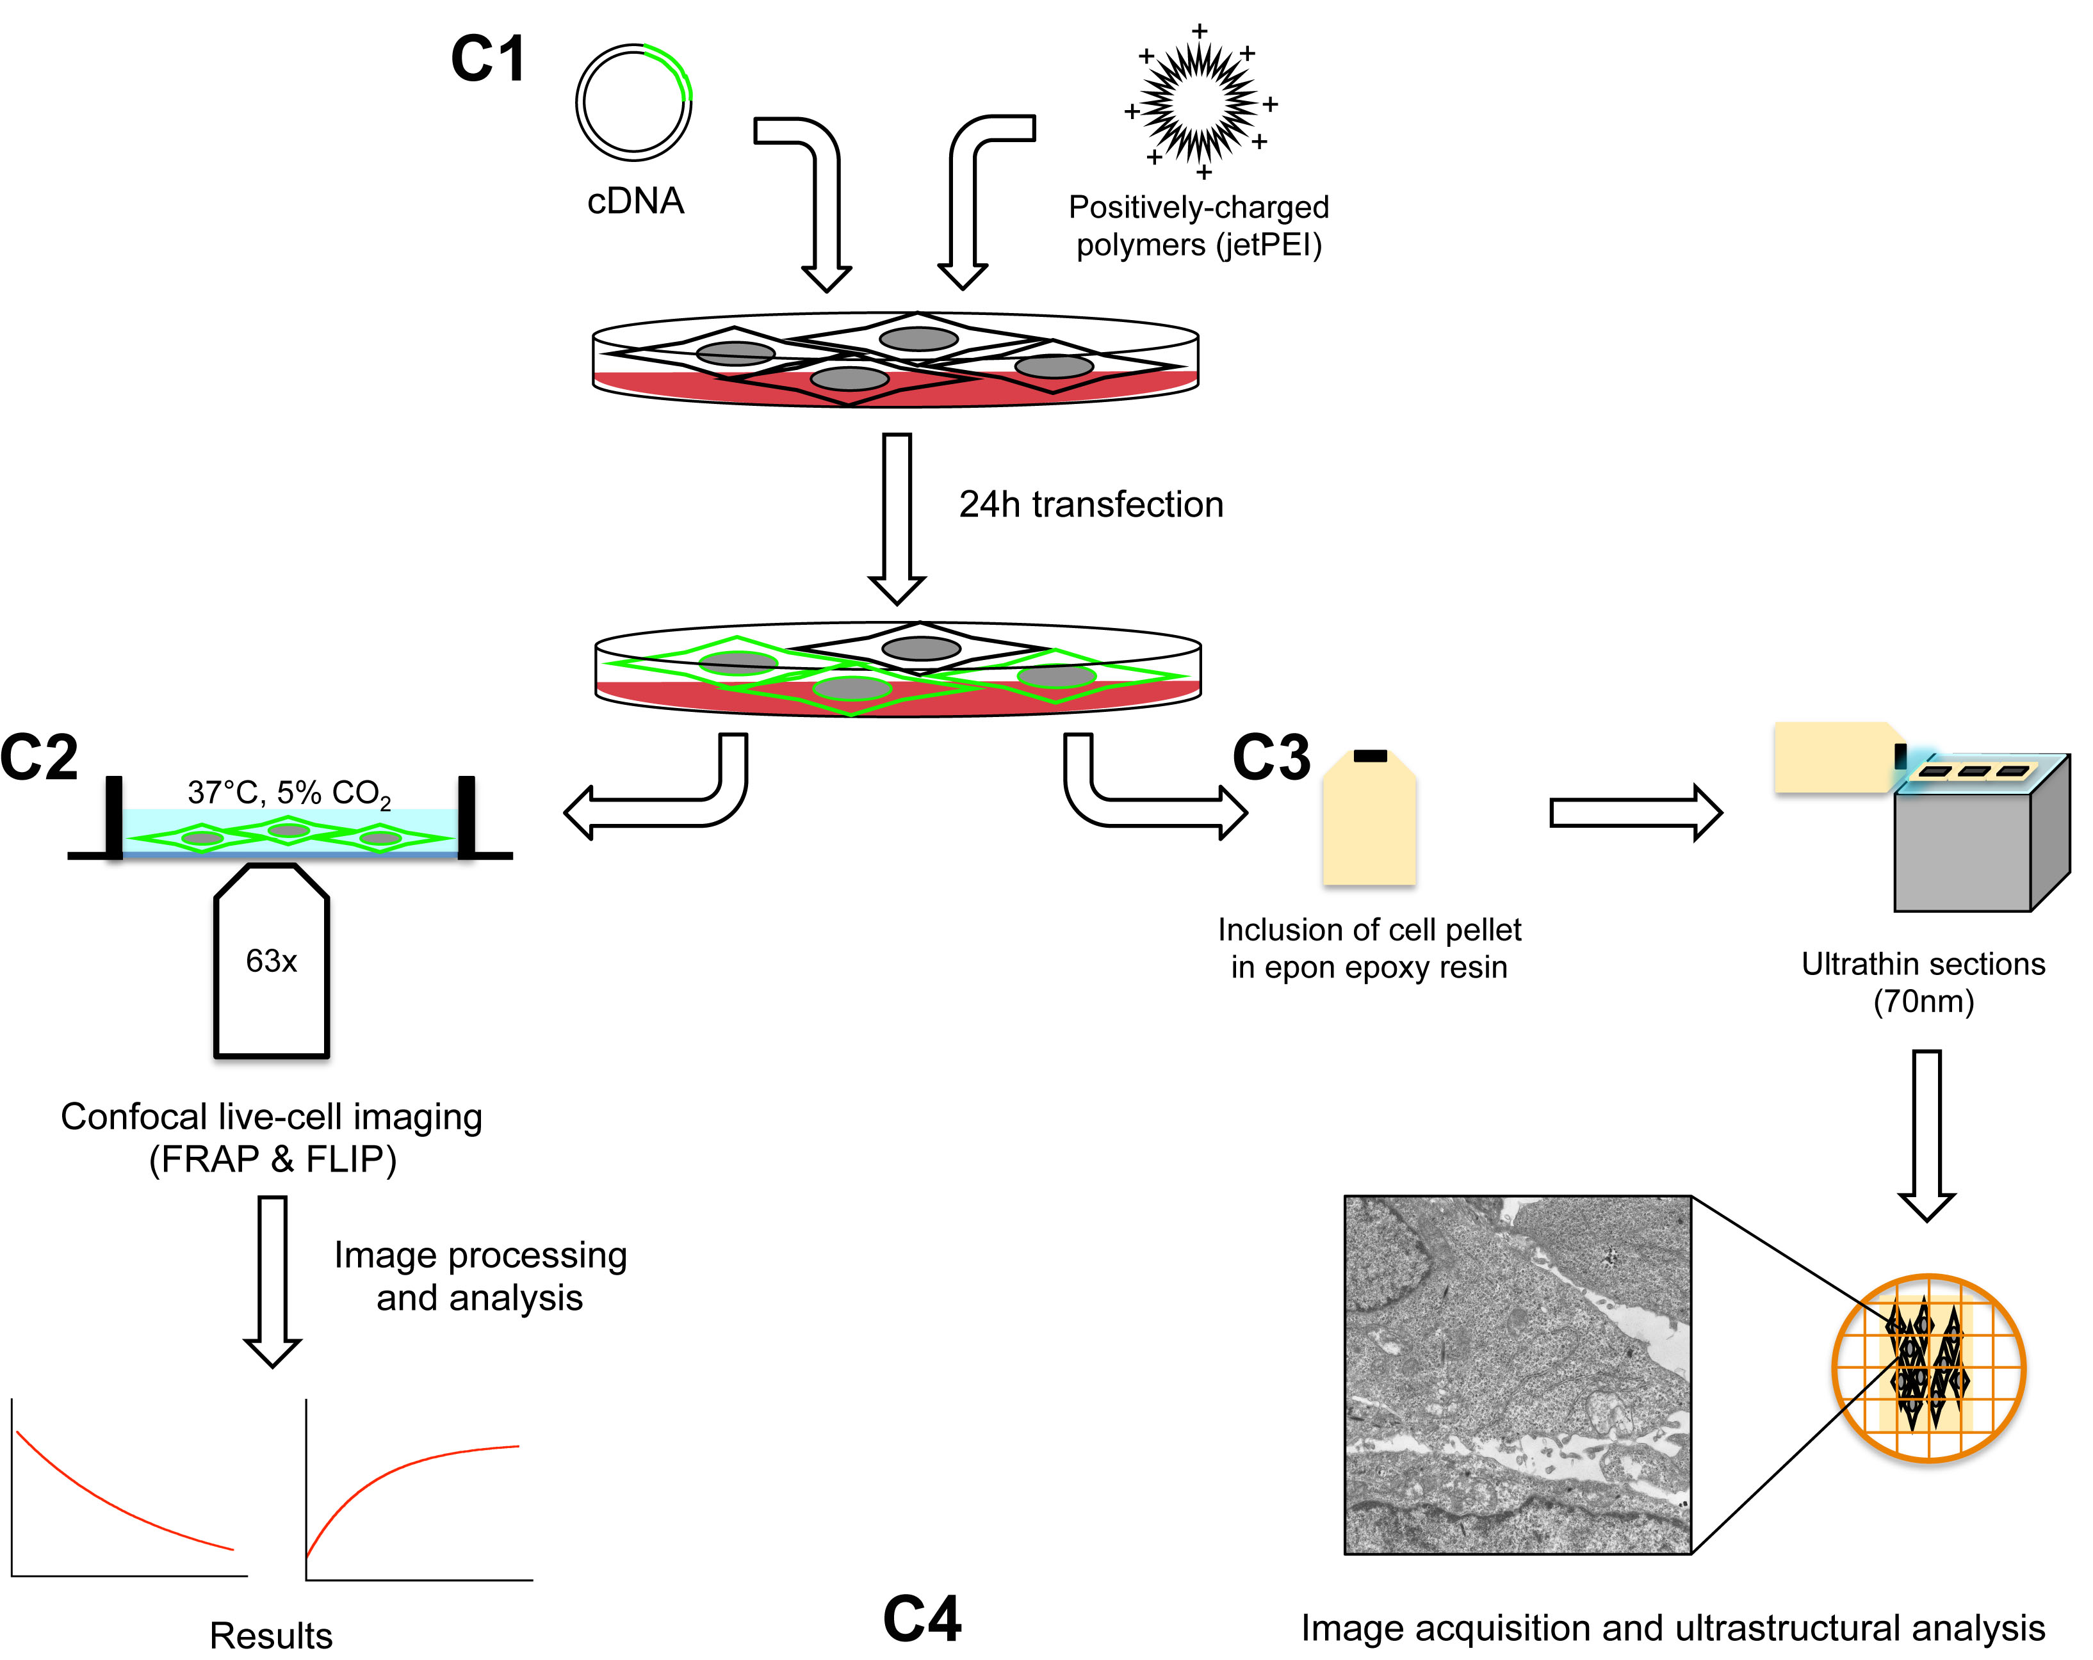

- Interview: (Said by you on camera. Don’t forget to smile!)

  - [Matteo Fossati]: The method we demonstrate here can provide insight into basic cell biology processes such as protein and lipid mobility and trafficking.

  - [Matteo Fossati]: It can also be used to study responses to pharmacological treatments, evaluate fluorescent protein oligomerization, or to study the role of pathogenic mutant proteins in the formation of intracellular aggregates of ER origin that may be relevant to their pathogenicity, such as in ALS.

Protocol (read by voice talent at JoVE):
- Plasmid, cell culture and transfection with ER fluorescent proteins
  - The plasmid used in this study consists of an enhanced version of GFP fused at its C-terminus to the tail region of the ER isoform of rat cytochrome b(5) via a linker sequence.
    - LAB MEDIA: 50985_Fossati_ConstructMap (A) (showing the GFP tagged b5 and linker sequence)

  - The tail region of b(5) contains the entire sequence that remains membrane-associated after cleavage by trypsin. This includes the 17-residue transmembrane domain, flanked by upstream and downstream polar sequences.
    - LAB MEDIA: 50985_Fossati_ConstructMap (B) - a diagram to describe the b5 tail region) (Editor use arrows to highlight Pro94-Asp13, then use an arrow to indicate the transmembrane domain, then use 2 arrows to show upstream and downstream polar sequences)

  - The linker consists of the myc (pronounced “mick”) epitope followed by [(Gly)₄Ser]₃. The entire cDNA is inserted into the HindIII-XbaI sites of the mammalian expression vector pCDNA3.
    - LAB MEDIA: 50985_Fossati_ConstructMap ©- Show plasmid before and after insertion of the construct)

  - In preparation for transfection, grow COS-7 cells in supplemented DMEM at 37°C and 5% CO₂. (Text overlay: DMEM + 10% FBS + 2 mM L-glutamine + 1% penicillin/streptomycin)
    - MED: Talent approaches the incubator, opens it, and takes a Petri dish of cells from the inside

  - The day before transfection, plate 3x10⁵ cells on round 24 mm glass coverslips in a 6-well plate.
    - CU: Talent pipettes cells onto coverslips in 6 well plate

  - The next day, transfect the cells with the JetPEI system as described by the manufacturer. Here, a JetPEI to DNA ratio of 2:1 is used. This typically leads to a transfection efficiency of 70-80%. (Text overlay: Note: The optimal JetPEI/DNA ratio should be determined for the plasmid and cell line used)
    - MED: Talent, working in hood, transfects cells

  - Maintain the cells at 37°C and 5% CO₂ for 24 hours prior to imaging.
    - CU: Talent places transfected cells into the incubator

- Live fluorescence scanning confocal microscopy
  - Next, use forceps to transfer a coverslip with transfected cells into the imaging chamber. Return the tissue culture dish to the incubator to save the remaining cells for ultrastructural analysis by electron microscopy.
    - CU: Talent uses forceps to transfer a coverslip with transfected cells into the imaging chamber.
    - CU: Talent shows the dish that they will save and sets it aside.

  - For live cell imaging, add 2 ml of imaging medium to a steel cell culture chamber. OxyFluor is included in the imaging medium to prevent the samples from photobleaching. (Text overlay: DMEM without phenol red, supplemented with 10% FBS, 2 mM L-glutamine, 1% pen/strep, 25 mM Hepes, 50 g/ml cycloheximide and 1:100 OxyFluor)
    - MED: Talent adds imaging medium to a few wells of the imaging chamber containing coverslip with transfected cells
    - CU: Talent adds imaging medium to a few more wells of the imaging chamber
CANCELLED: all in 3.1.1.

  - Matteo Fossati: “All experiments must be performed in the presence of cycloheximide, a translation inhibitor, to avoid any increase in the ER fluorescence signal, and consequently total fluorescence, due to protein biosynthesis.
    - MED: Talent looks up from adding medium to the imaging chamber and says the above line

  - (Text overlay: 37°C and 5% CO₂) Place the imaging chamber on the stage of a confocal microscope equipped with a temperature-controlled CO₂ incubator and appropriate lasers with appropriate photomultiplier settings.
    - MED: Talent places the imaging chamber on the stage of the confocal microscope

  - To perform fluorescence recovery after photobleaching or “FRAP”, bring the cells into focus. Set the acquisition parameters to avoid saturation of pixels. Also ensure that the laser power is set as low as possible to avoid photobleaching due to image acquisition.
    - SCREEN: Talent brings cells into focus and sets the imaging conditions
    - MED: Talent, seated at computer sets imaging parameters

  - Once the imaging parameters are set, move to a new field of view with two or more cells. One cell in each acquisition field should remain unbleached so it can be used to normalize the fluorescence signal of the bleached cell or cells.
    - SCREEN: Talent moves to a field of view with several cells in it

  - For bleaching, draw a region of interest or “ROI”, corresponding to an organized smooth endoplasmic reticulum, or “OSER”.
    - SCREEN: Talent draws an ROI

  - Set the imaging program to bleach using an adequate number of iterations for efficient and rapid photobleaching. If needed, a combination of 488 nm and 405 nm lasers can be used. (Text overlay: 100% 30 mW Argon laser, 60% 30 mW Diode laser).
    - SCREEN: Talent sets the imaging program to bleach as specified above

  - Instruct the software to capture a single frame every 10 seconds for 10 minutes over the entire course of the experiment. (Text overlay: pixel time = 1.61 μs/px) This includes the pre-bleach, bleach, and recovery periods.
    - SCREEN: Talent sets the program to record the experiment

  - Once everything is set, initiate bleaching and capture. When the capture is complete, move to a new field of view and repeat this process. Capture 4 to 5 fields of view for each coverslip.
    - MED: Talent seated at computer initiates capture.
    - SCREEN: Imaging capture completes and talent moves to a new field of view.

  - Next, to measure fluorescence loss in photobleaching or “FLIP”, instruct the program to perform a sequence of bleaching and post-bleaching imaging for 10 seconds, every 30 seconds for 10 minutes (text overlay: pixel time = 1.61 μs/px).
    - SCREEN: Talent sets the program to do FLIP bleaching and post bleaching

  - Move to a new field of view. Draw an ROI corresponding to an OSER structure and initiate bleaching and capture as before.
    - MED: Talent moves to a new field of view
    - SCREEN: Talent draws and ROI for OSER
    - MED: Talent initiates capture for FLIP experiments

  - For analysis, import the FRAP and FLIP images into ImageJ software. (text overlay: http://rsbweb.nih.gov/ij/download.html)
    - MED: Talent, seated at computer imports images into image J

  - First assess the fluorescence recovery of the bleached ROI over time for the FRAP experiments, and then determine the background fluorescence by selecting an area outside the cells and measure its mean intensity over time.
    - SCREEN: Talent selects area outside cells and measures its mean intensity over time

  - Next, subtract the background signal from the fluorescent intensities of the ROIs.
    - SCREEN: Talent subtracts the background signal

  - Normalize the data to the total fluorescence of the bleached cell, which should be constant over time.
    - SCREEN: Talent normalizes the data to the total florescence of the bleached cell

  - Then, fit the monoexponential equation shown here: where F_{post} is the fluorescence signal after photobleaching, F_{rec} is the maximum fluorescence recovery value reached after bleaching, $t$ is the final time of registration and tau is the mid time of registration. (Text overlay: $F\left(t\right)= F_{post}+\left(F_{rec}- F_{post}\right) (1- e^{-\frac{t}{τ}})$ -Authors, can you type this out so that the editors can cut and paste it into the video?)

$$F\left(t\right)= F_{post}+\left(F_{rec}- F_{post}\right) \left(1- e^{-\frac{t}{τ}}\right)$$

    - MED: Talent seated at computer, works to fit the shown equation

  - For analysis of the FLIP experiments, draw an ROI outside the bleached OSER, covering the whole cell and measure its fluorescence intensity over time. As for FRAP experiments, subtract background by using an area outside the cells.
    - SCREEN: Talent draws ROI outside the bleached OSER and measures its fluorescence intensity

  - Normalize the data to the fluorescence levels of an ROI drawn on an unbleached cell to correct for any decrease in fluorescence caused by the imaging itself.
    - SCREEN: Talent normalizes to fluorescence levels of ROI of unbleached cells

  - Finally, plot the results using GraphPad Prism or similar software.
    - MED: Talent seated at computer generates plot

- Ultrastructural analysis by means of transmission electron microscopy
  - Matteo Fossati: “Many of the reagents used in preparing the samples for electron microscopy are toxic. Therefore, the following steps should be carried out wearing a lab coat and gloves while working under a fume hood.”
    - MED: Talent standing in front of fume hood and wearing a lab coat and gloves, says the above line

  - (Text overlay: filtered 2% glutaraldehyde in 0.1 M cacodylate buffer, pH 7.4) After removing the coverslip from the Petri dish for optical microscopy, fix the remaining cells grown on the bottom of the dish as a monolayer for 10 min at room temperature.
    - CU: Talent removes coverslip from Petri dish and adds gluteraldeyhde

  - Next, using a Teflon scraper, detach the cells and transfer them into 1.5 ml microcentrifuge tubes. Pellet the cells by centrifugation at 9,000 X g for 10 minutes.
    - CU: Talent uses scraper to detach cells and transfers them to a microfuge tube.
    - MED: Talent places the tubes in centrifuge and closes the lid

  - Following the spin, remove the supernatant, add fresh fixative, and leave overnight at 4°C.
    - CU: Talent removes supernatant and adds fresh fixative
    - MED: Talent places tubes in fridge

  - The next day, wash the pellets by gently aspirating the fixative with a Pasteur pipette and adding cacodylate buffer. To avoid disturbing the pellet, allow the buffer to run down the side-wall of the tube as it is added.
    - CU: Talent aspirates fixative
    - CU: Talent touches the tip of the pipette to the side-wall and allows the solution to run into the tube.

  - Aspirate the wash solution and post-fix by resuspending cells in a solution of 1% osmium tetroxide in cacodylate buffer for 1 hour at room temperature.
    - CU: Talent aspirates the wash solution and adds osmium tetroxide

  - Next, rinse with MilliQ water and add 1% uranyl acetate in distilled water directly to the microcentrifuge tube. En bloc stain for 20 minutes to an hour.
    - CU: Talent rinses with milliQ
    - CU: Talent adds uranyl acetate to microfuge tube

  - Dehydrate the samples in an increasing ethanol series of 70%, 80%, 90%, 100% and 100% again for 10 min each. Then, briefly wash the pellets twice in propylene oxide for 15 minutes each time. (Text overlay: Ethanol series: 70%, 80%, 90%, 100%,100%)
    - CU: Talent removes solution and adds ethanol then removes ethanol and adds new ethanol (show labelled containers with prepared ethanol solutions on benchtop in background)

  - Infiltrate the samples by substituting the propylene oxide with a 1:1 mixture of propylene oxide and Epon. Incubate for at least 2 hours and as long as overnight.
    - CU: Talent withdraws solution from a container labelled “1:1 propylene oxide:Epon” and adds it to the tube

  - Next, to embed the samples, place the cell pellet fragments in embedding moulds that are pre-filled with Epon epoxy resin. Cure at 60°C for at least 24 hours.
    - Talent transfers fragments of the cell pellets into embedding moulds with epon
    - MED: Talent places samples in oven to cure

  - The next day, mount the resin block on an ultramicrotome equipped with a 45° diamond knife. Using a trimming knife, manually trim the resin blocks to remove the portions of the resin block in which the embedded sample is not present.
    - MED: Talent mounts the resin blocks on the ultramicrotome
    - CU: Talent trims resin blocks

  - Then, using the ultramicrotome, obtain 60-70 nm sections. Collect the sections on 300 mesh copper grids.
    - MED: Talent seated at ultra microtome sections blocks
    - CU: Talent collects sections on 300 mesh copper grids

  - To stain the sections, place the grids on 30 µL drops of a saturated solution of uranyl acetate and incubate for 20 minutes. Then, rinse three times in MilliQ water and incubate the grids again on small drops of lead citrate for 7 minutes. After the incubation, thoroughly wash the grids by immersing them in MilliQ water, and allow them to dry at room temperature.
    - CU: Talent places the grid on spall drops of saturated solution of uranyl acetate.
    - CU: Talent rinses three times in milliQ water.
    - CU: Talent places the grid on a small drop of lead citrate.
    - CU: Talent immerses grids in MilliQ

  - Observe the stained grids using a transmission electron microscope, and capture images using a bottom-mounted CCD camera at final magnifications ranging from 6,000 to 39,000x.
    - MED: Talent capturing images using TEM

- Representative Imaging Results
  - To investigate lateral diffusion of dEGFP-ER in organized smooth endoplasmic reticulum, transiently transfected COS-7 cells from three coverslips were analysed by FRAP as described in this video.
    - LAB MEDIA: FRAP movie.avi (Editor- freeze on first frame)

  - As shown in this time-lapse sequence, two OSER structures were bleached, and fluorescence recovery was recorded over time. *Clear fluorescence recovery was detected 1 min after bleaching, with a further increase in signal 4 minutes later.
    - LAB MEDIA: FRAP movie.avi (Editor, please use figure 2 as a guide to label with text overlay “Prebleach” during the time prior to 0s. Label the ROIs with arrows or circles, and keep the video slow/paused until *. Then run the video through)

  - To determine the recovery half-time and quantify the mobile fraction of dEGFP-ER, the captured images were analyzed as described in this video. As can be seen here, the fluorescence intensity of the bleached area increased over time, demonstrating that the fluorescent protein is highly mobile within the aggregates.
    - Figure 2B

  - To study the continuity between different subdomains of the endoplasmic reticulum, FLIP experiments were performed.
    - LAB MEDIA:FLIP movie.avi (Freeze on 1st frame of this movie)

  - As shown in this time-lapse sequence, the continuous bleaching of an OSER, indicated here by the red arrow, causes a progressive decrease in fluorescence in the rest of the ER and in other OSER structures within the same cell.
    - LAB MEDIA:FLIP movie.avi (Author use figure 3 as a guide to label this as for the FRAP movie using a red arrow, and a yellow arrow show the unbleached reference cell- circle entire cell in yellow as in the figure)

  - The yellow arrow indicates a portion of an unbleached cell in which the fluorescence signal is constant over time.
    - LAB MEDIA:FLIP movie.avi (turn off yellow highlighting of top cell and instead circle bottom cell)

  - Quantitative analysis of these data revealed a progressive and rapid emptying of the reticular ER, demonstrating that the aggregates are physically connected with the rest of the ER.
    - LAB MEDIA: Figure 3B

  - To examine the fine architecture of these aggregates, cells expressing high levels of dEGFP-ER were observed using a transmission electron microscope.
    - LAB MEDIA: Figure 4A

  - This micrograph shows a low magnification view of cell cytoplasm containing an aggregate of membranes. The aggregate consists of stacked cisternae and undulating sinusoidal membranes.
    - LAB MEDIA: Figure 4A

  - As can be seen here, mitochondria (Editor please highlight the M’s) can be seen clustered around the OSER structures, while ribosomes, indicated by the arrowheads, (Editor please indicate the arrowheads and inset) decorate only the membranes of the outermost cisternae.
    - LAB MEDIA: Figure 4A

  - Note that the 11 nm thick electron-dense space between the membranes (Editor get help from authors in identifying and marking this) is continuous with the cytoplasm. (Text overlay: L = lysosomes/autophagosomes).
    - LAB MEDIA: Figure 4A

  - An OSER may be formed by lamellar ER, which are stacks of flattened ER cisternae that can be continuous or fragmented in their appearance in thin sections. Vesicles budding from the outermost cisternae of the stack can occasionally be observed, as shown here (editor highlight asterisk) (Text overlay: PM, plasma membrane).
    - LAB MEDIA: Figure 4B

  - Taken together, these data demonstrate that the fluorescent aggregates observed in cultured cells transfected with dEGFP-ER represent patches of smooth and flattened ER cisternae that spatially organize themselves into well-defined 3D geometries.
    - LAB MEDIA: Figure 4B

- Conclusion (said by authors on camera)
  - [Matteo Fossati]: While attempting this procedure, it’s important to remember to acquire all images without saturated pixels, which may alter the fluorescence recovery and, consequently, the protein mobility analysis.

  - [Matteo Fossati]: Always be sure to normalize the fluorescence signal in the bleached ROI to the total fluorescence of the same cell in order to consider fluorescence intensity variations due to bleaching during image acquisition or small changes in the focus plane.

Provided Media
50985_Fossati_SchematicOverview
50985_Fossati_ConstructMap
50895_Fossati_FRAP MOVIE.avi
50895_Fossati_FLIP MOVIE.avi
50895_Fossati_Figure2B
50895_Fossati_Figure3B
50895_Fossati_Figure4A
50895_Fossati_Figure4B

General Preparation

It’s critical for a smooth and organized shoot that all reagents are accounted for, in advance.

Any overnight or long incubation steps should be recognized and specimens/samples be prepared in advance so that prior steps can be recorded and shooting can continue with pre-prepared specimens/samples.

All tubes/flasks should be pre-labeled neatly before we arrive.

Ex. Luciferase assay done in 96 well plates should be labeled with negative/positive control wells and experimental samples are labeled accordingly.

