Submission ID #: 50975

Editor Name: Peggy Kruse

Videographer name:

Film Date:
Authors and Affiliations: Damien M. O’Halloran, Department of Biological Sciences and Institute for Neuroscience, George Washington University

Title: A Practical Guide to Phylogenetics for Non-Experts

Corresponding Author: Damien M. O’Halloran, damienoh@email.gwu.edu

Co-authors:

Authors, please fill out the brief questionnaire below.

A. Does your protocol include detailed, step-by-step, descriptions of software usage? (Y/N)___Y_____
B. Which steps of your protocol will viewers benefit most from having filmed? Please list 4-6 steps____________Step 2_____________
C. What is the single most difficult aspect of this procedure and what do you do to ensure success? ________Be careful when writing commands in Windows or MAC Terminals as commands must be exact or they will return error codes, and if in doubt copy and paste the command to avoid errors______________________

1. Introduction (Schematic Overview and Interview)

A. Schematic Overview (read by voice talent at JoVE):
Authors, please select from “Procedural Narrative” or “Conceptual Narrative” and complete the statements below. Please do not add additional steps. Then, attach your finished graphic overview. See accompanying instructions for details and examples.

For your schematic graphic, you can consider showing a sample protein being aligned to a known protein, and a sample amino acid being aligned to a known amino acid, and a phylogenetic tree being created. Our video editors can make simple animations (protein x moving over to line up with Known Protein, and a branch of a phylogenetic tree moving from one branch to another), so if you want to submit some simple suggestions for animation along with your schematic graphic, that would be great!

Conceptual Narrative:
The overall goal of this video article is to __(insert overall goal here; e.g. observe the effect of your treatment on cell migration using wound healing assays)____. (Intro)

This is achieved by (1st step of protocol e.g. adding NGF to cells) to _(goal of 1st step - e.g. induce cell differentiation)__. (P1)

As a second step, _(insert 2nd step)__, which __(insert goal of 2nd step)_________ . (P2)

Next, __(insert 3rd step)_____in order to___(insert goal of 3rd step)_________. (P3)

The results show _(effect of treatment - e.g. differences in protein expression in NGF treated cells_ based on ___(method of analysis - e.g. Western blotting analysis)__. (P4)

Procedural Narrative:
The overall goal of this article is to reconstruct a reliable phylogenetic tree from DNA or Protein sequences_(. (Intro)

This is accomplished by first __ identifying similar sequences using BLAST programs at NCBI ______(insert 1st step)___________________________. (P1)

The second step is to __align similar sequences___(insert 2nd step)_____________________. (P2)

Next, the ____ the best-fit model of evolution is determined from the alignment ___(insert 3rd step)_______________________ . (P3)

The final step is ____to infer the phylogenetic relationship from the aligned sequences_(insert 4th step)_________________________. (P4)

Ultimately, the step by step pipeline _(insert method used to assay - e.g. immunofluorescence microscopy)_is used to show _ how users can go from sequence data to reliable phylogenies _____. (P5)

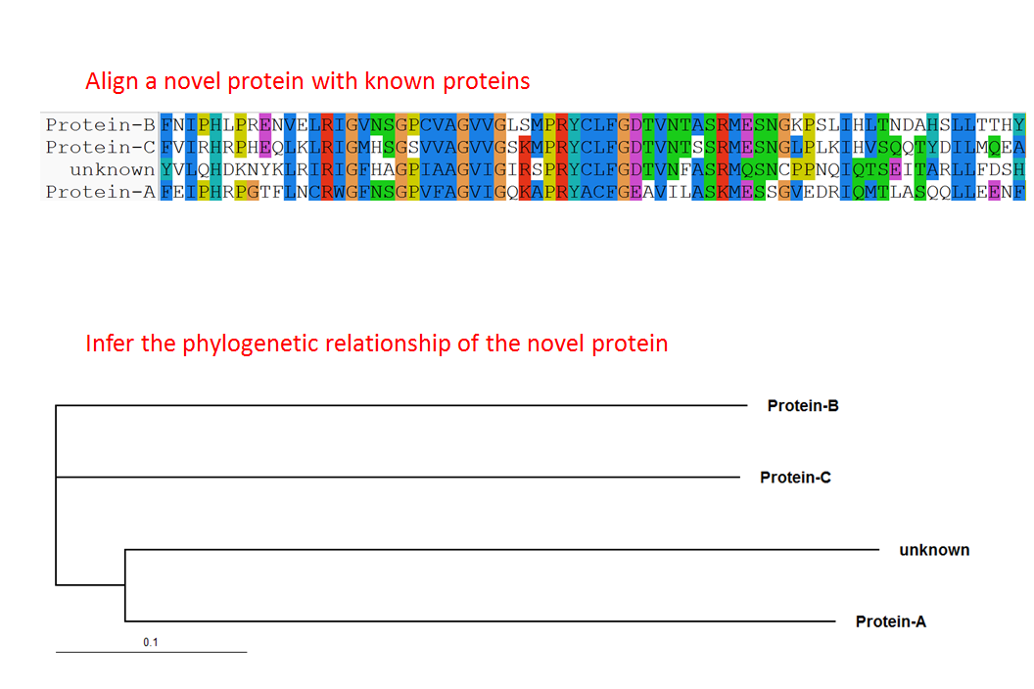

Paste a copy of your graphic overview here. The original file should be Adobe Illustrator (preferred) or Powerpoint (see instructions) and should be uploaded through your online submission on the JoVE website. Please keep all layers in the file (i.e., do not flatten the file).

B. Interview: (Said by you on camera. Don’t forget to smile!)

Authors: Below are statements we would like you to complete that are complementary to the information contained within the schematic overview.
- Only one statement should be chosen and completed per author who will be on camera demonstrating the protocol.
- Enter the name of the individual who will say each line.
- Please choose and fill out the statement(s) that convey the most important fact(s) about your protocol. You may revise the given prompts as necessary to improve the sentence flow.
- If any individuals will be doing demonstrations on camera but are not assigned a speaking part in this interview section, please use statement 1.8 to introduce these demonstrators (for example, the PI introduces students)

Only one statement should be chosen per speaker
  - Author name _________: The main advantage of this technique over existing methods, like __________, is that ___________.
  - Author name __Damien O’Halloran______: This method can help answer key questions in __very diverse_______ fields, by inferring identity and function to novel sequences
  - Author name _________: The implications of this technique extend toward therapy (or diagnosis) of_______, because ________.
  - Author name ________: Though this method can provide insight into ____________, it can also be applied to other systems (model organisms, studies of disease, organ systems), such as ____________.
  - Author name _______: Generally, individuals new to this method will struggle because ______________.
  - Author name ________: I/We first had the idea for this method, when I/we ___________.
  - Author name _________: Visual demonstration of this method is critical as the ______________ steps are difficult to learn, because _______________.

Please fill out the following only to introduce someone who will appear in the video but who is not making an interview statement (that is, to introduce someone who is not listed above):
  - **Author name ________: Demonstrating the procedure will be ________ a _______ (technician, post doc, grad student) from my laboratory. (Add additional mention of demonstrators as necessary).
    - Interview style: Author saying the above
    - The named technician, post doc, student looks up from workbench or desk or microscope and acknowledges the camera.

Protocol (read by voice talent at JoVE):
Authors: In order to ensure that your protocol can be filmed in a single day, the protocol text must be limited to 30 steps – each step being defined as 3 lines of 12 pt text in our formatting style below. This amounts to 3 pages of protocol text. The scope of the scripted protocol text should include only those aspects of the procedure that require visualization in order to be well understood.

- Basic Local Alignment Search Tool (BLAST): Online Interface
  - To use the online version of the Basic Local Alignment Search Tool, or BLAST, navigate to the National Center for Biotechnology Information, or NCBI’s, BLAST web server. Click on the appropriate Blast program, for example, “Protein Blast” (Figure 1).
  - Input a FASTA formatted text sequence, such as the one shown here, into the query box.
  - Click the appropriate BLAST program for use in the search, and then click “BLAST.” The output is in HTML format by default and displays the most similar sequences to the input text sequence.
Damien: Figure 1 shows a “Go” button rather than a “BLAST” button, so should this say “… then click “Go?” Or does a “BLAST” button appear after you’ve selected a BLAST program?
Also, what is the output showing? A best match of _____?
  - The next section covers using a local BLAST executable on Windows. Mac users can skip to the following section called “BLAST: Local Executables for Macs.”
Damien: As the viewer of the video will use either Windows or a Mac, I’ve reorganized the next two sections of the protocol to combine all the Windows steps in to Section and all the Mac steps into Section 4. I tried to incorporate the steps that cover both Mac and Windows into both sections, but please check the flow carefully in both sections, to be sure they are complete.
- BLAST: Local Executables for Windows
  - To run the BLAST command-line program on a Windows machine, download the appropriate Windows executable from the NCBI BLAST website.
  - After installing the BLAST program, configure the PC environment variable as follows: Click the PC’s “start” button and right click “computer,” then click “Properties.” In the new window, select “Advanced System Settings,” and in the “Advanced” tab of the new pop-up, click the “Environment Variables” button.
  - Then, under the “User variables for user” section, click the “New” button. In the new pop-up, add the variable name “Path” and the variable value shown here.
  - Next, download a preformatted BLAST database, which are updated daily, from the NCBI website:
  - Then, open a MS-DOS prompt by clicking “start” and typing “cmd” in the search bar and change to the ncbi-blast folder.
  - Create the database using the “make D-B” command shown here.
  - Create a query protein sequence called “test” by inserting a FASTA formatted protein text sequence into the “D-B” folder.
  - Then, to identify the most similar sequences to the “test” protein, interrogate the database via a “blast-P query” command.
To keep the viewer oriented as to what is going on, can we add a few words here – For example, would “Then, to interrogate the database to find the closest ____ matches to the “test” protein sequence, issue a ‘blastp query’ command.”
  - The following section repeats this information for Mac users. Windows users can skip to section 5, ”Generating Multiple Sequence Alignments.”
- BLAST: Local Executables for Macs
  - To run the BLAST command-line program on a Mac, download the appropriate Mac executable from the link shown here or by remotely accessing the NCBI ftp site (see step 4.2):
  - Open the Terminal application by opening “Finder” and searching for “Terminal.” In the terminal window, type the ftp command for the NCBI ftp site.
  - Type “anonymous” for Name and Password, and then type “C-D blast slash executables slash latest.”
  - List the executables by typing “L-S” … and download the latest version based upon most recent date that matches your system requirements. .
Is this a reasonable way to guide the user to picking the latest version?
  - Then, exit the NCBI ftp server site by typing “exit”.
  - Next, decompress the downloaded files:
  - Now, add the location of the binaries for the blast executable to your path so that the shell can search through this directory when looking for commands.
  - Download a preformatted BLAST database from the NCBI website … and then type “L-C-D dot dot slash databases slash.”
I’m writing out the commands so that the voice talent who has to read it knows how to say it correctly. Please check to be sure I’ve written it out correctly, here and elsewhere.
  - Then download the genome or sequence of interest by typing the “get N-C underscore” command … and then type “quit” to exit the ftp site.
  - Next, make the database by typing the “make blast D-B” instruction.
  - Insert a FASTA formatted query sequence into the “bin” folder and interrogate the database with the “blast-P query” command to find the most similar sequence to the test sequence data.
- Generating Multiple Sequence Alignments
Do sections 5, 6 & 7 apply to both Macs and Windows machines?
  - Among the commonly used Multiple Sequence Alignment, or MSA, programs is T-Coffee. After inputting FASTA formatted sequence data into the query box at the T-Coffee site, the output indicates similar residues by the color coding.
  - Another commonly used MSA program is the Clustal MSA, which can be downloaded as a command line version, Clustal W, or a graphical version, Clustal X, for various operating systems.
  - After downloading the Clustal program, load the data to the Clustal program as FASTA formatted sequence text by clicking the “Load sequences” button under the “File” tab and align the sequences by clicking the “do complete alignment” button under the “align” tab.
Is “Align” a button that you click on the Clustal software?

- Determining Best-fit Models of Evolution
  - For a best-fit model of evolution, download the ProtTest program.
  - Once ProtTest is downloaded, double-click on the “ProtTest dot jar” file.
  - Once ProtTest is launched, click on “select file” in the alignment box and load the sequence data.
There are two “Select file” button in figure 7, under Alignment and under Tree. Which do you click to upload the sequence data?
  - Then click “start” to run the program. After completing the run, the program indicates the best model based on the criteria.
I’m not seeing the words “Best model according to AIC: WAG+I+G” in Figure 8. Can you submit a new version of Figure 8 with the “Best model according to …” circled in red?
- Inferring Sequence Based Phylogenies by Maximum Likelihood or Bayesian Inference
  - For inferring sequences, after downloading and launching PhyML, load the input sequence as a PHYLIP formatted sequence by typing the filename and “dot P-H-Y”. Then launch the program by typing “Y”.
  - After downloading a Bayesian inference program from the MrBayes website, start the program by clicking on the executable file. Then read NEXUS formatted sequence data into the program by typing “execute filename dot N-E-X.
  - Next, set the evolutionary model, and select the number of generations to run.
  - After running the analysis with the “m-c-m-c” command, summarize the trees using the “sum t” command
- Visualizing Phylogenies
  - To view a phylogentic tree, download the TreeView program.
  - As a final note, there are constant releases of new software aimed at providing better alignments, similarity predictions, or phylogenetic trees. While the overview in this video covered popular programs, the viewer is encouraged to explore additional options.
- Results: Similarity Searches , Alignments, Determining Best-Fit Models, and Reconstructing Phylogenetic Trees If you’d prefer a different heading for the results section, please feel free to revise it but please keep it fairly short
  - The BLAST algorithm performs "local" alignments, which searches for short stretches of sequence similarity. After the algorithm has looked up all possible "stretches" from the query sequence and maximally extended these sequences, it then assembles alignments for each query sequence pair.
    - LAB MEDIA: Figure 4
  - The E value gives an indication of the statistical significance for a match. The lower the E-value, the more significant the hit, for example a sequence alignment with an E-value of 0.05 means that the likelihood of this match occurring by chance alone is 5 in 100.The bit score uses a specific scoring matrix to provide an indication of how good the alignment is. The higher the bit score, the better the alignment.
    - LAB MEDIA: Figure 4 (con’t).
  - A Multiple Sequence Alignment, or MSA, is a sequence alignment of three or more primary sequences composed of amino acids, DNA, or RNA. The output from the MSA “T-Coffee,” seen here, color codes similar residues.
    - LAB MEDIA: Figure 5
  - A sample alignment of six protein sequences aligned using ClustalX is shown here. ClustalX allows manual reﬁnement of alignments, which are often superior to fully automated methods.
    - LAB MEDIA: Figure 6
  - For amino-acid alignments, the program ProtTest is used to determine the selection of best-fit models of amino acid replacements within the data. The program lists the models as they are being analyzed and displays the best-fit after completion of the program.
    - LAB MEDIA: Figure 8
  - PhyML estimates maximum likelihood phylogenies from alignments of nucleotide or amino acid sequences. It incorporates a large number of substitution models coupled to various options to search tree topology space.
    - LAB MEDIA: Figure 10
  - MrBayes utilizes Bayesian MCMC inference across a number of evolutionary models to reconstruct phylogenetic relationships. Once the program is running, progress can be viewed in specific intervals, as shown here.
    - LAB MEDIA: Figure 11
  - Once a phylogenetic tree is generated, the topology needs to be visualized. In this figure, the TreeView window displays a sample tree of proteins from Flybase. TreeView includes a tree editor that allows the user to move branches, re-root trees, and rearrange the appearance of the tree.
    - LAB MEDIA: Figure 12.

INSTRUCTIONS FOR AUTHORS:
Please ensure that the representative results narration is appropriate and correctly describes your images, movies, or figures. Our editors have ensured that the results are written in our format.

We consider this section a critical aspect of the video, because here is where you provide validation for your experiments. For example, if this is a cell culture preparation, this section is where the video will show your cells at various time points following culturing. If this is an imaging prep, then this part is where you will show examples of your imaging experiments.

Please limit the extent of narration to no more than 2-3 lines of text per image or movie file being described. Figures with multiple panels submitted with the original protocol should be broken up so that each panel is a separate image. Like the schematic, each image or movie file supplied in the results should be referenced by annotation in parenthesis, however for the results, the specific filename should be given in parenthesis.

Below is an example of results text:

EXAMPLE REPRESENTATIVE RESULTS

5. Evaluation of Morpholino Injection and Knockdown
5.1 Representative results of both morpholino injection and mRNA injection are shown here. The
uninjected control at 48 hours post fertilization looks normal, as expected
-LAB MEDIA: 0123_PIname_Figure1.tif (Replace 0123 with your jove video #)

5.2 However, embryos injected with the morpholino heg_e3i3_egfr1, which knocks down Heg isoforms
containing the first of two EGF-like repeats, exhibit brain edema.
-LAB MEDIA: 0123_PIname_Figure2.tif

5.3 Injection of heart of glass mRNA also produced an obvious phenotype. At 24 hours post fertilization,
the heads of the uninjected controls look normal
-LAB MEDIA: 0123_PIname_Figure3.tif

5.4 Conversely, some of the embryos injected with the mRNA exhibit cyclopia
-LAB MEDIA: 0123_PIname_Figure4.jpg

Please visit the following URL to see an example of how the results will look when complete:
http://www.jove.com/video/1597/results-example-mably?access=ksw0bprj

- Conclusion (said by authors on camera)
Authors: Below are statements we would like you to complete that summarize and conclude the video. Only one statement should be chosen and completed per author who will be on camera demonstrating the protocol. In addition to choosing and filling out the appropriate statement, please enter the name of the individual who will say each line. You may revise the given prompts if necessary to better fit your protocol.

  - Author name ________: Once mastered, this technique can be done in ____________ (hours/min) if it is performed properly.
  - Author name __Damien O’Halloran______: While attempting this procedure, it’s important to remember to _read thoroughly the user guides for each program. This protocol provides a practical starting point to introduce the user as to how these programs work, however, I encourage the reader to play around with and become familiar with the many settings associated with each program __________.
  - Author name ________: Following this procedure, other methods like _____________ can be performed in order to answer additional questions like _____________.
  - Author name ________: After its development, this technique paved the way for researchers in the field of __________ to explore _____________ (subdivision of field, disease, natural phenomenon) in __________( model organism, patient demographic, organ system).
  - Author name _________: After watching this video, you should have a good understanding of how to _____________ (restate overall goal of the procedure mention specific steps).
  - Author name _________: Don't forget that working with _____________(reagent, pathogen, instrumentation) can be extremely hazardous and precautions such as ____________ should always be taken while performing this procedure.

Provided Media

Authors, Please list all images, movie files, or 3-D rendered animations that can be included in the video per editor’s request. The step in the script/video where these images will be inserted should be specified. For example:

6.2 – 0123_PIname_Figure1.tif - dual color imaging of tumor angiogenesis at 40X
6.2 – 0123_PIname_Figure2.tif - dual color imaging of tumor angiogenesis at 100X

Formats: For static images we prefer .tiff, .eps, Illustrator, Powerpoint or Photoshop files at dimensions of at least 720X480 pixels and 300 dpi. The higher resolution, the better. Likewise any exported movie files should have at minimum these dimensions and be rendered to .mov, .mp4, or .avi files.

Insert your media filenames here.

General Preparation

It’s critical for a smooth and organized shoot that all reagents are accounted for, in advance.

Any overnight or long incubation steps should be recognized and specimens/samples be prepared in advance so that prior steps can be recorded and shooting can continue with pre-prepared specimens/samples.

All tubes/flasks should be pre-labeled neatly before we arrive.

Ex. Luciferase assay done in 96 well plates should be labeled with negative/positive control wells and experimental samples are labeled accordingly.

You will receive more detailed preparation instructions, as well as an introduction to your videographer, closer to your filming date.

